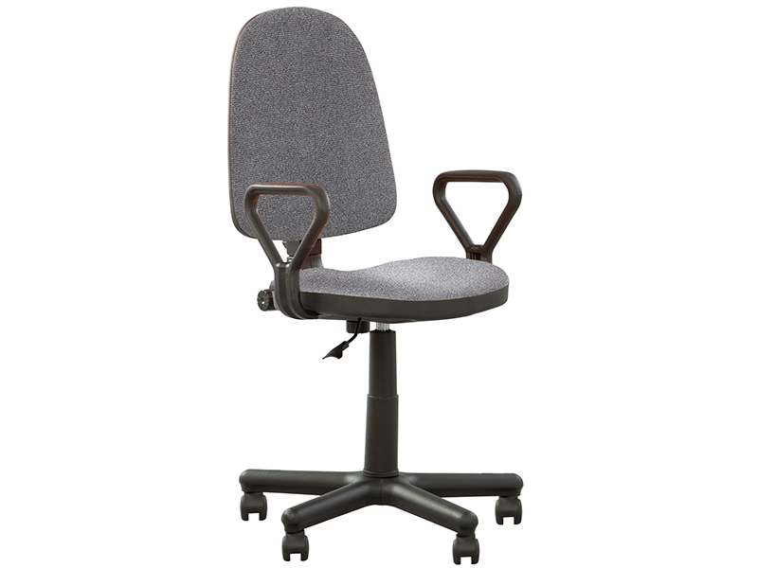

**Office chair:** “Prestige II GTP”.

1. Examples of Quality Attributes, that office chair should possess.

**Functional suitability**

The functional tasks of the office chair are to provide a comfortable sitting position for the one employee with his workplace.

**Performance efficiency**

The office chair is mobile, and it could use any employee anywhere in the office. The office chair should be designed for an employee weighing from 40 to 120 kg and a height from 1.5 to 1.9 m

**Compatibility**

In the lower position the height of the chair from the ground to the extreme point of the armrest should be 0.68 m so that it can be pushed under the table.

**Usability**

The design of the chair provides:

- backrest adjustment by 10 degrees;

- seat height adjustment from 0.45 to 0.9 m (measurement from the ground to the extreme point of the armrest);

- 360-degree swivel chair around the base;

- movable base with five pairs of wheels.

**Reliability**

Bill of materials:

1. Backrest: back – plastic; lining - synthetic fabric; inner part - plywood upholstered in paralon.
2. Seat: upper part - synthetic fabric; inner part - plywood upholstered in paralon; bottom part plastic.
3. Base: crosspiece - high-strength plastic; wheels 5 pcs. - high strength plastic; moving parts - hydraulic cylinder; fastening part - stamped steel 2.5 mm thick.
4. Bracket for mounting the backrest with seat - stamped steel 2.5 mm thick.
5. Screws for fastening the back and seat 2 pcs - plastic + special screws (screw dimension M8x30).
6. Screws to secure the base to the seat 6 pcs - high carbon steel (screw dimension M8x10).
7. Armrests 2 pcs - high strength plastic
8. Screws for mounting the armrests 4 pcs - high carbon steel (screw dimension M8x10).

**Security**

Not security. Everyone can sit by it.

**Maintainability**

The “Backrest”, “Seat”, “Armrests”, “Wheels” and all screws (М8х10 – 10 pcs., and 2 special screws M8x30) can be replaced

**Portability**

It possible to disassemble the backrest, seat, armrest for convenient transportation to another place (according to instructions)..

**List of Testing Types, which can be applied for office chain:**

Functional testing:

- check backrest tilt adjustment;

- check moving backrest adjustment;

- check seat height adjustment;

- check armrest adjustment

- check chair turnover to 360 degree

- check wheel rotation

Non-functional Testing

1. UI Testing - check appearance: Check if all parts (backrest, seat base,b racket for mounting the backrest with seat, crews for fastening the back and seat 2 pcs., screws M8x10 (10 pcs) are included, chair color, materials.

2. Performance and Load Testing - load a chair weighing 80 kg (average weight) along 8 hours.

3. Stress Testing - load a chair weighing 180 kg along 5 hours.

4. Stability / Reliability Testing - load a chair weighing 80 kg along 10 hours.

5. Installation testing - check how it easy to assemble a chair and set up (according to instructions).

6. Usability Testing - checks how simple and fast a new user can assembled it. Check how easy it is to adjust the chair (30 minutes according to instructions). Check convenience for people height 1.4 m; 1.5 m; 1.75 m; 1.9 m; 2.0 m.

7. Failover and Recovery Testing - check the suitability of the seat after accidentally unscrewing the screws on the backrest and seat.

8. Configuration Testing - check compatibility with different tables (tables high to testing: 0.7m; 0.8 m; 0.9 m; 1.0 m).

9. Interoperability Testing - testing with additional back support module.

Positive type testing - assemble according to the instructions.

Negative type testing - try to assemble with the screws M6x10 instead of screws M8x10.