**Feature name:** Authorization

**Bug ID:** VK-001

**Summary:** The user can log in with an invalid Account after a successful login with a valid one onAuthorization Page.

**Severity:** Critical

**Preconditions:**

1. User has an account.
2. User is logged in with valid Password and Username.
3. User clicks back button on the browser page.

**Steps to reproduce:**

1. Navigate to the Login Page.
2. Enter a valid Login.
3. Enter an invalid Password and clicks Log In button.

**Actual result:**

User is successfully logged in with invalid credentials.

**Expected result:**

System displays a message: "Incorrect Username or Password"

User is not logged in.

**Note:**

The issue is also reproducible with a random Username/Password combination.

**Feature name:** Registration

**Bug ID:** VK-002

**Summary:** User can be registered with an existing login on Registration Page.

**Severity:** Critical

**Preconditions:**

User has an account.

**Steps to reproduce:**

1. Navigate to the Registration page.
2. Enter valid previously created Login.
3. Enter the data into other fields.
4. Click the Submit button.

**Actual result:**

User can be registered with an existing login.

**Expected result:**

System displays a message: "User with this login already exists".

User is not registered.

**Attachments:**

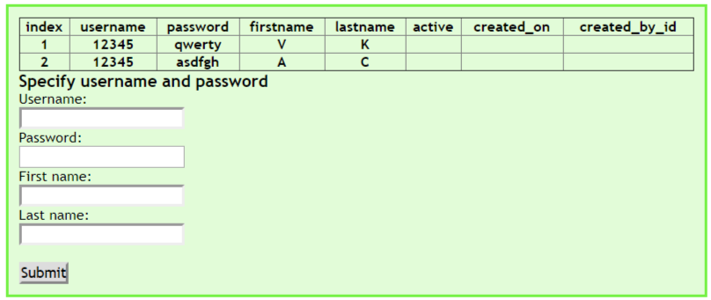

**Feature name:** Authorization

**Bug ID:** VK-003

**Summary: “**ENTREZ CONNECTER DГ©TAILS” message is displayed instead of “Entrez Vos détails” on French Login Page.

**Severity:** Minor

**Steps to reproduce:**

1. Navigate to the French Login Page.
2. Take a look at the message in the header of the Login form.

**Actual result:**

**“**ENTREZ CONNECTER DГ©TAILS” message is displayed.

**Expected result:**

“Entrez Vos détails” message is displayed.

**Attachments:**

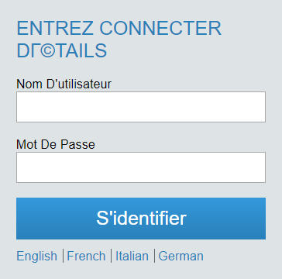

**Feature name:** Authorization

**Bug ID:** VK-004

**Summary:** “S'identifier” button is displayed instead of “Connecter”/”Accedi”/“Anmelden” on French/Italian/German Login Page.

**Severity:** Minor

**Steps to reproduce:**

1. Navigate to the French/Italian/German Login Page.
2. Take a look at the “S'identifier” button.

**Actual result:**

“S'identifier” button is displayed for all three regions.

**Expected result:**

“Connecter” button is displayed on the French Login Page

”Accedi” button is displayed on Italian Login Page

“Anmelden” button is displayed on German Login Page.

**Attachments:**

 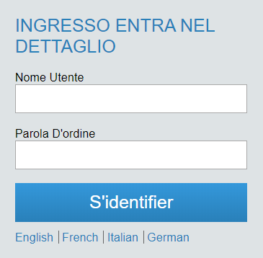

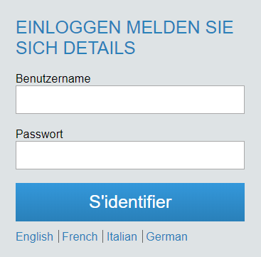

**Feature name:** Authorization

**Bug ID:** VK-005

**Summary:** System navigates to the English Login Page after clicking on the “S'identifier” button on French/Italian/German Login Page.

**Severity:** Normal

**Steps to reproduce:**

1. Navigate to the French/Italian/German Login Page.
2. Click the “S'identifier” button.

**Actual result:**

The system does not authorize the user and navigates to the English Login Page.

**Expected result:**

The system does not authorize the user and leaves on French/Italian/German Login Page.