ANS 235
Dairy Herd Reproduction
Partial Budget, Assignment 1
1/22/26

This assignment involves using an Excel spreadsheet and a partial budget to investigate the revenues and expenses associated with changing the reproductive status of a dairy herd. By following the directions given in class, and the directions below, you should be able to complete the assignment.

The spreadsheet will do all the calculations for you. You will need to provide the assumptions, or inputs, for the spreadsheet to work. You can use any assumptions you want except for what is explained below.

An Excel spreadsheet will be available in D2L. I would suggest downloading and saving the original file and renaming the file once you begin to work. This will allow you to start over, if necessary, with the original file. There are two sheets in this Excel file. One is for “Fixed” Calving Interval, the other for “Input EDR and CR”. You will use both sheets for this exercise.

ASSIGNMENT

GENERAL ASSUMPTIONS

In the general assumption section (top of spreadsheet), you will need to put in your own assumptions for your own dairy including size, costs, and the price of milk. You can use any numbers you want. However, you will need to turn in an explanation for all your assumptions. The more detail you provide, the higher your grade will be.

ANALYSIS (Questions)

1. Please use the “fixed calving interval” sheet, to compare an 18.2 month CI to a 13.4 month calving interval. Explain your results in detail.

The Herd size I choose is 500, because it seemed reasonable for following reasons:
- If the size is greater than 500, it will become difficult to manage (as a family business).
- If the size is less than 500, it will not give me the desired income.
- The part of the income allows me to update the equipment and improve the operational capability. Moreover, it will open more possibilities to develop the workflow by using Food Supplement, and apply the best genetics in the future.

The preferable CI in my opinion is 13.4 months. As you can notice the benefit from the CI exceeds the 18.2 months for 194 910 USD (390 USD more per cow ).
However, the 13.4 month CI requires additional effort, such as: an extra management, a better feeding, etc.
Daily Milk per cow also increased from 55 to 73, for 18.4 months and 13.4 months respectively. Since the 18.4 months (554 days) are longer, the cow’s capability to produce milk will decrease by the ending of the cycle. In contrast, the shorter interval allows the cows to be at their highest lactation period.

2. After completing #1, increase your Rolling Herd Average by 7000 lbs and explain all the changes and results in detail.

Before
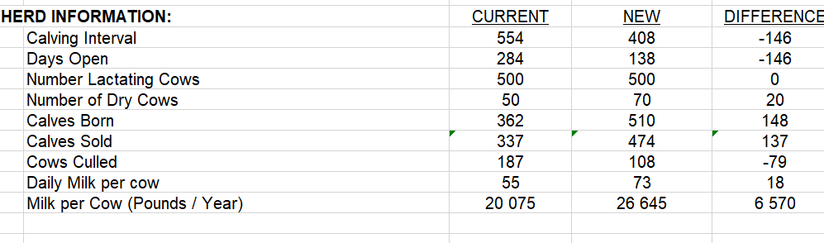

After the change:
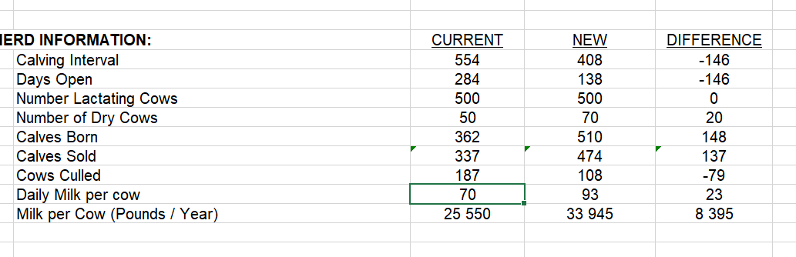

RHA (Rolling Herd Average) directly affects the Net by increasing the difference between CIs to 313 535 USD (627 USD more per cow).
A Daily Milk per cow also increased and demonstrated a better result.

3. Please use the “Input EDR and CR” sheet, compare your current EDR of 24% to a new EDR of 62%. Explain your results in detail.
The noticeable change happens to Pregnancy Rate because of the EDR increase, which also increases the Daily Milk per cow.
EDR is proportional to Pregnancy Rate:
$$Pregnancy rate=EDR*CR$$
Therefore, higher PR leads to higher daily milk.
In the example, the difference of daily milk between EDRs is 20 lb/day. Thanks to all of them, the overall Net also grows.
4. After completing #3, increase your milk price by $6.25 and explain all the changes and results in detail.
The Net result per Lactating cow increases for 1574 USD. And the difference of Net Result for Herd between two EDR is 919 USD more.

Electronic copies of each partial budget spreadsheet, explanation of your general assumptions, and answers to the questions must be uploaded to D2L. Files names should be your last name and include HW#1. Everyone is responsible for developing his or her own scenarios and explanations. If work is found to be similar between individuals, points will be deducted from all individuals involved.

ASSIGNMENT IS DUE VIA D2L BY SUNDAY FEBRUARY 9, 2026 by 8:00 pm.

