ASSIGNMENT 2
DAIRY HERD REPRODUCTION
ANS 235
2/10/26
DUE: 2/28/26

You are an owner of a 1200-cow dairy and are considering changing the reproductive program on your dairy to the proposed situation below. Your answers will need to be uploaded to D2L. The easiest way to complete this assignment is to build an excel spreadsheet. However, that is not a requirement to complete!

When you upload your file or files please use your last name as the file name.

Current Situation Proposed Situation

VWP = 60 Days VWP = 80 Days
Heat Detection (Service Rate) = 38% Heat Detection Rate (S. Rate) = 72%
Conception Rate = 33% Conception Rate = 49%
Cull cows after 11 estrous cycles. Cull cows after 11 estrous cycles

For each scenario, answer the following questions. PLEASE SHOW YOUR WORK FOR FULL CREDIT!

- What is the 21-day pregnancy rate for each situation?

Current situation: PR = CR*HDR = 0.33*0.38 = 0.1254 = 12.54%
Proposed Situation: PR = 0.49*0.72 = 0.3528 = 35.28%

- What is the distribution of cows in heat (or serviced), cows pregnant, cows open and total cows pregnant after each estrous cycle for each situation above. This should be provided in a table format.

Cycle Proposed | Start Open | HDR (72%) | CR (49% of Serviced) | Open | Total Pregnant (35,28%)
1 | 1200 | 864 | 588 | 777 | 423
2 | 777 | 559 | 256 | 503 | 274
3 | 503 | 362 | 165 | 326 | 177
4 | 326 | 234 | 107 | 211 | 115
5 | 211 | 151 | 69 | 137 | 74
6 | 137 | 98 | 45 | 89 | 48
7 | 89 | 64 | 29 | 58 | 31
8 | 58 | 41 | 19 | 38 | 20
9 | 38 | 27 | 12 | 25 | 13
10 | 25 | 18 | 8 | 17 | 8
11 | 17 | 12 | 5 | 12 | 5

- Provide a graph of open cows by Day in Milk (DIM) for each situation.

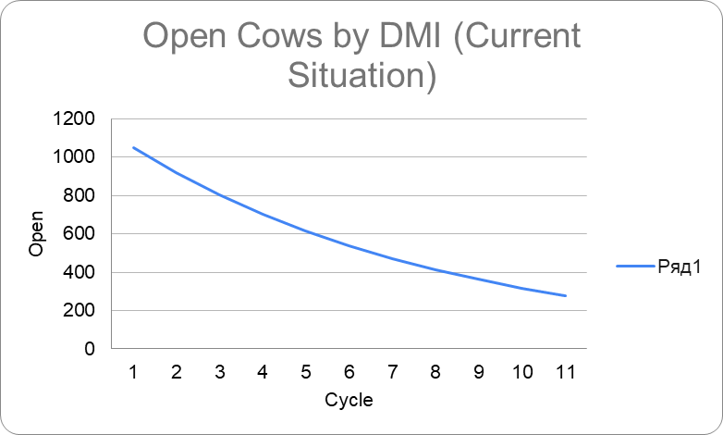

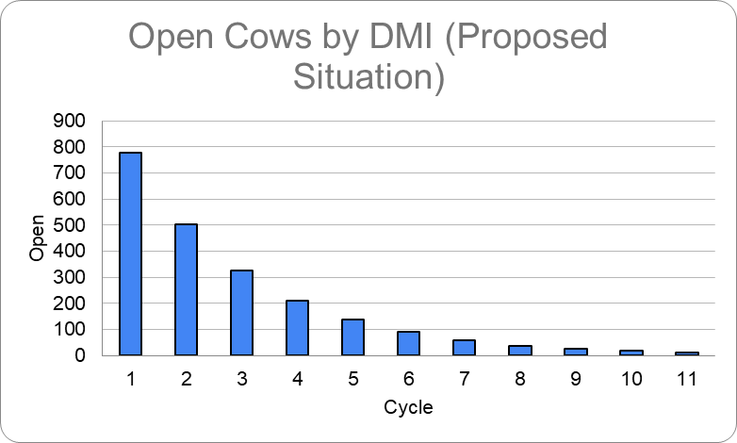

- How many total cows are pregnant at 140 DIM for each situation?

Current situation: 496 cows
Proposed: 989 cows

- How many cows are open after 11 estrous cycles for each situation?

Remaining open cows in current situation after the 11th cycle - 278;

Remaining open cows in proposed situation after the 11th cycle - 12.

- What is the average days open (ADO) for the current and proposed situation?

$VWP + (\frac{1}{PR}-0.5)*20$

Current situation:
$60 + (\frac{1}{0.1254}-0.5)*20 ≈210 days$

Proposed situation:
$80 + (\frac{1}{0.3528}-0.5)*20 ≈127 days$

- Discuss in detail the pros and cons of each situation.

One of the disadvantages of current situation, the number of open cows at the end of the cycle is high. Moreover, ADO is much larger compare to the benchmark. As a result, we won’t get the desired number of calves, and also we will see a decrease in the dairy production.

One of the advantages of current situation compare to the proposed situation is in the effort we put to detect the heat (HDR). A High HDR requires higher workload and more expenses.
However, Proposed Situation offers way more benefits than its drawbacks: less open cows at the cycle end results a large amount of calves.
99% of 1200 cows were conceived.

DUE February 28, 2026 by Noon

