Maps Project

Wesley Stanis

install.packages(“ggmap”) install.packages(“zipcodez”) install.packages(“scales”) install.packages(“rlang”) install.packages(“stringi”) install.packages(“zipcode”)

library(ggplot2)

## Warning: package 'ggplot2' was built under R version 3.5.3

library(ggmap)  
library(zipcode)  
  
df <- read.csv("locData.csv")  
colnames(df) <- c("zip","median","mean","population")  
  
  
data("zipcode")

#subsetting to remove Alaska and Hawaii  
dfzip1 <- subset(zipcode,zipcode$state != "AK")  
dfzip2 <- subset(zipcode,zipcode$state != "HI")

#merging data by zip codes into new dataframe  
df1 <- merge(x=df, y=dfzip2, by="zip")

state <- sort(unique(df1$state))

#getting the average median income and total population by state  
amidf1 <- tapply(as.numeric(df1$median), df1$state, mean)  
sdf1 <- tapply(as.numeric(df1$population), df1$state, sum)

#making a new dataframe  
ndf <- data.frame(amidf1, sdf1, state)

#matching states with abbreviations  
ndf$states <- state.name[match(ndf$state, state.abb)]

us <- map_data("state")

#plotting map  
map.simple <- ggplot()   
map.simple <- map.simple + geom_map(map = us, aes(x = us$long, y = us$lat, map_id=us$region))

## Warning: Ignoring unknown aesthetics: x, y

#adding coordinates  
map.simple <- map.simple + coord_map()  
map.simple

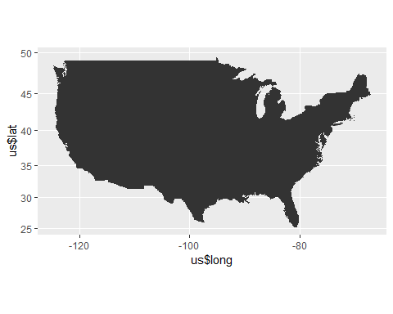

ndf$states <- tolower(ndf$states)

#filling map by averave median income  
amimap <- map.simple + geom_map(data=ndf, map=us, aes(fill=amidf1,map_id=states, col=amidf1))  
  
amimap

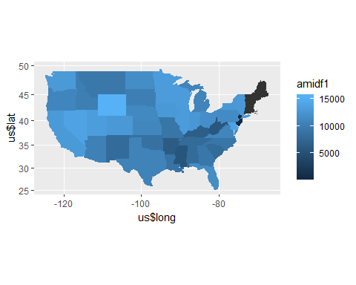

#filling map by state population  
spopmap <- map.simple + geom_map(data=ndf, map=us, aes(fill=sdf1, map_id=states, col=sdf1))  
  
spopmap

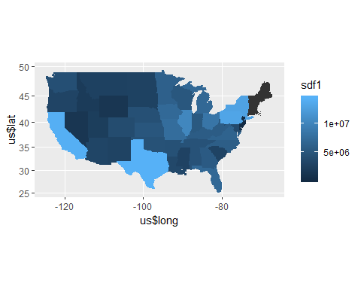

#map with zip code density  
zipmap <- map.simple + stat_density2d(aes(x= df1$longitude, y= df1$latitude), data = df1) + scale_fill_gradient(low="white", high="black")  
   
zipmap

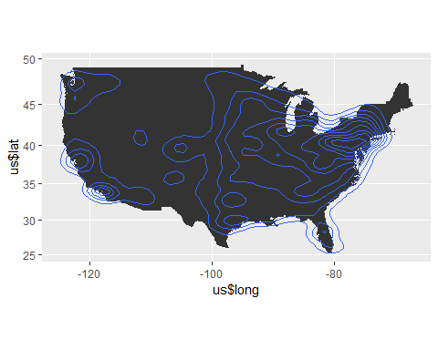

#coordinates for New York  
zoom <- geocode("New York", source = "dsk")

## Information from URL : http://www.datasciencetoolkit.org/maps/api/geocode/json?address=New%20York&sensor=false

zoom

## lon lat  
## 1 -74.00597 40.71427

#setting parameters to zoom map to New York  
zoomAmount <- 3  
centerx <-zoom$lon  
centery <-zoom$lat  
ylimit <- c(centery - zoomAmount, centery + zoomAmount)  
xlimit <- c(centerx - zoomAmount, centerx + zoomAmount)

#zooming in on new york. Map is filled by state population  
spopmap + coord_cartesian(x = xlimit, y = ylimit)

## Coordinate system already present. Adding new coordinate system, which will replace the existing one.

