Міністерство освіти і науки України

Національний університет «Львівська політехніка»

Інститут комп’ютерних наук та інформаційних технологій

Кафедра програмного забезпечення



**ЗВІТ**

**Про виконання лабораторної роботи № 11**

**На тему: «**Візуальні компоненти середовища програмування.**»**

**З дисципліни** «Об’єктно-орієнтоване програмування»

|  |
| --- |
| **Лектор:**  Доц. каф. ПЗ  Коротєєва Т.О. |
| **Виконав:**  Студент групи ПЗ-11  Володькін С. В. |
| **Прийняла:**  Доц. каф. ПЗ  Коротєєва Т.О. |
| 07 « 06 » 2023р  ∑= |
|  |

Львів – 2023

**ТЕМА РОБОТИ**: Візуальні компоненти середовища програмування.

**МЕТА РОБОТИ**: Навчитись використовувати візуальні компоненти середовища програмування при роботі з віконним проектом.

### ТЕОРЕТИЧНІ ВІДОМОСТІ

|  |  |
| --- | --- |
| Використані об’єкти | Характеристика |
| Panel | Використовується, щоб згрупувати колекції елементів керування  Controls->Add();  Name = L"name";  Size = System::Drawing::Size();  Location = System::Drawing::Point();  TabIndex = 2; |
| Label | Статичний незмінний користувачем текст  Location = System::Drawing::Point();  Name = L"name";  AutoSize = true;  Size = System::Drawing::Size();  TabIndex = 0;  Text = L"Text";  gcnew System::Windows::Forms::Label(); |
| TextBox | Елемент, що використовується для запису даних, для подальшого їх використання  ForeColor = System::Drawing::Color::Black;  Location = System::Drawing::Point();  Name = L"name";  Size = System::Drawing::Size();  TabIndex = 2;  TextChanged+=gcnewSystem::EventHandler(this,&MyForm::TextBox_TextChanged); |
| Button | Елемент, що виконує певну функцію, якщо користувач почне з ним взаємодіяти (натиснути)  BackColor=System::Drawing::SystemColors::Control;  Location = System::Drawing::Point();  Name = L"name";  Size = System::Drawing::Size();  TabIndex = 5;  Text = L"Text";  UseVisualStyleBackColor = false;  Click += gcnew System::EventHandler(this, &MyForm::Button_Click); |
| TableLeyoutPanel | Представляє панель, в якій вміст відображається у сітці, що складається з рядків та стовпців (вміст – елементи toolbox)  ColumnCount = 1;  ColumnStyles->Add((gcnew System::Windows::Forms::ColumnStyle(System::Windows::Forms::SizeType::Percent,0)));  Location = System::Drawing::Point();  Name = L"name";  RowCount = 1;  RowStyles->Add((gcnew System::Windows::Forms::RowStyle(System::Windows::Forms::SizeType::Percent, 0)));  Size = System::Drawing::Size();  TabIndex = 5; |
| MenuStrip | Групує елементи керування програми та робить їх легко доступними для користувача  Name = L"name";  Size = System::Drawing::Size();  Text = L"Text";  Click+=gcnewSystem::EventHandler(this,&MyForm::ToolStripMenuItem_Click); |

### ІНДИВІДУАЛЬНЕ ЗАВДАННЯ

1. Створити новий віконний проект. Відео-інструкція знаходиться за покликанням: https://www.youtube.com/watch?v=fnDIk66D8Xg
2. Проглянути у вікні інспектора об’єктів властивості форми. Змінити назву форми та її розміри.
3. На формі розмістити дві панелі (рис. 1). На одній з них розмістити таблицю (TableLayoutPanel), а на іншій – компоненти, які забезпечать можливість виконання таких дій:
4. ввести розміри таблиці: кількість рядків та стовпців (Label, TextBox) та заповнити її значеннями, згідно індивідуального завдання з додатку (Button);
5. ввести індекси рядка та стовпця таблиці та отримати значення елемента таблиці з заданими індексами;
6. очистити таблицю.
7. Забезпечити можливість обрати в діалоговому вікні ім’я текстового файлу,
8. з якого будуть зчитуватися дані для заповнення таблиці;
9. в який будуть записуватися дані з таблиці.

Примітка. У першому рядку текстового файлу вказано кількість рядків та стовпців таблиці.

1. На формі розмістити головне меню (MenuStrip), за допомогою якого теж можна виконати перелічені вище операції (рис. 2). Для пунктів меню вказати комбінації гарячих клавіш. На формі розмістити контекстне меню та за бажанням панель інструментів.

**Додаток:**

У квадратній матриці з заданими користувачем розмірами на заштрихованих позиціях знаходяться елементи, значення яких рівні 0, значення всіх інших елементів матриці рівні 1.

**Варіант 9**

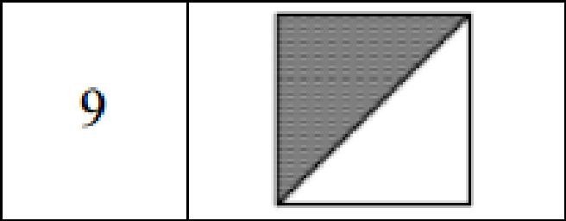

### Код програми

MYFORM.H [Design]

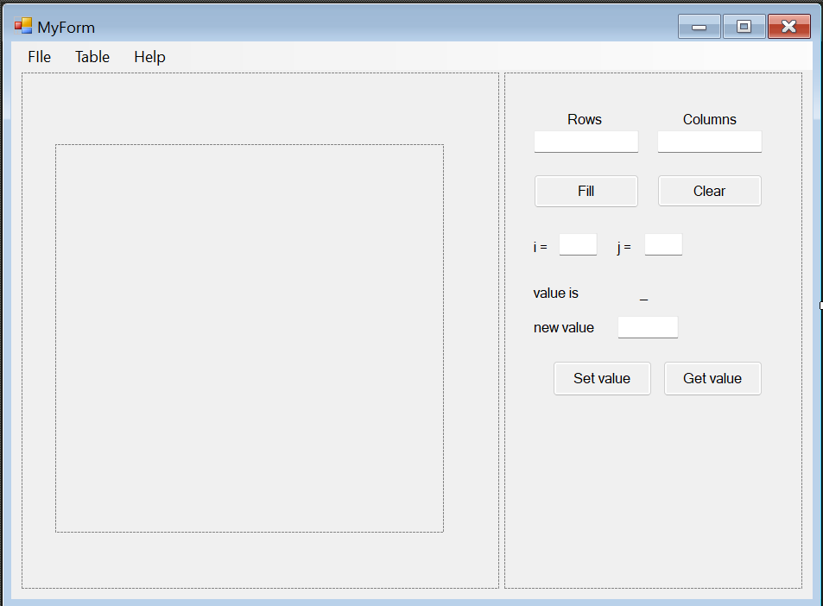  
MYFORM.H

#include <iostream>

#include <vector>

#pragma once

namespace lab11oop {

using namespace System;

using namespace System::ComponentModel;

using namespace System::Collections;

using namespace System::Windows::Forms;

using namespace System::Data;

using namespace System::Drawing;

using namespace System::IO;

using namespace System::Runtime::InteropServices;

/// <summary>

/// Summary for MyForm

/// </summary>

public ref class MyForm : public System::Windows::Forms::Form

{

public:

MyForm(void)

{

InitializeComponent();

//

//TODO: Add the constructor code here

//

}

protected:

/// <summary>

/// Clean up any resources being used.

/// </summary>

~MyForm()

{

if (components)

{

delete components;

}

}

private: System::Windows::Forms::Panel^ panelControl;

protected:

private: System::Windows::Forms::Label^ lColumns;

private: System::Windows::Forms::Label^ lRows;

private: System::Windows::Forms::TextBox^ tBRows;

private: System::Windows::Forms::Button^ buttonFill;

private: System::Windows::Forms::TextBox^ tBColumns;

private: System::Windows::Forms::Label^ labI;

private: System::Windows::Forms::Button^ buttonClear;

private: System::Windows::Forms::Label^ lValue;

private: System::Windows::Forms::TextBox^ tBJ;

private: System::Windows::Forms::TextBox^ tBI;

private: System::Windows::Forms::Label^ labJ;

private: System::Windows::Forms::Label^ lNewValue;

private: System::Windows::Forms::Button^ buttonGet;

private: System::Windows::Forms::Button^ buttonSet;

private: System::Windows::Forms::TextBox^ tBNewValue;

private: System::Windows::Forms::MenuStrip^ menuStrip1;

private: System::Windows::Forms::ToolStripMenuItem^ fIleToolStripMenuItem;

private: System::Windows::Forms::ToolStripMenuItem^ readToolStripMenuItem;

private: System::Windows::Forms::ToolStripMenuItem^ writeToolStripMenuItem;

private: System::Windows::Forms::ToolStripMenuItem^ exitToolStripMenuItem;

private: System::Windows::Forms::ToolStripMenuItem^ tableToolStripMenuItem;

private: System::Windows::Forms::ToolStripMenuItem^ fillToolStripMenuItem;

private: System::Windows::Forms::ToolStripMenuItem^ getValueToolStripMenuItem;

private: System::Windows::Forms::ToolStripMenuItem^ helpToolStripMenuItem;

private: System::Windows::Forms::ToolStripMenuItem^ setValueToolStripMenuItem;

private: System::Windows::Forms::ToolStripMenuItem^ clearToolStripMenuItem;

private: System::Windows::Forms::Panel^ panelDisplay;

private: System::Windows::Forms::TableLayoutPanel^ tableLayoutPanel1;

protected:

protected:

public:

bool cleanRows = true;

bool cleanColumns = true;

bool cleanI = true;

bool cleanJ = true;

bool cleanNewVal = true;

private:

/// <summary>

/// Required designer variable.

/// </summary>

System::ComponentModel::Container ^components;

;

array<array<System::Windows::Forms::Label^>^>^ labelArray;

int n, m;

int** arr;

int iVal, jVal;

int newVal;

private: System::Windows::Forms::Label^ lVal;

#pragma region Windows Form Designer generated code

/// <summary>

/// Required method for Designer support - do not modify

/// the contents of this method with the code editor.

/// </summary>

void InitializeComponent(void)

{

this->panelControl = (gcnew System::Windows::Forms::Panel());

this->lVal = (gcnew System::Windows::Forms::Label());

this->buttonGet = (gcnew System::Windows::Forms::Button());

this->buttonSet = (gcnew System::Windows::Forms::Button());

this->tBNewValue = (gcnew System::Windows::Forms::TextBox());

this->lNewValue = (gcnew System::Windows::Forms::Label());

this->lValue = (gcnew System::Windows::Forms::Label());

this->tBJ = (gcnew System::Windows::Forms::TextBox());

this->tBI = (gcnew System::Windows::Forms::TextBox());

this->labJ = (gcnew System::Windows::Forms::Label());

this->labI = (gcnew System::Windows::Forms::Label());

this->buttonClear = (gcnew System::Windows::Forms::Button());

this->buttonFill = (gcnew System::Windows::Forms::Button());

this->tBColumns = (gcnew System::Windows::Forms::TextBox());

this->tBRows = (gcnew System::Windows::Forms::TextBox());

this->lColumns = (gcnew System::Windows::Forms::Label());

this->lRows = (gcnew System::Windows::Forms::Label());

this->menuStrip1 = (gcnew System::Windows::Forms::MenuStrip());

this->fIleToolStripMenuItem = (gcnew System::Windows::Forms::ToolStripMenuItem());

this->readToolStripMenuItem = (gcnew System::Windows::Forms::ToolStripMenuItem());

this->writeToolStripMenuItem = (gcnew System::Windows::Forms::ToolStripMenuItem());

this->exitToolStripMenuItem = (gcnew System::Windows::Forms::ToolStripMenuItem());

this->tableToolStripMenuItem = (gcnew System::Windows::Forms::ToolStripMenuItem());

this->fillToolStripMenuItem = (gcnew System::Windows::Forms::ToolStripMenuItem());

this->getValueToolStripMenuItem = (gcnew System::Windows::Forms::ToolStripMenuItem());

this->setValueToolStripMenuItem = (gcnew System::Windows::Forms::ToolStripMenuItem());

this->clearToolStripMenuItem = (gcnew System::Windows::Forms::ToolStripMenuItem());

this->helpToolStripMenuItem = (gcnew System::Windows::Forms::ToolStripMenuItem());

this->panelDisplay = (gcnew System::Windows::Forms::Panel());

this->tableLayoutPanel1 = (gcnew System::Windows::Forms::TableLayoutPanel());

this->panelControl->SuspendLayout();

this->menuStrip1->SuspendLayout();

this->panelDisplay->SuspendLayout();

this->SuspendLayout();

//

// panelControl

//

this->panelControl->Controls->Add(this->lVal);

this->panelControl->Controls->Add(this->buttonGet);

this->panelControl->Controls->Add(this->buttonSet);

this->panelControl->Controls->Add(this->tBNewValue);

this->panelControl->Controls->Add(this->lNewValue);

this->panelControl->Controls->Add(this->lValue);

this->panelControl->Controls->Add(this->tBJ);

this->panelControl->Controls->Add(this->tBI);

this->panelControl->Controls->Add(this->labJ);

this->panelControl->Controls->Add(this->labI);

this->panelControl->Controls->Add(this->buttonClear);

this->panelControl->Controls->Add(this->buttonFill);

this->panelControl->Controls->Add(this->tBColumns);

this->panelControl->Controls->Add(this->tBRows);

this->panelControl->Controls->Add(this->lColumns);

this->panelControl->Controls->Add(this->lRows);

this->panelControl->Location = System::Drawing::Point(571, 36);

this->panelControl->Name = L"panelControl";

this->panelControl->Size = System::Drawing::Size(345, 598);

this->panelControl->TabIndex = 2;

//

// lVal

//

this->lVal->AutoSize = true;

this->lVal->Location = System::Drawing::Point(153, 245);

this->lVal->Name = L"lVal";

this->lVal->Size = System::Drawing::Size(18, 20);

this->lVal->TabIndex = 16;

this->lVal->Text = L"_";

//

// buttonGet

//

this->buttonGet->BackColor = System::Drawing::SystemColors::Control;

this->buttonGet->Location = System::Drawing::Point(184, 334);

this->buttonGet->Name = L"buttonGet";

this->buttonGet->Size = System::Drawing::Size(115, 41);

this->buttonGet->TabIndex = 15;

this->buttonGet->Text = L"Get value";

this->buttonGet->UseVisualStyleBackColor = false;

this->buttonGet->Click += gcnew System::EventHandler(this, &MyForm::buttonGet_Click);

//

// buttonSet

//

this->buttonSet->BackColor = System::Drawing::SystemColors::Control;

this->buttonSet->Location = System::Drawing::Point(56, 334);

this->buttonSet->Name = L"buttonSet";

this->buttonSet->Size = System::Drawing::Size(115, 41);

this->buttonSet->TabIndex = 14;

this->buttonSet->Text = L"Set value";

this->buttonSet->UseVisualStyleBackColor = false;

this->buttonSet->Click += gcnew System::EventHandler(this, &MyForm::buttonSet_Click);

//

// tBNewValue

//

this->tBNewValue->Location = System::Drawing::Point(131, 282);

this->tBNewValue->Name = L"tBNewValue";

this->tBNewValue->Size = System::Drawing::Size(71, 26);

this->tBNewValue->TabIndex = 12;

this->tBNewValue->TextChanged += gcnew System::EventHandler(this, &MyForm::tBNewValue_TextChanged);

//

// lNewValue

//

this->lNewValue->AutoSize = true;

this->lNewValue->Location = System::Drawing::Point(30, 285);

this->lNewValue->Name = L"lNewValue";

this->lNewValue->Size = System::Drawing::Size(79, 20);

this->lNewValue->TabIndex = 11;

this->lNewValue->Text = L"new value";

//

// lValue

//

this->lValue->AutoSize = true;

this->lValue->Location = System::Drawing::Point(30, 245);

this->lValue->Name = L"lValue";

this->lValue->Size = System::Drawing::Size(61, 20);

this->lValue->TabIndex = 10;

this->lValue->Text = L"value is";

//

// tBJ

//

this->tBJ->Location = System::Drawing::Point(162, 186);

this->tBJ->Name = L"tBJ";

this->tBJ->Size = System::Drawing::Size(45, 26);

this->tBJ->TabIndex = 9;

this->tBJ->TextChanged += gcnew System::EventHandler(this, &MyForm::tBJ_TextChanged);

//

// tBI

//

this->tBI->Location = System::Drawing::Point(63, 186);

this->tBI->Name = L"tBI";

this->tBI->Size = System::Drawing::Size(45, 26);

this->tBI->TabIndex = 8;

this->tBI->TextChanged += gcnew System::EventHandler(this, &MyForm::tBI_TextChanged);

//

// labJ

//

this->labJ->AutoSize = true;

this->labJ->Location = System::Drawing::Point(127, 192);

this->labJ->Name = L"labJ";

this->labJ->Size = System::Drawing::Size(29, 20);

this->labJ->TabIndex = 7;

this->labJ->Text = L"j = ";

//

// labI

//

this->labI->AutoSize = true;

this->labI->Location = System::Drawing::Point(30, 192);

this->labI->Name = L"labI";

this->labI->Size = System::Drawing::Size(29, 20);

this->labI->TabIndex = 6;

this->labI->Text = L"i = ";

//

// buttonClear

//

this->buttonClear->BackColor = System::Drawing::SystemColors::Control;

this->buttonClear->Location = System::Drawing::Point(177, 118);

this->buttonClear->Name = L"buttonClear";

this->buttonClear->Size = System::Drawing::Size(122, 38);

this->buttonClear->TabIndex = 5;

this->buttonClear->Text = L"Clear";

this->buttonClear->UseVisualStyleBackColor = false;

this->buttonClear->Click += gcnew System::EventHandler(this, &MyForm::buttonClear_Click);

//

// buttonFill

//

this->buttonFill->BackColor = System::Drawing::SystemColors::Control;

this->buttonFill->ForeColor = System::Drawing::SystemColors::ControlText;

this->buttonFill->Location = System::Drawing::Point(34, 118);

this->buttonFill->Name = L"buttonFill";

this->buttonFill->Size = System::Drawing::Size(122, 39);

this->buttonFill->TabIndex = 4;

this->buttonFill->Text = L"Fill";

this->buttonFill->UseVisualStyleBackColor = false;

this->buttonFill->Click += gcnew System::EventHandler(this, &MyForm::buttonFill_Click);

//

// tBColumns

//

this->tBColumns->Location = System::Drawing::Point(177, 67);

this->tBColumns->Name = L"tBColumns";

this->tBColumns->Size = System::Drawing::Size(122, 26);

this->tBColumns->TabIndex = 3;

this->tBColumns->TextChanged += gcnew System::EventHandler(this, &MyForm::tBColumns_TextChanged);

//

// tBRows

//

this->tBRows->ForeColor = System::Drawing::Color::Black;

this->tBRows->Location = System::Drawing::Point(34, 67);

this->tBRows->Name = L"tBRows";

this->tBRows->Size = System::Drawing::Size(122, 26);

this->tBRows->TabIndex = 2;

this->tBRows->TextChanged += gcnew System::EventHandler(this, &MyForm::tBRows_TextChanged);

//

// lColumns

//

this->lColumns->AutoSize = true;

this->lColumns->Location = System::Drawing::Point(203, 44);

this->lColumns->Name = L"lColumns";

this->lColumns->Size = System::Drawing::Size(71, 20);

this->lColumns->TabIndex = 1;

this->lColumns->Text = L"Columns";

//

// lRows

//

this->lRows->AutoSize = true;

this->lRows->Location = System::Drawing::Point(69, 44);

this->lRows->Name = L"lRows";

this->lRows->Size = System::Drawing::Size(49, 20);

this->lRows->TabIndex = 0;

this->lRows->Text = L"Rows";

//

// menuStrip1

//

this->menuStrip1->GripMargin = System::Windows::Forms::Padding(2, 2, 0, 2);

this->menuStrip1->ImageScalingSize = System::Drawing::Size(24, 24);

this->menuStrip1->Items->AddRange(gcnew cli::array< System::Windows::Forms::ToolStripItem^ >(3) {

this->fIleToolStripMenuItem,

this->tableToolStripMenuItem, this->helpToolStripMenuItem

});

this->menuStrip1->Location = System::Drawing::Point(0, 0);

this->menuStrip1->Name = L"menuStrip1";

this->menuStrip1->Size = System::Drawing::Size(928, 33);

this->menuStrip1->TabIndex = 3;

this->menuStrip1->Text = L"menuStrip1";

//

// fIleToolStripMenuItem

//

this->fIleToolStripMenuItem->DropDownItems->AddRange(gcnew cli::array< System::Windows::Forms::ToolStripItem^ >(3) {

this->readToolStripMenuItem,

this->writeToolStripMenuItem, this->exitToolStripMenuItem

});

this->fIleToolStripMenuItem->Name = L"fIleToolStripMenuItem";

this->fIleToolStripMenuItem->Size = System::Drawing::Size(55, 29);

this->fIleToolStripMenuItem->Text = L"FIle";

//

// readToolStripMenuItem

//

this->readToolStripMenuItem->Name = L"readToolStripMenuItem";

this->readToolStripMenuItem->Size = System::Drawing::Size(270, 34);

this->readToolStripMenuItem->Text = L"Read Ctrl + R";

this->readToolStripMenuItem->Click += gcnew System::EventHandler(this, &MyForm::readToolStripMenuItem_Click);

//

// writeToolStripMenuItem

//

this->writeToolStripMenuItem->Name = L"writeToolStripMenuItem";

this->writeToolStripMenuItem->Size = System::Drawing::Size(270, 34);

this->writeToolStripMenuItem->Text = L"Write Ctrl + W";

this->writeToolStripMenuItem->Click += gcnew System::EventHandler(this, &MyForm::writeToolStripMenuItem_Click);

//

// exitToolStripMenuItem

//

this->exitToolStripMenuItem->Name = L"exitToolStripMenuItem";

this->exitToolStripMenuItem->Size = System::Drawing::Size(270, 34);

this->exitToolStripMenuItem->Text = L"Exit Alt + F4";

this->exitToolStripMenuItem->Click += gcnew System::EventHandler(this, &MyForm::exitToolStripMenuItem_Click);

//

// tableToolStripMenuItem

//

this->tableToolStripMenuItem->DropDownItems->AddRange(gcnew cli::array< System::Windows::Forms::ToolStripItem^ >(4) {

this->fillToolStripMenuItem,

this->getValueToolStripMenuItem, this->setValueToolStripMenuItem, this->clearToolStripMenuItem

});

this->tableToolStripMenuItem->Name = L"tableToolStripMenuItem";

this->tableToolStripMenuItem->Size = System::Drawing::Size(68, 29);

this->tableToolStripMenuItem->Text = L"Table";

//

// fillToolStripMenuItem

//

this->fillToolStripMenuItem->Name = L"fillToolStripMenuItem";

this->fillToolStripMenuItem->Size = System::Drawing::Size(187, 34);

this->fillToolStripMenuItem->Text = L"Fill";

this->fillToolStripMenuItem->Click += gcnew System::EventHandler(this, &MyForm::fillToolStripMenuItem_Click);

//

// getValueToolStripMenuItem

//

this->getValueToolStripMenuItem->Name = L"getValueToolStripMenuItem";

this->getValueToolStripMenuItem->Size = System::Drawing::Size(187, 34);

this->getValueToolStripMenuItem->Text = L"Get value";

this->getValueToolStripMenuItem->Click += gcnew System::EventHandler(this, &MyForm::getValueToolStripMenuItem_Click);

//

// setValueToolStripMenuItem

//

this->setValueToolStripMenuItem->Name = L"setValueToolStripMenuItem";

this->setValueToolStripMenuItem->Size = System::Drawing::Size(187, 34);

this->setValueToolStripMenuItem->Text = L"Set value";

this->setValueToolStripMenuItem->Click += gcnew System::EventHandler(this, &MyForm::setValueToolStripMenuItem_Click);

//

// clearToolStripMenuItem

//

this->clearToolStripMenuItem->Name = L"clearToolStripMenuItem";

this->clearToolStripMenuItem->Size = System::Drawing::Size(187, 34);

this->clearToolStripMenuItem->Text = L"Clear";

this->clearToolStripMenuItem->Click += gcnew System::EventHandler(this, &MyForm::clearToolStripMenuItem_Click);

//

// helpToolStripMenuItem

//

this->helpToolStripMenuItem->Name = L"helpToolStripMenuItem";

this->helpToolStripMenuItem->Size = System::Drawing::Size(65, 29);

this->helpToolStripMenuItem->Text = L"Help";

//

// panelDisplay

//

this->panelDisplay->Controls->Add(this->tableLayoutPanel1);

this->panelDisplay->Location = System::Drawing::Point(12, 36);

this->panelDisplay->Name = L"panelDisplay";

this->panelDisplay->Size = System::Drawing::Size(553, 598);

this->panelDisplay->TabIndex = 4;

this->panelDisplay->Paint += gcnew System::Windows::Forms::PaintEventHandler(this, &MyForm::panelDisplay_Paint);

//

// tableLayoutPanel1

//

this->tableLayoutPanel1->ColumnCount = 1;

this->tableLayoutPanel1->ColumnStyles->Add((gcnew System::Windows::Forms::ColumnStyle(System::Windows::Forms::SizeType::Percent,

0)));

this->tableLayoutPanel1->Location = System::Drawing::Point(39, 83);

this->tableLayoutPanel1->Name = L"tableLayoutPanel1";

this->tableLayoutPanel1->RowCount = 1;

this->tableLayoutPanel1->RowStyles->Add((gcnew System::Windows::Forms::RowStyle(System::Windows::Forms::SizeType::Percent, 0)));

this->tableLayoutPanel1->Size = System::Drawing::Size(450, 450);

this->tableLayoutPanel1->TabIndex = 5;

this->tableLayoutPanel1->Paint += gcnew System::Windows::Forms::PaintEventHandler(this, &MyForm::tableLayoutPanel1_Paint);

//

// MyForm

//

this->AutoScaleDimensions = System::Drawing::SizeF(9, 20);

this->AutoScaleMode = System::Windows::Forms::AutoScaleMode::Font;

this->ClientSize = System::Drawing::Size(928, 646);

this->Controls->Add(this->panelDisplay);

this->Controls->Add(this->panelControl);

this->Controls->Add(this->menuStrip1);

this->MainMenuStrip = this->menuStrip1;

this->Name = L"MyForm";

this->Text = L"MyForm";

this->Load += gcnew System::EventHandler(this, &MyForm::MyForm_Load);

this->KeyDown += gcnew System::Windows::Forms::KeyEventHandler(this, &MyForm::MyForm_KeyDown);

this->panelControl->ResumeLayout(false);

this->panelControl->PerformLayout();

this->menuStrip1->ResumeLayout(false);

this->menuStrip1->PerformLayout();

this->panelDisplay->ResumeLayout(false);

this->ResumeLayout(false);

this->PerformLayout();

}

#pragma endregion

private: System::Void MyForm_Load(System::Object^ sender, System::EventArgs^ e) {

this->KeyPreview = true;

/*MessageBox::Show("Hello!", "MyForm");

return;*/

}

private: System::Void tBRows_TextChanged(System::Object^ sender, System::EventArgs^ e) {

cleanRows = false;

}

private: System::Void tBColumns_TextChanged(System::Object^ sender, System::EventArgs^ e) {

cleanColumns = false;

}

private: System::Void buttonFill_Click(System::Object^ sender, System::EventArgs^ e) {

if (cleanRows == false && cleanColumns == false) {

tableLayoutPanel1->Controls->Clear();

m = Convert::ToInt64(tBRows->Text);

n = Convert::ToInt64(tBColumns->Text);

if (m>10 || n>10) {

MessageBox::Show("Value too long!", "MyForm", MessageBoxButtons::OK, MessageBoxIcon::Exclamation);

return;

}

arr = new int* [n];

for (int i = 0; i < n; i++) {

arr[i] = new int[m];

}

for (int i = 0; i < n; i++) {

for (int j = 0; j < m; j++) {

if (i+j < m) {

arr[i][j] = 1;

}

else {

arr[i][j] = 0;

}

}

}

tableLayoutPanel1->ColumnCount = n;

tableLayoutPanel1->RowCount = m;

this->labelArray = gcnew array<array<System::Windows::Forms::Label^>^>(n);

for (int i = 0; i < n; i++) {

this->labelArray[i] = gcnew array<Label^>(m);

for (int j = 0; j < m; j++) {

this->labelArray[i][j] = (gcnew System::Windows::Forms::Label());

this->labelArray[i][j]->Name = L"label1";

this->labelArray[i][j]->Location = System::Drawing::Point(3, 0);

this->labelArray[i][j]->AutoSize = false;

this->labelArray[i][j]->Size = System::Drawing::Size(25, 25);

this->labelArray[i][j]->Text = L"" + arr[i][j];

//std::cout << "i: " << i << "j: "<< j << std::endl;

tableLayoutPanel1->Controls->Add(labelArray[i][j], i, j);

}

}

}

else {

MessageBox::Show("No value inserted!", "MyForm", MessageBoxButtons::OK, MessageBoxIcon::Exclamation);

return;

}

}

private: System::Void buttonClear_Click(System::Object^ sender, System::EventArgs^ e) {

tBRows->Text = "";

tBColumns->Text = "";

cleanRows = true;

cleanColumns = true;

tBI->Text = "";

tBJ->Text = "";

cleanI = true;

cleanJ = true;

tableLayoutPanel1->Controls->Clear();

}

private: System::Void tBI_TextChanged(System::Object^ sender, System::EventArgs^ e) {

cleanI = false;

}

private: System::Void tBJ_TextChanged(System::Object^ sender, System::EventArgs^ e) {

cleanJ = false;

}

private: System::Void tBNewValue_TextChanged(System::Object^ sender, System::EventArgs^ e) {

cleanNewVal = false;

}

private: System::Void buttonSet_Click(System::Object^ sender, System::EventArgs^ e) {

if (cleanNewVal == false) {

if ((cleanI != false || cleanJ != false)||(cleanRows != false || cleanColumns!= false)) {

MessageBox::Show("Didn't insert i, j values!", "MyForm", MessageBoxButtons::OK, MessageBoxIcon::Exclamation);

return;

}

newVal = Convert::ToInt64(tBNewValue->Text);

arr[iVal][jVal] = newVal;

this->labelArray[iVal][jVal]->Text = L"" + newVal;

cleanNewVal = false;

tBNewValue->Text = "";

}

else {

MessageBox::Show("No value inserted!", "MyForm", MessageBoxButtons::OK, MessageBoxIcon::Exclamation);

return;

}

}

private: System::Void buttonGet_Click(System::Object^ sender, System::EventArgs^ e) {

if (cleanI == false && cleanJ == false) {

iVal = Convert::ToInt64(tBI->Text);

jVal = Convert::ToInt64(tBJ->Text);

if ((iVal > n-1 || iVal < 0) || (jVal > m - 1 || jVal < 0)) {

MessageBox::Show("Inserted value is incorect!", "MyForm", MessageBoxButtons::OK, MessageBoxIcon::Exclamation);

tBI->Text = "";

tBJ->Text = "";

cleanI = true;

cleanJ = true;

return;

}

lVal->Text = L"" + arr[iVal][jVal];

}

else {

MessageBox::Show("No value inserted!", "MyForm", MessageBoxButtons::OK, MessageBoxIcon::Exclamation);

return;

}

}

private: System::Void tableLayoutPanel1_Paint(System::Object^ sender, System::Windows::Forms::PaintEventArgs^ e) {

}

private: System::Void panelDisplay_Paint(System::Object^ sender, System::Windows::Forms::PaintEventArgs^ e) {

}

private: System::Void fillToolStripMenuItem_Click(System::Object^ sender, System::EventArgs^ e) {

if (cleanRows == false && cleanColumns == false) {

tableLayoutPanel1->Controls->Clear();

m = Convert::ToInt64(tBRows->Text);

n = Convert::ToInt64(tBColumns->Text);

if (m > 10 || n > 10) {

MessageBox::Show("Value too long!", "MyForm", MessageBoxButtons::OK, MessageBoxIcon::Exclamation);

return;

}

arr = new int* [n];

for (int i = 0; i < n; i++) {

arr[i] = new int[m];

}

for (int i = 0; i < n; i++) {

for (int j = 0; j < m; j++) {

if (i + j < m) {

arr[i][j] = 1;

}

else {

arr[i][j] = 0;

}

}

}

tableLayoutPanel1->ColumnCount = n;

tableLayoutPanel1->RowCount = m;

this->labelArray = gcnew array<array<System::Windows::Forms::Label^>^>(n);

for (int i = 0; i < n; i++) {

this->labelArray[i] = gcnew array<Label^>(m);

for (int j = 0; j < m; j++) {

this->labelArray[i][j] = (gcnew System::Windows::Forms::Label());

this->labelArray[i][j]->Name = L"label1";

this->labelArray[i][j]->Location = System::Drawing::Point(3, 0);

this->labelArray[i][j]->AutoSize = false;

this->labelArray[i][j]->Size = System::Drawing::Size(25, 25);

this->labelArray[i][j]->Text = L"" + arr[i][j];

//std::cout << "i: " << i << "j: "<< j << std::endl;

tableLayoutPanel1->Controls->Add(labelArray[i][j], i, j);

}

}

}

else {

MessageBox::Show("No value inserted!", "MyForm", MessageBoxButtons::OK, MessageBoxIcon::Exclamation);

return;

}

}

private: System::Void getValueToolStripMenuItem_Click(System::Object^ sender, System::EventArgs^ e) {

if (cleanI == false && cleanJ == false) {

iVal = Convert::ToInt64(tBI->Text);

jVal = Convert::ToInt64(tBJ->Text);

if ((iVal > n - 1 || iVal < 0) || (jVal > m - 1 || jVal < 0)) {

MessageBox::Show("Inserted value is incorect!", "MyForm", MessageBoxButtons::OK, MessageBoxIcon::Exclamation);

tBI->Text = "";

tBJ->Text = "";

cleanI = true;

cleanJ = true;

return;

}

lVal->Text = L"" + arr[iVal][jVal];

}

else {

MessageBox::Show("No value inserted!", "MyForm", MessageBoxButtons::OK, MessageBoxIcon::Exclamation);

return;

}

}

private: System::Void setValueToolStripMenuItem_Click(System::Object^ sender, System::EventArgs^ e) {

if (cleanNewVal == false) {

if ((cleanI != false || cleanJ != false) || (cleanRows != false || cleanColumns != false)) {

MessageBox::Show("Didn't insert i, j values!", "MyForm", MessageBoxButtons::OK, MessageBoxIcon::Exclamation);

return;

}

newVal = Convert::ToInt64(tBNewValue->Text);

arr[iVal][jVal] = newVal;

this->labelArray[iVal][jVal]->Text = L"" + newVal;

cleanNewVal = false;

tBNewValue->Text = "";

}

else {

MessageBox::Show("No value inserted!", "MyForm", MessageBoxButtons::OK, MessageBoxIcon::Exclamation);

return;

}

}

private: System::Void clearToolStripMenuItem_Click(System::Object^ sender, System::EventArgs^ e) {

tBRows->Text = "";

tBColumns->Text = "";

cleanRows = true;

cleanColumns = true;

tBI->Text = "";

tBJ->Text = "";

cleanI = true;

cleanJ = true;

tableLayoutPanel1->Controls->Clear();

}

private: System::Void exitToolStripMenuItem_Click(System::Object^ sender, System::EventArgs^ e) {

if (MessageBox::Show("Do you realy want close the program?", "Exit", MessageBoxButtons::YesNo, MessageBoxIcon::Question) == System::Windows::Forms::DialogResult::Yes) {

Application::Exit();

}

else {

return;

}

}

private: System::Void readToolStripMenuItem_Click(System::Object^ sender, System::EventArgs^ e) {

OpenFileDialog^ openFileDialog = gcnew OpenFileDialog();

openFileDialog->InitialDirectory = "d:\\";

openFileDialog->Filter= "txt files (*.txt) | *.txt";

openFileDialog->FilterIndex = 2;

openFileDialog->RestoreDirectory = true;

String^ filePath;

if (openFileDialog->ShowDialog() == System::Windows::Forms::DialogResult::OK) {

filePath = openFileDialog->FileName;

}

char* charName = (char*)(Marshal::StringToHGlobalAnsi(filePath)).ToPointer();

//std::cout << charName;

FILE* ReadFile = fopen(charName, "r");

fscanf(ReadFile, "%i", &n);

tBRows->Text = " " + n;

fscanf(ReadFile, "%i", &m);

tBColumns->Text = " " + m;

if (m > 10 || n > 10) {

MessageBox::Show("Value too long!", "MyForm", MessageBoxButtons::OK, MessageBoxIcon::Exclamation);

fclose(ReadFile);

return;

}

arr = new int* [n];

for (int i = 0; i < n; i++) {

arr[i] = new int[m];

}

for (int i = 0; i < n; i++) {

for (int j = 0; j < m; j++) {

fscanf(ReadFile, "%i", &arr[i][j]);

}

}

tableLayoutPanel1->ColumnCount = n;

tableLayoutPanel1->RowCount = m;

this->labelArray = gcnew array<array<System::Windows::Forms::Label^>^>(n);

for (int i = 0; i < n; i++) {

this->labelArray[i] = gcnew array<Label^>(m);

for (int j = 0; j < m; j++) {

this->labelArray[i][j] = (gcnew System::Windows::Forms::Label());

this->labelArray[i][j]->Name = L"label1";

this->labelArray[i][j]->Location = System::Drawing::Point(3, 0);

this->labelArray[i][j]->AutoSize = false;

this->labelArray[i][j]->Size = System::Drawing::Size(25, 25);

this->labelArray[i][j]->Text = L"" + arr[i][j];

//std::cout << "i: " << i << "j: "<< j << std::endl;

tableLayoutPanel1->Controls->Add(labelArray[i][j], i, j);

}

}

fclose(ReadFile);

}

private: System::Void writeToolStripMenuItem_Click(System::Object^ sender, System::EventArgs^ e) {

OpenFileDialog^ openFileDialog = gcnew OpenFileDialog();

openFileDialog->InitialDirectory = "d:\\";

openFileDialog->Filter = "txt files (*.txt) | *.txt";

openFileDialog->FilterIndex = 2;

openFileDialog->RestoreDirectory = true;

String^ filePath;

if (openFileDialog->ShowDialog() == System::Windows::Forms::DialogResult::OK) {

filePath = openFileDialog->FileName;

}

char* charName = (char*)(Marshal::StringToHGlobalAnsi(filePath)).ToPointer();

//std::cout << charName;

FILE* WriteFile = fopen(charName, "w");

for (int i = 0; i < n; i++) {

for (int j = 0; j < m; j++) {

fprintf(WriteFile, "%i ", arr[j][i]);

}

fprintf(WriteFile, "\n");

}

fclose(WriteFile);

MessageBox::Show("Result writed in file!", "MyForm", MessageBoxButtons::OK, MessageBoxIcon::Information);

}

private: System::Void MyForm_KeyDown(System::Object^ sender, System::Windows::Forms::KeyEventArgs^ e) {

if (e->Control && e->KeyCode == Keys::R) {

//e->readToolStripMenuItem = true;

readToolStripMenuItem_Click(sender, e);

}

if (e->Control && e->KeyCode == Keys::W) {

//e->readToolStripMenuItem = true;

writeToolStripMenuItem_Click(sender, e);

}

if (e->Alt && e->KeyCode == Keys::F4) {

//e->readToolStripMenuItem = true;

exitToolStripMenuItem_Click(sender, e);

}

}

};

}

MAIN.CPP

#include <windows.h>

#include "MyForm.h"

using namespace System;

using namespace System::Windows::Forms;

[STAThread]

int main(array<String^>^ args) {

Application::SetCompatibleTextRenderingDefault(false);

Application::EnableVisualStyles();

lab11oop::MyForm form;

Application::Run(% form);

}

### Результати роботи

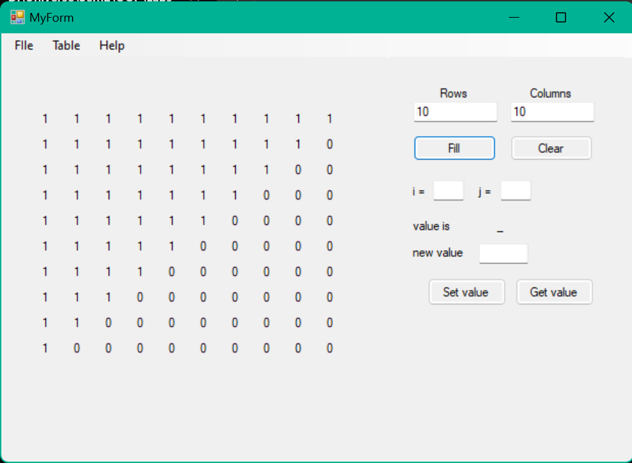

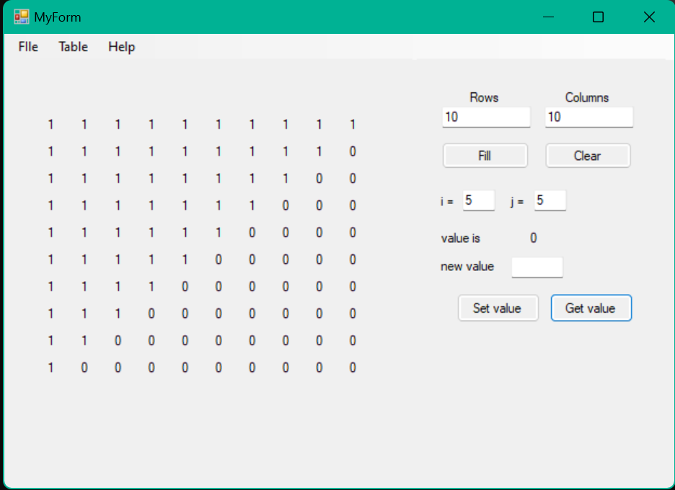

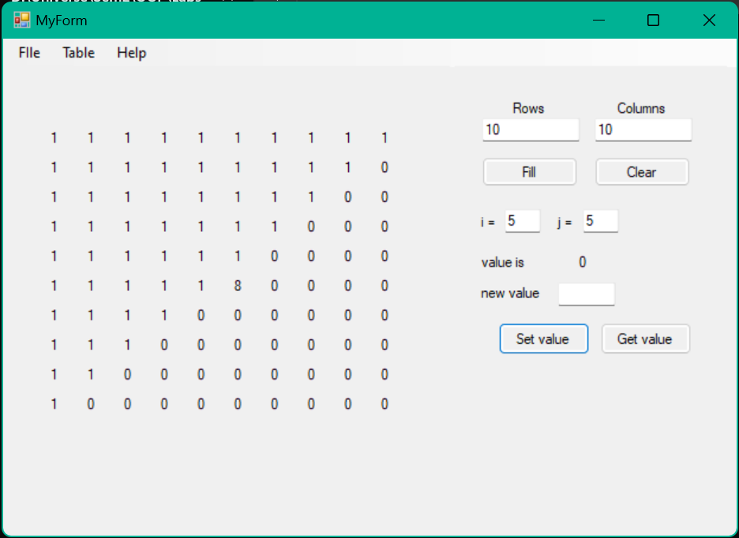

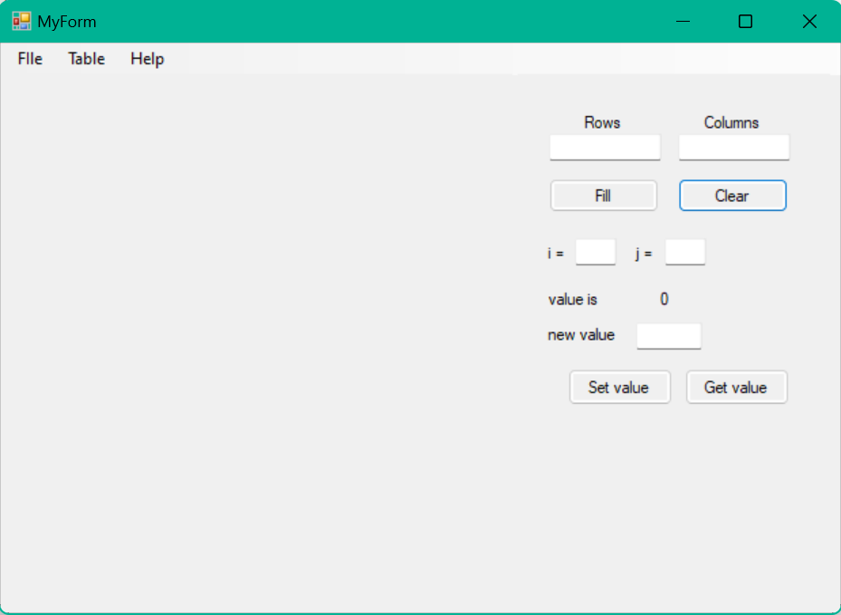

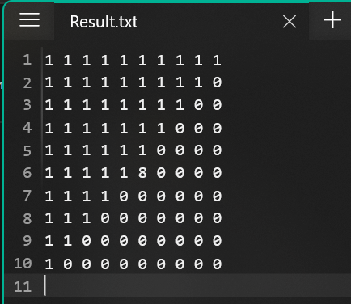

### ВИСНОВКИ

На лабораторній роботі ми навчились використовувати візуальні компоненти середовища програмування при роботі з віконним проєктом. Для цього створили віконну форму, куди додали візуальні об’єкти користувацького інтерфейсу, для яких описали функції, що викликаються під час взаємодії з об’єктами.