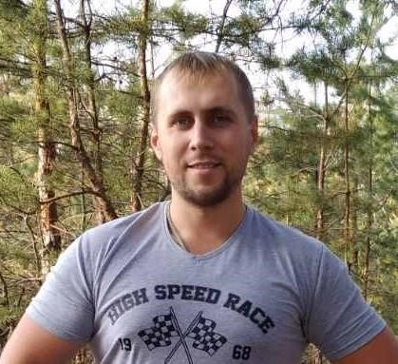**Stanislav Rud**

**Junior Front-end Developer**

Birthday: **31 July 1990**

City: **Kharkov**

Email: **rudstanislav1990@gmail.com**

Site: [**stanislavrud.github.io/personal_website**](https://stanislavrud.github.io/personal_website)

Skype: **zevas_2140**

LinkedIn: [**www.linkedin.com/in/stanislav-rud-527357111**](http://www.linkedin.com/in/stanislav-rud-527357111)

**Summary:**

Hello, I’m looking for my first job as a Junior Front-End developer. I have commercial experience in freelance (create, made, change of already landing pages (adaptive, responsive on PSD, Figma layouts), websites, sale-cards, registration-pages, sites, and quiz). I have HUGE desire to develop, improve and continue! Use my skills in real projects! Learn, learn, and learn☺

**Work Experience:**

(**2018 – today**) **System Administrator**, GROUP OF COMPANIES “**FACTOR**”

* Server management, workstations, routers, switches and existing network applications.
* Monitoring and daily system checks.
* Diagnostics and resolving various technical issues related to hardware and software.
* Support for all network systems LAN, WAN.
* Ensuring network security and integrity.
* Backup, data recovery in case of failures or other situations, system and data recovery.

(**2015 – 2018**) **System Administrator**, Chain of supermarkets «**CHUDO**»

* Server management, workstations, computers, laptops, printers, routers, switches and existing network applications.
* Monitoring and daily system checks.
* Diagnostics and resolving various technical issues related to hardware and software.
* Laying, construction, support of all network systems LAN, WAN.
* Ensuring security and integrity of the network.
* Backup, data recovery in case of failures or other situations, system and data recovery.
* Opening new branches, shops.
* Connecting and configuring commercial equipment.
* Remote user support.
* Working with users.
* Tenders and contracts with equipment suppliers

**Education:**

**KHAI** – (**2007 – 2011**)

Bachelor – Engineer Constructor Aircrafts and Helicopters.

**KHAI** – (**2011 – 2013**)

Specialist – Aircraft Testing and Certification.

**Additional Education:**

**Telesens Academy** (**2015**)

**QA Core** (manual testing WEB, mobile, desktop, UI, checklist, test cases, bug-report)

**NT School** (**2018**)

**Front-End developer** (HTML5/CSS3/SCSS/Flexbox).

**A-Level** (**2018 – 2019**)

**Full Stack** (HTML5/CSS3/Flexbox/JS/Git).

**Skills:**

* **HTML5** (Good knowledge)
* **CSS3, SCSS** (Good knowledge)
* **Flexbox, Grid**  (Good knowledge)
* **JavaScript** (Middle knowledge)
* **React**  (Starting, core knowledge, learning now)
* **Bootsrap 3,4** (Middle knowledge)
* **JQuery** (Using ready plugins)
* **Adobe Photoshop, Figma** (Middle knowledge)
* **Git** (Middle knowledge)
* **WebStorm, VSCode** (Middle knowledge)

**Additional information:**

Now I’m working as a System Administrator, but I want to change my profession and start a career as a Front-End Developer.

In free time, I learn React, JS, Typescript, and English.

I have an understanding and basic experience working with such assemblers as Gulp, Webpack, WordPress, Opencart.

* Quickly learning
* Initiative
* Executive
* Punctual
* Hard-working
* Responsible
* Great desire to learn and develop to front-end development