**DATABASE DOCUMENTATION**

Created by Stanislav Slobodenyuk

Creation date 2025-07-01

Last update date 2025-07-01

**CONTENT**

**DATABASE STRUCTURE** 3

**TABLES, KEYS, ATTRIBUTES** 4

**DESCRIPTION OF CONNECTIOS** 5

**DIAGRAMS** 6

**DATABASE STRUCTURE**

* 1. User

1. Identity User
2. 2
   1. Profile
3. Identity User
4. 2
   1. Education
5. Course
6. ModuleLessons
7. Lesson
8. Theory
9. Base question and questions 4 variables
10. Right answer
11. Answer options
    1. Common
12. 1
13. 2
14. 3
15. 4
16. 5
17. 6
    1. Storage
18. 1
19. 2
20. 3
21. 4
22. 5
23. 6

**TABLES, KEYS, ATTRIBUTES**

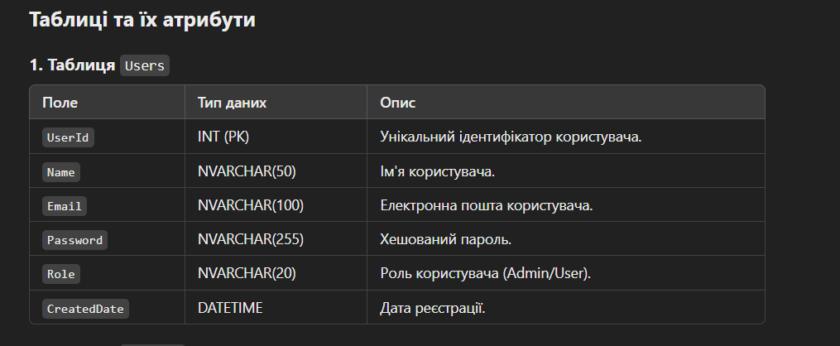

## IdentityUser

|  |  |  |  |
| --- | --- | --- | --- |
| Label | Data type | PK/FK | Description |
| **Id** | **Nvarchar** | **PK** | **Unique indentifier** |
| **UserName** | **Nvarchar** |  |  |
| **Email** | **Nvarchar** |  |  |
| **Email confirmed** | **BIT** |  |  |
| **Password hash** | **Nvarchar** |  | **User password in hash** |
| **Phone number** | **Nvarchar** |  | **-** |
|  |  |  |  |
|  |  |  |  |

**DESCRIPTION OF CONNECTIOS**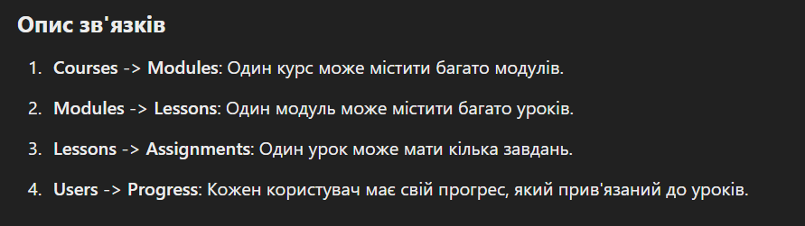

**DIAGRAMS**

