**BAN400 - PROJECT PROPOSAL** [**GROUP 99**](https://youtu.be/6uikJTnmtgw)

**Task:** Make a Shiny application that will compare currency exchange rates

This the draft of our cool (silicon valley) million dollar idea for now:

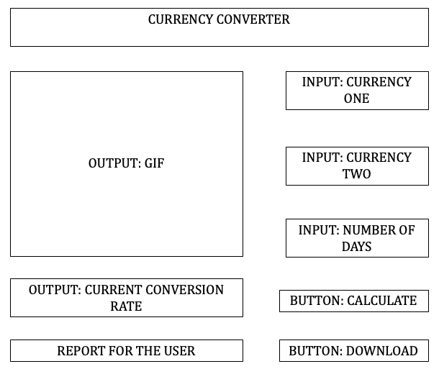

**Goals and programming challenges:**

* Create user input boxes
* Source latest available currency data from the web
* Add a recommendation tool that would check the current trend (either a running average or a more advanced function)
* Only accept correct input data, inform the user if input is incorrect
* Data wrangling to assess the volatility of the graph (data quality)
* Include a[**test**](https://youtu.be/3GqhApWmFtA?t=31)**!!!!** that would let the user know if the output is correct (e.g. if graph is too flat, too volatile, or data is too old the user should know that the output is bad quality)
* Learn how to use the package “shiny” to provide a client with a user friendly interface
* **Learn how to use github** to structurize and make a neat code
  + Have a main script to execute the code and separate files to run tests, functions etc.
* Implement elements from the seminars
* Make it possible for the user to download the whole output - low priority
* Look into shiny mobile app - prolly not tho

**Input:**

* Data input boxes for currency 1, currency 2, and number of days to look at.

**Output:**

* Current exchange rate of currency 1/ currency 2
* GIF that shows a historical exchange rate over a user-selected time frame - low priority
* Report informing the user of the quality of the output

Notes:

[Testing testing testing BigHawk & OP love testing](https://youtu.be/3GqhApWmFtA?t=31)