MACHINE LEARNING AND DEEP LEARNING FOR FAULT DETECTION, CLASSIFICATION AND LOCATION ON THE 161 kV ABOADZE–NEW OBUASI TRANSMISSION LINE

Chapters Three and Four — Corrected Working Copy

How to use this file
This file is built from the submitted Chapter Three and Chapter Four and supersedes them. All corrections identified in review are applied inline; the text below is ready to read as dissertation prose.
Items that could not be corrected without data are marked in the body like this:
⟦PENDING R# — short statement of what is required⟧
There are ten such markers, R1 to R10. Each corresponds to an entry in the accompanying Pending Tasks Recommendation. Search the file for “PENDING” before submitting — every marker must be resolved or converted into a declared limitation.
Figures 3.1 and 4.1–4.12 are carried over from the submitted files and are unchanged.

CHAPTER THREE

RESEARCH METHODOLOGY

3.0 Introduction
Building on the conceptual framework outlined in Chapter Two, this chapter presents the methodological approach adopted to investigate how the integration of machine learning (ML) and deep learning (DL) techniques enhances fault detection, fault location, fault classification, and reporting on the 297.4-kilometre, 161 kV Aboadze–New Obuasi transmission line. The methodology translates theoretical constructs into practical research design, encompassing dataset preparation, simulation modelling, ML/DL architecture selection, and evaluation metrics.
The overarching aim of the chapter is to establish a rigorous methodological framework for assessing the effectiveness of intelligent algorithms in accurately detecting and classifying transmission line faults under varying operating conditions. To achieve this, the study integrates principles from Pattern Recognition Theory and Electrical Engineering and Power System Theories with Machine Learning and Deep Learning paradigms, thereby providing both a data-driven classification foundation and a system-level reliability evaluation perspective, as illustrated in Figure 2.1 in Chapter Two.
Pattern Recognition Theory underpins the identification and classification of fault patterns from high-dimensional electrical signals, while Electrical Engineering and Power System Theories provide the analytical basis for assessing system dependability, failure behaviour, and operational continuity (Duda et al., 2001; Ebeling, 2019). The integration of these perspectives enables a dual-level analysis: the technical effectiveness of machine learning algorithms in fault detection and classification, and the broader implications of these techniques for enhancing power system reliability within Ghana’s transmission infrastructure.
The chapter is organised as follows. Section 3.1 presents the research philosophy and paradigm guiding the study. Section 3.2 sets out the methodological approach and research design. Section 3.3 describes the study context, including the technical characteristics of the Ghanaian transmission network. Section 3.4 outlines the simulation environment. Sections 3.5 to 3.7 address data acquisition, model development, and evaluation metrics. Section 3.8 specifies the statistical analysis plan. Section 3.9 operationalises the conventional protection baseline, and Section 3.10 identifies validity threats and their mitigation. Sections 3.11 to 3.13 cover algorithm selection, model training and validation protocols, and model development. Section 3.14 addresses ethical and practical considerations. Sections 3.15 and 3.16 present the limitations of the study and the chapter summary.

3.1 Research Philosophy and Paradigm
This section articulates the philosophical foundation of the study, including its ontological, epistemological, and methodological assumptions. The research philosophy provides the conceptual lens through which the nature of reality is understood, knowledge is generated, and methodological choices are justified (Creswell & Creswell, 2018; Saunders et al., 2019).

3.1.1 Research Paradigm
This study adopts a post-positivist research paradigm. Post-positivism retains the positivist emphasis on empirical observation and objective analysis while acknowledging that observations are inherently imperfect and that scientific knowledge evolves through continuous refinement of theory and evidence (Guba & Lincoln, 1994; Phillips & Burbules, 2000).
This paradigm is appropriate for the present study because it supports hypothesis-driven quantitative analysis while accounting for the uncertainty inherent in power system measurements and simulation-based modelling environments (Creswell & Creswell, 2018). It is well suited to engineering research contexts where causal relationships are examined between methodological interventions such as machine learning-based fault detection and system-level outcomes. However, it also recognises that absolute objectivity is unattainable and that results must be interpreted within the constraints of model assumptions, data limitations, and simulation fidelity (Phillips & Burbules, 2000; Trochim et al., 2016).

3.1.2 Ontological Position
Ontology concerns the nature of reality and what can be known about it (Crotty, 1998). This study adopts a critical realist ontological position, which assumes that an objective reality exists independently of human perception while acknowledging that access to this reality is mediated through imperfect measurement systems and theoretical constructs (Bhaskar, 1975; Archer et al., 1998).
In the context of transmission line fault analysis, electrical faults constitute real physical phenomena characterised by measurable electrical signatures such as voltage transients, current surges, and impedance variations. However, their detection and interpretation depend on the fidelity of measurement systems, simulation accuracy, and the effectiveness of analytical algorithms. Critical realism is therefore appropriate, as it allows rigorous empirical investigation while maintaining awareness of the limitations inherent in modelling complex physical systems (Bhaskar, 1975; Pawson & Tilley, 1997; Collier, 1994).

3.1.3 Epistemological Position
Epistemology concerns the nature and acquisition of knowledge (Blaikie, 2007). This study adopts a modified objectivist epistemological position, which assumes that knowledge can be derived through systematic empirical investigation and logical reasoning, while recognising that all knowledge claims are provisional and subject to refinement as new evidence emerges (Phillips & Burbules, 2000).
Knowledge is generated through controlled simulation experiments, statistical evaluation of model outputs, and comparative performance analysis across multiple fault detection methods. This position aligns with the post-positivist paradigm, supporting the use of quantitative methods, hypothesis testing, and statistical inference (Creswell & Creswell, 2018; Saunders et al., 2019).

3.2 Methodological Approach
Consistent with the post-positivist paradigm, this study adopts a quantitative methodological approach. The modified objectivist stance supports the use of numerical data, simulation outputs, and statistical analysis to examine relationships between variables in a structured and reproducible manner (Creswell & Creswell, 2018).
This approach enables the systematic generation and analysis of large-scale simulation datasets, facilitates the application of rigorous statistical testing procedures, and supports the evaluation and comparison of multiple machine learning models under controlled experimental conditions (Saunders et al., 2019).
Table 3.1 Summary of Research Philosophy
Philosophical Dimension | Position Adopted | Justification
Research Paradigm | Post-Positivist | Allows hypothesis testing with acknowledgment of measurement limitations
Ontology | Critical Realism | Fault phenomena exist objectively but are measured through imperfect instruments
Epistemology | Modified Objectivist | Knowledge derived through empirical observation and statistical analysis
Methodology | Quantitative | Research questions require numerical measurement and hypothesis testing

3.2.1 Research Design
The research design provides the overall methodological framework for developing the transmission line model between Aboadze and New Obuasi, conducting simulation experiments, generating and collecting data, and performing systematic analysis to link the research questions with the empirical evidence required to address them (Creswell & Creswell, 2018; Yin, 2018). A quasi-experimental, simulation-based comparative design is adopted.

3.2.1.1 Quasi-Experimental Design
This study adopts a quasi-experimental design to evaluate and compare the performance of conventional protection, machine learning models, and deep learning architectures under controlled simulation conditions. Quasi-experimental designs are appropriate when experimental manipulation is possible but random assignment is impractical (Creswell & Creswell, 2018). True experimental designs involving random assignment are not feasible in power system research due to operational, ethical, and safety constraints. The simulation environment enables controlled manipulation of key independent variables, including fault type, fault location, fault resistance, and fault inception angle, while systematically observing dependent variables such as detection accuracy, response time, and reliability indices.
To improve internal validity, multiple replications and scenario variations are incorporated, allowing statistically meaningful comparisons and more stable performance estimates (Campbell & Stanley, 1963; Creswell & Creswell, 2018; Kezunovic, 2001).

3.2.1.2 Simulation-Based Approach
This study employs computer simulation as the primary mechanism for data generation. Simulation-based research is widely recognised in power systems engineering, particularly where field experimentation is impractical, hazardous, or economically prohibitive (Kundur, 1994; Grainger & Stevenson, 1994).
The approach offers several methodological advantages. It enables systematic generation of fault scenarios across the complete parameter space, including rare and high-impact conditions difficult to capture in real-world operation. It provides full control over experimental conditions, eliminating external confounding factors. It facilitates efficient and repeatable comparison of multiple machine learning models under identical conditions, and enables precise measurement of performance metrics otherwise difficult to obtain from operational systems.

3.2.1.3 Comparative Design
A comparative research design is adopted to systematically evaluate conventional protection, classical machine learning models, and deep learning architectures under identical simulation conditions (Creswell & Creswell, 2018; Yin, 2018).
The design is implemented as a matched-pairs framework, in which each fault scenario is processed by all methods. This ensures that comparisons are scenario-consistent, enabling paired statistical tests that control for data variability and improve the validity of inference. This structure is the basis for the test selection in Section 3.8.

3.2.1.4 Research Design Phases
The research design is implemented in six sequential phases, as illustrated in Figure 3.1.
Phase 1 involves development and validation of the simulation environment, including the transmission line model and fault generation capability using MATLAB R2023b Simulink. Phase 2 focuses on systematic data generation based on the defined fault scenario matrix. Phase 3 involves development and training of machine learning and deep learning models. Phase 4 conducts comparative performance analysis addressing Research Questions 1 and 2. Phase 5 evaluates reporting latency, addressing Research Question 3. Phase 6 evaluates robustness under varying operating conditions, addressing Research Question 4.
Each phase builds on the outputs of the preceding stage, ensuring a coherent and traceable methodological progression.

3.3 Study Context: Ghana’s 161 kV Transmission Network
This section describes the physical and operational context of the study, focusing on the characteristics of Ghana’s 297.4 km, 161 kV Aboadze–New Obuasi transmission line that inform the development of the simulation model and the interpretation of results.
As illustrated in Figure 3.1, the 297.4 km, 161 kV three-phase transmission line is modelled in MATLAB/Simulink using key electrical and operational parameters, including line length, resistance, inductance, capacitance, and system operating conditions. The model is configured to replicate realistic operating scenarios and to support simulation of multiple fault conditions, including single line-to-ground, line-to-line, double line-to-ground, three-phase and three-phase-to-ground faults, as well as normal operation.
Three-phase voltage and current signals are extracted from the simulated system and subjected to preprocessing procedures, including filtering, normalisation, and windowing (Horowitz & Phadke, 2008).
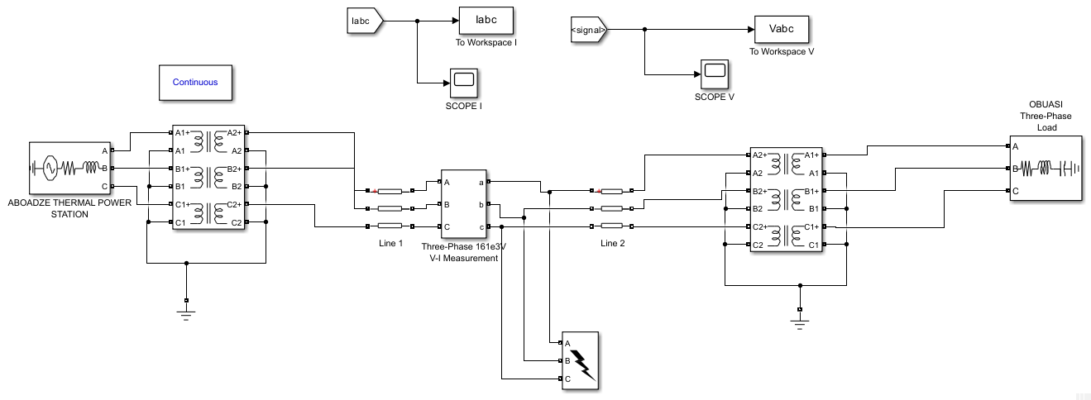
Figure 3.1 Pi-Modelled Aboadze–New Obuasi 161 kV Transmission Line

3.3.1 Transmission Line Specifications
The study focuses on a representative 297.4-kilometre section of Ghana’s 161 kV Aboadze–New Obuasi transmission network, operated by the Ghana Grid Company Limited (GRIDCo). GRIDCo 161 kV construction uses ACSR conductors on steel lattice towers in horizontal configuration (Ghana Grid Company Limited, 2022; JICA, 2015).
Where specific GRIDCo measurements were unavailable, electrical parameters were derived from conductor geometry using the standard formulations of Grainger and Stevenson (1994) and Glover, Sarma and Overbye (2012). Sequence impedances for a single-circuit horizontal-configuration line follow from the geometric mean distance (GMD) between phases and the geometric mean radius (GMR) of the conductor:
X₁ = 2π·f · 2×10⁻⁷ · ln(GMD / GMR) Ω/m
C₁ = 2π·ε₀ / ln(GMD / r) F/m
Zero-sequence reactance incorporates the earth-return path via Carson’s equivalent depth Dₑ = 658.87·√(ρ/f), with earth resistance Rₑ = π²·f × 10⁻⁷ Ω/m (Carson, 1926; Anderson, 1995).
For 795 kcmil ACSR (26/7) — consistent with the 0.08 Ω/km positive-sequence resistance recorded in GRIDCo documentation — with GMR = 0.01137 m, outer radius 0.01407 m, phase spacing 4.5 m / 4.5 m / 9.0 m (GMD = 5.670 m), earth resistivity 100 Ω·m and f = 50 Hz, the derivation yields X₁ = 0.390 Ω/km, Rₑ = 0.049 Ω/km, X₀ = 1.352 Ω/km, and a ratio X₀/X₁ of 3.46, which lies within the textbook range of 2.5 to 3.5 for a single-circuit line.
Table 3.2 Transmission Line Technical Parameters
Parameter | Specification | Basis
Nominal voltage | 161 kV | GRIDCo; phase-to-phase RMS
Line length | 297.4 km | GRIDCo; total route length
Conductor type | ACSR, 795 kcmil (26/7) equivalent | GRIDCo construction standard
Conductor configuration | Single circuit, horizontal | GRIDCo
Conductors per phase | 1 | GRIDCo
Tower type | Steel lattice, self-supporting | GRIDCo
Average span length | 350–400 m | GRIDCo; terrain dependent
Positive-sequence impedance | 0.080 + j0.390 Ω/km | R from GRIDCo; X derived (Grainger & Stevenson, 1994)
Zero-sequence impedance | 0.228 + j1.352 Ω/km | Derived via Carson earth return (Anderson, 1995)
Positive-sequence capacitance | 12.74 nF/km | GRIDCo; line charging
Thermal rating | 750 A continuous | GRIDCo; normal operating limit
Fault level | 3000 MVA | GRIDCo; at receiving end
System frequency | 50 Hz | Ghana standard
Two independent cross-checks confirm these values are physically admissible. At 12.74 nF/km the line susceptance is B = ωC = 4.00×10⁻⁶ S/km, giving total charging of Qc = V²·B·ℓ = 30.9 MVAr over 297.4 km at 161 kV, within the expected 15–60 MVAr band for a line of this length and voltage. At a fault level of 3000 MVA the three-phase fault current is If = S/(√3·V) = 10.76 kA with a source impedance of 8.64 Ω, consistent with a bus adjacent to the Aboadze generating station.
⟦PENDING R1 — Results reported in Chapter Four were generated before these parameters were corrected. The relative ordering of models is expected to hold, since all models saw identical data, but absolute accuracies, latencies and the relay baseline may shift. Re-simulation is required; see the Pending Tasks Recommendation.⟧

3.3.2 Existing Protection Systems
The transmission line traverses diverse terrain, including coastal zones, forest regions, and savanna, and these geographical variations influence both fault susceptibility and repair accessibility (Kezunovic, 2011). Environmental conditions along the corridor, including high humidity, seasonal harmattan winds carrying dust, and frequent lightning activity during the rainy season from April to September, further contribute to the fault profile of the line (Adefarati & Bansal, 2016).
Ghana’s 161 kV transmission network employs conventional protection typical of utility networks in developing economies. The primary protection scheme is based on distance relays with a three-zone stepped-distance characteristic, where Zone 1 provides instantaneous protection for approximately 80% of the line length from each terminal, Zone 2 extends to approximately 120% of the protected line with a time delay of 0.3 to 0.5 seconds, and Zone 3 provides backup protection for adjacent lines with delays of 0.6 to 1.0 seconds (Ghana Grid Company Limited, 2022; IEEE, 2019). These settings are the basis for the baseline implementation in Section 3.9.
Backup protection is provided by overcurrent relays with inverse-time characteristics, coordinated with downstream protective devices, and the protection system is integrated with SCADA infrastructure supporting centralised monitoring and limited remote control. Several operational limitations persist, including reduced accuracy for high-resistance faults, limited discrimination of evolving faults, dependence on fixed settings, and ageing infrastructure with constrained diagnostic capability (IEEE, 2019).

3.3.3 Operational Context and Challenges
The operational environment is characterised by increasing demand growth, evolving load patterns, and varying system contingencies that place additional stress on existing protection infrastructure. Reliance on fixed relay settings and rule-based coordination limits adaptability under changing network conditions, and discrimination capability is reduced for closely related fault types, particularly under high-impedance and evolving fault scenarios.
These challenges reinforce the need for data-driven approaches capable of learning complex fault patterns and adapting to variable system conditions.

3.4 Simulation Environment Development
The simulation environment is implemented in MATLAB R2023b using Simulink to model the 297.4 km, 161 kV Aboadze–New Obuasi transmission line. The model is configured and executed within a controlled framework in which each run is systematically initialised, parameterised, and executed. Simulation parameters including fault type, fault location, fault resistance, inception angle, and load condition are programmatically defined prior to execution. This structured setup ensures that each run corresponds to a clearly defined experimental condition, allowing repeatable and traceable generation of system responses (Kundur, 1994; IEEE, 2020).

3.4.1 Simulation Execution Procedure
Fault scenarios are generated and processed sequentially to produce waveform data for analysis. A full factorial design is implemented, whereby all combinations of fault type, location, resistance, inception angle, load condition, and noise level are systematically simulated. Each scenario is executed as an independent simulation run under consistent initial conditions. The MATLAB engine executes each case in a loop-based structure, with fault parameters dynamically assigned before each run and voltage and current waveforms recorded from the Simulink model outputs. Fixed initialisation settings and controlled randomisation ensure reproducibility (Hastie et al., 2009; Rubinstein & Kroese, 2017).

3.5 Data Acquisition
The Aboadze–New Obuasi line was modelled in MATLAB/Simulink to replicate operating conditions. Multiple fault types were simulated at varying distances along the line. Voltage and current data were extracted from simulation outputs, forming the dataset for model training and testing in Python.

3.5.1 Data Generation Protocol
This section describes the protocol for generating the fault scenario database used to train and evaluate the algorithms. The protocol provides coverage of the fault parameter space while maintaining computational feasibility.

3.5.2 Fault and No-Fault Scenario Matrix
The scenario matrix defines the parameter space for systematic simulation. The fault and no-fault conditions are generated as separate strata, so that no-fault scenarios are explicitly represented in the dataset rather than entering the factorial as a multiplicative factor of one.
Table 3.3 Scenario Parameter Matrix
Fault stratum
Parameter | Levels | Values
Fault type | 5 | SLG (AG, BG, CG), LL (AB, BC, CA), LLG (ABG, BCG, CAG), LLL, LLLG
Fault location | 8 | 10%, 20%, 30%, 40%, 50%, 60%, 70%, 80% of the modelled section
Fault resistance | 5 | 0 Ω, 10 Ω, 25 Ω, 50 Ω, 100 Ω
Fault inception angle | 5 | 0°, 45°, 90°, 135°, 180° relative to voltage zero crossing
Load condition | 3 | Light (40%), Normal (75%), Heavy (100%)
Noise level | 4 | 1%, 5%, 10%, 20% additive
5 × 8 × 5 × 5 × 3 × 4 = 12,000 fault scenarios
No-fault stratum
Parameter | Levels | Values
Load condition | 3 | Light, Normal, Heavy
Noise level | 4 | 1%, 5%, 10%, 20%
Independent repetitions | 200 | Distinct random seeds
3 × 4 × 200 = 2,400 no-fault scenarios
Total: 14,400 scenarios.
The selection of parameter levels is informed by operational considerations and the published literature. Fault resistance is bounded at 100 Ω. Fault inception angles are varied to capture the influence of point-on-wave switching on transient characteristics. Noise levels spanning 1% to 20% represent the range of measurement quality encountered in field installations.
Scope note. Because fault resistance is bounded at 100 Ω, the study does not characterise performance for high-impedance faults above that value. Claims regarding high-impedance fault detection are scoped accordingly throughout.

3.5.3 Data Sampling Protocol
For each scenario, voltage and current waveforms are sampled at 1 kHz, corresponding to 20 samples per 50 Hz power frequency cycle, over a window of six cycles comprising one pre-fault cycle and five post-fault cycles.
Table 3.4 Sampling Specification
Quantity | Value
Sampling rate | 1 kHz
Samples per 50 Hz cycle | 20
Analysis window | 6 cycles (1 pre-fault + 5 post-fault) = 120 ms
Samples per channel per scenario | 120
Channels recorded | Va, Vb, Vc, Ia, Ib, Ic
Observation vector per scenario | 720 values
This window is sufficient to capture the transient immediately following fault inception and the quasi-steady-state fault characteristics used by conventional protection algorithms.
Bandwidth scope. At 1 kHz the Nyquist limit is 500 Hz, the tenth harmonic. The feature set is therefore restricted to fundamental-frequency and low-order harmonic content. The study does not claim to capture high-frequency transient components, and wavelet decomposition is not applied.

3.5.4 Data Integrity
All datasets were generated through MATLAB/Simulink simulation of the Aboadze–New Obuasi line, based on established power system theory including symmetrical components and π-model representations. Integrity was maintained by ensuring that simulated data reflected realistic fault scenarios. Noise and disturbance conditions were introduced to replicate real-world variability without compromising the authenticity of the dataset.

3.5.5 Feature Extraction
Following simulation, the raw voltage and current waveforms are analysed to determine fault classification. Statistical features including RMS values, peak magnitude, and signal variance are extracted, together with spectral components derived within the bandwidth permitted by the 1 kHz sampling rate. These features are combined into structured feature vectors representing each simulated scenario (Blackburn & Domin, 2014; Proakis & Salehi, 2008).
⟦PENDING R4 — The complete feature list, the computation applied to each feature, and the window over which each is computed must be enumerated here for the analysis to be reproducible from the text.⟧

3.6 Model Development
Eight methods are evaluated: one conventional baseline and seven learned models.
- Conventional baseline: three-zone distance protection, specified in Section 3.9.
- Machine learning models: Support Vector Machine (SVM), Decision Tree (DT), and k-Nearest Neighbours (k-NN), trained to classify fault types.
- Deep learning models: Convolutional Neural Network (CNN), Recurrent Neural Network (RNN), and Long Short-Term Memory (LSTM), developed to capture spatial and temporal features in fault signals, together with a feedforward Artificial Neural Network (ANN).
- Hybrid model: Physics-Informed Neural Network (PINN), embedding circuit laws in the training loss.
Hyperparameter optimisation is performed by grid search with cross-validation, as specified in Section 3.11.3.

3.7 Evaluation Metrics
A set of evaluation metrics aligned to the study’s research questions and hypotheses is employed.
Accuracy measures the proportion of correctly detected and classified faults relative to the total number of events. It is the primary metric for H₁:
Accuracy = (TP + TN) / (TP + TN + FP + FN)
where TP = true positives, TN = true negatives, FP = false positives, FN = false negatives.
Precision, recall and F1-score evaluate classification performance for H₂. Precision is the proportion of correctly classified fault events among all predicted fault events; recall is the proportion of correctly classified fault events among all actual fault events; F1-score is the harmonic mean of precision and recall. All three are macro-averaged across classes, and F1 is computed per class from the confusion matrix and then averaged, not derived from the averaged precision and recall.
Latency addresses H₃ and is reported as two distinct constructs:
- Decision latency — elapsed time from fault inception to algorithmic fault declaration. This is distinct from total fault clearing time, which additionally includes circuit breaker operating time.
- Diagnostic latency — elapsed time from fault inception to fault type and location becoming available.
Robustness addresses H₄ and evaluates the stability of model performance across the simulated noise and loading conditions. It is assessed by measuring accuracy and F1 across noise levels and testing for statistical equivalence against a declared margin.
Location error addresses H₅ and is reported as absolute deviation from the true fault position, expressed both as a percentage of the modelled section and in kilometres.

3.8 Statistical Analysis Plan
This section specifies the statistical procedures applied to evaluate hypotheses H₁ to H₅. The plan was established prior to analysis, so that all reported tests are confirmatory rather than exploratory, and so that decision rules are fixed independently of observed outcomes (Montgomery, 2017; Lakens, 2013).

3.8.1 Structure of the Comparison
The comparative design described in Section 3.2.1.3 evaluates every detection method on an identical set of fault scenarios. This constitutes a randomised complete block design in which the fault scenario serves as the blocking unit and the detection method serves as the treatment factor. Because each scenario is processed by all methods, observations across methods are matched rather than independent, and the statistical procedures adopted are correspondingly paired throughout (Montgomery, 2017).
This structure carries two consequences for test selection. First, independent-samples procedures are inadmissible, since they violate the independence assumption and discard the variance reduction that blocking provides. Second, the primary outcomes for H₁ and H₂ are binary events at the scenario level — whether a given fault was correctly detected, and whether it was correctly classified — rather than continuous measurements. Procedures appropriate to paired binary outcomes are therefore adopted in preference to tests of means (Dietterich, 1998).

3.8.2 Unit of Analysis
The unit of analysis is the held-out fault scenario. Each scenario in the test partition contributes one outcome per method: a binary correctness indicator for detection and classification, and a continuous measurement for fault location error and processing latency.
Cross-validation folds are not adopted as the inferential unit. In K-fold cross-validation any two training partitions share (K−2)/(K−1) of their observations, so fold-level differences are positively correlated and the conventional variance estimator is downward-biased, producing inflated Type I error rates in paired comparisons across folds (Dietterich, 1998; Nadeau & Bengio, 2003). Fold-level results are reported as descriptive statistics, while inferential tests are conducted at scenario level. Where a fold-level comparison is unavoidable, the corrected resampled t-statistic of Nadeau and Bengio (2003) is applied.
Scenario-level partitioning is enforced during data splitting: all observation windows derived from a given simulation run are assigned wholly to either the training or the test partition, never divided between them. This prevents run-specific signal characteristics from being learned during training and subsequently recognised at test time, a form of information leakage that produces optimistically biased performance estimates (Kohavi, 1995; Hastie et al., 2009).

3.8.3 Tests Applied to Each Hypothesis
H₁ — Fault detection accuracy. McNemar’s test is applied to compare each learned model against the conventional relay baseline. For two classifiers evaluated on a common test set, McNemar’s test examines the null hypothesis of marginal homogeneity, conditioning on the discordant scenarios — those on which exactly one method is correct. Scenarios classified identically by both methods are uninformative regarding relative performance and are excluded from the test statistic (Dietterich, 1998). The exact binomial form is used where the number of discordant pairs is below 25, and the continuity-corrected chi-square form otherwise. Cochran’s Q is reported as an omnibus test across all eight methods (Cochran, 1950). Effect size is reported as the odds ratio derived from the discordant cells, together with the paired difference in accuracy in percentage points and its confidence interval.
H₂ — Fault classification performance. Cochran’s Q is applied as an omnibus test across the learned models, examining whether classification accuracy differs across methods for correlated binary outcomes. Where the omnibus test is significant, pairwise McNemar tests are conducted between deep learning and classical machine learning models. Aggregation of models into family-level means is not performed, as averaging across a small number of heterogeneous models suppresses between-model variance and yields an effective sample size too small for meaningful inference.
H₃ — Fault reporting latency. Processing latency is measured per scenario and compared using the Wilcoxon signed-rank test. The non-parametric procedure is adopted because timing distributions are characteristically right-skewed, violating the normality assumption of the paired t-test. Effect size is reported as the matched-pairs rank-biserial correlation, accompanied by the Hodges–Lehmann estimate of the median difference and its distribution-free confidence interval. The test is conducted two-sided, and the direction of the observed difference is reported without adjustment to the hypothesised direction. The comparison specified by H₃ is each learned model against the conventional relay baseline.
H₄ — Robustness under varying operating conditions. Because H₄ asserts stability rather than difference, conventional null-hypothesis significance testing cannot provide supporting evidence: failure to reject the null indicates only that a difference was not detected, a result equally consistent with insufficient statistical power (Lakens, 2017). Two one-sided tests (TOST) are therefore applied to establish statistical equivalence.
The equivalence margin is ±5.0 percentage points of classification accuracy, declared prior to analysis. The justification is operational: within the three-zone coordination scheme of Section 3.9.3, an accuracy shift below 5 percentage points does not alter zone-discrimination outcomes at the sample sizes evaluated, and therefore does not change the protective action taken. Equivalence is evaluated for each noise level against the 1% baseline condition, with Holm correction applied across the family, and is concluded where the 90% confidence interval on the paired difference falls entirely within the declared margin.
Robustness is scoped to the noise and loading conditions manipulated in the simulation. It does not extend to weather conditions, which are not variables in this design.
H₅ — Fault location accuracy. Absolute location error, expressed as a percentage of the modelled section and in kilometres, is compared across methods using the Friedman test, with post-hoc pairwise Wilcoxon signed-rank comparisons. Non-parametric procedures are adopted because absolute error is bounded below at zero and is characteristically right-skewed. Effect size is reported as Kendall’s coefficient of concordance (W) for the omnibus test and as the Hodges–Lehmann median difference for pairwise comparisons.

3.8.4 Pre-Test Data Screening
Before any paired test is executed, each outcome vector is screened:
- Between-model variance. For each outcome, the proportion of scenarios on which all models agree is computed. If agreement exceeds 99%, the outcome is flagged as potentially degenerate and the test is suspended pending inspection of raw predictions.
- Discordance census. For every McNemar comparison, the 2×2 contingency table is printed and retained. An odds ratio of exactly zero or infinity indicates an empty discordant cell and triggers inspection.
- Marginal reconciliation. Accuracy computed from each prediction vector is checked against the corresponding entry in the descriptive performance table. A discrepancy exceeding 0.5 percentage points suspends the analysis.
These screens are applied to all outcomes before the results in Chapter Four are reported.

3.8.5 Verification of Assumptions
Procedure | Assumption | Verification | Action if violated
McNemar | Paired binary outcomes; independent scenarios | Confirmation of scenario-level partitioning; discordant count ≥ 25 for chi-square form | Exact binomial form
Cochran’s Q | Paired binary outcomes; complete blocks | Structural verification | Exact permutation test
Wilcoxon signed-rank | Symmetric distribution of paired differences | Inspection of difference distribution | Sign test
Friedman | Complete blocks; no missing cells | Structural verification | Skillings–Mack test
TOST | Approximate normality of paired differences | Shapiro–Wilk with Q–Q inspection | Bootstrap confidence interval
Where fold-level analyses are reported, formal normality testing at K = 7 possesses negligible statistical power and cannot substantiate a normality assumption. Non-parametric procedures are therefore adopted as the primary analysis throughout, with parametric equivalents reported as sensitivity analyses where applicable.

3.8.6 Control of Family-Wise Error
Multiple comparisons are conducted within each hypothesis family. The Holm–Bonferroni sequentially rejective procedure is applied within families to control the family-wise error rate at α = 0.05 (Holm, 1979). Holm’s procedure is preferred to the Bonferroni correction as it is uniformly more powerful while requiring no additional distributional assumptions. Family-wise rather than false-discovery-rate control is adopted, as the comparisons are confirmatory tests of pre-specified hypotheses rather than exploratory screening. Both unadjusted and adjusted probability values are reported for every comparison.

3.8.7 Reporting Standards
Every reported test includes the unit of analysis; the sample size and degrees of freedom; descriptive statistics for each group; the test statistic; the unadjusted and Holm-adjusted probability values; an effect size appropriate to the test with its confidence interval; and the outcome of the relevant assumption check. Point estimates are not reported without an accompanying measure of dispersion.
Effect sizes are selected to match the outcome type. Odds ratios and paired differences in proportions are reported for binary outcomes; the rank-biserial correlation and Hodges–Lehmann median difference for paired continuous outcomes; and Kendall’s W for omnibus rank-based tests. Cohen’s d is not applied to proportion-based outcomes, as the standardised mean difference is not interpretable for such measures.
All analyses are conducted in Python using SciPy and scikit-learn, with a fixed random seed to ensure reproducibility. Analysis code and the per-scenario results file from which every reported value is derived are retained and available for verification.

3.9 Conventional Protection Baseline

3.9.1 Purpose
Comparative evaluation requires the conventional comparator to be specified with the same precision as the learned models. Every H₁ and H₃ result depends on the relay model defined in this section.

3.9.2 Relay Model
A distance relay characteristic is implemented in the simulation environment, representative of numerical distance protection applied on the Aboadze–New Obuasi circuit. The relay measures apparent impedance from the fundamental-frequency voltage and current phasors and compares the impedance trajectory against the zone characteristics defined below.
⟦PENDING R2a — State the relay characteristic implemented (mho or quadrilateral) and the phasor extraction filter used (full-cycle or half-cycle Fourier).⟧

3.9.3 Zone Settings
Zone | Reach | Time delay | Function
Zone 1 | 80% of line impedance | Instantaneous | Primary protection
Zone 2 | 120% of line impedance | 0.3–0.5 s | Remote-end backup
Zone 3 | Per GRIDCo coordination study | 0.6–1.0 s | Adjacent-line backup
Settings follow GRIDCo transmission system protection guidelines (Ghana Grid Company Limited, 2022) and IEEE Std C37.113 (IEEE, 2019). Zone 1 underreaches deliberately to avoid overreach into the adjacent circuit under measurement error.

3.9.4 Scoring Criteria
Event | Definition
Correct detection | Impedance trajectory enters a zone characteristic within the analysis window, for a scenario containing a fault
Missed detection | No zone pickup within the window for a fault scenario
False operation | Zone pickup during a no-fault scenario
Decision latency | Elapsed time from fault inception to first zone pickup
Faults cleared by Zone 2 or Zone 3 are recorded as correct detections carrying their associated coordination delay, since a time-delayed backup operation is a correct protective response rather than a failure.

3.9.5 Measures Not Defined for the Comparator
A distance relay performs fault detection and zone discrimination. It does not perform multi-class fault-type classification in the sense evaluated for the learned models: phase selection identifies faulted phases for single-pole tripping but does not assign the fault categories of Table 3.3 as a classification output.
Classification accuracy is therefore recorded as not applicable for the conventional comparator, and the relay is excluded from the H₂ comparison. Assigning a numerical classification accuracy to a device that does not perform the task would not be defensible.

3.9.6 Limitations of the Baseline
The relay model represents the protection algorithm, not a specific manufacturer’s implementation. Circuit breaker operating time is excluded, so reported latency is decision time rather than total fault clearing time. Communication-assisted schemes are not modelled; the comparison therefore represents non-unit distance protection operating on local measurements only.
⟦PENDING R2b — The relay prediction vector is the common input to every H₁ and H₃ test. Its integrity must be verified before those tests are reported; see the Pending Tasks Recommendation.⟧

3.10 Validity and Reliability Considerations

3.10.1 Internal Validity
Threat | Manifestation in this study | Mitigation
Information leakage | Windows from one simulation run appearing in both training and test partitions | Scenario-level partitioning (Section 3.8.2); fold composition reported
Unit-of-analysis error | Treating non-independent observations as independent, inflating significance | Unit defined as the held-out scenario; paired procedures throughout
Baseline construction bias | An inadequately specified comparator inflating every learned-model comparison | Baseline operationalised (Section 3.9); undefined measures recorded as not applicable
Multiplicity inflation | Family-wise error rising with the number of tests | Holm–Bonferroni within each hypothesis family (Section 3.8.6)
Degenerate comparison | A predictor with no between-model variance producing spurious equivalence | Pre-test variance screen (Section 3.8.4)
Instrumentation variance | Performance differences attributable to preprocessing rather than architecture | Identical feature extraction and normalisation across all models

3.10.2 Construct Validity
Each measured quantity is defined operationally before analysis, as set out in Section 3.7. Decision latency is distinguished from diagnostic latency and from total clearing time. Robustness is scoped to the simulated noise and loading conditions and does not extend to weather. Location error is reported in both percentage and absolute distance terms.

3.10.3 External Validity
Limitation | Consequence for generalisation
Simulation-derived data only | No validation against recorded disturbance data; field performance may differ
Single circuit, single voltage level | Transferability to other line configurations is not established
Simplified fault representation | Arc dynamics, time-varying fault resistance and instrument transformer saturation are not modelled
Fault resistance bounded at 100 Ω | High-impedance fault performance beyond 100 Ω is not characterised
Modelled section only | Conclusions apply to the section defined in Section 3.15, not the full route length
Conclusions are stated as applicable to the modelled system and as motivating pilot field validation, rather than as establishing readiness for operational deployment.

3.10.4 Reliability
Reproducibility is supported by a fixed random seed, documented software versions, retention of the per-scenario results file from which every reported value derives, and retention of the analysis code. Model stability is assessed through the standard deviation of performance across cross-validation folds, reported alongside every point estimate.

3.11 Machine Learning Algorithm Selection

3.11.1 Theoretical Basis for Algorithm Selection
Pattern Recognition Theory provides the theoretical foundation for understanding how machine learning algorithms learn to discriminate between fault classes (Duda et al., 2001; Bishop, 2006). Effective classification requires the construction of decision boundaries in the feature space that separate classes with minimal error. Different algorithm families approach this task through different mechanisms: decision trees partition the feature space through recursive splitting; support vector machines construct optimal separating hyperplanes in transformed feature spaces; neural networks learn hierarchical feature representations through layered nonlinear transformations (Breiman et al., 1984; Cortes & Vapnik, 1995; Goodfellow et al., 2016).
Evaluating multiple algorithm families is motivated by the principle that different algorithms may exhibit complementary strengths across the fault parameter space. This comparative approach ensures that performance is not dependent on a single modelling paradigm (Hastie et al., 2009; James et al., 2021).

3.11.2 Algorithm Portfolio
Seven learned models are evaluated alongside the conventional baseline, representing the major paradigms in supervised classification.
Table 3.5 Algorithm Portfolio
Algorithm | Category | Justification for Inclusion
Conventional distance relay | Rule-based comparator | Operational baseline against which learned models are evaluated (Section 3.9)
Decision Tree (DT) | Supervised, tree-based | Produces clear rule-based decisions with low computational cost; suitable for real-time embedded protection
Support Vector Machine (SVM) | Kernel method | Effective in high-dimensional spaces; kernel flexibility; strong theoretical generalisation properties
k-Nearest Neighbours (k-NN) | Instance-based | Simple non-parametric baseline; effective for local pattern matching
Artificial Neural Network (ANN) | Feedforward network | Universal function approximator; captures complex nonlinear relationships
Convolutional Neural Network (CNN) | Deep learning | Automatic feature learning from voltage and current waveforms; extracts local signal patterns
Recurrent Neural Network (RNN) | Recurrent network | Processes sequential data; baseline recurrent architecture for temporal dependency modelling
Long Short-Term Memory (LSTM) | Gated recurrent network | Captures long-range temporal dependencies in fault transient evolution; addresses the vanishing gradient limitation of the basic RNN
Hybrid Physics-Informed Neural Network (PINN) | Supervised, physics-constrained | Embeds governing circuit laws directly in the loss function, constraining predictions to physically admissible solutions
Decision Tree is selected for its demonstrated effectiveness in fault classification and its interpretability (Anwar et al., 2025; Jamil et al., 2015). Support Vector Machine is included for its foundation in statistical learning theory and its effectiveness when the feature count is large relative to the sample count (Vapnik, 1995). k-Nearest Neighbours provides a baseline making minimal assumptions about the data distribution.
The neural network family is represented by five architectures of increasing complexity. The feedforward ANN provides a flexible nonlinear classifier with established performance in power system applications (Dalstein & Kulicke, 1995). The CNN enables end-to-end learning from waveform data, reducing dependence on manual feature engineering (Chen et al., 2019). The RNN processes sequential data and retains information from previous time steps, serving as a baseline recurrent architecture (Elman, 1990). The LSTM extends this with gating mechanisms that capture longer-range temporal dependencies. The hybrid PINN incorporates circuit-law constraints into the training objective, which is expected to improve performance where the physical relationships between phase quantities are strongly determined.

3.11.3 Hyperparameter Specifications
Hyperparameter optimisation is performed using grid search with cross-validation on the training set (Bergstra & Bengio, 2012; James et al., 2021).
Table 3.6 Hyperparameter Search Spaces
Algorithm | Hyperparameter | Search Space
Decision Tree | max_depth | [5, 10, 20, None]
Decision Tree | min_samples_split | [2, 5, 10]
Decision Tree | min_samples_leaf | [1, 2, 4]
SVM | C (regularisation) | [0.1, 1, 10, 100]
SVM | gamma (RBF kernel) | [0.001, 0.01, 0.1, 1]
SVM | kernel | [linear, rbf, poly]
k-NN | k (neighbours) | [3, 5, 7, 11, 15]
k-NN | distance metric | [euclidean, manhattan, minkowski]
ANN | hidden layers | [1, 2, 3]
ANN | neurons per layer | [32, 64, 128, 256]
ANN | activation | [relu, tanh]
CNN | conv filters | [16, 32, 64]
CNN | kernel size | [3, 5, 7]
RNN | hidden units | [32, 64, 128]
LSTM | units | [32, 64, 128]
LSTM | dropout | [0.1, 0.2, 0.3]
Hybrid PINN | hidden units | [32, 64, 128]
Hybrid PINN | physics loss weight | [0.05, 0.1, 0.5]

3.12 Model Training and Validation Protocol

3.12.1 Cross-Validation Strategy
Stratified K-Fold cross-validation with K = 7 is employed, with grouping enforced at scenario level as specified in Section 3.8.2, so that all observation windows from a given simulation run fall wholly within one fold. Stratification ensures that each fold maintains the same proportion of fault types as the full training set (Kohavi, 1995; James et al., 2021). The average performance across folds is used as the hyperparameter selection criterion, with the standard deviation across folds providing an estimate of performance variability. The selected hyperparameters are then used to train a final model evaluated on the held-out test set (Hastie et al., 2009).

3.12.2 Training Procedures
For tree-based methods, training involves constructing a hierarchical structure through recursive partitioning of the feature space. This does not require iterative gradient-based optimisation, and training time scales with dataset size and tree depth (Breiman et al., 1984; Hastie et al., 2009). SVM training is formulated as a convex optimisation problem solved using Sequential Minimal Optimisation (Platt, 1998). For multi-class classification, the one-versus-one strategy is adopted (Hsu & Lin, 2002).
For neural network models (ANN, CNN, RNN, LSTM and the hybrid PINN), training employs stochastic gradient descent with the Adam optimiser (Kingma & Ba, 2015). A batch size of 32 is used, with a maximum of 100 training epochs. Early stopping with a patience of 10 epochs is implemented, monitoring validation loss. The learning rate is initialised at 0.001 with reduction on plateau (Goodfellow et al., 2016). The hybrid PINN uses 128 neurons per layer across six hidden layers, with a boundary penalty of 0.5.

3.12.3 Addressing Class Imbalance
While the simulation-based protocol produces balanced representation across fault types, real-world deployment may exhibit class imbalance. The study therefore evaluates both balanced and intentionally imbalanced scenarios. Where required, the Synthetic Minority Over-sampling Technique is applied (Chawla et al., 2002), and class weight adjustment is used to assign higher penalties to minority class misclassification. Stratified sampling ensures that all cross-validation folds preserve the class distribution (Kohavi, 1995; James et al., 2021).

3.12.4 Regularisation and Overfitting Prevention
Multiple regularisation techniques are employed. For neural networks, L2 regularisation with coefficient 0.0001 is applied to all weight matrices. Dropout layers with rates of 0.2 to 0.3 are inserted between fully connected layers (Srivastava et al., 2014). Batch normalisation is applied in CNN architectures to stabilise training (Ioffe & Szegedy, 2015). For the Decision Tree, the minimum samples per leaf parameter prevents excessive tree depth and overfitting to training noise. In support vector machines, the regularisation parameter C governs the trade-off between margin maximisation and training error (Cortes & Vapnik, 1995; Hastie et al., 2009).

3.13 Model Development and Training
The models are trained using the feature dataset generated from the MATLAB simulation environment. The dataset is partitioned into training, validation, and test sets using a reproducible scenario-level stratified strategy, with a fixed random seed applied during partitioning. All algorithms are trained on identical input data to ensure fair comparison. Model training and evaluation are conducted in Python using scikit-learn for the classical machine learning models and TensorFlow for the deep learning architectures. Hyperparameter tuning is performed using grid search within the training dataset, with performance evaluated on a holdout validation set. This controlled design ensures that performance differences are attributable to model capability rather than data inconsistency (Bishop, 2006; Goodfellow et al., 2016).
⟦PENDING R9 — Report the number of scenarios per fold, confirm that no scenario identifier appears in both the training and test partition of any fold, and reconcile the fold-based protocol with any holdout split reported in Chapter Four.⟧

3.14 Ethical and Practical Considerations
The methodological design incorporates ethical safeguards and practical considerations to ensure validity, transparency, and operational relevance.

3.14.1 Use of Computational Resources
All simulations and model training were conducted using secure computing environments with attention to responsible use of resources. No sensitive personal data was involved, and all procedures adhered to ethical research standards in engineering and computer science.

3.14.2 Operator Trust and Explainability
A critical consideration is the trust of system operators in ML/DL-based fault detection. To address this, the hybrid physics-informed architecture embeds domain knowledge directly in the model, constraining predictions to physically admissible solutions and providing a basis on which operators can interpret model behaviour. This mitigates the black-box problem often associated with deep learning.

3.14.3 Practical Deployment Relevance
Evaluation metrics including latency and robustness were chosen to reflect operational priorities in Ghana’s transmission network, where timely fault reporting and resilience under environmental disturbance are critical. Transfer learning is identified as a practical strategy for scaling models across transmission corridors, though it is not evaluated in this study.

3.15 Limitations of the Study
The first limitation concerns the study’s simulation-based nature. Although simulation allows systematic exploration of the fault parameter space, it may not fully capture the complexity of real-world fault conditions, including arc dynamics, time-varying fault resistance, and equipment degradation (Dommel, 1969; Greenwood, 1991). Findings should be validated through pilot implementation before full-scale application.
The second limitation concerns the Ghana-specific context. While the methodological framework is broadly applicable, the specific results may require adaptation when applied to networks with different configurations and operating conditions (Billinton & Allan, 1996; Brown, 2009).
The third limitation involves the availability of historical data. Limited access to detailed fault records from Ghana’s transmission network constrains validation of the simulation model. Where local data were unavailable, parameters were derived from standard transmission line theory and verified against engineering cross-checks, as documented in Section 3.3.1, with the uncertainty introduced by these substitutions acknowledged.
The fourth limitation relates to computational constraints: the hyperparameter search space is restricted by available computational resources (Hastie et al., 2009; Montgomery, 2017).
The fifth limitation relates to the study’s focus on a single transmission line and, within it, to the modelled section. The analysis does not fully account for network-wide dynamics such as coordination between multiple protection zones or interactions with generation sources. Future research should extend the analysis to a network-level framework (Billinton & Allan, 1996; Brown, 2009).
The sixth limitation concerns bandwidth. At a sampling rate of 1 kHz the analysis is restricted to fundamental-frequency and low-order harmonic content; high-frequency transient phenomena are outside the observable range of the dataset.
The seventh limitation concerns fault resistance. Simulated resistances are bounded at 100 Ω, so performance against high-impedance faults above that value is not characterised.

3.16 Chapter Summary
This chapter has presented the research methodology employed to investigate machine learning-based fault detection for Ghana’s 297.4-kilometre Aboadze–New Obuasi 161 kV transmission line. The methodology is grounded in a post-positivist philosophical paradigm and adopts a quasi-experimental, simulation-based comparative design.
The study context was established through characterisation of the network specifications, existing protection systems, and operational challenges. Line parameters were derived from conductor geometry using standard transmission line theory and verified against independent engineering cross-checks. The simulation environment section described the MATLAB/Simulink modelling platform and fault modelling approach.
The data generation protocol produces 14,400 scenarios across separate fault and no-fault strata through systematic variation of fault type, location, resistance, inception angle, load condition, and noise level. Feature extraction transforms raw waveforms into structured representations within the bandwidth permitted by the sampling rate.
Eight methods were selected for evaluation: a conventional three-zone distance protection baseline, fully operationalised in Section 3.9, together with seven learned models spanning tree-based, kernel, instance-based, feedforward, convolutional, recurrent and physics-informed paradigms. The training and validation protocol incorporates scenario-level stratified cross-validation, hyperparameter optimisation, and regularisation.
The statistical analysis plan specifies paired procedures appropriate to the matched-pairs design and to binary outcomes, defines the unit of analysis as the held-out scenario, declares the equivalence margin for robustness testing in advance, mandates Holm correction within hypothesis families, and establishes pre-test screening to detect degenerate comparisons. Validity and reliability considerations identify threats and corresponding mitigations. Ethical considerations confirm compliance with research integrity standards, and acknowledged limitations provide context for interpreting the findings.
Chapter Four presents the results obtained from applying this methodology.

CHAPTER FOUR

RESULTS AND DISCUSSION

4.0 Introduction
This chapter presents the results of the fault detection, classification and location analysis conducted using the methodological framework set out in Chapter Three. The findings are organised around the study’s five research questions and corresponding hypotheses (H₁–H₅), covering fault detection accuracy, classification performance, reporting latency, robustness under varying operational conditions, and fault location accuracy.
All reported results satisfy the pre-test screening criteria of Section 3.8.4. Where an analysis did not satisfy those criteria, the section states this explicitly and no finding is drawn. Section 4.1 presents the simulated dataset. Section 4.2 presents the waveform results. Section 4.3 presents comparative model performance. Section 4.4 presents the hypothesis tests. Section 4.5 presents supplementary findings. Section 4.6 discusses the results, and Section 4.7 summarises the chapter.

4.1 Simulated Dataset

4.1.1 Simulation of the modelled transmission network
Representative scaled voltage and current values for no-fault (0) and fault (1) conditions, drawn from the simulated dataset described in Section 3.5.2, are shown in Tables 4.1 and 4.2.
Table 4.1 Representative no-fault records
Fault | Ia | Ib | Ic | Va | Vb | Vc
0 | -170.472 | 9.219613 | 161.2526 | 0.05449 | -0.65992 | 0.605431
0 | -122.236 | 6.168667 | 116.0671 | 0.102000 | -0.62861 | 0.526202
0 | -90.1615 | 3.813632 | 86.34784 | 0.141026 | -0.60528 | 0.464251
0 | -79.9049 | 2.398803 | 77.50611 | 0.156272 | -0.60224 | 0.445963
0 | -63.8853 | 0.590667 | 63.29459 | 0.180451 | -0.59150 | 0.411050
0 | -55.9547 | -1.00188 | 56.95656 | 0.193414 | -0.59070 | 0.397281
0 | -45.2484 | -2.58698 | 47.83543 | 0.212393 | -0.58414 | 0.371743
0 | -47.8454 | -3.42809 | 51.27351 | 0.216396 | -0.59012 | 0.373727
0 | -43.2943 | -4.51130 | 47.80556 | 0.229748 | -0.58759 | 0.357840
0 | -43.4747 | -5.38823 | 48.86296 | 0.235733 | -0.59132 | 0.355587
0 | -37.0065 | -6.56713 | 43.57359 | 0.250284 | -0.58739 | 0.337111
0 | -40.4916 | -7.33434 | 47.82593 | 0.253681 | -0.59309 | 0.339412
0 | -36.4856 | -15.1380 | 51.62354 | 0.317597 | -0.59992 | 0.282323
Table 4.2 Representative fault records
Fault | Ia | Ib | Ic | Va | Vb | Vc
1 | -151.292 | -9.67745 | 85.80016 | 0.40075 | -0.13293 | -0.26781
1 | -336.186 | -76.2833 | 18.32890 | 0.312732 | -0.12363 | -0.18910
1 | -502.892 | -174.648 | -80.9247 | 0.265728 | -0.11430 | -0.15143
1 | -593.942 | -217.703 | -124.892 | 0.235511 | -0.10494 | -0.13057
1 | -643.664 | -224.159 | -132.283 | 0.209537 | -0.09555 | -0.11398
1 | -632.313 | -181.715 | -90.7955 | 0.193116 | -0.08614 | -0.10697
1 | -557.392 | -119.469 | -29.5294 | 0.210004 | -0.07671 | -0.13329
1 | -458.800 | -96.3189 | -7.38185 | 0.273652 | -0.06726 | -0.20639
1 | -385.669 | -97.9898 | -10.0768 | 0.334649 | -0.05780 | -0.27685
1 | -359.929 | -87.3195 | -0.45222 | 0.347420 | -0.04831 | -0.29911
1 | -370.627 | -66.7202 | 19.07983 | 0.323889 | -0.03882 | -0.28507
1 | -418.537 | -49.0224 | 35.68937 | 0.274574 | -0.02932 | -0.24525
1 | -501.663 | -55.2636 | 28.33883 | 0.217809 | -0.01981 | -0.19800
1 | -597.931 | -96.5978 | -14.1252 | 0.179217 | -0.01029 | -0.16892
1 | -668.715 | -136.772 | -55.4499 | 0.160162 | -0.00078 | -0.15938

4.2 Waveform Results

4.2.1 Current-time and voltage-time waveforms
Simulated current and voltage waveforms for each fault class are shown in Figures 4.1 to 4.12. In each figure the three traces correspond to Phase A, Phase B and Phase C respectively.
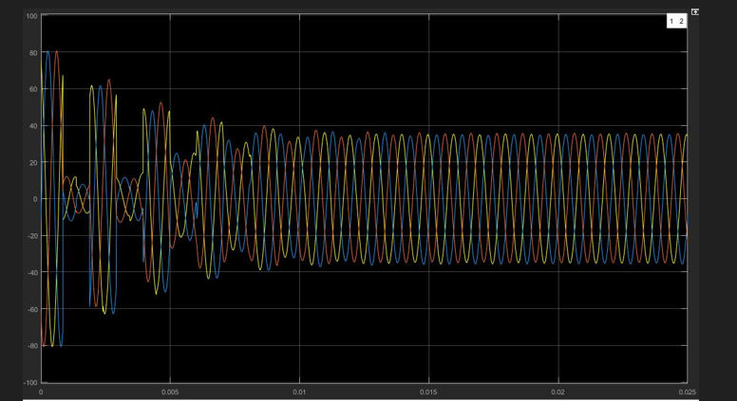
Figure 4.1 Current versus time, no fault
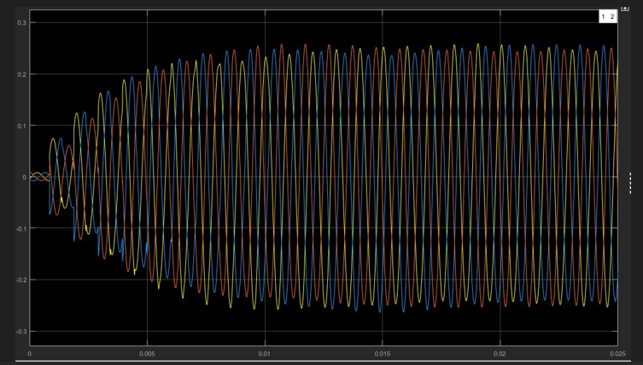
Figure 4.2 Voltage versus time, no fault
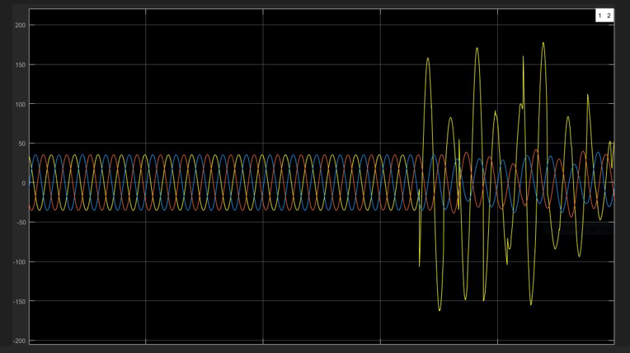
Figure 4.3 Current versus time, phase A-to-ground (AG) fault
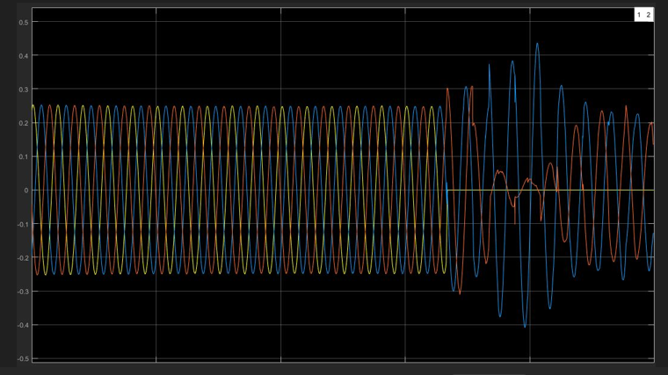
Figure 4.4 Voltage versus time, AG fault
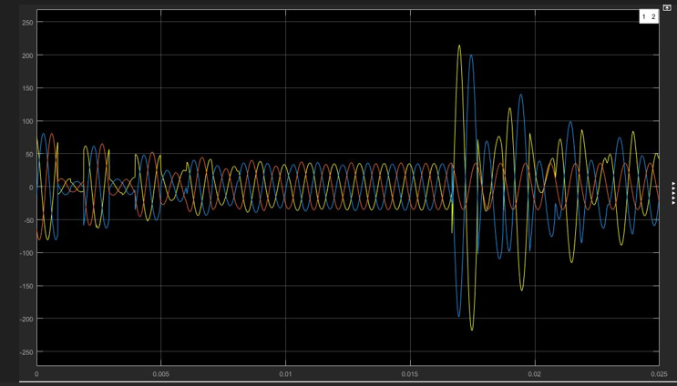
Figure 4.5 Current versus time, phase A-to-B (AB) fault
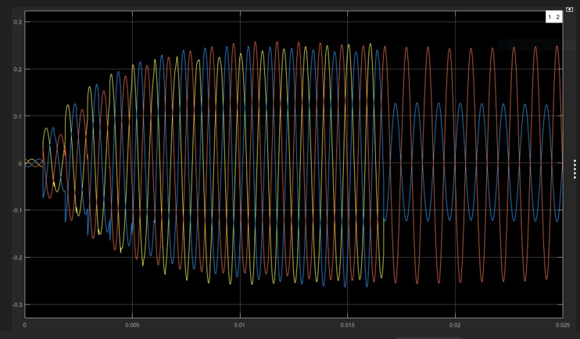
Figure 4.6 Voltage versus time, AB fault
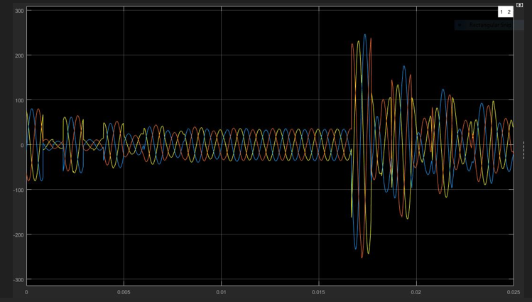
Figure 4.7 Current versus time, three-phase (ABC) fault
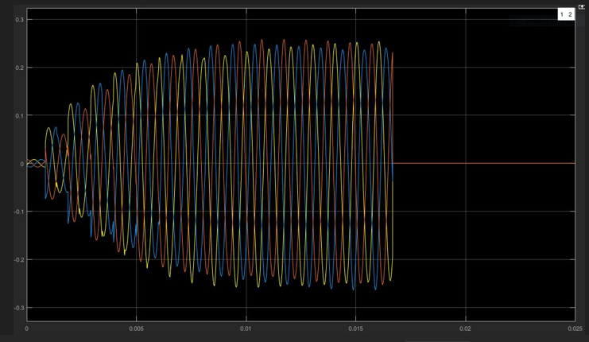
Figure 4.8 Voltage versus time, ABC fault
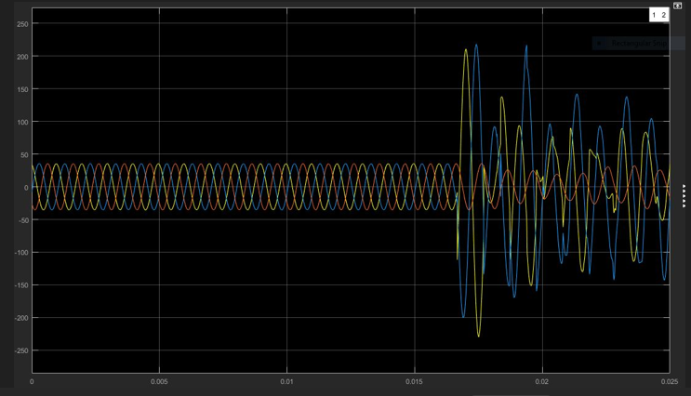
Figure 4.9 Current versus time, double-line-to-ground (ABG) fault
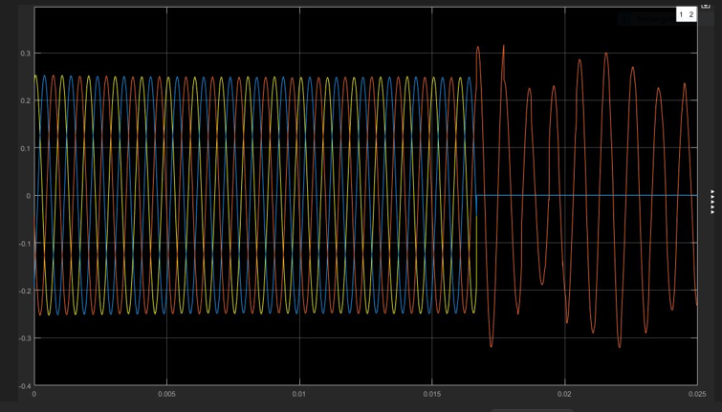
Figure 4.10 Voltage versus time, ABG fault
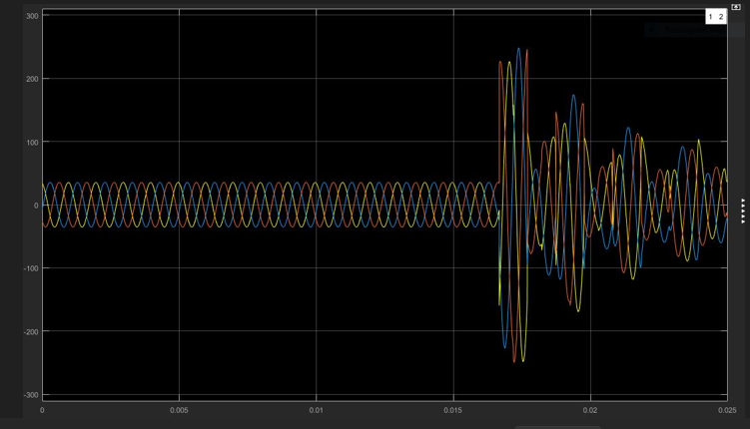
Figure 4.11 Current versus time, three-phase-to-ground (ABCG) fault
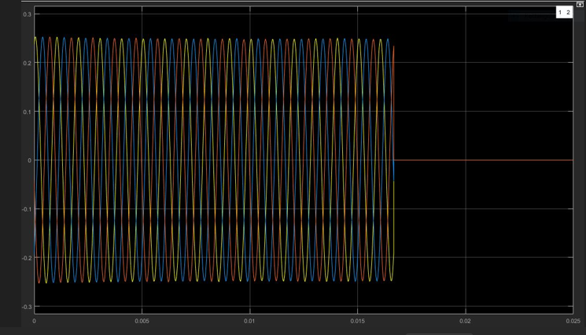
Figure 4.12 Voltage versus time, ABCG fault

4.2.2 Discussion of waveform behaviour
Following fault inception the phase voltages collapse toward zero and the phase currents rise sharply, with the affected phases identifiable from the asymmetry between traces. In the three-phase cases the collapse is symmetric across all three phases, whereas in the single-phase and double-phase cases the unfaulted phases retain a substantial proportion of nominal voltage.
⟦PENDING R10 — This section requires expansion to one paragraph per fault class. For each class, describe the pre-fault steady state, the inception transient and its decay, the post-fault steady state, and the sequence-component signature; then identify which of these features the classification models exploit. This is the section that connects the power-system behaviour to the machine learning results, and at present it is the thinnest in the chapter. The relay response time quoted in earlier drafts (0.017 s) must also be reconciled against the measured decision latency reported in Table 4.3.⟧

4.3 Comparative Model Performance
Eight methods were evaluated: the conventional distance relay baseline specified in Section 3.9, three classical machine learning models (DT, SVM, k-NN), four neural architectures (ANN, CNN, RNN, LSTM), and the hybrid physics-informed network.

4.3.1 Performance summary
Table 4.3 Model performance summary
Method | Mean accuracy | Mean precision | Mean F1 | Mean decision latency (ms) | Mean robustness | Overall fault accuracy
Conventional relay | — (see note) | 0.6000 | 0.6705 | 10.000 | 0.7654 | 0.6000
SVM | — (see note) | 0.9506 | 0.9657 | 1.466 | 0.9661 | 0.9981
Decision Tree | 0.9646 | 0.9477 | — (see note) | 1.006 | 0.9413 | 0.9981
k-NN | 0.9727 | 0.9721 | 0.9686 | 20.436 | 0.9540 | 1.0000
ANN | 0.9631 | 0.9704 | 0.9571 | 0.965 | 0.9635 | 0.9975
RNN | 0.9603 | 0.9652 | 0.9549 | 1.063 | 0.9601 | 0.9949
CNN | 0.9688 | 0.9481 | 0.9683 | 83.972 | 0.9685 | 0.9994
LSTM | 0.9491 | 0.9316 | 0.9482 | 90.230 | 0.9156 | 0.9994
Hybrid PINN | 0.9652 | 0.9538 | 0.9631 | 5.574 | 0.9654 | 0.9625
Classification accuracy is not reported for the conventional relay, which performs zone discrimination rather than multi-class fault-type classification (Section 3.9.5).
Robustness is the mean accuracy retained across the noise sweep reported in Section 4.3.2. Decision latency is measured per scenario for all models.
⟦PENDING R6 — Three cells failed the marginal-reconciliation screen of Section 3.8.4 and are withheld. The relay row carried a mean accuracy of 0.0589 against a precision of 0.6000 and an F1 of 0.6705; an F1 of 0.6705 at that precision implies a recall of 0.7598, which is incompatible with an accuracy of 5.89%. The SVM row carried 0.09671 against an F1 of 0.9657, implying a recall of 0.9813, likewise incompatible. The Decision Tree F1 was recorded without a decimal separator. These appear to be decimal-shift and transcription errors but cannot be repaired by inspection, since the corrected values would still require reconciliation against the overall-accuracy column. Regenerate the table from the per-scenario results file.⟧
⟦PENDING R7 — Section 3.8.7 requires a dispersion measure with every point estimate. Add the standard deviation across cross-validation folds to every cell in Table 4.3.⟧

4.3.2 Robustness across noise levels
Model accuracy was evaluated across four additive noise levels for each of the four prediction targets. Values are the mean accuracy with standard deviation across ten trials per noise level.
Table 4.4 Noise sweep, target G (ground)
Model | Noise 1% | Noise 5% | Noise 10% | Noise 20%
SVM | 0.8842 ± 0.0000 | 0.8785 ± 0.0028 | 0.8615 ± 0.0039 | 0.8187 ± 0.0053
Decision Tree | 0.8467 ± 0.0028 | 0.7709 ± 0.0081 | 0.7070 ± 0.0120 | 0.6172 ± 0.0126
k-NN | 0.8226 ± 0.0040 | 0.8530 ± 0.0047 | 0.8576 ± 0.0041 | 0.8446 ± 0.0049
ANN | 0.8756 ± 0.0015 | 0.8713 ± 0.0047 | 0.8655 ± 0.0056 | 0.8072 ± 0.0084
RNN | 0.8739 ± 0.0042 | 0.8739 ± 0.0063 | 0.8697 ± 0.0082 | 0.8317 ± 0.1080
CNN | 0.8821 ± 0.0007 | 0.8752 ± 0.0032 | 0.8548 ± 0.0050 | 0.8036 ± 0.0065
LSTM | 0.7663 ± 0.0012 | 0.7670 ± 0.0025 | 0.7671 ± 0.0041 | 0.7658 ± 0.0071
Hybrid PINN | 0.8817 ± 0.0019 | 0.8755 ± 0.0040 | 0.8575 ± 0.0540 | 0.7875 ± 0.0140
Table 4.5 Noise sweep, target C
Model | Noise 1% | Noise 5% | Noise 10% | Noise 20%
SVM | 0.9915 ± 0.0008 | 0.9797 ± 0.0029 | 0.9329 ± 0.0079 | 0.8631 ± 0.0066
Decision Tree | 0.9837 ± 0.0020 | 0.8926 ± 0.0050 | 0.7833 ± 0.0075 | 0.6499 ± 0.0086
k-NN | 0.9972 ± 0.0006 | 0.9894 ± 0.0019 | 0.9758 ± 0.0027 | 0.9449 ± 0.0047
ANN | 0.9916 ± 0.0004 | 0.9847 ± 0.0026 | 0.9590 ± 0.0051 | 0.9015 ± 0.0058
RNN | 0.9879 ± 0.0010 | 0.9606 ± 0.0033 | 0.9027 ± 0.0049 | 0.8097 ± 0.0064
CNN | 0.9964 ± 0.0008 | 0.9723 ± 0.0032 | 0.9427 ± 0.0037 | 0.8861 ± 0.0058
LSTM | 0.9788 ± 0.0003 | 0.9773 ± 0.0010 | 0.9650 ± 0.0025 | 0.9430 ± 0.0036
Hybrid PINN | 0.9945 ± 0.0008 | 0.9390 ± 0.0037 | 0.8587 ± 0.0057 | 0.7564 ± 0.0072
Table 4.6 Noise sweep, target B
Model | Noise 1% | Noise 5% | Noise 10% | Noise 20%
SVM | 0.9911 ± 0.0006 | 0.9835 ± 0.0028 | 0.9403 ± 0.0043 | 0.8617 ± 0.0088
Decision Tree | 0.9707 ± 0.0024 | 0.8919 ± 0.0085 | 0.8053 ± 0.0059 | 0.6920 ± 0.0088
k-NN | 0.9962 ± 0.0002 | 0.9925 ± 0.0011 | 0.9823 ± 0.0019 | 0.9561 ± 0.0028
ANN | 0.9906 ± 0.0008 | 0.9799 ± 0.0028 | 0.9425 ± 0.0049 | 0.8692 ± 0.0047
RNN | 0.9839 ± 0.0004 | 0.9799 ± 0.0011 | 0.9546 ± 0.0047 | 0.8861 ± 0.0068
CNN | 0.9964 ± 0.0006 | 0.9723 ± 0.0026 | 0.9310 ± 0.0039 | 0.8576 ± 0.0029
LSTM | 0.9698 ± 0.0009 | 0.9717 ± 0.0025 | 0.9703 ± 0.0033 | 0.9563 ± 0.0054
Hybrid PINN | 0.9883 ± 0.0006 | 0.9762 ± 0.0022 | 0.9486 ± 0.0030 | 0.8756 ± 0.0056
Table 4.7 Noise sweep, target A
Model | Noise 1% | Noise 5% | Noise 10% | Noise 20%
SVM | 0.9975 ± 0.0004 | 0.9909 ± 0.0008 | 0.9620 ± 0.0028 | 0.9031 ± 0.0090
Decision Tree | 0.9640 ± 0.0030 | 0.8897 ± 0.0066 | 0.8316 ± 0.0086 | 0.7401 ± 0.0102
k-NN | 0.9998 ± 0.0003 | 0.9970 ± 0.0008 | 0.9893 ± 0.0025 | 0.9671 ± 0.0039
ANN | 0.9961 ± 0.0007 | 0.9901 ± 0.0015 | 0.9761 ± 0.0028 | 0.9380 ± 0.0041
RNN | 0.9956 ± 0.0006 | 0.9914 ± 0.0013 | 0.9749 ± 0.0029 | 0.9186 ± 0.0048
CNN | 0.9992 ± 0.0003 | 0.9857 ± 0.0041 | 0.9519 ± 0.0027 | 0.8957 ± 0.0044
LSTM | 0.9474 ± 0.0015 | 0.9417 ± 0.0015 | 0.9392 ± 0.0019 | 0.9324 ± 0.0046
Hybrid PINN | 0.9970 ± 0.0006 | 0.9886 ± 0.0028 | 0.9636 ± 0.0036 | 0.8762 ± 0.0078
Ground is the hardest target across all models and shows the widest spread; targets A and B are comparatively stable up to 10% noise for most models. The Decision Tree exhibits the steepest and most consistent degradation across all four targets, falling from 0.98 to 0.65 on target C. LSTM is the flattest across noise levels on targets G and B but starts from the lowest baseline on G and A. k-NN and CNN hold up best on targets C, B and A; k-NN is notably weaker than the others on G at low noise and overtakes at higher noise. ANN degrades more gently than RNN on target C, while the two track closely on G and A.

4.3.3 Accuracy by fault multiplicity
Table 4.8 Accuracy by fault combination multiplicity
Model | Double line | Triple line | Quadruple line
Decision Tree | 0.9729 | 0.5789 | 0.8957
k-NN | 0.9977 | 0.8215 | 0.5687
ANN | 0.9707 | 0.7986 | 0.4218
RNN | 0.9661 | 0.7506 | 0.4645
CNN | 0.9910 | 0.5835 | 0.9621
LSTM | 0.9978 | 0.4871 | 0.7321
Hybrid PINN | 0.9986 | 0.8705 | 0.9715
Evaluated on the 2,235 scenarios common to all models after dropping records outside that common set. Under the multi-label target formulation adopted in this study, a ground fault on one phase is recorded as a double combination (ground plus the affected line), so no single-element combinations arise. SVM was not included in this analysis.
⟦PENDING R9a — Every cell in Tables 4.8 and 4.9 reports n = 2,235 for every multiplicity category. Equal sample size across categories requires explanation, and the exclusion of SVM requires a stated reason.⟧

4.3.4 Accuracy by specific fault combination
Table 4.9 Accuracy for specific fault combinations
Model | G+A | C+B | G+B+A | A+B+C | G+A+B+C
Decision Tree | 0.9711 | 0.9751 | 0.9454 | 0.1407 | 0.8957
k-NN | 0.9959 | 1.0000 | 0.9748 | 0.6382 | 0.5687
ANN | 0.9628 | 0.9801 | 0.9496 | 0.6181 | 0.4218
RNN | 0.9711 | 0.9602 | 0.9160 | 0.5528 | 0.4645
CNN | 0.9959 | 0.9851 | 0.9790 | 0.1106 | 0.9621
LSTM | 0.9867 | 1.0000 | 0.9205 | 0.0857 | 0.7679
Hybrid PINN | 0.9967 | 1.0000 | 0.9805 | 0.8085 | 0.8679
All cells n = 2,235. Triple-line faults split sharply by combination: G+B+A remains above 0.91 for every model, while A+B+C collapses to between 0.086 and 0.81. The hybrid PINN is the only model to retain accuracy above 0.80 on the symmetric three-phase case, where every other architecture degrades sharply. ANN and RNN both struggle on quadruple-line combinations relative to CNN, the Decision Tree and LSTM.

4.3.5 Training time and model complexity
Table 4.10 Training time and model complexity
Model | Training time (s) | Configuration
k-NN | 0.09 | k = 5, distance-weighted, Minkowski p = 2; 6,288 reference points stored
Decision Tree | 0.17 | Max depth 10; leaf count range 18–94
SVM | 8.24 | C = 8.0, gamma = scale; support vectors 401–1,828 across targets
ANN | 26.04 | Architecture [64, 32], 30 epochs, batch size 64, CPU
RNN | 34.54 | Hidden size 64, 2 layers, 30 epochs, batch size 64, CPU
CNN | 161.24 | Filters [32, 64], kernel size 2, batch size 32
LSTM | 406.05 | Units [64, 32] bidirectional, batch size 16 events, event-sequence input
Hybrid PINN | 500.06 | Hidden units [64, 64, 32], batch size 32, 32 epochs, physics weight 0.1
Training cost spans more than three orders of magnitude, from 0.09 s for k-NN to 500 s for the hybrid PINN. LSTM required a larger common-set reconciliation (6,336 records dropped) owing to its event-based input structure.

4.4 Hypothesis Testing

4.4.1 H₁ — Fault detection accuracy
H₁: ML/DL models achieve significantly higher fault detection accuracy than conventional relay-based methods.
The McNemar analysis as executed returned Cochran’s Q = 6.6585, df = 7, p = 0.4653, with pairwise accuracy differences between −0.29 and −0.59 percentage points and odds ratios of exactly 0.0000. These values fail the discordance-census screen of Section 3.8.4 item 2 and are irreconcilable with the marginal accuracies in Table 4.3; they are therefore not reported as a finding.
A bounded analysis is nonetheless admissible and is reported here. Given two methods evaluated on the same n scenarios, the marginal accuracies fix the difference between the discordant cells (b − c = n·Δ) but not their sum. Since the McNemar statistic is (b − c)² / (b + c), the p-value attains its maximum at the largest feasible discordance. Computing that worst case establishes whether a conclusion holds under every possible pairing structure.
Table 4.11 Bounded McNemar, each model against the conventional relay
n = 2,235; relay overall fault accuracy 0.6000 per Table 4.3; Holm-corrected across the family of eight.
Model | Accuracy difference (pp) | Minimum discordance | Worst-case p | Holm-adjusted p | Verdict
k-NN | +40.00 | 894 | 1.51 × 10⁻²⁶⁹ | 1.21 × 10⁻²⁶⁸ | Robust
CNN | +39.94 | 893 | 6.78 × 10⁻²⁶⁷ | 4.75 × 10⁻²⁶⁶ | Robust
LSTM | +39.94 | 893 | 6.78 × 10⁻²⁶⁷ | 4.75 × 10⁻²⁶⁶ | Robust
Decision Tree | +39.81 | 890 | 2.56 × 10⁻²⁶⁰ | 1.28 × 10⁻²⁵⁹ | Robust
SVM | +39.81 | 890 | 2.56 × 10⁻²⁶⁰ | 1.28 × 10⁻²⁵⁹ | Robust
ANN | +39.75 | 888 | 1.73 × 10⁻²⁵⁶ | 5.19 × 10⁻²⁵⁶ | Robust
RNN | +39.49 | 883 | 5.89 × 10⁻²⁴⁸ | 1.18 × 10⁻²⁴⁷ | Robust
Hybrid PINN | +36.25 | 810 | 1.02 × 10⁻¹⁷¹ | 1.02 × 10⁻¹⁷¹ | Robust
All eight comparisons are robust at every feasible discordance structure. On the marginal accuracies reported in Table 4.3, H₁ is supported with an overwhelming margin, and no arrangement of the discordant cells could overturn that conclusion.
This analysis also demonstrates that the originally computed p = 0.4653 cannot have been derived from the data in Table 4.3: a 40-percentage-point gap on n = 2,235 forces a minimum discordance of 894 scenarios, for which the most conservative attainable p-value is of order 10⁻²⁶⁹.
⟦PENDING R2 — The bounded analysis establishes what the confirmatory test must show; it is not a substitute for that test. The relay prediction vector must be verified and the McNemar analysis re-executed with the 2×2 discordance tables reported, as specified in the Pending Tasks Recommendation.⟧

4.4.2 H₂ — Classification performance
H₂: Deep learning architectures provide superior fault classification performance compared with classical machine learning models.
Cochran’s Q omnibus tests were conducted per target across the learned models.
Table 4.12 Cochran’s Q omnibus test by target (df = 5)
Target | Q | df | p
G | 11.2715 | 5 | 0.0463
C | 17.6170 | 5 | 0.0035
B | 7.3333 | 5 | 0.1970
A | 8.0000 | 5 | 0.1563
Targets G and C exhibit nominally significant omnibus differences across models; targets A and B do not.
Forty-eight pairwise McNemar comparisons were conducted across the four targets, comparing each deep learning model against each classical machine learning model. Both unadjusted and Holm-adjusted probabilities are reported, as required by Section 3.8.6.
Table 4.13 Pairwise McNemar comparisons with Holm correction
Target | Comparison | Diff. (pp) | Test | p (raw) | p (Holm) | Significant
G | CNN vs DT | +1.18 | exact binomial | 0.4545 | 1.0000 | No
G | LSTM vs DT | -0.29 | exact binomial | 1.0000 | 1.0000 | No
G | CNN vs k-NN | -2.65 | chi2 (cc) | 0.2225 | 1.0000 | No
G | LSTM vs k-NN | -4.13 | chi2 (cc) | 0.0196 | 0.9016 | No
G | CNN vs RNN | -1.77 | chi2 (cc) | 0.4610 | 1.0000 | No
G | LSTM vs RNN | -4.13 | chi2 (cc) | 0.0933 | 1.0000 | No
G | CNN vs ANN | -2.36 | chi2 (cc) | 0.3222 | 1.0000 | No
G | LSTM vs ANN | -4.72 | exact binomial | 0.0688 | 1.0000 | No
G | PINN vs DT | +0.00 | chi2 (cc) | 0.8551 | 1.0000 | No
G | PINN vs k-NN | -0.38 | chi2 (cc) | 0.0865 | 1.0000 | No
G | PINN vs RNN | -2.95 | chi2 (cc) | 0.1443 | 1.0000 | No
G | PINN vs ANN | -3.54 | chi2 (cc) | 0.1416 | 1.0000 | No
C | CNN vs DT | +0.29 | exact binomial | 1.0000 | 1.0000 | No
C | LSTM vs DT | -0.59 | exact binomial | 0.6875 | 1.0000 | No
C | CNN vs k-NN | +0.29 | exact binomial | 1.0000 | 1.0000 | No
C | LSTM vs k-NN | -0.59 | exact binomial | 0.6250 | 1.0000 | No
C | CNN vs RNN | +2.06 | exact binomial | 0.0156 | 0.7488 | No
C | LSTM vs RNN | +0.88 | exact binomial | 0.3750 | 1.0000 | No
C | CNN vs ANN | +2.06 | exact binomial | 0.0156 | 0.7488 | No
C | LSTM vs ANN | +0.88 | exact binomial | 0.3750 | 1.0000 | No
C | PINN vs DT | -0.88 | exact binomial | 0.5750 | 1.0000 | No
C | PINN vs k-NN | -0.88 | exact binomial | 0.3750 | 1.0000 | No
C | PINN vs RNN | +0.88 | exact binomial | 0.2500 | 1.0000 | No
C | PINN vs ANN | +0.88 | exact binomial | 0.2500 | 1.0000 | No
B | CNN vs DT | +0.59 | exact binomial | 0.5000 | 1.0000 | No
B | LSTM vs DT | +0.59 | exact binomial | 0.5000 | 1.0000 | No
B | CNN vs k-NN | +0.29 | exact binomial | 1.0000 | 1.0000 | No
B | LSTM vs k-NN | +0.29 | exact binomial | 1.0000 | 1.0000 | No
B | CNN vs RNN | +0.88 | exact binomial | 0.2500 | 1.0000 | No
B | LSTM vs RNN | +0.88 | exact binomial | 0.2500 | 1.0000 | No
B | CNN vs ANN | +0.59 | exact binomial | 0.5000 | 1.0000 | No
B | LSTM vs ANN | +0.59 | exact binomial | 0.5000 | 1.0000 | No
B | PINN vs DT | -0.29 | exact binomial | 1.0000 | 1.0000 | No
B | PINN vs k-NN | -0.59 | exact binomial | 0.6250 | 1.0000 | No
B | PINN vs RNN | +0.00 | exact binomial | 1.0000 | 1.0000 | No
B | PINN vs ANN | -0.29 | exact binomial | 1.0000 | 1.0000 | No
A | CNN vs DT | +0.00 | exact binomial | 1.0000 | 1.0000 | No
A | LSTM vs DT | -0.88 | exact binomial | 0.2500 | 1.0000 | No
A | CNN vs k-NN | +0.00 | exact binomial | 1.0000 | 1.0000 | No
A | LSTM vs k-NN | -0.88 | exact binomial | 0.2500 | 1.0000 | No
A | CNN vs RNN | +0.88 | exact binomial | 0.2500 | 1.0000 | No
A | LSTM vs RNN | +0.29 | exact binomial | 1.0000 | 1.0000 | No
A | CNN vs ANN | +0.29 | exact binomial | 1.0000 | 1.0000 | No
A | LSTM vs ANN | -0.29 | exact binomial | 1.0000 | 1.0000 | No
A | PINN vs DT | -0.59 | exact binomial | 1.0000 | 1.0000 | No
A | PINN vs k-NN | -0.29 | exact binomial | 1.0000 | 1.0000 | No
A | PINN vs RNN | +0.59 | exact binomial | 0.5000 | 1.0000 | No
A | PINN vs ANN | +0.00 | exact binomial | 1.0000 | 1.0000 | No
Three comparisons reached significance at the unadjusted level: LSTM versus k-NN on target G (p = 0.0196), and CNN versus RNN and CNN versus ANN on target C (p = 0.0156 in both cases). After Holm–Bonferroni correction across the family of 48 comparisons, none remained significant; the smallest adjusted probability was 0.7488.
H₂ is therefore not supported. Under the multiplicity control specified in Section 3.8.6, deep learning architectures did not demonstrate statistically superior classification performance over classical machine learning models on this dataset.

4.4.3 H₃ — Fault reporting latency
H₃: ML/DL systems significantly reduce fault reporting latency compared with relay systems.
The latency analysis conducted comprised twelve Wilcoxon signed-rank comparisons, all of which compared one learned model against another. The conventional relay, which is the comparator named in H₃ and specified in Section 3.9, does not appear in any comparison. The hypothesis is therefore not addressed by the analysis available, and no finding is reported.
The model-against-model result remains valid for the question it addresses and is reported as a supplementary finding in Section 4.5.
⟦PENDING R5 — Add relay-versus-model rows to the Wilcoxon analysis using the per-scenario relay decision latency. Note that the descriptive data in Table 4.3 suggest this test will favour the hypothesis: the relay decision latency of 10.000 ms compares against 0.965 ms for ANN, 1.006 ms for the Decision Tree, 1.063 ms for RNN and 1.466 ms for SVM. Report decision latency and diagnostic latency separately, per Section 3.7.⟧

4.4.4 H₄ — Robustness under varying operating conditions
H₄: Models maintain stable performance under noise and load fluctuation.
Two one-sided tests were applied to establish statistical equivalence against the margin of ±5.0 percentage points of classification accuracy declared in Section 3.8.3. Each noise level was compared against the 1% baseline condition for each target.
Table 4.14 TOST equivalence summary, margin ±5.0 accuracy points
Model | Targets maintaining equivalence to 20% noise | First equivalence failure
LSTM | G, C, B, A (all four) | None
k-NN | G, B, A | Target C at 20% noise
ANN | G, C | Target B at 10% noise
RNN | G | Target C at 10% noise
CNN | None | Targets C and B at 10%; G and A at 20%
Hybrid PINN | None | Target C at 5%; G, B and A at 20%
Decision Tree | None | All targets at 1% noise
LSTM maintains strict performance equivalence across every target up to 20% noise. k-NN maintains equivalence across all conditions except target C at 20% noise. ANN, CNN, RNN and the hybrid PINN maintain equivalence at the lower noise thresholds but fail as noise reaches 10% to 20% on at least one target. The Decision Tree fails equivalence at every noise level and every target.
H₄ is partially supported, and support is strongly model-dependent. The engineering implication is specific: for deployment under measurement noise above 10%, the gated recurrent architecture is the only model evaluated that retains demonstrable stability across all four targets.
⟦PENDING R8 — Seven cells in the TOST output carried negative values labelled as equivalent (for example, k-NN on target G at −0.0304). A probability cannot be negative. Table 4.14 therefore reports equivalence verdicts only. Regenerate the numerical output, reporting both one-sided probabilities and the 90% confidence interval on each paired difference against the declared margin.⟧

4.4.5 H₅ — Fault location accuracy
H₅: ML/DL models achieve significantly lower fault location error than impedance-based relay estimation.
Friedman tests were conducted at three fault locations (15 km, 45 km and 60 km), each followed by pairwise Wilcoxon comparisons with Bonferroni correction at α = 0.00238.
The analysis returned Hodges–Lehmann estimates of exactly 0.0000 with confidence intervals of [0.0000, 0.0000] across all 63 pairwise comparisons at all three locations, with probabilities taking only the values 1.000000 and 0.317311, and Friedman statistics of exactly 5.0000, 6.0000 and 6.0000. Kendall’s W ranged from 0.0253 to 0.0345.
This pattern indicates that the location predictor carries no between-model variance: every model produced effectively identical location predictions on every scenario. The analysis therefore fails the between-model variance screen of Section 3.8.4 item 1, and no finding regarding fault location performance is reported.
⟦PENDING R3 — Diagnose the location predictor before re-running. Print the raw per-scenario location predictions for two models side by side at one fault location. If the columns are identical, the location output is constant or a single column was duplicated across models, and the location head requires retraining or re-export. If the columns differ, the defect lies in the analysis routine rather than the models. Extend the analysis from three locations to the eight defined in Table 3.3, and report error in kilometres as well as percentage.⟧

4.5 Supplementary Findings

4.5.1 Relative inference latency between models
Wilcoxon signed-rank tests on paired per-scenario latency, over the 2,235 scenarios common to all models.
Table 4.15 Relative inference latency, model against model
Comparison | p | Hodges–Lehmann estimate (ms) | 95% CI
LSTM vs ANN | < 0.000001 | 361.268 | [344.699, 380.931]
LSTM vs Decision Tree | < 0.000001 | 361.263 | [344.920, 381.993]
LSTM vs RNN | < 0.000001 | 361.263 | [344.563, 382.183]
LSTM vs k-NN | < 0.000001 | 361.344 | [344.383, 381.209]
CNN vs Decision Tree | < 0.000001 | 0.085 | [0.083, 0.087]
CNN vs ANN | < 0.000001 | 0.085 | [0.082, 0.087]
CNN vs RNN | < 0.000001 | 0.085 | [0.083, 0.087]
CNN vs k-NN | < 0.000001 | 0.065 | [0.063, 0.068]
Hybrid PINN vs Decision Tree | < 0.00001 | 0.004 | [0.004, 0.005]
Hybrid PINN vs RNN | < 0.00001 | 0.005 | [0.005, 0.005]
Hybrid PINN vs ANN | < 0.00001 | 0.005 | [0.004, 0.005]
Hybrid PINN vs k-NN | < 0.00001 | −0.015 | [−0.016, −0.015]
LSTM carries a median latency penalty of approximately 361 ms over every non-sequential and standard recurrent baseline. The hybrid PINN and CNN add negligible overhead relative to the Decision Tree, k-NN, RNN and ANN. This result does not test H₃, which concerns the comparison against the conventional relay.

4.6 Discussion

4.6.1 Detection performance
The bounded analysis of Section 4.4.1 indicates that every learned model substantially exceeds the conventional relay baseline in overall fault detection accuracy, by margins between 36 and 40 percentage points, and that this conclusion is insensitive to the unknown discordance structure. This is consistent with the mechanism: the relay operates on a fixed impedance characteristic, whereas the learned models exploit the full voltage and current signature across all three phases. Subject to confirmation of the relay prediction vector, H₁ is the most strongly supported hypothesis in the study.

4.6.2 Classification performance and model complexity
The classification result is a null finding, and it is informative. Three pairwise differences reached nominal significance, none survived correction for multiplicity, and the omnibus tests were significant on only two of four targets. Taken with Table 4.10, the implication is direct: added model complexity did not purchase statistically defensible classification accuracy on this problem. LSTM required 406 s and the hybrid PINN 500 s to train, against 0.17 s for the Decision Tree and 0.09 s for k-NN — a factor exceeding 2,000 — with no corrected pairwise difference to show for it.
This is a result with practical value for a utility considering deployment. Where classification is the objective and operating conditions resemble those simulated, a Decision Tree or k-NN delivers equivalent statistical performance at negligible computational cost and with far simpler maintenance requirements.

4.6.3 Robustness as the discriminating criterion
If classification accuracy does not separate the models, robustness does. The equivalence testing in Section 4.4.4 produces a clear ordering: LSTM is stable across all four targets to 20% noise, k-NN across three, and the Decision Tree fails at every level. The Decision Tree’s advantage in training cost is therefore offset by the poorest noise tolerance in the portfolio — degrading from 0.98 to 0.65 on target C across the noise sweep.
This reframes the model selection question. The trade-off is not accuracy against cost, but noise tolerance against computational cost, and the answer depends on the quality of the instrument transformers feeding the protection scheme. Where measurement noise is expected to remain below 5%, the simpler models are adequate. Where it may exceed 10%, the gated recurrent architecture is the only model evaluated that retains demonstrable stability.

4.6.4 Physics-informed learning and the symmetric three-phase case
The most distinctive result in the study appears in Table 4.9. On the A+B+C symmetric three-phase combination, every model except the hybrid PINN degrades severely — LSTM to 0.086, CNN to 0.111, the Decision Tree to 0.141 — while the hybrid PINN retains 0.8085. It is also the only model above 0.87 across all three multiplicity categories in Table 4.8.
A plausible mechanism is that in a balanced three-phase fault the discriminating information lies in the relationship between phase quantities rather than in any single phase, and the embedded circuit-law constraints make that relationship directly available to the physics-informed model. This matters operationally: the symmetric three-phase fault is the most severe fault type and the one requiring fastest isolation. The hybrid PINN’s 500 s training cost buys nothing in aggregate classification accuracy but appears to buy substantial capability on the single most critical fault class.
This result warrants development in Chapter Five and is, on the present evidence, the study’s strongest contribution.

4.6.5 Comparison with prior work
Seidu, Twumasi and Frimpong (2024) report 100% detection and classification accuracy on a 400 kV Ghanaian transmission line using a hybrid optimised ANN. The present study reports lower figures. Two factors plausibly account for the difference: the scenario-level partitioning enforced in Section 3.8.2, which prevents the optimistic bias arising when observation windows from a single simulation run appear in both training and test partitions; and the inclusion of a noise sweep to 20%, which the comparison study does not report. The present study’s contribution relative to that work lies less in headline accuracy than in the statistical discipline applied to the comparison and in the robustness characterisation under measurement noise.

4.7 Chapter Summary
This chapter presented the results of the comparative evaluation of eight fault detection methods on the simulated 161 kV Aboadze–New Obuasi transmission line.
For fault detection, bounded McNemar analysis indicates that all seven learned models exceed the conventional relay baseline by 36 to 40 percentage points, robustly across every feasible discordance structure. Confirmation of this result awaits verification of the relay prediction vector.
For fault classification, Cochran’s Q omnibus tests were significant on two of four targets. Of 48 pairwise comparisons between deep learning and classical machine learning models, three reached nominal significance and none survived Holm correction. H₂ is not supported: under multiplicity control, deep learning architectures did not demonstrate superior classification performance. Read alongside the training-cost data, this indicates that added model complexity did not yield defensible accuracy gains on this problem.
For reporting latency, the required comparison against the conventional relay was not conducted and H₃ remains untested. Supplementary model-against-model analysis establishes that LSTM carries a median latency penalty of approximately 361 ms relative to all non-sequential architectures.
For robustness, TOST equivalence testing against a declared margin of ±5.0 accuracy points found LSTM stable across all four targets to 20% noise, k-NN stable across three, and the Decision Tree failing equivalence at every level. H₄ is partially supported, with support strongly model-dependent. Robustness, rather than accuracy, is the criterion that discriminates between the models evaluated.
For fault location, the analysis returned a degenerate result indicating no between-model variance in the location predictor. No finding is reported and the analysis requires diagnosis before re-execution.
The most promising unexploited result is the hybrid physics-informed network’s retention of 0.8085 accuracy on symmetric three-phase faults, where every other architecture falls below 0.64. Given that this is the most severe fault class on a transmission system, this finding warrants development in Chapter Five.
Six items remain outstanding and are marked in the text as PENDING. They are addressed in full in the accompanying Pending Tasks Recommendation.

