CPT 208 Individual Project

Coursework/Assignment Submission Form

2020/21 Semester 2

Bachelor’s degree – Year 3

|  |  |  |
| --- | --- | --- |
| Module Code | Module Leader | Module Title |
| **CPT208** | **Lingyun Yu** | **Human-Centric Computing** |

**Section A: Your Details**

*To be completed by the student (in English using BLOCK CAPITALS)*

|  |  |
| --- | --- |
| Student’s Name | **Tianlei Shi** |
| Student ID | **1824152** |

**Section B: Assignment Details**

*To be completed by the student (in English using BLOCK CAPITALS)*

|  |  |
| --- | --- |
| Coursework Assignment Number | **COURSEWORK 3** |
| Coursework (assignment) Title | **GUI INTERFACE** |
| Method of Working | **INDIVIDUAL** |
| Date and time of submission | **Friday, 28 May 2021, 23:59** |

*Assignment details can be found in the assignment description.*

**Section C: Statement of Academic Honesty**

*To be completed by the student*

By submitting this coursework for assessment, you are confirming that you have read and understood the University’s policy on plagiarism and collusion and that the submitted work is your own.

1. I confirm that I have read a copy of the current University’s definitions of collusion and plagiarism on coursework and academic honesty, and that I fully understand the meaning of these terms.
2. I confirm that the submitted coursework has been created solely by me and that I have not been assisted, nor have copied part or all of somebody else’s work, either with their explicit approval or without their knowledge or consent.
3. I confirm that this is my own work and that use of material from other sources, including the Internet, has been properly and fully acknowledged and referenced.

|  |  |  |  |
| --- | --- | --- | --- |
| Student’s signature | Tianlei Shi | Date | 2021.5.28 |

1. I confirm that the information I have given is correct to the best of my knowledge.

*If this form is submitted electronically, please type your name in English (BLOCK CAPTIALS)*

Report

In this coursework, I designed and implemented an interface of a hotel booking system by using Java Swing.

This system consists of three pages: login page, register page, and booking page (shown as Fig.1.). Users can use the corresponding buttons to jump between the three pages, and complete a series of operations related to hotel-booking, such as login, choose check-in/check-out date, and choose number of rooms. In addition, system also provides operations on the map, such as zoom in/out, and drag.

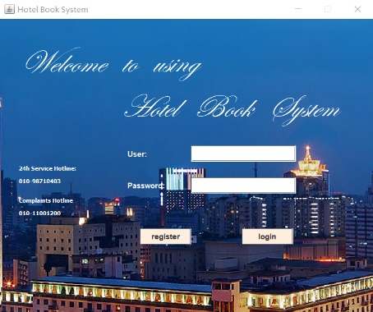 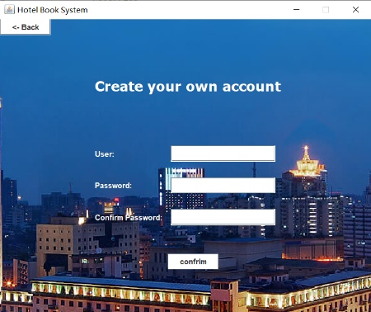 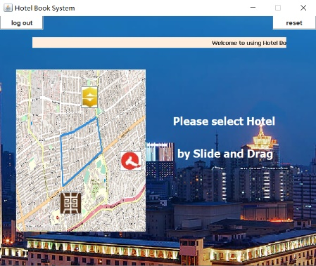

Fig.1. login page, register page, and booking page of hotel booking system

Moreover, several design principles have been considered when designing system.

Firstly, design principle of “Simple and Natural Dialog, Mental Model” is used in this system. User can zoom in (or zoom out) map by sliding mouse wheel up (or down) in booking page.

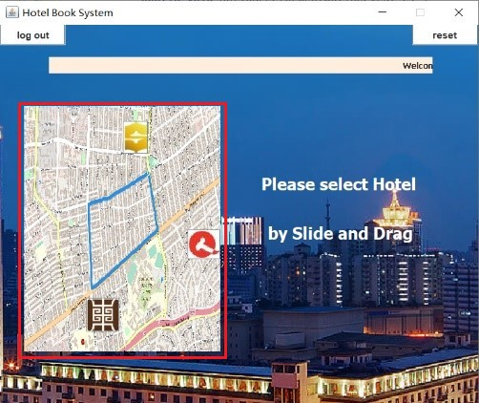 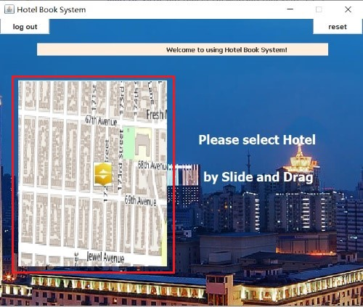

Fig.2. zoom in (or zoom out) map by sliding mouse wheel up (or down) in booking page

Additionally, no matter which page of the system, only information useful to the user will be displayed, which satisfying the design principles of “Present exactly the information the user needs”.

Secondly, design principle of “Minimize the User’s Memory Load” is used in hotel-booking. When user selects check-in/check-out date, a calendar appears for the user to select rather than enter.

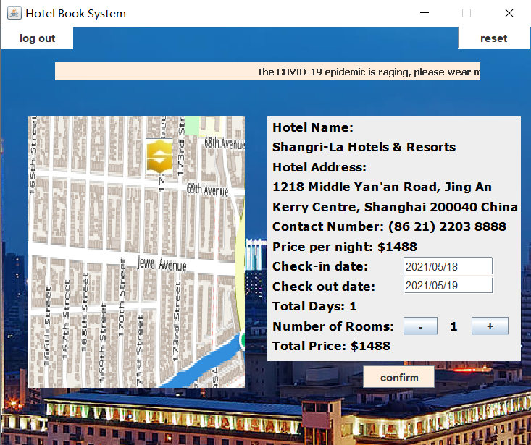 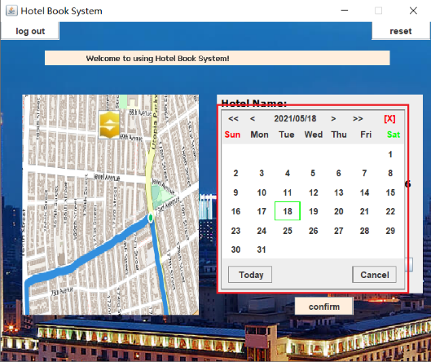

Fig.3. appear calendar to minimize the user’s memory load

This design principle is used in map as well. A prompt about how to operating will appear when user hover mouse over the map region.

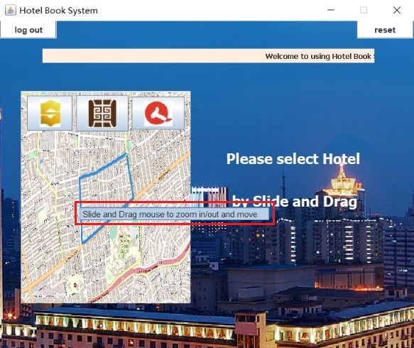

Fig.4. prompt appear when mouse be hovered over the map region

Thirdly, when user selects the hotel information and clicks “confirm” bottom, system will give a feedback. This design applied the design principle of “Provide Feedback”, system will give different feedbacks when facing correct and incorrect operations (such as check-in date is later than check-out date).

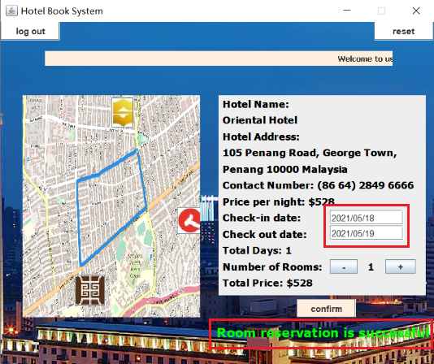 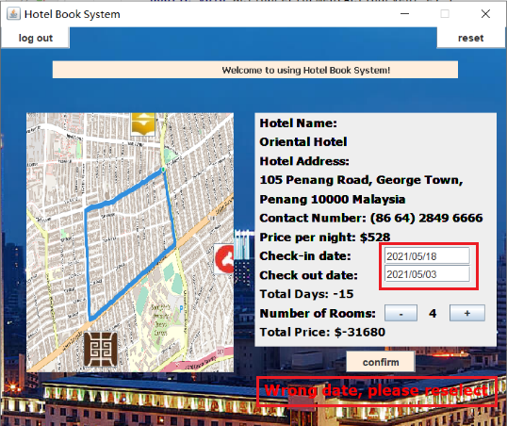

Fig.5. system provide different feedback for different operation

Finally, the exit function is designed to prevent users from being trapped by a page. At any page, the user can log out, and this satisfy the design principle of “Provide Clearly Marked Exits”.

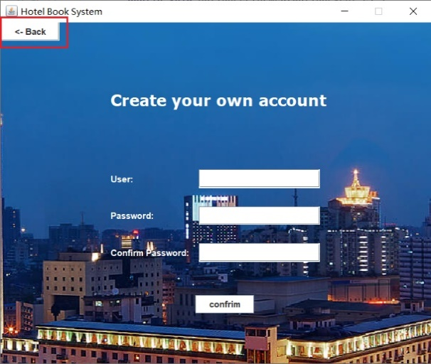 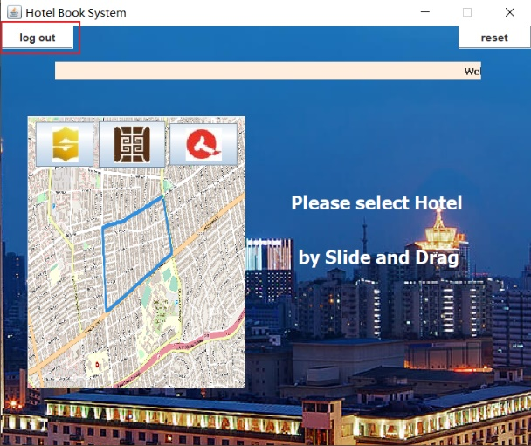

Fig.6. system provide clearly marked exit button

In conclusion, this report discusses the designed and implemented an interface of a hotel booking system by using Java Swing, and applied several design principles in this system.