\subsection{Testing process for Covasim}

First a scenario name “Covasim” is created, in this scenario, we focus on the interventions part of Covasim. Starting with \textsl{.dot} file, one graph for input parameter and another one for output is created,

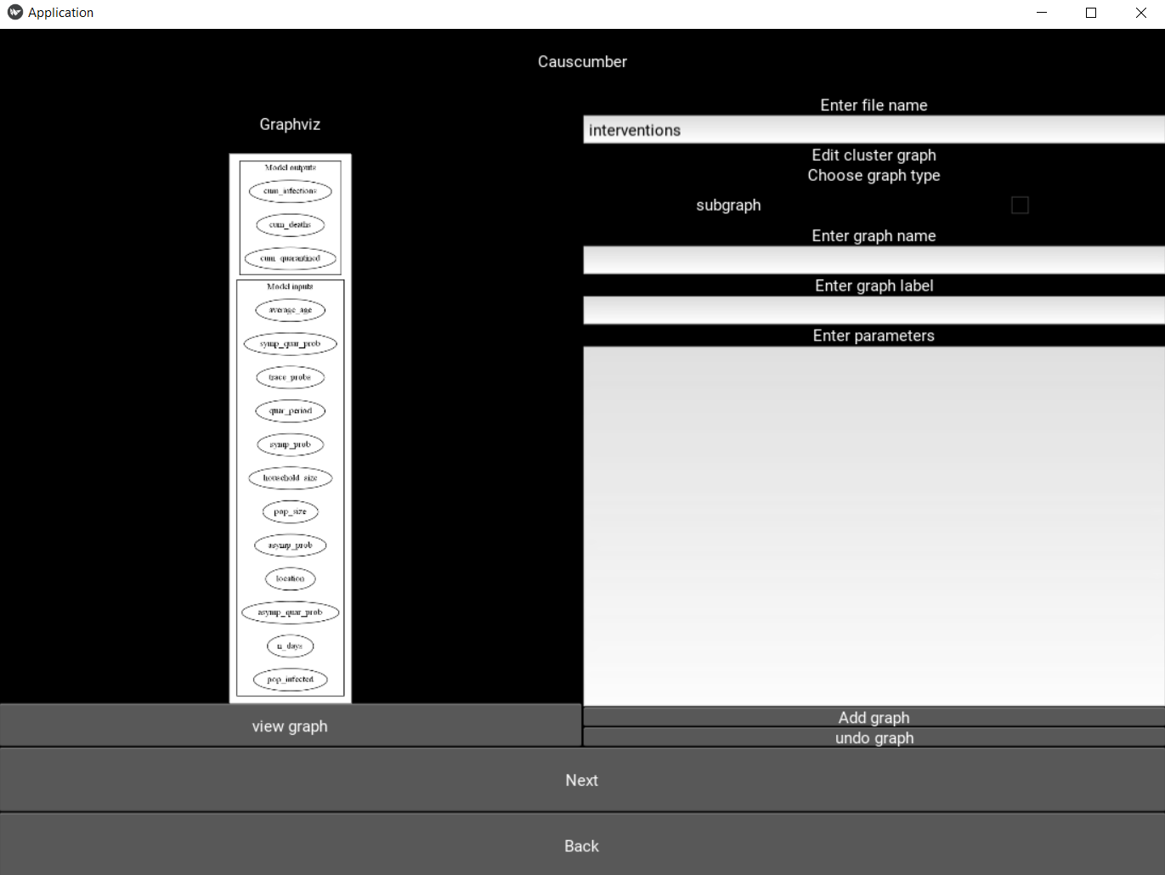

And the following relations are defined,

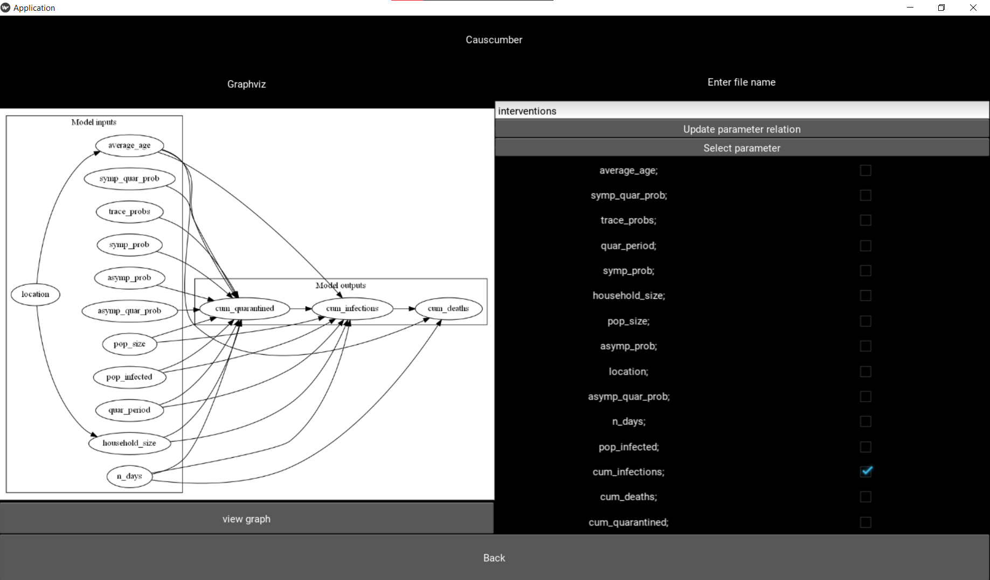

Next is to define the three background file, in \textsl{abstract.py}, there are two custom constraints needs to be define, “average_age” and “household_size”. In covasim, one of the parameters requires string, therefore in \textsl{dag_steps.py} a custom constrain named “countries” is defined. Next, there are several meta variables in the background, these meta variables are also defined as functions in \textsl{dag_steps.py}. \\*\\*

Last is the feature file, in the first section, one of the parameters is location, since it only accepts string, its distribution will be using the custom distribution “countries” defined before. Also, there are meta variables require, so in this section meta variable are also required to be defined. There is also multiple extra initial condition require to be defined, this is also done in the first section.

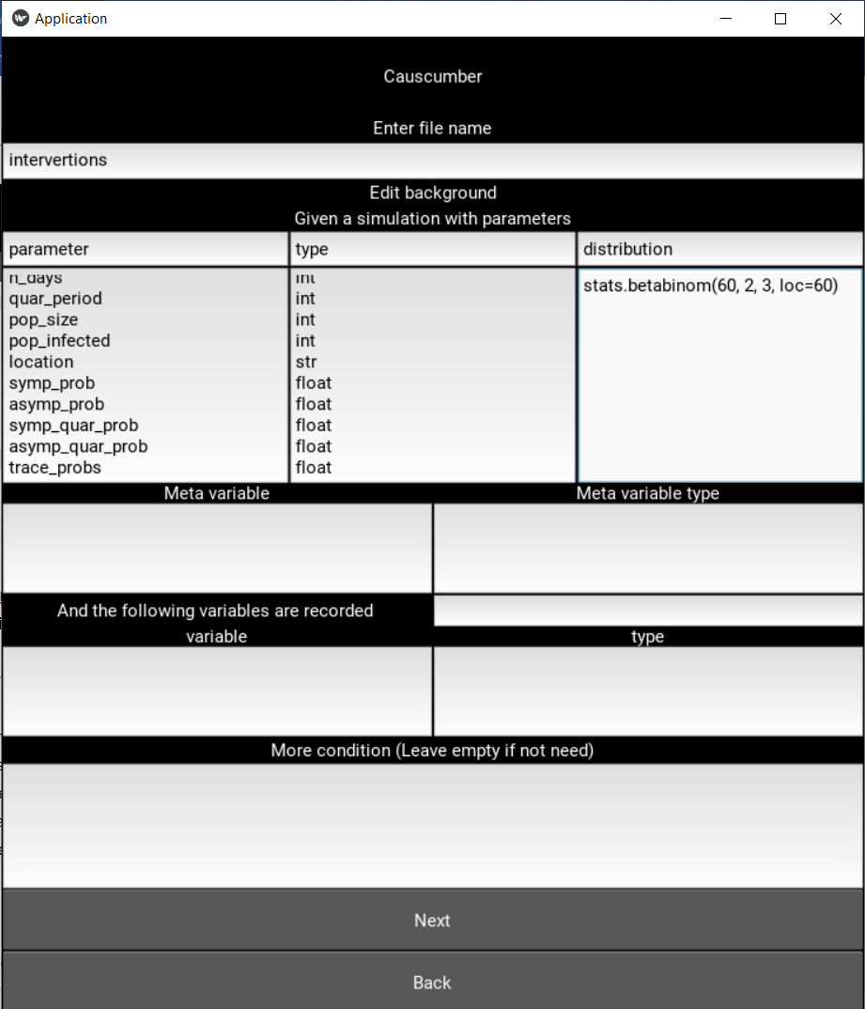

In next section, same as influenza1918, edges are defined using the assisting tools, in Covasim, there are

*Todo update abstract template with right constrain example