
Banks AI - Master Architecture & Technical Implementation Guide
Autonomous Multi-Turn LLM Agent with Live Parameterized SQL Tool Calling Across All 27 ERP Modules

Chapter 1: Live Domain Database Tools Across All 27 Modules
Banks AI is grounded in the operational MySQL database. Below is the complete catalog of live domain database tools available in `server/services/ai/banks.tools.js`:
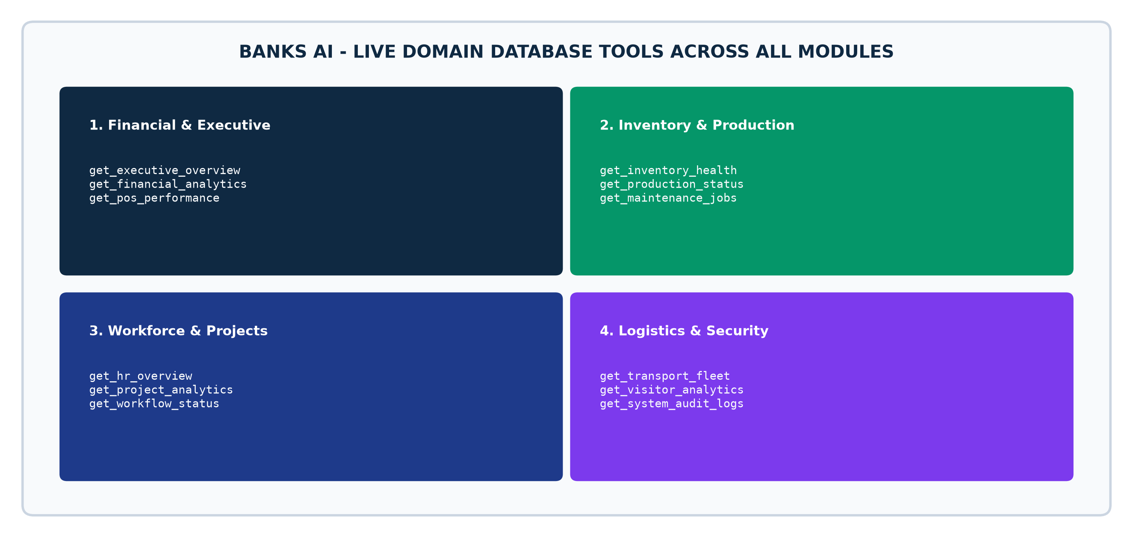
Figure: Banks AI Live SQL Domain Execution Tools Map
Domain Tool Name | Required Module(s) | Database Execution & Data Grounding
get_executive_overview | bi, admin, sales, finance | Queries MTD revenue, purchase expenses, inventory valuation, active headcount.
get_financial_analytics | sales, finance, purchase | Queries gross profit margins, top 5 revenue customers, top 5 suppliers by spend.
get_inventory_health | inventory | Queries SKU counts, total valuation, safety stock shortages, warehouse stock distribution.
get_production_status | production | Queries active factory work orders, completed units, scrap rates, active BOMs.
get_project_analytics | project_management, projects | Queries active projects, milestones, overdue tasks, budget vs. actual cost variance.
get_pos_performance | pos | Queries active cash registers, today's retail gross sales, basket size, top sellers.
get_hr_overview | human_resource, hr | Queries total headcount, department distribution, pending leave requests, active loans.
get_transport_fleet | transport | Queries vehicle statuses (Available/On Trip/Maintenance), fuel receipts, active waybills.
get_maintenance_jobs | maintenance | Queries open repair tickets, scheduled preventive maintenance, spare parts costs.
get_visitor_analytics | visitors, administration | Queries visitor logs, active visitors on site, host departments, security compliance.

