OMNISUITE ERP
REST API DOCUMENTATION & OPENAPI SPECIFICATION
The Definitive Developer Guide, OpenAPI 3.0.3 Contract, Authentication Pipeline, Multi-Tenant Scoping, and Complete Endpoint Reference across All 27 Enterprise Modules

API Architecture | RESTful JSON Gateway over Node.js Express & MySQL2 Connection Pool
OpenAPI Specification | OpenAPI 3.0.3 (Importable into Swagger UI, Postman, Insomnia)
Base Gateway URL | http://localhost:5000/api (Dev) / https://erp.yourcompany.com/api (Prod)
Authentication Standard | JWT (JSON Web Token) Bearer Header + x-company-id & x-branch-id Scope
API Release Version | v4.5 Enterprise Production Release (August 2026)
Companion Deliverables | OmniSuite_ERP_OpenAPI.yaml & OmniSuite_ERP_OpenAPI.json

Document Control & API Revision History
This document serves as the official API technical reference manual for software engineers, backend developers, frontend integrators, mobile developers, and technical integration partners working with OmniSuite ERP.
Version | Release Date | API Changes & Technical Scope | Author / Approver
v1.0 | 15/01/2026 | Initial baseline REST APIs (Auth, Basic Sales, Inventory) | API Architect
v2.5 | 10/04/2026 | Added Multi-Tenant x-company-id / x-branch-id Scope Headers & POS terminal APIs | Backend Engineering
v3.8 | 01/07/2026 | Added Project WBS, Fleet Waybills, and Push Notification subscriptions | DevOps Team
v4.5 | 24/08/2026 | Full OpenAPI 3.0.3 compliance, Banks AI dual-provider chat API, and complete 27-module endpoint catalog | Enterprise Architecture Board

Master API Table of Contents
Section Number & Title | Technical Scope & Core Topics Covered
Section 1: OmniSuite API — Quick Start (5-Minute Guide) | Base URLs, acquiring JWT token, making your first cURL request
Section 2: API Architecture & Request Gateway Pipeline | Middleware execution chain, requireAuth, companyScope, error handlers
Section 3: Authentication & Multi-Tenant Scoping Headers | Bearer tokens, x-company-id, x-branch-id, Superadmin bypass
Section 4: Complete CRUD & Endpoint Availability Matrix | GET, POST, PUT, DELETE matrix across all 27 ERP modules
Section 5: Module-by-Module API Reference | Detailed endpoints, parameters, request bodies, responses & HTTP codes
Section 6: Postman & Swagger UI Integration Guide | How to import OmniSuite_ERP_OpenAPI.yaml into Swagger & Postman
Section 7: API Error Handling & Diagnostic Troubleshooting | Standard JSON error formats, HTTP 400/401/403/429/500 remediation
Section 8: API Security, Versioning & Best Practices | SQL injection protection, rate limits, breaking change management

Section 1: OmniSuite API — Quick Start Guide
This section enables any developer to authenticate and execute their first API request in less than 5 minutes.

1.1 Base URLs & Gateway Environments
Environment | Base Gateway URL | Usage & Notes
Local Development | http://localhost:5000/api | Active during local npm run dev. CORS enabled for port 5173.
Production Gateway | https://erp.yourcompany.com/api | Production Plesk Node.js Passenger gateway with SSL (HTTPS).

1.2 Step 1: Authenticate and Acquire JWT Bearer Token
Send a POST request to /api/auth/login with valid user credentials:
# 1. Acquire JWT Bearer Token
curl -X POST "http://localhost:5000/api/auth/login" \
-H "Content-Type: application/json" \
-d '{"username": "admin@omnisuite.com", "password": "Password123!"}'
# Response:
{
"token": "eyJhbGciOiJIUzI1NiIsInR5cCI6IkpXVCJ9...",
"user": {
"id": 1,
"username": "admin",
"email": "admin@omnisuite.com",
"role_name": "Super Admin",
"company_id": 1,
"branch_id": 1
}
}
Listing: Authenticating via cURL (POST /api/auth/login)

1.3 Step 2: Make Authenticated API Request with Scoping Headers
Pass the Bearer token in the Authorization header along with tenant scoping headers:
# 2. Query Scoped Inventory Items
curl -X GET "http://localhost:5000/api/inventory/items?search=cement" \
-H "Authorization: Bearer <YOUR_JWT_TOKEN>" \
-H "x-company-id: 1" \
-H "x-branch-id: 1" \
-H "Content-Type: application/json"
Listing: Making a Scoped API Call (GET /api/inventory/items)

Section 2: API Architecture & Request Pipeline
OmniSuite's API Gateway operates as a layered Express 4.19 pipeline where requests flow through authentication, multi-tenant scoping, input validation, and named-parameter database queries:
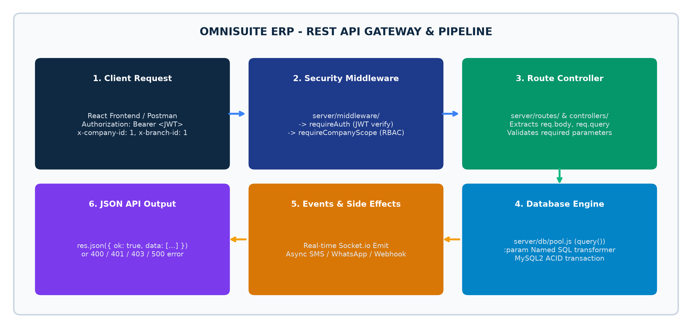
Figure 2.1: OmniSuite REST API Middleware Pipeline & Gateway Execution Flow

Section 3: Complete CRUD & Endpoint Availability Matrix
Below is the verified availability matrix across all implemented ERP resources in the codebase:
Module Resource | API Base Path | GET | POST | PUT | DEL | Operational Purpose
Authentication | /api/auth/login, /me, /profile | — | POST | PUT | — | User login & profile
Administration | /api/admin/users, /roles, /branches | GET | POST | PUT | DELETE | RBAC & Tenant setup
Inventory Items | /api/inventory/items | GET | POST | PUT | DELETE | Product catalog & prices
Inventory Transfers | /api/inventory/transfers | GET | POST | PUT | — | Warehouse dispatch & accept
Purchase Orders | /api/purchase/orders | GET | POST | PUT | — | LPO procurement contracts
Goods Receipt Notes | /api/purchase/grn | GET | POST | PUT | — | Warehouse GRN acceptance
Sales Quotations | /api/sales/quotations | GET | POST | PUT | DELETE | Customer price quotes
Sales Orders | /api/sales/orders | GET | POST | PUT | — | Confirmed sales orders
Sales Invoices | /api/sales/invoices | GET | POST | PUT | — | Official tax invoices
POS Cashier Sales | /api/pos/sales | GET | POST | — | — | Retail register checkouts
POS Shift Sessions | /api/pos/sessions | GET | POST | PUT | — | Cashier float & Z-Reports
Production BOM | /api/production/boms | GET | POST | PUT | DELETE | Manufacturing formulas
Production Orders | /api/production/work-orders | GET | POST | PUT | — | Shop-floor work orders
Chart of Accounts | /api/finance/chart-of-accounts | GET | POST | PUT | — | General ledger accounts
Finance Vouchers | /api/finance/vouchers | GET | POST | PUT | — | JV, PV, RV, CV transactions
HR Employees | /api/hr/employees | GET | POST | PUT | DELETE | Staff master records
HR Payroll Runs | /api/hr/payroll | GET | POST | PUT | — | Monthly salary computations
Project WBS | /api/projects/projects | GET | POST | PUT | DELETE | Project tasks & timesheets
Transport Waybills | /api/transport/waybills | GET | POST | PUT | — | Digital delivery waybills
Asset Maintenance | /api/maintenance/job-orders | GET | POST | PUT | — | Repair job orders
Service Invoices | /api/service/invoices | GET | POST | PUT | — | Customer service billing
Visitor Logs | /api/visitors/logs | GET | POST | PUT | — | Gate check-in & badges
BI Overview | /api/bi/overview | GET | — | — | — | Cross-module KPI summary
Banks AI Chat | /api/ai/chat | — | POST | — | — | Natural language query engine

Section 4: Module-by-Module API Specification
This section provides detailed endpoint references, query parameters, request payloads, and status code specifications for core endpoints across all functional modules.

4.1 Authentication & Profile APIs
Method & Endpoint | Purpose | Auth Required? | Scope Headers Required? | Sample Request / Response
POST /api/auth/login | Authenticate user and issue JWT bearer token | No | No | Request: { username, password }  Response: { token, user }
GET /api/auth/me | Fetch active user profile and permitted module list | Yes (Bearer) | Yes (x-company-id) | Response: { user, modules: ['sales', 'pos'] }
POST /api/auth/logout | Invalidate active session and clear Redis cache | Yes (Bearer) | No | Response: { ok: true }
PUT /api/auth/password | Change user password with old password verification | Yes (Bearer) | No | Request: { oldPassword, newPassword }

4.2 Inventory & Warehouse APIs
Method & Endpoint | Query / Body Parameters | Validation Rules | Database Entity Affected
GET /api/inventory/items | ?search=string&category_id=int&page=1&limit=20 | Filters items scoped to company_id | inv_items, inv_categories
POST /api/inventory/items | Body: { item_code, item_name, cost_price, selling_price, uom } | item_code must be unique per company | inv_items
POST /api/inventory/transfers | Body: { source_warehouse_id, dest_warehouse_id, items: [] } | Source warehouse must have >= quantity | inv_stock_transfers, inv_stock_balance
PUT /api/inventory/transfers/:id/accept | Path: id. Body: { received_items: [] } | Only receiving warehouse storekeeper can accept | inv_stock_balance (Adds to dest)

4.3 Sales & Commercial Billing APIs
Method & Endpoint | Query / Body Parameters | Validation Rules | Database Entity Affected
GET /api/sales/invoices | ?status=POSTED&customer_id=int | Scaped to active company and branch | sal_invoices, sal_customers
POST /api/sales/invoices | Body: { customer_id, invoice_date, items: [], taxes: [] } | Calculates GRA taxes (NHIL, GETFund, VAT) | sal_invoices, sal_invoice_details
PUT /api/sales/invoices/:id/post | Path: id | Posts revenue to General Ledger (Accounts) | sal_invoices, fin_vouchers, fin_general_ledger

4.4 Point of Sale (POS) APIs
Method & Endpoint | Query / Body Parameters | Validation Rules | Database Entity Affected
POST /api/pos/sessions/open | Body: { terminal_id, opening_float: 200.00 } | Only 1 active shift allowed per terminal | pos_sessions
POST /api/pos/sales | Body: { session_id, payment_method, gross_amount, lines: [] } | Deducts physical stock immediately | pos_sales, pos_sale_lines, inv_stock_balance
POST /api/pos/sessions/close | Body: { session_id, physical_cash_count: number } | Generates official Z-Report summary | pos_sessions (Status: CLOSED)

4.5 Banks AI Copilot API
Method & Endpoint | Payload Structure | AI Provider & Execution | Response Output
POST /api/ai/chat | Body: { messages: [{ role: 'user', content: 'when was last sales done?' }], userContext: {} } | Groq qwen/qwen3.6-27b with auto-fallback to OpenRouter stealth/ox-alpha on 429 | Response: { data: { reply: '...', toolCallsExecuted: ['get_recent_sales'] } }
GET /api/ai/status | Headers: Bearer Auth | Checks active connectivity to Groq Cloud & OpenRouter | Response: { groq: { connected: true }, openrouter: { connected: true } }
POST /api/ai/save-openrouter-key | Body: { apiKey: 'sk-or-v1-...' } | Updates runtime API key for 0x Alpha failover engine | Response: { success: true }

Section 5: Swagger UI & Postman Integration Guide
The companion OpenAPI 3.0.3 specification file (OmniSuite_ERP_OpenAPI.yaml / .json) can be imported into Postman or rendered with Swagger UI:

5.1 How to Import into Postman
1. Open Postman and click the **Import** button in the top-left corner.
2. Drag and drop `OmniSuite_ERP_OpenAPI.yaml` from your workspace root.
3. Select **Import as API Collection**.
4. In the Collection Authorization settings, select **Bearer Token** and paste your JWT token.
5. In the Collection Pre-request Script, add `pm.request.headers.add({ key: 'x-company-id', value: '1' })`.

5.2 Recommended Swagger UI Express Setup
To mount live interactive Swagger UI directly on the OmniSuite backend, add the following lines to `server/index.js`:
// Recommended Swagger UI Mount in server/index.js
import swaggerUi from 'swagger-ui-express';
import yaml from 'yamljs';
import path from 'path';
const swaggerDocument = yaml.load(path.resolve('../OmniSuite_ERP_OpenAPI.yaml'));
app.use('/api-docs', swaggerUi.serve, swaggerUi.setup(swaggerDocument));
console.log('Swagger UI interactive API docs available at http://localhost:5000/api-docs');
Listing: Mounting Swagger UI on Express Gateway (server/index.js)

Section 6: API Error Handling & Troubleshooting Guide
All OmniSuite API errors return structured JSON objects accompanied by standard HTTP status codes:
HTTP Status Code | Typical Operational Cause | Developer Remediation Action
400 Bad Request | Missing required payload parameters or validation failure. | Inspect error message string. Verify all required body fields exist.
401 Unauthorized | Missing, invalid, or expired JWT Bearer token. | Call /api/auth/login to acquire a fresh token and pass in Authorization header.
403 Forbidden | User role lacks authorization for the requested module or branch. | Check adm_user_branches and role feature permissions in adm_roles.
404 Not Found | The requested resource ID or API route path does not exist. | Verify URL endpoint spelling and confirm resource ID exists in database.
429 Rate Limit Exceeded | AI inference rate limits reached on primary Groq Cloud engine. | System automatically fails over to OpenRouter (stealth/ox-alpha).
500 Internal Server Error | Uncaught backend exception or SQL syntax/connection crash. | Inspect server terminal / Passenger logs and check named :param bindings.

