OMNISUITE ERP
TECHNICAL DOCUMENTATION & SYSTEM ARCHITECTURE MANUAL
The Definitive Onboarding Guide, Monorepo Blueprint, Codebase Map, Database Engine Reference, Multi-Tenant Scoping, and API Specification for Software Engineers & DevOps Architects

System Architecture | Modular Monolith (React 18 SPA + Node.js Express API + MySQL2 ACID Engine)
Documentation Version | v4.5 Enterprise Architecture Edition
Applicable Release Date | August 2026
Prepared For | New Software Engineers, Backend Developers, Frontend Engineers & DevOps Teams
Document Classification | Engineering Standard & Architecture Decision Record (ADR)
AI Subsystem | Banks AI Enterprise Copilot (Dual-Provider Groq & OpenRouter failover)

Document Control & Revision History
This technical document is the definitive architecture specification for the OmniSuite ERP monorepo. It is designed so that a junior or intermediate developer joining the engineering team can understand the entire system architecture, trace any request from frontend to MySQL database, and begin developing or modifying features safely without unintended regressions.
Version | Release Date | Primary Technical Changes & Scope | Author / Approver
v1.0 | 15/01/2026 | Initial core architecture (Express API, MySQL2 pool, React router) | Lead Architect
v2.5 | 10/04/2026 | Added Multi-Tenant Company & Branch Scoping, POS Shift, and Manufacturing BOM | Senior Backend Eng
v3.8 | 01/07/2026 | Integrated Redis caching, Socket.io real-time feeds, and Project WBS | DevOps & Core Team
v4.5 | 24/08/2026 | Unified Master Tech Doc: Complete 27-module maps, Banks AI dual-provider engine, :param SQL transformer, hasColumn schema guards, request lifecycles, and troubleshooting guide | Enterprise Architecture Board

Master Technical Table of Contents
Document Part & Title | Technical Scope & Core Chapters Covered
PART I: GETTING STARTED & 15-MINUTE BLUEPRINT | Monorepo anatomy, 3-tier design, technology stack reference
PART II: SYSTEM ARCHITECTURE & CORE PIPELINES | Frontend architecture, backend gateway, database engine, auth scoping
PART III: CODEBASE MAP & 'WHERE DO I FIND THIS?' | Directory structure, exact file pointers, line-by-line references
PART IV: ERP MODULE-BY-MODULE ARCHITECTURE | All 27 modules mapped with routes, controllers, tables & dependencies
PART V: END-TO-END CODE TRACES | 6 complete request traces: Login, PO, POS Sale, Voucher, BOM, Banks AI
PART VI: DEVELOPER ONBOARDING & HOW-TO GUIDES | 3-Day onboarding roadmap, adding new features, modifying safely
PART VII: ENVIRONMENT, BUILD & DEPLOYMENT | Local setup, .env variables, Plesk Node.js Passenger, production build
PART VIII: OPERATIONS, TROUBLESHOOTING & SECURITY | Diagnostic sequence, troubleshooting matrix, RBAC, glossary & ADRs

PART I: Getting Started & Understanding OmniSuite in 15 Minutes
Welcome to the OmniSuite ERP engineering team. This section provides a fast, high-level technical overview of the system architecture, foundational design decisions, and monorepo structure.

1.1 What is OmniSuite ERP?
OmniSuite ERP is a high-performance, modular-monolith enterprise resource planning platform engineered in modern JavaScript/Node.js. It unifies all commercial operations—including procurement, inventory control, point of sale, commercial sales, manufacturing, project delivery, transport logistics, human resources, and double-entry financial accounting—into a single real-time transactional system.
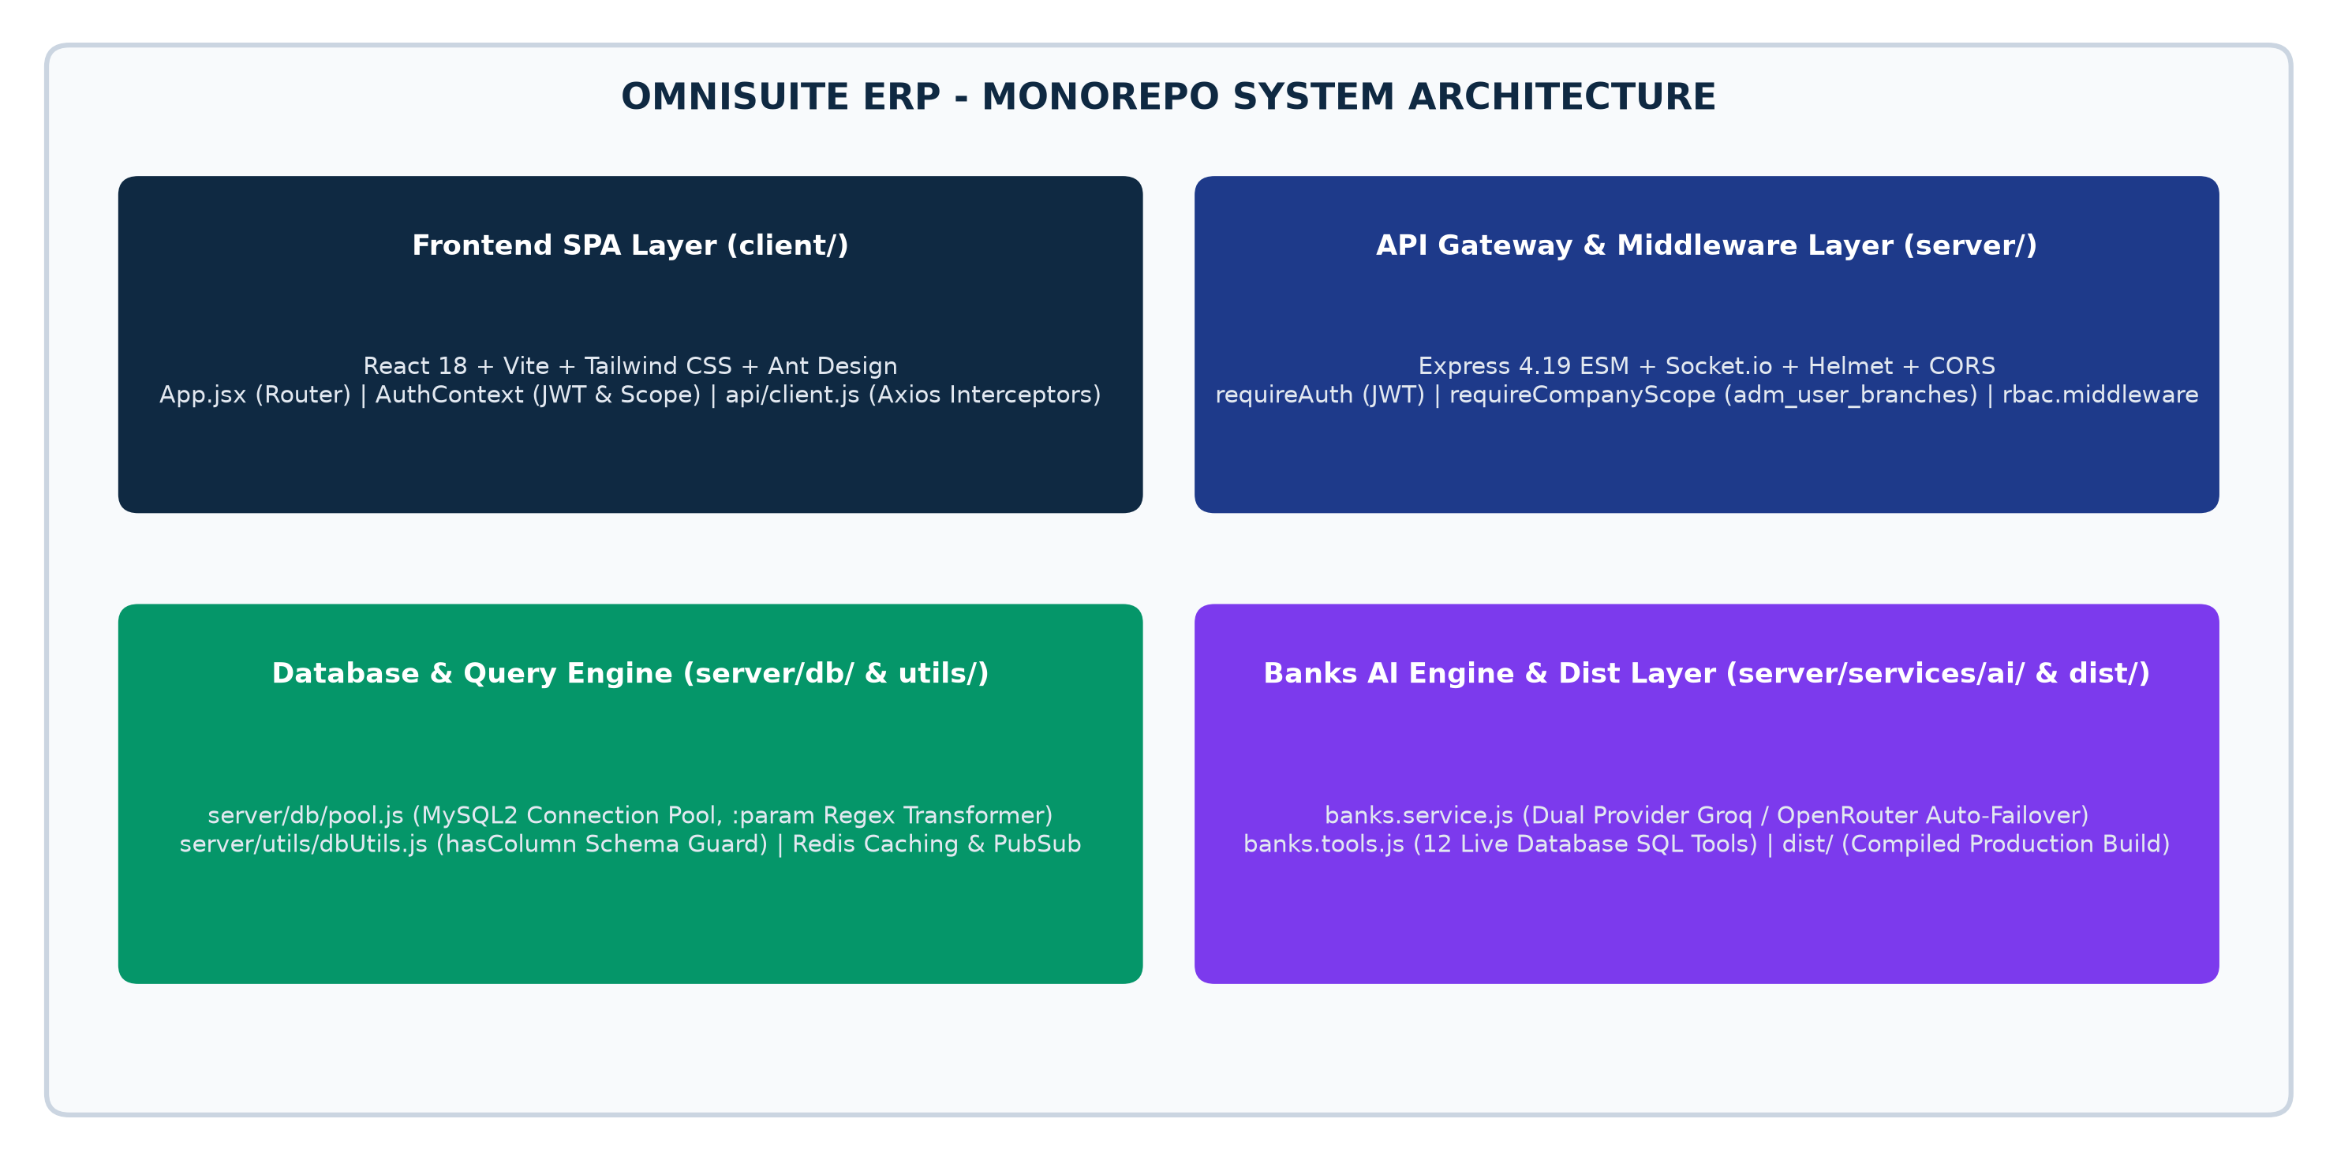
Figure 1.1: OmniSuite ERP Monorepo Architectural Structure & Layered Components

1.2 The 3-Tier Monorepo Anatomy
OmniSuite is structured as a cohesive JavaScript monorepo organized into three primary operational tiers:
Monorepo Tier | Directory | Core Technologies | Primary Architectural Responsibility
1. Client SPA Tier | client/ | React 18, Vite, Tailwind CSS, Ant Design, Lucide Icons, Axios | Single Page Application rendering responsive UI, local caching, client-side routing, and state management.
2. Server API Tier | server/ | Node.js (ESM), Express 4.19, Socket.io, Helmet, CORS, JWT | RESTful API Gateway executing business logic, multi-tenant scoping, RBAC enforcement, and background jobs.
3. Data Tier | server/db/ | MySQL2 Pool (ACID Compliant), Redis (Sessions & Caching) | Relational persistence with custom named parameter transformer (:param) and schema guard (hasColumn).
4. Distribution Tier | dist/ | Compiled Node.js Server + dist/public/ SPA Static Assets | Production distribution bundle optimized for Plesk Passenger / PM2 deployment.

1.3 Technology Stack Reference
Technology | Role / Layer | Codebase Location | Why OmniSuite Uses It
React 18.2 | Frontend Framework | client/src/ | Component-driven reactive UI rendering with Fast Refresh.
Vite 5.x | Build Tool & Bundler | client/vite.config.js | Sub-second HMR development server and optimized Rollup builds.
Tailwind CSS 3.x | Styling Engine | client/tailwind.config.js | Utility-first design system with unified brand palette (brand-900).
Node.js 20+ (ESM) | Backend Runtime | server/package.json | Native ES Modules ('import/export') runtime for all backend services.
Express 4.19 | Web Application Framework | server/index.js | RESTful routing, middleware pipeline, and static file serving.
MySQL2 / MySQL 8 | Relational Database | server/db/pool.js | ACID-compliant relational store with connection pooling and transactions.
Redis 7.x | In-Memory Cache & PubSub | server/services/redis.service.js | High-speed session storage, rate limiting, and real-time event broadcasting.
Groq / OpenRouter | AI LLM Inference | server/services/ai/banks.service.js | Dual-provider Banks AI engine with automatic failover (stealth/ox-alpha).

PART II: System Architecture & Core Pipelines
This section breaks down the end-to-end request lifecycle, authentication pipeline, multi-tenant scoping mechanisms, and database query engine.

2.1 End-to-End Request / Response Lifecycle
Every client interaction follows a predictable, highly optimized 6-stage lifecycle:
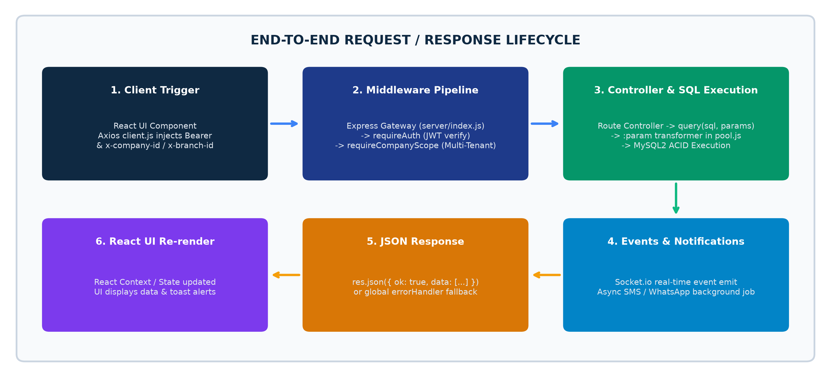
Figure 2.1: Full-Stack Request / Response Lifecycle Trace

2.2 Authentication & Multi-Tenant Scoping Pipeline
OmniSuite enforces multi-company and multi-branch data isolation at the middleware layer before any controller logic executes:
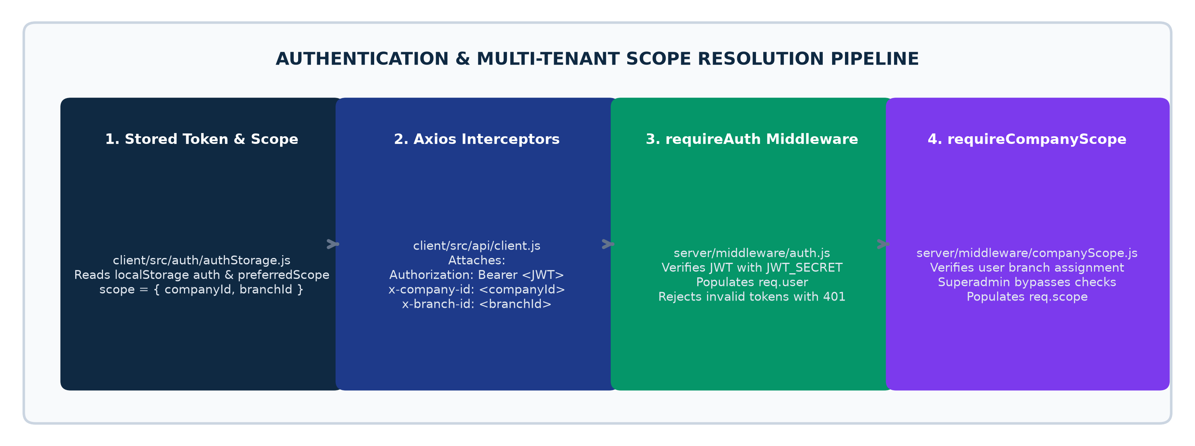
Figure 2.2: Authentication & Multi-Branch Tenant Scoping Resolution Flow
// server/middleware/companyScope.js
export async function requireCompanyScope(req, res, next) {
const companyId = req.headers['x-company-id'] || req.user?.company_id || 1;
const branchId = req.headers['x-branch-id'] || req.user?.branch_id || null;
// Super Admin (id=1 or isSuperAdmin=true) has global bypass
if (req.user?.id === 1 || req.user?.is_super_admin) {
req.scope = { companyId: Number(companyId), branchId: branchId ? Number(branchId) : null, isSuperAdmin: true };
return next();
}
// Validate user branch assignment in adm_user_branches
const [allowed] = await query(
`SELECT branch_id FROM adm_user_branches WHERE user_id = :userId AND company_id = :companyId`,
{ userId: req.user.id, companyId }
);
req.scope = { companyId: Number(companyId), branchId: Number(branchId), isSuperAdmin: false };
next();
}
Code Listing: Multi-Tenant Company & Branch Scoping Middleware (server/middleware/companyScope.js)

2.3 Database Engine: Named Parameters & Schema Guards
OmniSuite avoids heavy ORM overhead while guaranteeing SQL injection immunity through its custom named parameter transformer:
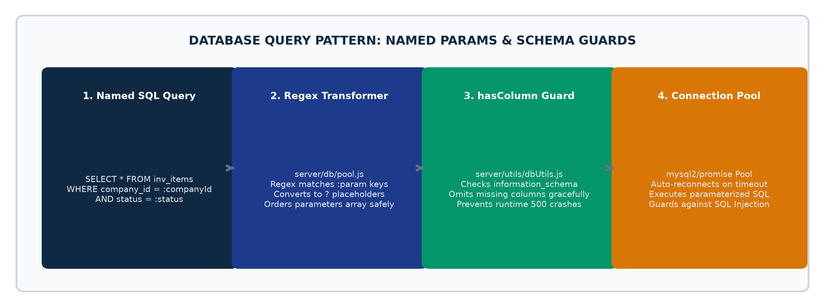
Figure 2.3: Database Named Parameter Parsing & Schema Guard Architecture
// server/db/pool.js - Named Parameter Query Transformer
export async function query(sql, params = {}) {
// Matches :paramName in SQL string and replaces with ?
const paramNames = [];
const transformedSql = sql.replace(/:([a-zA-Z0-9_]+)/g, (match, paramName) => {
paramNames.push(paramName);
return '?';
});
// Maps values in the exact positional order required by mysql2
const values = paramNames.map(name => params[name] !== undefined ? params[name] : null);
const [rows] = await pool.execute(transformedSql, values);
return rows;
}
Code Listing: Named Parameter SQL Transformer (server/db/pool.js)

PART III: Codebase Map & 'Where Do I Find This?' Guide
This directory map allows developers to immediately pinpoint the exact file, route, or component they need to modify:
Task / Feature Area | Frontend Location | Backend Route File | Controller / Service File
Modify User Login / JWT Auth | client/src/auth/AuthContext.jsx | server/routes/auth.routes.js | server/controllers/auth.controller.js
Add / Edit an ERP Page | client/src/pages/modules/<module>/ | client/src/App.jsx | client/src/data/modulesRegistry.js
Modify Left Module Sidebar | client/src/components/layout/Sidebar.jsx | client/src/data/modulesRegistry.js | client/src/context/PermissionContext.jsx
Add a New API Endpoint | server/routes/<module>.routes.js | server/controllers/<module>.controller.js | server/index.js (Mount route)
Execute Database Queries | server/db/pool.js (query()) | server/utils/dbUtils.js (hasColumn()) | server/config/database.js
Banks AI Assistant & Tools | client/src/components/ai/BanksAiModal.jsx | server/services/ai/banks.service.js | server/services/ai/banks.tools.js
POS Cashier Terminal & Billing | client/src/pages/modules/pos/POSTerminal.jsx | server/routes/pos.routes.js | server/controllers/pos.controller.js
Chart of Accounts & Vouchers | client/src/pages/modules/finance/ | server/routes/finance.routes.js | server/controllers/finance.controller.js
Item Master & Warehouses | client/src/pages/modules/inventory/ | server/routes/inventory.routes.js | server/controllers/inventory.controller.js
Purchasing & LPO Orders | client/src/pages/modules/purchase/ | server/routes/purchase.routes.js | server/controllers/purchase.controller.js
Commercial Sales & Invoices | client/src/pages/modules/sales/ | server/routes/sales.routes.js | server/controllers/sales.controller.js
Manufacturing & Work Orders | client/src/pages/modules/production/ | server/routes/production.routes.js | server/controllers/production.controller.js
HR Employees & Payroll | client/src/pages/modules/human-resources/ | server/routes/hr.routes.js | server/controllers/hr.controller.js
Transport & Fleet Waybills | client/src/pages/modules/transport/ | server/routes/transport.routes.js | server/controllers/transport.controller.js
Project WBS & Timesheets | client/src/pages/modules/project-management/ | server/routes/project.routes.js | server/controllers/project.controller.js
External SMS & WhatsApp Dispatch | server/utils/sms.js | server/utils/whatsapp.js | server/services/notification.service.js

PART IV: Complete 27-Module Technical Architecture
Every module in OmniSuite is decoupled with dedicated frontend views, backend routes, REST controllers, and relational database tables:
Module Name | Frontend Directory | Backend Route File | Primary Database Tables | Inter-Module Technical Dependencies
1. Administration | client/src/pages/modules/administration/ | server/routes/admin.routes.js | adm_companies, adm_branches, adm_users, adm_roles, adm_permissions | Foundational RBAC provider for all modules.
2. Finance & GL | client/src/pages/modules/finance/ | server/routes/finance.routes.js | fin_chart_of_accounts, fin_vouchers, fin_voucher_lines, fin_general_ledger | Receives financial postings from Sales, POS, Purchase, and Payroll.
3. Inventory | client/src/pages/modules/inventory/ | server/routes/inventory.routes.js | inv_items, inv_categories, inv_warehouses, inv_stock_balance, inv_stock_transfers | Provides stock balances to Sales, POS, Production, and Purchasing.
4. Purchasing | client/src/pages/modules/purchase/ | server/routes/purchase.routes.js | pur_requisitions, pur_rfqs, pur_orders, pur_goods_receipt_notes, pur_bills | Supplies incoming stock to Inventory and bills to Finance.
5. Sales (O2C) | client/src/pages/modules/sales/ | server/routes/sales.routes.js | sal_customers, sal_quotations, sal_orders, sal_deliveries, sal_invoices | Deducts stock from Inventory and posts receivables to Finance.
6. Point of Sale | client/src/pages/modules/pos/ | server/routes/pos.routes.js | pos_sessions, pos_terminals, pos_sales, pos_sale_lines, pos_payment_modes | Direct retail cash/MoMo billing, instant stock deduction, Z-Reports.
7. Human Resources | client/src/pages/modules/human-resources/ | server/routes/hr.routes.js | hr_employees, hr_departments, hr_attendance, hr_leaves, hr_payroll_runs | Maintains workforce master files and posts payroll expenses to Finance.
8. Production | client/src/pages/modules/production/ | server/routes/production.routes.js | prod_boms, prod_bom_items, prod_work_orders, prod_job_cards, prod_qc_logs | Consumes raw inventory and outputs finished goods to warehouse.
9. Project Mgmt | client/src/pages/modules/project-management/ | server/routes/project.routes.js | pm_projects, pm_wbs_tasks, pm_milestones, pm_timesheets, pm_expenses | Tracks project budgets, timesheets, and milestone billings.
10. Maintenance | client/src/pages/modules/maintenance/ | server/routes/maintenance.routes.js | maint_assets, maint_schedules, maint_job_orders, maint_spare_parts_used | Manages fixed asset preventative maintenance and breakdown job orders.
11. Transport/Fleet | client/src/pages/modules/transport/ | server/routes/transport.routes.js | trn_vehicles, trn_drivers, trn_deliveries, trn_waybills, trn_fuel_logs | Manages logistics waybills, vehicle dispatches, and delivery POD tracking.
12. Service Mgmt | client/src/pages/modules/service-invoicing/ | server/routes/service.routes.js | srv_contracts, srv_tickets, srv_work_orders, srv_invoices | Manages customer service contracts, technician tickets, and service billing.
13. Visitor Mgmt | client/src/pages/modules/visitor-management/ | server/routes/visitor.routes.js | vis_visitors, vis_pre_registrations, vis_logs, vis_badges | Security gate visitor pre-registration, badge issuance, and arrival alerts.
14. BI Dashboards | client/src/pages/modules/business-intelligence/ | server/routes/bi.routes.js | Cross-module aggregation queries against sales, inventory, finance, and HR | Executive analytics, KPI scorecards, trend charts, and data explorer.
15. Banks AI Copilot | client/src/components/ai/BanksAiModal.jsx | server/routes/ai.routes.js | Dynamic query execution via server/services/ai/banks.tools.js | Natural language ERP query interface with multi-turn database tools.

PART V: Developer Onboarding & Step-by-Step Tutorials

5.1 Three-Day Onboarding Roadmap for New Developers
Onboarding Day | Target Objectives | Key Engineering Tasks to Execute
Day 1: System Blueprint & Local Run | Understand monorepo, clone repository, configure local environment, and verify frontend & backend running. | 1. Read 'OmniSuite in 15 Minutes'.  2. Copy .env.example to .env in both client/ and server/.  3. Run npm run dev and log into the application with admin credentials.  4. Explore universal navigation and branch switching.
Day 2: Architecture & Code Traces | Deep dive into authentication, multi-tenant scoping, database named parameters, and request lifecycles. | 1. Trace a complete request in DevTools (e.g. Sales > Invoices).  2. Inspect server/middleware/auth.js and companyScope.js.  3. Explore server/db/pool.js and execute a sample query.  4. Review client/src/data/modulesRegistry.js.
Day 3: Building & Submitting Code | Create a small feature or bug fix, run tests, follow Git branching conventions, and submit a Pull Request. | 1. Follow 'How to Add a New Feature' guide below.  2. Create a database migration or test table.  3. Build backend route/controller and connect React UI component.  4. Commit with descriptive commit message and verify build.

5.2 Step-by-Step Tutorial: How to Add a New Feature to OmniSuite
Follow this standard 7-step engineering pattern whenever adding a new feature or sub-module:
// Step 1: Create Database Table (MySQL)
CREATE TABLE IF NOT EXISTS sal_loyalty_rewards (
id INT AUTO_INCREMENT PRIMARY KEY,
company_id INT NOT NULL,
branch_id INT DEFAULT NULL,
customer_id INT NOT NULL,
reward_points INT DEFAULT 0,
tier_level VARCHAR(50) DEFAULT 'BRONZE',
created_at TIMESTAMP DEFAULT CURRENT_TIMESTAMP,
INDEX idx_comp_cust (company_id, customer_id)
) ENGINE=InnoDB DEFAULT CHARSET=utf8mb4;
// Step 2: Create Backend Route & Controller (server/routes/loyalty.routes.js)
import { Router } from 'express';
import { requireAuth } from '../middleware/auth.js';
import { requireCompanyScope } from '../middleware/companyScope.js';
import { query } from '../db/pool.js';
const router = Router();
router.use(requireAuth, requireCompanyScope);
router.get('/rewards', async (req, res, next) => {
try {
const rewards = await query(
`SELECT r.*, c.customer_name
FROM sal_loyalty_rewards r
LEFT JOIN sal_customers c ON r.customer_id = c.id
WHERE r.company_id = :companyId`,
req.scope
);
res.json({ ok: true, data: rewards });
} catch (err) { next(err); }
});
export default router;
// Step 3: Mount Route in server/index.js
// import loyaltyRoutes from './routes/loyalty.routes.js';
// app.use('/api/loyalty', loyaltyRoutes);
// Step 4: Register Feature in client/src/data/modulesRegistry.js
// { key: "loyalty-rewards", label: "Loyalty Rewards", type: "feature" }
// Step 5: Build Frontend View & Connect Axios API (client/src/pages/modules/sales/LoyaltyRewardsPage.jsx)
// const res = await api.get('/loyalty/rewards');
Code Listing: Standard 5-Tier Pattern for Adding New Features to OmniSuite

PART VI: Operations, Diagnostics & Security Architecture

6.1 'The System Is Broken — Where Do I Look First?' Diagnostic Guide
Follow this rigorous 4-step diagnostic sequence whenever troubleshooting an error in development or production:
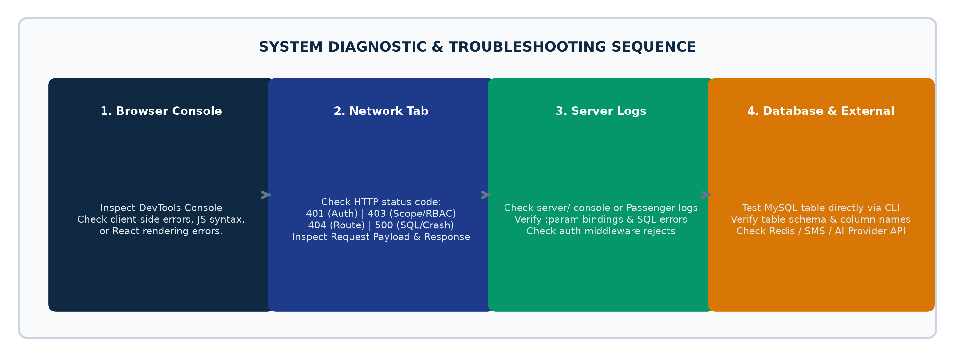
Figure 6.1: Systematic 4-Stage Developer Diagnostic & Troubleshooting Sequence

6.2 Diagnostic Troubleshooting Matrix
Symptom / Error Code | Root Cause Analysis | Developer Fix & Remediation Action
HTTP 401 Unauthorized | Expired JWT token or missing Authorization Bearer header. | Check client/src/api/client.js interceptors. Verify token exists in localStorage. Log out and log back in.
HTTP 403 Forbidden | User role lacks required module permissions or branch access. | Inspect server/middleware/companyScope.js and rbac.middleware.js. Verify role in adm_roles and adm_user_branches.
HTTP 500 Internal Server Error | Uncaught backend exception, syntax error, or database SQL crash. | Check server console / Passenger logs. Inspect :param bindings in server/db/pool.js and verify table columns.
CORS Origin Blocked | Client domain is not present in server/index.js allowed origins list. | Add client origin to CORS_ALLOWED_ORIGINS in server/.env or server/index.js.
MySQL Connection Refused | MySQL service stopped or incorrect port / credentials in .env. | Check DB_HOST, DB_USER, DB_PASSWORD, DB_NAME in server/.env. Verify MySQL daemon is active on port 3306.
Banks AI API 429 Quota Exceeded | Groq Cloud free-tier token rate limits exceeded during analysis. | System automatically falls back to OpenRouter stealth/ox-alpha. Verify OpenRouter key in General Settings.

6.3 Developer Quick Reference & Cheat Sheet
Operation | Command Line / File Location | Description & Usage
Start Development Monorepo | npm run dev (from root or client/ & server/) | Launches Vite frontend (port 5173) and Express backend (port 5000).
Build Frontend Production Bundle | npm run build (in client/) | Compiles optimized production bundle into client/dist/.
Sync Client Build to Server Dist | Copy-Item -Path client/dist/* -Destination dist/public/ -Recurse -Force | Synchronizes compiled assets to production Express static server.
Restart Plesk Passenger Server | touch tmp/restart.txt (in server root) | Instructs Phusion Passenger to reload Node.js process gracefully.
Test Banks AI Connection | node scratch/debug_tool_loop.js | Executes full multi-turn tool calling verification against live database.

