OMNISUITE ERP
ENTERPRISE USER MANUAL & SOP GUIDE
Complete Standard Operating Procedures, Field References, Business Process Maps, Role Responsibilities & Troubleshooting Handbook for All Business Users

System Name | OmniSuite Enterprise Resource Planning (ERP)
Documentation Version | v4.5 Enterprise Production Release
Applicable Release Date | August 2026
Prepared For | Enterprise Business Users, Operations Staff, Storekeepers, Cashiers, Accountants & Managers
Document Classification | Official Corporate Standard Operating Procedure (SOP)
Engine & Copilot | Integrated with Banks AI Natural Language Intelligence

Document Control & Release Information
This document serves as the authoritative operational manual and training reference for the OmniSuite ERP platform. All employees, department supervisors, warehouse personnel, cashiers, accountants, and system administrators must follow the documented standard operating procedures to maintain transaction integrity, statutory tax compliance, and audit readiness.
Version | Release Date | Primary Changes & Scope | Author / Approver
v1.0 | 15/01/2026 | Initial core ERP baseline manual (Sales, Inventory, Finance) | Technical Writing Team
v2.5 | 10/04/2026 | Added POS Multi-Tender, Manufacturing BOM & HR Payroll | QA & Business Systems
v3.8 | 01/07/2026 | Added Project Management, Logistics Waybills & Visitor Module | Operations Lead
v4.5 | 24/08/2026 | Unified Master Manual: Comprehensive field guides, Banks AI integration, dual-provider failover, error troubleshooting, and step-by-step procedures across all 27 ERP modules | Enterprise Architecture Board

Master Table of Contents
Section Number & Title | Operational Scope & Key Topics Covered
Section 1: Executive Introduction & System Architecture | Multi-tenant scoping, core tiers, Banks AI intelligence
Section 2: Getting Started & Quick-Start Guide | Login, OTP verification, UI navigation, switching branches
Section 3: User Roles, Permissions & Responsibility Matrix | Role definitions, segregation of duties, delegation
Section 4: System-Wide Navigation & UI Conventions | Universal search, data grids, column filters, Excel exports
Section 5: Administration & System Configuration | Companies, branches, user accounts, workflow rules, backup
Section 6: Finance & Accounting Module | COA, Vouchers (JV, PV, RV, CV), GL, P&L, Balance Sheet, Taxes
Section 7: Inventory & Stores Management | Item master, UOM, multi-warehouse bins, stock transfers, audits
Section 8: Purchasing & Procurement (P2P) | Requisitions, RFQs, quotes, LPO/IPO, GRN, 3-way matching
Section 9: Sales & Order Management (O2C) | Price lists, quotes, sales orders, delivery notes, tax invoices
Section 10: Point of Sale (POS) Module | Shift open float, barcode scanning, multi-tender, Z-Report close
Section 11: Production & Manufacturing | Bill of Materials (BOM), Work Orders, Job Cards, QC inspections
Section 12: Project Management | WBS tasks, Kanban boards, milestones, timesheets, job costing
Section 13: Human Resources & Payroll | Employee master, attendance, leave approvals, automated PAYE/SSNIT
Section 14: Maintenance & Asset Management | Fixed asset register, preventive schedules, repair job orders
Section 15: Transport & Fleet Logistics | Vehicles, drivers, digital waybills, fuel tracking, delivery POD
Section 16: Service Management & Invoicing | Service contracts, ticketing, work orders, service invoices
Section 17: Visitor Management & Security | Pre-registration, gate check-in, badge print, host arrival alert
Section 18: Business Intelligence (BI) & Dashboards | Executive KPIs, revenue trends, inventory aging, data explorer
Section 19: Banks AI Enterprise Copilot | Natural language queries, real-time database grounding, tools
Section 20: Platform Collaboration & Workflows | Approval rules engine, document review, social feed, alerts
Section 21: End-to-End Business Workflows | Complete Procure-to-Pay, Order-to-Cash, and Production walks
Section 22: Error Handling & Troubleshooting Guide | Common validation errors, stock locks, posting errors & fixes
Section 23: Common User Mistakes to Avoid | Key operational traps, duplicate entry prevention, tax errors
Section 24: Enterprise ERP Glossary | 50+ detailed definitions of business, accounting & ERP terms
Section 25: Appendices & Standard Tax Formulas | Ghana GRA tax calculation models, default account mappings

Section 1: Executive Introduction & System Architecture
OmniSuite ERP is a modern, full-lifecycle Enterprise Resource Planning suite designed to streamline multi-company and multi-branch operations. The platform integrates end-to-end commercial operations—including procurement, inventory control, point of sale, commercial sales, manufacturing, project delivery, transport logistics, human resources, and double-entry financial accounting—into a single unified real-time database.
The application operates on a 3-tier architecture delivering high reliability, sub-second query performance, strict branch data isolation, and automated failover capabilities:
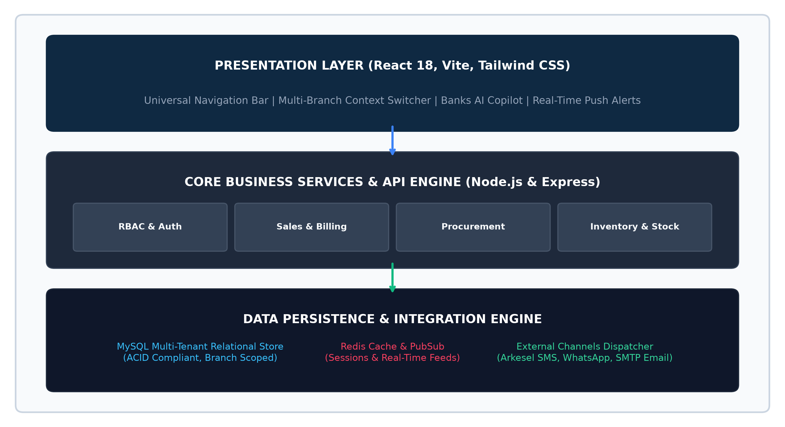
Figure 1.1: OmniSuite ERP Multi-Tier System Architecture & Data Flow
[DATA SECURITY & SCOPING NOTE]
OmniSuite ERP enforces strict Multi-Company and Multi-Branch data scoping. Users logged into Branch A will only see stock balances, sales orders, and invoices associated with Branch A, unless assigned Super Administrator or Multi-Branch Executive permissions in Role Setup.

Section 2: Getting Started & Quick-Start Guide
This section provides new employees with immediate instructions on how to access the ERP, navigate the interface, manage notifications, and execute their daily duties without delays.

2.1 Logging In & Multi-Branch Authentication
Step 1: Access Application URL — Open Google Chrome, Microsoft Edge, or Mozilla Firefox and navigate to your organization's designated OmniSuite URL (e.g., https://erp.yourcompany.com).
Step 2: Enter Credentials — Type your assigned official email address or username and password into the login dialog. If Two-Factor Authentication (2FA) is enabled, enter the 6-digit OTP sent to your registered mobile device.
Step 3: Select Active Company & Branch — From the top-right context switcher, select the primary operating branch where you will be performing transactions today (e.g., 'Accra Central Branch' or 'Tema Warehouse').
System Result: The system loads all inventory, pricing, tax rules, and document sequences tied to that specific operating unit.

2.2 Universal AppShell Navigation
The OmniSuite interface is organized into five key persistent UI zones:
UI Zone | Location | Primary Purpose & User Action
Top Navigation Bar | Top of Screen | Displays Active Company, Branch Selector, Universal Search bar, Push Notification bell, Banks AI launcher, and User Profile menu.
Left Module Sidebar | Left Screen Margin | Provides 1-click access to all authorized functional modules (Sales, Inventory, Purchase, Finance, HR, POS, Production, etc.).
Breadcrumb Trail | Top-Left of Content | Shows the exact operational path (e.g., Sales > Invoices > Create Invoice) allowing quick 1-click back navigation.
Active Workspace Grid | Center of Screen | Displays searchable data tables, transaction forms, statistical KPI cards, and interactive charts.
Action Bar / Modal Drawer | Bottom & Right | Contains primary transaction buttons ('Save Draft', 'Submit for Approval', 'Post to Ledger', 'Print Tax Invoice').

Section 3: User Roles & Responsibility Matrix
OmniSuite ERP uses Role-Based Access Control (RBAC) to ensure strict segregation of duties (SoD) and safeguard commercial data integrity. Below is the operational responsibility matrix across all core business roles:
Enterprise Role | Department | Core System Responsibilities & Transaction Scope
Super Administrator | IT / Executive | Full system configuration, user provisioning, global company parameters, custom workflow approvals, and database backups.
Branch Manager | Executive Management | Branch-level dashboard review, purchase requisition approvals, expense authorization, and sales discount overrides.
Finance Officer | Accounts & Finance | General ledger postings, journal vouchers, bank reconciliations, tax returns (VAT/NHIL/GETFund), and financial statements.
Procurement Officer | Purchasing Department | Supplier vendor management, RFQ floating, supplier quotation analysis, and Local Purchase Order (LPO) creation.
Warehouse Storekeeper | Inventory & Logistics | Goods Receipt Note (GRN) acceptance, bin transfers, stock issue, cycle counting, and scrap adjustments.
Sales Representative | Commercial Sales | Customer master creation, quotation generation, sales order entry, and delivery note tracking.
POS Cashier | Retail Outlets | POS register shift opening with float, barcode scanning, multi-tender billing, and daily Z-Report closing.
Production Supervisor | Manufacturing Floor | Bill of Materials (BOM) setup, Work Order scheduling, Job Card operator assignment, and finished goods QC.
Project Manager | Project Engineering | WBS task scheduling, milestone tracking, timesheet approval, and project budget-vs-actual cost monitoring.
HR & Payroll Officer | Human Resources | Employee files, biometric attendance verification, leave request approval, and automated PAYE/SSNIT payroll runs.
Fleet & Logistics Officer | Logistics Department | Vehicle assignment, driver trip dispatches, digital waybills, and fuel consumption auditing.

Section 4: Navigation, Data Grids & Export Conventions
Every module in OmniSuite ERP follows consistent user-interface conventions. Mastering these standard controls enables users to operate any screen effortlessly:
UI Feature | How to Use | Operational Benefit & Shortcut
Universal Search | Click the search icon in the top header or press Ctrl + K. | Instantly search across customers, suppliers, item codes, invoice numbers, or work orders.
Column Sorting | Click any table column header (e.g., 'Date', 'Amount', 'Status'). | Toggles ascending (A-Z, 0-9) and descending (Z-A, 9-0) order across all records.
Multi-Filter Drawer | Click the 'Filter' button above any data grid. | Filter by Date Range, Branch, Status, Customer/Vendor, or Payment Method simultaneously.
Export to Excel / CSV | Click the 'Export' button located at top-right of any table. | Downloads clean, formatted spreadsheets suitable for external reporting or auditing.
Print / PDF Generator | Click the 'Print' or 'PDF' button on any approved transaction. | Generates official branded tax documents with QR codes, company logo, and digital signature lines.
Bulk Action Checkbox | Select the checkbox on multiple table rows and click 'Actions'. | Perform batch approvals, batch printings, or bulk status updates in seconds.

Section 5: Administration & System Configuration
The Administration module is restricted to authorized System Administrators and IT personnel. It governs system security, corporate hierarchies, user permissions, and multi-tier approval rules.

5.1 Company & Branch Master Setup
OmniSuite supports hierarchical corporate structures where a parent holding company oversees multiple operating entities or retail branches:
Configuration Field | Description | Required? | Validation Rule / Example
Company Name | Official registered corporate legal entity name. | Yes | e.g., 'OmniSuite Manufacturing Ltd'
TIN / VAT Registration | National Tax Identification Number for statutory GRA compliance. | Yes | e.g., 'C0012345678' (Printed on official invoices)
Base Operating Currency | Primary currency used for general ledger financial statements. | Yes | Select 'GHS (Ghana Cedi)' or 'USD ($)'
Branch Code & Name | Unique branch identifier and descriptive location. | Yes | e.g., 'ACC-01' -> 'Accra Central Showroom'
Physical Address & Phone | Official location, email, and phone contact. | Yes | Appears on receipt headers, invoices, and waybills.

5.2 User Management & Role Permissions
Step 1: Navigate to Users — Go to Administration > Users & Roles > User Management.
Step 2: Click 'Add New User' — Enter the employee's Full Name, Corporate Email, Mobile Number, and Primary Department.
Step 3: Assign Role & Branches — Select the user's primary functional role and check all branches the employee is authorized to access.
Step 4: Set Approval Limits — Specify maximum monetary approval limits for purchase orders or invoice discounts where applicable.
Step 5: Save & Send Invite — Click 'Save & Send Activation Email'. The user receives a secure link to create their password.

Section 6: Finance & Accounting Module
The Finance module is the economic core of OmniSuite ERP. It implements an automated, double-entry general ledger that records real-time financial postings from commercial sales, procurement bills, payroll disbursements, and retail POS shifts.

6.1 Chart of Accounts (COA) Structure
OmniSuite utilizes a 5-tier standard accounting structure:
Account Class | Code Range | Normal Balance | Financial Statement Mapping | Example Accounts
1000 - Assets | 1000 - 1999 | Debit (Dr) | Balance Sheet (Current & Non-Current) | Cash on Hand, Stanbic Bank, Accounts Receivable, Inventory
2000 - Liabilities | 2000 - 2999 | Credit (Cr) | Balance Sheet (Current & Long-Term) | Accounts Payable, GRA VAT Output Payable, Accrued Wages
3000 - Equity | 3000 - 3999 | Credit (Cr) | Balance Sheet (Owner's Equity) | Share Capital, Retained Earnings, Owner Drawings
4000 - Revenue | 4000 - 4999 | Credit (Cr) | Profit & Loss (Income Statement) | Commercial Sales, Retail POS Revenue, Service Income
5000 - Cost of Sales | 5000 - 5999 | Debit (Dr) | Profit & Loss (Gross Profit) | Cost of Goods Sold (COGS), Direct Material Costs
6000 - Expenses | 6000 - 6999 | Debit (Dr) | Profit & Loss (Operating Expenses) | Salaries & Wages, Facility Rent, Vehicle Fuel, Electricity

6.2 Voucher Types & Standard Postings
All financial movements must be executed through approved accounting vouchers:
Voucher Type | Code | When to Use | Accounting Entry Rule
Journal Voucher | JV | Manual adjustments, depreciation, accruals, and inter-account corrections. | Debit destination account, Credit source account (Total Dr = Total Cr).
Payment Voucher | PV | Supplier payments, staff salary disbursements, and utility bills. | Debit Accounts Payable / Expense Account, Credit Bank / Cash Account.
Receipt Voucher | RV | Customer debt collections, capital injections, and other cash receipts. | Debit Bank / Cash Account, Credit Accounts Receivable / Other Income.
Contra Voucher | CV | Internal cash movements between company bank accounts or petty cash. | Debit Destination Bank/Cash, Credit Source Bank/Cash.

6.3 Statutory Tax Engine & Automated Calculations
OmniSuite includes an automated Ghana Revenue Authority (GRA) tax computation engine configured for all commercial and retail invoices:
Statutory Tax Component | Rate | Tax Base / Calculation Formula | Accounting Ledger Account
NHIL (National Health Insurance) | 2.50% | Tax Base = Goods Net Selling Price | 2110 - GRA NHIL Output Tax Payable
GETFund (Education Trust Fund) | 2.50% | Tax Base = Goods Net Selling Price | 2120 - GRA GETFund Output Tax Payable
COVID-19 Health Recovery Levy | 1.00% | Tax Base = Goods Net Selling Price | 2130 - GRA COVID-19 Levy Output Payable
Standard VAT (Value Added Tax) | 15.00% | Tax Base = Net Price + NHIL + GETFund + COVID | 2140 - GRA Standard VAT Output Payable

Section 7: Inventory & Stores Management
The Inventory module ensures complete real-time tracking of raw materials, work-in-progress (WIP), and finished goods across all warehouses and retail storage bins.

7.1 Item Master Setup & Product Catalog
Field Name | Description | Required? | Business Rules & Guidance
Item Code / SKU | Unique system alphanumeric product identifier. | Yes | Auto-generated or entered manually (e.g., 'ITM-00428').
Item Name & Description | Full trade name of the product or raw material. | Yes | e.g., 'Portland Cement 50kg Grade 42.5R'.
Product Category | Classification group for inventory reporting. | Yes | Select from Setup (e.g., 'Raw Materials', 'Finished Goods').
Base Unit of Measure (UOM) | Standard unit for stocking and billing. | Yes | e.g., 'PCS', 'KG', 'BAG', 'BOX', 'LTR', 'TON'.
Cost Price (Standard/Average) | Purchase acquisition or manufacturing cost. | Yes | Used for inventory valuation and Cost of Goods Sold (COGS).
Default Selling Price | Base retail selling price before tax and discounts. | Yes | Populates automatically on Quotations and POS terminals.
Reorder Level / Min Stock | Threshold that triggers low-stock alerts. | Yes | e.g., '20'. System alerts storekeeper when balance <= 20.

7.2 Warehouse Stock Transfers & Dispatch Procedures
Step 1: Initiate Transfer Request — Go to Inventory > Stock Transfers > Create Transfer. Select the Source Warehouse and Destination Warehouse.
Step 2: Select Items & Quantities — Add line items, specify transfer quantities, and verify that the source warehouse has sufficient available stock.
Step 3: Dispatch & Issue Waybill — Click 'Dispatch Stock'. The items enter 'In-Transit' status and are deducted from Source Available Stock.
Step 4: Destination Physical Verification — Upon arrival, the receiving storekeeper inspects physical goods, enters received quantities, and clicks 'Accept Transfer'.
Step 5: Stock Acceptance & Ledger Posting — Stock is officially added to Destination Available Balance, and any transit discrepancies are flagged for supervisor review.
System Result: Stock movement completed with full digital audit trail.

Section 8: Purchasing & Procurement (P2P)
The Procurement module manages the complete Procure-to-Pay (P2P) cycle, ensuring that all organization spending is authorized, budget-checked, and matched against received physical goods.
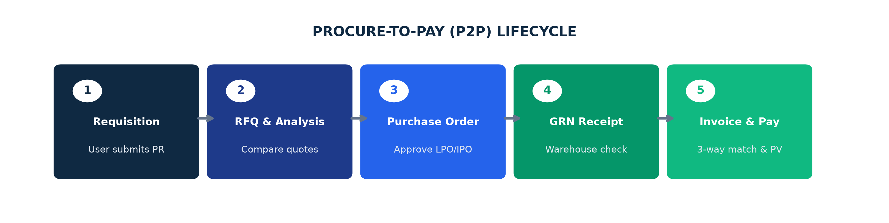
Figure 8.1: Complete End-to-End Procure-to-Pay (P2P) Operational Lifecycle

8.1 How to Create and Approve a Purchase Requisition (PR)
Step 1: Open PR Form — Navigate to Purchasing > Purchase Requisitions > Create New Requisition.
Step 2: Select Requesting Department — Choose your department (e.g., 'Production', 'Maintenance', 'IT') and specify the required delivery date.
Step 3: Add Required Items — Search and select item codes, enter quantities required, and state the business justification.
Step 4: Submit for Manager Approval — Click 'Submit Requisition'. The document status moves to 'Pending Department Approval'.
Step 5: Department Head Approval — The authorized supervisor receives a notification, reviews budget availability, and clicks 'Approve'.
System Result: The approved PR moves to Procurement for LPO issuance.

8.2 Goods Receipt Note (GRN) & 3-Way Invoice Matching
To protect against supplier overbilling or missing items, OmniSuite enforces strict 3-Way Matching before accounts payable can issue payment:
P2P Document | Originating Role | Key Verification Point | System Validation
1. Purchase Order (LPO) | Procurement Officer | Contracted items, agreed unit prices, payment terms, and delivery timeline. | Approved commercial authorization.
2. Goods Receipt Note (GRN) | Warehouse Storekeeper | Physical quantities received, batch numbers, and damaged goods inspection. | Stock enters warehouse inventory.
3. Supplier Purchase Bill | Finance / Accounts | Supplier commercial invoice amounts, tax breakdowns, and credit terms. | Validated against PO and GRN quantities.

Section 9: Sales & Order Management (O2C)
The Sales module governs the entire Order-to-Cash (O2C) workflow, converting prospect inquiries into quotations, confirmed sales orders, warehouse dispatch deliveries, and posted tax invoices.
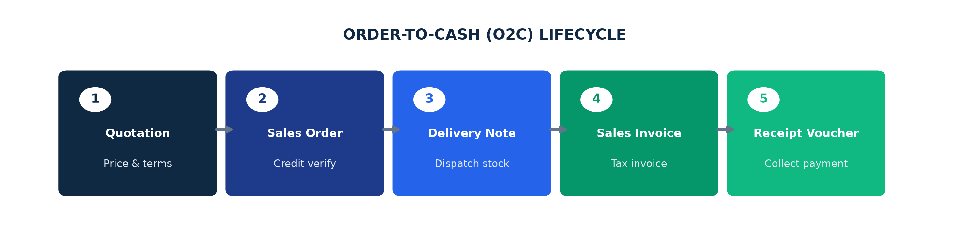
Figure 9.1: Complete Order-to-Cash (O2C) Commercial Sales Workflow

9.1 Step-by-Step Sales Order Processing
Step 1: Issue Official Quotation — Go to Sales > Quotations > Create Quotation. Select Customer, price list, and items. Send PDF quote to client.
Step 2: Convert to Sales Order — Upon customer approval, click 'Convert to Sales Order'. The system validates customer credit limit and stock availability.
Step 3: Generate Delivery Dispatch Note — Click 'Create Delivery Note'. Storekeeper picks goods and confirms dispatch with delivery driver.
Step 4: Issue Official Tax Invoice — Generate official sales invoice from delivery. System calculates statutory GRA taxes and posts revenue to General Ledger.
Step 5: Record Customer Payment — Upon receipt of funds via bank transfer, cheque, or cash, record a Receipt Voucher (RV) to clear customer accounts receivable.

Section 10: Retail Point of Sale (POS) Module
The POS module is optimized for high-volume retail environments, supermarket counters, and showroom cashier terminals, supporting rapid barcode scanning, hold-cart capabilities, and multi-tender settlements.
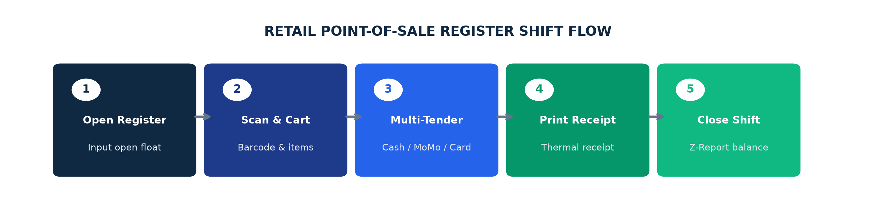
Figure 10.1: Cashier Shift Opening, Multi-Tender Checkout, and Z-Report Closing

10.1 Daily Cashier Shift Procedures
Step 1: Open POS Terminal Shift — Launch POS Terminal. Enter your Cashier PIN and input your Opening Float Cash amount (e.g., GH₵ 200.00).
Step 2: Scan or Search Items — Scan product barcodes or click visual category tiles. Adjust quantities or apply authorized cashier discounts.
Step 3: Select Payment Tender — Click 'Checkout'. Choose from Cash, Mobile Money (MoMo), Visa/Mastercard, or Split Tender (e.g., GH₵ 50 Cash + GH₵ 100 MoMo).
Step 4: Print Receipt & Complete Sale — Click 'Complete Sale'. Thermal receipt prints automatically and cash drawer triggers open.
Step 5: End of Shift Z-Report Reconciliation — At shift end, click 'Close Register'. Perform blind cash count. System prints official Z-Report comparing expected cash with physical cash.
System Result: Shift closed and sales figures posted to Finance.

Section 11: Production & Manufacturing
The Production module enables shop-floor scheduling, multi-level Bill of Materials (BOM) management, material requisitioning, machine routing, and finished goods quality inspections.
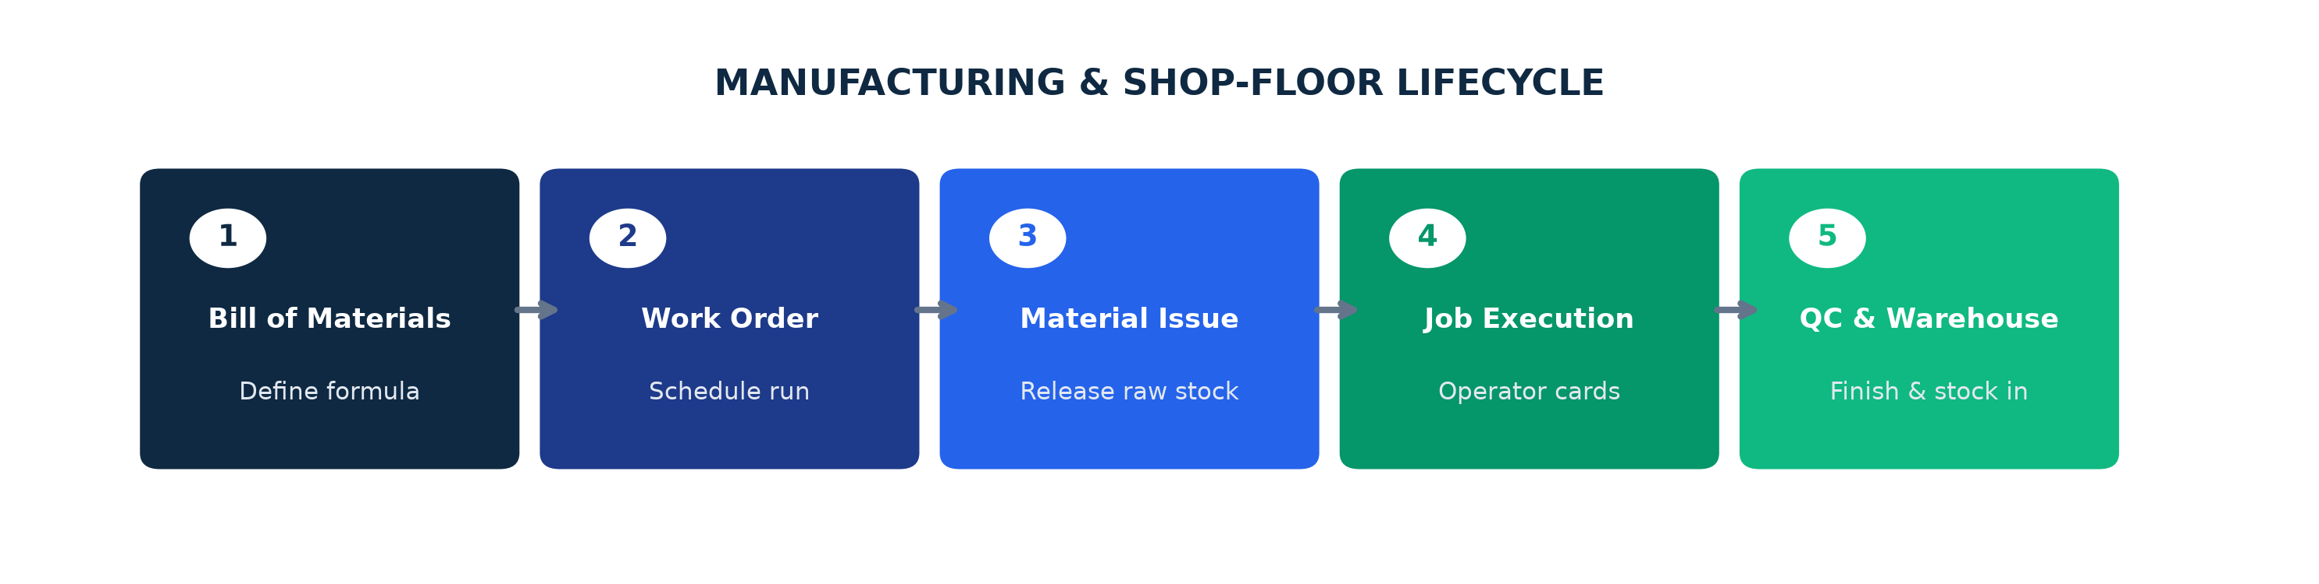
Figure 11.1: Bill of Materials, Work Order Issuance, and Quality Control Workflow

11.1 Bill of Materials (BOM) Definition
A BOM defines the exact recipe and standard input quantities required to manufacture 1 unit of finished product:
BOM Component | Item Type | Standard Quantity | Scrap Allowance % | Cost Allocation
Clinker Ore (Raw) | Raw Material | 850.00 KG | 2.00% | Direct Raw Material Cost
Gypsum Mineral | Additive | 50.00 KG | 1.00% | Direct Material Cost
Kraft Paper Sack | Packaging | 20.00 PCS | 0.50% | Packaging Material Cost
Grinding Machine Power | Direct Overhead | 15.00 KWh | 0.00% | Manufacturing Overhead
Operator Labor | Direct Labor | 0.50 Hours | 0.00% | Direct Labor Cost

Section 12: Project Management & Costing
The Project Management module tracks client project deliverables, Work Breakdown Structure (WBS) task hierarchies, resource timesheets, and project financial profitability against budgeted baselines.
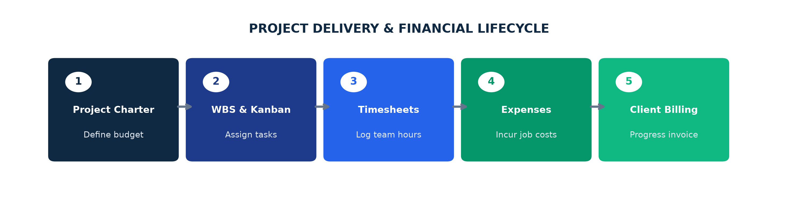
Figure 12.1: Project Milestone Tracking, Timesheet Approvals, and Cost vs Budget Monitoring

12.1 Project Lifecycle & Cost Accumulation
Step 1: Create Project Master — Go to Project Management > Projects > New Project. Set Client, Total Budget, Start Date, and Deadline.
Step 2: Define WBS Tasks & Milestones — Break project down into specific phases, assign task owners, and set expected completion milestones.
Step 3: Log Timesheets & Expenses — Team members log daily working hours and link supplier purchase bills or materials directly to the project code.
Step 4: Monitor Cost vs Budget Variance — Project Manager reviews the real-time financial health dashboard: Total Budget vs Actual Spent vs Remaining Funds.
Step 5: Milestone Billing & Closure — Generate milestone progress invoices to client. Upon completion of all deliverables, officially close project.
System Result: Final project profitability report generated.

Section 13: Human Resources & Payroll
The HR module manages employee records, department structures, leave management, biometric attendance logs, and automated monthly payroll calculation with statutory Ghana tax and social security deductions.

13.1 Automated Payroll Calculation Formula
OmniSuite automatically computes gross-to-net pay using standard statutory formulas:
Payroll Element | Type | Calculation Basis | Statutory Reference
Basic Salary | Base Earnings | Contracted monthly base salary. | Employment Agreement
Cash Allowances | Earnings | Housing, transport, and utility allowances (Taxable). | GRA Income Tax Act
Gross Salary | Total Income | Basic Salary + Taxable Allowances. | Total Earnings
SSNIT Employee Contribution | Statutory Deduction | 5.5% of Basic Salary (Tax-deductible). | National Pensions Act 766
Taxable Income | Net Tax Base | Gross Salary - 5.5% SSNIT Employee. | GRA PAYE Tax Base
PAYE Income Tax | Statutory Deduction | Graduated GRA monthly tax brackets (0% to 35%). | GRA PAYE Tax Schedule
SSNIT Employer Contribution | Company Expense | 13.0% of Basic Salary (Company overhead). | National Pensions Act 766
Net Take-Home Pay | Final Disbursement | Gross Salary - SSNIT (5.5%) - PAYE - Staff Loans. | Disbursed to Bank Account

Section 14: Asset Maintenance & Logistics
OmniSuite provides dedicated operational modules for Fixed Asset Maintenance and Transport Fleet Logistics.
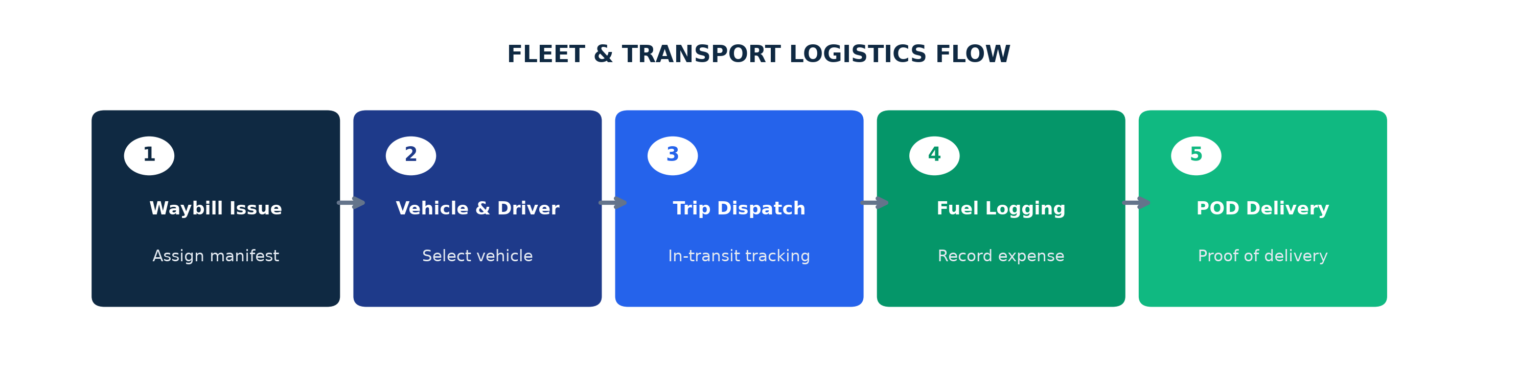
Figure 14.1: Fleet Vehicle Assignment, Digital Waybill Tracking, and Delivery POD Flow
Logistics Function | Key Steps & User Procedures | Operational Output
Trip Waybill Issuance | Select Vehicle, assigned Driver, Destination Customer, and line items being transported. | Official Digital Waybill with QR verification code.
Fuel Consumption Log | Record odometer reading, fuel volume (Liters), fuel station, and purchase cost receipt. | Fuel efficiency auditing and fleet expense posting.
Proof of Delivery (POD) | Receiving customer inspects cargo, signs digital glass / delivery note, and status changes to 'Delivered'. | Triggers sales order completion and invoice release.
Asset Maintenance Job Order | Log breakdown issue, assign maintenance technician, issue spare parts from inventory, and log labor hours. | Restores equipment to service and updates asset log.

Section 15: Business Intelligence & Banks AI
OmniSuite combines interactive multi-dimensional BI dashboards with 'Banks AI'—an integrated executive AI assistant capable of answering natural language queries and executing live read-only database tools across all modules.

15.1 How to Interact with Banks AI
Banks AI is accessible from any screen via the golden spark icon in the top navigation bar:
Example Natural Language Query | Underlying Tool Executed | Information Returned to User
'When was the last sale done?' | get_recent_sales | Exact date/time, POS receipt number, gross/net amount in GH₵, customer, and payment method.
'What is our total inventory valuation?' | get_inventory_health | Total active item count, total warehouse units on hand, and total GHS valuation.
'Show financial performance this month' | get_financial_analytics | Total revenue, total purchases, gross profit margin, top customers, and top suppliers.
'Check active project budgets' | get_project_analytics | Total projects, active projects, allocated budget, incurred expenses, and remaining funds.
'How do I process a sales return?' | get_erp_workflow_guide | Step-by-step Standard Operating Procedure guide tailored to OmniSuite navigation.

[AI SECURITY & PERMISSION SCOPING]
Banks AI enforces strict RBAC security. A user with Warehouse permissions cannot query payroll data or executive financial margins. The AI automatically respects the active user's permitted modules.

Section 16: Error Handling, Validation Rules & Troubleshooting
When encountering unexpected system alerts or validation blocks, refer to this diagnostic troubleshooting matrix:
System Error / Alert Message | Root Cause Analysis | Step-by-Step Resolution Action
Cannot Submit: 'Insufficient Available Stock' | Requested quantity exceeds available unreserved stock in source warehouse. | Perform a physical stock check. If items exist, check for unaccepted transfers or enter a stock adjustment.
'Permission Denied / Unauthorized Action' | User role lacks required privilege for this specific transaction. | Contact System Administrator under Admin > Roles to verify user's assigned role permissions.
'Period Closed / Cannot Post Voucher' | Accounting period has been locked by Finance to prevent backdating. | Request Finance Controller authorization to reopen the specific accounting period.
'Customer Credit Limit Exceeded' | Sales order total causes customer balance to exceed approved credit line. | Collect outstanding customer payments via Receipt Voucher or request Manager credit override.
'Document Sequence Number Conflict' | Simultaneous multi-terminal transactions generated duplicate numbering. | Refresh screen. System automatically increments to the next available sequential voucher number.
'PO Unit Price Mismatch on GRN' | Supplier invoice price differs from contracted Purchase Order price. | Procurement Officer must approve a Price Variance tolerance or request amended supplier invoice.
'POS Terminal: Hardware Printer Offline' | Thermal receipt printer disconnected or out of paper roll. | Check USB/Ethernet printer cable, verify paper roll feed, and click 'Reprint Last Receipt'.
Banks AI: 'API Quota Exceeded / Failover' | Primary Groq AI token limits reached during peak analysis. | System automatically fails over to OpenRouter 0x Alpha without interrupting user conversation.

Section 17: Common User Mistakes to Avoid
To maintain clean data, flawless audit trails, and smooth daily operations, business users must avoid these frequent operational errors:
Common Operational Mistake | Why It Causes Business Issues | Correct Standard Procedure to Follow
1. Creating Duplicate Master Records | Adding a new customer or inventory item instead of searching existing database codes. | Always perform a search by Phone Number, TIN, or Item Code before creating new master data.
2. Selecting Wrong Operating Warehouse | Dispatching stock from 'Main Warehouse' instead of 'Retail Showroom'. | Double-check the Source Warehouse dropdown before clicking 'Submit Transfer' or 'Complete Sale'.
3. Skipping Delivery Notes during Sales | Invoicing a sales order without generating a delivery dispatch note. | Always follow the standard O2C workflow: Quote -> Sales Order -> Delivery Note -> Tax Invoice.
4. Forgetting to Close POS Shift | Leaving POS register open overnight without generating a daily Z-Report. | Always complete shift closing reconciliation at the end of each working day.
5. Unmatched GRN Postings | Entering supplier bills directly into Finance without referencing the warehouse GRN. | Always use 3-Way Matching by creating purchase bills directly from approved GRN records.
6. Backdating Transactions without Approval | Setting voucher dates in prior closed months without Finance authorization. | Ensure all transaction dates reflect actual operational timing unless authorized by Finance.

Section 18: Enterprise ERP Operational Glossary
ERP Terminology | Authoritative Operational Definition
Accounts Payable (AP) | Monies owed by the company to suppliers and vendors for goods and services purchased on credit terms.
Accounts Receivable (AR) | Monies owed to the company by customers for goods and services delivered on commercial invoice terms.
Bill of Materials (BOM) | Comprehensive list of raw materials, assemblies, sub-components, and quantities needed to produce a finished unit.
Chart of Accounts (COA) | Systematic financial listing of all ledger accounts used by the organization to categorize transactions.
Cost of Goods Sold (COGS) | Direct costs attributable to the production or acquisition of the goods sold by the company during a period.
Double-Entry Accounting | Accounting standard where every financial transaction has equal and opposite debits and credits.
FIFO (First-In, First-Out) | Inventory valuation method where oldest purchased inventory batches are assumed to be sold or utilized first.
Goods Receipt Note (GRN) | Official warehouse document confirming physical receipt, inspection, and acceptance of incoming goods.
Local Purchase Order (LPO) | Official commercial contract issued by procurement authorizing a supplier to deliver specified goods at agreed prices.
Mobile Money (MoMo) | Integrated digital wallet payment gateway supporting instant mobile settlements at retail counters.
Order-to-Cash (O2C) | Complete commercial business process spanning customer order capture, fulfillment, invoicing, and collection.
Point of Sale (POS) | Dedicated retail checkout terminal handling barcode scanning, multi-tender payments, and shift balancing.
Procure-to-Pay (P2P) | End-to-end purchasing workflow from employee requisition through purchase order, goods receipt, and invoice payment.
Role-Based Access Control (RBAC) | Security framework restricting system features, menus, and database records based on user job roles.
Work Breakdown Structure (WBS) | Hierarchical decomposition of total project scope into manageable task packages and milestones.
Z-Report | Official end-of-shift financial summary printed by POS terminals detailing total cash, card, and MoMo collections.

