OMNISUITE ERP — OPERATIONAL MANUAL & SPECIFICATION
Facilities Management Module Process Flow
Version 2026.1 | Scope: Properties, Service Contracts, SLAs, Field Service, Checklists, Soft Services | Author: OmniSuite Architecture Team

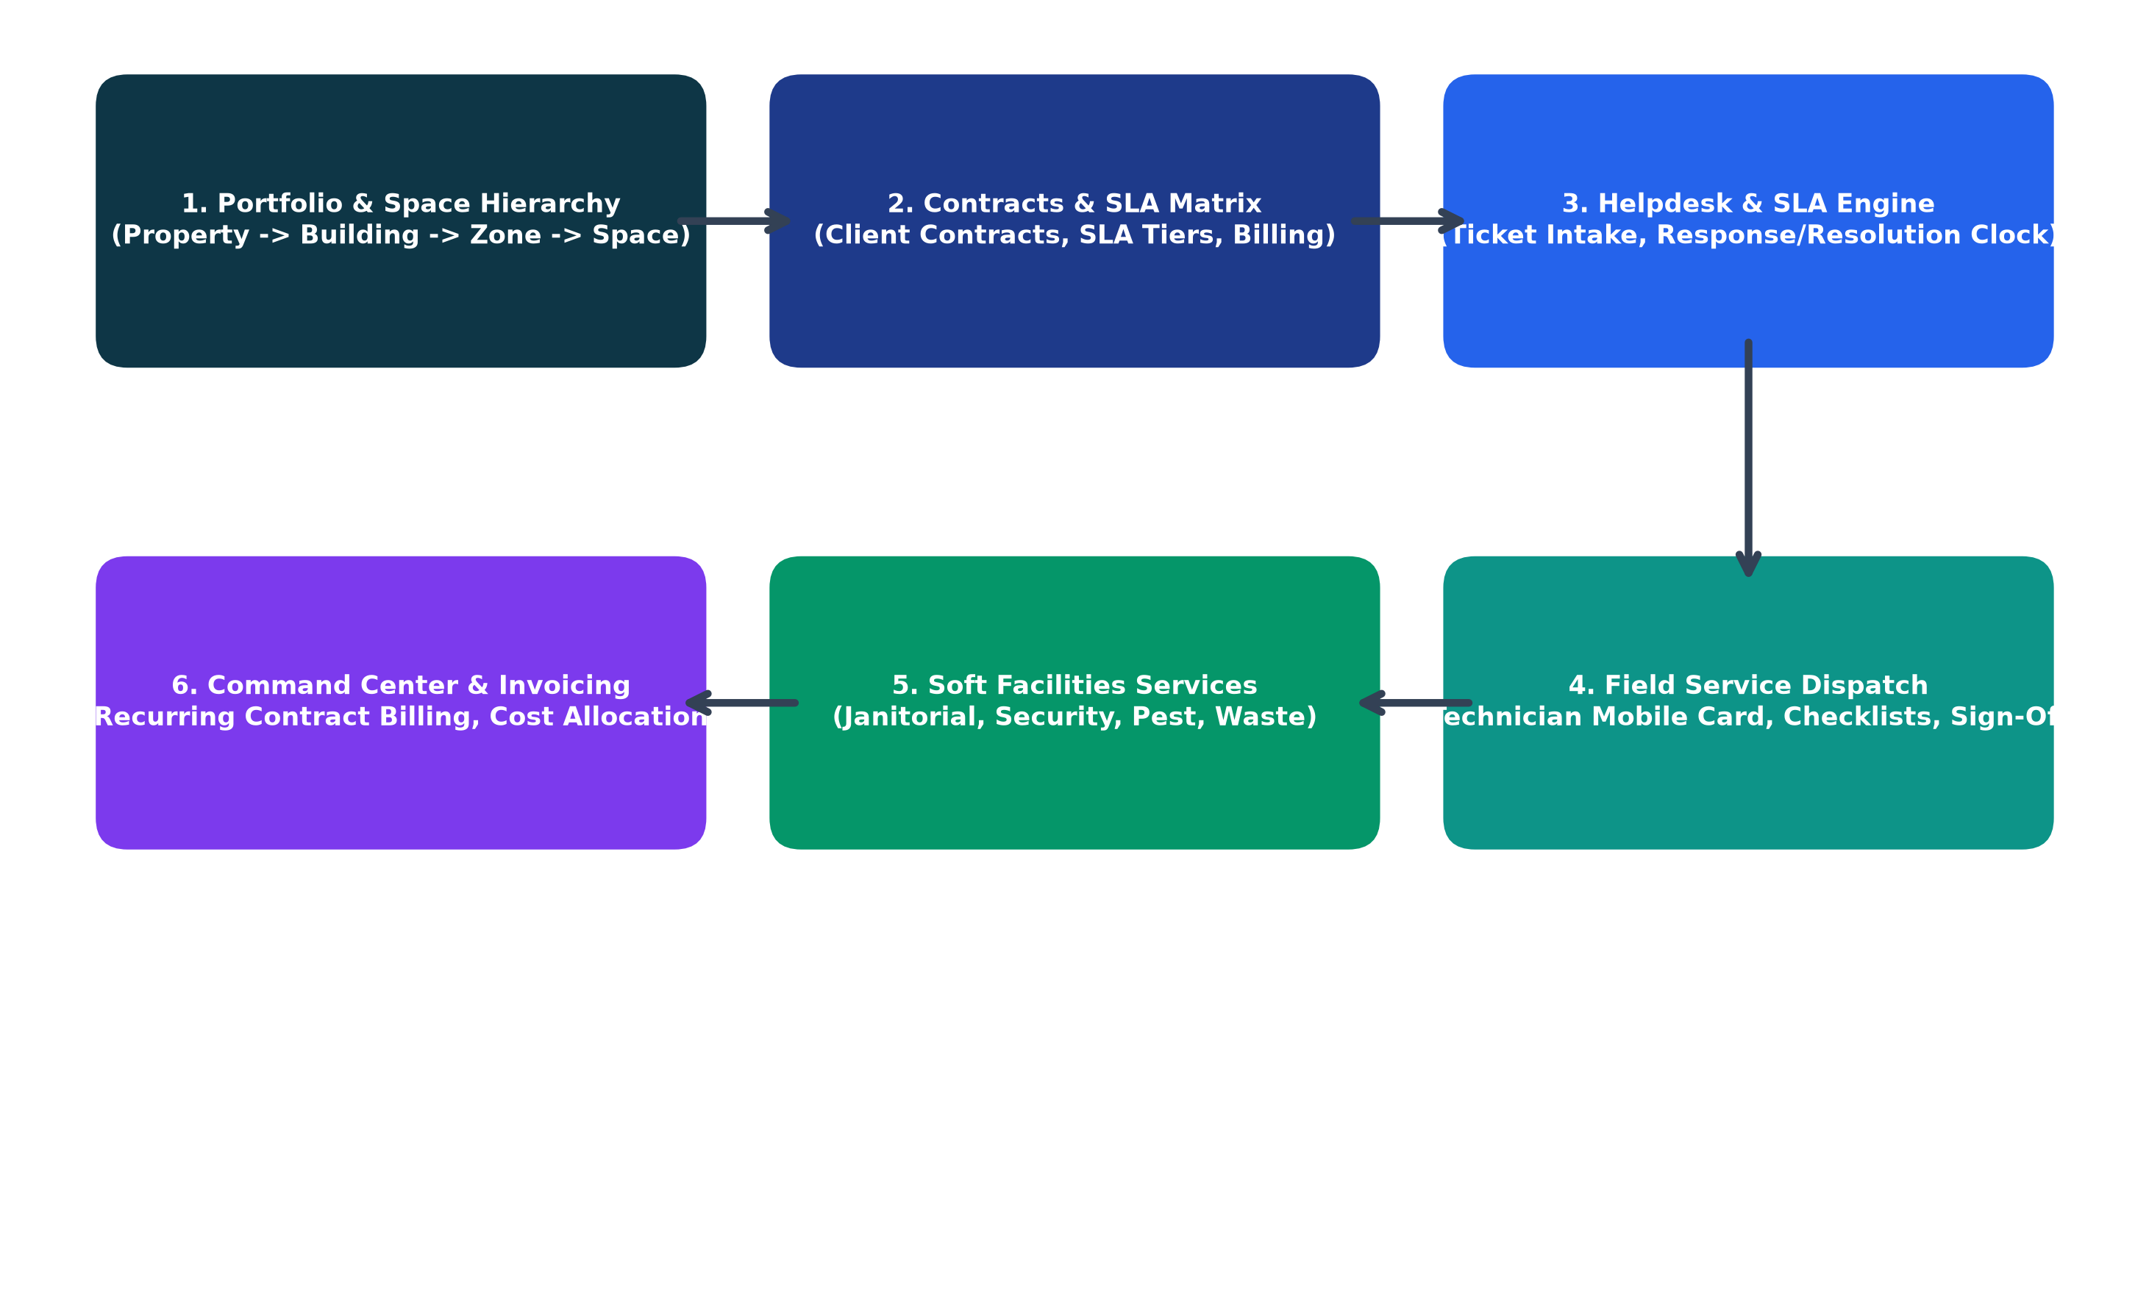
Figure 1.0: End-to-End Operational Process Flow for Facilities Management

1. Executive Overview & Module Purpose
The Facilities Management (FM) module in OmniSuite ERP is an enterprise-grade operational suite designed to manage real estate portfolios, multi-tier spatial hierarchies, client service-level agreements (SLAs), field technician job dispatches, digital safety inspections, and soft facilities services. It integrates seamlessly with Finance for recurring contract billing and with Fixed Asset Management for equipment upkeep.

2. Stage 1: Portfolio & Space Hierarchy Setup
Facilities management begins with establishing the physical hierarchy. Every physical element in OmniSuite is mapped in a 4-tier tree structure to enable precise cost allocation, job dispatching, and asset tracking.
Tier Level | Entity Name | Description & Operational Function | Example
Tier 1 | Property / Estate | Top-level real estate asset, commercial park, or campus. Manages geographical location & address. | East Legon Tech Park
Tier 2 | Building | Specific physical structure or tower within the property boundary. | Tower A (Corporate HQ)
Tier 3 | Zone | Floors, wings, or functional security partitions within a building. | 3rd Floor - Executive Wing
Tier 4 | Space / Unit | Individual rentable units, offices, boardrooms, server rooms, or bays. | Suite 302 (Server Room)

3. Stage 2: Client FM Service Contracts & SLA Governance
Commercial FM providers and enterprise facilities teams operate under contracted Service Level Agreements (SLAs). The contract sets the coverage scope, response benchmarks, billable labor rates, and recurring retainer billing.
[AUTOMATED COVERAGE CHECK] When an incident is logged, OmniSuite automatically queries the property and space to verify whether the reported service line is covered under an active contract. If covered, contract SLA clocks trigger automatically. If out of scope, the system flags the job as billable with ad-hoc labor and material pricing.

Severity Tier | Typical Incidents | Mandatory Response SLA | Mandatory Resolution SLA
Critical (P1) | Complete power failure, major plumbing flood, server room AC failure | Within 1 Hour | Within 4 Hours
High (P2) | HVAC unit failure in open office, elevator outage, security gate fault | Within 2 Hours | Within 8 Hours
Medium (P3) | Lighting fixture replacement, door handle repair, non-urgent leak | Within 4 Hours | Within 24 Hours
Low (P4) | Cosmetic paint touch-up, furniture realignment, scheduled PPM | Within 8 Hours | Within 48 Hours

4. Stage 3 & 4: Helpdesk Tickets, Work Orders & Field Dispatch
1. Ticket Logging: Tenants or facilities staff submit tickets with description, photo attachments, and space selection.
2. SLA Countdown: Real-time countdown timers track Response and Resolution limits based on the contract priority matrix.
3. SLA Pausing: If work is halted due to client site access restrictions or awaiting spare parts delivery, the SLA timer is paused with a formal audit reason.
4. Work Order Dispatch: Qualified field technicians receive the job card on their mobile interface.
5. Execution Lifecycle: The technician updates status through En Route -> On Site -> In Progress -> Completed.
6. Customer Sign-off: Digital completion is verified via customer signature capture directly on the mobile job card.

5. Stage 5: Soft Facilities Services & Audits
Beyond hard technical maintenance, Facilities Management encompasses recurring soft services:
• Janitorial Audits: Daily inspections of restrooms, lobbies, and cafeterias with pass/fail hygiene scoring.
• Security Patrol Rounds: Real-time QR checkpoint logs confirming guard patrol timings.
• Pest Control: Routine fumigation certifications and chemical safety audit logs.
• Waste Disposal: Environmental manifest documentation tracking recycled vs. landfill waste tonnage.

6. Stage 6: Command Center, Invoicing & Financial Integration
• Automated Contract Invoicing: Generates monthly retainer invoices and extra billable work invoices directly in the Finance module.
• Property Cost Allocation: Compiles all labor, materials, and soft service costs against the property to track Net Operating Income (NOI).
• SLA Compliance Analytics: Evaluates technician performance, breach ratios, and first-time fix rates.

