OMNISUITE ERP — FINANCIAL ACCOUNTING & OPERATIONAL SPECIFICATION
Fixed Asset Management Process Flow
Version 2026.1 | Scope: Capitalization, Tagging, Depreciation Engine, Transfers, Revaluation, Disposal | IFRS IAS 16 & GAAP

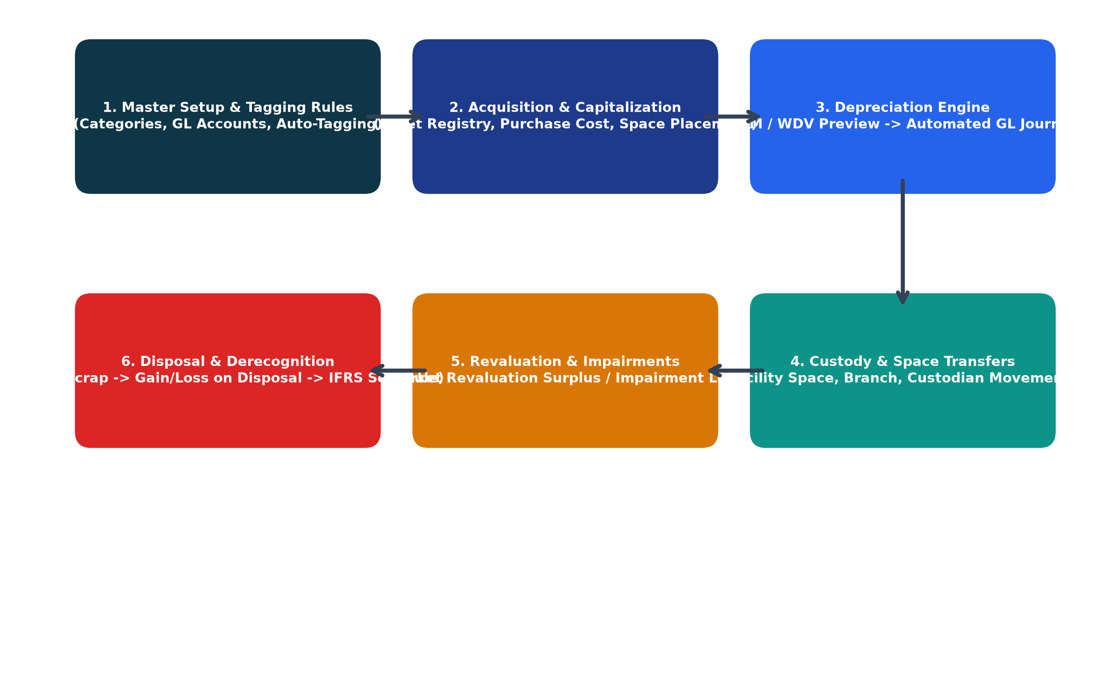
Figure 1.0: Complete Financial & Operational Lifecycle for Fixed Assets

1. Executive Overview & Accounting Standard Compliance
The Fixed Asset Management module in OmniSuite ERP maintains the complete statutory registry of capitalized tangible assets. Built in compliance with International Financial Reporting Standards (IAS 16 Property, Plant and Equipment) and GAAP, the module automates depreciation calculations, GL journal postings, physical space custody, impairment adjustments, and disposal realization.

2. Stage 1: Asset Categories, GL Mapping & Tagging Nomenclature
Before assets can be capitalized, default financial rules and tagging nomenclature must be established. Every asset category maps to dedicated balance sheet and profit & loss General Ledger accounts.
Asset Category | Depr. Method | Useful Life | Cost GL Account | Accum. Depr. GL | Depr. Expense GL
Land & Buildings | Straight Line | 30 - 50 Yrs | 1500 - Buildings | 1510 - Accum Depr | 6500 - Depr Exp
Plant & Machinery | Straight Line | 10 - 15 Yrs | 1520 - Machinery | 1530 - Accum Depr | 6510 - Depr Exp
Motor Vehicles | Reducing Bal. | 4 - 5 Yrs | 1540 - Vehicles | 1550 - Accum Depr | 6520 - Depr Exp
IT & Computers | Straight Line | 3 - 4 Yrs | 1560 - IT Hardware | 1570 - Accum Depr | 6530 - Depr Exp
Furniture & Fixtures | Straight Line | 7 - 10 Yrs | 1580 - Furniture | 1590 - Accum Depr | 6540 - Depr Exp

[AUTOMATIC BARCODE TAGGING] Tag Nomenclature Rules: OmniSuite auto-generates asset barcodes following configured patterns (e.g., [AST]-[SITE]-[YEAR]-[SEQUENCE] -> AST-HQ-2026-0001). Barcode labels can be printed directly for physical tagging.

3. Stage 2: Acquisition, Invoicing & Asset Capitalization
1. Acquisition Ingestion: Fixed assets can be onboarded from an approved Purchase Invoice or entered directly.
2. Asset Profiling: Captures Serial Number, Manufacturer/Brand, Model, Warranty Expiry, and Supplier details.
3. Financial Baseline: Records Gross Acquisition Cost, Residual/Salvage Value, and Depreciation Start Date.
4. Physical Custody: Assigns the asset to a specific Branch, Department, Facility Property Space, and Employee Custodian.

4. Stage 3: Automated Depreciation Engine & GL Journal Posting
The Depreciation Engine executes periodic accounting runs (Monthly, Quarterly, Half-Yearly, or Annually):
1. Preview Calculation: The system audits every capitalized asset and calculates periodic depreciation based on its method:
• Straight Line (SLM): (Cost - Salvage Value) / Useful Life Months
• Reducing Balance (WDV): Remaining Net Book Value * Depreciation Rate %
2. Finance Approval & Commit: The finance controller reviews the batch preview for anomalies.
3. Automated GL Journal Voucher: Automatically creates and commits the balancing entry in Finance:
Dr. Depreciation Expense Account (P&L)
Cr. Accumulated Depreciation Account (Balance Sheet)
4. NBV Synchronization: Recalculates Net Book Value (NBV = Gross Cost - Accum. Depreciation - Impairment).

5. Stage 4 & 5: Custody Transfers, Revaluations & Disposals
• Custody & Space Transfers: Track movements across branches, departments, or facility spaces with signed transfer slips.
• Revaluation Surplus (IAS 16): Independent appraisals that increase asset fair value credit Revaluation Surplus (Equity).
• Impairment Loss (IAS 36): Damaged or obsolete equipment is written down to recoverable amount via Dr. Impairment Loss.
• Asset Disposal & Gain/Loss: When an asset is sold, scrapped, or donated, the system derecognizes original cost, eliminates accumulated depreciation, and posts the realized gain or loss directly to the General Ledger.

6. Stage 6: Statutory Fixed Asset Schedule (IFRS IAS 16)
The module outputs the standard IFRS Fixed Asset Movement Schedule required for external financial audits:
• Gross Cost Movement: Opening Cost + Additions - Disposals + Revaluations = Closing Cost
• Accumulated Depreciation Movement: Opening Depr + Period Charge - Disposals = Closing Depr
• Net Book Value (NBV): Opening NBV vs. Closing Carrying Amount by Asset Class

