OmniSuite Enterprise ERP
End-to-End Business Process Handbook & Visual Workflow Manual
Facilities Management • Project Management & Construction • Fixed Asset Management
TARGET AUDIENCE  Beginners, PMs, FM Leads, Accountants | SCOPE & COVERAGE  100% Complete — 65 Total System Pages | VISUAL INTEGRATION  5 High-Resolution Workflow Flowcharts

PART 1: The Master ERP Architecture — How the Three Modules Connect
A common mistake made by beginners in enterprise systems is viewing Facilities Management, Project Management, and Asset Management as isolated, standalone software screens. In a world-class ERP, these three modules form a continuous, interlocked lifecycle governing an organization's physical and financial existence.
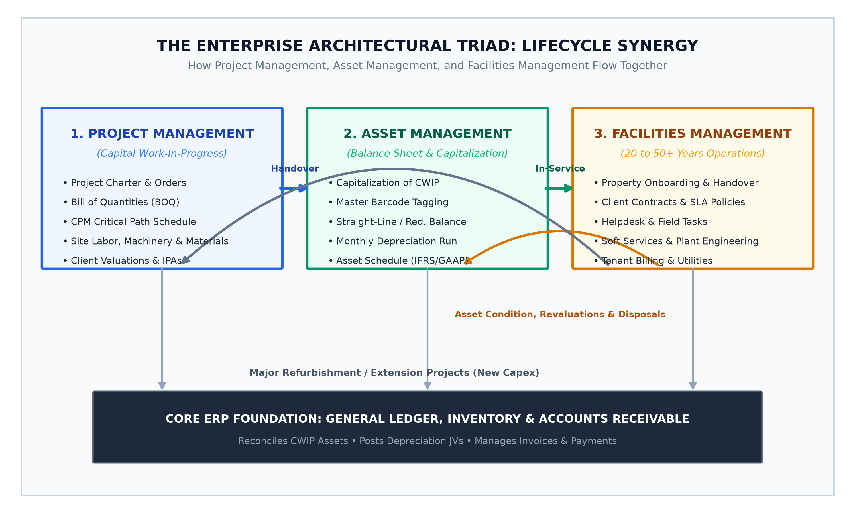
Figure: The Enterprise Architectural Triad — Interlocking lifecycle model connecting Capital Projects (CWIP), Fixed Assets, and Operational Facilities.
📌 Beginner's Mental Model: The Infrastructure Life Cycle
1. Project Management (PM) BUILDS IT: Temporary, budget-driven, timeline-focused. Costs accumulate in Capital Work-in-Progress (CWIP).
2. Asset Management (AM) CAPITALIZES IT: Holds the legal, financial, and tax value on the Balance Sheet. Calculates monthly depreciation and tracking book value.
3. Facilities Management (FM) OPERATES & MAINTAINS IT: Long-term operational custody (20 to 50+ years). Manages repairs, cleaning, security, tenant billing, and health compliance.

When a physical asset—such as a 10-story commercial tower or a 500 kVA standby generator—is conceived, it begins in Project Management. Thousands of labor hours, bulk materials (cement, rebar, cabling), and plant machine logs are tracked against a Bill of Quantities (BOQ). Upon project handover, this accumulated expenditure is capitalized into the Fixed Asset Register. The asset is assigned a barcode tag, an accounting useful life, and a depreciation formula. Immediately thereafter, the physical asset is registered in Facilities Management, where daily service tickets, preventive checklists, maintenance tasks, and energy bills ensure it remains operational for decades.
PART 2: Facilities Management (FM) Business Process
The Facilities Management module controls the ongoing operations, maintenance, statutory safety, and commercial tenant billing for all real estate properties, technical building engineering equipment, and campus environments. Below is the visual flowchart followed by the exact, unskipped operational sequence of all 27 pages.
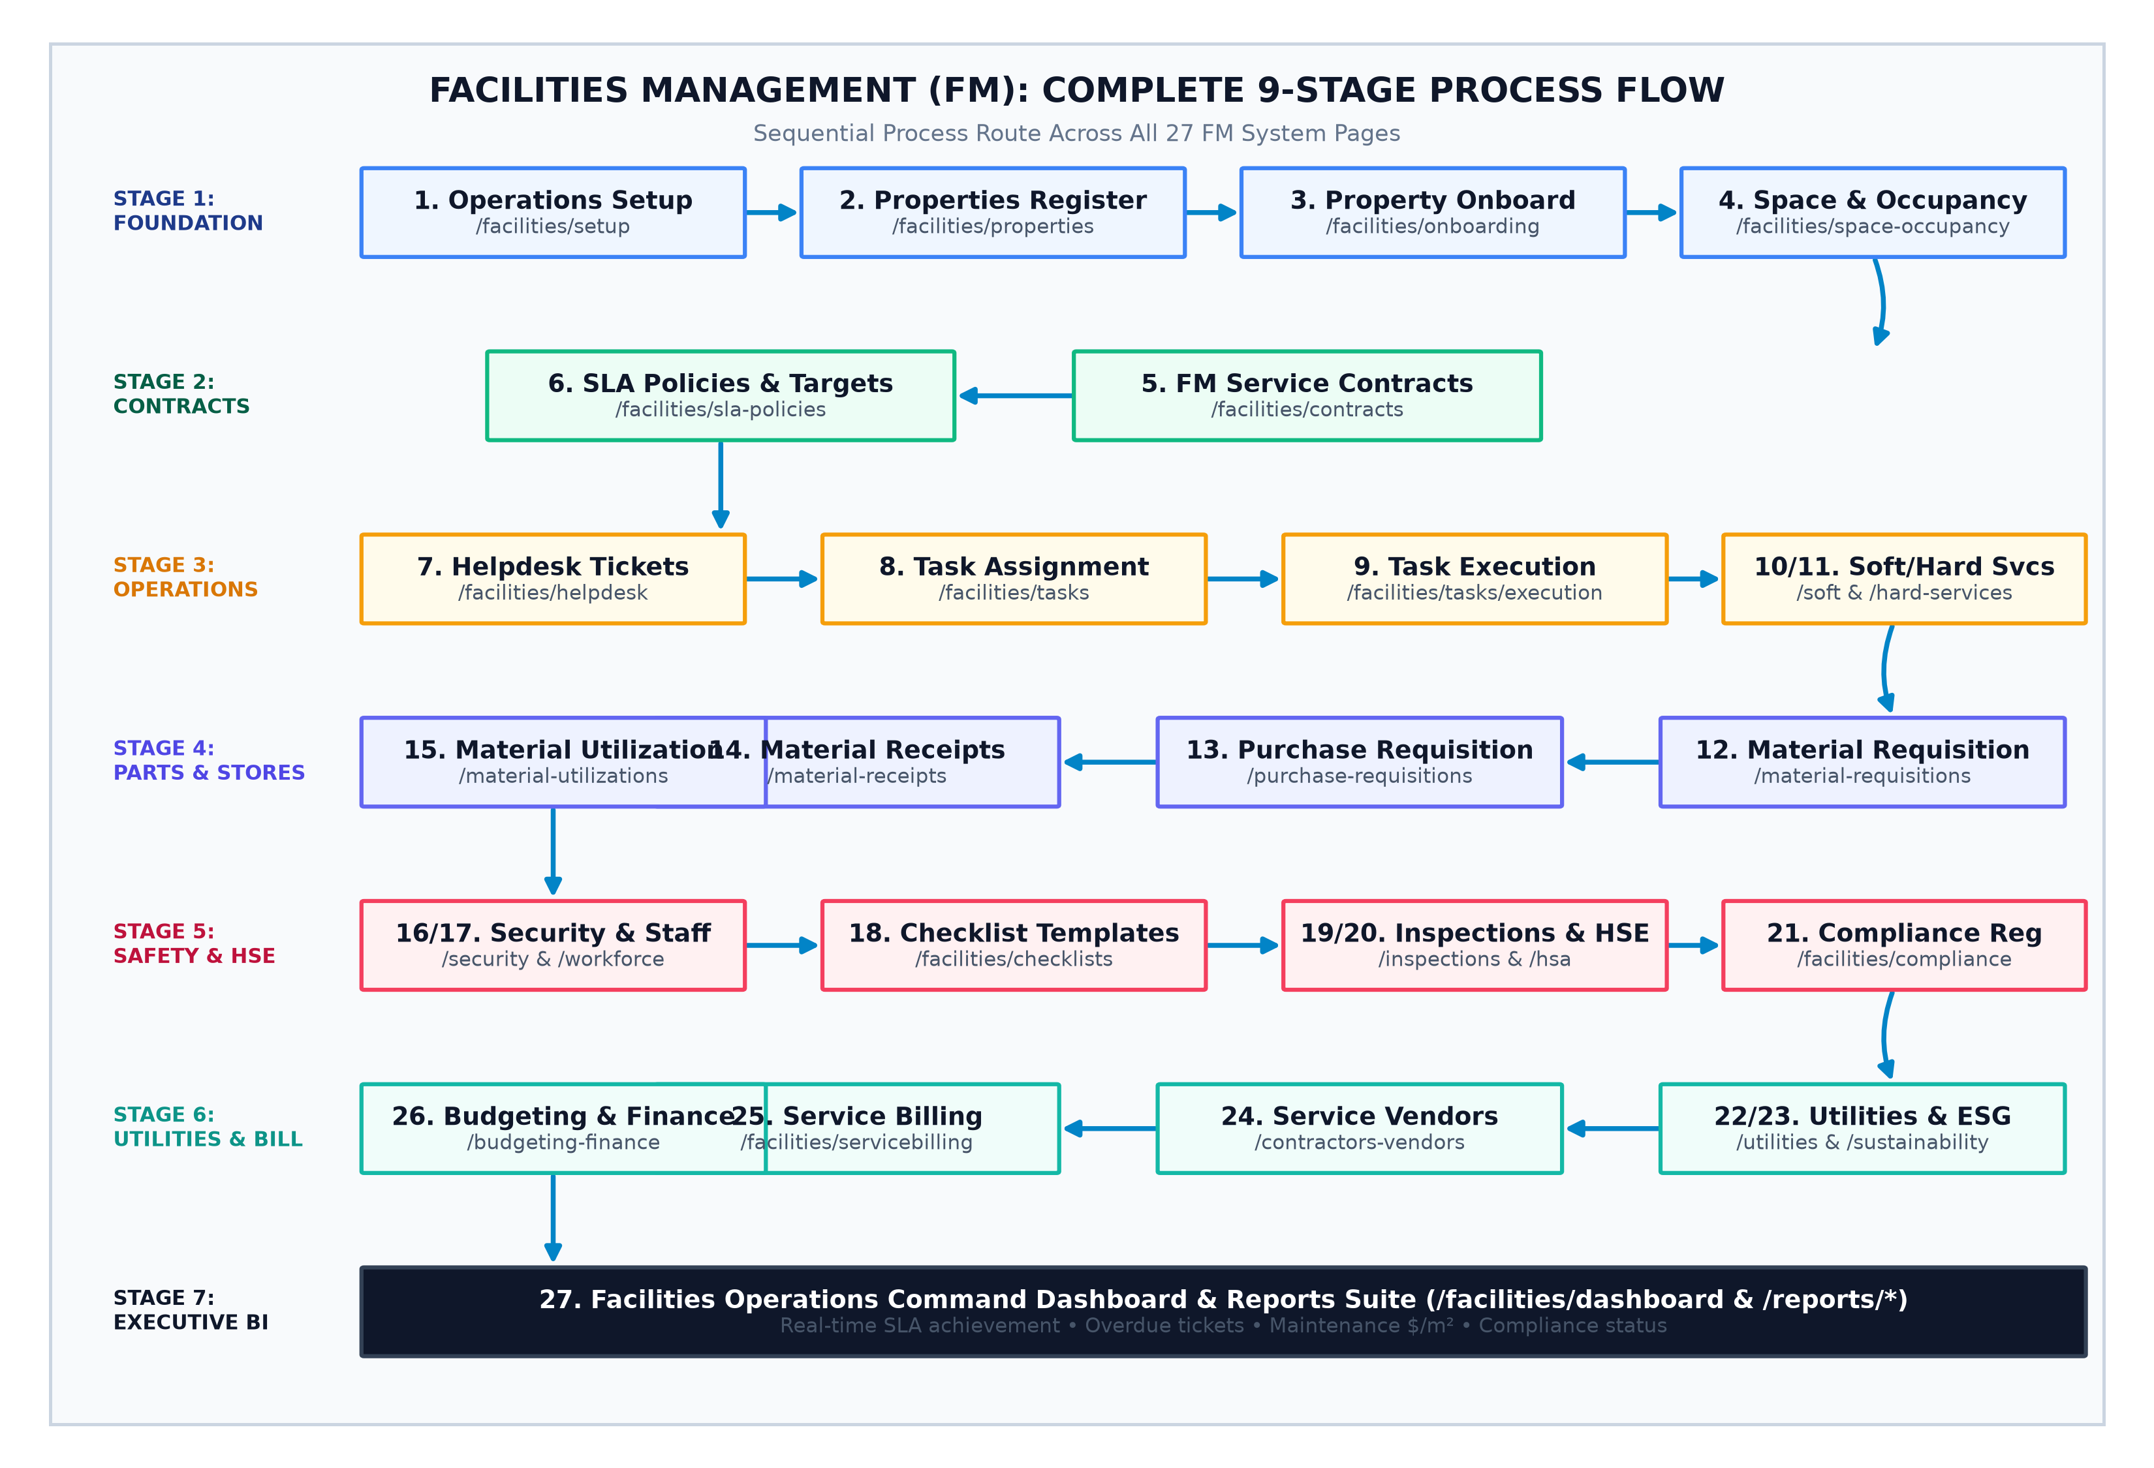
Figure: Facilities Management (FM) End-to-End Workflow — Sequential operational flow across all 9 operational stages and 27 system pages.
Stage 1: Master Setup & Property Structure (The Physical Foundation)
Step 1: Operations Setup
Page URL & Code File | /facilities/setup | FacilitiesSetupPage.jsx
Primary User / Role | Facilities Administrator / Operations Director
Operational Purpose | Configures master lookups required before daily operations begin: shift schedules (Day, Night, Swing), service categories (Janitorial, Electrical, HVAC, Plumbing), supervisor approval hierarchies, and priority matrices.
Process Sequence Logic | Why this step is here: System lookups must exist first. Without shifts and categories configured, no technician can be scheduled and no work order can be categorized.
Inputs & Resulting Output | Input: Shift hours, service categories, priority rules ➔ Output: Active operations configuration. ➔ Next Destination: Step 2: Properties & Estates Register

Step 2: Properties & Estates Register
Page URL & Code File | /facilities/properties | PropertiesList.jsx
Primary User / Role | Portfolio Manager / Property Director
Operational Purpose | Establishes physical multi-tier campus hierarchies: Estate ➔ Building ➔ Floor ➔ Wing ➔ Zone. Captures gross internal area (m²), physical GPS coordinates, handover dates, and master warranty certificates.
Process Sequence Logic | Why this step is here: Every work order, contract, utility meter, and incident must be physically tied to a verified building location.
Inputs & Resulting Output | Input: Building architectural data, GPS, square meters ➔ Output: Verified active Property ID. ➔ Next Destination: Step 3: Property Onboarding

Step 3: Property Onboarding
Page URL & Code File | /facilities/onboarding | PropertyOnboardingPage.jsx
Primary User / Role | Facility Onboarding Lead / Handover Engineer
Operational Purpose | A formal multi-step intake checklist executed when taking over a new building from a construction team or third-party landlord. Verifies as-built drawings, operating licenses, master keys/fobs, snagging clearance, and equipment warranties.
Process Sequence Logic | Why this step is here: Prevents the enterprise from accepting liability for a defective building without signed snags and legal operating permits.
Inputs & Resulting Output | Input: As-built drawings, defect punch lists, keys ➔ Output: Formal Property Handover Acceptance Certificate. ➔ Next Destination: Step 4: Space & Occupancy Management

Step 4: Space & Occupancy Management
Page URL & Code File | /facilities/space-occupancy | SpaceOccupancyPage.jsx
Primary User / Role | Space Planner / Leasing Coordinator
Operational Purpose | Subdivides floors into allocatable and rentable spaces: Private Offices, Meeting Rooms, Retail Bays, and Common Areas. Tracks tenant lease contracts, headcount per m², desk utilization, and vacancy percentages.
Process Sequence Logic | Why this step is here: Provides the exact square-meter basis used later by Service Billing to calculate tenant service charge allocations.
Inputs & Resulting Output | Input: Floor plans, tenant names, desk counts ➔ Output: Rentable space register and occupancy metrics. ➔ Next Destination: Step 5: FM Service Contracts

Stage 2: Commercial Agreements & Service Quality Commitments
Step 5: FM Service Contracts
Page URL & Code File | /facilities/contracts | FMContractsList.jsx
Primary User / Role | Commercial Manager / Client Account Executive
Operational Purpose | Establishes legally binding maintenance contracts with clients or tenants. Specifies contract duration, billing periodicity (Monthly, Quarterly, Annual), covered services, renewal terms, and indexation clauses.
Process Sequence Logic | Why this step is here: Facilities management is a commercial business. Every work request dispatched must be checked against an active contract to decide if work is covered under warranty/retainer or billable out-of-scope.
Inputs & Resulting Output | Input: Client legal entity, billing retainer rate, covered scope ➔ Output: Active commercial contract. ➔ Next Destination: Step 6: SLA Policies & Performance

Step 6: SLA Policies & Performance
Page URL & Code File | /facilities/sla-policies | SLAPoliciesPage.jsx
Primary User / Role | Quality & Compliance Manager / SLA Officer
Operational Purpose | Defines Service Level Agreements tied to contracts. Establishes Target Response Time (Emergency = 15 mins, Routine = 4 hrs) and Target Resolution Time (Emergency = 2 hrs, Routine = 48 hrs), plus breach penalty calculations.
Process Sequence Logic | Why this step is here: When a service ticket is submitted on the Helpdesk, the SLA countdown clock immediately begins ticking based on these policies.
Inputs & Resulting Output | Input: Priority levels, target response/resolution hours ➔ Output: Automated SLA monitoring rules. ➔ Next Destination: Step 7: Helpdesk & Service Requests

Stage 3: Service Delivery, Helpdesk & Field Task Execution
Step 7: Helpdesk & Service Requests
Page URL & Code File | /facilities/helpdesk | FMHelpdeskPage.jsx
Primary User / Role | Helpdesk Dispatcher / Call Center Agent / Tenants
Operational Purpose | Central ticketing clearinghouse. Requesters submit complaints and service calls (e.g., 'Chiller leaking on 4th Floor East'). System matches priority, validates contract coverage, and starts the SLA countdown clock.
Process Sequence Logic | Why this step is here: Acts as the single front door for all facilities issues. Incoming tickets are triaged and converted into actionable field work orders.
Inputs & Resulting Output | Input: Tenant problem report, photos, location ➔ Output: Validated Helpdesk Ticket ID. ➔ Next Destination: Step 8: FM Task Assignment

Step 8: FM Task Assignment
Page URL & Code File | /facilities/tasks | FMTaskList.jsx & FMTaskForm.jsx
Primary User / Role | Facilities Supervisor / Maintenance Planner
Operational Purpose | Converts approved helpdesk tickets and scheduled PPMs into detailed work orders. Allocates the responsible technician, planned start/finish times, required spare parts, and safety precautions.
Process Sequence Logic | Why this step is here: Connects a customer's reported complaint to specific physical personnel and material resources.
Inputs & Resulting Output | Input: Ticket ID, assigned technician, parts list ➔ Output: Dispatched Work Order. ➔ Next Destination: Step 9: FM Task Execution & Work Log

Step 9: FM Task Execution & Field Work Log
Page URL & Code File | /facilities/tasks/execution | FMTaskExecution.jsx & FieldTechnicianJobCard.jsx
Primary User / Role | Field Technician / Maintenance Engineer
Operational Purpose | Technicians log into their mobile job card, record clock-in time, step through technical checklists, document spare parts used, upload before/after photos, and obtain client sign-off signatures upon completion.
Process Sequence Logic | Why this step is here: Provides ground-level verification that work was completed to standard before tickets can be closed.
Inputs & Resulting Output | Input: Work order ID, physical labor, parts consumed ➔ Output: Completed Job Card & Closed Work Order. ➔ Next Destination: Step 10 / Step 12 (Materials)

Step 10: Soft Services & Site Operations
Page URL & Code File | /facilities/soft-services | SoftServicesPage.jsx
Primary User / Role | Soft Services Supervisor / Janitorial & Hygiene Lead
Operational Purpose | Coordinates non-technical, human-centric operations: daily restroom sanitation checklists, deep floor scrubbing, groundskeeping, pest control fumigation cycles, and solid waste removal manifests.
Process Sequence Logic | Why this step is here: Soft services operate continuously on repetitive shift schedules, separate from technical break-fix repairs.
Inputs & Resulting Output | Input: Daily shift checklists, consumable chemical logs ➔ Output: Soft services sanitation compliance log. ➔ Next Destination: Step 11: Hard Services

Step 11: Hard Services & Technical Engineering
Page URL & Code File | /facilities/hard-services | HardServicesPage.jsx
Primary User / Role | Chief Facilities Engineer / Plant Room Lead
Operational Purpose | Dedicated tracking of heavy mechanical and electrical infrastructure: Central Chiller plants, Standby Diesel Generators, Elevator safety interlocks, High-Voltage Transformers, and Fire Pumps. Tracks operating hours, diesel levels, and oil pressure.
Process Sequence Logic | Why this step is here: Critical plant assets require specialized thermodynamic and electrical telemetry tracking beyond standard work orders.
Inputs & Resulting Output | Input: Machine running hours, fuel levels, vibration logs ➔ Output: Plant health telemetry and PPM schedules. ➔ Next Destination: Step 12: Material Requisitions

Stage 4: FM Materials, Supply Chain & Site Inventory
📌 The 4-Step Site Material Lifecycle
Requisition Stock (Step 12) ➔ Procure Missing Items (Step 13) ➔ Receive at Site (Step 14) ➔ Consume into Work Order (Step 15)

Step 12: FM Material Requisitions
Page URL & Code File | /facilities/material-requisitions | FMMaterialRequisitionList.jsx & Form.jsx
Primary User / Role | Maintenance Supervisor / Site Engineer
Operational Purpose | Requests replacement spare parts (e.g., HVAC filters, ballasts, circuit breakers) from the company's central inventory warehouse for a specific work order or property.
Process Sequence Logic | Why this step is here: Enforces internal store controls, ensuring technicians do not withdraw stock without authorization.
Inputs & Resulting Output | Input: Part numbers, quantities, work order ID ➔ Output: Approved Material Requisition (MR). ➔ Next Destination: Step 13: FM Purchase Requisitions

Step 13: FM Purchase Requisitions
Page URL & Code File | /facilities/purchase-requisitions | FMPurchaseRequisitionList.jsx & Form.jsx
Primary User / Role | Site Engineer / Procurement Officer
Operational Purpose | If requested spare parts are out-of-stock in the central warehouse, this page triggers a formal external purchase requisition to procurement for vendor buying.
Process Sequence Logic | Why this step is here: Prevents unbudgeted rogue purchasing by channeling all external procurement through formal approvals.
Inputs & Resulting Output | Input: Unstocked items, vendor quotes, budget code ➔ Output: Formal Purchase Order (PO). ➔ Next Destination: Step 14: FM Material Receipts

Step 14: FM Materials Receipt
Page URL & Code File | /facilities/material-receipts | FMMaterialReceiptList.jsx & Form.jsx
Primary User / Role | Site Storekeeper / Facilities Receiver
Operational Purpose | Records physical arrival of ordered parts at the facility site. Inspects items against delivery notes, checks specifications, and confirms quantities received.
Process Sequence Logic | Why this step is here: Ensures items are physically verified before being booked into local facility holding stock.
Inputs & Resulting Output | Input: Vendor delivery note, physical goods ➔ Output: Goods Received Note (GRN). ➔ Next Destination: Step 15: FM Material Utilization

Step 15: FM Material Utilization
Page URL & Code File | /facilities/material-utilizations | FMMaterialUtilizationList.jsx & Form.jsx
Primary User / Role | Field Technician / Maintenance Supervisor
Operational Purpose | Records the actual physical consumption of spare parts into the designated work order. Relieves facility stock balance and debits the property's maintenance expense ledger in Finance.
Process Sequence Logic | Why this step is here: Provides true job-costing by linking exact material expenses to specific properties and equipment.
Inputs & Resulting Output | Input: Material ID, quantity consumed, task ID ➔ Output: General Ledger inventory expense posting. ➔ Next Destination: Step 16: Security & Access

Stage 5: Security, Workforce & Site Custody
Step 16: Security & Access Management
Page URL & Code File | /facilities/security | SecurityAccessPage.jsx
Primary User / Role | Chief Security Officer / Front Desk Guard
Operational Purpose | Real-time access control: Electronic Visitor Check-in/Check-out with badge printing, Physical Key Register (issuing/returning master keys), and Access Zone clearances (server rooms, rooftops, high-voltage switchrooms).
Process Sequence Logic | Why this step is here: Controls physical human movement, safeguarding property occupants, intellectual property, and high-risk equipment.
Inputs & Resulting Output | Input: Visitor ID, host employee, key tag number ➔ Output: Active site visitor badges and key audit logs. ➔ Next Destination: Step 17: Workforce Roster

Step 17: Workforce Roster & Deployment
Page URL & Code File | /facilities/workforce | FMWorkforceRosterPage.jsx
Primary User / Role | Facilities Operations Manager / Staff Scheduler
Operational Purpose | Assigns internal cleaners, technicians, and security officers to specific properties, zones, and shift patterns. Tracks clock-ins, shift rotations, absences, and overtime hours.
Process Sequence Logic | Why this step is here: Ensures minimum statutory manning ratios are met across all managed properties 24/7.
Inputs & Resulting Output | Input: Employee profiles, shift templates, property rosters ➔ Output: Published Monthly Workforce Roster. ➔ Next Destination: Step 18: Checklist Templates

Stage 6: Quality, Health, Safety & Statutory Compliance
Step 18: Checklist Templates
Page URL & Code File | /facilities/checklists | ChecklistTemplatesList.jsx
Primary User / Role | QA/QC Manager / Safety Director
Operational Purpose | Builds standardized multi-point digital inspection templates (e.g., 'Monthly Generator 25-Point Audit', 'Quarterly Fire Damper Test', 'Daily Kitchen Hygiene Audit').
Process Sequence Logic | Why this step is here: Standardizes inspection procedures so all properties are audited against identical benchmarks.
Inputs & Resulting Output | Input: Inspection criteria, pass/fail thresholds ➔ Output: Standardized Digital Checklist Template. ➔ Next Destination: Step 19: Inspections & CAPA

Step 19: Inspections & Corrective Actions (CAPA)
Page URL & Code File | /facilities/inspections | FMInspectionsPage.jsx
Primary User / Role | Facilities Inspector / Quality Auditor
Operational Purpose | Executes scheduled site audits using checklist templates. If an item fails (e.g., emergency exit door bolted shut), the system auto-triggers a CAPA and dispatches a priority ticket to the Helpdesk.
Process Sequence Logic | Why this step is here: Enforces closed-loop accountability so safety defects discovered during audits are immediately repaired.
Inputs & Resulting Output | Input: Completed checklist findings, audit photos ➔ Output: Audit Score & Triggered CAPA Work Orders. ➔ Next Destination: Step 20: Health & Safety (HSE)

Step 20: Health, Safety & Compliance (HSE)
Page URL & Code File | /facilities/hsa-compliance | HealthSafetyCompliancePage.jsx
Primary User / Role | Site HSE Officer / Risk Manager
Operational Purpose | Manages hazardous operational risk: Incident reporting, Near-miss investigation root causes, Permits-to-Work (PTW) for dangerous activities (Working at Heights, Hot Work welding, Confined Spaces), and Safety Induction logs.
Process Sequence Logic | Why this step is here: Guarantees that dangerous maintenance work is safely isolated and approved prior to commencement.
Inputs & Resulting Output | Input: PTW hazard assessment, isolation tags, incident details ➔ Output: Authorized Permit-to-Work. ➔ Next Destination: Step 21: Statutory Compliance Obligations

Step 21: Compliance Obligations & Statutory Documents Register
Page URL & Code File | /facilities/compliance | FMCompliancePage.jsx
Primary User / Role | Statutory Compliance Officer / In-House Legal
Operational Purpose | Maintains statutory operating licenses: Fire Safety Certificates, Environmental Protection Agency (EPA) discharge permits, Lift Inspection certificates, and Insurance policies. Direct Cloudinary integration enables uploading certificates with automatic expiration alerts.
Process Sequence Logic | Why this step is here: Protects the enterprise from legal shut-down orders, fines, or criminal liability resulting from expired operating licenses.
Inputs & Resulting Output | Input: Certificate PDFs, issuing authorities, expiry dates ➔ Output: Active legal compliance register with renewal alarms. ➔ Next Destination: Step 22: Utilities & Energy

Stage 7: Utilities, Energy & Sustainability
Step 22: Utilities & Energy Management
Page URL & Code File | /facilities/utilities-energy | UtilitiesEnergyPage.jsx
Primary User / Role | Energy Manager / Facilities Accountant
Operational Purpose | Logs periodic meter readings for Electricity (kWh), Municipal Water (m³), and Diesel bulk tanks. Detects consumption anomalies (indicating pipe leaks or malfunctioning equipment) and verifies utility bills.
Process Sequence Logic | Why this step is here: Utilities represent 30–50% of a building's operating expense. Accurate metering enables fair tenant cost allocation.
Inputs & Resulting Output | Input: Sub-meter readings, utility supplier bills ➔ Output: Reconciled utility consumption and cost allocations. ➔ Next Destination: Step 23: Sustainability Management

Step 23: Sustainability & Environmental Management
Page URL & Code File | /facilities/sustainability | SustainabilityManagementPage.jsx
Primary User / Role | Sustainability Officer / ESG Lead
Operational Purpose | Converts utility energy data into Scope 1 & Scope 2 greenhouse gas carbon emissions (tCO2e). Tracks recycled waste tonnage, on-site solar generation, and rainwater harvesting metrics.
Process Sequence Logic | Why this step is here: Provides required corporate ESG (Environmental, Social, Governance) reporting and green building certification data.
Inputs & Resulting Output | Input: kWh power, diesel liters, waste manifests ➔ Output: Corporate Carbon Footprint & ESG Scorecard. ➔ Next Destination: Step 24: Contractors & Vendors

Stage 8: Vendors, Service Billing & Financial Oversight
Step 24: Contractors & Service Vendors
Page URL & Code File | /facilities/contractors-vendors | ContractorVendorManagementPage.jsx
Primary User / Role | Vendor Manager / Procurement Lead
Operational Purpose | Manages third-party specialist contractors (e.g., Otis Elevators, Carrier Chillers, Chubb Fire). Evaluates vendor insurance coverage, SLA performance compliance, and work orders dispatched to third parties.
Process Sequence Logic | Why this step is here: Monitors specialized maintenance services executed by external certified specialists.
Inputs & Resulting Output | Input: Vendor master agreements, certificates of insurance ➔ Output: Approved contractor work authorizations. ➔ Next Destination: Step 25: Service Billing

Step 25: Service Billing
Page URL & Code File | /facilities/servicebilling | ServiceBillingList.jsx & Form.jsx
Primary User / Role | Billing Specialist / Accounts Receivable Accountant
Operational Purpose | Generates customer-facing facilities invoices. Pulls monthly contract retainers, adds metered tenant utility consumption, and appends approved out-of-scope reactive work orders. Links to Finance AR.
Process Sequence Logic | Why this step is here: Converts facility operations into earned revenue by invoicing clients and tenants.
Inputs & Resulting Output | Input: Contract retainers, metered utility usage, completed work orders ➔ Output: Official Customer Tax Invoice. ➔ Next Destination: Step 26: Budgeting & Finance

Step 26: Budgeting & Financial Management
Page URL & Code File | /facilities/budgeting-finance | FacilitiesBudgetingFinancePage.jsx
Primary User / Role | Facilities Finance Controller / Portfolio Director
Operational Purpose | Tracks Year-to-Date (YTD) actual operational expenditures (labor, parts, contractors, energy) against approved property budgets. Calculates operational cost per square meter ($/m²).
Process Sequence Logic | Why this step is here: Maintains financial control over building operations, identifying cost overruns early.
Inputs & Resulting Output | Input: Budget targets, actual General Ledger expense entries ➔ Output: Financial variance analysis per m². ➔ Next Destination: Step 27: Executive Operations Dashboard

Step 27: Facilities Operations Dashboard & Reports Suite
Page URL & Code File | /facilities/dashboard & /reports/* | FacilitiesOperationsDashboard.jsx
Primary User / Role | Executive Leadership / Chief Operating Officer
Operational Purpose | Real-time operational command center: live SLA compliance percentages, overdue helpdesk tickets, maintenance costs per property, soft services audit scores, and contract renewal alerts.
Process Sequence Logic | Why this step is here: Provides executive oversight across the entire real estate portfolio from a single dashboard.
Inputs & Resulting Output | Input: Real-time telemetry from all 26 preceding pages ➔ Output: High-level KPI oversight and executive decisions. ➔ Next Destination: Continuous Operational Loop

PART 3: Project Management & Construction Business Process
The Project Management module controls engineering design, physical construction execution, procurement supply chain, subcontractor certifications, quality testing, and commercial client valuations. Below is the visual execution roadmap followed by the sequential breakdown of all 29 pages.
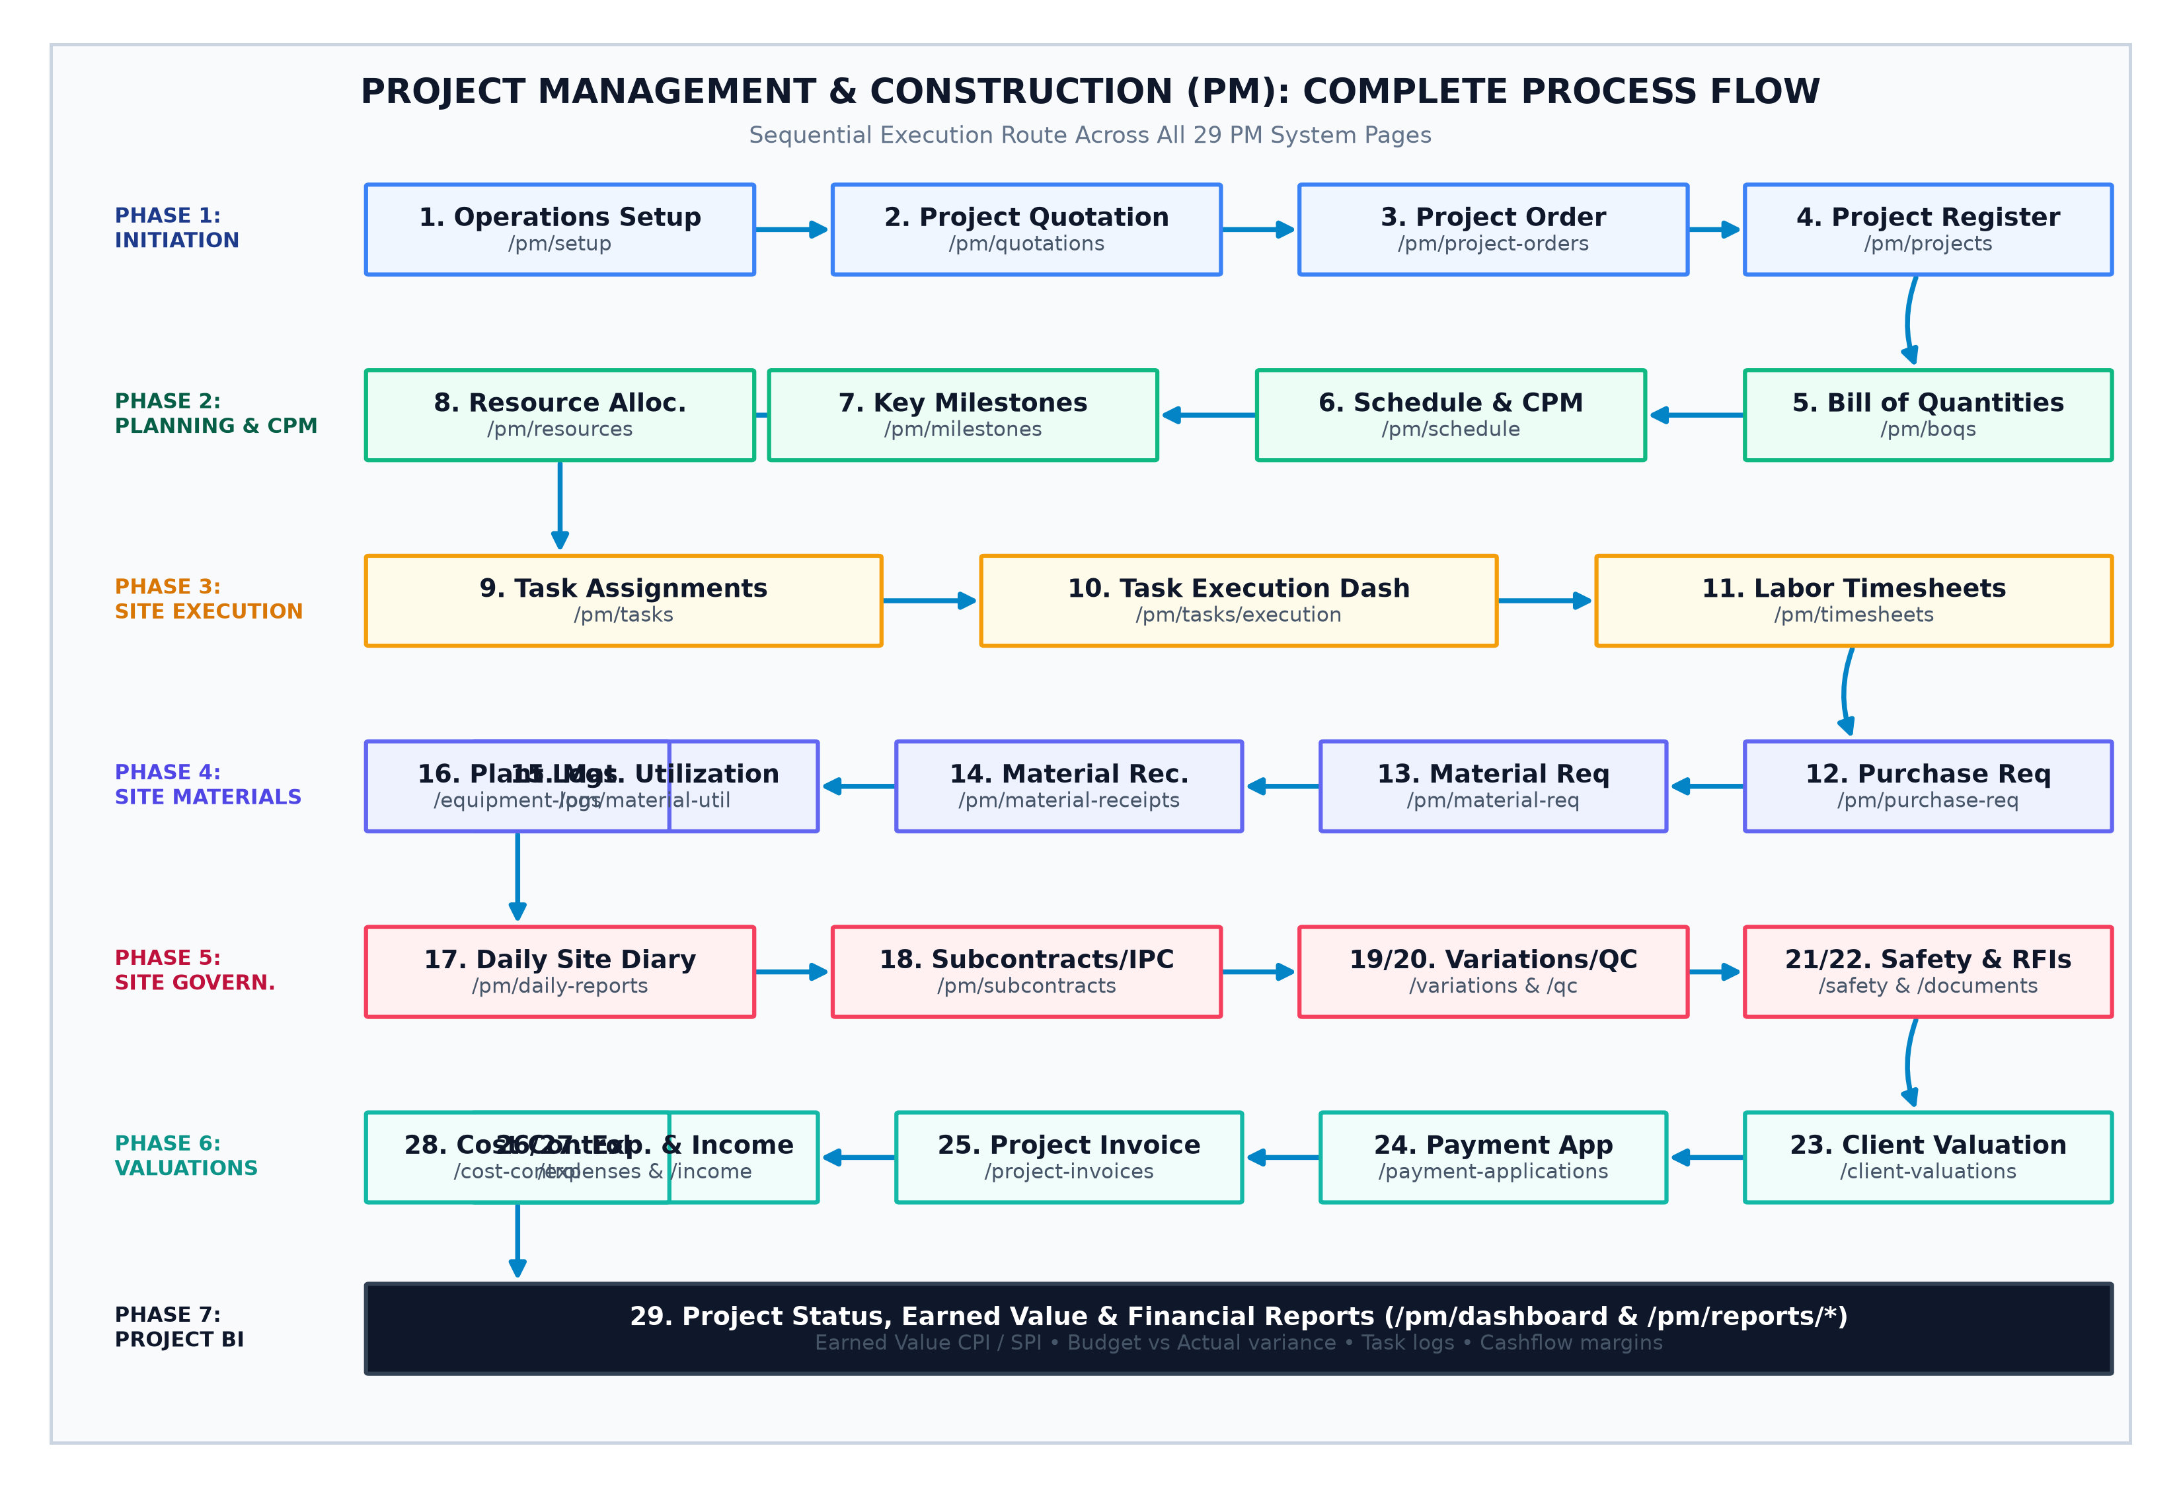
Figure: Project Management & Construction (PM) End-to-End Workflow — Sequential execution flow across all 7 project phases and 29 system pages.
Stage 1: Commercial Tendering & Project Initiation
Step 1: Operations Setup
Page URL & Code File | /project-management/setup | PMSetup.jsx
Primary User / Role | PMO Director / Lead Project Scheduler
Operational Purpose | Establishes master project definitions: Project Types (Civil Infrastructure, EPC, Commercial MEP, Interior Fit-out), Standard Cost Codes (Labor, Plant, Materials, Subcontractors), and Default Working Calendars (6-day site week, holidays).
Process Sequence Logic | Why this step is here: Standard project controls must be configured before setting up tenders, budgets, and scheduling baselines.
Inputs & Resulting Output | Input: Project types, standard cost codes, working calendar ➔ Output: Project management operational rules. ➔ Next Destination: Step 2: Project Quotations

Step 2: Project Quotations
Page URL & Code File | /project-management/quotations | ProjectQuotationList.jsx & Form.jsx
Primary User / Role | Senior Estimator / Bid Proposal Manager
Operational Purpose | Prepares commercial bids for client tenders. Compiles estimated costs (Direct Materials, Plant hire, Labor timesheets, Specialist Subcontractors), applies target markups, and produces formal quote proposals.
Process Sequence Logic | Why this step is here: Establishes the initial commercial baseline and target gross profit margin for prospective projects.
Inputs & Resulting Output | Input: Client tender package, drawings, material estimates ➔ Output: Commercial Project Quote Proposal. ➔ Next Destination: Step 3: Project Orders

Step 3: Project Orders
Page URL & Code File | /project-management/project-orders | ProjectOrderList.jsx & Form.jsx
Primary User / Role | Contracts Administrator / Legal Counsel
Operational Purpose | When the client accepts the quote and issues a Letter of Award (LOA) or signed construction contract, this page binds the order, locking in contract value, advance payment terms, and retention percentages.
Process Sequence Logic | Why this step is here: Converts a bid estimate into a legally binding contractual commitment before site mobilization starts.
Inputs & Resulting Output | Input: Signed contract, client PO number, advance payment terms ➔ Output: Binding Project Order. ➔ Next Destination: Step 4: Projects Master Register

Step 4: Projects Master Register & Detail Dashboard
Page URL & Code File | /project-management/projects | ProjectList.jsx & ProjectDetailDashboard.jsx
Primary User / Role | Senior Project Manager / Project Director
Operational Purpose | Registers the active project in the ERP, designates Project Managers, defines planned start/finish dates, assigns financial branches, and acts as the central hub. Opening a project dashboard displays its completion percentage and budget burn.
Process Sequence Logic | Why this step is here: Acts as the master parent entity to which all tasks, material requisitions, valuations, and site reports attach.
Inputs & Resulting Output | Input: Project order ID, appointed PM, contract sum ➔ Output: Active Project Master Record. ➔ Next Destination: Step 5: Bill of Quantities (BOQ)

Stage 2: Technical Baseline, Scheduling & Estimating
Step 5: Bill of Quantities (BOQ)
Page URL & Code File | /project-management/boqs | BOQManager.jsx
Primary User / Role | Lead Quantity Surveyor (QS) / Cost Engineer
Operational Purpose | Constructs the Work Breakdown Structure (WBS) and itemized Bill of Quantities: Division ➔ Bill ➔ Section ➔ Item (e.g., 'Item 3.2: C30 Reinforced Concrete in Foundations - 850 m³ @ $145/m³'). Captures rate build-ups.
Process Sequence Logic | Why this step is here: The BOQ is the commercial foundation for all client payment valuations, subcontractor scopes, and material requisitions.
Inputs & Resulting Output | Input: Architectural & structural engineering drawings ➔ Output: Approved Master Bill of Quantities. ➔ Next Destination: Step 6: Schedule & Critical Path Method

Step 6: Schedule & Critical Path Method (CPM Gantt)
Page URL & Code File | /project-management/schedule | GanttScheduleView.jsx
Primary User / Role | Project Planner / Schedulng Engineer
Operational Purpose | Builds the CPM network. Connects activities with Finish-to-Start (FS), Start-to-Start (SS) dependencies, leads, and lags. Automatically calculates Early Start (ES), Early Finish (EF), Late Start (LS), Late Finish (LF), and Total Float. Highlights the Critical Path.
Process Sequence Logic | Why this step is here: Identifies zero-float critical activities that, if delayed by a single day, will delay overall project completion.
Inputs & Resulting Output | Input: Activity durations, dependency logic, calendar rules ➔ Output: Baseline CPM Gantt Chart & Float Matrix. ➔ Next Destination: Step 7: Milestones & Timeline

Step 7: Milestones & Timeline
Page URL & Code File | /project-management/milestones | ProjectMilestonesTimeline.jsx
Primary User / Role | Project Director / Client Representative
Operational Purpose | Translates the detailed 1,000-line Gantt chart into contractual milestones: 'Foundation Substructure Complete', 'Building Top-Out', 'Building Enclosure Weathertight', 'Practical Completion'.
Process Sequence Logic | Why this step is here: Aligns contractual commercial payment milestones with the engineering schedule.
Inputs & Resulting Output | Input: CPM schedule milestones, client contract dates ➔ Output: Executive Milestones Timeline. ➔ Next Destination: Step 8: Resource Management

Step 8: Resource Management
Page URL & Code File | /project-management/resources | ResourceManagement.jsx
Primary User / Role | Resource Manager / Plant & Labor Coordinator
Operational Purpose | Allocates project team personnel, certified engineers, specialized tools, and heavy equipment across project activities. Prevents over-allocation and resource bottlenecks across parallel projects.
Process Sequence Logic | Why this step is here: Ensures critical activities on the CPM path have confirmed labor and machinery before work starts.
Inputs & Resulting Output | Input: Resource pool, task dates, skill profiles ➔ Output: Allocated Project Team & Plant Fleet. ➔ Next Destination: Step 9: Task Assignment

Stage 3: Task Execution, Labor & Site Machinery
Step 9: Task Assignment
Page URL & Code File | /project-management/tasks | TaskList.jsx & TaskForm.jsx
Primary User / Role | Project Engineer / Section Engineer
Operational Purpose | Deconstructs WBS work packages into short-cycle assignments for site engineers, trade foremen, and subcontractor gangs.
Process Sequence Logic | Why this step is here: Translates macro project planning into micro-level weekly assignments.
Inputs & Resulting Output | Input: WBS work packages, assigned foremen ➔ Output: Published Site Work Tasks. ➔ Next Destination: Step 10: Task Execution Dashboard

Step 10: Task Execution Dashboard
Page URL & Code File | /project-management/tasks/execution | TaskExecution.jsx
Primary User / Role | Site Engineer / Trade Foreman
Operational Purpose | Site supervisors update daily physical progress percentages, record active working hours, and log delay roadblocks (e.g., 'waiting for crane access').
Process Sequence Logic | Why this step is here: Feeds actual progress back into the CPM scheduling engine to update forecast completion dates.
Inputs & Resulting Output | Input: Task ID, physical work completed, delay logs ➔ Output: Live Progress Updates. ➔ Next Destination: Step 11: Labor Timesheets

Step 11: Labor Timesheets
Page URL & Code File | /project-management/timesheets | TimesheetList.jsx
Primary User / Role | Site Clerk / Individual Engineers
Operational Purpose | Logs daily labor hours worked by employee, trade code, and task. Approved timesheets calculate direct labor costs against project cost codes and feed payroll.
Process Sequence Logic | Why this step is here: Tracks direct site labor costs against budgeted allowances.
Inputs & Resulting Output | Input: Employee hours, trade codes, project cost codes ➔ Output: Approved Project Labor Cost Entries. ➔ Next Destination: Step 12: Purchase Requisitions

Stage 4: Construction Supply Chain & Plant Fleet
Step 12: PM Purchase Requisitions
Page URL & Code File | /project-management/purchase-requisitions | PMPurchaseRequisitionList.jsx & Form.jsx
Primary User / Role | Site QS / Project Engineer
Operational Purpose | Initiates procurement for bulk construction materials (ready-mix concrete, rebar steel, MEP piping) directly against BOQ allowances.
Process Sequence Logic | Why this step is here: Enforces budgetary control by preventing material orders that exceed BOQ quantities.
Inputs & Resulting Output | Input: BOQ bill item, material specifications, quantity required ➔ Output: Approved Purchase Requisition. ➔ Next Destination: Step 13: PM Material Requisitions

Step 13: PM Material Requisitions
Page URL & Code File | /project-management/material-requisitions | PMMaterialRequisitionList.jsx & Form.jsx
Primary User / Role | Site Materials Engineer
Operational Purpose | Requests materials already held in company central storage depots to be transferred out to the construction site.
Process Sequence Logic | Why this step is here: Controls internal warehouse inventory transfers to the project site.
Inputs & Resulting Output | Input: Required site inventory items, destination site ➔ Output: Internal Store Transfer Request. ➔ Next Destination: Step 14: PM Material Receipts

Step 14: PM Material Receipts
Page URL & Code File | /project-management/material-receipts | PMMaterialReceiptList.jsx & Form.jsx
Primary User / Role | Site Materials Clerk / Receiving Inspector
Operational Purpose | Inspects physical delivery of bulk materials at the site gate. Verifies weighbridge tickets, delivery notes, and mill test certificates (e.g., steel tensile strength certificates).
Process Sequence Logic | Why this step is here: Ensures sub-standard or incorrect materials are rejected before reaching site storage.
Inputs & Resulting Output | Input: Supplier delivery dispatch, physical goods ➔ Output: Site Goods Received Note (GRN). ➔ Next Destination: Step 15: PM Material Utilization

Step 15: PM Material Utilization
Page URL & Code File | /project-management/material-utilizations | PMMaterialUtilizationList.jsx & Form.jsx
Primary User / Role | Site Engineer / Cost Controller
Operational Purpose | Records physical installation of materials into specific BOQ work items. Relieves site holding stock and debits the project's Capital Work-In-Progress (CWIP) account.
Process Sequence Logic | Why this step is here: Books actual material costs against the project ledger, updating Earned Value metrics.
Inputs & Resulting Output | Input: Consumed materials, task code, BOQ line item ➔ Output: General Ledger CWIP Material Expense Entry. ➔ Next Destination: Step 16: Plant & Equipment Logs

Step 16: Plant & Equipment Logs
Page URL & Code File | /project-management/equipment-logs | EquipmentLogsPage.jsx
Primary User / Role | Plant Superintendent / Mechanical Foreman
Operational Purpose | Tracks daily machinery operating hours (Tower Cranes, Excavators, Concrete Pumps). Logs active working hours, standby idle hours, mechanical breakdown downtime, and diesel fuel consumed.
Process Sequence Logic | Why this step is here: Accurately distributes heavy plant hourly costs across project activities based on actual machine runtime.
Inputs & Resulting Output | Input: Machine hour meter readings, diesel liters pumped ➔ Output: Plant Operating Cost Distribution. ➔ Next Destination: Step 17: Daily Site Diary (DSR)

Stage 5: Site Governance, Quality & Safety Controls
Step 17: Daily Site Diary (DSR)
Page URL & Code File | /project-management/daily-reports | DailySiteReportList.jsx & Form.jsx
Primary User / Role | Site Agent / General Foreman
Operational Purpose | The legal site record: AM/PM weather conditions (e.g., rain stopping concrete pours), total site workforce headcount by trade, machinery active, work completed, site visitors, and safety occurrences.
Process Sequence Logic | Why this step is here: Provides primary contemporaneous evidence required in contractual delay claims and Extension of Time (EOT) disputes.
Inputs & Resulting Output | Input: Weather observations, workforce counts, site logs ➔ Output: Signed Official Daily Site Report. ➔ Next Destination: Step 18: Subcontractors & IPCs

Step 18: Subcontractor Agreements & IPCs
Page URL & Code File | /project-management/subcontracts | SubcontractorManager.jsx
Primary User / Role | Contracts Manager / Commercial QS
Operational Purpose | Manages trade packages (Piling, Structural Steelwork, Curtain Walling). Evaluates subcontractor monthly valuation claims and issues Interim Payment Certificates (IPCs) with retention deductions (e.g., 5-10%).
Process Sequence Logic | Why this step is here: Enforces subcontractor payment controls, ensuring subcontractors are only paid for inspected, defect-free work.
Inputs & Resulting Output | Input: Subcontractor progress claims, measurement sheets ➔ Output: Certified Interim Payment Certificate (IPC). ➔ Next Destination: Step 19: Variations & Change Orders

Step 19: Variations & Change Orders
Page URL & Code File | /project-management/variations | VariationRegister.jsx
Primary User / Role | Lead Quantity Surveyor / Project Director
Operational Purpose | Manages formal changes to contract scope: Site Instructions (SI), Architect's Instructions (AI), and Variation Orders (VO). Evaluates cost impact and calculates schedule Extension of Time (EOT) claims.
Process Sequence Logic | Why this step is here: Protects project profitability by preventing scope creep without approved commercial compensation.
Inputs & Resulting Output | Input: Client variation request, rate build-up, schedule delay ➔ Output: Approved Contract Variation Order. ➔ Next Destination: Step 20: Quality Control (QA/QC)

Step 20: Quality Control (QA/QC)
Page URL & Code File | /project-management/quality-control | QualityControlPage.jsx
Primary User / Role | QA/QC Manager / Resident Engineer
Operational Purpose | Coordinates engineering quality: Inspection Requests (IRs) to invite client consultants to witness tests before concrete pours, Non-Conformance Reports (NCRs) for defective work, lab cube crush tests, and snagging punch lists.
Process Sequence Logic | Why this step is here: Prevents concealment of non-compliant work, ensuring construction adheres strictly to project specifications.
Inputs & Resulting Output | Input: Inspection requests, concrete cube test certificates, NCRs ➔ Output: QA/QC Clearance Certificates. ➔ Next Destination: Step 21: Safety Management (HSE)

Step 21: Safety Management (HSE), Incidents & Toolbox Talks
Page URL & Code File | /project-management/safety | SafetyManagementPage.jsx, IncidentRegisterPage.jsx, ToolboxTalksPage.jsx
Primary User / Role | Site HSE Officer / Safety Inspector
Operational Purpose | Runs site safety operations: daily morning Toolbox safety briefings for trade gangs, hazard observations, incident investigations, and Lost Time Injury Frequency Rates (LTIFR).
Process Sequence Logic | Why this step is here: Protects site worker life and health while meeting statutory occupational safety regulations.
Inputs & Resulting Output | Input: Toolbox talk topics, safety hazard logs, incident reports ➔ Output: Site HSE Compliance Record. ➔ Next Destination: Step 22: Drawings & RFIs

Step 22: Approved Drawings & Requests for Information (RFIs)
Page URL & Code File | /project-management/documents | DocumentRegisterPage.jsx
Primary User / Role | Technical Coordinator / Document Controller
Operational Purpose | Maintains the register of current Issued for Construction (IFC) architectural and structural drawings with revision control. Manages RFIs to design engineers whenever discrepancies exist between drawings and site conditions.
Process Sequence Logic | Why this step is here: Prevents construction errors caused by crews working from superseded drawing revisions.
Inputs & Resulting Output | Input: Revision drawings, engineering RFIs, design responses ➔ Output: Approved Drawing Register. ➔ Next Destination: Step 23: Client Valuations

Stage 6: Commercial Billing, Cost Control & EVM
Step 23: Client Valuations
Page URL & Code File | /project-management/client-valuations | ClientValuationList.jsx
Primary User / Role | Senior Quantity Surveyor / Commercial Director
Operational Purpose | Monthly joint physical work measurement with the client's consultant. Quantifies percentage completion against every BOQ item and approved variation order.
Process Sequence Logic | Why this step is here: Establishes the gross assessed value of work completed on site during the valuation period.
Inputs & Resulting Output | Input: Site measurement sheets, verified progress percentages ➔ Output: Joint Measurement Certificate. ➔ Next Destination: Step 24: Interim Payment Applications

Step 24: Interim Payment Applications (IPAs)
Page URL & Code File | /project-management/payment-applications | PaymentApplicationList.jsx
Primary User / Role | Commercial Manager / Finance Director
Operational Purpose | Converts the valuation into a formal commercial payment application: Gross Work Assessed minus Retention Deductions (e.g., 10%) minus Advance Payment Amortization Recovery minus Previous Payments.
Process Sequence Logic | Why this step is here: The formal contractual document submitted to the client's consultant for payment certification.
Inputs & Resulting Output | Input: Client valuation sum, retention rules, recovery terms ➔ Output: Certified Payment Application (IPA). ➔ Next Destination: Step 25: Project Invoices

Step 25: Project Invoices
Page URL & Code File | /project-management/project-invoices | ProjectInvoiceList.jsx & Form.jsx
Primary User / Role | Project Billing Accountant
Operational Purpose | Once the client consultant issues the Interim Payment Certificate, Finance generates the official commercial tax invoice and posts it to Accounts Receivable.
Process Sequence Logic | Why this step is here: Creates the legal debt on the client's account in the General Ledger.
Inputs & Resulting Output | Input: Certified Payment Certificate, client tax ID ➔ Output: Official Commercial Project Invoice. ➔ Next Destination: Step 26: Project Direct Expenses

Step 26: Project Direct Expenses
Page URL & Code File | /project-management/expenses | ExpenseList.jsx
Primary User / Role | Site Cashier / Project Accountant
Operational Purpose | Records direct site petty cash costs: municipal road-opening fees, water tankers, survey instrumentation calibration, and site office running expenses.
Process Sequence Logic | Why this step is here: Ensures non-material miscellaneous cash costs are charged directly to the project ledger.
Inputs & Resulting Output | Input: Expense receipts, project cost code, cashier vouchers ➔ Output: Posted Project Cash Expenses. ➔ Next Destination: Step 27: Project Income

Step 27: Project Income Tracking
Page URL & Code File | /project-management/income | ProjectIncomeList.jsx
Primary User / Role | Accounts Receivable Accountant
Operational Purpose | Reconciles incoming bank payments from the client against outstanding project invoices, recording bank withholding taxes and net cash received.
Process Sequence Logic | Why this step is here: Tracks cash collection against billed project amounts.
Inputs & Resulting Output | Input: Bank credit advice, payment remittance notes ➔ Output: Closed Invoices & Project Cash Inflow Record. ➔ Next Destination: Step 28: Cost Control & EVM Dashboard

Step 28: Cost Control & Earned Value Management (EVM)
Page URL & Code File | /project-management/cost-control | CostControlDashboard.jsx
Primary User / Role | Commercial Director / Lead Cost Controller
Operational Purpose | Calculates project financial and schedule performance metrics: Planned Value (PV), Earned Value (EV), and Actual Cost (AC). Computes Cost Performance Index (CPI = EV/AC), Schedule Performance Index (SPI = EV/PV), and Estimate at Completion (EAC).
Process Sequence Logic | Why this step is here: Provides objective mathematical warning of cost overruns or schedule delays while corrective action is still possible.
Inputs & Resulting Output | Input: Planned budgets, actual expenses (labor, materials, plant, subs), earned progress ➔ Output: Real-Time EVM Performance Matrix. ➔ Next Destination: Step 29: PM Reports Suite

Step 29: PM Status, Execution & Financial Reports Suite
Page URL & Code File | /project-management/dashboard & /reports/* | ProjectManagementDashboardPage.jsx & Reports.jsx
Primary User / Role | Executive Leadership / Project Director
Operational Purpose | Executive reporting hub: Project Status Variance Reports, Task Execution logs, Project Income vs Expense Margins, and Resource Utilization heatmaps.
Process Sequence Logic | Why this step is here: Consolidates project performance data for executive governance and board reporting.
Inputs & Resulting Output | Input: Live data from all 28 preceding construction pages ➔ Output: Executive project health reports. ➔ Next Destination: Project Closeout & Asset Capitalization (Part 4)

PART 4: Fixed Asset Management (AM) Business Process
The Fixed Asset Management module controls financial capitalization, balance sheet accounting, depreciation, custody transfers, revaluations, and disposals. Below is the statutory lifecycle flowchart followed by the sequential breakdown of all 9 pages.
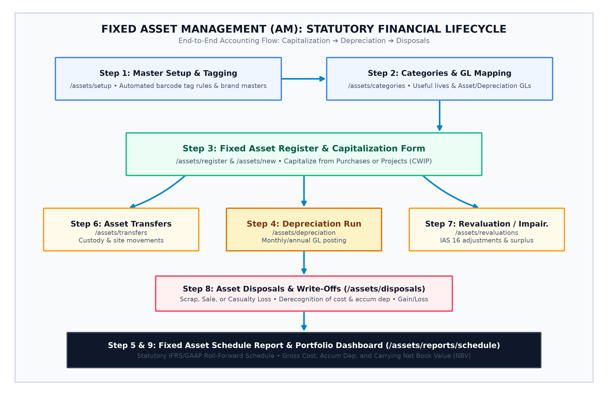
Figure: Fixed Asset Management (AM) Financial Lifecycle — Accounting movement flowchart from Capitalization to Depreciation, Transfers, and Disposal.
Step 1: Master Setup & Tagging Rules
Page URL & Code File | /assets/setup | AssetSetupPage.jsx
Primary User / Role | Asset Accountant / Internal Auditor
Operational Purpose | Configures asset identification standards: Automated Tag Numbering rules (e.g., 'AST-[CAT]-[YEAR]-[SEQ]'), barcode/QR code generation formats, physical site definitions, and manufacturer brand masters.
Process Sequence Logic | Why this step is here: Standardizes asset tagging across the enterprise before assets are registered.
Inputs & Resulting Output | Input: Tag prefix syntax, barcode symbologies, site masters ➔ Output: Automated Tagging Rules Engine. ➔ Next Destination: Step 2: Asset Categories

Step 2: Asset Categories & GL Account Mapping
Page URL & Code File | /assets/categories | AssetCategoriesPage.jsx
Primary User / Role | Financial Controller / Chief Accountant
Operational Purpose | Defines asset classes and links them directly to the General Ledger: Buildings (50 yrs, Straight-Line), Plant & Machinery (10 yrs, Reducing Balance), Motor Vehicles (5 yrs), IT Equipment (3 yrs). Maps Asset Cost GL, Accumulated Depreciation GL, and Depreciation Expense GL accounts.
Process Sequence Logic | Why this step is here: Prevents accounting errors by routing all depreciation, additions, and disposals to predefined GL accounts.
Inputs & Resulting Output | Input: Useful life years, depreciation methods, GL account codes ➔ Output: Validated Asset Categories Master. ➔ Next Destination: Step 3: Fixed Asset Register

Step 3: Fixed Asset Register & Registration Form
Page URL & Code File | /assets/register | AssetRegisterList.jsx & AssetRegisterForm.jsx
Primary User / Role | Fixed Asset Accountant
Operational Purpose | The master financial ledger of capitalized property, plant, and equipment. Assets enter the register from direct purchase invoices or capital project completions. Captures Tag ID, Serial Number, In-Service Date, Cost, Salvage Value, Custodian, and Location.
Process Sequence Logic | Why this step is here: Establishes the opening book value for assets capitalized onto the corporate Balance Sheet.
Inputs & Resulting Output | Input: Capitalization cost, in-service date, tag ID, location ➔ Output: Active Capitalized Asset Master Record. ➔ Next Destination: Step 4: Depreciation Engine

Step 4: Asset Depreciation Engine
Page URL & Code File | /assets/depreciation | DepreciationRunPage.jsx
Primary User / Role | General Ledger Accountant / Financial Controller
Operational Purpose | Executes period depreciation batches (Monthly, Quarterly, Annual). Automatically calculates period depreciation using assigned Straight-Line or Reducing Balance rules, updates Net Book Value (NBV), and posts General Ledger Journal Vouchers (Debit: Depreciation Expense, Credit: Accumulated Depreciation).
Process Sequence Logic | Why this step is here: Amortizes asset value across its useful life in compliance with IFRS and GAAP accounting standards.
Inputs & Resulting Output | Input: Active asset master records, accounting period cutoff date ➔ Output: Posted Depreciation Journal Vouchers. ➔ Next Destination: Step 5: Fixed Asset Schedule Report

Step 5: Fixed Asset Schedule Report (IFRS / GAAP Statutory Audit)
Page URL & Code File | /assets/reports/schedule | FixedAssetScheduleReport.jsx
Primary User / Role | External Financial Auditors / Chief Financial Officer
Operational Purpose | Produces the statutory fixed asset roll-forward movement schedule: Opening Gross Cost + Additions - Disposals +/- Revaluations = Closing Cost. Opening Accumulated Depreciation + Period Charge - Eliminated on Disposal = Closing Depreciation. Final Carrying Amount / NBV.
Process Sequence Logic | Why this step is here: Provides required financial statement disclosures and the primary audit trail for balance sheet fixed assets.
Inputs & Resulting Output | Input: Fiscal year dates, asset transaction ledgers ➔ Output: Statutory Fixed Asset Schedule. ➔ Next Destination: Step 6: Asset Transfers

Step 6: Asset Transfers & Custody Tracking
Page URL & Code File | /assets/transfers | AssetTransfersPage.jsx
Primary User / Role | Internal Auditor / Logistics Officer
Operational Purpose | Tracks physical movements and changes in custody across branches, properties, floors, or assigned employees. Logs sending custodian, receiving custodian, condition at transfer, and maintains an audit trail.
Process Sequence Logic | Why this step is here: Maintains physical custody controls, preventing asset loss, unrecorded relocation, or theft.
Inputs & Resulting Output | Input: Asset Tag ID, destination property/room, receiving custodian ➔ Output: Executed Asset Transfer Certificate. ➔ Next Destination: Step 7: Asset Revaluations

Step 7: Asset Value Adjustments & Revaluations
Page URL & Code File | /assets/revaluations | AssetRevaluationPage.jsx
Primary User / Role | Senior Financial Controller / Chartered Valuation Surveyor
Operational Purpose | Manages asset carrying value adjustments under IAS 16: Upward Revaluations to fair market value (crediting Revaluation Surplus in Equity) or Impairment Losses recognizing severe physical damage or obsolescence (debited to P&L).
Process Sequence Logic | Why this step is here: Ensures balance sheet asset values reflect fair market value and impairments under accounting standards.
Inputs & Resulting Output | Input: Certified valuation survey, impairment appraisal ➔ Output: Posted Revaluation / Impairment Journal Voucher. ➔ Next Destination: Step 8: Asset Disposals

Step 8: Asset Disposals & Write-Offs
Page URL & Code File | /assets/disposals | AssetDisposalsPage.jsx
Primary User / Role | Fixed Asset Accountant / Finance Director
Operational Purpose | Retires assets via Sale, Scrapping, Donation, or Casualty Loss. Eliminates Gross Cost and Accumulated Depreciation from the Balance Sheet, records proceeds received, and posts the resulting accounting Gain or Loss on Disposal.
Process Sequence Logic | Why this step is here: Formally removes retired assets from corporate books and records disposal gains or losses.
Inputs & Resulting Output | Input: Disposal reason, selling price, approval sign-off ➔ Output: Asset Retirement Journal Voucher & Deregistration. ➔ Next Destination: Step 9: Asset Portfolio Dashboard

Step 9: Asset Management Landing & Executive Dashboard
Page URL & Code File | /assets | AssetManagementHome.jsx
Primary User / Role | Chief Financial Officer / Asset Management Director
Operational Purpose | Portfolio financial dashboard displaying Total Active Assets, Gross Historical Cost, Total Accumulated Depreciation, and Portfolio Net Book Value (NBV).
Process Sequence Logic | Why this step is here: Provides executive visibility over corporate balance sheet capital assets.
Inputs & Resulting Output | Input: Real-time asset register and financial ledgers ➔ Output: Executive portfolio balance sheet KPIs. ➔ Next Destination: End of Asset Cycle

PART 5: The Integrated Cross-Module Lifecycle Swimlane
To understand how work moves across departmental boundaries, the swimlane diagram below maps the precise handshakes between Project Management, Finance & General Ledger, Fixed Asset Management, and Facilities Operations across a single physical asset's lifetime.
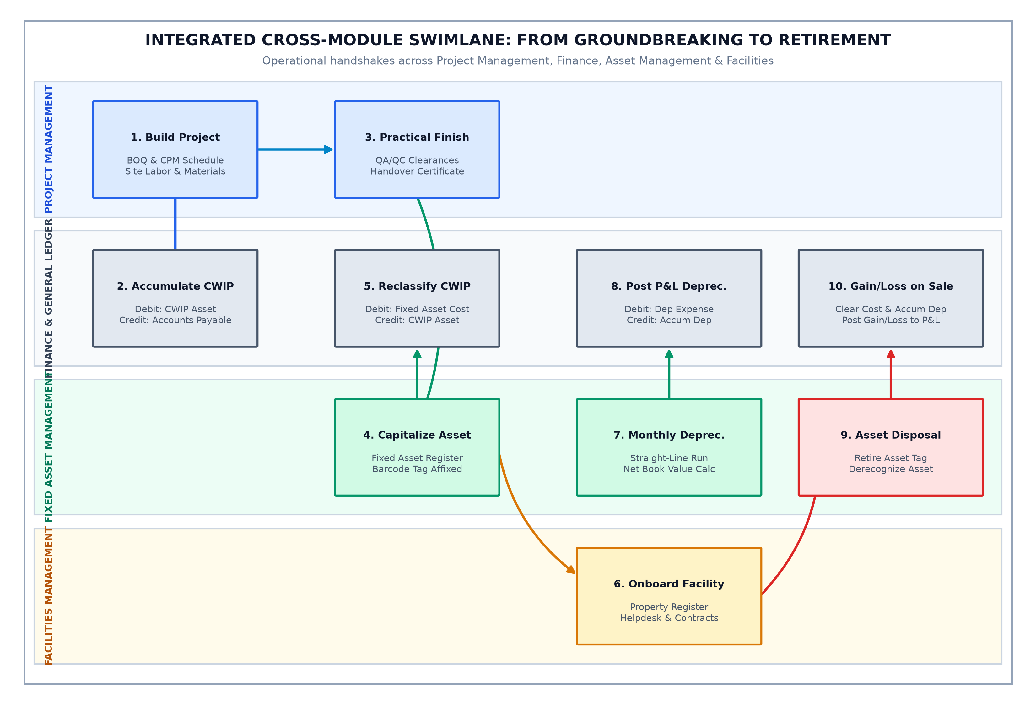
Figure: Cross-Module Enterprise Swimlane — Departmental interactions across Project Management, Finance General Ledger, Fixed Assets, and Facilities Operations.
PART 6: Beginner's Comprehensive Glossary of Technical ERP Terms
Below are straightforward, plain-English definitions of specialized terms used across the three modules:
Term & Acronym | Plain-English Practical Definition
BOQ (Bill of Quantities) | A comprehensive list of every material, labor trade, and machine task needed to complete a project, priced by unit rate (e.g. 100 m³ of concrete at $120/m³).
CPM (Critical Path Method) | A scheduling technique calculating the longest sequence of dependent activities. Activities on the Critical Path have zero float; if one is delayed by 1 day, the entire project completion is delayed by 1 day.
Total Float vs. Free Float | Total Float is the amount of time an activity can slip without delaying the final project deadline. Free Float is the time an activity can slip without delaying the Early Start of its immediate successor.
EVM (Earned Value Management) | A project performance method comparing Planned Budget (PV), Actual Money Spent (AC), and Real Work Completed (EV) to determine if a project is running over-budget or behind-schedule.
CPI (Cost Performance Index) | Measure of cost efficiency: EV divided by AC. Above 1.0 means under-budget (good); below 1.0 means over-budget (cost overrun).
SPI (Schedule Performance Index) | Measure of time efficiency: EV divided by PV. Above 1.0 means ahead of schedule; below 1.0 means delayed.
EAC (Estimate at Completion) | The projected final total cost of a project, calculated using current cost efficiency metrics.
DSR (Daily Site Report) | A daily site log recording weather conditions, workforce headcount, machinery operating, work completed, and site occurrences. Critical evidence in legal claims.
IPA vs. IPC | Interim Payment Application (IPA) is the contractor's monthly bill claiming payment for work done. Interim Payment Certificate (IPC) is the consultant's certified approval confirming the verified amount to be paid.
SLA (Service Level Agreement) | A contractual commitment defining response and resolution times (e.g. Emergency electrical repairs response within 15 minutes, resolution within 2 hours).
CAPA (Corrective Action) | A formal process triggered when an inspection fails: identifying the root cause, executing corrective repairs, and implementing preventive controls to prevent recurrence.
PTW (Permit to Work) | A formal safety document authorizing personnel to perform high-risk work (working at heights, hot work welding, confined spaces) after safety controls are verified.
CWIP (Capital Work-in-Progress) | An asset account accumulating construction costs (materials, labor, plant) while a project is being built, prior to completion and capitalization.
Capitalization | The accounting process of transferring accumulated construction costs out of CWIP and into the Fixed Asset Register as an operational Balance Sheet asset.
Net Book Value (NBV) | The current balance sheet value of an asset: Gross Historical Cost minus Accumulated Depreciation.
Straight-Line vs. Reducing Balance | Straight-Line charges an equal depreciation expense every year across useful life. Reducing Balance charges higher depreciation in early years based on remaining book value.
Revaluation Surplus vs. Impairment | Revaluation Surplus records an increase in asset value to fair market value in equity. Impairment recognizes severe damage or obsolescence, writing down asset value against profit/loss.
PART 7: Financial Double-Entry Accounting Guide (Debit & Credit Ledgers)
A critical strength of an integrated enterprise ERP is that operational events in Project Management, Asset Management, and Facilities Management automatically generate balanced double-entry General Ledger (GL) journal vouchers. Every physical action—pouring concrete, depreciating a chiller, replacing an electrical breaker, or billing a tenant—updates the Balance Sheet and Profit & Loss (P&L) statements in real time.
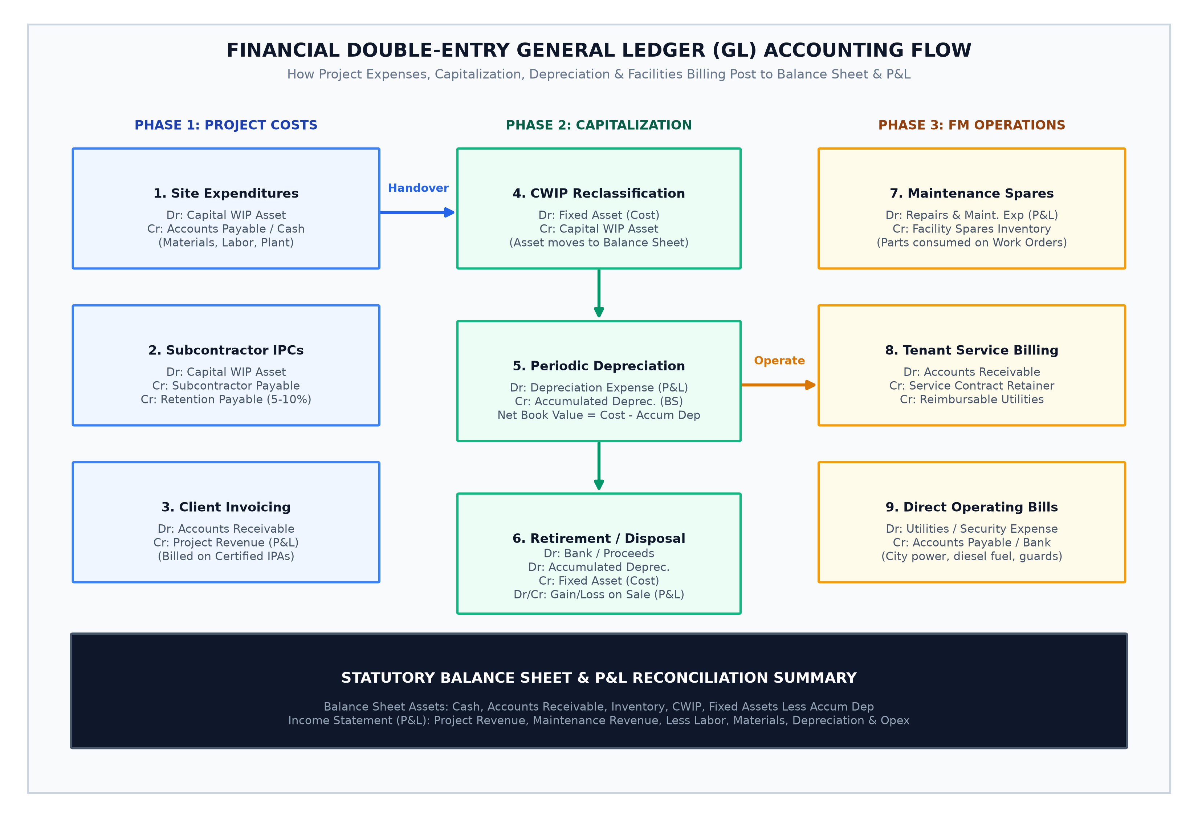
Figure: Financial Double-Entry General Ledger Accounting Flow — How operational events post to Balance Sheet assets, liabilities, and P&L accounts.
The Master ERP Journal Entry Matrix
Below is the standard double-entry accounting matrix governing all transactions across the three modules:
Operational Event | Mod | Debit (Dr) / Credit (Cr) Journal Entries | Accounting & Financial Purpose
1. Issue Site Materials | PM | Dr: Capital WIP - Materials (Asset)  Cr: Stores Inventory (Asset) | Relieves raw materials from inventory and capitalizes them into project construction work-in-progress.
2. Site Labor Timesheets | PM | Dr: Capital WIP - Direct Labor (Asset)  Cr: Accrued Payroll Clearing (Liability) | Capitalizes direct labor hours worked by site workers and engineering staff into project construction costs.
3. Machinery Usage | PM | Dr: Capital WIP - Plant Hire (Asset)  Cr: Equipment Internal Recovery (P&L) | Distributes heavy plant hourly operating costs (cranes, excavators) to specific project work items.
4. Subcontractor IPC | PM | Dr: Capital WIP - Subcontracts (Asset)  Cr: Subcontractor Payable (Liability)  Cr: Retention Payable (Liability) | Certifies monthly subcontractor work, recognizing payable debt while deducting 5-10% retention until defect expiry.
5. Client IPA Invoice | PM | Dr: Accounts Receivable - Client (Asset)  Cr: Project Contract Revenue (P&L) | Billed upon consultant certification of monthly work done, creating legal debtor balance.
6. Client Cash Received | PM | Dr: Bank Cash Account (Asset)  Cr: Accounts Receivable - Client (Asset) | Reconciles cash payment deposited by client into bank against outstanding project invoice.
7. Asset Capitalization | AM | Dr: Fixed Assets - Building (Asset)  Dr: Fixed Assets - Plant & Equip (Asset)  Cr: Capital WIP (Asset) | Project practical completion: reclassifies accumulated construction costs out of CWIP and onto Balance Sheet as Fixed Assets.
8. Depreciation Run | AM | Dr: Depreciation Expense (P&L Expense)  Cr: Accumulated Depreciation (Contra-Asset) | Amortizes asset value across useful life. Net Book Value = Gross Historical Cost minus Accumulated Depreciation.
9. Upward Revaluation | AM | Dr: Fixed Asset Carrying Value (Asset)  Cr: Revaluation Surplus (Equity) | IAS 16 fair value increase: boosts asset balance sheet value and credits equity without touching operating profit.
10. Impairment Loss | AM | Dr: Asset Impairment Loss (P&L Expense)  Cr: Fixed Asset Carrying Value (Asset) | Recognizes catastrophic damage, obsolescence, or market collapse, writing down asset value directly against earnings.
11. Asset Disposal / Sale | AM | Dr: Bank Cash (Proceeds received)  Dr: Accumulated Depreciation (Eliminated)  Cr: Fixed Asset Cost (Eliminated)  Dr/Cr: Loss / (Gain) on Sale (P&L) | Completely removes retired asset and accumulated depreciation from corporate books, posting net gain or loss to P&L.
12. FM Spares Consumed | FM | Dr: Repairs & Maintenance Expense (P&L)  Cr: Facility Spares Inventory (Asset) | Consumes replacement parts (valves, filters, switches) onto an active facility work order.
13. Tenant Service Billing | FM | Dr: Accounts Receivable - Tenants (Asset)  Cr: FM Service Retainer Revenue (P&L)  Cr: Reimbursable Utilities Recovery (P&L) | Invoices commercial tenants for monthly contractual maintenance retainers and metered electrical/water consumption.

PART 8: Master RACI Responsibility Matrix (Governance Model)
A clear division of responsibility prevents operational bottlenecks and compliance lapses. The RACI framework defines decision rights across all three modules:
• R (Responsible): The role that actively executes the step or creates the document.
• A (Accountable): The sole role with final approval authority and ultimate business ownership.
• C (Consulted): Subject matter experts who must provide data, technical specs, or compliance inputs.
• I (Informed): Stakeholders kept updated on progress or outcomes.
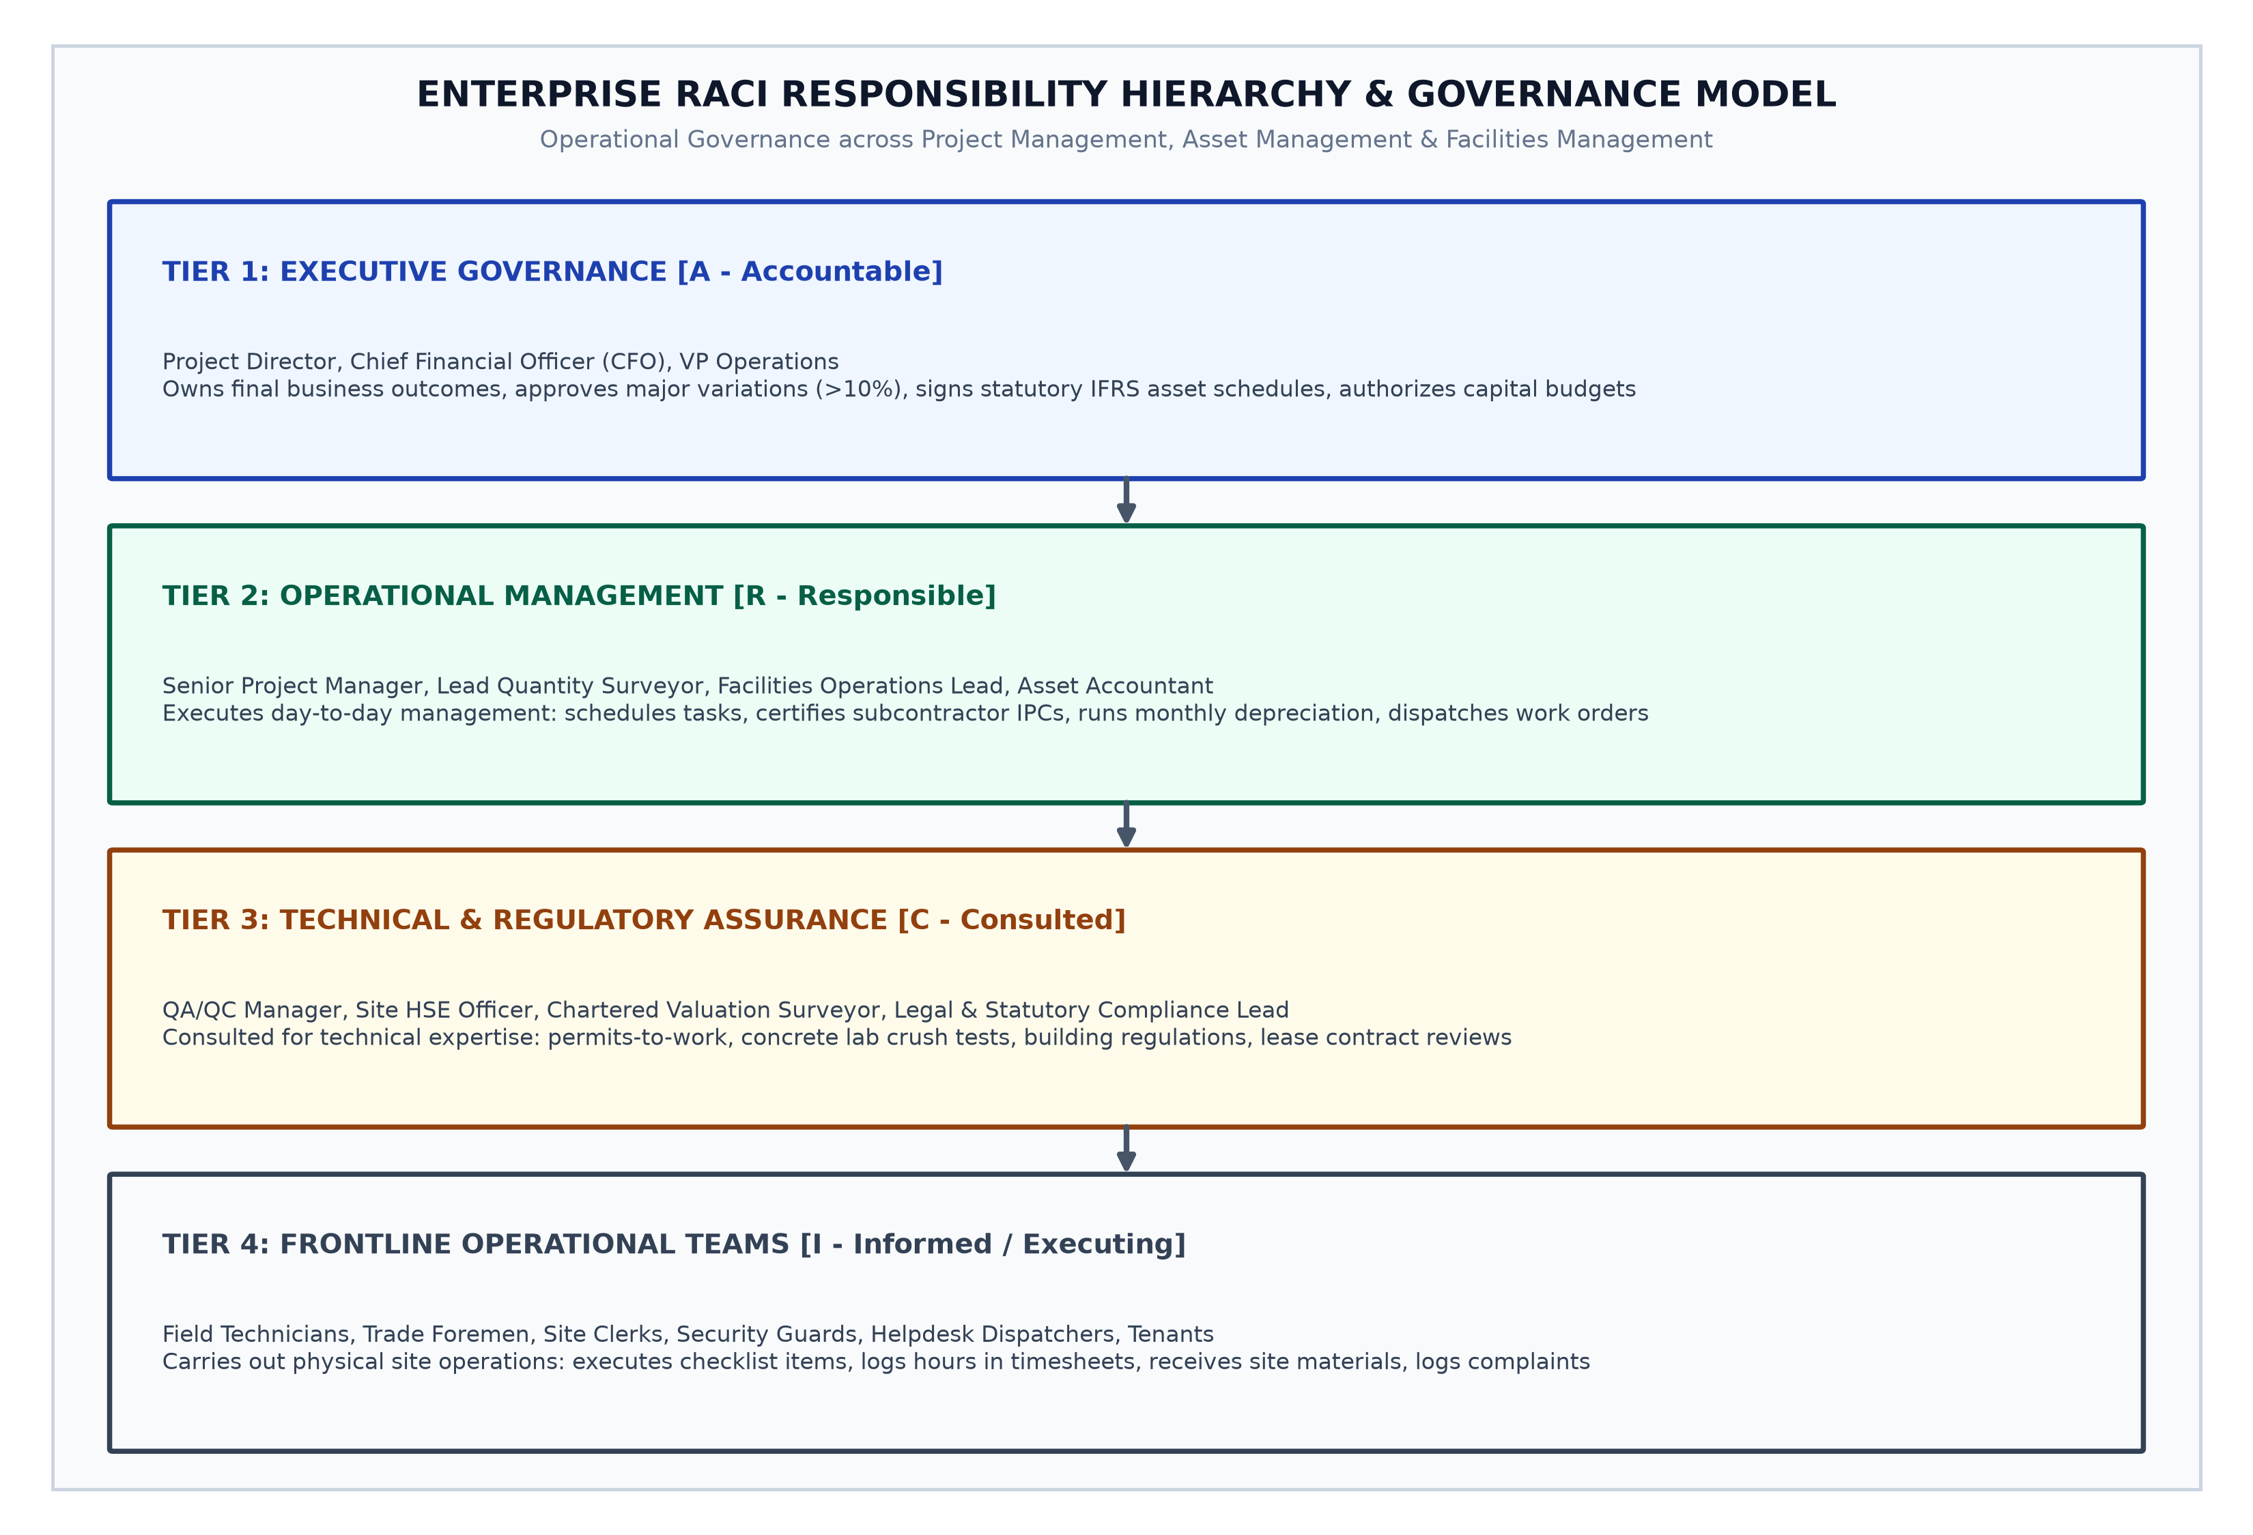
Figure: Enterprise RACI Governance Hierarchy — Four tiers of governance from Executive Leadership to Management, Compliance, and Frontline Teams.
Key Process / Milestone Activity | PM | SE | QS | AC | FM | HSE | HD | TECH
Project Charter & Contract Binding | A | R | C | I | C | I | I | I
Bill of Quantities (BOQ) Build-up | A | C | R | I | C | I | I | I
CPM Schedule & Critical Path Baseline | A | C | R | I | I | C | I | I
Daily Site Report (DSR) & Timesheets | I | R | I | I | I | C | I | I
Quality Inspection (IRs) & NCR Clearance | I | C | I | R | I | C | I | I
Subcontractor IPC Certification | A | C | R | I | C | I | I | I
Client Interim Payment Application (IPA) | A | C | R | I | C | I | I | I
Project Practical Completion & Handover | A | R | C | C | C | C | C | I
Fixed Asset Capitalization & Tagging | C | I | I | R | I | I | I | I
Monthly Asset Depreciation Batch Run | I | I | I | R | I | I | I | I
Statutory Fixed Asset Schedule Report | A | I | I | R | I | I | I | I
Asset Revaluation & Impairment Review | A | I | I | R | C | I | I | I
Asset Retirement & Scrap Disposal | A | I | I | R | I | C | I | I
Property Handover Intake & Space Setup | I | C | I | C | R | C | I | I
Commercial FM Service Contracts & SLAs | A | I | I | C | R | I | I | I
Helpdesk Ticket Triage & SLA Dispatch | I | I | I | I | I | I | R | I
FM Work Order Field Execution | I | I | I | I | A | C | I | R
FM Spare Parts Material Utilization | I | I | I | I | A | I | I | R
Site Safety Inspections & CAPA Audits | I | I | I | I | A | R | I | C
Tenant Facilities Service Billing | I | I | I | C | R | I | I | I

PART 9: Practical Step-by-Step Real-World Execution Scenarios
To bridge the gap between theory and day-to-day work, this section walks through four realistic corporate scenarios demonstrating exactly how users execute work across the software screens.
Scenario A: Fast-Track Commercial Construction Project (PM Execution)
📌 Scenario A Context
Apex Properties awards your firm a contract to construct a $2.4M regional warehouse facility. Total planned duration: 180 working days.

1. Bid Quotation & Order Binding: The Senior Estimator opens /pm/quotations, builds direct labor, concrete, steel, and plant estimates, applying a 15% margin ($2.4M). Upon receiving the client's Letter of Award, the contract administrator converts it into an active Project Order at /pm/project-orders.
2. WBS & Bill of Quantities Baseline: The Quantity Surveyor opens /pm/boqs, importing the 450-line itemized BOQ (Substructure, Superstructure, Roofing, MEP). Rates and quantities are baseline-locked.
3. Critical Path Scheduling: The Project Planner opens /pm/schedule. They input dependencies: Foundation Curing (7 days) must finish before Steel Portal Frame Erection starts. The CPM engine flags Steel Frame as zero-float Critical Path. Key milestones are established at /pm/milestones.
4. Site Mobilization & Daily Diary: Groundbreaking begins. The Site Foreman opens /pm/daily-reports every afternoon, logging weather (clear), 42 workers present, and concrete pour volumes. Machinery hours for the mobile crane are entered at /pm/equipment-logs.
5. Materials Supply Chain: The site engineer submits a Purchase Requisition at /pm/purchase-requisitions for 60 tonnes of rebar. When delivered, the storekeeper records the Goods Receipt at /pm/material-receipts. As ironworkers install it into the foundations, the engineer posts Material Utilization at /pm/material-utilizations, debiting CWIP.
6. Quality Inspection & Subcontractor IPC: Before the concrete pour, the engineer submits an Inspection Request (IR) at /pm/quality-control. The consultant inspects and signs off. The piling subcontractor submits their monthly bill; the QS certifies the Interim Payment Certificate at /pm/subcontracts, deducting 10% retention.
7. Client Monthly Valuation & Invoicing: On day 30, the QS and client consultant jointly measure work completed: 18% physical progress. The QS opens /pm/client-valuations, inputs certified quantities ($432,000), and generates the formal Interim Payment Application (IPA) at /pm/payment-applications. Finance generates the commercial invoice at /pm/project-invoices.
8. Practical Handover: On day 175, all snag items are cleared. The project manager conducts the final handover walkthrough, generates the Practical Completion Certificate, and prepares the file for Asset Capitalization.
Scenario B: Capital Handover, Fixed Asset Tagging & Property Onboarding (The Bridge)
📌 Scenario B Context
The $2.4M warehouse construction is complete. The building must now be transferred onto the corporate Balance Sheet and onboarded for commercial operations.

1. CWIP Capitalization Reconciliation: The Financial Controller reviews the project ledger: Total accumulated CWIP = $2,380,000 (Direct materials $1.1M, labor $480k, plant $320k, subcontractors $480k). The project finished $20,000 under budget!
2. Asset Classification: The Asset Accountant navigates to /assets/categories to verify asset classes: 'Industrial Buildings' (useful life 40 years, straight-line) and 'Heavy MEP Plant' (useful life 15 years, reducing balance).
3. Capitalization & Barcode Tagging: The accountant opens /assets/new. They capitalize the building at $2,000,000 (Tag AST-BLD-2026-001) and the central HVAC/transformer plant at $380,000 (Tag AST-PLT-2026-001). The system automatically reclassifies $2,380,000 from Capital WIP to Fixed Asset Cost.
4. Property Onboarding: The Facilities Manager navigates to /facilities/onboarding. They step through the 12-point intake checklist: verifying fire safety occupancy permits, water discharge certificates, electrical single-line diagrams, operating manuals, and master keys.
5. Property & Space Registration: The building is registered at /facilities/properties as 'Regional Logistics Hub A'. The Space Planner opens /facilities/space-occupancy to zone the facility into Warehouse Bay 1, Bay 2, and Admin Office Suites.
6. Monthly Depreciation Kick-Off: At month-end, the GL accountant navigates to /assets/depreciation and runs the batch. The engine automatically debits Depreciation Expense and credits Accumulated Depreciation, posting the journal voucher to the General Ledger.
Scenario C: Emergency HVAC Breakdown & Reactive Tenant Billing (FM Operations)
📌 Scenario C Context
At 10:15 AM on a hot summer Tuesday, a major chilled water pipe joint ruptures in the 3rd-floor server room of an executive office tenant. Water threatens electrical racks.

1. Helpdesk Ticket Intake: The tenant logs into /facilities/helpdesk reporting 'CRITICAL: Chilled water pipe burst in Server Room B'. System detects priority 'EMERGENCY' and immediately starts the 15-minute response SLA countdown clock.
2. Immediate Dispatch: The dispatcher receives the alert, opens /facilities/tasks/new, and assigns Senior MEP Technician Kwame Mensah with a 15-minute target arrival.
3. Field Arrival & Safety Isolation: At 10:24 AM (9 minutes—well within SLA!), the technician arrives, opens /facilities/tasks/execution on his mobile tablet, clocks in, isolates the sectional ball valve, and takes photos of the damaged gasket.
4. Spare Part Requisition: The technician needs a 4-inch high-pressure EPDM flange gasket. He opens /facilities/material-requisitions. The site storekeeper issues the part from inventory.
5. Repair Execution & Client Sign-Off: Kwame installs the new gasket, torque-bolts the flange, restores water pressure, tests for leaks, and takes post-repair photos. The tenant facility manager inspects the server room and signs the digital tablet screen.
6. Material Utilization & CAPA Inspection: Kwame logs 2 hours labor and 1 gasket used at /facilities/material-utilizations. The Safety Officer opens /facilities/inspections, logs a CAPA investigation, and orders ultrasonic pipe wall thickness testing on adjacent joints.
7. Commercial Billing: Because the pipe rupture was caused by tenant third-party server installers bumping the pipe, the contract rules it billable out-of-scope. Billing Specialist opens /facilities/servicebilling/new, automatically pulls Kwame's labor hours ($160) and gasket ($45), applies markup, and generates an invoice to the tenant.
Scenario D: Year-End Financial Audit, Asset Schedule & Revaluation
📌 Scenario D Context
Corporate fiscal year-end close. External auditors (PwC) arrive to audit the company's $45M Fixed Asset portfolio, WIP capitalizations, and maintenance expense allocations.

1. Statutory Fixed Asset Schedule: The Asset Controller opens /assets/reports/schedule and generates the statutory IFRS/GAAP Fixed Asset Movement Matrix for the fiscal year. The report proves full balance sheet integrity:
Opening Gross Cost ($41.2M) + Capex Additions ($4.5M) - Asset Disposals ($0.7M) = Closing Cost ($45.0M).
Opening Accumulated Dep ($12.1M) + Period Charge ($2.8M) - Disposals Eliminated ($0.5M) = Closing Accum Dep ($14.4M).
Net Book Value (NBV) = $30.6M. The auditors verify the figures match the General Ledger trial balance exactly.
2. Asset Impairment Testing: An older commercial generator experienced catastrophic alternator burnout during a storm. Repair is uneconomical. The accountant opens /assets/revaluations, records an Impairment Loss of $45,000, and writes down the asset's book value to scrap salvage.
3. Asset Disposal Execution: The damaged generator is sold to a certified recycler for $4,000 cash. The accountant opens /assets/disposals, logs the transaction, and the system automatically posts the gain/loss derecognition journal entry.
4. PM EVM Final Audit: The PMO Director opens /project-management/reports/project-status, verifying that all closed projects have their cost variance (CV) and schedule variance (SV) reconciled.

PART 10: Standard Operating Procedures (SOPs) & Pre-Flight Checklists
To maintain operational quality and audit readiness, teams must execute these four standardized pre-flight checklists:
SOP 1: Construction Site Pre-Mobilization Checklist
No. | Verification Checkpoint & Action Item | Target Responsible Role
1 | Client Project Order legally executed and signed (/pm/project-orders) | Contracts Manager
2 | Approved Bill of Quantities (BOQ) imported and baseline budget locked (/pm/boqs) | Lead Quantity Surveyor
3 | CPM Schedule generated with critical path and working calendar validated (/pm/schedule) | Project Planner
4 | Contractual project milestones agreed with client consultant (/pm/milestones) | Project Manager
5 | Site HSE Risk Assessment completed and safety induction materials prepared (/pm/safety) | Site HSE Officer
6 | Initial bulk materials Purchase Requisitions submitted for early works (/pm/purchase-requisitions) | Project Engineer
7 | Trade Subcontractor agreements signed with retention terms (/pm/subcontracts) | Commercial Manager
8 | Approved Issued For Construction (IFC) drawings verified in document register (/pm/documents) | Document Controller
9 | Daily Site Report (DSR) logging protocol established with site clerks (/pm/daily-reports) | Site General Foreman
10 | Advance payment bank guarantee submitted and payment application logged (/pm/payment-applications) | Finance Director

SOP 2: Facility Handover & Property Onboarding Checklist
No. | Verification Checkpoint & Action Item | Target Responsible Role
1 | Final architectural and MEP As-Built CAD/PDF drawings archived (/facilities/onboarding) | Handover Lead
2 | Statutory Fire Safety, EPA discharge permits, and Lift operating certificates uploaded (/facilities/compliance) | Compliance Lead
3 | Physical property, building, floor, and zone hierarchy structured (/facilities/properties) | Property Manager
4 | Space layouts, office suites, and tenant lease agreements registered (/facilities/space-occupancy) | Space Planner
5 | Client/Tenant service contracts and SLA response policies mapped (/facilities/contracts & /sla-policies) | Commercial Manager
6 | Preventive maintenance checklist templates configured for technical plant (/facilities/checklists) | Chief Engineer
7 | Utility meters (electricity, water, diesel) read, recorded, and baseline logged (/facilities/utilities-energy) | Energy Manager
8 | Key management register established and access zones programmed (/facilities/security) | Security Chief
9 | Cleaning, technical, and security workforce shift rosters published (/facilities/workforce) | Operations Lead
10 | Helpdesk ticketing portal opened and tenant welcome briefing conducted (/facilities/helpdesk) | Helpdesk Lead

SOP 3: Periodic Fixed Asset Physical Barcode Audit Checklist
No. | Verification Checkpoint & Action Item | Target Responsible Role
1 | Current active capitalized asset listing exported from register (/assets/register) | Asset Accountant
2 | Barcode / QR code scanning scanners calibrated with asset tagging rules (/assets/setup) | Internal Auditor
3 | Physical wall-to-wall scan conducted by location (Floor, Room, Zone) | Audit Field Team
4 | Unrecorded physical asset transfers identified and logged (/assets/transfers) | Logistics Officer
5 | Damaged, obsolete, or broken assets flagged for impairment testing (/assets/revaluations) | Valuation Lead
6 | Unlocatable missing assets flagged for formal loss investigation | Security Lead
7 | Capital additions during period verified against CWIP completion certificates | Project Accountant
8 | Asset physical condition ratings updated in master register | Fixed Asset Lead
9 | Physical inventory reconciled with Balance Sheet Net Book Value (NBV) | Financial Controller
10 | Audit sign-off certificate issued for external financial auditors | Chief Financial Officer

SOP 4: Month-End Operational & Financial Close Checklist
No. | Verification Checkpoint & Action Item | Target Responsible Role
1 | All site labor timesheets approved and locked for payroll processing (/pm/timesheets) | Site Clerks / PM
2 | All site material utilization entries posted against BOQ tasks (/pm/material-utilizations) | Site Engineers
3 | Subcontractor interim payment certificates certified and retention deducted (/pm/subcontracts) | Quantity Surveyor
4 | Client monthly valuation measurement signed and IPA invoice issued (/pm/payment-applications) | Commercial Manager
5 | Project Cost Control EVM dashboard metrics (CPI, SPI, EAC) computed (/pm/cost-control) | Cost Controller
6 | Asset monthly depreciation batch run executed and GL journal vouchers posted (/assets/depreciation) | Asset Accountant
7 | Fixed Asset roll-forward schedule report balanced against Trial Balance (/assets/reports/schedule) | General Ledger Lead
8 | Facilities maintenance material consumption posted to property expense ledgers (/facilities/material-utilizations) | FM Supervisor
9 | Tenant utility sub-meter readings entered and monthly service bills issued (/facilities/servicebilling) | Billing Specialist
10 | Facilities actual operational expenses reconciled against annual property budget (/facilities/budgeting-finance) | Finance Controller

