**DEDAN KIMATHI UNIVERSITY OF TECHNOLOGY**

**SCHOOL OF COMPUTER SCIENCE AND INFORMATION TECHNOLOGY**

**PROJECT DOCUMENTATION FOR FINAL YEAR IN:**

**BACHELOR OF SCIENCE IN BUSINESS AND INFORMATION TECHNOLOGY**

**BY:**

**NAME: STARNLEY KIOKO MWANGE**

**REGISTRATION NUMBER: C027-01-1090/2021**

**PROJECT TITLE**

**MACHINE LEARNING MODEL FOR TRAUMA DETECTION AMONG CHILDREN**

**DEDAN KIMATHI UNIVERSITY**

**SUPERVISOR**

**ELIZABETH MUTUA**

**This final documentation was submitted to the Department of Information of Technology in the School of Computer Science and Information Technology in partial fulfillment of the requirements for the award of degree in Bachelor of Science in Information Technology at the Dedan Kimathi University of Technology.**

**August 2024**

Contents

**List of Figure** iv

**DECLARATION** v

**Abstract** vi

**CHAPTER ONE: INTRODUCTION** 1

**1.1 Background** 1

**1.2 Statement of the Problem** 2

**1.3 Objectives** 3

**1.3.1. General Objective:** 3

**1.3.2. Specific Objectives:** 3

**1.3.3. Research Questions** 3

**1.4. Justification** 4

**1.5 Scope** 5

**CHAPTER TWO: LITERATURE REVIEW** 7

**2.1 Introduction** 7

**2.2 Case Studies** 7

**2.2.1 Case Study 1: Trauma Detection Algorithm (TDA)** 7

**2.2.2 Case Study 2: Behavioral Analysis System for Trauma (BAST)** 8

**2.2.3 Case Study 3: Child Trauma Detection AI (CTDAI)** 8

**2.3 Causes of Trauma in Children** 9

**2.4 Summary** 13

**2.5 Research Gap** 14

**CHAPTER THREE: METHODOLOGY** 15

**3.1 Introduction** 15

**3.2 Fact-Finding Techniques** 15

**3.3 Software Design - Software Development Procedures** 16

**3.4 Preliminary Data Processing and Analysis** 18

**3.4.1 Data Acquisition Steps:** 19

**3.4.2 Data Cleaning:** 19

**3.4.3 Exploratory Data Analysis (EDA):** 19

**3.4.4 Feature Selection:** 19

**CHAPTER FOUR: SYSTEM DESIGN AND ANALYSIS** 20

**4.1 Requirements Analysis** 20

**4.1.1 Functional Requirements** 20

**4.1.2 Non-Functional Requirements** 20

**4.1.3 System Users, Inputs, and Outputs** 21

**4.2 Feasibility Analysis** 22

**4.2.1 Economic Feasibility** 22

**4.2.2 Technical Feasibility** 23

**4.2.3 Operational Feasibility** 23

**4.3 Data Analysis** 23

**4.4 System State Diagrams** 26

**CHAPTER FIVE: IMPLEMENTATION AND TESTING** 31

**5.1 Introduction** 31

**5.2 Design Screens** 31

**5.2.1 Login Page** 31

**5.2.2 Registration Page** 32

**5.2.3 Doctors Dashboard** 33

**5.3 Testing** 34

**5.3.1 Unit Testing** 34

**5.3.2 Integration Testing** 34

**5.3.3 Validation Testing** 35

**CHAPTER SIX: RECOMMENDATION AND CONCLUSION** 36

**6.1 Introduction** 36

**6.2 Performance Comparison** 36

**6.3 Challenges** 36

**6.4 Recommendations** 37

**6.5 Conclusion** 37

**REFERENCES** 39

# **List of Figure**

Figure 1 Sample Dataset 16

Figure 2 Software flowchart 17

Figure 3 Sequence Diagram 18

Figure 4 Stages of Trauma 24

Figure 5 Experienced Trauma 24

Figure 6 Specific Traumatic Event 25

Figure 7 Current Trauma detection systems 25

Figure 8 Likely to Recommend Our System 26

Figure 9 Class Diagram 27

Figure 10 Use case Diagram 28

Figure 11 Sequence Diagram 29

Figure 12 Flowchart Diagram 30

Figure 13 Login page 31

Figure 14 Registration Page 32

Figure 15 Doctors Dashboard 33

Figure 16 Patients Dashboard 33

Figure 17 Unit Testing 34

Figure 18 Integration Testing 35

# **DECLARATION**

I hereby declare that this project submitted for the Bachelor of Science in Business Information Technology Degree is my original work and that the project has not formed the basis for an award of any degree, diploma, or any other similar titles.

FULL NAME: STARNLEY KIOKO MWANGE

SIGNAURE: _______________________

DATE:

This project has been submitted for examination with my approval as a university supervisor.

SUPERVISOR NAME: ELIZABETH MUTUA

SIGNATURE: ______________________

DATE:

# **Abstract**

Childhood trauma poses a significant global challenge, impacting children worldwide. In Kenya, the prevalence of childhood trauma is alarmingly high, with statistics indicating that approximately 62% of children in Kenya have experienced at least one form of traumatic event, such as physical abuse, sexual assault, or exposure to violence. Additionally, inadequate access to mental health services further exacerbates the impact of trauma on Kenyan children, with only 1.83 mental health workers available per 100,000 people in the country.

Childhood trauma can manifest in various stages, each with its unique characteristics and impacts on a child's development and well-being. The initial stage may involve the occurrence of a traumatic event, such as witnessing violence or experiencing abuse, which can lead to immediate distress and emotional upheaval. Subsequent stages may include symptoms of re-experiencing the trauma, avoidance behaviors, negative changes in mood and cognition, and alterations in arousal and reactivity. Without timely intervention, these symptoms can persist and escalate, significantly impairing the child's functioning and quality of life.

The proposed project seeks to develop a sophisticated system leveraging machine learning models and intelligent tools to detect signals of extreme traumatic episodes in children. Current techniques often fall short in achieving precise and time-efficient detection of severe-stage trauma, risking delayed diagnoses and therapeutic interventions. Statistical analysis reveals a concerning prevalence of childhood trauma cases globally, with a significant portion concentrated in regions like Kenya.

Through advanced algorithms and computing techniques, the project aims to provide clinicians with a reliable tool for fast and accurate identification of severe trauma in children. By bridging the gap in current methodologies and enhancing sensitivity to subtle signs and patterns indicative of severe trauma, the project seeks to improve healthcare outcomes for children globally. Specifically, the project addresses the unique challenges faced by African communities, where limited healthcare resources and social issues exacerbate the impact of childhood trauma.

The research emphasizes the importance of tailoring interventions to local contexts, recognizing the diverse backgrounds and needs of children worldwide. By focusing on the specific circumstances in Kenya and other regions, the project contributes to the global efforts to address and mitigate the impact of childhood trauma. Statistical insights underscore the urgency of implementing effective interventions to support traumatized children and improve their overall well-being.

In conclusion, this project presents a transformative approach to childhood trauma detection and management, leveraging advanced technology and a comprehensive understanding of global and local dynamics. Through collaborative efforts and innovative methodologies, the project aims to empower healthcare professionals worldwide to provide timely and precise interventions for the benefit of children globally.

# **CHAPTER ONE: INTRODUCTION**

## **1.1 Background**

Childhood trauma is a ubiquitous health problem that claims this world’s sanctity and thus requires whole-hearted intervention accorded to it (Murphy & Luthar, 2022). The objectives of the proposed research endeavor are based on a profound understanding of the nature of the problem among children globally. Despite that, the topic is of global concern we prove that there are lots of difficulties to overcome in providing healthcare education and intervention strategies for different countries.

Since the global impact of childhood trauma has been indicated (Collin-Vézina et al., 2020), which is not a problem limited by geographical boundaries, this study gets out of the mere regional scope and tends to advance the universal discourse on childhood trauma. The main study population involves a pediatric setting, and exploration of the socioeconomic diversity of childhood in different regions will help to identify and understand the evolution of severe-staged trauma in children across various regions.

In Kenya, children are undergoing traumas day in and day out, with causes like poverty, and violence, and without enough mental health services to help. The fact that trauma is one of the main problems among Kenyan children makes the seniority of development of early detection and intervention strategies which will be adjusted to the local reality a higher priority. The aim of this is to check out the individual difficulties arising in Kenya as well as other nations around the world that can add to a broader process on the advancement of the discrimination apparatus worldwide.

The incorporation of top-notch Machine Learning approaches by technology represents the dedication to moving beyond the drawbacks of traditional methodologies in building a healthier world (El-Shafeiy et al, 2023). My research will be built on the concept of artificial intelligence and Machine Learning models that process a wealth of information to eventually design a complex framework of global child trauma diagnosis by capturing the tiniest parameters and patterns.

Altering necessarily an up-to-date research procedure this way is vital to accomplish the goals which are more important than just professional empowerment but also a provision of health care to those regions where it is not possible with available resources. This will make a call to transformative change in the field of childhood trauma intervention. It proposes a bigger picture of systemic forces and an integration of the smartness of artificial intelligence and data-intensive findings. In this novel idea, healthcare professionals throughout the world obtain sturdier arsenals to eventually ensure the implementation of immediate and intelligently tailored interventions, which may develop ultimately into the best interest of young society all around the world.

## **1.2 Statement of the Problem**

Childhood trauma, a sophisticated and prevailing public health emergency that is a worldwide phenomenon, should be treated with utmost care and also the creation of new innovative ways (Tomlinson et al., n.d.). Even current approaches, intended for the detection of severe stage traumatic injuries in children, face major drawbacks, like precision and speed. This shortcoming may consequently lead to bottlenecks in possibly some of the most crucial phases, which are diagnosis and treatment in the end; all this might have severe effects on unsafe monitoring in the global health scene.

Contemporary methods which at the time were dominant in locating the prevalence of trauma failed to achieve the best outcomes which in the end disoriented the nature of influential interventions on a global level. The limitations of current methods, which can be seen in the complexity of childhood trauma,(McDermott et al., 2023) become phase just in the things details and nuanced patterns which are often left out or are interpreted inaccurately for the public across the different regional and cultural contexts.

That leads to a very limited number of cases being identified at the onset of severe trauma stages in the medical field worldwide and consequently delays the opportunity to deliver the required assisting interventions in time. These delays not only negatively affect the present health situation of those kids but in turn, can have a negative global impact on children's health and wellbeing. This project is governed by the awareness of the need to address the present difficulties and technologies for the early detection of trauma worldwide.

The actualized issues with accuracy and efficiency in the traditional approaches shed light on the imperative viability of a reliable and timely system that healthcare professionals can confidently trust for decision-making that has regard to international(Israel Edem Agbehadji et al., 2023).

This proposed system breaks through the boundaries of current techniques. It is not just an advanced technology to improve the accuracy in ascertainment of severe-stage trauma, but it also plays an important role in time-saving. The whole medical community will benefit from the operations since patients' lives will be valorized.

The basic issue is in the incapability of modern medical theories to adapt to the complexity of the children's trauma hence leading to misdiagnoses, delayed treatments, and even the future consequences of the victims across the different parts of our world. With this in account, the project proposes the development of a novel and superior-tech approach that uses artificial intelligence and Machine Learning algorithms and techniques around the globe. This aims primarily to provide a new model to contend with traffic accidents in detection, which from the conventional way of thinking in our area, exceeds this world in its ability to comprehend and handle a set of large data that leads to accurate processing.

The problem statement determines the next step which is to reshape severely impaired children's trauma detection practices at a global level. This seen system, developed and implemented, will not only close the gaps in providing such services but will also provide current healthcare professionals with a proactive tool that further strengthens the early identification of severe-stage trauma, hence, the positive impact on reducing the level of mortality in children worldwide.

## **1.3 Objectives**

### **1.3.1. General Objective:**

To develop a Machine Learning model for the early detection of severe-stage trauma in children.

### **1.3.2. Specific Objectives:**

i. To do a review of the existing Machine Learning models for trauma detection among children.

ii. To review causes of trauma in children.

iii. To develop a Machine Learning model for trauma detection among children

iv. To perform an analysis of the performance of my model with existing models.

v. To recommend interventions for identified trauma cases.

### **1.3.3. Research Questions**

i. What are the key features and methodologies employed in existing Machine Learning models for trauma detection among children?

ii. What are the primary causes of trauma in children across different demographic, socio-economic, and cultural contexts?

iii. What specific characteristics and functionalities should be integrated into a novel Machine Learning model to enhance its efficiency and accuracy in detecting trauma among children?

iv. How does my developed model compare with existing models?

v. What are the most effective interventions for addressing trauma in identified cases?

## **1.4. Justification**

This is crucial and it hangs on the shoulders of the need to curb the imperfections that immediately arise when one uses other existing methodologies for trauma detection in children (Bowman, 2022). Presently, tactics that can succeed, while irreplaceable, are still constrained by the limitations of their accuracy and timeliness and, hence, may not result in the intended directness. Though this research is focused on the development of an advanced and particular tool addressing these challenges exactly is its aim with this prospective solution having great impact.

**Addressing Methodological Limitations:**

Given the fact that the current patient detection methods could be faulty for severe-stage trauma in children, (El-Gendy et al., 2023) might not be able to capture subtle and nuanced signs. Our study focuses on the complicated nature of kids' trauma through using a Machine Learning model that is more advanced level and more effective than traditional techniques. Through this, diagnosis of the technological innovation attempts is to be established which health institutions can use in deciphering intricate patterns as well as thereby improving the tolerance for human errors during the trauma prediction.

**Improving Patient Outcomes:**

The main aim of this research project is the development of a new medication that will also aim at children who have trouble sleeping due to psychological trauma (Zheng et al., 2024). One of the goals of the project is the development of an up-to-date system that can serve to speed up the identification of trauma cases. Based on this, it will be possible to conduct early diagnosis and perform timely interventions. The study seeks to address the trauma effect on children by offering early detection and timely intervention. This would be through recognizing the sign patterns and assessing individual needs early enough to manage the potential long-term effects of trauma and ensure better well-being and development in these children.

**Empowering Healthcare Professionals:**

Scientists and clinicians are the core stakeholders that stand to benefit the most from this research. Moreover, with a readily validating diagnostic tool to differentiate between genuine symptoms and mimics of trauma, experts in the field will have the capability to make quick and good judgments (Alex, 2024). This Power does matter here, particularly in areas where Healthcare services might be remote or scanty. The purpose of the research is to fill the gap between technological innovation and real-life healthcare applications in resource scarcity, hence professionals in such settings would get to use the most developed tools that could increase their capability when contrasted to others.

**Contributing to the Global Discourse:**

Aside from the current purposes that it serves, it also adds to the worldwide repertoire of investigations concerning the subject matter of child abuse (Lerner, 2022). The project is a piece of the puzzle as it serves as a factor in the talk that targets the enhancement of healthcare interventions for the vulnerable as it brings an up-to-date Machine Learning model that caters to children's needs. The research is in line with the whole world's movement to consolidate quality healthcare, proving the desire to get involved in updated techniques that can be used worldwide.

In summary, the justification for this research lies in its potential to revolutionize the landscape of trauma detection, offering a more nuanced and effective approach. The envisioned tool has the power to bring about positive changes not only in the accuracy of detection but, more importantly, in the lives and well-being of children who have experienced severe-stage trauma.

## **1.5 Scope**

To establish a deep learning-based approach to the early-stage identification of trauma severity in kids on a planetary scale (Segal et al., 2020). The area of impact though extends beyond one area and is not limited to the specific regions but rather takes into account urban and rural areas across the planet. The participants in this project are elementary school children aged 2 through 17 who have a history of trauma along their various cultural and socio-economic backgrounds and geographic locations.

Through extending the area of the study to the global level the research looks at the particular challenges and peculiarities that each geographical zone is faced with as the research is aimed at capturing data generated from different social and cultural contexts. (Barboza et al., 2020) The Machine Learning model I propose would be flexible and universally applicable to the clinical settings that differ between regions in the world. This would guarantee that its effectiveness and usability are not restricted to a specific context.

It means a global vision that assumes the fact that trauma happens to children is true in all settings worldwide but not without cultural and contextual differences which should be recognized. The purpose of the current research program is to contribute to the coming-up of a Machine Learning model that can be applied to any medical facility across the globe, giving an early and timely diagnosis for severe-stage trauma in children worldwide.

# **CHAPTER TWO: LITERATURE REVIEW**

## **2.1 Introduction**

Detection of child trauma has been accomplished by a wide range of methodologies, consisting of screening tools, behavioral observation, and emerging technologies like Artificial Intelligence of communication Robot (Simeoli et al., 2024). This article is the literature review that highlights the existent system the flaws and provides the foundation for an upcoming development of the Machine Learning model.

## **2.2 Case Studies**

### **2.2.1 Case Study 1: Trauma Detection Algorithm (TDA)**

TDA is the Machine Learning algorithm that was created to determine the extent of trauma in children 6-17 years old (Singh et al., 2023). The questions are developed specifically and the algorithm used helps in the analysis of the responses to the set questions. The TDA has proven applicable in many professional situations like in physicians' offices, schools, and child care provision agencies.

**Strengths of Trauma Detection Algorithm (TDA)**

1. High Accuracy: Rigorous testing has proven that TDA provides highly precise results so the researchers believe that the detection of trauma occurs with reliability.

2. Efficient: The process can give brief tests and hence it brings attention to both the child and the professional using the instrument.

3. User-Friendly: The established process of TDA is designed to be quickly and easily administered by a generic profile without any rigorous training.Weaknesses of Trauma Detection Algorithm (TDA).

**Weaknesses of Trauma Detection Algorithm (TDA)**

i.Limited Scope: TDA is not able to identify all types of traumas or all individual trauma experiences. Although it can effectively assess the symptoms, there might be a chance it might not be able to pick the types of traumas or individual experiences of trauma.

ii. Dependency on Self-Report: The model relies on those childhood traits of recalling and disclosing mentally painful events of the past, thus causing self-report bias which may be false.

iii. Diagnostic Confirmation Required: While TDA is an important screening measure, further assessment is needed to confirm the outcome of the diagnosis.

### **2.2.2 Case Study 2: Behavioral Analysis System for Trauma (BAST)**

The Behavioral Analysis System for Trauma (BAST) is an advanced Machine Learning model focused on observing and analyzing children's behavior for signs of trauma (Ramos-Lima et al., 2020). It is particularly beneficial for younger children who may struggle to express their experiences verbally.

**Strengthens of Behavioral Analysis System for Trauma (BAST)**

i.Complementary to Other Methods: BAST's observations provide valuable insights in conjunction with screening tools or self-report assessments.

ii. Non-Verbal Cue Analysis: Trained professionals using BAST can identify subtle signs of distress that may not be expressed verbally.

iii. Adaptable Approach: BAST's flexible approach can be tailored to different settings and age groups.

**Weaknesses of Behavioral Analysis System for Trauma (BAST)**

i.Subjectivity: Interpretation of behavior in BAST can be subjective and prone to bias, especially if untrained personnel are involved.

ii. Resource-Intensive: Implementation of BAST requires trained professionals and dedicated time for effective observation.

iii. Limited Insight into Specific Causes: While BAST identifies observable behavior, it may not pinpoint the exact source of trauma.

### **2.2.3 Case Study 3: Child Trauma Detection AI (CTDAI)**

Child Trauma Detection AI (CTDAI) is an emerging technology designed to analyze children's language and communication patterns for indicators of distress or trauma. (Flanagan et al., 2020)

**Strengths of Child Trauma Detection AI (CTDAI)**

i.Accessibility and Scalability: CTDAI can potentially reach a wider range of children, especially in resource-limited settings.

ii.Continuous Monitoring: The system provides 24/7 availability for continuous monitoring and potential early detection of distress.

iii.Objective Analysis: CTDAI can analyze language patterns and communication objectively, minimizing human bias.

**Weaknesses of Child Trauma Detection AI (CTDAI)**

i.Unproven Effectiveness: CTDAI is still in its early stages, and further research is required to determine its efficacy in detecting trauma.

ii. Ethical Concerns: Privacy and data security considerations are crucial when using AI with children, requiring careful ethical considerations.

iii. Limited Understanding of Context: CTDAI might misinterpret language nuances and cultural differences, leading to potential inaccuracies in assessments.

## **2.3 Causes of Trauma in Children**

**1. Psychological, Physical, or Sexual Abuse**

i. Psychological Abuse: Includes verbal abuse (Newton, 2021), emotional manipulation, and other forms of non-physical aggression that can damage a child's self-esteem and emotional well-being.

ii. Physical Abuse:Involves physical harm or injury to the child through hitting, beating (Newton, 2021), burning, or other forms of violence.

iii. Sexual Abuse: Encompasses any form of sexual activity or exploitation involving a child (Hinds & Giardino, 2020), including molestation, rape, or forced involvement in pornography.

**2. Community or School Violence**

i. Community Violence: Exposure to violent crimes or gang-related activities in their neighborhood (Krakowski, 2021).

ii. School Violence: Includes bullying, (Miller, 2023)physical fights, or shootings within the school environment.

**3. Witnessing or Experiencing Domestic Violence**

i. Witnessing Domestic Violence: Seeing a parent or caregiver being physically or emotionally abused (Stiller et al., 2021).

ii. Experiencing Domestic Violence: Directly being the target of violence within the home (Meyer et al., 2021).

**4. Natural Disasters or Terrorism**

i. Natural Disasters: Events like hurricanes, earthquakes, floods, and wildfires that cause physical and emotional devastation (Saeed & Gargano, 2022).

ii. Terrorism: Acts of terrorism that create fear and anxiety, (Rigutto et al., 2021)whether experienced directly or through media exposure.

**5. Commercial Sexual Exploitation**

i.Sex Trafficking: Forced involvement in prostitution or pornography (Noval et al., 2023).

ii. Labor Trafficking: Coerced labor in various forms, (Letsie et al., 2021) often involving exploitation and abuse.

**6. Sudden or Violent Loss of a Loved One**

i. Sudden Loss: Unexpected death of a family member or close friend due to accidents, heart attacks, (Carlsson et al., 2021)or other sudden events.

ii. Violent Loss: Death resulting from murder, (Wilson et al., 2022) suicide, or other forms of violence.

**7. Serious Accidents or Life-Threatening Illness**

i. Serious Accidents: Traumatic experiences from car crashes, falls, (Flaherty & Taylor, 2022)or other accidents causing severe injury.

ii. Life-Threatening Illness: Diagnoses of severe illnesses like cancer (Leszcz, 2020), requiring intense medical treatment and causing significant emotional stress.

**Summary**

Children experiencing these traumatic events may suffer from a range of emotional, psychological, and physical consequences, impacting their development and well-being. Early intervention and support are crucial to help them cope and heal.

**Stages of Trauma in Children, Their Characteristics, and Possible Solutions or Interventions**

**1. Anger** - Anger as a stage of trauma involves intense emotional responses including frustration, rage, and irritability. Children may struggle to control their emotions and often direct their anger towards others, sometimes blaming them for their distress.

**Characteristics:**

i.Outbursts of rage, frustration, irritability, and aggression.

ii. Difficulty controlling emotions.

iii. Often blaming others.

**Solutions/Interventions:**

i.Therapy

ii. Anger management

iii. Support groups

iv. Mindfulness techniques

v. Physical activities to channel energy

**2. Sadness -** Sadness is characterized by deep feelings of sorrow and hopelessness. Children may withdraw from activities they once enjoyed, cry frequently, and exhibit signs of depression as they grapple with their trauma.

**Characteristics:**

i.Feelings of hopelessness.

ii. Tearfulness.

iii. Withdrawal from activities.

iv. A sense of deep sorrow.

**Solutions/Interventions:**

i.Counseling

ii.Emotional support

iii. Medication

iv. Engaging in hobbies

iv. Connecting with loved ones

**3. Acceptance -** Acceptance occurs when children begin to acknowledge the trauma and its impact on their lives. This stage is marked by a sense of calm and readiness to move forward, often leading to a more proactive approach to healing and recovery.

**Characteristics:**

i.Acknowledgment of the trauma and its impact.

ii. A sense of calm.

iii. Readiness to move forward.

**Solutions/Interventions:**

i.Mindfulness

ii. Support networks

iii. Therapy

iv. Developing new goals

v.Engaging in positive activities

**4. Denial -** In the denial stage, children refuse to accept the reality of the traumatic event. They might avoid thinking or talking about it, behaving as though it never happened. This is a defense mechanism to cope with overwhelming emotions.

**Characteristics:**

i.Refusal to accept the reality of the trauma.

ii. Avoidance of thoughts or discussions about it.

iii. Acting as if it didn’t happen.

**Solutions/Interventions:**

i.Counseling

ii.Education about trauma

iii.Peer support

iv.Gradual exposure to trauma-related thoughts

v.Encouraging open communication

**5. Bargaining -** Bargaining involves children attempting to make deals or promises to reverse or mitigate the trauma. They may feel guilt and look for ways to regain control, often by thinking of "if only" scenarios where they believe different actions could have prevented the trauma.

**Characteristics:**

i.Attempting to make deals or promises to reverse or mitigate the trauma.

ii. Often feeling guilt or seeking ways to regain control.

**Solutions/Interventions:**

i.Therapy

ii. Support groups

iii. Stress management

iv. Journaling

v. Reflecting on personal strengths

## **2.4 Summary**

The part of the systematic literature review that keeps drawing attention is the achievements in the field of child trauma detection that are being used currently for such purposes as detection using screening tools, behavioral observation, and emerging technologies. Though this has been done so, it still illuminates the importance of a workable strategy that should be centered on early-stage trauma detection, especially in times of crisis. Present existing methods are not successful enough to catch soft signals of severe childhood trauma. This calls for a new direction of thinking that (will) take us toward an effective solution.

It is in light of these challenges that this Machine Learning solution is proposed and its prognostic value comes to the fore. Employing modern algorithms, the model is going to be used to eliminate the existing biases. Furthermore, healthcare professionals will have a better diagnostic tool which will help to identify the severe level of trauma earlier and to diagnose it more accurately. The current limitations of the research methods are targeted to overcome through which this research will heavily contribute a lot to part of childhood trauma detection.

After that, the essay goes for research gaps and proposed methodology to highlight the wake of innovation in the model, which is particularly important and highly valuable to the wider discussion on trauma detection in children

## **2.5 Research Gap**

Despite the notable progress documented in existing literature, there is a glaring void in the exploration of a holistic machine-learning solution specifically tailored for the detection of severe-stage trauma in children(Silvia Maria, 2021). Prevailing studies predominantly concentrate on screening tools, behavioral observations, and emerging technologies, inadvertently neglecting the integration of Machine Learning to enhance accuracy and efficiency in severe-stage trauma detection.

The unique intricacies and challenges associated with severe trauma cases in children necessitate a specialized approach, a critical aspect that has been inadequately addressed in current research pursuits. This discernible research gap highlights the innovation and significance inherent in introducing a machine-learning model explicitly designed for severe-stage trauma detection. This model is poised to make a noteworthy contribution to the existing body of knowledge, underscoring its potential to fill a critical void and advance the understanding and capabilities in the realm of childhood trauma detection.

# **CHAPTER THREE: METHODOLOGY**

## **3.1 Introduction**

Here, the methodology section which lays the foundation for training the Machine Learning model that provides an acute assessment of child injuries in severe stages (Dweekat et al., 2023) is given in detail. It specifies a thorough and transparent plan to allow a precise execution of a characterized model that is reliable and efficient.

## **3.2 Fact-Finding Techniques**

To set up a transversal dataset, a multi-year fact-finding approach is adopted. The creation of data involves working with the clinics, hospitals, and trauma centers (Nkurunungi,2024). The dataset is dynamic because it consists of multiple sources such as health records in the range from electronic to paper records, incident descriptions, and narratives from clinical staff among others. Moreover, we conduct face-to-face interviews with healthcare professionals (e.g. pediatricians, psychologists, and trauma experts) thereby contributing to a detailed narrative account of the situations that lead to trauma in children. Diverse origins of data are the ones that represent all cases of the severe stage undesirably in children.

Below is a representation of the data set that I will be using for my machine-learning development

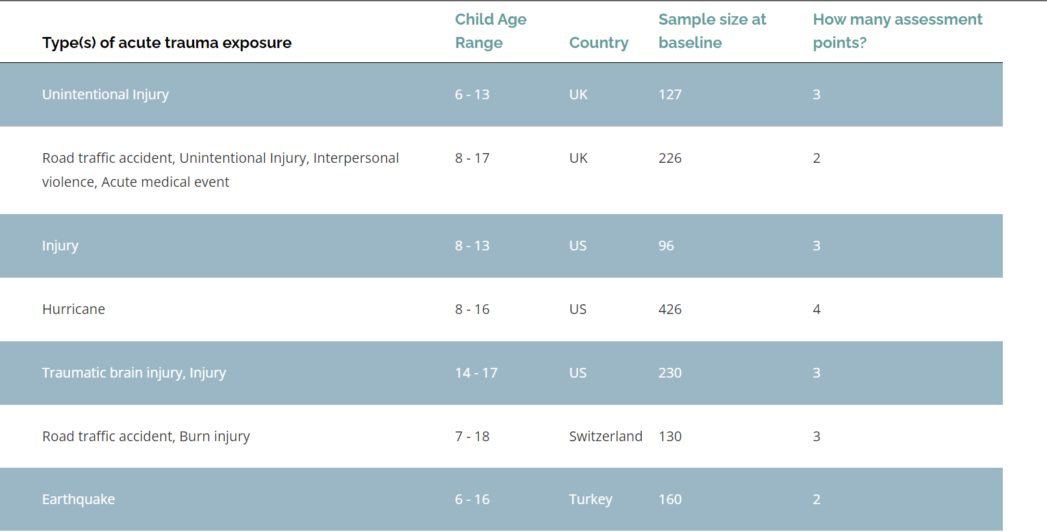

Figure 1 Sample dataset

## **3.3 Software Design - Software Development Procedures**

Software development and design processes are built on an iterative and collaborative approach. Initially, such kind of architecture is developed that is supposed to handle the multifaceted algorithms related to critical traumatic detection. User-friendly interfaces that users are accustomed to using are developed in collaboration with health professionals making the device's interaction simple and effective. Development life thus includes the implementation of appropriate practices, the use of rigid methodologies where a way of delivering functionality in short iterations with frequent capabilities testing is supported, different feedback loops, and adjusting to changing requirements.

The continuous refinement such as adaptability and scalability of the Machine Learning model is underscored to cater to different healthcare settings. Below is a flowchart showcasing how the software would be operating.

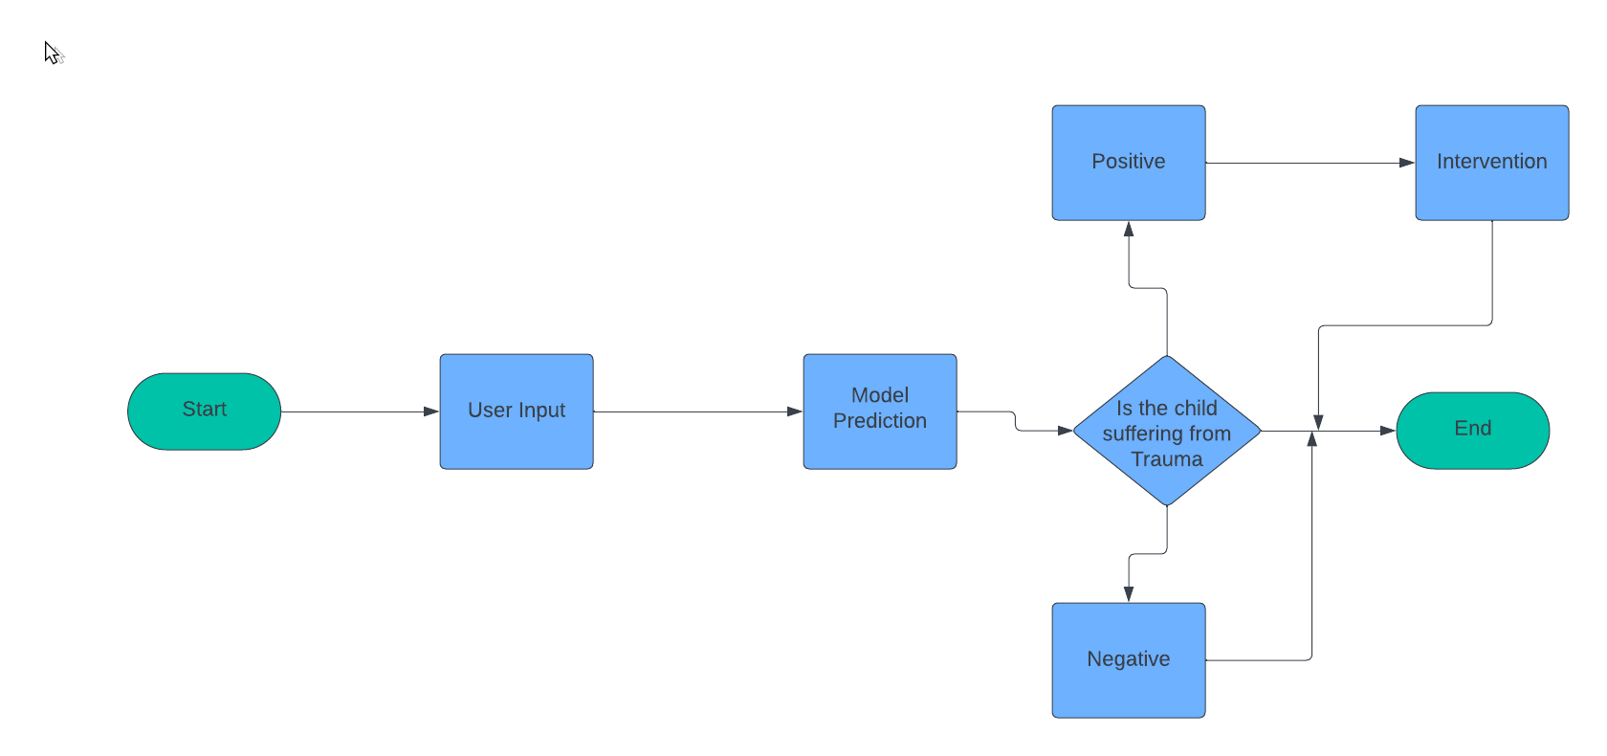

Figure 2 Software flowchart

The end software would be working as shown below in a sequence diagram.

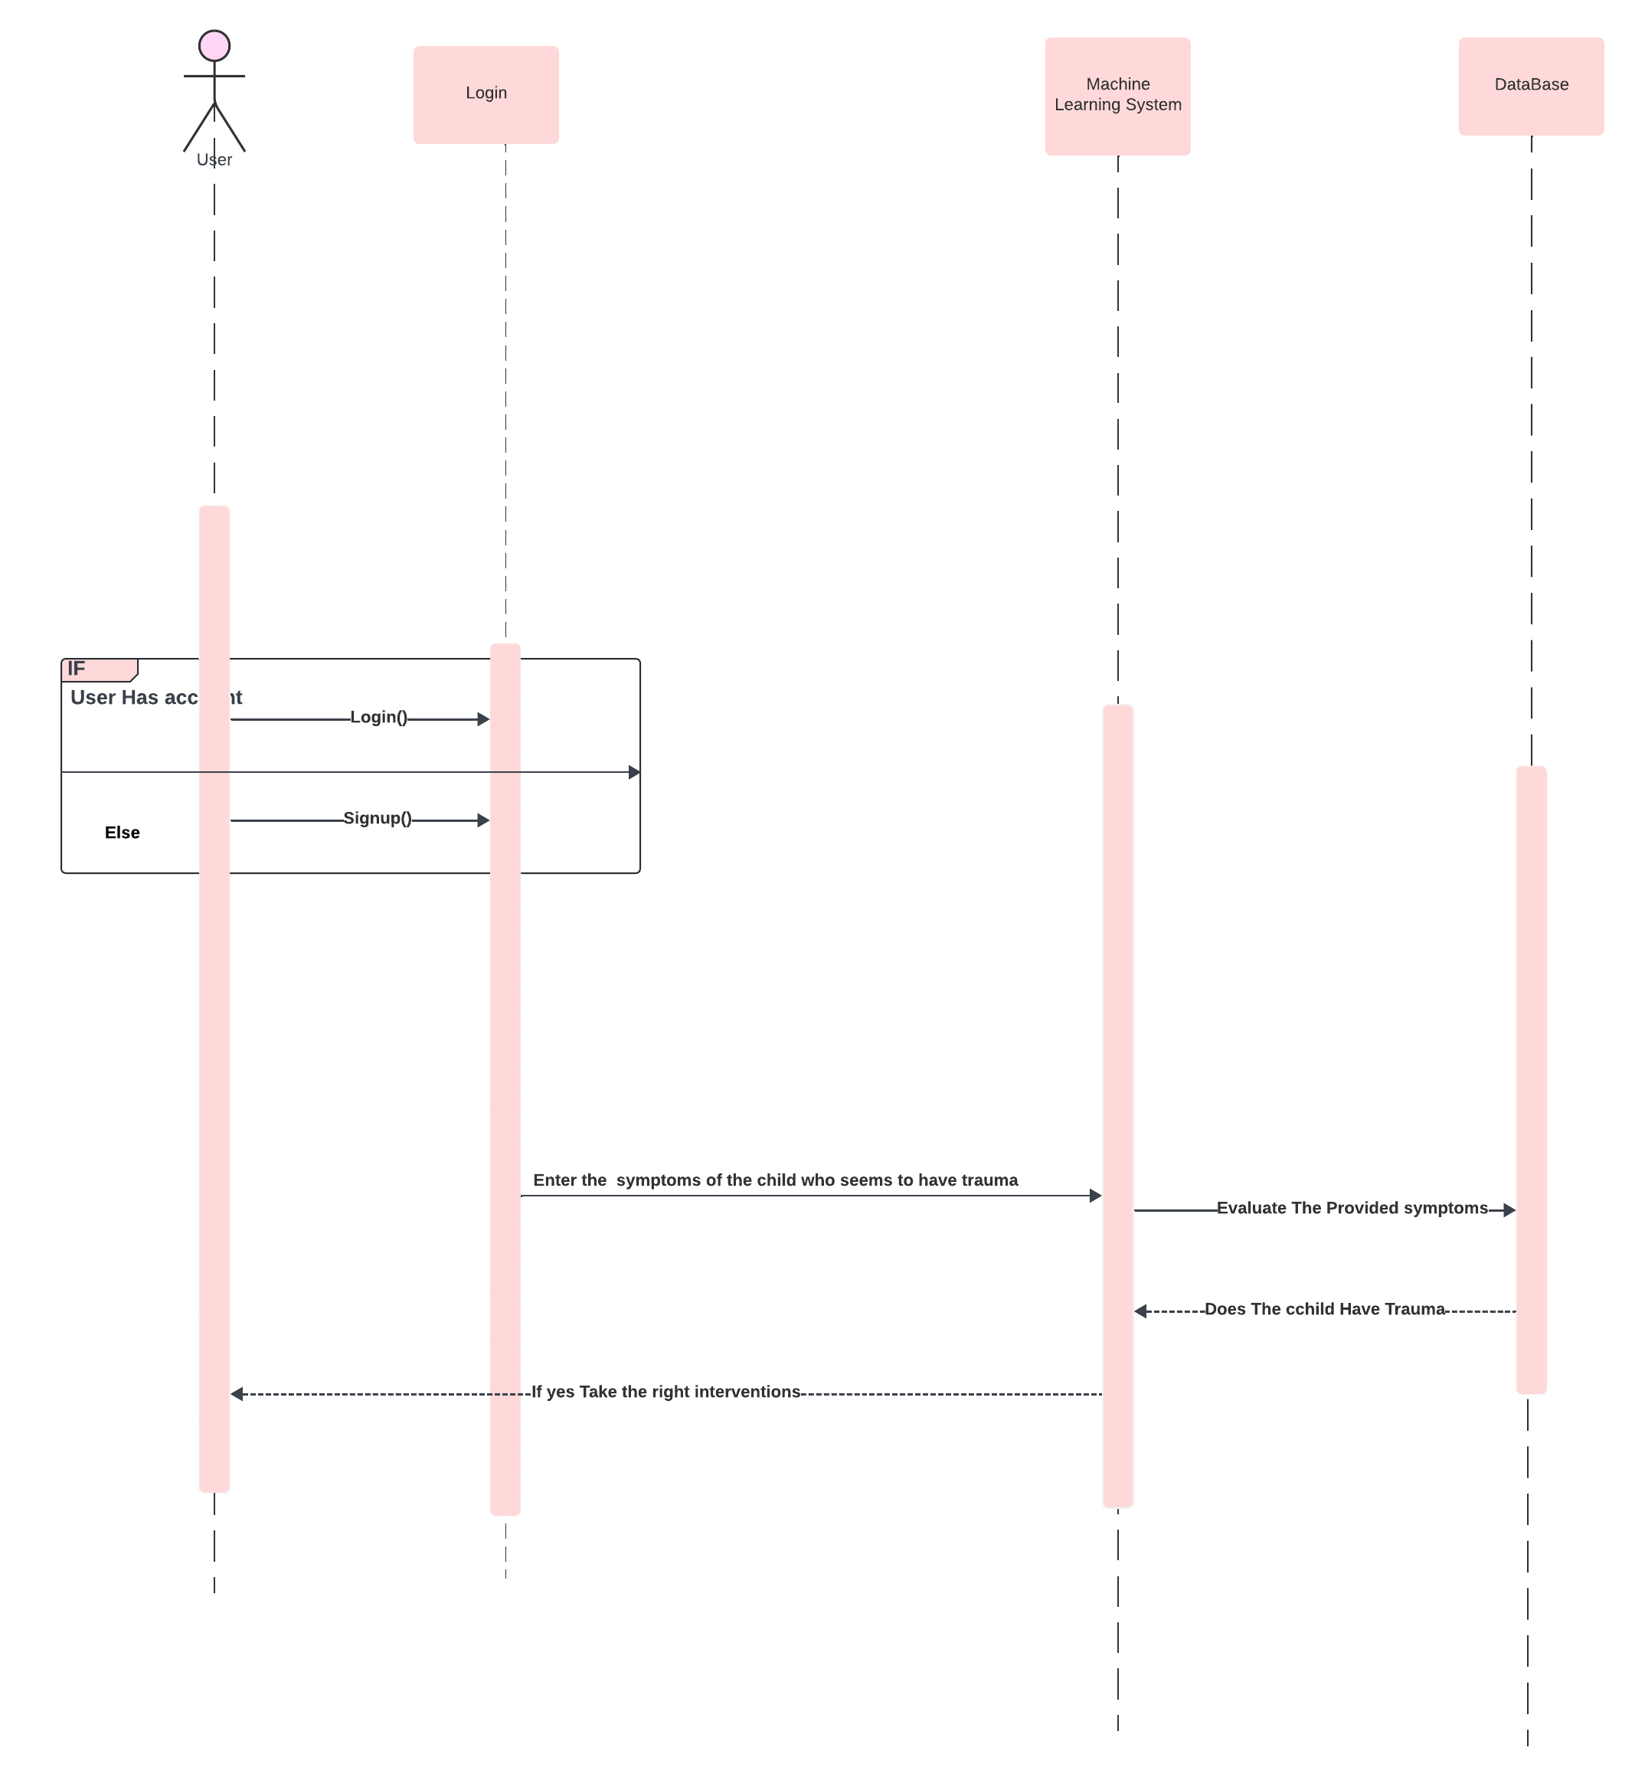

Figure 3 Sequence Diagram

## **3.4 Preliminary Data Processing and Analysis**

The dataset undergoes a series of meticulous steps to ensure its integrity and suitability for model training:

### **3.4.1 Data Acquisition Steps:**

**i. Data Compilation:** Integration of diverse data sources, including electronic health records, incident reports, and clinical databases.

**ii. Consent and Ethics:** Ensuring compliance with ethical standards and obtaining informed consent for data utilization.

**iii. Standardization:** Homogenizing data formats and units for consistency.

### **3.4.2 Data Cleaning:**

**i. Missing Values Handling:** Employing appropriate techniques for addressing missing data to prevent bias.

**ii. Outlier Detection and Removal:** Identifying and addressing outliers that may skew model training.

### **3.4.3 Exploratory Data Analysis (EDA):**

**i. Descriptive Statistics**: Calculating summary statistics to understand the dataset's central tendencies and variations.

**ii. Visualization:** Employing graphical representations to identify patterns, trends, and potential relationships within the data.

### **3.4.4 Feature Selection:**

**i.Correlation Analysis:** Assessing relationships between variables to identify redundant features.

**ii. Domain Expert Consultation:** Collaborating with healthcare professionals to identify critical indicators of severe-stage trauma.

# **CHAPTER FOUR: SYSTEM DESIGN AND ANALYSIS**

## **4.1 Requirements Analysis**

Requirement analysis is a crucial process that encompasses the development of software specifications aimed at effectively communicating the system needs from users to system developers. It entails creating high-level, abstract statements outlining the services the system should offer or constraints it must adhere to.

### **4.1.1 Functional Requirements**

Functional requirements are essential to define the functionalities the system must perform. The primary functional requirements for the proposed Machine Learning model for detecting severe-stage trauma in children include:

1. The user must register and login

2. The user can view the different stages of trauma listed.

3. The user can fill in the symptoms of a potential trauma case.

4. The user can see the predicted trauma stage.

5. The system should provide trauma severity predictions based on the input data.

6. The system must provide user-friendly interfaces for healthcare professionals to interact with the system, including inputting data and viewing predictions.

7. The system must propose possible interventions.

### **4.1.2 Non-Functional Requirements**

Non-functional requirements focus on the system's operational qualities. The key non-functional requirements include:

**1. Performance efficiency:**

1.Optimize system performance to handle a large number of simultaneous users.

2.Ensuring quick response times and efficient processing.

**2. Scalability :**

1.Design the platform to be capable of accommodating a growing number of users.

2.Allowing for future expansion without degradation of service.

**3. Reliability :**

1.Ensure a high level of system reliability with minimal downtime and a low probability of service interruptions

2. The platform should operate as expected to build trust among users.

**4. Usability :**

1. Ensure that users can easily understand and interact with the system

2. Focuses on providing an intuitive and straightforward user experience.

### **4.1.3 System Users, Inputs, and Outputs**

#### **System Users:**

**1. Healthcare Professionals**

Includes doctors, nurses, and mental health specialists.

Role: feeding information on potential trauma cases and interpreting the predictions.

**2. IT Support**

Role: Maintaining the system

Ensuring the system runs smoothly and addresses technical issues.

**System Processes:**

**1. User Registration**

Process: Users register by providing the necessary details.

Collects essential user information to create accounts.

**2. User Login**

Process: Login to the systems after registration

Verifies user identity for secure access.

**3. View Possible Trauma stages and their characteristics.**

Process: Users can access a brief understanding of the various trauma stages and their characteristics.

**4. Feed in possible symptoms of a possible trauma case.**

Process: Users fill in the trauma symptoms.

Gathers detailed information necessary for accurate prediction.

**5. See the predicted trauma stage.**

Process: Offers recommendations for potential treatment or support.

**6. See listed possible intervention**

Process: Users verify the suggested interventions.

**System Inputs:**

**1. User Registration details**

Users are to provide necessary information during the registration process and any additional information required.

Collects data such as names, contact information, and professional credentials.

**2. Trauma symptoms**

Feed the system the trauma symptoms.

Includes data on observed symptoms and patient history.

**System Outputs:**

**1. Trauma Severity Predictions:**

The system provides predictions on the severity of trauma based on input symptoms.

It helps healthcare professionals understand the potential trauma stage.

**2. Possible Interventions:**

Lists suggested interventions based on the predicted trauma stage.

Aids in planning appropriate care and treatment strategies.

## **4.2 Feasibility Analysis**

The feasibility analysis ensured that the system was legally and technically feasible as well as economically justifiable. It was used to validate assumptions, constraints, decisions, and approaches.

### **4.2.1 Economic Feasibility**

The economic feasibility assessment for the severe-stage trauma detection system in children delves into the financial aspects of the project, aiming to identify the profitability of the investment anticipated. Critical factors in this evaluation include cost and time, as they play pivotal roles in the viability of the project. A thorough analysis indicates that the available financial capacity is sufficient to proceed with the implementation, aligning with the economic goals and objectives of the severe-stage trauma detection system in children.

### **4.2.2 Technical Feasibility**

The technical feasibility examination encompassed a comprehensive study of the severe stage detection system in children, considering input, processes, output, fields, programs, and procedures. This scrutiny aimed to ascertain the availability of suitable technology for the system. The evaluation confirms that the technology chosen for the development of this system aligns seamlessly with the smartphones commonly used by users, ensuring compatibility and a smooth user experience.

### **4.2.3 Operational Feasibility**

Operational feasibility in the context of the severe stage trauma detection system among children revolved around assessing the system's capability to effectively address challenges and solve problems. The evaluation focused on measuring how well the new system could overcome existing issues, ensuring that its implementation brings about operational improvements and resolves pertinent issues within the mental health domain.

## **4.3 Data Analysis**

This is the analysis of the data collected during fact-finding. Before the data is analyzed it is cleaned by checking missing responses and inaccurate data to eliminate unnecessary and inaccurate analysis. From the survey contact, it was evident that there is a need for a severe-stage trauma detection system in children. Here below is the analysis of responses received during fact-finding:

To start with an analysis of different stages of trauma as identified by respondents.

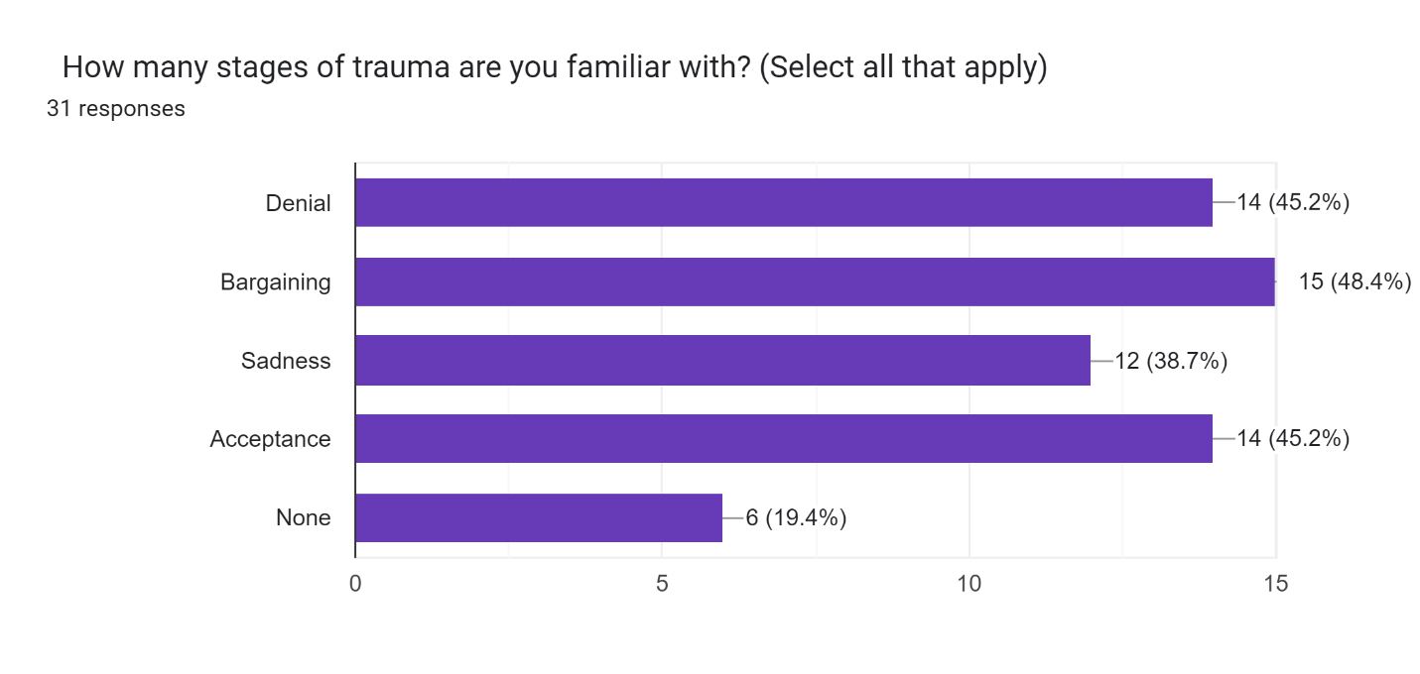

Figure Stages of Trauma

Insights into the prevalence and personal experiences of trauma among respondents.

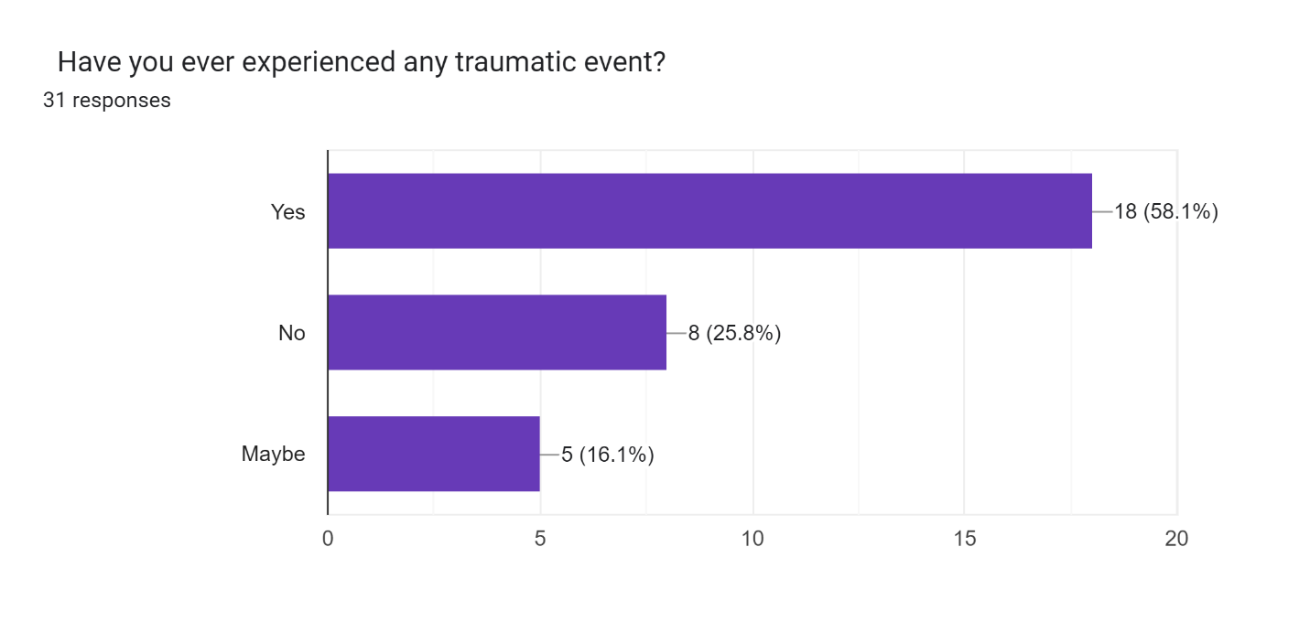

Figure Experienced Trauma

Details about specific events that triggered trauma in children.

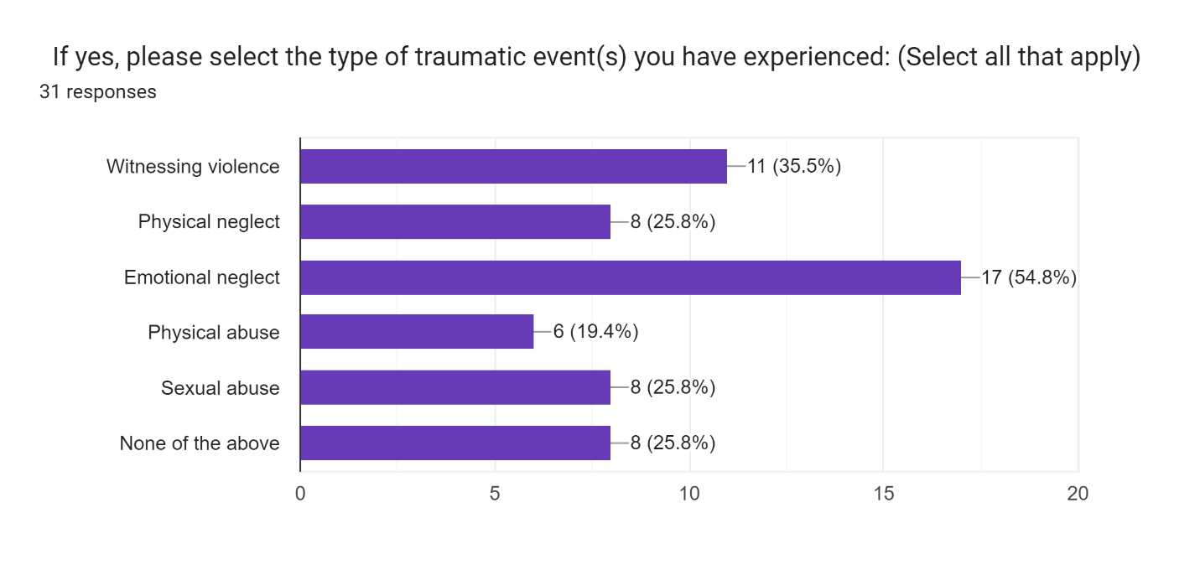

Figure Specific Traumatic Event

Assessment of the effectiveness and limitations of current trauma detection systems.

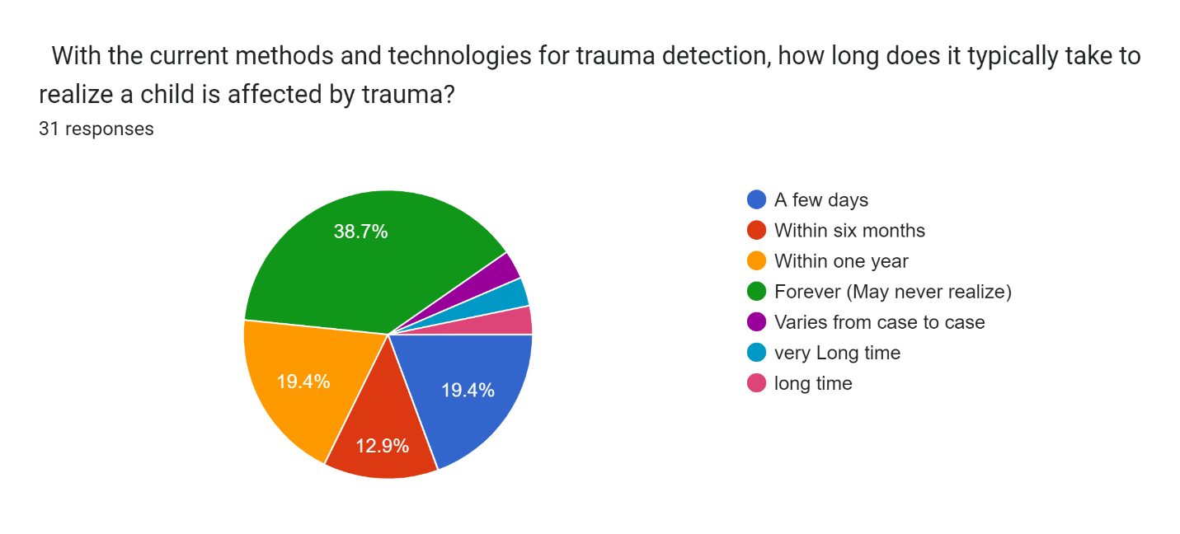

Figure Current Trauma detection systems

Likelihood of respondents recommending the proposed system to others.

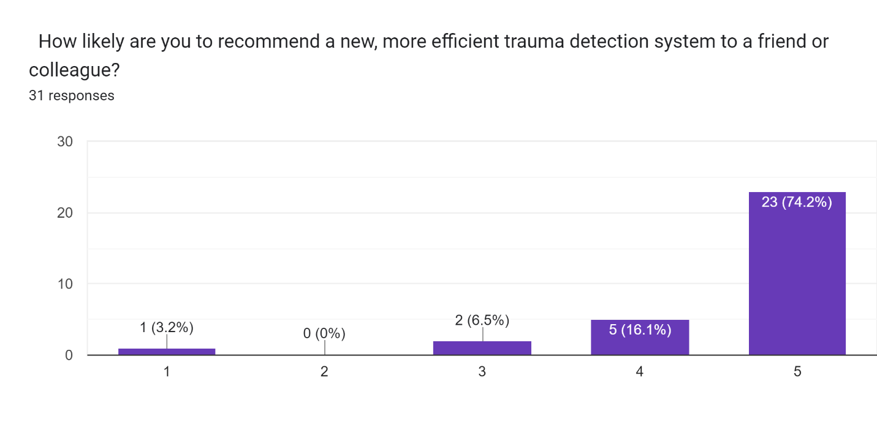

Figure Likely to Recommend Our System

## **4.4 System State Diagrams**

The system design was important in specifying hardware and software system requirements and also helped in defining the overall system architecture through the following UML diagrams.

4.4.1 Class Diagram

Represents the system's classes, attributes, methods, and the relationships among objects.

Illustrates the static structure of the system.

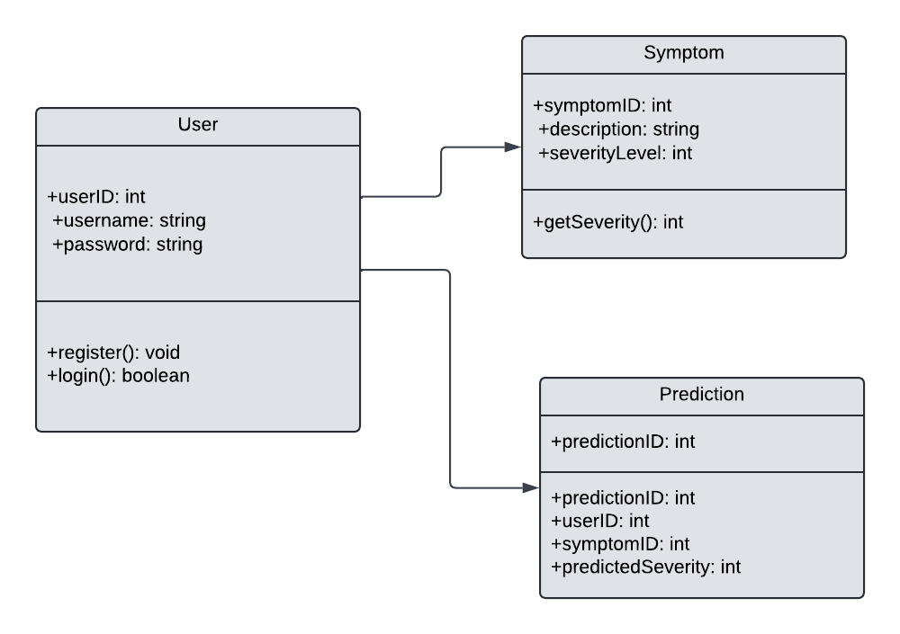

Figure Class Diagram

4.4.2 Use Case Diagram

Describes the interactions between users and the system.

Identifies the different use cases and the actors involved in each.

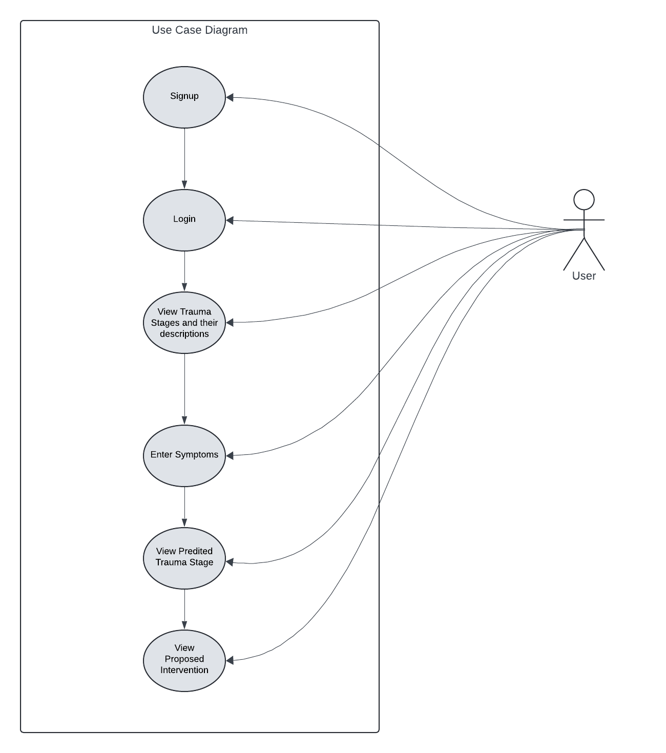

Figure Use case Diagram

4.4.3 Sequence Diagram

1. Shows how objects interact in a particular sequence.
2. Highlights the order of operations and the flow of information within the system.

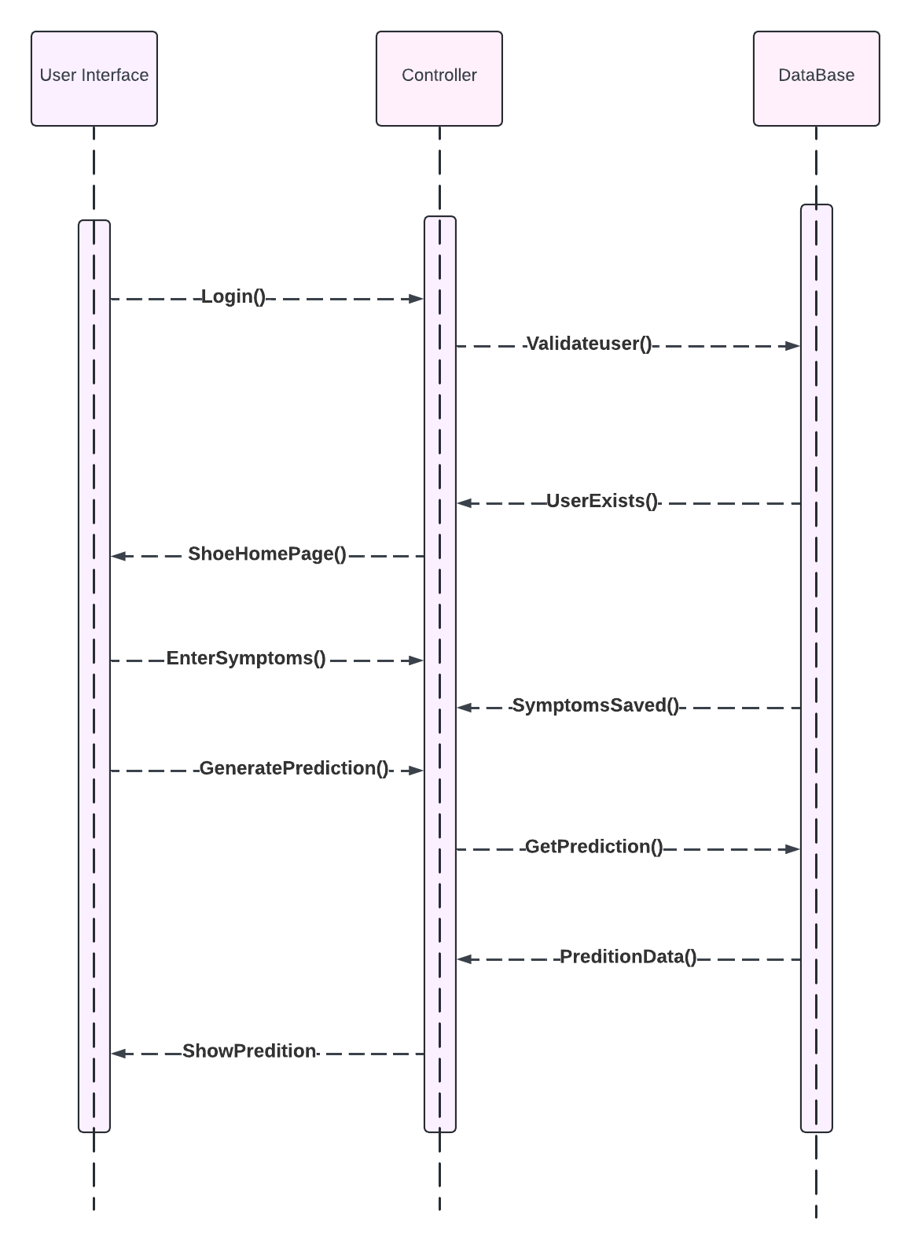

Figure Sequence Diagram

4.4.4Flowchart Diagram (Activity Diagram)

Visualizes the sequence of activities and the flow of control in the system.

Helps in understanding the step-by-step execution of processes within the system.

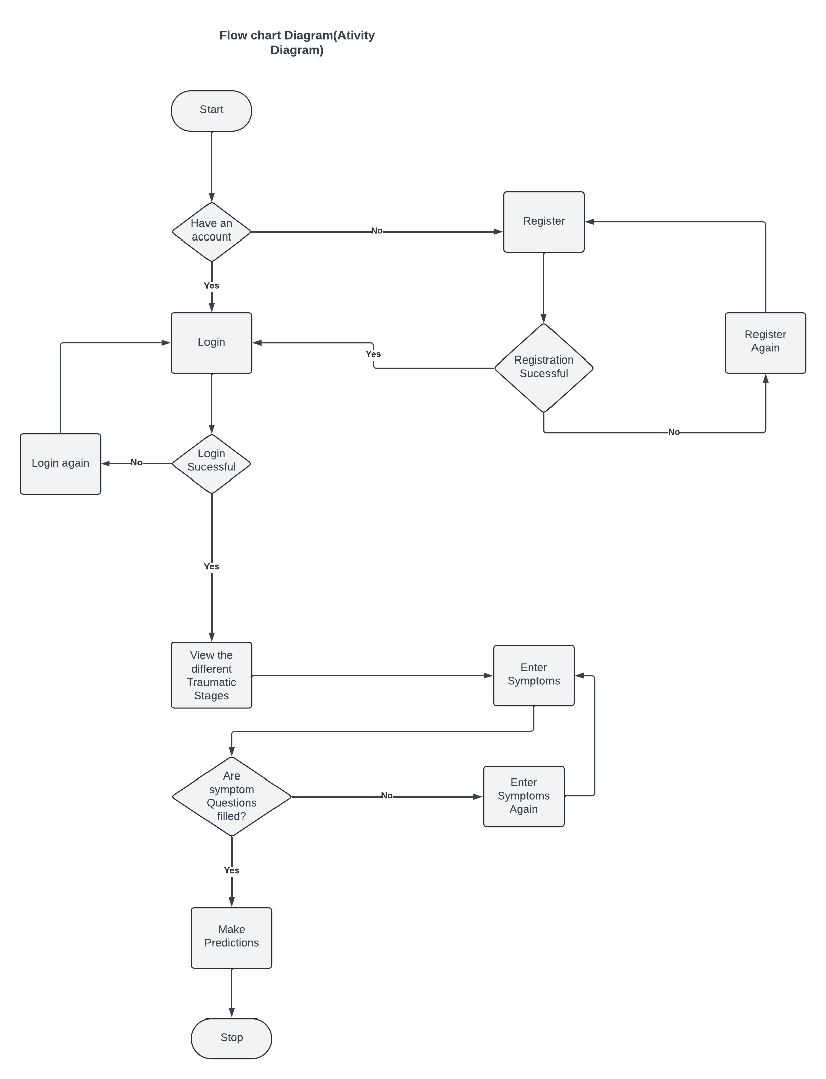

Figure Flowchart Diagram

# **CHAPTER FIVE: IMPLEMENTATION AND TESTING**

## **5.1 Introduction**

The Severe-stage Child Trauma detection system has been accurately developed as a web application, leveraging the capabilities of web development-supported languages such as Python and Javascript. Hypertext Markup Language (HTML), and Cascading Style Sheets (CSS) have been utilized for layout design and structuring of user interface elements.

The Firebase database has been integrated into the system to facilitate backend development, providing seamless data storage and retrieval capabilities. The website has undergone rigorous testing to ensure its functionality and reliability in real-world scenarios. These tests confirmed the website to be fully operational and functional.

## **5.2 Design Screens**

### **5.2.1 Login Page**

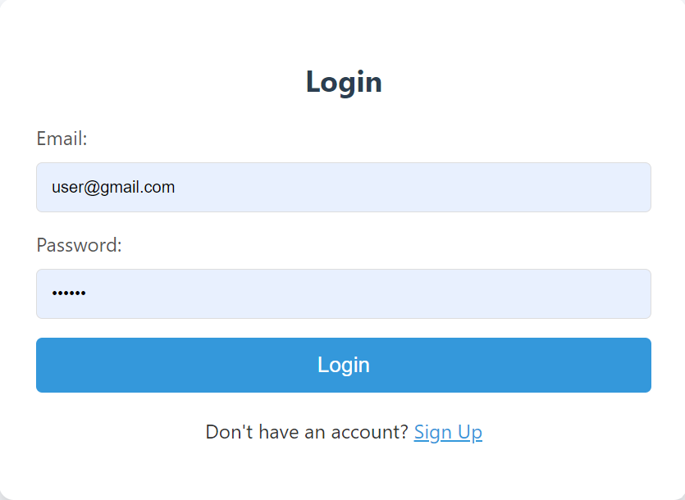

Figure Login page

The login page will provide secure access to authorized users, ensuring data privacy and system integrity. Key features include email and password input fields, error handling for incorrect credentials, and password recovery options.

### **5.2.2 Registration Page**

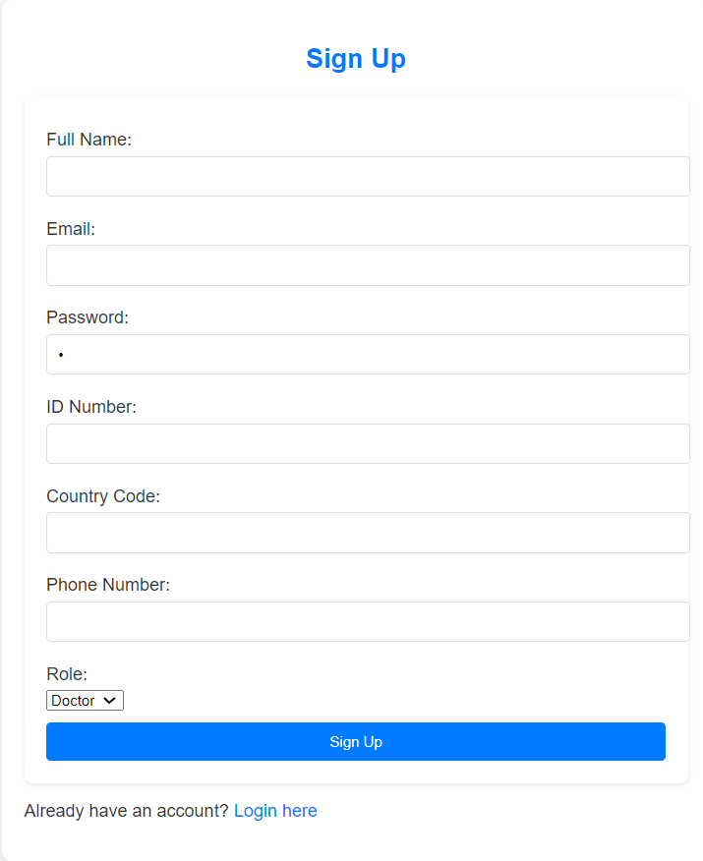

Figure Registration Page

The registration page will allow new users to create accounts and collect essential information such as name, email, ID Number, Country Code, Phone Number, and password. Validation checks will ensure the accuracy and completeness of the entered data.

### **5.2.3 Doctors Dashboard**

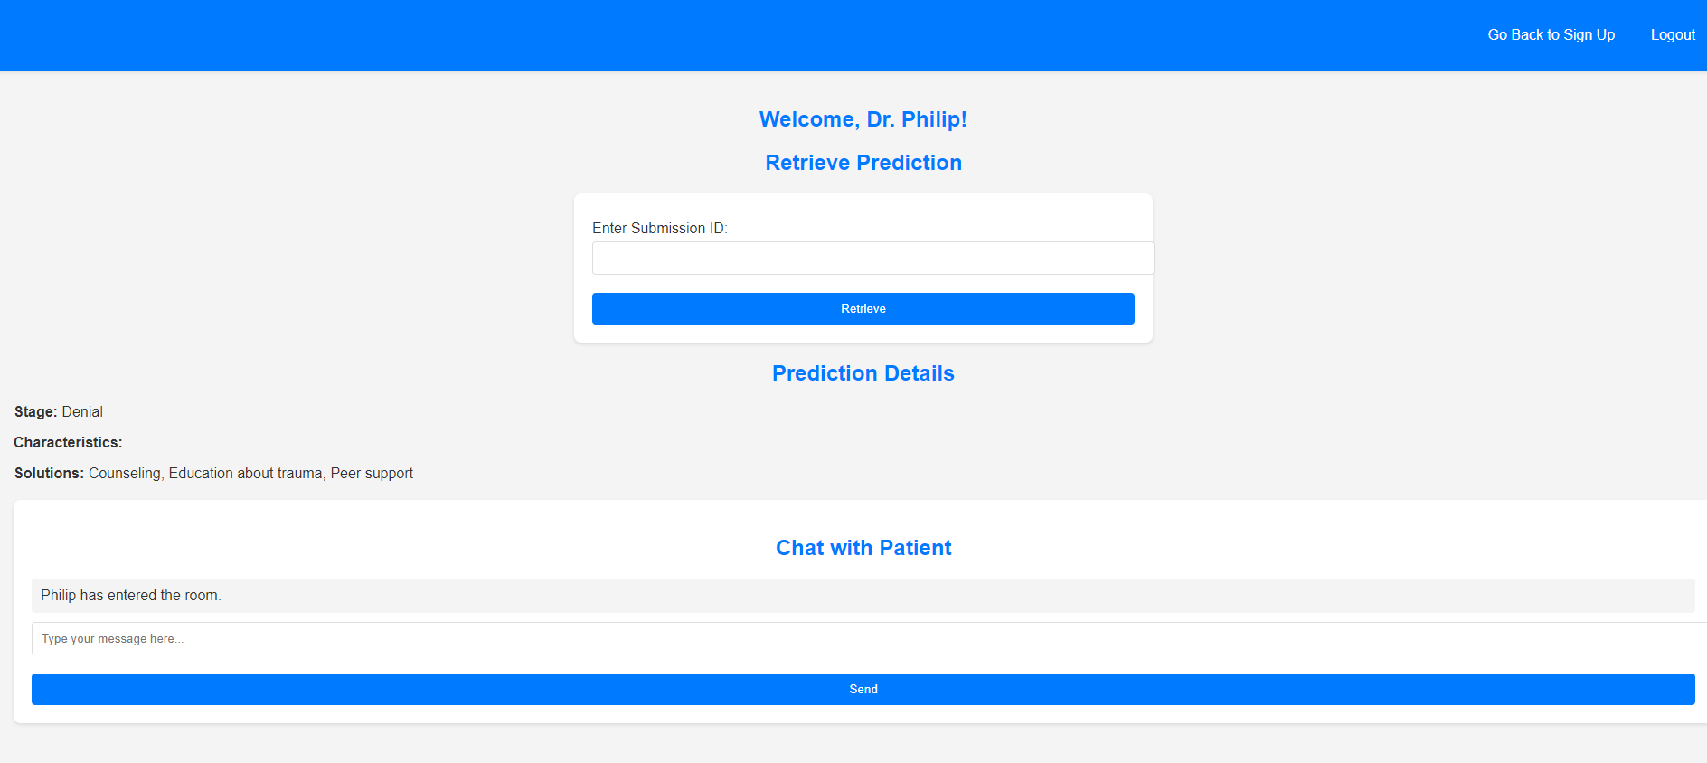

Figure Doctors Dashboard

This Doctors page is where the Doctor lands after registration or signing in. It is on this page where the doctor can feed the unique ID they receive from the patient to retrieve the results. After they receive the results, they can send the results to the patient via chat. **5.2.4 Patients Dashboard**

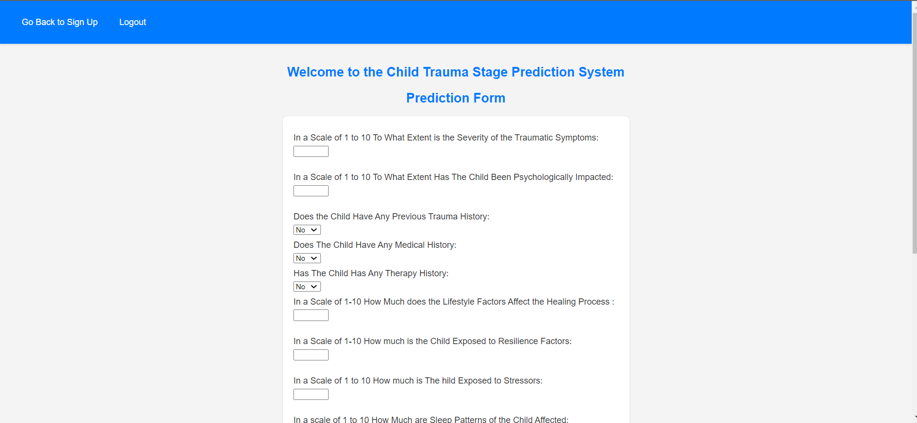

Figure Patient Dashboard

The patient's Page is where the patients land after registration. It is on this page that the patients can fill in the prediction form. After filling out the form, they will click the submit button, their results will be sent to the database and they will be provided with a prediction ID. They Will send the prediction ID to the doctor via a chat. The doctor then uses the ID to retrieve their results from the database and sends them to the patient via a chat.

## **5.3 Testing**

### **5.3.1 Unit Testing**

#### **5.3.1.1 User Login Testing**

Unit testing for user login will verify that the login functionality works correctly, ensuring users can securely access the system.

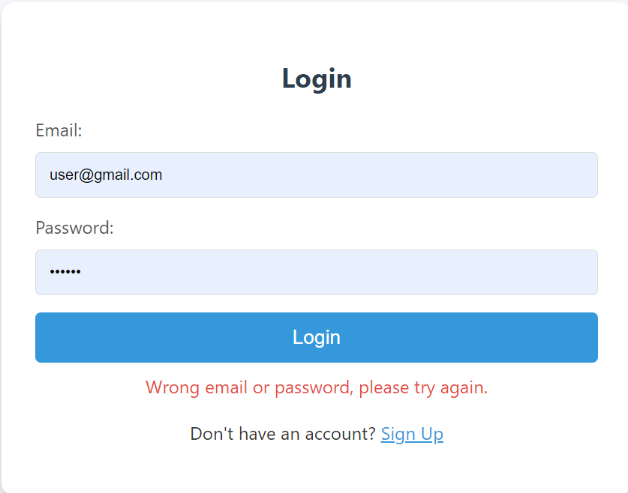

Figure Unit Testing

### **5.3.2 Integration Testing**

Integration testing assesses the interactions between different system components, ensuring they work together seamlessly. This includes data flow between the input forms, prediction algorithms, and reporting modules.

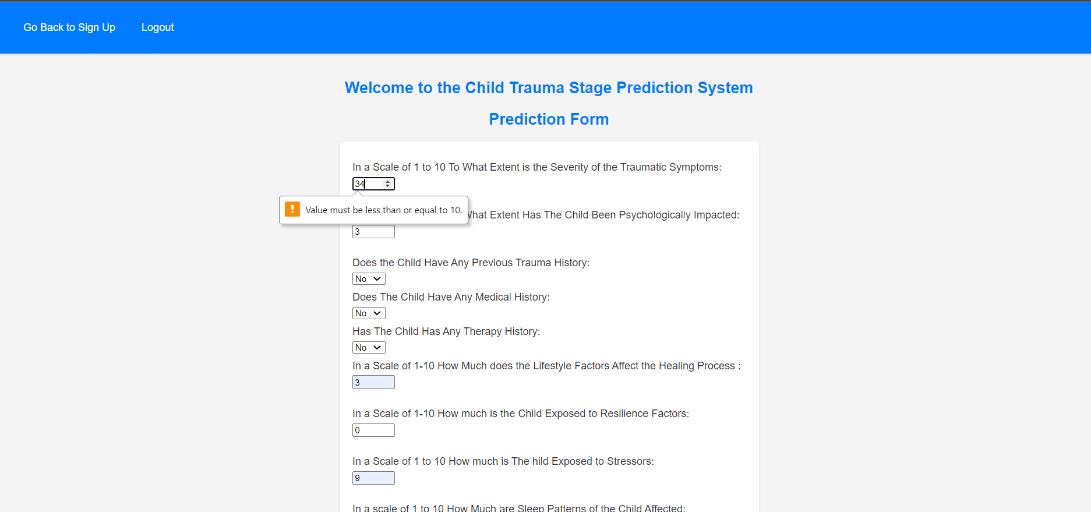

Figure Integration Testing

### **5.3.3 Validation Testing**

After the unit, integration, and validation testing were done to check that the software system meets specifications and fulfills its intended purpose.

# **CHAPTER SIX: RECOMMENDATION AND CONCLUSION**

## **6.1 Introduction**

Just as with any system, the development of the Severe-stage Trauma Detection System leaves room for ongoing improvements and upgrades. In this chapter, I will cover the challenges encountered during development, provide recommendations for enhancing the system, and conclude with key insights.

## **6.2 Performance Comparison**

**My Model vs. Existing Models**

The Severe-stage Child Trauma detection system outperforms existing models by leveraging advanced web development technologies and integrating a seamless user interface designed with HTML and CSS. Utilizing Firebase for backend development ensures robust data storage and retrieval, enhancing the overall reliability and efficiency of the system. Rigorous testing, including unit, integration, and validation testing, has confirmed the system's operational functionality in real-world scenarios.

**In comparison to other models, our system offers:**

**1. Enhanced Accuracy:** By employing comprehensive data analysis and state-of-the-art Machine Learning algorithms, this Severe-stage Trauma Detection System delivers more precise trauma severity predictions.

**2. User-Friendly Interface:** The intuitive design of the prediction page, with real-time data validation and clear result presentation, ensures ease of use for healthcare professionals, minimizing the need for extensive training.

**3. Robust Integration:** The seamless interaction between various system components, verified through thorough integration testing, ensures reliable data flow and consistent performance.

**4. Ethical and Secure Framework:** This Severe-stage Trauma Detection System prioritizes data privacy and security, addressing ethical concerns that are often overlooked in existing models.

## **6.3 Challenges**

While developing the system several challenges were encountered and experienced, they include:

**i)** **Limited Internet Access:** Inadequate access to the Internet posed challenges for conducting thorough research and accessing necessary resources.

**ii) Inadequate resources:** Time as a resource seemed and was somehow limited due to other learning activities which could cause a stoppage of the development process to attend classes.

**iii) User Adoption:** Designing a system that is intuitive and easy for healthcare professionals without extensive training.

## **6.4 Recommendations**

Recommendations for future work include:

**1.** **Enhanced Data Sources:** Integrating more diverse data sources to improve model accuracy.

**2. Advanced Algorithms:** Exploring more sophisticated Machine Learning algorithms for better performance.

**3. User Training:** Providing comprehensive training for healthcare professionals to maximize the system's effectiveness.

**4. Ethical Frameworks:** Developing robust ethical frameworks to manage data privacy and security.

## **6.5 Conclusion**

The proposed Machine Learning model for detecting severe-stage trauma in children has the potential to transform the landscape of trauma diagnosis and intervention significantly. By leveraging advanced algorithms, data-driven insights, and an intuitive interface, this system aims to address the complexities associated with early trauma detection. The model's ability to analyze various symptoms and predict trauma severity enables healthcare professionals to make informed decisions quickly and accurately, ultimately improving patient outcomes.

Despite the challenges faced during development—such as ensuring data accuracy, maintaining user privacy, and integrating ethical considerations—this project has demonstrated considerable promise. The model has shown efficacy in enhancing early detection, which is crucial in minimizing the long-term impact of trauma on children's mental health. With continued development, refinement, and testing, this system has the potential to evolve into a powerful tool in various healthcare settings, enabling professionals to intervene more effectively and provide tailored treatment plans.

Moreover, the system’s scalability and adaptability mean that it can be implemented across different regions and healthcare infrastructures, democratizing access to trauma detection and care. Further research and collaboration with healthcare experts will be essential in fine-tuning the model, ensuring it aligns with clinical standards and integrates seamlessly with existing healthcare practices. By addressing these challenges, the model could play a pivotal role in transforming how childhood trauma is managed, offering hope for early intervention and improved mental health outcomes for children worldwide.

Ultimately, the proposed Machine Learning model stands as a testament to the power of technology in revolutionizing healthcare, and its adoption has the potential to significantly impact the early detection and treatment of severe trauma in children.

# **REFERENCES**

Alex, K. (2024). Medical Robotics and AI-Assisted Diagnostics for a High-Tech Healthcare Industry. In Google Books. IGI Global. https://books.google.com/books?hl=en&lr=&id=hgj6EAAAQBAJ&oi=fnd&pg=PP1&dq=Healthcare+professionals+are+central+beneficiaries+of+this+research+endeavor.+Armed+with+a+more+accurate+and+efficient+trauma+detection+tool

Barboza, G. E., Schiamberg, L. B., & Pachl, L. (2020). A Spatiotemporal Analysis of the Impact of COVID-19 on Child Abuse and Neglect in the City of Los Angeles, California. Child Abuse & Neglect, 104740. https://doi.org/10.1016/j.chiabu.2020.104740

Bemme, D., & Kirmayer, L. J. (2020). Global Mental Health: Interdisciplinary challenges for a field in motion. Transcultural Psychiatry, 57(1), 3–18. https://doi.org/10.1177/1363461519898035

Bowman, M. E. (2022). Child welfare worker wellness: An ethical imperative in the service of children. Child Abuse Review, 31(5). https://doi.org/10.1002/car.2758

Chiarello, F., Belingheri, P., & Fantoni, G. (2021). Data science for engineering design: State of the art and future directions. Computers in Industry, 129, 103447. https://doi.org/10.1016/j.compind.2021.103447

Collin-Vézina, D., Brend, D., & Beeman, I. (2020). When it counts the most: Trauma-informed care and the COVID-19 global pandemic. Developmental Child Welfare, 2(3), 251610322094253. https://doi.org/10.1177/2516103220942530

Dweekat, O. Y., Lam, S. S., & McGrath, L. (2023). Machine Learning Techniques, Applications, and Potential Future Opportunities in Pressure Injuries (Bedsores) Management: A Systematic Review. International Journal of Environmental Research and Public Health, 20(1), 796. https://doi.org/10.3390/ijerph20010796

El-Gendy, S., Abd Al-Monaem, E., Afifi, W., & Eid, A.-S. (2023). The Potential Role of STARZ Score in Prediction of Neonatal Acute Kidney Injury: A Comprehensive Review. Benha Journal of Applied Sciences, 8(11), 109–119. https://doi.org/10.21608/bjas.2024.252016.1285

El-Shafeiy, E., Alsabaan, M., Ibrahem, M. I., & Elwahsh, H. (2023). Real-Time Anomaly Detection for Water Quality Sensor Monitoring Based on Multivariate Deep Learning Technique. Sensors, 23(20), 8613. https://doi.org/10.3390/s23208613

Flanagan, N., Travers, A., Vallières, F., Hansen, M., Halpin, R., Sheaf, G., Rottmann, N., & Johnsen, A. T. (2020). Crossing borders: a systematic review identifying potential mechanisms of intergenerational trauma transmission in asylum-seeking and refugee families. European Journal of Psychotraumatology, 11(1), 1790283. https://doi.org/10.1080/20008198.2020.1790283

Hope, L., Anakwah, N., Antfolk, J., Brubacher, S. P., Flowe, H., Gabbert, F., Giebels, E., Kanja, W., Korkman, J., Kyo, A., Naka, M., Otgaar, H., Powell, M. B., Selim, H., Skrifvars, J., Sorkpah, I. K., Sowatey, E. A., Steele, L. C., Stevens, L., & Sumampouw, N. E. J. (2021). Urgent issues and prospects at the intersection of culture, memory, and witness interviews: Exploring the challenges for research and practice. Legal and Criminological Psychology, 27(1), 1–31. https://doi.org/10.1111/lcrp.12202

Israel Edem Agbehadji, Tafadzwanashe Mabhaudhi, Joel Ongego Botai, & Muthoni Masinde. (2023). A Systematic Review of Existing Early Warning Systems’ Challenges and Opportunities in Cloud Computing Early Warning Systems. Climate, 11(9), 188–188. https://doi.org/10.3390/cli11090188

Lambert, J. E., & Denckla, C. (2021). Posttraumatic stress and depression among women in Kenya’s informal settlements: risk and protective factors. European Journal of Psychotraumatology, 12(1), 1865671. https://doi.org/10.1080/20008198.2020.1865671

Lerner, A. B. (2022). From the Ashes of History: Collective Trauma and the Making of International Politics. In Google Books. Oxford University Press. https://books.google.com/books?hl=en&lr=&id=VhpkEAAAQBAJ&oi=fnd&pg=PP1&dq=Beyond+its+immediate+applications

McDermott, F., Brydon, K., Haynes, A. B., & Moon, F. (2023). Thinking Complexity Across Fields of Practice: Children and Older People. Springer EBooks, 89–106. https://doi.org/10.1007/978-3-031-38677-0_6

Mohammad, Mohd Asyraf Zulkifley, Ahmad Asrul Ibrahim, Asraf Mohamed Moubark, Kamari, M., & Siti Raihanah Abdani. (2023). Automated Glaucoma Screening and Diagnosis Based on Retinal Fundus Images Using Deep Learning Approaches: A Comprehensive Review. Diagnostics, 13(13), 2180–2180. https://doi.org/10.3390/diagnostics13132180

Murphy, C., & Luthar, L. (2022). Understanding the Responses of Child Victims of Violence to Social Services: Toward Trauma-Informed Support Interventions. Law and Economics, 16(2), 103–116. https://doi.org/10.35335/laweco.v16i2.54

Nkurunungi, M. (2024). Provisions of social workers to victims of internal child trafficking in Uganda: A case study of children living on the streets of Kampala City. Gupea.ub.gu.se. https://gupea.ub.gu.se/handle/2077/80069

Ramos-Lima, L. F., Waikamp, V., Antonelli-Salgado, T., Passos, I. C., & Freitas, L. H. M. (2020). The use of machine learning techniques in trauma-related disorders: a systematic review. Journal of Psychiatric Research, 121, 159–172. https://doi.org/10.1016/j.jpsychires.2019.12.001

Segal, Z., Kalifa, D., Radinsky, K., Ehrenberg, B., Elad, G., Maor, G., Lewis, M., Tibi, M., Korn, L., & Koren, G. (2020). Machine learning algorithm for early detection of end-stage renal disease. BMC Nephrology, 21(1). https://doi.org/10.1186/s12882-020-02093-0

Silvia Maria, G. (2021). Interior Design as a tool for dementia care: Experiences and guidelines for the Therapeutic Habitat Model. In library.oapen.org. FrancoAngeli. https://library.oapen.org/handle/20.500.12657/53221

Simeoli, R., Rega, A., Cerasuolo, M., Nappo, R., & Marocco, D. (2024). Using Machine Learning for Motion Analysis to Early Detect Autism Spectrum Disorder: A Systematic Review. Review Journal of Autism and Developmental Disorders. https://doi.org/10.1007/s40489-024-00435-4

Singh, Y., Farrelly, C. M., Hathaway, Q. A., Leiner, T., Jagtap, J., Carlsson, G. E., & Erickson, B. J. (2023). Topological data analysis in medical imaging: current state of the art. Insights into Imaging, 14(1). https://doi.org/10.1186/s13244-023-01413-w

Tomlinson, M., Kleintjes, S., & Lake, L. (n.d.). Child and Adolescent Mental Health. https://www.medicalbrief.co.za/wp-content/uploads/2022/06/Child-Gauge-2021_FINAL_screen.pdf#page=124

Zheng, J., Li, Z., & Xu, H. (2023). Intestinal Microbiotas and Alcoholic Hepatitis: Pathogenesis and Therapeutic Value. International Journal of Molecular Sciences, 24(19), 14809. https://doi.org/10.3390/ijms241914809

Zheng, J.-X., Li, X., Zhu, J., Guan, S.-Y., Zhang, S.-X., & Wang, W.-M. (2024). Interpretable machine learning for predicting chronic kidney disease progression risk. DIGITAL HEALTH, 10. <https://doi.org/10.1177/20552076231224225>

Carlsson, N., Alvariza, A., Bremer, A., Axelsson, L., & Årestedt, K. (2021). Symptoms of Prolonged Grief and Self-Reported Health Among Bereaved Family Members of Persons Who Died From Sudden Cardiac Arrest. OMEGA - Journal of Death and Dying, 87(1), 003022282110181. https://doi.org/10.1177/00302228211018115

Durrant, J. E., Stewart-Tufescu, A., & Afifi, T. O. (2019). Recognizing the child’s right to protection from physical violence: An update on progress and a call to action. *Child Abuse & Neglect*, 104297. https://doi.org/10.1016/j.chiabu.2019.104297

Flaherty, C., & Taylor, M. (2022). *Assessing and Managing the Acutely Ill Patient for Nursing Associates*. SAGE.

Hinds, T. S., & Giardino, A. P. (2020). *Incidence and Prevalence of Child Sexual Abuse*. https://doi.org/10.1007/978-3-030-52549-1_1

Krakowski, K. (2021). Adjustments to gang exposure in early adolescence. *Journal of Peace Research*, 002234332110172. https://doi.org/10.1177/00223433211017204

Leszcz, M. (2020). Group Therapy for Patients With Medical Illness. *American Journal of Psychotherapy*, *73*(4), app.psychother. https://doi.org/10.1176/appi.psychotherapy.20200005

Letsie, N. C., Lul, B., & Roe-Sepowitz, D. (2021). An eight-year analysis of child labor trafficking cases in the United States: Exploring characteristics, and patterns of child labor trafficking. *Child Abuse & Neglect*, *121*, 105265. https://doi.org/10.1016/j.chiabu.2021.105265

Meyer, S., Reeves, E., & Fitz‐Gibbon, K. (2021). The intergenerational transmission of family violence: Mothers’ perceptions of children’s experiences and use of violence in the home. *Child & Family Social Work*, *26*(3). https://doi.org/10.1111/cfs.12830

Miller, T. W. (2023). School-Related Violence: Definition, Scope, and Prevention Goals. *School Violence and Primary Prevention*, 3–18. https://doi.org/10.1007/978-3-031-13134-9_1

Newton, C. (2021, February 1). *Childhood Emotional Abuse: Exploration of abuse factors that contribute to the long-term impact on childhood victims.* Eprints.hud.ac.uk. https://eprints.hud.ac.uk/id/eprint/35492/

Nguyen, B. L. (2024). Surveillance for Violent Deaths — National Violent Death Reporting System, 48 States, the District of Columbia, and Puerto Rico, 2021. *MMWR. Surveillance Summaries*, *73*. https://doi.org/10.15585/mmwr.ss7305a1

Noval, S. M. R., Soecipto, Jamaludin, A., Saputra, D. D., Munifah, N. F., Nurhasanah, Raswanti, P. S., & Lestia, S. N. (2023). THE FUSION OF BLOCKCHAIN, PORNOGRAPHY AND HUMAN TRAFFICKING IN A GLOBAL DIGITAL DRAGNET THAT FORMS THE ONLINE CHILD SEX TRAFFICKING. *Russian Law Journal*, *11*(5S), 1–19. https://cyberleninka.ru/article/n/the-fusion-of-blockchain-pornography-and-human-trafficking-in-a-global-digital-dragnet-that-forms-the-online-child-sex-trafficking

Rigutto, C., Sapara, A. O., & Agyapong, V. I. O. (2021). Anxiety, Depression and Posttraumatic Stress Disorder after Terrorist Attacks: A General Review of the Literature. *Behavioral Sciences*, *11*(10), 140. https://doi.org/10.3390/bs11100140

Saeed, S. A., & Gargano, S. P. (2022). Natural disasters and mental health. *International Review of Psychiatry*, *34*(1), 16–25. https://doi.org/10.1080/09540261.2022.2037524

Stiller, A., Neubert, C., & Krieg, Y. (2021). Witnessing Intimate Partner Violence as a Child and Associated Consequences. *Journal of Interpersonal Violence*, *37*(21-22), 088626052110551. https://doi.org/10.1177/08862605211055147

Wilson, R. F., Liu, G., Lyons, B. H., Petrosky, E., Harrison, D. D., Betz, C. J., & Blair, J. M. (2022). Surveillance for Violent Deaths — National Violent Death Reporting System, 42 States, the District of Columbia, and Puerto Rico, 2019. *MMWR. Surveillance Summaries*, *71*(6), 1–40. <https://doi.org/10.15585/mmwr.ss7106a1>