UTS2707: Decoding Complexity

**The boundaries of bounded rationality**

Written by: Stanley Neoh Jia Jun

Matriculation Number: A0234457B

Email: e0726457@u.nus.edu

Submitted to: Dr Lyon Loh Han Zhou

Date:

Contents

**1.** **Introduction** 3

**2.** **Literature Review** 3

2.1 The paradox of choice (PoC) 3

2.2 Bounded rationality 3

2.3 Rational herding 3

**3.** **Model Design and methodology** 4

3.1 Documentation of model parameters 4

3.2 Model Description 5

3.3 Methodology 5

**4.** **Findings and discussions** 6

4.1 Effect of *nchoices* on *avesatis* 6

4.1.1 When baseline-performance follow a “bounded” linear distribution 6

4.1.2 When baseline-performance follow a normal distribution 7

4.1.3 Discussion 8

*4.2* Effect of *influence-chance* on *avesatis* 8

4.2.1 Impact of *influence-chance* at different *performance-dev* 8

4.2.2 Discussion 9

*4.3* Effect of *performance-dev* on *avesatis* 9

4.3.1 A common trend 9

4.3.2 Discussion 9

**5.** **Limitations** 9

**6.** **Conclusion** 9

**7.** **NetLogo model and resources** 9

**8.** **References** 9

# **Introduction**

An individual’s freewill and autonomy are touted as necessary components to happiness. Hence, it would stand to reason that more choices will bring about greater satisfaction. However, in *The Paradox of Choice (2004)* by Barry Schwartz, the author pointed that despite “modern Americans hav[ing] more choice than any group of people ever has before, and thus, presumably, more freedom and autonomy, [they] don’t seem to be benefiting from it psychologically” (Schwartz, 2004, p. 99). This seems to suggest that more choices need not bring about more satisfaction and might even have the opposite effect. This paper aims to utilise agent-based modelling to study how utility differs across different number of choices, assumptions and time periods when making choices with bounded rationality.

# **Literature Review**

## The paradox of choice (PoC)

Verme (2009) defines freedom of choice as “the size of an opportunity set with mutually exclusive alternatives” (Verme, 2009, p. 3) and suggests that the happiness that derives from freedom of choice stems from an “aspect of personality known as the locus of control” (Verme, 2009, p. 1) and the set of choices whose outcomes depend more heavily on internal factors such as effort and skill as compared to external factors such as fate or destiny will lead to greater appreciation of freedom of choice. In today’s increasingly VUCA world, external factors tend to contribute significantly towards the outcome of a decision as experimentally corroborated by Salganik et al. (2006).

## Bounded rationality

Herbert Simon (1955) introduced the idea of bounded rationality, suggesting that we choose not to make optimal choices but instead choices that are ‘good enough’, also known as satisficing. In his book, Schwartz (2004) noted that a satisficer is less impacted by the number of choices available compared to a maximiser. Once a satisficer encounter a choice that is “good enough to meet [his] standard, [he] looks no further” (Schwartz, 2004, p. 85) while for a maximiser, every additional choice can lead to “anxiety, regret, and second-guessing” (Schwartz, 2004, p. 85). Furthermore, Schwartz (2010) believes that how individuals should satisfice over maximise “given the limits of human cognition and the complexity of the environment.” (Schwartz, 2010, p. 219). This justifies focusing on the effects satisficing has on utility in this paper.

## Rational herding

Rossa et al. (2020) found that when “social interaction among the agents is present but not predominant, imitative behaviours can be beneficial” (Rossa et al., 2020, p. 13) in artificial financial markets. However, when individual price expectations are overshadowed by social price expectations, the price expectations will conform towards a small set of influential agents, which results any expectation errors being compounded from herding. (Rossa et al., 2020). Hence, for herding to be beneficial, individual participants need to contribute their own opinion for the system to exhibit “crowd wisdom”.

# **Model Design and methodology**

## Documentation of model parameters

(Figure 3.1.1 – The NetLogo Model)

Let be the set of *services*, be the set of *cells*.

|  |  |
| --- | --- |
| ***Services* parameter** | **Description** |
| *baseline-performance* | The *baseline performance* of *service* refers to the average *performance* of .  For each *service* , represents *baseline performance* of where . |
| *performance* | The *performance* of a *service* is denoted as refers to the utility an *cell* experiences that takes up said *service* in a single encounter. |

|  |  |
| --- | --- |
| **Global parameters** | **Description** |
| *services-normally-distributed* | If *services-normally-distributed* , the spread of *baseline-performance* of *services* will follow a normal distribution .  Otherwise, the *baseline-performance* of *services* is spread out evenly in a “bounded” linear distribution with *baseline-performance* . More specifically, an arbitrary ordering is imposed on such where . is defined such that . |
| *nchoices* | Refer to the number of *services* *cells* can choose from. |
| *baseline-dev* | If *services-normally-distributed* , refers to the standard deviation of *baseline-performance*.    Otherwise, refers to the maximum difference between the *baseline-performance* of any 2 *services.*  This quantity can be thought of as the degree of spread in average *performance* in of *services.* |
| *performance-dev* | Refers to the standard deviation of *performance*.  This quantity can be thought of as the uncertainty in *performance* and the |
| *cell-standard* | Refers to the threshold which *performance* of a *service* will need to be greater than or equal to guarantee the *cell* chooses the same *service* in the next step.  This quantity can be thought of as the “pickiness” of the *cell*. |
| *influence-chance* | Refers to the probability a *cell* will take on the choice of a random *cell* in its Moore’s neighbourhood given that the *performance* of its current choice is less that .  This quantity can be thought of as the degree of herding behaviour. |
| *avesatis* | Refers to the average utility of all *cells* in a particular step. |

## Model Description

The custom NetLogo model shown in Figure 3.1.1 consist of a grid with each grid cell containing a *cell*. Each *cell* represents a single decision maker and will choose a *service* from a set of *services* to take up at every step of the simulation. A *service* represents one of the choices a *cell* can make.

Each *cell* makes their choice at each step under bounded rationality. The *cell* first chooses a random *service* and looks at the in this single encounter.

If, will choose again in the next step as is satisficing and has deemed “good enough” to choose again.

Otherwise, will EITHER choose the *service* made by a random *cell* in its Moore’s neighbourhood of the time OR choose a *service* the remaining of the time.

## Methodology

With the behaviour space tool, parameter sweeping is performed. Each unique combinations of parameters performed 10 times when *services-normally-distributed* and 100 times otherwise, recording *avesatis* at steps 2, 5, 10, 20, 40 and 80.

You may refer to Appendix A for all the plots made and Section 8 to view the raw data used to generate these plots.

# **Findings and discussions[1]**

## Effect of *nchoices* on *avesatis*

### When baseline-performance follow a “bounded” linear distribution

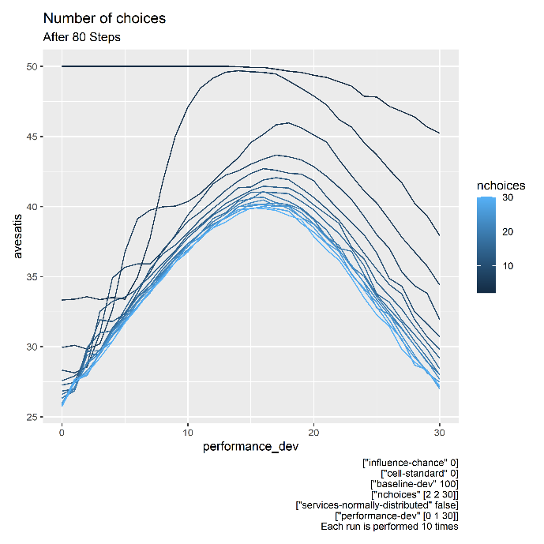

(Figure 4.1.1.1 – Effect of *nchoices* on *avesatis* when *services-normally-distributed* )

From Figure 4.1.1.1, it is observed that fewer number of choices is consistently correlated with a higher *avesatis* across all values of *performance-dev* when the *baseline-performance* of the *services* follows a “bounded” linear distribution. When there are few choices, an additional choice is correlated with a larger decrease in *avesatis* as compared to when there are many choices. Furthermore, the trend of fewer choices leading to higher *avesatis* appear to persist regardless of the number of steps. This observation appears to follow the PoC whereby more choices need not bring about greater utility which is represented by *avesatis*.

### When baseline-performance follow a normal distribution

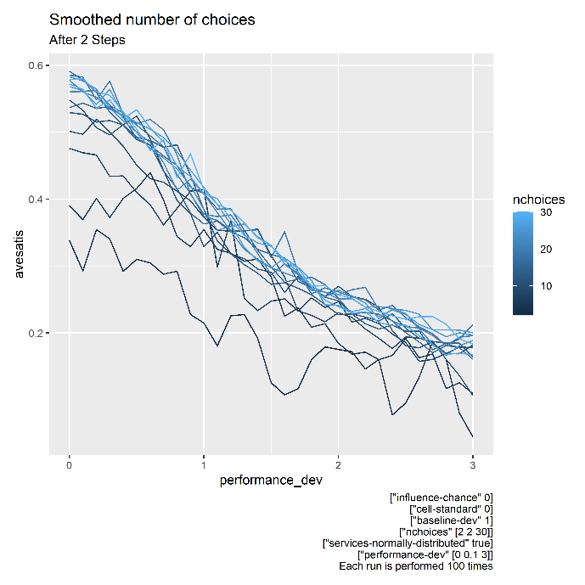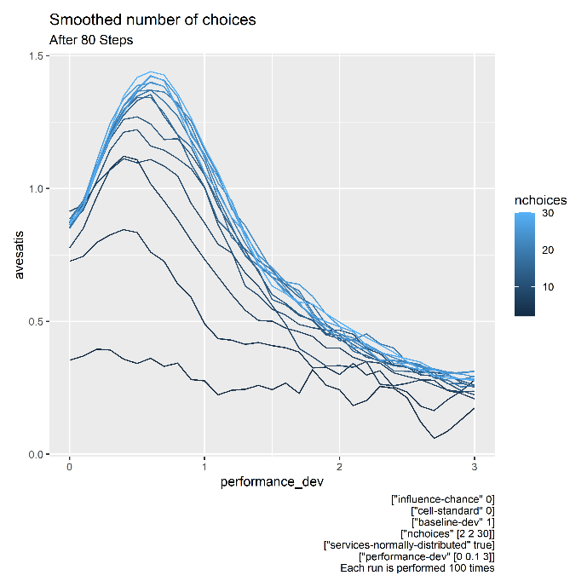

(Figure 4.1.2.1 – Effect of *nchoices* on *avesatis* when *services-normally-distributed* )

However, when the *baseline-performance* of the *services* follows a normal distribution instead, the trend where more choices lead to less *avesatis* from Section 4.1.1 is inverted. From Figure 4.1.2.1, it is observed that more choices are consistently correlated with a higher *avesatis* score across all values of *performance-dev*. Furthermore, the trend of more choices leading to higher *avesatis* appear to persist regardless of the number of steps.

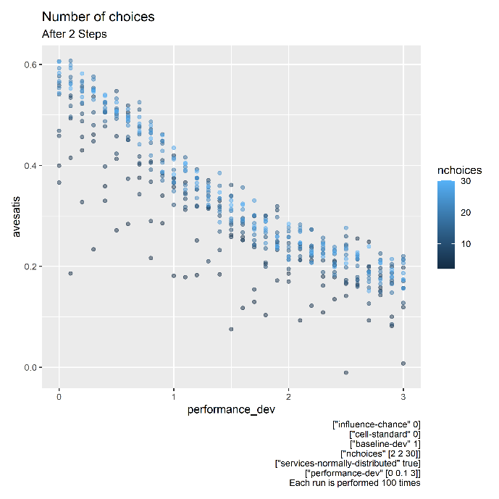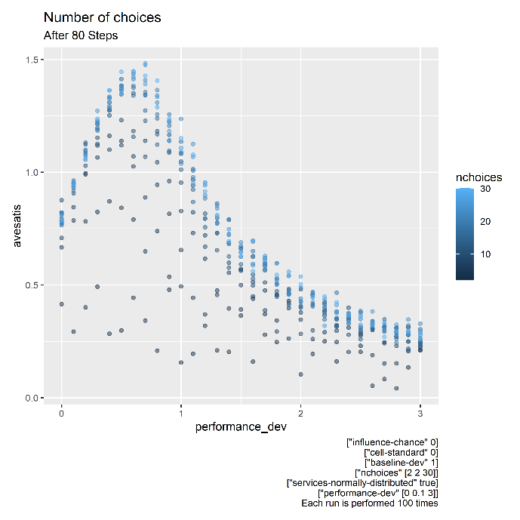

(Figure 4.1.2.2 – Scatter plot of *nchoices* on *avesatis* when *services-normally-distributed* )

It is important to note that the *avesatis* for a given *performance-dev* and *nchoices* has a very high variance. From Figure 4.1.2.2, we see high large random differences in *avesatis* for small changes of *performance-dev* especially when *nchoices* is small despite each data point being the average from 100 repeated runs. Hence, this result is limited in usefulness for predicting utility when *baseline-performance* is normally distributed.

### Discussion

Scheibehenne et al. (2010) found that “overall effect size in the meta-analysis was virtually zero” (Scheibehenne et al., 2010, p. 421) when studying the impact of the number of choices on satisfaction. Based on the above findings, it appears how *baseline-performance* of *services* are distributed play an important role whether the PoC is exhibited and could be a reason why reproducing the PoC reliably is difficult. A possible reason for the trend inversion from Section 4.1.1 to 4.1.2 could be the additional bounds on *baseline-*performance imposed in Section 4.1.1. More choices often led to better choices when *baseline-performance* is normally distributed in Section 4.1.2 which did not apply when *baseline-performance* is upper bounded in Section 4.1.1. This seems to suggest that the more choices only bring about higher utility if there are better choices when satisficing. Otherwise, more choices would result in the PoC even when satisficing.

## Effect of *influence-chance* on *avesatis*

### Impact of *influence-chance* at different *performance-dev*

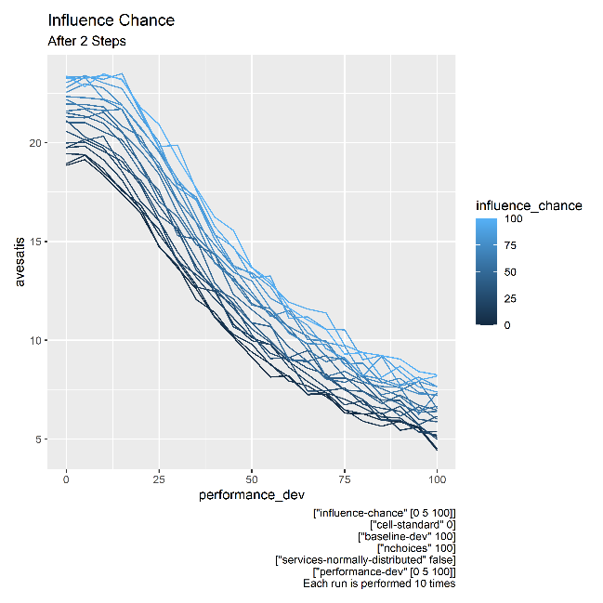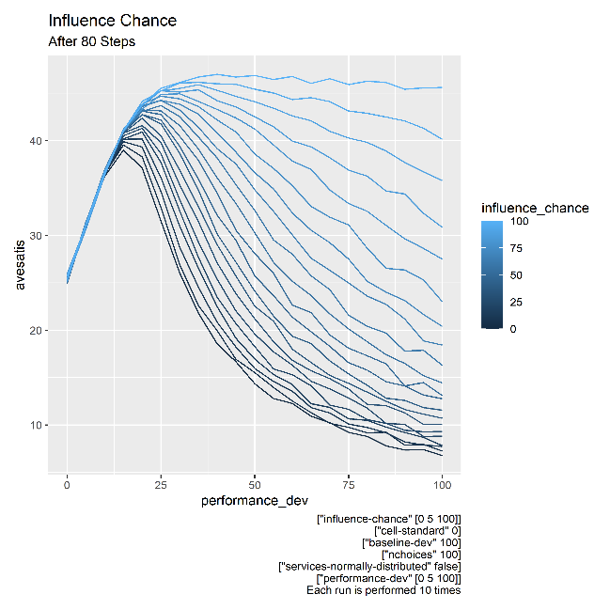

(Figure 4.2.1 Effect of *influence-chance* on *avesatis* when *services-normally-distributed* )

From Figure 4.2.1, it is observed that higher *influence-chance* is correlated with higher *avesatis* across all values of *performance-dev* when the *baseline-performance* of the *services* follows a “bounded” linear distribution.

In the short-term (after 2 steps), a higher *influence-chance* seems to bring approximately the same increase in *avesatis* regardless of *performance-dev*.

However, in the long-term (after 80 steps), a higher *influence*-*chance* seems to only bring about an increase in *avesatis* for values of *performance-dev* beyond some threshold value (approximately *performance-dev* for the conditions in Figure 4.2.1). When *performance-dev* is above this threshold value, *avesatis* decreases for all values of *influence-chance* with low *influence-chance* experiencing the largest decrease while high values of *influence-chance­* experiencing the smallest decrease. When *influence-chance* is 100, the decrease in *performance-dev* is almost negligible.

### Discussion

From the above findings, herding behaviour appears to be advantageous in every way. In the short-term, it provides a distinct increase in average utility while in the long-term, it provides great resilience against uncertainty (represented by *performance-dev*). There appears to be some form of emergence and self-organised criticality under higher uncertainty in the long-term. Despite the individual *cells* being unaware of which *services* have the highest *baseline-performance*, with high herding behaviour the *cells* collectively are always able to narrow down and choose only *services* of the highest *baseline-performance* even under an environment of high uncertainty. As *cells* only consider the choices made by other *cells* when unsatisfied by its own choice, this emergence agrees with Rossa et al. (2020) findings that herding can combat uncertainty provided that the individual opinion is dominant to adoption of other’s opinion.

## Effect of *performance-dev* on *avesatis*

### A common trend

From Figures 4.1.1.1, 4.1.2.1, and 4.2.1, there is a common trend of *avesatis* against *performance­-dev*. In the short-term (after 2 steps), *avesatis* monotonically decreases with *performance-dev* regardless of the initial conditions. However, in the long-term (after 80 steps), we consistently see *avesatis* increasing with *performance-dev* until a threshold value of *performance-dev* is reached where the threshold is dependent on the initial conditions. Beyond this this threshold, *avesatis* can be seen decreasing as *performance-dev* increases where the magnitude depends on the initial conditions.

### Discussion

This trend suggests that when there are few opportunities to make a choice, lower uncertainty would bring about a higher utility. However, when there are many opportunities to make a choice, some degree of uncertainty brings about a higher utility when satisficing.

A possible reason could stem from the shortcomings of satisficing. Under is low uncertainty, so long as a choice meets his requirement, a satisficer has no reason to try out other choices despite there being better choices. With some uncertainty present, a satisficer favouring an inferior choice will more likely be disappointed than one favouring a superior choice, resulting in a higher likelihood a satisficer will be disappointed by an inferior choice and changing to a superior one as compared to the other way around.

# **Limitations**

Oftentimes, decisions that are not made regularly are usually important such as choosing one’s major. Decision makers will likely employ maximisation to a higher degree for these kinds of decisions which is not captured in the model. The model is also unable to verify Verme’s (2009) hypothesis that the appreciation of freedom of choice hinges on the dependence of internal factors as opposed to external factors.

# **Conclusion**

Schwartz (2004) remarked that when a satisficer encounters a decision that meets his requirements, “the countless other available choices become irrelevant” (Schwartz, 2004, p.85). Our results showed that under bounded rationality, PoC can still occur depending on the way the distribution of choices and that utility can increase with some uncertaint. Our findings also agree Rossa et al. (2020) analysis that suggest that wisdom of the crowd can be exhibited when there is imitative behaviour in the model.

# **NetLogo model and resources**

# **References**

Della Rossa, F., Giannini, L., & DeLellis, P. (2020). Herding or wisdom of the crowd? controlling efficiency in a partially rational financial market. *PLOS ONE*, *15*(9). https://doi.org/10.1371/journal.pone.0239132

Salganik, M. J., Dodds, P. S., & Watts, D. J. (2006). Experimental study of inequality and unpredictability in an artificial cultural market. *Science*, *311*(5762), 854–856. https://doi.org/10.1126/science.1121066

Scheibehenne, B., Greifeneder, R., & Todd, P. M. (2010). Can there ever be too many options? A meta-analytic review of Choice Overload. *Journal of Consumer Research*, *37*(3), 409–425. https://doi.org/10.1086/651235

Schwartz, B. (2004). *The paradox of choice*. Harper Collins.

Schwartz, B., Ben-Haim, Y., & Dacso, C. (2010). What makes a good decision? robust satisficing as a normative standard of rational decision making. *Journal for the Theory of Social Behaviour*, *41*(2), 209–227. https://doi.org/10.1111/j.1468-5914.2010.00450.x

Simon, H. A. (1955). A behavioral model of rational choice. *The Quarterly Journal of Economics*, *69*(1), 99. https://doi.org/10.2307/1884852

Verme, P. (2009). Happiness, freedom and control. *Journal of Economic Behavior & Organization*, *71*(2), 146–161. https://doi.org/10.1016/j.jebo.2009.04.008

1. The specifications of each plot made can be found on the plot itself.