Christian Assembly Newsletter August 2018

Sharing on Marriage at Christian Fellowship (CF)

-Sharing by Bro. Ching Han and Sis. Faith

“How can I know what God’s will is?”
This is one of the most asked questions by many young people, and sometimes it pertains to which areas to study or which line of work to pursue, but sometimes this is a proxy question to “How do I know who is God’s will for me?”
Does God want me to marry or remain single? Will He send the right person, and will I know it? When we search the Bible, it becomes confusing because there are so many different accounts of how people met their spouses: Adam and Eve; Isaac and Rebecca; Jacob and Rachel; or even Hosea and Gomer. There doesn’t seem to be similarities that can help us decide. Even when we look around in church we find so many individual stories, and no two are the same.
Looking back prayerfully, it becomes clearer to me that the purpose of God is not whether or who to marry, but that our entire experience on earth is a process of refining us to be the bride He desires.
Yes, the heartache and the tears are real. As are the joys. But God prizes our holiness above our happiness, and so even our struggle to know God’s will in this area of marriage is part of growing closer in fellowship with Him.
Are you currently struggling with these questions? Turn to God in prayer. Fellowship with close brothers or sisters that you trust. And slowly, the Holy Spirit leads us to a place of surrender where the outcome of our earthly lives matter less, and we realise that we already have a perfect husband, and we are preparing for the grandest, most beautiful marriage of all.

Summary of what the youths learnt at CF

-Sharing by Bro. Nigel on behalf of the youth

We started off listing out our favourite wedding verse. Least to say, there were many many verses quoted. From those that were married, things like getting the shortest verse to fit in the wedding invitation was important. But why do we want to be married? And must we?
What is our life partner supposed to be like?
Whether we admit it or not, we all have list of what our future partner is to be like. But is this what God calls for you?
We learnt how important it is to put God first in everything, to make Him the one who guides our life. Be it getting married or not, God doesn't call for one choice or the other, but instead submission to Him who knows best for you.
This isn't just praying about the person you feel attracted to. But giving up all your entire list of criteria, and to see the person in God's perspective, a person who will choose God over anything, even you, and a relationship where you can both build each other up spiritually.

So…..What is marriage???

Bro. Keen Mun & Sis. Janet- “Marriage as instituted by God is that two become one, to be a testimony of the relationship between Christ and the church. That as ONE, we should be in oneness to worship God and to do His will e.g. in the family, in church ministry, etc.”

Bro. Chun Huat & Sis. Karen- “As unbelievers when we were married, the challenges and heartache that both of us went through almost led us to thrown in the towel. By God’s grace, He sought us through a health crisis of Karen, and through it we accepted Christ four years after our marriage.
We were deceived by the worldly idea that “What you don’t know won’t hurt you” and so decided to be transparent with each other about our past, but not without pain. We struggled greatly but God softened our heart and caused us to forgive each other.
God instituted marriage for His glory. Therefore the union must first consist of BOTH His children in order to receive His full blessings. May we also purpose to keep nothing from our spouses to prevent the fiery darts of accusation from the evil one.”
Bro Hock Heng & Sis Bee Hong- “Marriage is a covenant relationship between 3 parties: God, man and his helpmate. It is not to be enter hastily and without much consideration (Gen.2:18, 21-23).”
Bro. Lim Yong & Sis. Jenny- “Wedding officiators, in numerous weddings that we have attended, made mention of Jesus' first recorded miracle performed at the wedding at Cana where water was turned into wine. Below are our humble thoughts:
The "wedding narrative" - starting from the Garden of Eden right up to the "marriage consummation" of Christ the Bridegroom's return and receiving of His Bride, the Church - is a standout theme in the Bible.
Therefore, we ought to recognise and uphold the sanctity of marriage.”

What are important considerations for a life partner?

Bro. Lim Yong & Sis. Jenny
Three important factors to consider when it comes to select partners:
- Is the person IN the Lord? (1 Corinthians 6:14)
- Is your choice OF/FROM the Lord? (Matthew 6:33-seek to do His will and matters like marriage will "fall in place" in His own time)
- Be sure to act only after confirmations from the Lord - not from our self-seeking inner voices (Genesis 12:4a - act only after the Lord has spoken)
Bro. Sagar & Sis. Elizabeth
1. Marriage is honourable among all as we know from the Holy Bible - so 1st factor for consideration will be that both the spouses should be willing to Honour and Glorify God (Our Lord Jesus Christ)
2. Only marry Genuine Born Again and Baptised Believer.
3. Have proper, full assurance and confirmation sbout the perfect will of God.
4. Unmarried persons should not marry divorced.
5. Look for spiritual Christ like qualities and Worth rather than physical.
6. Both spouses should have similar burden and vision for the House of God. i. e. The Church / Fellowship/ Ministry etc.
7. Marrying persons from other denomination causes confusion and Chaos in the family especially Children.
8. Marriage is not just a physical union as people if this world assume. But it's a Divine design of God from Heaven for all those who will fully Trust and believe the Word of God - Holy Bible.
9. Parents should be involved and proper guidance in prayer from the Spiritual servants and Men.
Bro. Chris & Sis. Ivy
In my humble opinion, it’s really not what we look out for in our selection of partner for marriage. It’s about being ready and prepared in the Lord for the partner that God has in store for us. I remembered praying to God when I was about 10-12 years old, to keep me pure and chaste, if God wanted me to be married, so that I can be a good helpmate to my future husband. Otherwise, let me be wholeheartedly serving God, if He wanted be to be single. Similarly, Chris prayed, and God encouraged him with this verse, “He has made everything beautiful in its time. Also He has put eternity in their hearts, except that no one can find out the work that God does from beginning to end.”
‭‭Ecclesiastes‬ ‭3:11‬ ‭NKJV‬‬, which was our verse on our wedding day. We are very different individuals, with very diverse temperaments, characters and personalities. Only God can make all things beautiful for both of us.

Bro Hock Heng & Sis Bee Hong
To begin with: there must be some attraction between the two parties: they must like one another’s company and have some mutual interests and willing to make a life-long commitment.
Your spouse must be a born-again Christian and it would be better if both have the same mind in pursuit of the Lord (Amos 3:3, 2Cor.6:14).
In possession of good character/conduct/habits that you would appreciate and able to accept. As regard to this matter it would be good to observe your would-be spouse in various circumstances and see how he/she relate or act. It would be helpful to see him/her behave at home, with friends and others.
Education and social status of both partners should not be too far apart: as this will affect the relationship after marriage when you need to accompany your spouse for events and meet up with the in-laws and each other circle of friends and colleagues.
Other factors to consider would be finance capability to support the family and the life style both of you aspire.
But most importantly, to look to the Lord to guide you in this important decision (Isa.58:11).

Now, we turn to couples who have been married for some time to share with us important lessons from their marriage…

Bro Hock Heng & Sis Bee Hong
Willing to accept the need to leave your own family and establish a new home with your spouse. This mean not only to live physically apart but also allow for independent living free from the influence of the parents (Gen.2:24).
Of course, this does not mean to sever ties with your families; and any assistance is welcome. This avoid over reliance on parents and allow for the marriage to flourish and grow as you face life challenges together.
The marriage vows remind us the relationship is bound by steadfast love, faithfulness and a commitment that only death put apart.
This require constant effort, making choices, sacrifices and adjustment to accommodate one another in various stages of life. (Example: when the children come along or when one party become sick.)
Each party must be responsible and must pay mutual respect; providing comfort and hope to their partner.
Disagreements, even quarrels are inevitable and need to be manage with love and consideration for the other person. As we value our spouse more than ourselves, our marriage will grow as we build up one another in love. As we experience the unconditional love of Jesus Christ, we can love our spouse as He loves us (Eph.52,22-29).

Bro. Chris & Sis. Ivy
We do have disagreements. As God is the centre in our marriage, He binds us closely.
“.... And a threefold cord is not quickly broken.”
‭‭Ecclesiastes‬ ‭4:12‬b NKJV‬‬
It’s important to have couple time no matter how one is busy at work or minding the children. I really agree with what Sister Linda shared in Church Camp 2017. In our initial stage of our marriage, I used to think I loved Chris more, and felt neglected as he was busy at work. Now, as I begin to be more independent, being busy with children and others, it seems like Chris loves me more. We appreciate each other more as the years of marriage roll on. Now he laughs at every wry comment I make, which he didn’t understand in the past. And we laugh and tease each other very often. I also complement him in areas he is weak at. Indeed, we hope to echo with these verses from Song of Solomon
“I am my beloved’s, And his desire is toward me.”
‭‭Song of Solomon‬ ‭7:10‬ ‭NKJV‬‬
“My beloved is mine, and I am his. He feeds his flock among the lilies.”
‭‭Song of Solomon‬ ‭2:16‬ ‭NKJV‬‬
Solomon’s love toward his Shulamite lover is deep, so is hers to her beloved.
Bro. Lim Yong & Sis. Jenny
Important lessons we are (still) learning in the Lord in order for our marriage to work:
- Being aware of your role in the marriage: husband as head of household, to love the wife. Wife to submit to husband as head (Ephesians 5:21-33; 1 Peter 3:1&7)
- Put aside your pride, prejudice and presumptions. Be ever ready and willing to lend a listening ear. Be a "helper" to your spouse (Genesis 2:18) - be open when sharing your problems and fears
- Be sensible and sensitive to the other party's physical and emotional needs (1 Corinthians 7:3-5)
- Form a close support group with like-minded brothers- and sisters-in-Christ to find and lend support in times of spiritual and physical needs (Proverbs 17:17)
- Devote time to pray together (which admittedly we fail to do much)(Philippians 4:6; 1 Thessalonians 5:17; James 5:16)
Bro. Keen Mun & Sis. Janet:
To know that it is God, by His grace, who has brought us together to make us complete in Him, and I remembered what our late brother Timothy Sun said "what God provided is the BEST for me". Since it is God who has made everything beautiful in His time, we need God always to make our marriage works; otherwise, we will not be able to manage the challenges in parenting, crisis/ trials in our life and ups and downs in husband-wife relationship, etc.
Because as ONE, we need to be ONE in spirit, mind, heart in our relationship, it is important to have communications and fellowship with one another so as to be like-minded in God's ministry and service. However, this is one area still works in progress, and much to learn. Another thing is to love God and to walk close to God. Only then can we love one another in the love of God.


Notes and News

Erratum in the Notes and News section of July’s issue of Newsletter
Brother Clement Chong and Sis Ka Woon’s wedding was on “30 June 18” instead of “30 July 18”. The editorial team apologizes for the typographical error.

Thanksgiving
We thank God that He has seen Sis Ling Kam through the operation to remove cancerous tissues from her right breast. Please continue to pray for her speedy & complete recovery as she recuperates at home.

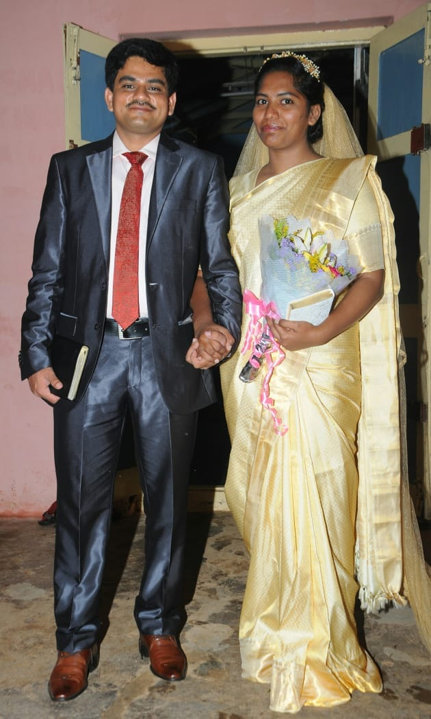
Wedding bells
We rejoice with Bro. Anil and Sis. Rachel on their Holy Matrimony on 26th May 2018 in Bengaluru, India.

May the Lord bless the newly wedded couple in their lives ahead!

Baptism Service – 19 Aug 18
Many in our assembly have believed in the Lord but have yet to take this step of obedience. Pray for the Holy Spirit’s conviction, removal of doubts/fears, desire to give God glory and boldness to declare their identity in Christ.
Gospel Service
Gospel Service every 1st week of the month - Pray that we be active in inviting family & friends to hear the good news and to participate in the great commission.

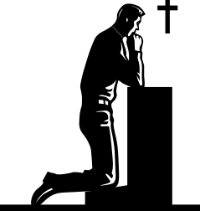
Be careful for nothing; but in everything by prayer and supplication with thanksgiving let your requests be made known unto God. (Philippians 4:6)
And the peace of God, which passeth all understanding, shall keep your hearts and minds through Christ Jesus. (Philippians 4:7)

Prayer items
Watch and Pray

Pulpit ministry
- God’s anointing on the speakers
- God’s word to be faithfully discharged & HS to work mightily to transform the hearts of the listeners.
- All to have attentive ears, willing hearts, a submissive spirit to hear what God is saying and to obey.
Speakers for the coming weeks are:

Date | Speakers
Date | Wilkie | Asiawide | Gospel
05 Aug 2018 | Eddy Lim | Yeo Choon Guan | Eddy Lim
12 Aug 2018 | Chan Keen Mun | Pat Mun Fai
19 Aug 2018 | Chng Yak Beng (Combined Baptism Service)
26 Aug 2018 | Sng Hock Heng | Teo Ching Han

Sunday School
- Sunday School teachers to fully depend on God to teach & be true to God’s Word.
- Sunday School students to come early with the desire to study God’s Word, treasure it & develop a close relationship with God.
- Parents/guardians of these Sunday School students to be faithful in bringing them to church to attend Sunday School.

Elders and deacons
To be focused on the spiritual aspects of church matters rather than being preoccupied with the administrative side. Desire to see God’s perspective and follow God’s heart in their shepherding roles.

Remember brothers and sisters in prayer, including those who are not well, elderly and those who are not able to attend church:
- A group of brothers & sisters from both assemblies will be traveling along part of the silk route in China during September - they covet your prayers for protection & journey mercies.
- Bro Bobby Sng
- Bro Loh Sit Ming
- Bro Sng Hock Heng
- Sis Hee Aik
- Sis Ling Kam
- Bro. Keen Mun’s mother
- Sis Teo Siew Eng
- Sis Christina has difficulty in breathing, and the right part of heart is failing
- Mrs Wang Li Zhong and Mrs Lee have weak legs
- Others whom the Lord knows by name


Church ministries
Your prayer support and involvement in any of the ministries would be an encouragement to the body of Christ.
“Now you are the body of Christ, and each one of you is a part of it.” 1 Corinthians 12:27

Newsletter … sharing of testimonies, pictures and articles to edify brothers and sisters
- Transportation needs … Pray for brothers and sisters to volunteer to serve as Gospel van drivers and for those with cars to give lifts to those in needs especially the elderly and the younger ones living in various areas.
Note:
Please note that prayer requests are reported up to the 3rd Wednesday of every month in order to prepare for translation and preparation for the printing of the newsletter, which will target to be available on the 1st Sunday of every month.
Those prayer items requested on the 4th Wednesday of every month, which is valid only for the following month, will not be reported because by the time the next newsletter is printed, these prayer requests would have been outdated. We thank all church members for their understanding.

