Stanley Ung

011743626

EE 381

**Project 3: Binomial and Poisson Distributions**

**Problem 1:**

**Introduction:**

In problem 1, we want to calculate the probability of rolling three 6’s in a roll of three fair die. We will simulate this through python.

**Methodology:**

To get our results, I simulated this by generating 3 random numbers between 1 and 6 and taking their sum. If the sum was 18, the roll was three 6’s, and if not a failure. This was ran 1000 times for a single experiment. This experiment was repeated N = 10000 times in order to achieve the results, a list of successes out of 1000 experiments each.

**Code:**

def problem_1(N):

n = 1000

success = [sum([int(sum([np.random.randint(1, 7) for i in range(0, 3)]) == 18) for i in range(0, n)]) for i in range(0, N)]

b = range(1, 18)

h1, bin_edges = np.histogram(success, bins = b)

b1 = bin_edges[0 : 16]

fig1 = plt.figure(1)

plt.stem(b1, h1/N)

plt.title('Exoerimental Results: Problem 1')

plt.xlabel('Number of successes in n = 1000 trials')

plt.ylabel('Probability of success')

plt.savefig('PMF.png')

**Results and Conclusion:**

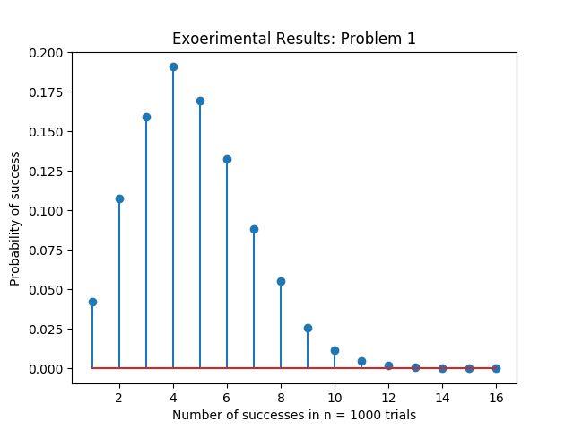

The graph shows that we have a very little chance of landing three 6’s in a roll of 3 fair die with the max looking to be only about 11 – 12 at best out of 10000 experiments.

**Problem 2:**

**Introduction:**

In problem 2, we are still calculating the probability of rolling three 6’s in a roll of 3 fair die. The difference between problem 2 and problem 1 is that here, we do it using a theoretical calculation rather than a simulation of rolls.

**Methodology:**

We want to calculate the probability of rolling three 6’s in a roll of 3 fair die using the binomial. We use the equation for range of 0 to 20:

p(X = x) = (n , x) px qn – x

**Code:**

def problem_2():

binomial = lambda n, p, q, x : ((factorial(n) // (factorial(x) * factorial(n - x))) * (p**x) * (q**(n - x)))

n = 1000

p = 1/216

q = 1 - p

X = [binomial(n, p, q, x) for x in range(0, 21)]

plt.stem(X, bins = range(1, 18))

plt.title('Exoerimental Results: Problem 2')

plt.xlabel('Number of successes in n = 1000 trials')

plt.ylabel('Probability of success')

plt.savefig('Binomial.png')

**Results and Conclusion:**

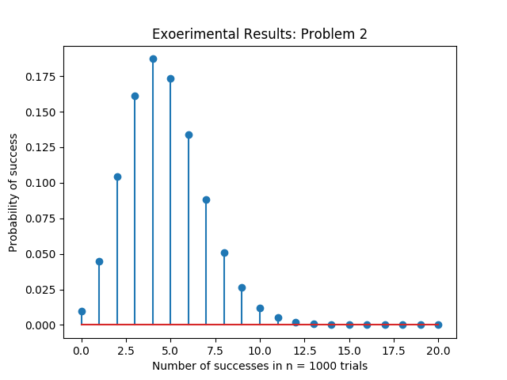

The theoretical calculation from this program shows us that we are most likely to get 5 successes in n = 1000 trials

**Problem 3:**

**Introduction:**

We want to calculate the same thing as is problem 1 and 2. This time we want to do it through the Poisson distribution.

**Methodology:**

Since n <= 50 and np <= 5, we can use the Poisson to estimate approximate the probability of successes in n trials. We will use the equation for the range 0 to 20:

p(X = x) = λxe-x / x!

**Code:**

def problem_3():

poisson = lambda l, x: ((l**x) * exp(-l)) / factorial(x)

n = 1000

p = 1/216

q = 1 - p

l = n * p

X = [poisson(l, x) for x in range(0, 21)]

plt.stem(X, bins = 18)

plt.title('Exoerimental Results: Problem 3')

plt.xlabel('Number of successes in n = 1000 trials')

plt.ylabel('Probability of success')

plt.savefig('Poisson.png')

**Results and Conclusion:**

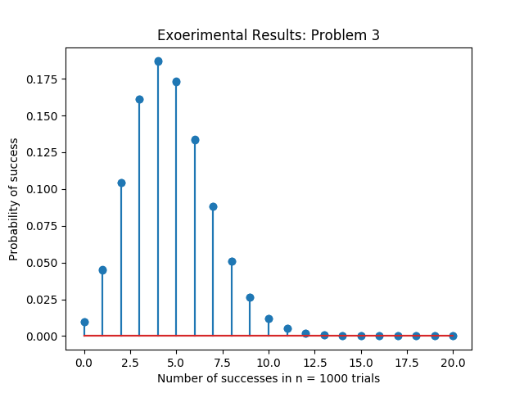

This graph was created to approximate the binomial and it looks very similar to the results that we got from the calculations in problem 2.