Stanley Ung

011743626

EE 381

**Project 3: Central Limit Theorem Simulate RVs and Exponential Distributions**

**Problem 1:**

**Introduction:**

Problem 1 focuses on the central limit theorem. We want to find the distribution of thickness for a number of books.

**Methodology:**

Using np.random.uniform, we can construct a distribution of book thickness. We use a thickness of 1 to 3 cm. The number books we use for this is 1, 5, 10, and 15. The distribution for these are plotted on a histogram.

**Code:**

**def problem_1():**

**N = 10000**

**a = 1; b = 3 # a=min bookwidth ; b=max bookwidth**

**nbooks = 15 # Number of books**

**nbins = 30 # Number of bins**

**mu= 2; sigma = 0.33; sig_sqrt = 0.57**

**X = [sum(np.random.uniform(a, b, nbooks)) for i in range(0, N)]**

**# Create bins and histogram**

**bins = [float(x) for x in np.linspace(nbooks * a, nbooks * b,nbins + 1)]**

**h1, bin_edges = np.histogram(X, bins, density=True)**

**# Define points on the horizontal axis**

**be1 = bin_edges[0 : len(bin_edges) - 1]**

**be2 = bin_edges[1 : len(bin_edges)]**

**b1 = (be1 + be2) / 2**

**barwidth = b1[1] - b1[0] # Width of bars in the bargraph**

**plt.close('all')**

**plt.bar(b1, h1, width = barwidth, edgecolor = 'w')**

**fig1 = plt.figure(1)**

**# Labels**

**plt.xlabel('Book stack height for n = ' + str(nbooks) + ' books')**

**plt.ylabel('PDF')**

**plt.title('PDF of book stack height and comparison with Gaussian')**

**plt.show()**

**Results and Conclusion:**

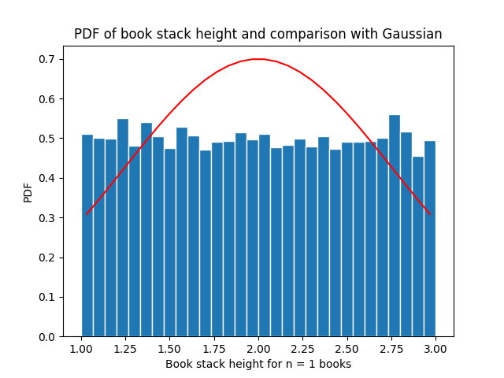

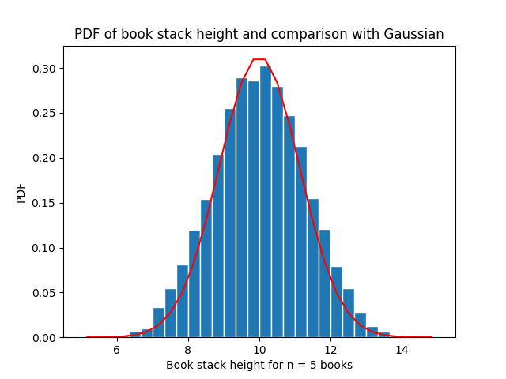

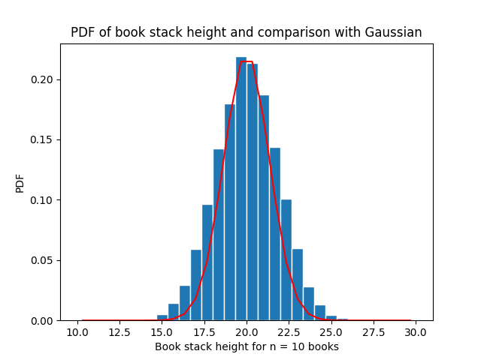

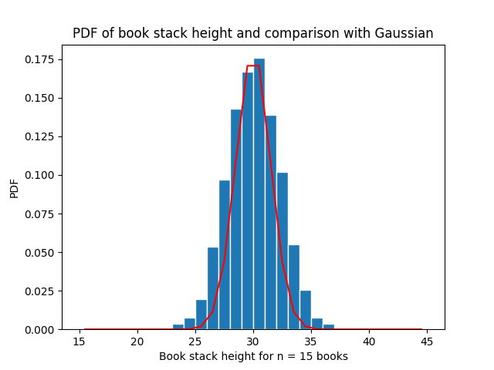

**Problem 2:**

**Introduction:**

In problem 2, we want to simulate and exponentially distributed RV.

**Methodology:**

In this problem, a distribution of number is acquired by doing np.random.exponential using a beta of 0.5. These numbers are then plotted on a histogram.

**Code:**

**def problem_2():**

**N = 10000**

**beta = 0.5**

**nbins = 30**

**edgecolor = 'w'**

**mu, sigma, sig_sqrt = 2, 0.33, 0.57**

**X = np.random.exponential(beta, N)**

**# Create bins and histogram**

**bins = np.linspace(0, 5)**

**h1, bin_edges = np.histogram(X, bins, density=True)**

**# Define points on the horizontal axis**

**be1 = bin_edges[0 : len(bin_edges) - 1]**

**be2 = bin_edges[1 : len(bin_edges)]**

**b1 = (be1 + be2) / 2**

**barwidth = b1[1] - b1[0] # Width of bars in the bargraph**

**plt.close('all')**

**plt.bar(b1, h1, width = barwidth, edgecolor = 'w')**

**plt.plot(bins, 2 * np.exp(-2 * bins), color='r')**

**fig1 = plt.figure(1)**

**# Labels**

**plt.xlabel('Random Variable T')**

**plt.ylabel('PDF')**

**plt.title('Exponentially Distributed RV')**

**plt.show()**

**Results and Conclusion:**

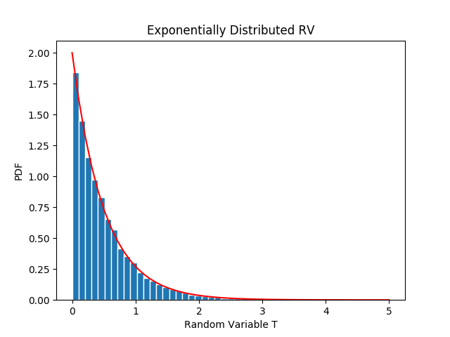

**Problem 3:**

**Introduction:**

Problem 3 involves a battery operated critical medical monitor. The lifetime of the battery is exponentially distributed just like problem 2. The goal is to simulate the RV of a pack of 24 batteries and its lifetime.

**Methodology:**

The batteries are purchased in a pack of 24, so we always get a distribution of 24 numbers. Each battery should last roughly 45 days. This number is used as our beta for the exponential distribution. These numbers are plotted on a histogram to show the distribution.

**Code:**

**def problem_3():**

**N = 10000**

**beta = 45**

**carton_size = 24**

**nbins = 30**

**X = [sum(np.random.exponential(beta, carton_size)) for i in range(0, N)]**

**# Create bins and histogram**

**bins = [float(x) for x in np.linspace(carton_size, 2500, nbins + 1)]**

**h1, bin_edges = np.histogram(X, bins, density = True)**

**# Define points on the horizontal axis**

**be1 = bin_edges[0 : len(bin_edges) - 1]**

**be2 = bin_edges[1 : len(bin_edges)]**

**b1 = (be1 + be2) / 2**

**barwidth = b1[1] - b1[0] # Width of bars in the bargraph**

**plt.close('all')**

**plt.bar(b1, np.cumsum(h1) * barwidth, width = barwidth, edgecolor = 'w')**

**# Plots the red line on the same graph as the bar graph**

**plt.axhline(y = 1.0, color='r')**

**fig1 = plt.figure(1)**

**# Labels**

**plt.xlabel('Lifetime of battery T')**

**plt.ylabel('PDF of battery life')**

**plt.title('Distribution of Sum of RV: Battery Life')**

**plt.show()**

**Results and Conclusion:**

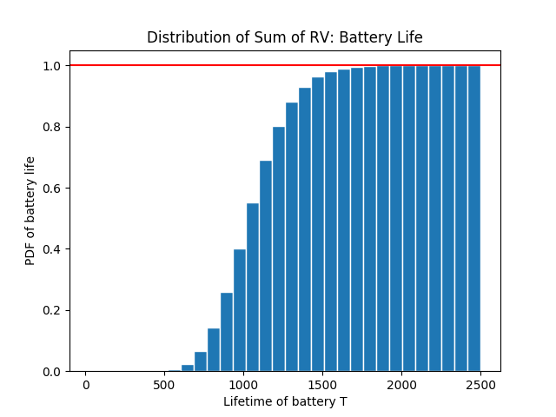

|  |  |
| --- | --- |
| **Question** | **Answer** |
| 1. Probability that the carton will last longer than three years | 0.81 |
| 1. Probability that the carton will last between 2.0 and 2.5 years | 0.98 |