Stanley Ung

011743626

EE 381

**Project 5: Confidence Intervals**

**Problem 1:**

**Introduction:**

In problem 1, we want to see the effect on the 95% and 99% confidence intervals given a certain sample with a certain mean and standard deviation.

**Methodology:**

First, I create a random population using np.random.standard_normal to give me 1000000 random numbers. I then use np.random.choice to grab a random sample out of the population from 1 to 200. The mean is calculated with each sample and then plotted as a function of n. The two graphs are differentiated with one being a 95% confidence interval, and the other being the 99% confidence interval.

**Code:**

**Nb = 10**6 # Total number of bearings**

**mu = 75 # sample mean**

**sigma = 7.5 # standard deviation**

**n = range(1, 201) # range from 1 to 200**

**plt.title('Sample Means and 95% Confidence Intervals')**

**plt.xlabel('Sample Size n')**

**plt.ylabel('x_bar')**

**B = mu + np.random.standard_normal(Nb) * sigma**

**x_bar = [np.mean(np.random.choice(B, i)) for i in n]**

**# Sample Means (n, x_bar)**

**plt.plot(n, list(x_bar), 'x', n, np.repeat(mu, len(n)), 'k')**

**# 95% Confidence Interval**

**plt.plot(n, mu + 1.96 * sigma/np.sqrt(n), 'r--', n, mu - 1.96 * sigma/np.sqrt(n), 'r--')**

**# 99% Confidence Interval**

**plt.plot(n, mu + 2.58 * sigma/np.sqrt(n), 'g:', n, mu - 2.58 * sigma/np.sqrt(n), 'g:')**

**plt.show()**

**Results and Conclusion:**

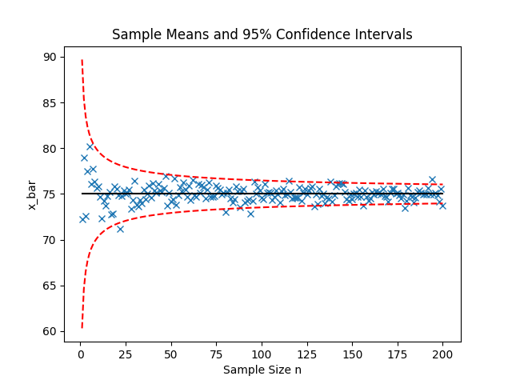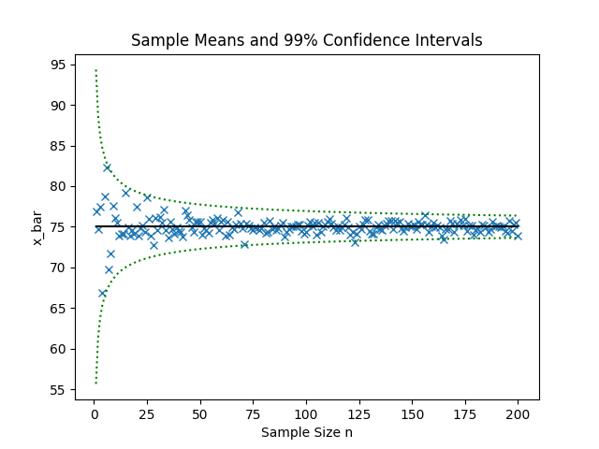

**Problem 2:**

**Introduction:**

In this problem, we are testing different sample sizes of 5, 40, and 120 to test whether our mu will be within a certain interval for the given sample size.

**Methodology:**

We are given sample sizes of 5, 40 and 120 and we are testing four things with these sample sizes. These sizes are used with our original population of 1000000. We then test if our mu is between intervals for 95% normal and student’s t distribution and 99% normal and student’s t distribution.

**Code:**

**Nb = 10**6 # Total number of bearings**

**mu = 75 # sample mean**

**sigma = 7.5 # standard deviation**

**B = mu + np.random.standard_normal(Nb) * sigma # random sample**

**M = 10**5 # number of trials**

**# 5: 2.78, 4.6**

**# 40: 2.02, 2.70**

**# 120: 1.98, 2.62**

**success_95_n = 0**

**success_99_n = 0**

**success_95_t = 0**

**success_99_t = 0**

**for i in range(0 , M):**

**x_j = np.random.choice(B, j)**

**x_bar = np.mean(x_j)**

**s_hat = np.sqrt(sum((x_j - x_bar)**2) / (j - 1))**

**# 95% Confidence Normal**

**n_95_lower = x_bar - 1.96 * (s_hat / np.sqrt(j))**

**n_95_upper = x_bar + 1.96 * (s_hat / np.sqrt(j))**

**if n_95_lower <= mu <= n_95_upper:**

**success_95_n += 1**

**# 99% Confidence Normal**

**n_99_lower = x_bar - 2.58 * (s_hat / np.sqrt(j))**

**n_99_upper = x_bar + 2.58 * (s_hat / np.sqrt(j))**

**if n_99_lower <= mu <= n_99_upper:**

**success_99_n += 1**

**# 95% Confidence t Distribution**

**t_95_lower = x_bar - 2.78 * (s_hat / np.sqrt(j))**

**t_95_upper = x_bar + 2.78 * (s_hat / np.sqrt(j))**

**if t_95_lower <= mu <= t_95_upper:**

**success_95_t += 1**

**# 99% Confidence t Distribution**

**t_99_lower = x_bar - 4.6 * (s_hat / np.sqrt(j))**

**t_99_upper = x_bar + 4.6 * (s_hat / np.sqrt(j))**

**if t_99_lower <= mu <= t_99_upper:**

**success_99_t += 1**

**success = [success_95_n, success_99_n, success_95_t, success_99_t]**

**print ([s / M for s in success])**

**Results and Conclusion:**

|  |  |  |  |  |
| --- | --- | --- | --- | --- |
| **Sample Size (n)** | **95% Confidence** (Using Normal Distribution) | **99% Confidence** (Using Normal Distribution) | **95% Confidence** (Using Student’s t Distribution) | **99% Confidence** (Using Student’s t Distribution) |
| **5** | 0.87652 | **0.93659** | **0.94858** | **0.99021** |
| **40** | **0.94379** | **0.98719** | **0.95036** | **0.99055** |
| **120** | **0.94786** | **0.98837** | **0.95028** | **0.99** |