6.1 -- Factoring by Greatest Common Factor

Factor: Two or more numbers or variables that are multiplied to create a term
Ex. 15 >>> 3&5 factors always come in pairs.
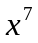>>>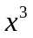&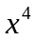

Common Factor: shared factors
Ex. 12 >>> 1&12, 2&6, 3&4
28> >>> 1&28 2&14, 4&7

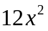 >>> 1,2,3,4,6,12, x,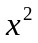 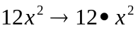
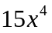 >>>1,3,5,15, x,,,

Greatest Common Factor, take the largest factor from all terms and put them together.
GCF from 12 and 28 is 4
GCF from and is 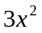

Greatest Common Factor >>> biggest shared factor
Ex. 45 >>> 1,3,5,9,15,45
75 >>> 1,3,5,15,25,75

Use Prime factorization as trees to discover GCF
Use smallest prime numbers to you only have prime numbers left

The GCF will always be the smallest power of the factor tree smallest powers is 3 and 5 multiplies together which is 15.
- 45 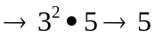
  - 3
  - 15
    - 3
    - 5

- 75 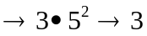
  - 3
  - 25
    - 5
    - 5

Greatest Common Factor >>> biggest shared factor
Ex. 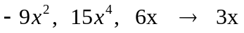

Factoring GCF. (factoring is to add parentheses by division)
- Find GCF of all terms
- Write GCF in front of Parentheses ()
- Divide each term by GCF
- Check you work by Distribution (Multiply) (relatively prime)

Ex. 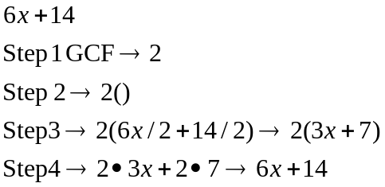

Ex.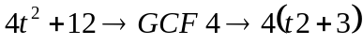
Ex.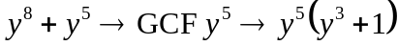
Ex.
Ex.
Ex.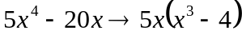
Ex
Ex 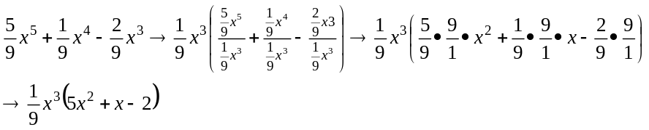

Factoring by grouping
- Look for GCF
- No GCF then factor by grouping
- Organize terms by common factors
- If grouping creates a factor of 1 for all groupings regroup

Ex 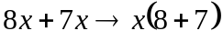
Ex 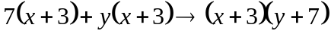
Ex. 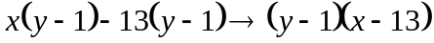
Ex.
Ex.

Ex.
Ex.
Ex.
Ex .
Ex
Ex.
Ex.
Ex.

