Report for Machine Learning Homework 2 電機碩一 盧冠維 109061621

**Results**

This is the best result of using different methods. I use O1=2, O2=5 for BLR and O1=2, O2=2 for MLR.



**Discussion**

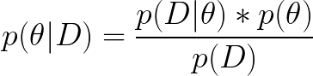

In maximum likelihood, we are searching for a point value for 𝜃 which maximizes the likelihood, 𝑝(𝐷|𝜃). We can denote this value as 𝜃̂^. In MLE, 𝜃̂^ is a point estimate, not a random variable.

In bayesian estimation, we treat 𝜃 as a random variable, putting in probability density functions and get probability density functions, rather than a single point as in MLE

As you can see, while O1 and O2 are small, MLR tend to be stable. When it comes to larger O1 and O2, MLR start to become unstable, while BLR still remain stable.



