Report for Machine Learning Homework 3

電機碩一盧冠維109061621

**Part 1**

The results shown in figure 1 are the result of using MLP with 1 hidden layer. The dimension of the hidden layer I used is 1200, serve with an SGD optimizer and momentum is 0.9. I also show the decision region of trainset and testset in figure 2 and 3.

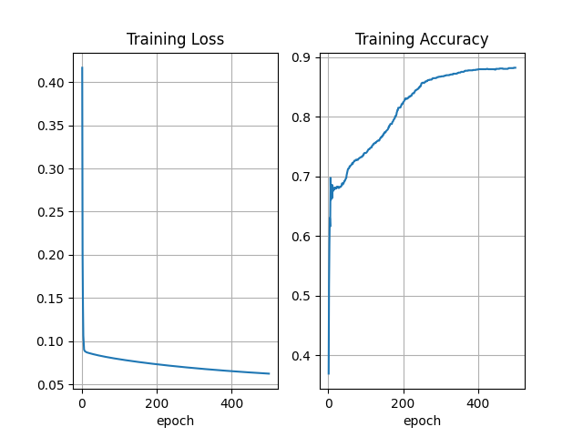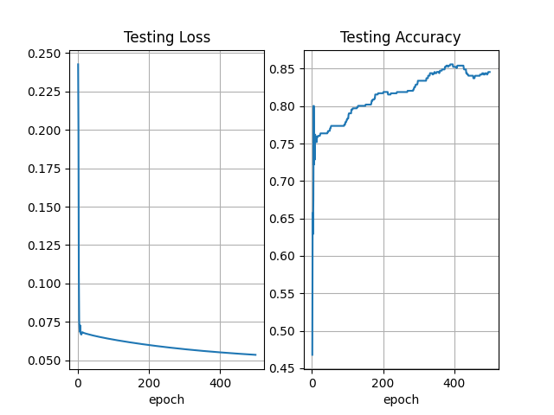

Fig 1. Results of neural network using 1 hidden layer

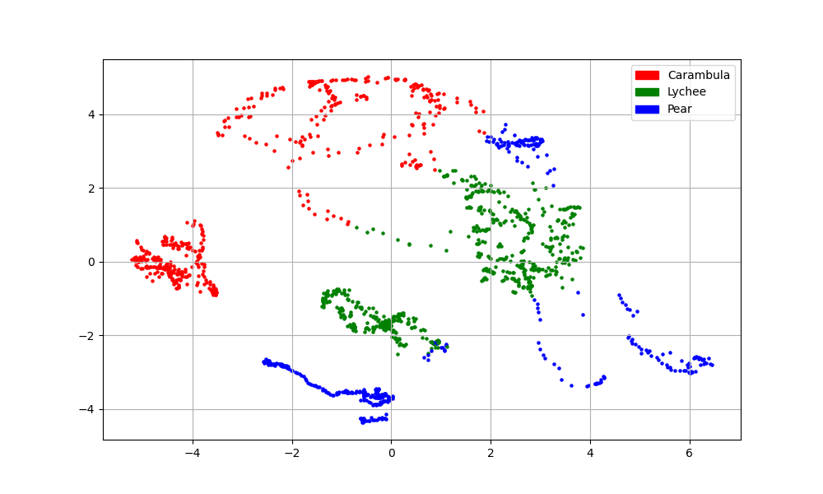

Fig 2. Decision region of the model using one hidden layer perform on trainset

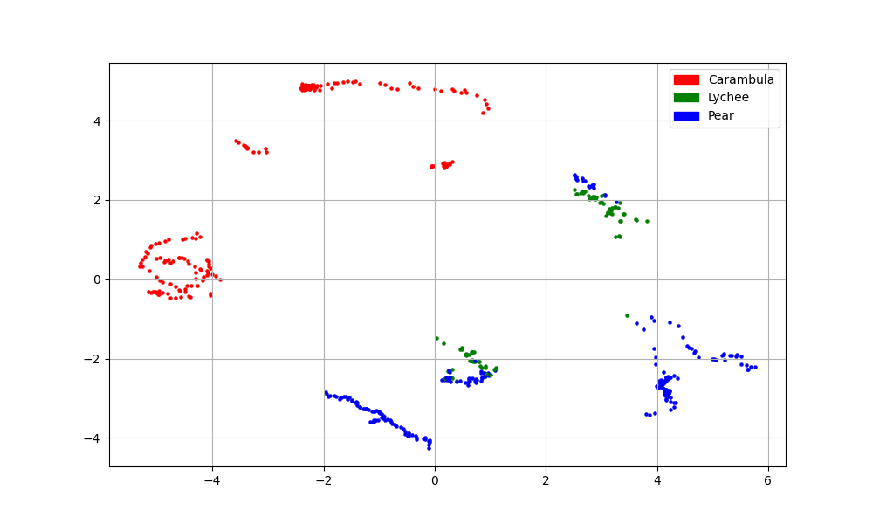

Fig 3. Decision region of the model using one hidden layer perform on testset

**Part 2**

The results shown in figure 4 is the result of using MLP with 2 hidden layer. Following the setting of part 1, I used 200 and 150 as the dimension of the hidden layers respectively. I also show the decision region of trainset and testset in figure 5 and 6.

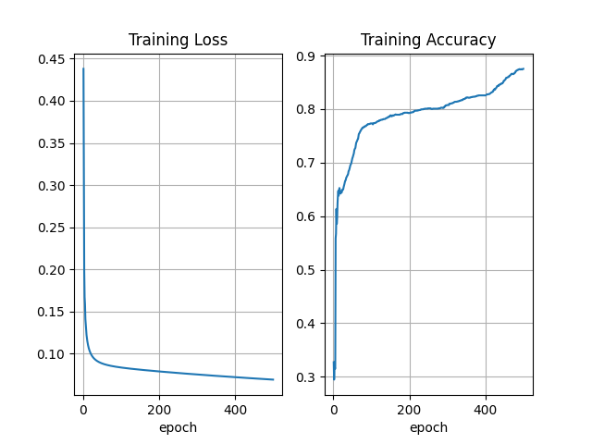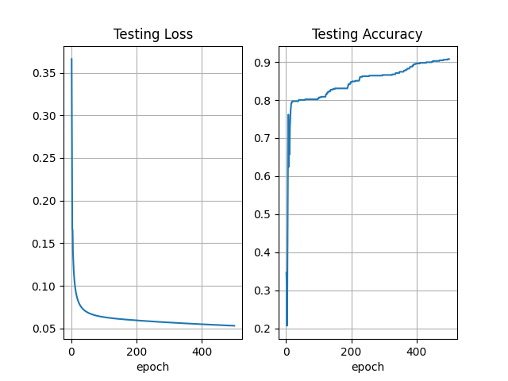

Fig 4. Result of neural network using 2 hidden layer

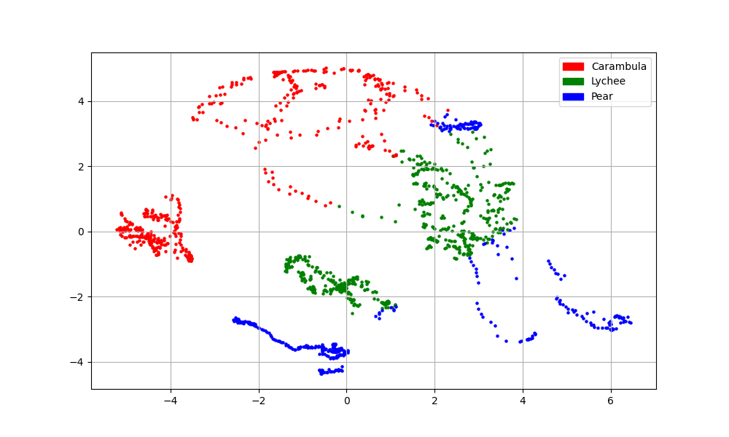

Fig 5. Decision region of the model using two hidden layer perform on trainset

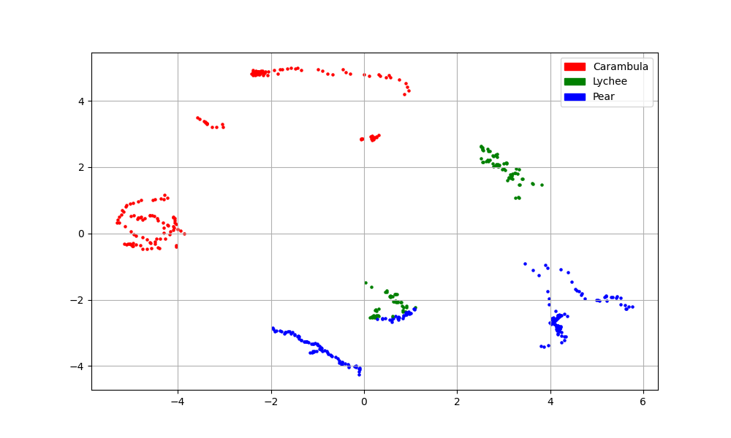

Fig 6. Decision region of the model using two hidden layer perform on testset

**Discussion**

By adding one layer, the performance of the classifier has been improved, and the decision boundary has slightly moved to a better position. During tuning the dimension of the two hidden layers, I found that the dimension of the first hidden layer has to be larger than the second one. If switch the dimension of two hidden layers, will lead to a performance drop.