**Reflective Journal on AI 900 Lab 4**

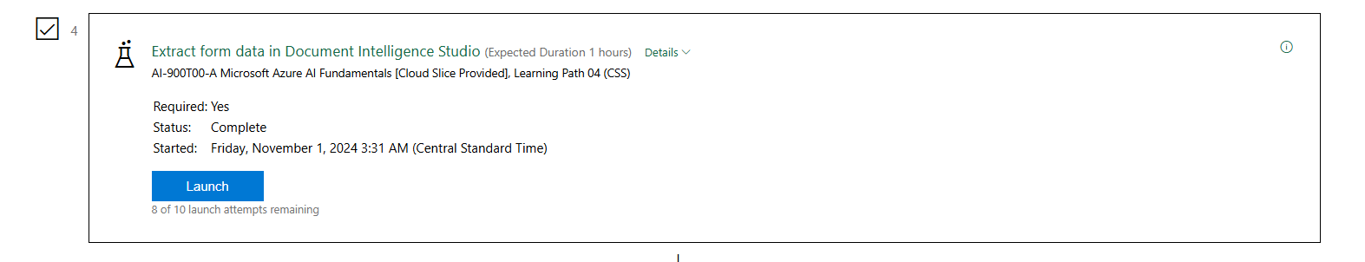

In this lab, I engaged with the Document Intelligent Studio, which is a powerful tool designed for extracting data from various document types, including receipts. My primary objective was to understand how AI technologies can automate the data extraction process and enhance efficiency in handling document workflows.

Through this lab, I learned about the sophisticated machine learning algorithms employed by the Document Intelligent Studio to accurately identify and extract relevant information from receipts, such as vendor names, transaction dates, and total amounts. I was particularly impressed by the tool’s ability to handle different receipt formats, showcasing its flexibility and robustness.

However, I encountered challenges during the lab, particularly with the extraction accuracy of handwritten text on receipts. In some instances, the AI misinterpreted characters or failed to extract certain elements entirely. This experience underscored the importance of high-quality training data and the ongoing need to refine AI models to improve their accuracy and reliability.

The insights gained from this lab experience were invaluable. I now appreciate the potential of AI in automating mundane tasks and how it can free up time for more strategic decision-making. Furthermore, I recognized that while AI tools like the Document Intelligent Studio are powerful, they still require human oversight to ensure data integrity.

Overall, this lab not only deepened my understanding of AI applications in document processing but also reinforced the significance of continuous learning and adaptation in this rapidly evolving field.

### 

### 

### **References**

Microsoft. (n.d.). *Document Intelligence*. Azure. Retrieved November 1, 2024, from<https://azure.microsoft.com/en-us/services/cognitive-services/document-intelligence/>