# Running Instruction for NYCFreeWIFI

(Only for Windows, do not run it on Mac)

Note: In order to successfully run our program, please follow the instructions below strictly.

1. **Download “2XB3_Final_Project_Codes.zip”.**
2. **Extract “2XB3_Final_Project_Codes”.**
3. **Copy the “debug.keystore” to “C:\Users\"YOURUSERNAME"\.android” directory in windows.**

**4.** **Extract “NYCFreeWIFI” and import it into android studio.**

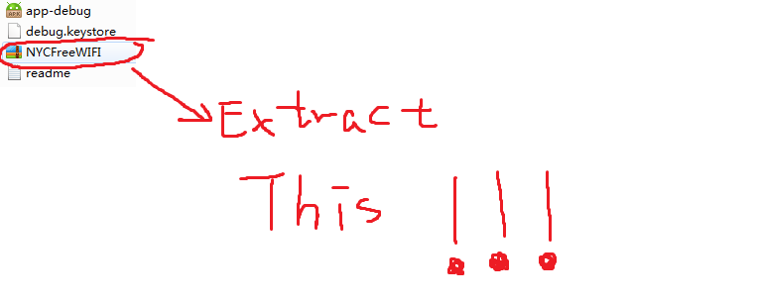

1. **Click File => Settings => Build, Execution, Deployment => Instant Run and uncheck “Enable Instant Run……….”**

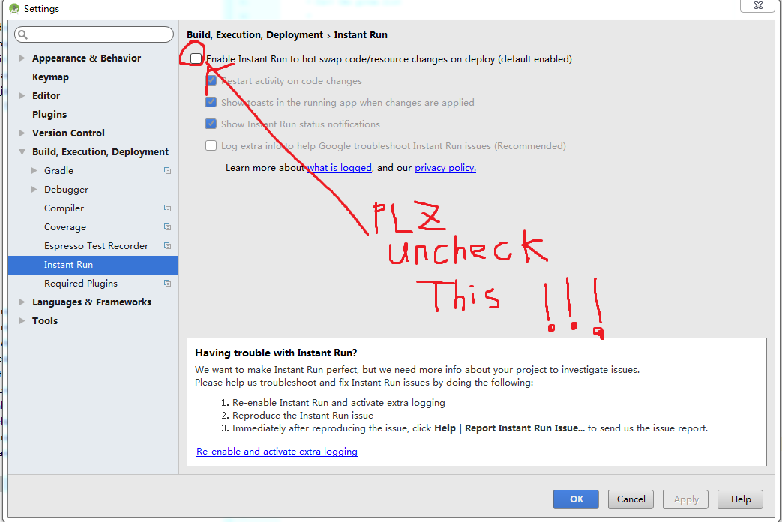

**6.**  **Create an android phone emulator.**

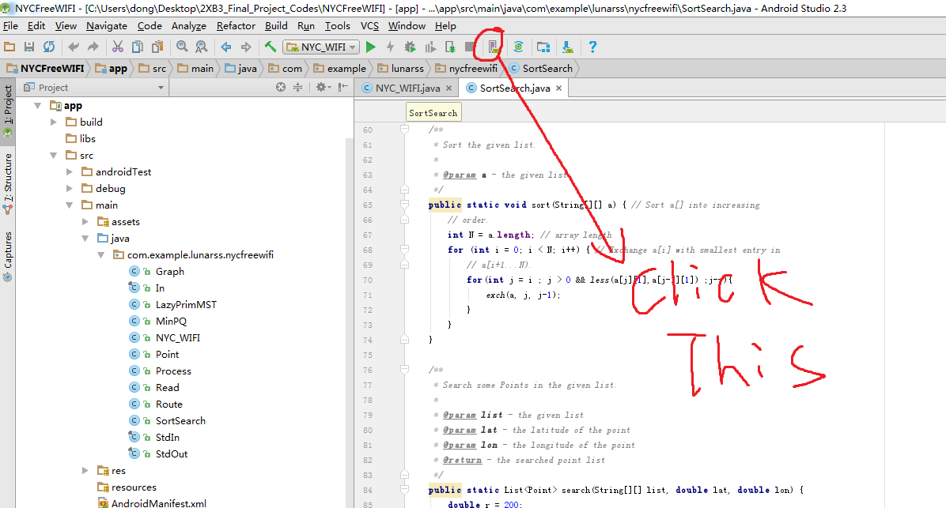

**7.**  **Find NYC_WIFI and click run NYC_WIFI.**

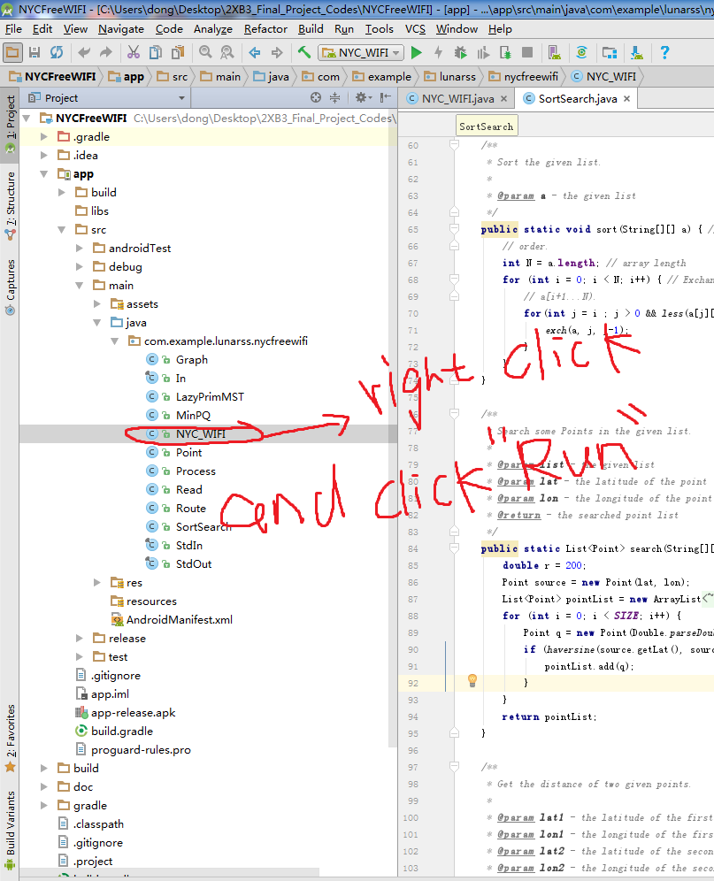

**8. Note: You can also run “app-debug.apk” on your android phone by copying this file to your android phone and install it on your phone.**

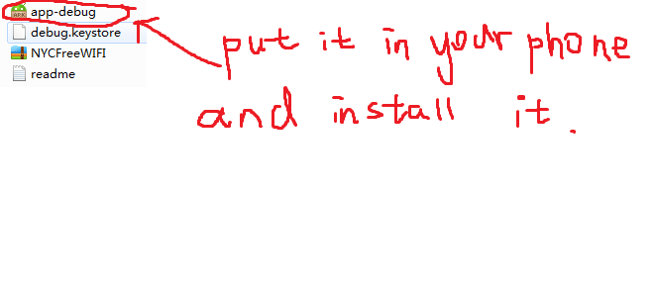

**9. When you first open our application, maybe it will take some time to load the map, please be patient!**

**10. Enjoy!!**