DESIGN AND IMPLEMENTATION OF A NETWORK INTRUSION DETECTION SYSTEM USING RANDOM FOREST MACHINE LEARNING ALGORITHM
BY

OKAFOR MICHAEL OSINACHI
(2022/249971)

OKAFOR UGOCHUKWU STANLEY
(2022/249519)

OKECHUKWU DANIEL SOMTOCHUKWU
(2022/245117)

A BSC PROJECT SUBMITTED IN PARTIAL FULFILLMENT OF THE REQUIREMENTS FOR THE AWARD OF BACHELOR OF SCIENCE (BSC) DEGREE IN COMPUTER SCIENCE,

DEPARTMENT OF COMPUTER SCIENCE
UNIVERSITY OF NIGERIA, NSUKKA

PROJECT SUPERVISOR:
DR. U.K UMEH

JULY, 2026

DECLARATION
We, Okafor Michael Osinachi (2022/246655), Okafor Ugochukwu Stanley (2022/249519), and Okechukwu Daniel Somtochukwu (2022/248965), hereby declare that this project report entitled "Design and Implementation of a Network Intrusion Detection System Using Random Forest Machine Learning Algorithm" is a record of original research work carried out by us under the supervision of Dr. U.K Umeh.
We further declare that this work has not been previously submitted, in part or in full, for the award of any degree or diploma in this or any tertiary institution.

______________________________ | ________________________
Okafor Michael Osinachi | Date

______________________________ | ________________________
Okafor Ugochukwu Stanley | Date

______________________________ | ________________________
Okechukwu Daniel Somtochukwu | Date

CERTIFICATION
This is to certify that this project work, "Design and Implementation of a Network Intrusion Detection System Using Random Forest Machine Learning Algorithm", written by Okafor Michael Osinachi, Okafor Ugochukwu Stanley, and Okechukwu Daniel Somtochukwu, has been examined and approved as meeting the requirements for the award of the degree of Bachelor of Science (B.Sc.) in Computer Science.

______________________________ | ________________________
Dr. U.K Umeh  (Project Supervisor) | Date

______________________________ | ________________________
Head of Department  (Department of Computer Science) | Date

DEDICATION
This project is dedicated to Almighty God for His infinite grace, wisdom, and protection throughout our academic journey. It is also dedicated to our beloved parents for their unending support, encouragement, and sacrifices.

ACKNOWLEDGEMENTS
We wish to express our profound gratitude to the Almighty God for granting us the strength and wisdom to complete this research work.
Our sincere appreciation goes to our supervisor, Dr. U.K Umeh, for his invaluable guidance, patience, and constructive criticism throughout the course of this project. His mentorship has been instrumental in the success of this work.
We are deeply grateful to the Head of Department, and all the lecturers in the Department of Computer Science at the University of Nigeria, Nsukka, for their tireless efforts in imparting knowledge to us.
Special thanks to our parents, family, and friends for their moral and financial support, as well as their prayers, which sustained us through our studies.

ABSTRACT
The rapid growth of computer networks and digital infrastructure has made continuous network security a fundamental necessity. With the increasing sophistication of cyberattacks, traditional signature-based Intrusion Detection Systems (IDS) often fail to identify zero-day attacks and unseen anomalies. To address these limitations, this study presents the design and implementation of an anomaly-based Network Intrusion Detection System utilizing the Random Forest machine learning algorithm. The system was trained and evaluated using the benchmark NSL-KDD dataset to detect and classify various network intrusions with high accuracy while minimizing false positive rates. The Random Forest classifier, an ensemble learning method, demonstrated robustness against overfitting and proved effective in distinguishing between benign and malicious network traffic. The designed system features a user-friendly dashboard for real-time monitoring and alert generation, providing network administrators with actionable insights into potential threats. The evaluation results indicate that the machine learning-based approach significantly outperforms conventional systems in detection accuracy and operational efficiency. The study concludes that integrating machine learning models into network security frameworks provides a viable and robust defense mechanism against advanced persistent threats.

TABLE OF CONTENTS
Title Page i
Declaration ii
Certification iii
Dedication iv
Acknowledgements v
Abstract vi
Table of Contents vii
List of Figures viii
List of Tables ix

CHAPTER ONE: INTRODUCTION
1.1 Background to the Study 1
1.2 Statement of the Problem 3
1.3 Aim and Objectives of the Study 4
1.4 Significance of the Study 5
1.5 Scope and Limitation of the Study 6
1.6 Definition of Terms 7

CHAPTER TWO: LITERATURE REVIEW
2.1 Theoretical Framework 9
2.2 Review of Related Empirical Studies 14
2.3 Summary of Literature and Research Gap 19

CHAPTER THREE: SYSTEMS ANALYSIS AND DESIGN
3.1 Research methodology 21
3.2 Description of the existing system 21
3.2.1 Weaknesses of the existing system 22
3.3 Analysis of the proposed system 23
3.4 Design of the proposed system 25
3.4.1 The Use Case Diagram 25
3.4.2 The Class Diagram 26
3.4.3 The Sequence Diagram 27
3.4.4 The Activity Diagram 28
3.4.5 Database Design 29

LIST OF FIGURES
Figure 3.1: Use Case Diagram of the Proposed System 23
Figure 3.2: Class Diagram of the Proposed System 24
Figure 3.3: Sequence Diagram of the Prediction Process 25
Figure 3.4: Activity Diagram of the Prediction Workflow 26
Figure 4.1: Login Page 32
Figure 4.2: Admin Dashboard 34
Figure 4.3: Threat Detection Log 36

LIST OF TABLES
Table 3.1: Dataset Description 20
Table 3.2: Hardware Requirements 28
Table 3.3: Software Requirements 29
Table 4.1: Model Performance Evaluation 38
Table 4.2: Comparison with Existing Systems 40

CHAPTER ONE
INTRODUCTION
1.1 Background to the Study
The rapid growth of computer networks and digital infrastructure across governments, businesses, financial institutions, and academic organizations has made continuous network security increasingly important. As reliance on interconnected systems deepens, large volumes of sensitive data are transmitted across computer networks daily, increasing exposure to unauthorized access, service disruption, and data exploitation (Abdulganiyu et al., 2023).
Network intrusion remains a persistent threat in this environment. Traditional perimeter security tools such as firewalls and access controls are necessary, but they cannot detect attacks that bypass initial boundaries. While Intrusion Detection Systems (IDS) monitor network activity, signature-based intrusion detection systems cannot detect previously unseen or zero-day attacks, and conventional anomaly-based systems produce high false positive rates, causing severe alert fatigue for system administrators (Hashmi et al., 2024).
To address these challenges, prior research successfully developed standardized benchmark datasets such as NSL-KDD (Tavallaee et al., 2009) to eliminate duplicate record bias. Studies have demonstrated that machine learning algorithms, particularly ensemble methods such as Random Forest, can achieve high detection accuracy and reduce false alarm rates when evaluated on benchmark datasets (Abdulganiyu et al., 2023; Moualla et al., 2021).
Despite these advancements, existing studies focus almost entirely on offline statistical metrics, leaving a gap in deployable, user-facing monitoring tools. In addition, many deep learning-based intrusion detection models provide limited interpretability, making it difficult for administrators to understand the reasons behind detection decisions. This study addresses these remaining issues by integrating a Random Forest classifier, using transparent feature importance rankings, with an interactive Flask web dashboard to provide a practical, low-cost IDS prototype for academic settings like the University of Nigeria, Nsukka. The specific problems that motivate this study are presented in the next section.
1.2 Statement of the Problem
Network intrusion remains one of the most damaging and persistent threats to digital infrastructure worldwide. Organizations across sectors continue to suffer unauthorized access, data theft, service disruption, and financial loss as a result of network attacks. Despite significant investment in security infrastructure, attackers continue to exploit weaknesses in existing systems, and the rate and sophistication of attacks continues to increase. This situation demands reliable, automated detection mechanisms that can identify malicious network activity with high accuracy and low false alarm rates.
Specifically, the following problems are identified in existing intrusion detection approaches that this study seeks to resolve:
i. Traditional signature-based systems are fundamentally unable to detect novel or zero-day threats, as detection depends entirely on predefined attack signatures that must be continuously updated.
ii. While anomaly-based systems can detect previously unseen attacks, they are frequently associated with high false positive rates, which create alert fatigue for administrators and may cause genuine threats to be overlooked.
iii. Most published academic IDS solutions present experimental classification results only, without any user-facing interface or deployment mechanism that would allow administrators to easily interact with and interpret detection outputs in a practical environment.
This study therefore addresses the need for a network intrusion detection system that minimizes false positive rates while retaining the ability to detect unseen attacks, is implemented as functional software using the Random Forest algorithm, and presents its results through an accessible web-based dashboard suited to the Nigerian academic computing environment.
1.3 Aim and Objectives of the Study
The aim of this study is to develop a machine learning-based network intrusion detection system using the Random Forest algorithm for classifying network traffic as normal or malicious.
The specific objectives of the study are to:
i. Collect and preprocess the NSL-KDD dataset, including data cleaning, encoding of categorical features, and feature selection, to prepare it for model training.
ii. Design and train a Random Forest classification model on the preprocessed dataset to distinguish between normal and attack network traffic.
iii. Evaluate the performance of the trained model using standard metrics including accuracy, precision, recall, F-measure, and false positive rate.
iv. Develop a web-based dashboard using the Flask framework to visualize classification results and display the system's detection outputs.
1.4 Significance of the Study
This study provides a practical software-based Network Intrusion Detection System that applies the Random Forest algorithm to the NSL-KDD benchmark dataset and presents detection results through a web-based interface. By combining machine learning-based classification with an accessible dashboard, the study provides a practical approach to presenting intrusion detection results for easier interpretation and use. The beneficiaries of the study include network administrators and security practitioners, researchers and students, academic institutions, and the Department of Computer Science. The benefits to each group are outlined as follows:
i. For Network Administrators and Security Practitioners: The system offers a transparent and interpretable detection mechanism. Unlike deep learning models, Random Forest produces feature importance rankings that identify which network attributes most strongly indicate malicious activity. This gives administrators meaningful insight into detection decisions rather than opaque outputs. The web dashboard further enhances practical usability by presenting results in a structured, visual format without requiring direct access to model code.
ii. For the Department of Computer Science, University of Nigeria, Nsukka: The project provides a reproducible, open-source IDS prototype built entirely with freely available tools and public datasets. It demonstrates that a functional intrusion detection system can be developed and deployed within an academic setting at minimal cost. Recent work by Hashmi et al. (2024) and Moualla et al. (2021) confirms that carefully implemented ML-based IDS solutions continue to achieve competitive detection accuracy on standard benchmarks, supporting the academic and practical value of this approach.
iii. For the Broader Academic Community: The study provides a documented implementation of a machine learning-based network intrusion detection system that can serve as a useful reference for future research and similar implementations within academic institutions and related organizations. It encourages further applied research at the intersection of machine learning and network security, an area of increasing national relevance as digital infrastructure continues to expand across public and private sectors.
1.5 Scope of the Study
This study covers the design, implementation, and evaluation of a software-based network intrusion detection system using the Random Forest algorithm. The system is implemented entirely in Python using the scikit-learn machine learning library and the Flask web framework. No physical network hardware, packet capture tools, or virtual laboratory environments are used. All training and evaluation are performed on the NSL-KDD benchmark dataset.
The system performs binary classification only, assigning each network traffic record to one of two categories: normal or attack. The identification of specific attack subcategories such as denial-of-service, probing, remote-to-local, or user-to-root attacks is outside the scope of this study. The web dashboard displays classification results based on processed input data and does not perform live traffic capture or real-time packet interception.
The key concepts addressed in this study include: network intrusion detection, anomaly-based detection, the Random Forest algorithm, feature selection, model performance evaluation, and web-based system deployment. The study is conducted within the discipline of computer science and is carried out at the University of Nigeria, Nsukka.
1.6 Limitation of the Study
Several limitations of this study are acknowledged upfront. First, the system is trained and evaluated on the NSL-KDD benchmark dataset rather than live network traffic. While NSL-KDD is a widely accepted standard, Abdulganiyu et al. (2023) note that it does not fully reflect the attack landscape of contemporary networks. Detection performance on real-world traffic may therefore differ from results obtained on benchmark data.
Second, the study is limited to binary classification. The system indicates whether a traffic record is normal or an attack but does not identify the specific type of attack. This reduces the depth of information available to administrators when responding to detected threats.
Third, the web dashboard does not support live network monitoring. It presents classification results based on data fed into the system rather than traffic captured from a real network interface. Extending the system to live monitoring would require integration with network packet capture tools such as Scapy or Wireshark, which is beyond the scope of this project.
Fourth, only one algorithm is applied. Random Forest was selected based on its documented accuracy, interpretability, and computational efficiency in recent IDS studies (Hashmi et al., 2024; Moualla et al., 2021). A comparative evaluation against other algorithms such as Support Vector Machines or gradient boosting methods was outside the scope of this work.
1.7 Definition of Terms
The following technical terms are used throughout this project work:
Intrusion Detection System (IDS): A software system that monitors network or system activities for malicious activities or policy violations and reports detected events to an administrator.
Network-Based Intrusion Detection System (NIDS): An IDS deployed across a computer network to monitor and analyse network traffic in order to detect malicious or suspicious activities.
Anomaly-Based Detection: An IDS approach that builds a model of normal network behaviour and flags deviations from that model as potential intrusions, enabling detection of previously unseen attacks.
Signature-Based Detection: An IDS approach that identifies attacks by comparing network traffic against a pre-built database of known attack signatures. Also referred to as misuse detection.
Random Forest: A supervised ensemble machine learning algorithm that builds multiple decision trees during training and outputs the class that receives the majority vote across all trees.
NSL-KDD Dataset: A benchmark dataset for intrusion detection proposed by Tavallaee et al. (2009) as a refined version of the KDD Cup 99 dataset, removing redundant records that caused biased classifier evaluations in the original.
Binary Classification: A supervised learning task in which each input is assigned to one of two categories, in this study, normal traffic or attack traffic.
False Positive Rate (FPR): The proportion of legitimate (normal) traffic records incorrectly classified as attacks. Also called the False Alarm Rate (FAR). A high FPR creates unnecessary alerts and reduces the practical usefulness of an IDS.
Feature Selection: The process of identifying and retaining the most relevant attributes from a dataset for model training, improving classification accuracy and reducing computational cost.
Flask: A lightweight Python web framework used in this study to develop the monitoring dashboard. Flask enables rapid development of web-based interfaces with minimal configuration.
scikit-learn: An open-source Python library for machine learning that provides implementations of the Random Forest algorithm and standard model evaluation metrics used in this project.

CHAPTER TWO
LITERATURE REVIEW
2.0 Introduction
This chapter presents a detailed review of related literature on network intrusion detection systems (IDS) with a focus on machine learning-based approaches. The chapter is organised into three main sections. The first section provides the theoretical background, covering the core concepts underpinning intrusion detection—progressing from foundational networking and security principles to the specific machine learning techniques employed—as well as the technologies used in building the proposed system. The second section reviews closely related studies that have applied machine learning techniques, particularly the Random Forest algorithm, to network intrusion detection, arranged chronologically from the earliest to the most recent. The third section identifies the research gap that the present study seeks to address. All references cited in this chapter follow the American Psychological Association (APA) referencing style.
2.1 Theoretical Background
This section provides a foundational understanding of the key concepts and technologies relevant to the design and implementation of a machine learning-based network intrusion detection system. The discussion is organised into two parts: conceptual foundations, which progress from broad networking concepts to the specific algorithm used in this study, and the technological tools employed in the implementation.
2.1.1 Concepts
2.1.1.1 Computer Networks and Cybersecurity
A computer network is a collection of interconnected computing devices that exchange data and share resources through wired or wireless communication links. Networks range from Local Area Networks (LANs), which connect devices within a limited geographical area, to Wide Area Networks (WANs) that span cities, countries, and the Internet (Kurose & Ross, 2021). The increasing dependence of governments, educational institutions, businesses, and individuals on computer networks has made network security a critical concern. Cybersecurity encompasses the policies, technologies, and practices designed to protect computer systems, networks, and digital information against unauthorized access, cyberattacks, and data breaches. Common security mechanisms include firewalls, encryption protocols, authentication systems, and access control policies. Although these mechanisms provide the first line of defence, they cannot detect every attack, particularly insider threats or attacks that exploit previously unknown vulnerabilities. Consequently, organisations deploy intrusion detection systems to complement these preventive controls by continuously monitoring network activities for malicious behavior (Stallings & Brown, 2023).
2.1.1.2 Network Intrusion
A network intrusion refers to any unauthorized attempt to access, manipulate, disrupt, or compromise a computer network or the resources connected to it. Such intrusions may originate from external attackers or malicious insiders and can lead to data theft, service disruption, financial loss, or complete system compromise. According to Abdulganiyu et al. (2023), the increasing sophistication of cyberattacks has made network intrusion one of the most significant cybersecurity threats facing modern organisations. Detecting these intrusions quickly is essential for limiting damage and maintaining the confidentiality, integrity, and availability of network resources.
2.1.1.3 Intrusion Detection Systems (IDS)
An Intrusion Detection System (IDS) is a hardware- or software-based security mechanism designed to monitor network traffic or host activities and identify malicious actions, policy violations, or unauthorized access attempts. Unlike preventive technologies such as firewalls, an IDS focuses on detecting attacks that have bypassed existing security controls and notifying administrators so that appropriate action can be taken (Khraisat et al., 2019). IDS forms an important component of modern network security architectures because it provides continuous visibility into network activities.
2.1.1.4 Network Intrusion Detection Systems (NIDS)
Intrusion Detection Systems are generally classified according to their deployment location into Host-Based Intrusion Detection Systems (HIDS) and Network-Based Intrusion Detection Systems (NIDS). A HIDS monitors activities occurring on an individual computer, including file modifications, application behavior, and operating system logs. In contrast, a NIDS analyses packets travelling across a network segment, allowing it to detect attacks affecting multiple devices simultaneously (Liao et al., 2013). Since this study aims to classify network traffic as either normal or malicious, it adopts the Network Intrusion Detection System paradigm.
2.1.1.5 Threat Monitoring
Threat monitoring is the continuous observation of network traffic, system events, and security logs to identify suspicious activities before they develop into serious security incidents. Effective threat monitoring enables security administrators to detect unusual patterns early and respond before attackers achieve their objectives. According to Younus and Alanezi (2023), continuous monitoring forms the foundation of modern cybersecurity operations because it provides the information required for timely threat detection and response. In this study, threat monitoring is achieved through the continuous analysis of network connection records contained in the NSL-KDD dataset.
2.1.1.6 Signature-Based Detection
Signature-based detection identifies malicious activities by comparing observed network traffic against a database of previously known attack signatures. This approach is highly effective for detecting attacks that have already been documented because matching patterns can be identified accurately with relatively few false alarms. However, its effectiveness depends entirely on the availability of updated attack signatures, making it incapable of detecting new or zero-day attacks that have not yet been documented (Abdulganiyu et al., 2023).
2.1.1.7 Anomaly-Based Detection
Anomaly-based detection establishes a model representing normal network behavior and identifies deviations from this baseline as potential intrusions. Unlike signature-based methods, anomaly detection is capable of identifying previously unseen attacks because detection is based on behavioral differences rather than known attack patterns. Nevertheless, anomaly-based systems frequently produce higher false positive rates, where legitimate network activities are incorrectly classified as attacks (Ahmad et al., 2021). Since the proposed system is intended to detect both known and unknown attacks, this study adopts the anomaly-based detection approach using a Random Forest classifier.
2.1.1.8 Real-Time Alerting
Real-time alerting is the process through which an intrusion detection system immediately notifies administrators whenever suspicious activity is detected. Prompt notification allows administrators to investigate threats quickly and reduce potential damage. However, excessive false alarms reduce the usefulness of alerting systems by creating alert fatigue, making it difficult for administrators to distinguish genuine attacks from harmless events (Albasheer et al., 2022). In the proposed system, classification results are presented through a Flask-based dashboard immediately after prediction.
2.1.1.9 Incident Response
Incident response refers to the coordinated actions taken after a security incident has been detected in order to investigate, contain, eradicate, and recover from the attack. According to Alturkistani and El-Affendi (2022), intrusion detection represents only the first stage of the cybersecurity response process, while incident response transforms detection into practical security action. Although the proposed system does not automate incident response, its detection results provide administrators with timely information needed to initiate appropriate response procedures.
2.1.1.10 Visibility and Logging
Visibility refers to the ability of administrators to observe activities occurring across a network, while logging involves maintaining records of network events for auditing, forensic analysis, and future investigation. González-Granadillo et al. (2021) emphasised that effective security monitoring depends not only on accurate detection but also on presenting information in a form that administrators can easily interpret. In this study, visibility is enhanced through a web-based dashboard that presents detection outcomes clearly, while prediction results can be stored for later analysis.
2.1.1.11 Machine Learning in Intrusion Detection
Machine learning enables computers to learn patterns from historical data and apply that knowledge when making predictions on new, unseen data. In intrusion detection, machine learning allows systems to distinguish between normal and malicious network traffic without relying solely on predefined attack signatures. Supervised learning algorithms are particularly suitable because they learn from labelled datasets containing examples of both legitimate and malicious traffic (Sarker et al., 2020). Recent studies have demonstrated that machine learning significantly improves intrusion detection performance by increasing detection accuracy while reducing manual rule creation (Mishra et al., 2022).
2.1.1.12 Random Forest Algorithm
Random Forest is a supervised ensemble learning algorithm introduced by Breiman (2001). The algorithm constructs multiple decision trees using random subsets of training samples and predictor variables, before combining their predictions through majority voting. This ensemble approach improves classification accuracy, reduces overfitting, and performs well with high-dimensional datasets. Random Forest also provides feature importance scores that help explain which variables contribute most to prediction decisions (Hashmi et al., 2024).
The algorithm has been widely adopted for intrusion detection because it consistently achieves high accuracy, precision, recall, and F1-score on benchmark datasets while remaining computationally efficient compared with many deep learning models (Moualla et al., 2021). Owing to these advantages, Random Forest is selected as the classification algorithm for the proposed intrusion detection system.
2.1.1.13 NSL-KDD Dataset
The NSL-KDD dataset is a benchmark dataset developed by Tavallaee et al. (2009) to address the shortcomings of the earlier KDD Cup 99 dataset. It removes duplicate records that previously biased classifier performance and provides a more balanced distribution of training and testing samples. Each record contains 41 network traffic features together with a label indicating whether the connection is normal or represents one of several attack categories. Because of its widespread acceptance and suitability for comparative evaluation, the NSL-KDD dataset is used in this study to train and evaluate the Random Forest classifier (Abdulganiyu et al., 2023).
2.1.1.14 Flask Framework
Flask is a lightweight Python web framework used for developing web applications and application programming interfaces (APIs). Its simplicity, flexibility, and ease of integration with machine learning models make it particularly suitable for academic research and prototype development (Grinberg, 2018). In this study, Flask is used to develop a web-based dashboard that displays intrusion detection results generated by the Random Forest classifier. The dashboard improves usability by allowing users to interact with the system and view prediction outcomes without directly accessing the underlying source code.
2.1.2 Technology
This section discusses the core software tools and technologies adopted to implement the proposed network intrusion detection system. The key technological components are itemized below:
i. Python: A high-level, general-purpose programming language widely used in data science, machine learning, and cybersecurity research. Its clean syntax and extensive ecosystem of third-party packages make it particularly suitable for rapid prototyping of machine learning systems (Raschka et al., 2020). In this study, Python serves as the primary programming language for data preprocessing, model training, evaluation, and web interface development.
ii. scikit-learn: An open-source Python library that provides simple and efficient tools for data mining and machine learning. It offers implementations of algorithms, including the Random Forest classifier used in this study, as well as utilities for data preprocessing and evaluation (Pedregosa et al., 2011).
iii. Flask: A lightweight web application framework for Python. It follows a minimalist design philosophy, providing essential components for web development. In this study, Flask is used to develop a web-based interface that displays classification results and feature importance rankings to users, serving strictly as a visualization tool for presenting pre-computed classification outputs (Grinberg, 2018).
iv. Pandas: A foundational tool for data manipulation. Pandas provides high-performance data structures such as DataFrames for organising and transforming tabular data, which is essential for loading, cleaning, and preprocessing the NSL-KDD dataset (McKinney, 2022).
v. NumPy: A library supporting large, multi-dimensional arrays and matrices along with a collection of mathematical functions optimised for numerical operations. Together with Pandas, it forms the backbone of the data pipeline in this study (McKinney, 2022).
2.2 Review of Related Literature
This section reviews closely related studies that have applied machine learning techniques to network intrusion detection. The studies are presented in chronological order, from the earliest to the most recent, in accordance with departmental guidelines. Each study is discussed in terms of the contribution of the author(s), the methodology employed, the key findings, and the similarities and differences with the present study.
Tavallaee et al. (2009) proposed the NSL-KDD dataset as a revised version of the original KDD Cup 1999 dataset, which had been the standard benchmark for evaluating intrusion detection systems for nearly a decade. The authors identified critical flaws in the KDD Cup 99 dataset, including a large number of redundant and duplicate records that artificially inflated classifier accuracy. To address these issues, the authors removed all duplicate records from the training set and introduced a stratified sampling approach to balance the difficulty level of test records. The resulting NSL-KDD dataset consists of 41 network traffic features and labels for both binary and multi-class classification tasks. The present study relies directly on the NSL-KDD dataset for training and evaluating its Random Forest classifier. Both studies share a focus on improving the reliability of IDS evaluation. They differ in that Tavallaee et al. focused on dataset construction and evaluation methodology, while the present study applies the dataset within a complete detection system with a web-based visualization interface.
Liao et al. (2013) conducted a broad review of intrusion detection systems, tracing the evolution of IDS from early rule-based systems to modern data-driven approaches. The review classified IDS into categories based on detection method (signature-based, anomaly-based, and specification-based) and data source (host-based and network-based). The authors noted that anomaly-based methods offer the advantage of detecting previously unseen attacks but tend to produce higher false positive rates compared to signature-based systems. The review also identified the growing role of machine learning in automating the construction of detection models. The present study builds on the anomaly-based paradigm described in this review, applying a Random Forest classifier to learn the boundary between normal and attack traffic. Both studies address the classification of network traffic, but differ in that Liao et al. presented a survey of existing approaches while the present study implements a working detection system.
Khraisat et al. (2019) published a survey of intrusion detection techniques, datasets, and open challenges. The survey categorised detection methods into signature-based, anomaly-based, and hybrid approaches, and evaluated the most commonly used benchmark datasets including KDD Cup 99, NSL-KDD, UNSW-NB15, and CICIDS2017. The authors identified several persistent challenges in IDS research, including high false alarm rates, difficulty in detecting low-frequency attack types, and the lack of up-to-date datasets that reflect current network conditions. The survey recommended ensemble methods, including Random Forest, as promising directions for improving detection performance. The present study is similar in its adoption of Random Forest as the primary detection algorithm and its use of the NSL-KDD dataset. It differs in that the present study goes beyond surveying techniques to implement a functioning prototype with a user-facing web interface for result visualization.
Ferrag et al. (2020) presented an extensive survey of deep learning-based intrusion detection systems, reviewing architectures such as Convolutional Neural Networks (CNN), Recurrent Neural Networks (RNN), Autoencoders, and Generative Adversarial Networks (GAN). The survey evaluated these architectures on multiple benchmark datasets including NSL-KDD, CICIDS2017, and UNSW-NB15. The authors found that while deep learning models achieved high accuracy, they required significantly more computational resources and training time compared to traditional machine learning methods such as Random Forest. The survey also identified the lack of interpretability in deep learning models as a major barrier to their adoption in operational IDS environments. The present study is related in its focus on machine learning for intrusion detection but differs fundamentally in its choice of a traditional ML algorithm (Random Forest) over deep learning, prioritising interpretability and computational efficiency over marginal gains in detection accuracy.
Sarker et al. (2020) proposed a context-aware machine learning-based approach to cybersecurity, incorporating temporal and contextual features extracted from network traffic. The study applied several ML algorithms, including Random Forest, Gradient Boosting, and Logistic Regression, and evaluated them on the UNSW-NB15 dataset. The results demonstrated that context-aware feature engineering improved detection performance, with Random Forest achieving a balanced accuracy of 96.2% and an F1-score of 0.95. The authors emphasised the importance of interpretable models in cybersecurity applications where administrators need to understand the basis of detection decisions. The present study shares this emphasis on interpretability through the use of Random Forest’s feature importance rankings and a web interface that presents results in a transparent, human-readable format. However, the present study differs in dataset selection (NSL-KDD versus UNSW-NB15) and does not incorporate contextual feature engineering.
Ahmad et al. (2021) proposed a network intrusion detection system using a combination of feature selection techniques and ensemble classifiers. The study applied information gain and correlation-based feature selection to the NSL-KDD and UNSW-NB15 datasets before training Random Forest, Bagging, and AdaBoost classifiers. The results showed that feature selection markedly improved detection accuracy, with Random Forest achieving the highest accuracy of 99.81% on the NSL-KDD dataset when trained on the reduced feature set. The authors concluded that feature selection is essential for building efficient and accurate IDS. The present study is similar in its application of Random Forest to the NSL-KDD dataset and its emphasis on feature selection. However, the present study differs in its inclusion of a web-based interface for visualizing classification results and its focus on binary classification rather than multi-class detection.
Moualla et al. (2021) investigated the performance of multiple machine learning algorithms on the UNSW-NB15 dataset for network intrusion detection. The algorithms evaluated included Random Forest, Decision Tree, Naive Bayes, and Support Vector Machine. The study applied data preprocessing techniques including normalisation, label encoding, and feature selection to improve classification performance. Results showed that Random Forest consistently outperformed the other algorithms, achieving an accuracy of 97.49% and the lowest false positive rate among all tested classifiers. The authors attributed this performance to Random Forest’s ability to handle high-dimensional data and its resistance to overfitting. The present study is similar in its use of Random Forest and its application of data preprocessing techniques. However, it differs in the dataset used (NSL-KDD versus UNSW-NB15) and the inclusion of a web-based visualization component for presenting detection outcomes.
Thakkar and Lohiya (2021) conducted a review of feature selection and feature extraction techniques for intrusion detection systems. The study analysed over 70 published works and categorised feature engineering approaches into filter, wrapper, embedded, and hybrid methods. The authors found that effective feature selection consistently improved detection accuracy while reducing training time and model complexity. Random Forest-based feature importance was highlighted as one of the most effective embedded feature selection techniques for IDS. The review also identified a lack of standardisation in feature selection practices across studies, making direct comparison of results difficult. The present study is similar in its use of Random Forest’s embedded feature importance for identifying the most informative network attributes. It differs in that the present study implements a complete IDS prototype with a user-facing web interface rather than focusing on feature engineering techniques in isolation.
Mishra et al. (2022) developed a machine learning-based network intrusion detection system and compared the performance of Random Forest, XGBoost, and LightGBM algorithms on the NSL-KDD dataset. The study employed SMOTE (Synthetic Minority Over-sampling Technique) to address class imbalance and applied hyperparameter tuning using grid search cross-validation. Results indicated that Random Forest achieved an accuracy of 99.67% and a false positive rate of 0.29%, outperforming both XGBoost and LightGBM in terms of overall detection accuracy. The study concluded that ensemble methods, particularly Random Forest, remain highly competitive for network intrusion detection when combined with appropriate data balancing and tuning strategies. The present study is similar in its use of Random Forest on the NSL-KDD dataset and its focus on binary classification. It differs in that the present study includes a web-based visualization component for presenting classification results and does not apply SMOTE for class balancing.
Abdulganiyu et al. (2023) conducted a systematic literature review of network intrusion detection systems, surveying 150 studies published between 2015 and 2022. The review categorised IDS approaches into signature-based, anomaly-based, and hybrid methods, and evaluated the strengths and limitations of various machine learning algorithms used in each category. The authors noted that Random Forest and Deep Neural Networks were among the most frequently applied algorithms, while the NSL-KDD and CICIDS2017 datasets were the most commonly used benchmarks. The review also highlighted persistent challenges including class imbalance, high false positive rates, and the absence of real-time evaluation on live network traffic. The present study draws on the findings of this review, particularly the identified strengths of Random Forest for IDS applications. The present study is similar in its focus on anomaly-based detection using ML but differs in that it presents an implemented, functional system rather than a survey of existing literature.
Hashmi et al. (2024) developed a hybrid intrusion detection system that combined Random Forest with a feature weighted attention-based deep learning model. The study was evaluated on the NSL-KDD and CICIDS2017 datasets. The authors applied Random Forest as a baseline classifier and then enhanced detection performance by integrating an attention mechanism to weight the most discriminative features. The hybrid model achieved an accuracy of 99.34% on the NSL-KDD dataset and 99.89% on the CICIDS2017 dataset. Feature importance analysis was used to identify the most informative attributes for intrusion detection. The study demonstrated that combining traditional ensemble methods with deep learning architectures can yield notable performance improvements. The present study is similar in its use of the Random Forest algorithm and the NSL-KDD dataset for intrusion detection. However, it differs in that the present study employs a standalone Random Forest classifier without a deep learning component, focusing instead on interpretability and practical visualization of detection results through a Flask web interface.
2.3 Research/Knowledge Gap
The literature reviewed in this chapter demonstrates that machine learning, particularly the Random Forest algorithm, has been extensively applied to network intrusion detection with consistently strong results on benchmark datasets. However, a major operational gap emerges from the existing body of work: the disconnect between theoretical model training and practical, deployable systems.
While studies regularly achieve high accuracy scores, the overwhelming majority of research concludes at the evaluation phase. Authors present confusion matrices and accuracy tables without providing a usable system that end-users or network administrators can interact with. A highly accurate anomaly detection model that only exists as an offline script provides limited practical utility, as it fails to offer transparent, real-time visualization of its findings (such as feature importance rankings). Furthermore, there is a critical lack of locally developed IDS prototypes that demonstrate the feasibility of building these systems within Nigerian academic environments using open-source tools.
The present study specifically addresses this gap by bridging the divide between statistical data science and software engineering. It implements a cohesive, end-to-end intrusion detection prototype that combines a trained Random Forest classifier with a Flask-based web dashboard. This transitions the IDS from a purely theoretical exercise into an accessible, visual application that presents classification results and interpretability metrics directly to administrators, thereby providing a reproducible foundation for cybersecurity capacity building in the Nigerian academic context.

CHAPTER THREE
SYSTEMS ANALYSIS AND DESIGN METHODOLOGY
3.0 Introduction
This chapter presents the systems analysis and design methodology adopted for the development of the proposed network intrusion detection system. It begins by discussing the software development methodology adopted for the project and justifying its selection. This is followed by an analysis of the existing system, including an examination of how comparable machine learning-based intrusion detection systems are typically developed and evaluated in the literature, and an identification of the weaknesses associated with this existing approach. The chapter then presents a detailed analysis of the proposed system, covering its architecture, input design, processing design, output design, and database design. Finally, the chapter presents the system design, expressed through Unified Modelling Language (UML) diagrams consistent with the object-oriented methodology adopted for the project.
3.1 Research methodology
A number of software development methodologies were considered for this project, including the Structured Systems Analysis and Design Method (SSADM), the Object-Oriented Analysis and Design Method (OOADM), and Prototyping. Each of these approaches offers a distinct way of moving from requirements to a working system, and the choice of methodology has a direct bearing on how the system described in this chapter is analyzed, designed, and eventually implemented.
SSADM is a structured, stage-based methodology that separates a system into processes, data flows, and data stores, typically represented through data flow diagrams and entity relationship diagrams (Dennis et al., 2015). It works well for systems whose behavior can be fully specified in advance and whose components are primarily concerned with the flow of data between fixed processes. However, SSADM does not naturally accommodate a system in which a trained machine learning model must be loaded, queried, and combined with a persistent data store and a web interface as interacting components, since its process-and-data-flow view does not map cleanly onto the objects, methods, and relationships that such a system requires.
Prototyping, by contrast, involves the early construction of a simplified, working version of the system so that its behavior can be observed and refined before the full system is completed (Sommerville, 2016). Prototyping is well suited to the iterative process of training and evaluating a machine learning classifier, since model performance is typically improved through repeated cycles of training, evaluation, and adjustment of preprocessing steps. However, prototyping alone does not provide a structured mechanism for representing the static and dynamic relationships between the components of the finished system, which is necessary for producing the class-level and interaction-level design documentation required by the department.
The Object-Oriented Analysis and Design Method (OOADM) models a system as a collection of interacting objects, each encapsulating its own data and behavior, and represents these objects and their relationships using UML diagrams (Booch et al., 2005; Larman, 2004). This project consists of exactly such a collection of interacting software objects: a trained Random Forest model object that performs classification, a dataset manager object that handles the loading and preprocessing of the NSL-KDD dataset, a database manager object that persists prediction history, and a Flask application object that mediates interaction with the administrator. Python natively supports object-oriented programming, and the Flask framework used to implement the web interface is itself organized around classes and route-handling objects, meaning that an object-oriented design maps directly onto the eventual Python implementation without requiring translation between the design notation and the code.
OOADM was therefore adopted as the primary methodology for this project, supplemented by an iterative prototyping approach specifically for the development and refinement of the Random Forest classifier. OOADM was selected for four reasons specific to this project. First, the system genuinely consists of interacting objects with distinct responsibilities, as described above, rather than a simple linear sequence of data transformations. Second, because Python and Flask are themselves object-oriented, an object-oriented design carries over into implementation with minimal translation loss. Third, OOADM supports the production of UML diagrams, including the use case, activity, class, and sequence diagrams required later in this chapter, whereas SSADM's data flow diagrams would not adequately capture the class-level structure of the system. Fourth, an object-oriented design isolates the responsibilities of each component behind clear interfaces, so that future maintenance or enhancement, for example replacing the Random Forest classifier with an alternative algorithm, can be carried out by modifying a single class without requiring changes throughout the rest of the system (Fowler, 2003).
System analysis is the process of examining an existing approach to a problem in order to understand its operation and identify the weaknesses that motivate the development of a new system (Dennis et al., 2015). This section examines how existing machine learning-based intrusion detection systems are typically developed and evaluated in the literature reviewed in Chapter Two, identifies the weaknesses associated with this existing approach, and then presents a detailed analysis of the system proposed to address these weaknesses.
3.2 Description of the existing system
As established in the literature reviewed in Chapter Two, existing machine learning-based intrusion detection research generally follows a consistent experimental pattern. A benchmark dataset such as NSL-KDD or UNSW-NB15 is first collected. The dataset is then preprocessed, typically involving the encoding of categorical features, normalization of numerical features, and in some cases feature selection to reduce dimensionality. A classifier, frequently an ensemble method such as Random Forest, is then trained on the preprocessed data. The trained classifier is evaluated using standard performance metrics, including accuracy, precision, recall, F-measure, and false positive rate, and the results are published in the form of accuracy tables and comparative performance figures, as demonstrated by studies such as Chiche and Meshesha (2021) and Hashmi et al. (2024).
Many published studies stop at this point. Once the trained model has been evaluated and its performance metrics reported, the research is generally considered complete, and no further work is done to make the model accessible outside of the script or notebook in which it was trained. As a result, an administrator who wished to make use of one of these published models would have no practical interface through which to submit a traffic record and obtain a classification; they would instead need direct access to the underlying code, the trained model file, and a working Python environment. This is consistent with the gap identified in Chapter One and Chapter Two, in which the disconnect between IDS research and practical deployment was highlighted as one of the most persistent limitations in the field.
3.2.1 Weaknesses of the existing system
The analysis of the existing approach to machine learning-based intrusion detection, as described above and supported by the literature reviewed in Chapter Two, reveals the following weaknesses:
1. Dependence on offline evaluation only: existing studies typically report performance on a static train-test split of a benchmark dataset and do not extend their work into a system that can accept and classify new input after the research has concluded.
2. Lack of user-friendly dashboards: as established in Chapter One and Chapter Two, most published IDS studies present experimental classification results only, without any accompanying interface through which detection outputs can be viewed or interpreted by an administrator.
3. High false positive rates: several of the studies reviewed in Chapter Two report that anomaly-based detection approaches, while capable of identifying previously unseen attacks, tend to produce elevated false positive rates that place additional burden on administrators reviewing detection outputs (Hashmi et al., 2024).
4. Poor interpretability in deep learning approaches: studies employing deep learning architectures generally offer limited insight into why a specific traffic record was classified as an attack, which reduces an administrator's ability to trust or act on a given classification with confidence.
5. Limited deployment support: few of the studies reviewed provide any documented mechanism for storing prediction outcomes over time or for reviewing a history of past classifications, which limits their usefulness beyond the immediate experimental evaluation.
3.3 Analysis of the proposed system
The proposed system is an offline, machine learning-based network intrusion detection prototype that classifies a given network traffic record as either Normal or Attack, using a Random Forest classifier trained on the NSL-KDD benchmark dataset. The system does not capture live network packets, does not monitor a real network, and does not perform automated incident response. It is developed entirely in Python, with the trained Random Forest model implemented using scikit-learn, a persistent record of prediction outcomes stored in an SQLite database, and a Flask web interface through which an administrator submits traffic data and views prediction results.
The system architecture consists of four cooperating components. The input component accepts a network traffic record, either as a row selected or uploaded from a CSV file consistent with the NSL-KDD feature format, or as a set of feature values entered manually through a web form. The processing component loads the previously trained Random Forest model from disk, applies the same preprocessing steps used during training, such as categorical encoding and feature scaling, to the submitted record, and passes the preprocessed record to the model to obtain a classification. The output component returns the classification result, labelling the record as Normal or Attack, and where available, the confidence associated with that prediction. The database component stores each prediction, together with the submitted feature values and a timestamp, as a new entry in the prediction history, allowing the administrator to review past predictions through the dashboard.
Information flows through the system in a single, well-defined direction. A traffic record is submitted through the Flask interface, either through manual entry or CSV selection. The Flask application passes this record to the preprocessing routine, which transforms it into the numerical format expected by the trained model. The preprocessed record is passed to the loaded Random Forest model, which returns a classification. This classification, together with the original submitted values, is written to the SQLite database as a new prediction history entry. Finally, the Flask application retrieves the result and renders it on the dashboard for the administrator to view, and the prediction history can be queried and displayed on request.
3.3.1 Model Training Phase
Before deployment, the NSL-KDD dataset is preprocessed and divided into training and testing subsets. The Random Forest algorithm is trained using the training subset, after which its performance is evaluated using accuracy, precision, recall, F1-score, and false positive rate. Once satisfactory performance is achieved, the trained model is serialized using Joblib and integrated into the Flask application for prediction. During normal system operation, the model is not retrained; it only classifies newly submitted traffic records.
3.3.2 Input Design
The system simulates continuous network traffic monitoring by reading connection records from a pre-configured network traffic log file stored on the server. Rather than requiring manual feature entry or CSV uploads during operation, the administrator initiates the detection process by clicking the Start Monitoring button on the web dashboard. Once activated, the Flask backend sequentially reads each network traffic record from the log file, preprocesses the data, and forwards it to the trained Random Forest classifier for prediction. The classification result, together with the prediction confidence and timestamp, is displayed on the dashboard and stored in the prediction history. This approach provides a practical simulation of continuous network monitoring while avoiding the additional complexity of implementing live packet capture.
3.3.3 Processing Design
Once a prediction request is received, the system performs the following sequence of operations. When the Flask application starts, the trained Random Forest model is loaded into memory using joblib. For each prediction request, the submitted record is preprocessed and passed to the already loaded model for classification. Second, the submitted input is preprocessed using the same encoding and scaling procedures applied to the training data, ensuring that categorical fields are converted to the numerical representation expected by the model. Third, the preprocessed input is passed to the loaded model, which returns a predicted class label of Normal or Attack. Fourth, the prediction result, together with the submitted feature values, is stored in the SQLite database as a new prediction history record. Fifth, the result is returned to the Flask application and displayed to the administrator on the dashboard.
3.3.4 Output Design
The system produces three categories of output. The first is the prediction label itself, indicating whether the submitted traffic record has been classified as Normal or Attack. The second is the associated confidence value, derived from the proportion of decision trees in the Random Forest ensemble that voted for the predicted class. The third is the prediction history, a chronological listing of previous predictions retrieved from the database and displayed on the dashboard, allowing the administrator to review past classification outcomes without needing to resubmit the corresponding traffic records.
3.3.5 Algorithm Design
The processing logic of the system is expressed in the following pseudocode, covering the loading of the trained model, receipt of input, preprocessing, prediction, storage of the result, and display of the output.
BEGIN
LOAD trained_model FROM model_file USING joblib
DISPLAY Login Page
RECEIVE username, password
IF authentication fails THEN
DISPLAY "Invalid username or password"
RETURN Login Page
ENDIF
DISPLAY Dashboard
WHILE user has not logged out DO
RECEIVE input_record FROM prediction form
VALIDATE input_record
IF input_record is invalid THEN
DISPLAY validation error
ELSE
preprocessed_record = PREPROCESS(input_record)
ENCODE categorical features
SCALE numerical features (if required)
prediction = trained_model.PREDICT(preprocessed_record)
confidence =
trained_model.PREDICT_PROBABILITY(preprocessed_record)
STORE
traffic_record
predicted_label
confidence_score
timestamp
INTO PredictionHistory
DISPLAY prediction
DISPLAY confidence_score
DISPLAY updated prediction history
ENDIF
ENDWHILE
END
3.3.6 High Level Model (HLM)
The overall flow of the proposed system is summarized in the high-level model below, showing the progression from the NSL-KDD dataset through preprocessing, classification by the Random Forest model, storage of the prediction, and presentation of the result through the Flask dashboard.
Administrator
│
▼
Traffic Record Input
│
▼
Preprocessing
│
▼
Random Forest Model
│
▼
Prediction
│
▼
SQLite Database
│
▼
Flask Dashboard
3.3.7 Instantiation of the model
The proposed model is instantiated as a set of cooperating Python components. The Random Forest classifier is implemented using the RandomForestClassifier class provided by scikit-learn and, once trained, is serialized to disk using the joblib library so that it can be reloaded without retraining each time a prediction is requested. The Flask framework provides the web application layer, exposing routes through which the administrator submits traffic data and views results, and rendering the dashboard using Jinja2 templates. The SQLite database, accessed through Python's built-in sqlite3 module, provides persistent storage for the prediction history, administrator credentials, and model metadata described in the database design above. Together, these components form a complete, working instantiation of the proposed system, implemented entirely in software with no dependence on external hardware or live network infrastructure. The trained Random Forest model is serialized using the Joblib library after the training phase and subsequently loaded by the Flask application during runtime to perform predictions on unseen traffic records.
3.4 Design of the proposed system
Because the Object-Oriented Analysis and Design Method was adopted for this project, the system design is expressed through a set of Unified Modelling Language (UML) diagrams, consistent with standard object-oriented design practice (Booch et al., 2005). These diagrams include a use case diagram, an activity diagram, a class diagram, and a sequence diagram, each of which captures a different perspective of the system's structure and behaviour.
3.4.1 The Use Case Diagram
The use case diagram illustrates the interactions between the Administrator, the System, and the functions the system provides. The Administrator can log in, upload a CSV Record, enter a traffic record manually, generate a prediction, view a prediction, and view the prediction history. It is presented in Figure 3.1 below.
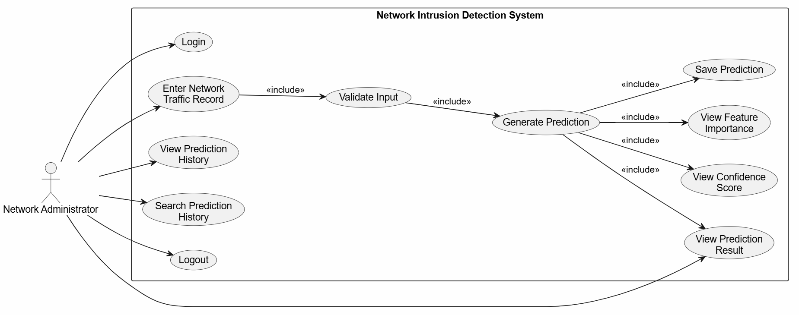
Figure 3.1: Use Case Diagram of the Proposed System
3.4.2 Class Diagram
The class diagram represents the static structure of the system, identifying the classes Admin, Prediction, RandomForestModel, DatasetManager, DatabaseManager, and FlaskApp, together with their attributes, methods, and relationships. The FlaskApp class coordinates the interaction between the Admin, DatasetManager, RandomForestModel, and DatabaseManager classes, while the Prediction class represents an individual classification outcome. The corresponding PlantUML source is presented below. It is presented in Figure 3.2 below.
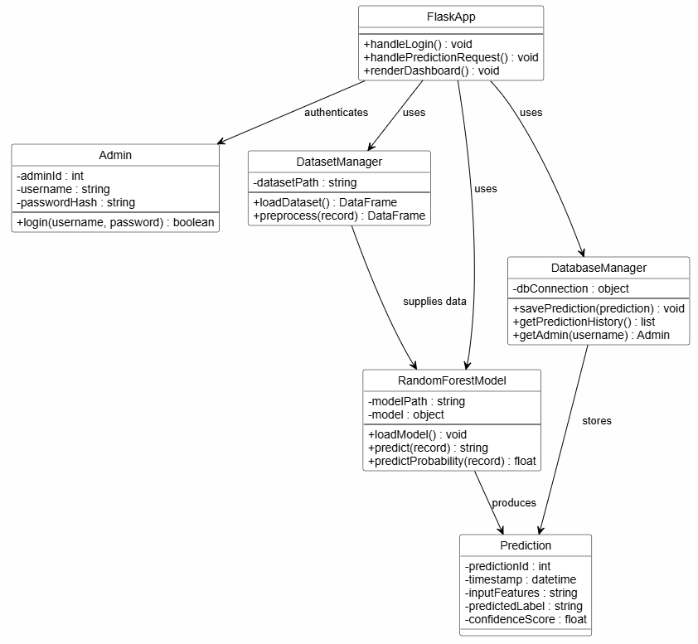

Figure 3.2: Class Diagram of the Proposed System
3.4.3 The Sequence Diagram
The sequence diagram illustrates the order of interactions between the Administrator, the Flask Interface, the Prediction Controller, the Random Forest Model, and the Database when a prediction is requested and a result is returned. It is presented in Figure 3.3 below.
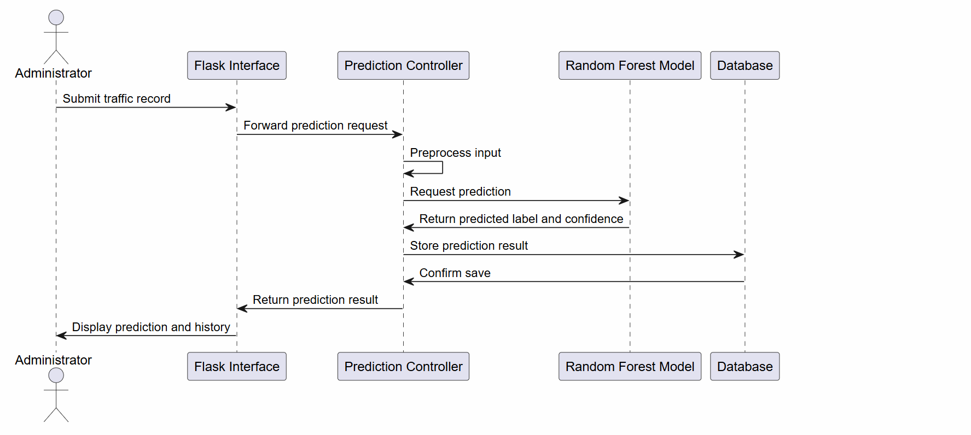
Figure 3.3: Sequence Diagram of the Prediction Process
3.4.4 The Activity Diagram
The activity diagram models the step-by-step workflow followed when an administrator obtains a prediction from the system, beginning with login and concluding with the display of the classification result. It is presented in Figure 3.4 below.
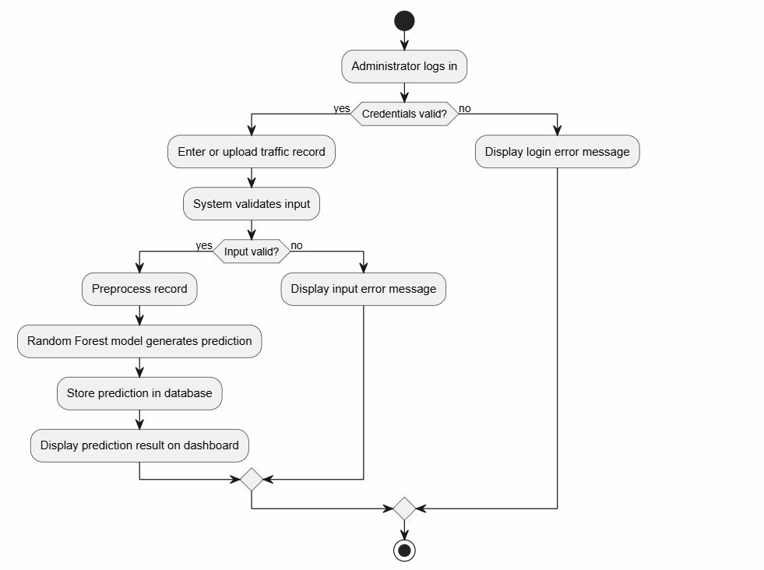
Figure 3.4: Activity Diagram of the Prediction Workflow
3.4.5 Database Design
The system uses SQLite as its database engine, chosen for its lightweight, file-based operation, which requires no separate database server and is well suited to a single-user academic prototype of this scale. Three tables are defined: PredictionHistory, which stores each classification outcome; Admin, which stores the credentials of the administrator permitted to access the dashboard; and ModelInformation, which stores metadata describing the currently deployed Random Forest model.
Table 3.1: PredictionHistory Table
Field | Data Type | Key | Description
prediction_id | INTEGER | Primary Key | Unique identifier for each prediction record
timestamp | DATETIME |  | Date and time the prediction was made
traffic_record | TEXT |  | The submitted feature values, stored as a serialized record
predicted_label | TEXT |  | The classification result: Normal or Attack
confidence_score | REAL |  | The model's confidence in the predicted label, if available
Table 3.2: Admin Table
Field | Data Type | Key | Description
admin_id | INTEGER | Primary Key | Unique identifier for the administrator account
username | TEXT |  | Login username used to access the dashboard
password_hash | TEXT |  | Hashed password used for authentication
Table 3.3: ModelInformation Table
Field | Data Type | Key | Description
model_id | INTEGER | Primary Key | Unique identifier for the model record
model_name | TEXT |  | Name of the trained model, e.g. Random Forest Classifier
training_dataset | TEXT |  | Name of the dataset used for training, e.g. NSL-KDD
date_trained | DATETIME |  | Date on which the model was trained
accuracy | REAL |  | Recorded accuracy of the model on the test split

REFERENCES
Abdulganiyu, O. H., Ait Tchakoucht, T., & Saheed, Y. K. (2023). A systematic literature review for network intrusion detection system (IDS). International Journal of Information Security, 22(5), 1125–1162. https://doi.org/10.1007/s10207-023-00682-2
Ahmad, Z., Shahid Khan, A., Wai Shiang, C., Abdullah, J., & Ahmad, F. (2021). Network intrusion detection system: A systematic study of machine learning and deep learning approaches. Transactions on Emerging Telecommunications Technologies, 32(1), e4150. https://doi.org/10.1002/ett.4150
Albasheer, H., Md Siraj, M., Mubarakali, A., Elsier Tayfour, O., Salih, S., Hamdan, M., Khan, S., Zainal, A., & Kamarudeen, S. (2022). Cyber-attack prediction based on network intrusion detection systems for alert correlation techniques: A survey. Sensors, 22(4), 1494. https://doi.org/10.3390/s22041494
Alturkistani, H., & El-Affendi, M. A. (2022). Optimizing cybersecurity incident response decisions using deep reinforcement learning. International Journal of Electrical and Computer Engineering, 12(6), 6768-6776. https://doi.org/10.11591/ijece.v12i6.pp6768-6776
Booch, G., Rumbaugh, J., & Jacobson, I. (2005). The Unified Modeling Language User Guide (2nd ed.). Addison-Wesley.
Breiman, L. (2001). Random forests. Machine Learning, 45(1), 5–32. https://doi.org/10.1023/A:1010933404324
Dennis, A., Wixom, B. H., & Roth, R. M. (2015). Systems Analysis and Design (6th ed.). John Wiley & Sons.
Ferrag, M. A., Maglaras, L., Moschoyiannis, S., & Janicke, H. (2020). Deep learning for cyber security intrusion detection: Approaches, datasets, and comparative study. Journal of Information Security and Applications, 50, 102419. https://doi.org/10.1016/j.jisa.2019.102419
Fowler, M. (2003). UML Distilled: A Brief Guide to the Standard Object Modeling Language (3rd ed.). Addison-Wesley.
González-Granadillo, G., González-Zarzosa, S., & Diaz, R. (2021). Security information and event management (SIEM): Analysis, trends, and usage in critical infrastructures. Sensors, 21(14), 4759. https://doi.org/10.3390/s21144759
Goodrich, M. T., & Tamassia, R. (2015). Data Structures and Algorithms in Java (6th ed.). John Wiley & Sons.
Grinberg, M. (2018). Flask web development: Developing web applications with Python (2nd ed.). O’Reilly Media.
Gu, J., Wang, L., Wang, H., & Wang, S. (2019). A novel approach to intrusion detection using SVM ensemble with feature augmentation. Computers & Security, 86, 53–62. https://doi.org/10.1016/j.cose.2019.05.022
Hashmi, A., Barukab, O. M., & Hamza Osman, A. (2024). A hybrid feature weighted attention based deep learning approach for an intrusion detection system using the random forest algorithm. PLOS ONE, 19(5), e0302294. https://doi.org/10.1371/journal.pone.0302294
Khraisat, A., Gondal, I., Vamplew, P., & Kamruzzaman, J. (2019). Survey of intrusion detection systems: Techniques, datasets and challenges. Cybersecurity, 2(1), Article 20. https://doi.org/10.1186/s42400-019-0038-7
Kurose, J. F., & Ross, K. W. (2021). Computer networking: A top-down approach (8th ed.). Pearson.
Larman, C. (2004). Applying UML and Patterns: An Introduction to Object-Oriented Analysis and Design and Iterative Development (3rd ed.). Prentice Hall.
Liao, H. J., Lin, C. H. R., Lin, Y. C., & Tung, K. Y. (2013). Intrusion detection system: A comprehensive review. Journal of Network and Computer Applications, 36(1), 16–24. https://doi.org/10.1016/j.jnca.2012.09.004
McKinney, W. (2022). Python for data analysis: Data wrangling with Pandas, NumPy, and Jupyter (3rd ed.). O’Reilly Media.
Mishra, N., Pandya, S., Patel, P., & Bhatt, C. (2022). Machine learning-based network intrusion detection system with NSL-KDD dataset. In Smart Innovation, Systems and Technologies (Vol. 266, pp. 153–163). Springer. https://doi.org/10.1007/978-981-16-6309-3_16
Moualla, S., Khorzom, K., & Jafar, A. (2021). Improving the performance of machine learning-based network intrusion detection systems on the UNSW-NB15 dataset. Computational Intelligence and Neuroscience, 2021, Article 5557577. https://doi.org/10.1155/2021/5557577
Moustafa, N., & Slay, J. (2015). UNSW-NB15: A comprehensive data set for network intrusion detection systems (UNSW-NB15 network data set). Proceedings of the 2015 Military Communications and Information Systems Conference (MilCIS), Canberra, Australia, 1–6. https://doi.org/10.1109/MilCIS.2015.7348942
Pedregosa, F., Varoquaux, G., Gramfort, A., Michel, V., Thirion, B., Grisel, O., Blondel, M., Prettenhofer, P., Weiss, R., Dubourg, V., Vanderplas, J., Passos, A., Cournapeau, D., Brucher, M., Perrot, M., & Duchesnay, E. (2011). Scikit-learn: Machine learning in Python. Journal of Machine Learning Research, 12, 2825–2830.
Pressman, R. S., & Maxim, B. R. (2020). Software Engineering: A Practitioner’s Approach (9th ed.). McGraw-Hill Education.
Raschka, S., Patterson, J., & Nolet, C. (2020). Machine learning in Python: Main developments and technology trends in data science, machine learning, and artificial intelligence. Information, 11(4), 193. https://doi.org/10.3390/info11040193
Sarker, I. H., Kayes, A. S. M., Badsha, S., Alqahtani, H., Watters, P., & Ng, A. (2020). Cybersecurity data science: An overview from machine learning perspective. Journal of Big Data, 7(1), Article 41. https://doi.org/10.1186/s40537-020-00318-5
Sommerville, I. (2016). Software Engineering (10th ed.). Pearson.
Stallings, W., & Brown, L. (2023). Computer security: Principles and practice (5th ed.). Pearson.
Tavallaee, M., Bagheri, E., Lu, W., & Ghorbani, A. A. (2009). A detailed analysis of the KDD CUP 99 data set. Proceedings of the 2009 IEEE Symposium on Computational Intelligence for Security and Defense Applications (CISDA), Ottawa, Canada, 1–6. https://doi.org/10.1109/CISDA.2009.5356528
Thakkar, A., & Lohiya, R. (2021). A survey on intrusion detection system: Feature selection, model, performance measures, application perspective, challenges, and future research directions. Artificial Intelligence Review, 55(1), 453–563. https://doi.org/10.1007/s10462-021-10037-9

