**Addressing Accessibility and Usability**

# Responsive Web Design (Mobile friendly)

* Website design and CSS is friendly for mobile browsing, DIVs change shape and size according to the screen size the user is viewing the site on.

1024x700

400x700

# Legible font

* Chose a font with simple features (arial) to avoid characters from being indistinguishable from each other, allowing for those with visual impairment ease of use.

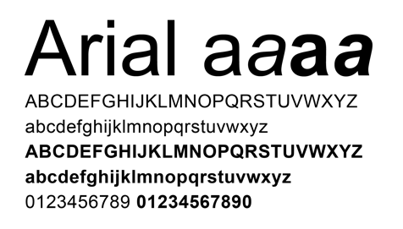

Alt text

* Text which describes the contents of an image for screen readers to better describe what a developer intended to portray through the inclusion of an image.



# Consistent Layout

* Navigation bar is in the same location throughout all pages.
* Layout is intuitive and functionality is predictable for ease of use.

# Contrast

* Text and backgrounds are contrasting colour to allow clearer and more eligible reading while browsing.