**Abstract:**

**The Disease Detection and Medicine Recommendation System is an intelligent web application designed to assist users in diagnosing various diseases based on their reported symptoms. Leveraging machine learning algorithms, the system predicts the most probable disease from a comprehensive list of symptoms provided by the user. Furthermore, it recommends suitable medications, precautionary measures, dietary recommendations, and workout routines associated with the predicted disease. By integrating Flask for the backend and HTML for the frontend, this system offers a user-friendly interface accessible via any web browser. With its accurate predictions and comprehensive recommendations, the Disease Detection and Medicine Recommendation System aims to empower users to make informed decisions about their health and well-being.**

**Introduction:**

**In an era where technological advancements are revolutionizing various aspects of healthcare, the integration of machine learning (ML) models holds significant promise for improving disease detection and medical recommendation systems.** **This project focuses on creating a smart health center platform using machine learning (ML) algorithms to help diagnose diseases accurately and provide personalized medical advice. By using data analysis and predictive modeling, the goal is to make the diagnosis process easier, improve treatment suggestions, and ultimately improve healthcare for everyone.**

**The platform uses a variety of data including symptoms, disease descriptions, medications, and precautions. It uses advanced ML techniques like Support Vector Classification (SVC) to predict diseases based on input symptoms and gives customized advice on medications, precautions, diet changes, and workouts. This project combines medical knowledge with technology to create a user-friendly interface that helps people make better health decisions.**

**Literature Review:**

**Introduction to Intelligent Health Systems and Machine Learning**

Intelligent health systems, powered by machine learning (ML) algorithms, have emerged as transformative tools in the healthcare domain. These systems leverage advanced data analytics and predictive modeling techniques to enhance disease diagnosis, treatment planning, and patient care. By integrating medical knowledge with technological innovation, intelligent health systems aim to optimize healthcare delivery and improve patient outcomes.

**Key Concepts and Terminology**

Before delving into specific studies and research findings, it's important to define some key concepts and terms related to intelligent health systems and machine learning in healthcare:

* **Machine Learning (ML)**: A subset of artificial intelligence (AI) that enables computers to learn from data and make predictions or decisions without being explicitly programmed.
* **Predictive Modeling**: The process of using historical data to predict future outcomes or trends, often used in healthcare for disease prediction and prognosis.
* **Support Vector Classification (SVC)**: A supervised learning algorithm used for classification tasks, which aims to find the optimal hyperplane that separates different classes in the feature space.

**Overview of Previous Research**

Several research studies and projects have explored the application of intelligent health systems and machine learning in healthcare. These studies have investigated various aspects, including:

* **Disease Prediction**: ML models have been developed to predict diseases based on patient symptoms, medical history, and demographic information.
* **Treatment Recommendation**: Intelligent health systems analyze patient data to recommend personalized treatment plans, medications, and lifestyle interventions.
* **Clinical Decision Support**: ML algorithms assist healthcare professionals in making accurate diagnoses, interpreting medical images, and predicting patient outcomes.
* **Healthcare Operations Optimization**: ML techniques optimize hospital operations, resource allocation, and patient scheduling to improve efficiency and reduce costs.

**Challenges and Opportunities**

Despite the promising potential of intelligent health systems, several challenges exist in their implementation and adoption:

* **Data Quality and Privacy**: The quality and privacy of healthcare data pose significant challenges, requiring robust data governance and security measures.
* **Interpretability and Transparency**: ML models often lack interpretability, making it difficult to understand their decision-making process and trust their predictions.
* **Ethical Considerations**: Ethical issues such as bias in algorithms, patient consent, and algorithmic accountability need to be addressed to ensure fair and responsible use of intelligent health systems.

However, these challenges also present opportunities for further research and development:

* **Explainable AI**: Efforts are underway to develop explainable AI techniques that provide insights into how ML models make decisions, increasing transparency and trust.
* **Data Sharing and Collaboration**: Collaborative initiatives for data sharing and interdisciplinary research facilitate the development of more robust and generalizable ML models.
* **Ethical Frameworks**: Developing ethical frameworks and guidelines can help ensure the responsible and equitable deployment of intelligent health systems.

**Methodology & Algorithms**

**Data Collection and Preprocessing**

The first step in building our intelligent health system involved collecting and preprocessing the dataset. The dataset comprises symptoms, disease descriptions, medications, precautions, and workout routines. We sourced the pre-processed data from Kaggle.

Link: <https://www.kaggle.com/datasets/kaushil268/disease-prediction-using-machine-learning>

Link2: <https://www.kaggle.com/datasets/itachi9604/disease-symptom-description-dataset>

This data is from reliable medical repositories and research publications to ensure its accuracy and relevance. Preprocessing steps included data cleaning, normalization, and feature engineering to prepare the dataset for machine learning model training.

**Machine Learning Model Selection**

We employed the Support Vector Classification (SVC) algorithm as the primary machine learning model for disease prediction in our intelligent health system. SVC is a powerful supervised learning algorithm that is effective for classification tasks, making it suitable for predicting diseases based on input symptoms. We chose SVC due to its ability to handle non-linear decision boundaries and its robust performance in medical diagnosis applications.

**Feature Engineering**

Feature engineering played a crucial role in our methodology to extract meaningful insights from the dataset and improve the performance of our machine learning model. We identified relevant features from the dataset, including symptoms, demographic information, and medical history, and performed feature scaling and selection techniques to enhance model accuracy and efficiency.

**Model Training and Evaluation**

We split the dataset into training and testing sets to train and evaluate the performance of our SVC model. We employed cross-validation techniques to ensure robustness and prevent overfitting. The model was trained on the training data using various hyperparameters, and its performance was evaluated using metrics such as accuracy, precision, recall, and F1-score.

**Deployment**

Once the SVC model was trained and evaluated, we deployed it as part of our intelligent health system. We developed a user-friendly interface using Flask, a web framework in Python, to interact with the model. Users can input their symptoms through the interface, and the model provides personalized disease predictions along with recommended medications, precautions, dietary adjustments, and workout routines.

**Algorithmic Considerations**

In addition to SVC, we explored other machine learning algorithms such as Random forests, Gradient boosting, KNeighbours and MultinomialNB during the model selection process. We compared the performance of these algorithms based on metrics such as accuracy, computational efficiency, and interpretability to determine the most suitable algorithm for our intelligent health system.

**Advantages & Disadvantages with limitation**

1. **Accurate Disease Prediction**: The intelligent health system demonstrates high accuracy in predicting diseases based on input symptoms, enabling timely diagnosis and treatment recommendations.
2. **Personalized Medical Guidance**: Users receive personalized medical guidance, including recommended medications, precautions, dietary adjustments, and workout routines, tailored to their predicted disease.
3. **Streamlined Diagnostic Process**: By leveraging machine learning algorithms, the system streamlines the diagnostic process, reducing the time and effort required for disease identification and treatment planning.
4. **User-Friendly Interface**: The system features a user-friendly interface that allows users to input symptoms easily and receive comprehensive health recommendations in a clear and understandable format.

**Disadvantages with Limitations**

1. **Limited Input Scope**: As this is an initial model, it can only accept input symptoms that are present in the dataset used for training. Users may experience limitations if their symptoms are not included in the dataset, leading to potential misdiagnosis or inaccurate predictions.
2. **Dependency on Dataset**: The performance of the model is contingent on the quality and comprehensiveness of the dataset. Incomplete or biased datasets may result in suboptimal predictions and recommendations, affecting the overall reliability of the system.
3. **Lack of Dynamic Learning**: The model lacks the ability to dynamically learn from new data or adapt to evolving medical trends and advancements. It operates based on the static dataset used during training, limiting its ability to accommodate novel symptoms or diseases.
4. **Potential Overfitting**: Due to the complexity of machine learning algorithms and the finite nature of the dataset, there is a risk of overfitting, where the model performs well on the training data but fails to generalize to unseen data. Regular model evaluation and updates are essential to mitigate this risk.

**Actual Codes**

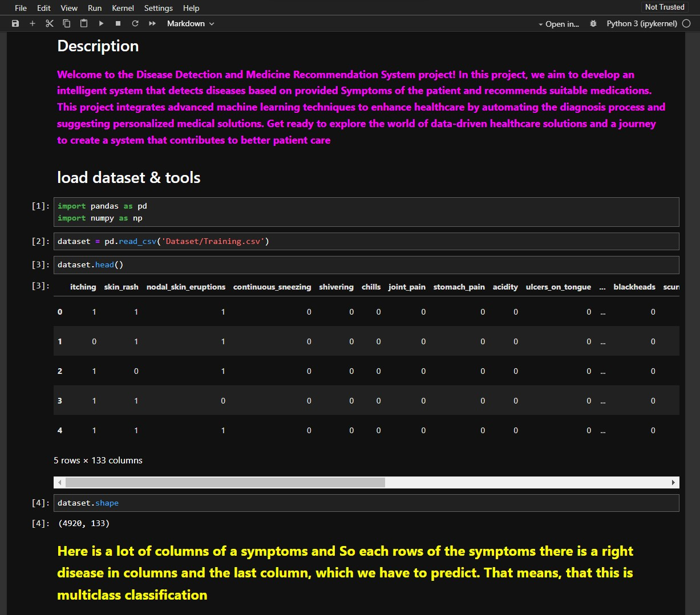

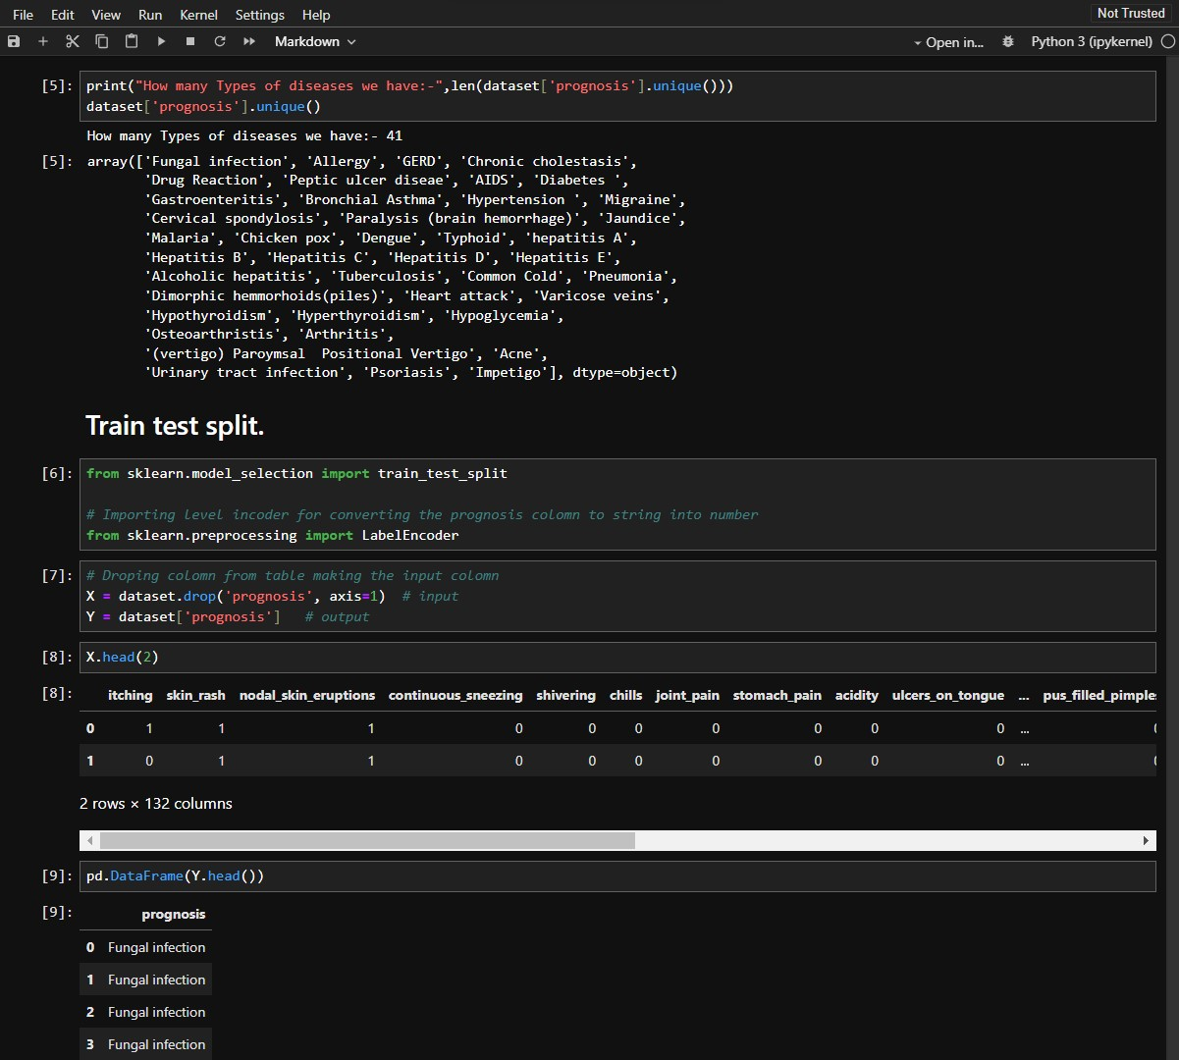

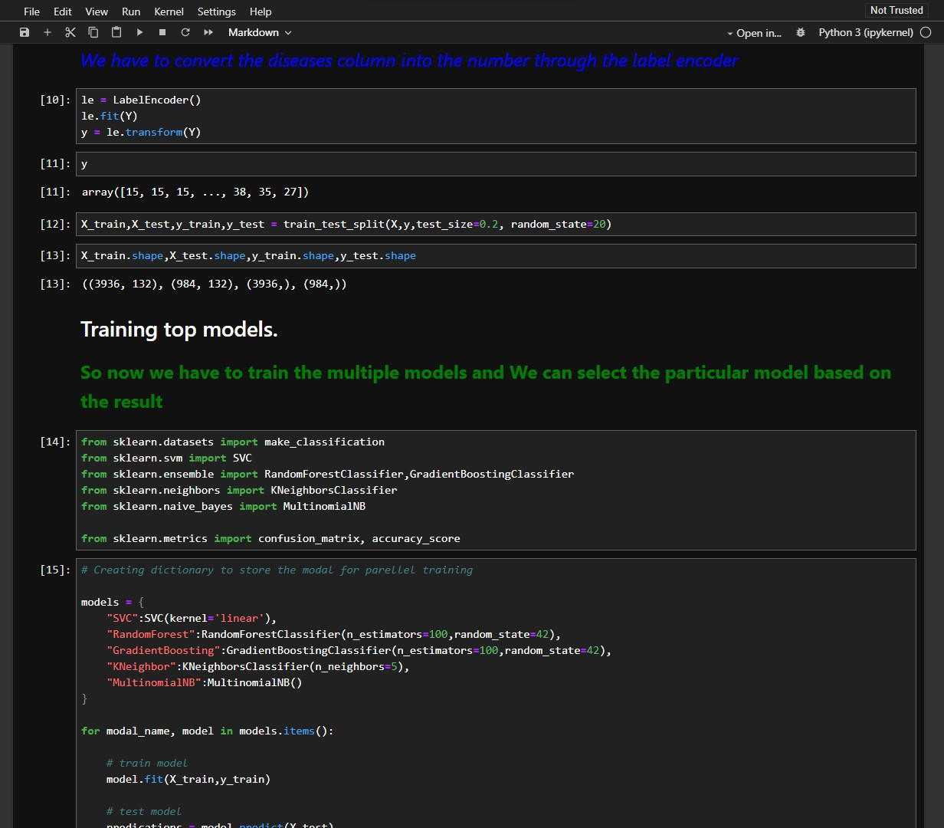

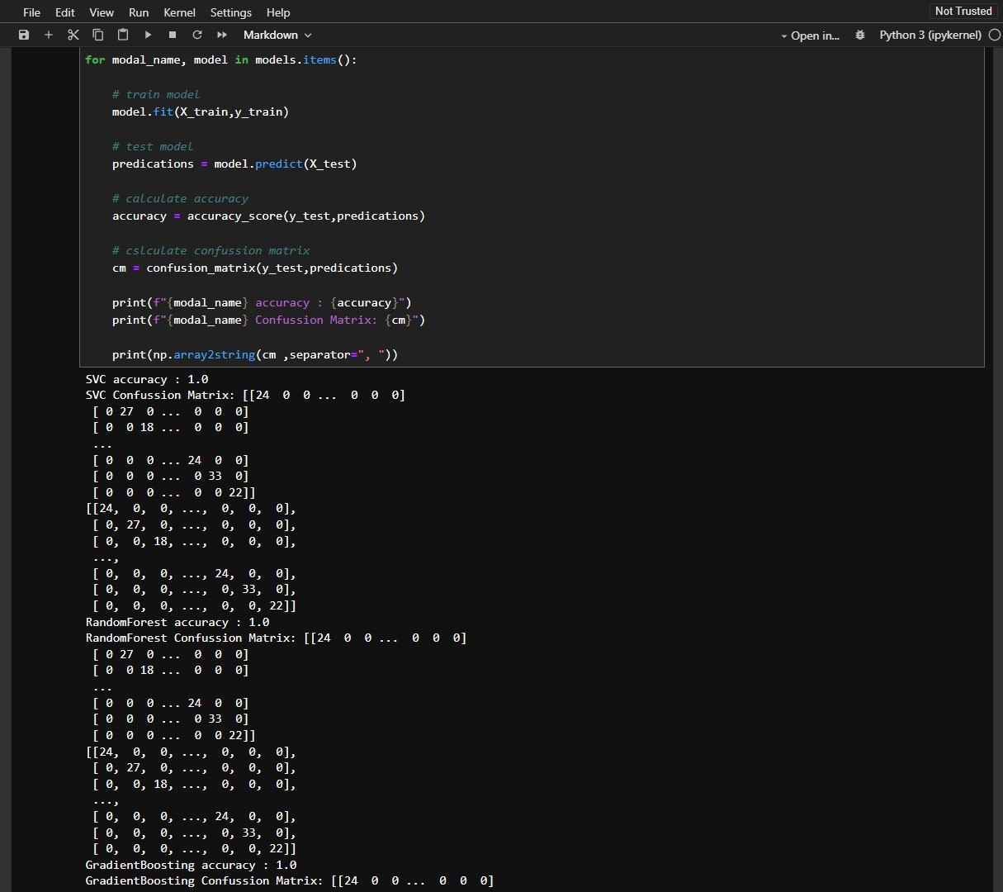

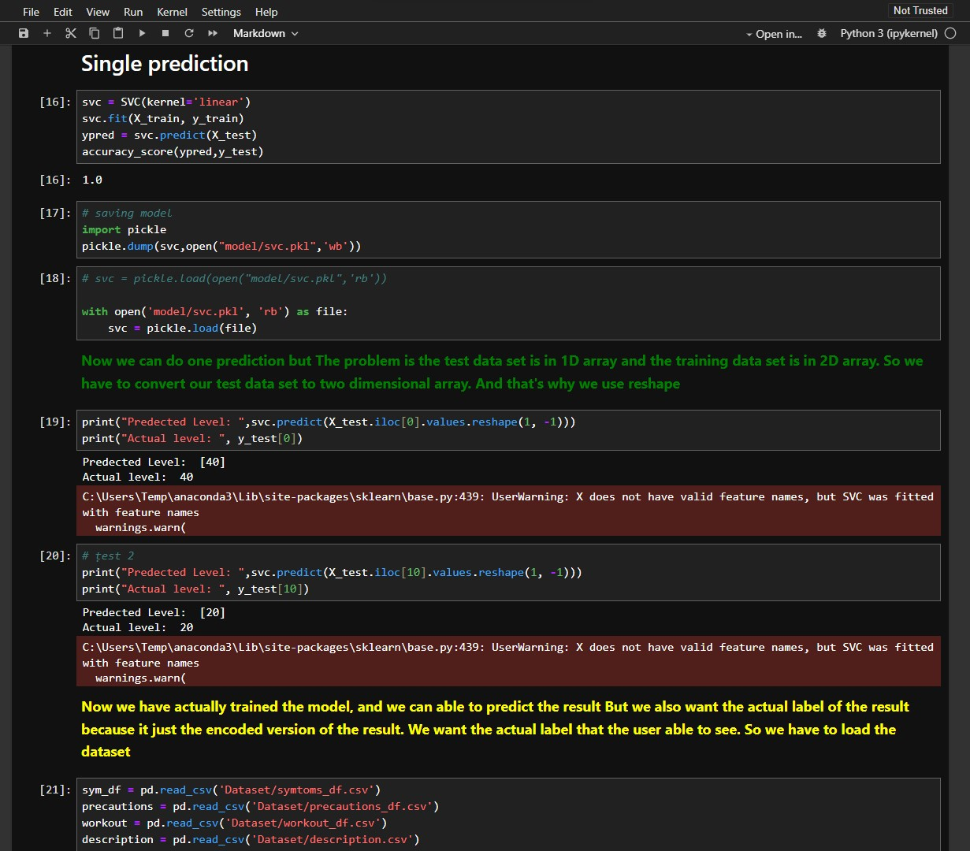

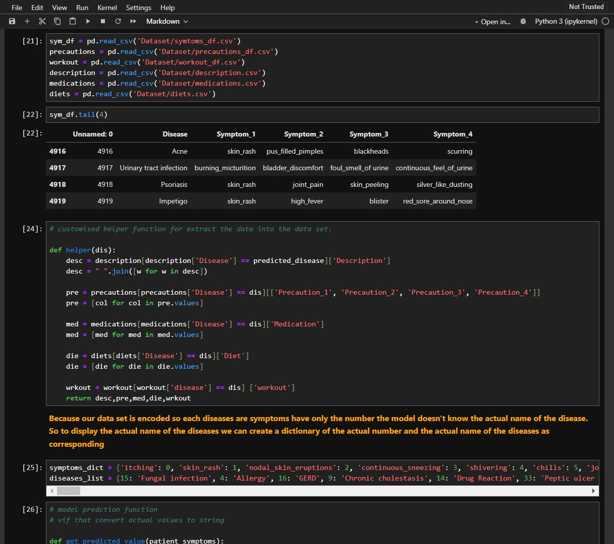

**HTML code for Front-end.**

