*

CLDV6211

POE Part 1

Arlo (Abby) Staples

ST10404431

**Azure URL:** st10404431-eventease-eydma9hweychake9.southafricanorth-01.azurewebsites.net

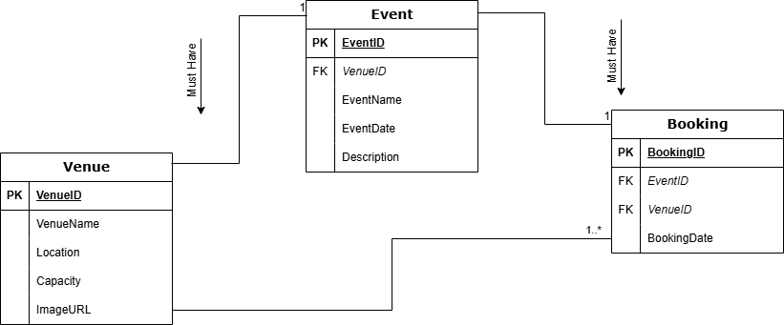

**Azure Server**

**

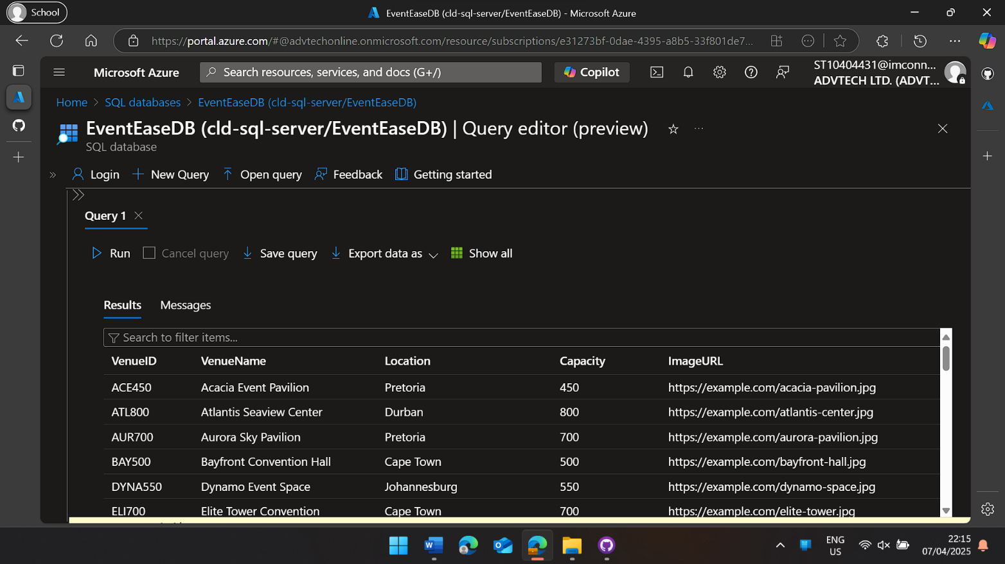**Table Results with SELECT * FROM Venues**

**Web Application Home Page**

**Create New Event**

**Cloud Hosting Models:**

Cloud hosting models define how data is stored and managed online:

* **Public Cloud**: Shared resources, cost-effective, scalable.
* **Private Cloud**: Dedicated, secure, more expensive.
* **Hybrid Cloud**: Mix of public and private for flexibility.
* **Multi-Cloud**: Uses multiple providers to avoid reliance on one.
* **Community Cloud**: Shared by groups with common needs, like healthcare or government.

**On-premises vs. cloud deployment**

On-premises vs. cloud deployment is about where a company’s IT infrastructure lives:

* **On-Premises**: Servers are physically owned and managed by the company. This offers complete control but requires high costs and maintenance.
* **Cloud Deployment**: Servers are hosted by providers like AWS or Azure, and businesses access them remotely. It’s more flexible and cost-effective but has some limitations on control.