1. 新建文件夹

Mkdir faster_lio && cd faster_lio && mkdir src

cd src

1. 下载faster_lio

git clone <https://github.com/gaoxiang12/faster-lio.git>（命令行安装不了，直接离线下载在提取到指定位置，后续下载同此）

编译：

1）、安装依赖：

ROS (melodic or noetic)（csdn,查找鱼香ros，按提示步骤来）

glog: sudo apt-get install libgoogle-glog-dev

eigen: sudo apt-get install libeigen3-dev

pcl: sudo apt-get install libpcl-dev

yaml-cpp: sudo apt-get install libyaml-cpp-dev

2）、编译

mkdir build

cd build

cmake .. -DCMAKE_BUILD_TYPE=Release

make -j4

1. 下载Livox-SDK2（home下，任意位置皆可）

git clone <https://github.com/Livox-SDK/Livox-SDK2.git>

cd Livox-SDK2

mkdir build

cd build

cmake .. && make -j8

sudo make install

1. 下载***livox_ros_driver2***

cd /faster_lio/src

git clone https://github.com/Livox-SDK/livox_ros_driver2.git ws_livox/src/livox_ros_driver2

*cd /livox_ros_driver2*

./build.sh ROS1

至此，编译完成

5、配置雷达

1. 接上雷达网线，电脑右上角设置里配置雷达IP
2. 在faster_lio/src/livox_ros_driver2/config/MID_360_config.jsonl里：

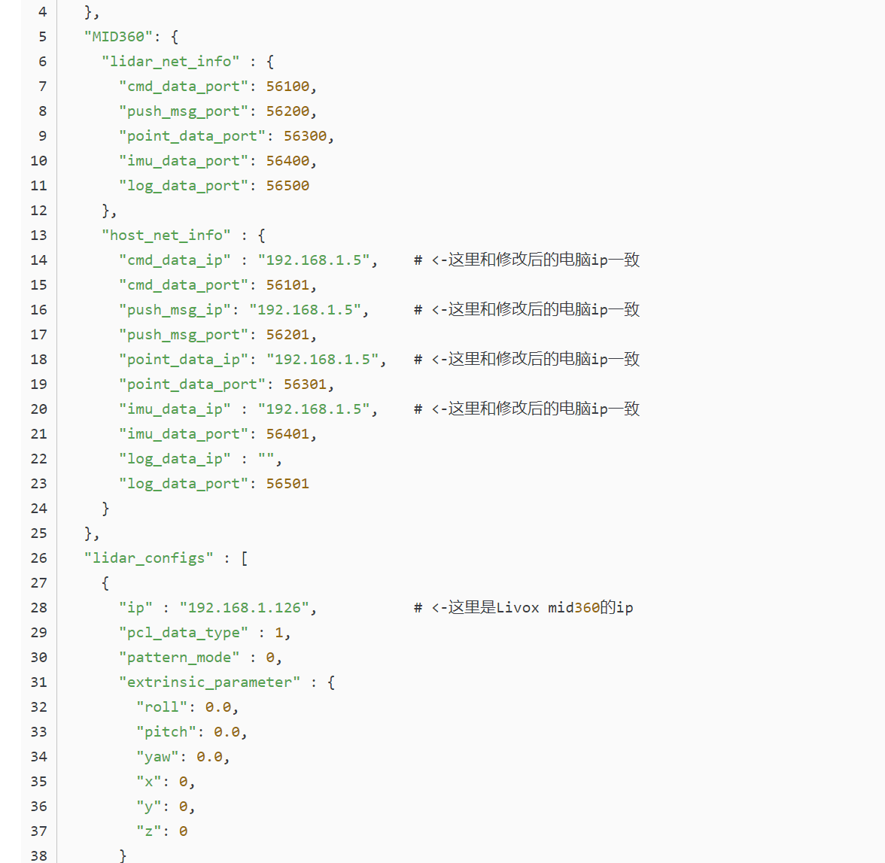

*注：上次雷达IP是：192.168.1.3*

1. 启动雷达

cd /faster_lio

source /devel/setup.bash

roslaunch livox_ros_driver2 msg_MID360.launch

验证雷达是否成功启动：

1. rostopic list
2. rostopic echo “雷达话题“（mid_360是 /livox/lidar）

rostopic echo /livox/lidar

若有数据，则雷达启动成功。

1. 启动faster_lio

cd /faster_lio

source /devel/setup.bash

roslaunnch faster_lio mapping_avia.launch

1. 雷达imu标定

[https://blog.csdn.net/weixin_43728093/article/details/124947105?ops_request_misc=%257B%2522request%255Fid%2522%253A%2522170858805316800184183676%2522%252C%2522scm%2522%253A%252220140713.130102334.pc%255Fall.%2522%257D&request_id=170858805316800184183676&biz_id=0&utm_medium=distribute.pc_search_result.none-task-blog-2~all~first_rank_ecpm_v1~rank_v31_ecpm-1-124947105-null-null.142^v99^pc_search_result_base6&utm_term=3D%E6%BF%80%E5%85%89slam%20velodyne%E6%BF%80%E5%85%89%E9%9B%B7%E8%BE%BE%2Bimu%E5%A4%96%E5%8F%82%E6%A0%87%E5%AE%9A&spm=1018.2226.3001.4187](https://blog.csdn.net/weixin_43728093/article/details/124947105?ops_request_misc=%257B%2522request%255Fid%2522%253A%2522170858805316800184183676%2522%252C%2522scm%2522%253A%252220140713.130102334.pc%255Fall.%2522%257D&request_id=170858805316800184183676&biz_id=0&utm_medium=distribute.pc_search_result.none-task-blog-2~all~first_rank_ecpm_v1~rank_v31_ecpm-1-124947105-null-null.142%5ev99%5epc_search_result_base6&utm_term=3D%E6%BF%80%E5%85%89slam%20velodyne%E6%BF%80%E5%85%89%E9%9B%B7%E8%BE%BE%2Bimu%E5%A4%96%E5%8F%82%E6%A0%87%E5%AE%9A&spm=1018.2226.3001.4187)

1. 录制、播放bag包

启动雷达：

cd /faster_lio

source /devel/setup.bash

roslaunch livox_ros_driver2 msg_MID360.launch

录制：

rosbag record -O “bag包名称(自己取)“ /livox/lidar /livox/imu

例：rosbag record -O faster_lio.bag /livox/lidar /livox/imu

播放：

rosbag play faster_lio.bag

播放bag包的同时，运行faster_lio，就可以看到建图效果。