Course 1: Neural Network & Deep Learning

- What is a Neural Network?
It basically acts like a function taking in an input, x and generating an output, y based on x. The input may include a single parameter or a combination of many parameters (x₁, x₂, x₃, ...). It consists of neurons which take decisions and lead to an output.

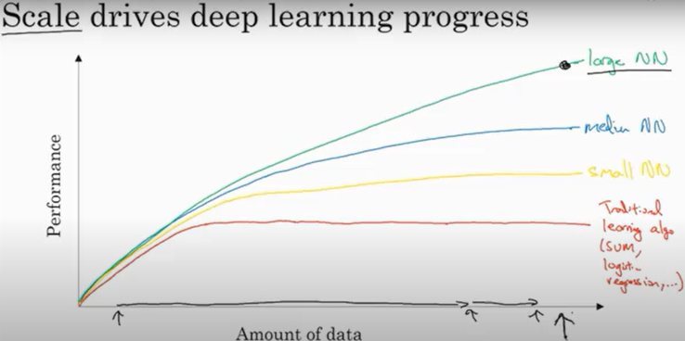

Larger NNs perform better at larger amount of data while smaller NNs tend to saturate after some point.
- Logistic Regression -
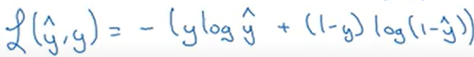
Loss Function –

Cost function is the average of loss function summed over all the data-points.

