一、select the best one. (2 * 35 = 70)

1. Which of the following hazards is NOT introduced by the pipeline technique?

A. Structure Hazard

B. Exception Hazard

C. Data Hazard

D. Control Hazard

(B)

2. For a RISC - V processor that implements precise exceptions and runs in M - mode (machine mode), which one of the following statements is wrong?

A. Instructions before the faulting instruction can complete

B. Instructions after the faulting instruction might be restarted later

C. Address of the instruction that caused the exception will be written to the mtvec register

D. The mval register can be used to store exception - specific information like the faulting virtual address

(C)

3. [单选题]

In the following code segments, which one would benefit most from loop unrolling?

A. for (i = 0; i < 100; i = i + 1) {

Sum = Sum + A[i]

}

B. for (i = 0; i < 100; i = i + 1) {

C[i] = A[i] + B[i]

}

C. for (i = 0; i < 100; i = i + 1) {

C[i] = A[i - 1] + B[i - 1]

}

D. for (i = 0; i < 100; i = i + 1) {

C[i] = C[i - 1] + B[i]

}

4. Consider a program with the following six consecutive RISC - V instructions. Which of the following execution order is incorrect?

I1: DIV x6, x6, x4

I2: MUL x0, x2, x4

I3: LD x2, 32(x8)

I4: SUB x10, x0, x6

I5: DIV x8, x6, x2

I6: ADD x6, x8, x2

A. I1 - I4 - I2 - I3 - I5 - I6

B. I1 - I2 - I4 - I5 - I3 - I6

C. I2 - I3 - I1 - I4 - I5 - I6

D. I2 - I1 - I3 - I5 - I4 - I6

(B)

5. Which one of the following statements about dynamic scheduling is correct?

A. With hardware - based speculation, instructions could be committed out of order

B. Tomasulo algorithm introduces register renaming to minimize RAW hazards

C. For Tomasulo algorithm, the instructions queue will watch CDB for operands

D. Scoreboard algorithm can detect WAR/RAW hazards, but can not eliminate them

(D)

6. Which one is not the category of the miss rate for the cache of single - core CPU?

A. compulsory miss B. conflict miss C. coherence miss D. capacity miss

Solution: (C)

7. Among choices below, which is the most effective way to reduce cache miss penalty for single - time memory access.

A. Reducing block size

B. Enlarging block size

C. Reducing Cache total size

D. Enlarging Cache total size

Solution: (A)

8. Which one of the following statements about cache optimization are incorrect below?

A. Larger block size reduces compulsory misses, but it also increase the miss penalty.

B. Increasing cache capacity can reduce miss rate.

C. Higher associativity will reduce power consumption.

D. Multilevel cache can reduce miss penalty.

Solution: (C)

9. Which one of the following statements about multiprocessors are incorrect below?

A. SMP architectures are also sometimes called UMA multiprocessors, arising from the fact that all processors have a uniform latency accessing memory.

B. All processors in the NUMA architectures have local memory, and local memory is somewhat faster.

C. Cache consistency defines the behavior of reads and writes to the same memory location, while cache coherence defines the behavior of reads and writes with respect to accesses to other memory locations.

D. A DSM multiprocessor is also called a NUMA because the access time depends on the location of a data word in memory.

(C)

10. Which sequence of instructions cannot use forwarding path to address all potential data hazards?

A. ld x1, 0(x2)

and x6, x1, x7

or x8, x1, x9

B. ld x1, 0(x2)

sub x6, x2, x7

or x8, x6, x9

C. add x1, x2, x3

ld x4, 0(x1)

D. add x1, x2, x3

sd x4, 12(x1)

(A)

11. On handling exceptions, if the pipeline can be stopped so that the instruction issued before the faulting instruction complete and those after it can be restarted, then the pipeline is said to implement _________.

A. Asynchronous exceptions

B. Precise exceptions

C. Unordered exceptions

D. Imprecise exceptions

(B)

12. Suppose that in 1000 memory references there are 40 misses in the first - level cache and 20 misses in the second - level cache. Assume the miss penalty from the L2 cache to memory is 200 clock cycles, the hit time of the L2 cache is 10 clock cycles, the hit time of L1 is 1 clock cycle, and there are 1.5 memory references per instruction. What is the average stall cycles per instruction?

A. 6.6

B. 5.4

C. 11

D. 15

(A)

13. Which is the code sequence for C = A + B for load - store ISA?

A. Push A

Push B

Add

Pop C

B. Load A

Add B

Store C

C. Load R1, A

Load R2, B

Add R3, R1, R2

Store R3, C

D. Load R1, A

Load R2, B

Add R3, R1, R2

Store R3, C

(D)

14. All of the following are types of data hazards except ________

A. RAR

B. WAW

C. RAW

D. WAR

(A)

15. Assume that the following code is running on a 5 stage pipelined CPU executing RISC - V RV32I instructions with double bump and all the forwarding path, which one of the following is correct?

sub R3, R2, R1 ;I1

addi R5, R4, 4 ;I2

add R6, R3, R5 ;I3

A. Use the forwarding path EX/MEM ALUout -> ALU input port to send I1.R3 to I3

B. Use the forwarding path MEM/WB ALUout -> ALU input port to send I2.R5 to I3

C. Use the forwarding path MEM/WB ALUout -> ALU input port to send I1.R3 to I3

D. Use the forwarding path MEM/WB LDM -> ALU input port to send I2.R5 to I3

(C)

16. Which one of the following is not correct?

A. We called it a Write After Read (WAR) hazard if anti - dependence caused a hazard in the pipeline.

B. Scoreboard Algorithm issue a instruction when no other active instruction has the same destination register to avoid WAW hazard.

C. Tomasulo Algorithm can avoid true dependencies by using Reservation Stations and Common Data Bus.

D. To avoid WAR and WAW hazards, register renaming by software or hardware can be done.

(C)

17. Which of the following techniques may get CPI (cycle per instruction) smaller than 1?

A. Scoreboard

B. Tomasulo

C. Multiple - issue

D. Loop unrolling

(C)

18.

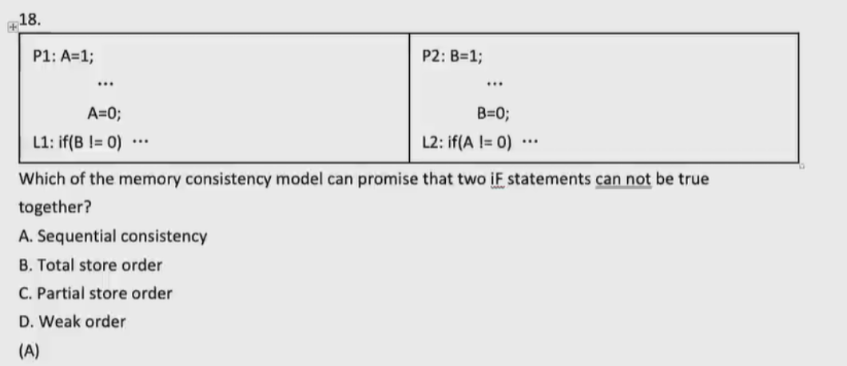

P1: A = 1;

...

A = 0;

L1: if (B == 0)...

P2: B = 1;

...

B = 0;

L2: if (A!= 0)...

Which of the memory consistency model can promise that two if statements can not be true together?

A. Sequential consistency

B. Total store order

C. Partial store order

D. Weak order

(A)

19. Which cache optimization technique can_not reduce the miss rate?

A. pipelined cache access

B. larger block size

C. large cache size

D. higher associativity

(A)

20. Here is a blocked and unblocked version of C code to perform a matrix on a 256x256 matrix:

for (int i = 0; i < 1024; i += 16) {

for (int j = 0; j < 1024; j += 16) {

for (int m = 0; m < 16; m++) {

for (int n = 0; n < 16; n++) {

output[i + n][j + m] = input[j + m][i + n];

}

}

}

}

for (int i = 0; i < 1024; i++) {

for (int j = 0; j < 1024; j++) {

output[i][j] = input[i][j];

}

}

Suppose the size of the element in the matrix is 32bit and we execute the codes above on a processor with a 2KB fully associative data cache using the least recently used (LRU) replacement strategy. The cache block size is 64 bytes. What is the relative number of cache misses when running the blocked and unblocked version?

A. 2 : 17

B. 1 : 8

C. 1 : 17

D. 1 : 16

(A)

21. Assume a processor with a single level of cache and its ideal CPI equals 1. No instruction cache misses. 30% of instructions are data access. The data cache miss rate is 10%. The miss penalty is 20 clock cycles. What is the real CPI of the processor?

A. 1.8

B. 2

C. 1.6

D. 1.2

(C)

22.

for (int i = 0; i < 524; i++) {

c[i] = a[i] + b[i];

}

Consider the code above, arrays a, b and c each have 524 8 - byte - wide integer elements. Assume that a 64 - bit - wide integer add instruction takes 1 clock cycle and a 512 - bit - wide vector add instruction takes 4 clock cycles. How many clock cycles do we need to finish the above calculation using 512 - bit - wide vector add instructions?

A. 264

B. 268

C. 524

D. 48

(A)

23. Which one of the following statement is not correct?

A. Write - allocate caches load the missing block into the cache on a write miss before anything else occurs.

B. In general, write - back caches use write - allocate, and write - through caches use write - around.

C. For write - through, read misses may result in memory writes.

D. For write - back, the modified cache block is written to the main memory when it is replaced.

(C)

24. If the branch condition and target address are determined until the end of the EXE stage, what are the penalties when 1) the branch is taken and the predicted taken policy is used and 2) the branch is untaken, and the predicted untaken policy is used?

A. 2, 0

B. 2, 2

C. 3, 0

D. 3, 3

(A)

25. Which of the following states does not belong to the MESI protocol?

A. Invalid

B. Exclusive

C. Outdated

D. Shared

(C)

26. Which of the following is NOT an operation of ID stage In the 5 - stage pipelined CPU of RISC - V?

A. A <- Regs[rs]

B. B <- Regs[rt]

C. ALUOutput <- A + IMM

D. IMM <- sign - extended immediate field of IR

(C)

27. Compared to fully associative cache, the advantage of direct mapped is _______.

A. Smaller tag field takes less chip area

B. Low rate of block conflict.

C. Small hit time & simple hardware.

D. High utilization of main memory.

(C)

28. The simplest way to reduce miss rate is to increase the block size. Larger blocks take advantage of ________ and will reduce ________ misses. At the same time, larger blocks increase the miss penalty. Since they reduce the number of blocks in the cache, larger blocks may increase conflict misses and even capacity misses if the cache is small.

A. temporal locality, compulsory

B. spatial locality, compulsory

C. temporal locality, collision

D. spatial locality, collision

(B)

29. TLB (Translation look - aside buffer) is actually a cache. If it's implemented as a full associated cache, which of the following statements is correct?

A. The tag in TLB correspond to the virtual page number in virtual address, and data line correspond to the page offset.

B. The tag in TLB correspond to the virtual page number in virtual address, and data line correspond to the physical page number.

C. The tag in TLB correspond to the physical page number in physical address, and data line correspond to the virtual page number.

D. The tag in TLB correspond to the physical page number in physical address, and data line correspond to the page offset.

(B)

30. Consider the following description of a memory hierarchy.

Virtual address wide = 46 bits, Memory physical address wide = 36 bits, Page size = 8KB. Cache capacity = 16KB.

If it's a direct mapped cache, then tag in the 16KB cache is _______ bits.

A. 25

B. 24

C. 23

D. 22

(D)

31. Consider the following description of a memory hierarchy.

Virtual address wide = 46 bits, Memory physical address wide = 36 bits, Page size = 8KB. Cache capacity = 16KB.

If it's a 8 - way physical addressed cache, then tag in the 16KB cache is _______ bits.

A. 25

B. 26

C. 27

D. 28

(A)

32. Multiple - issue processors have two basic types: ________ and ________, the purpose of which is to pursue CPI < 1. The difference is that ________ is the hardware - intensive technique using hardware to do hazard detection, while ________ use compiler - based approaches using primarily software to detect hazard.

A. Multiprocessor, superscalar; Superscalar, multiprocessor

B. VLIW, superscalar; VLIW, superscalar

C. Superscalar, VLIW; Superscalar, VLIW

D. superscalar, VLIW; VLIW, superscalar

(C)

33. Consider the following description of a memory hierarchy.

Virtual address wide = 46 bits, Memory physical address wide = 36 bits, Page size = 8KB. Cache capacity = 16KB.

If it's a virtual indexed and physical tagged cache, then tag in a 2 - way associative cache is _______ bits.

A. 26

B. 25

C. 24

D. 23

(D)

34.

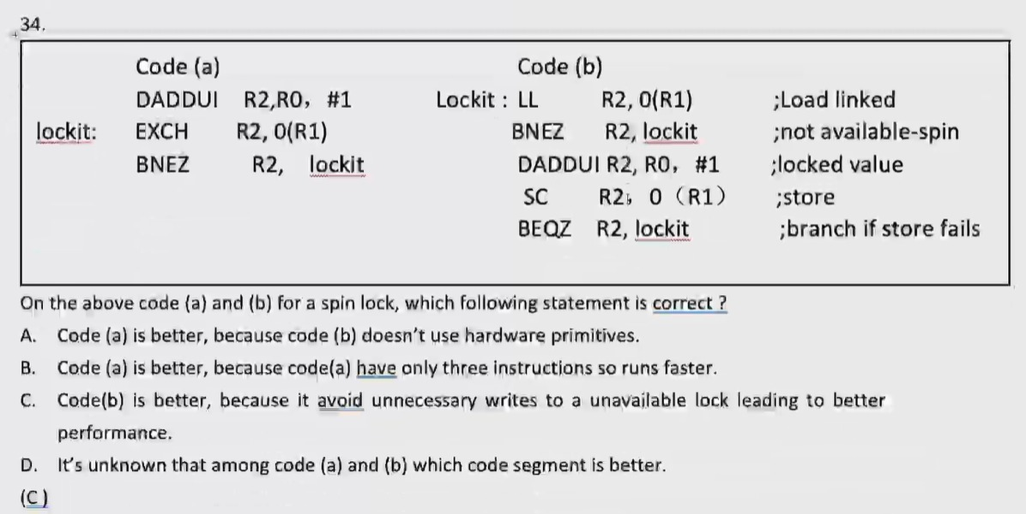

35. For a shared memory multi - processor system, which statement on cache coherence is incorrect?

A. Using write invalidate cache coherence will need less memory bandwidth compared with write broadcast coherence.

B. Write invalidate cache coherence generate less bus and memory traffic than write broadcast.

C. Using write invalidate cache coherence will have longer latency from writing a shared variable to read it compared with write update.

D. Write broadcast uses spatial locality: only the first write to a block needs to broadcast to other processors.

(D)

