**國立臺南大學**

**資訊工程學系**

**網路程式設計**

**作業三**

**指導教授：楊文霖教授**

**S11059003曾俊杰**

**西元2024年3月16日**

1. 開啟程式初始畫面。

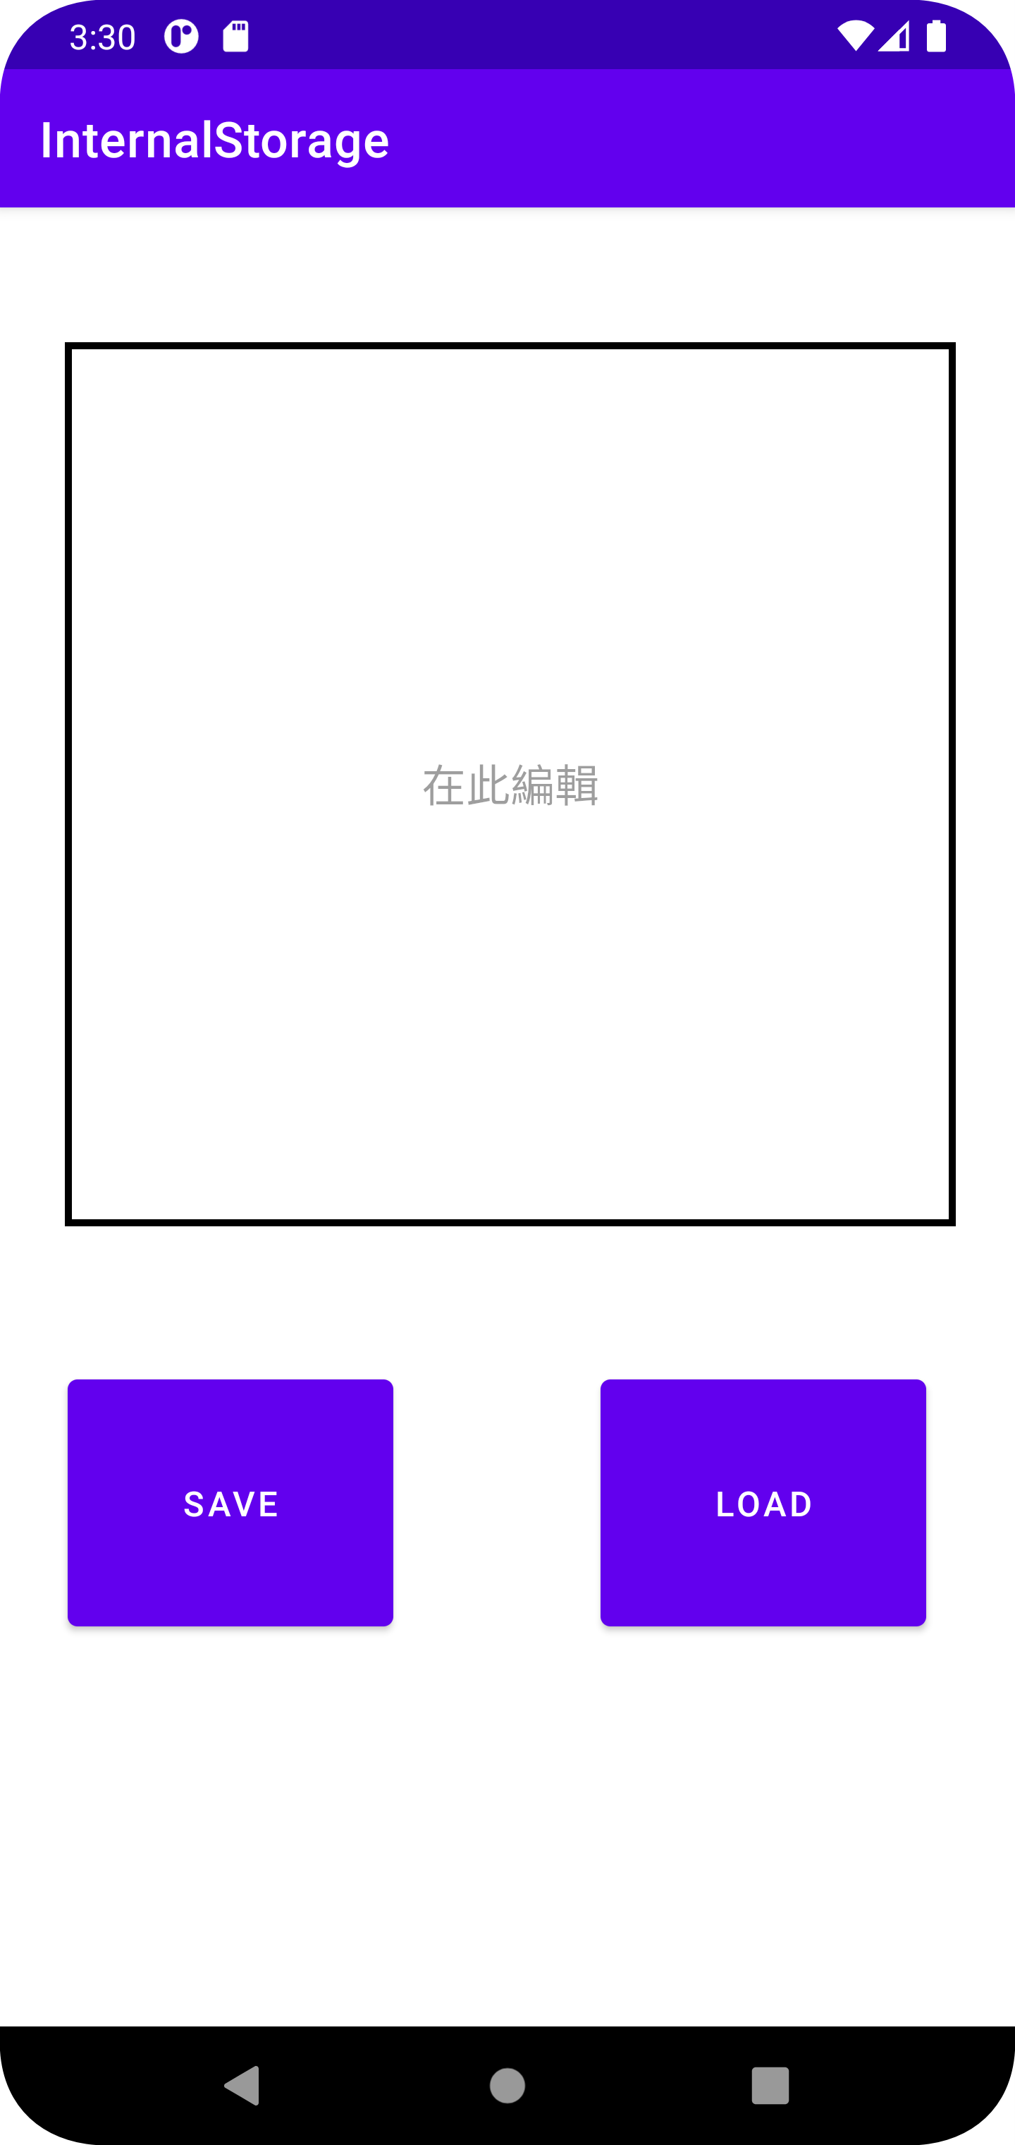

1. 分別在輸入框輸入文章，按下SAVE按鈕，然後即可按下LOAD切換頁面。

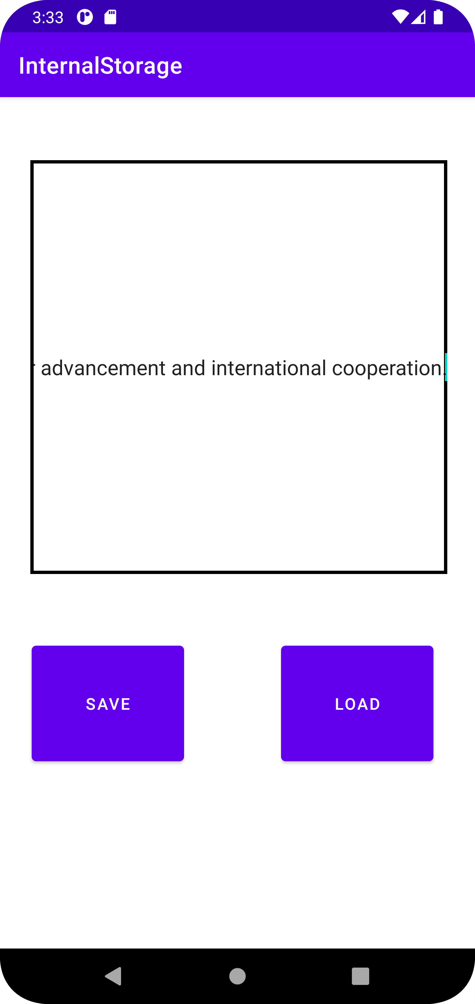

1. 跳轉頁面(Activity)，顯示剛剛輸入的文章，壓著文字框內部往上滑動，可以繼續顯示未顯示完的文章，按下BACK可以回去初始頁面。

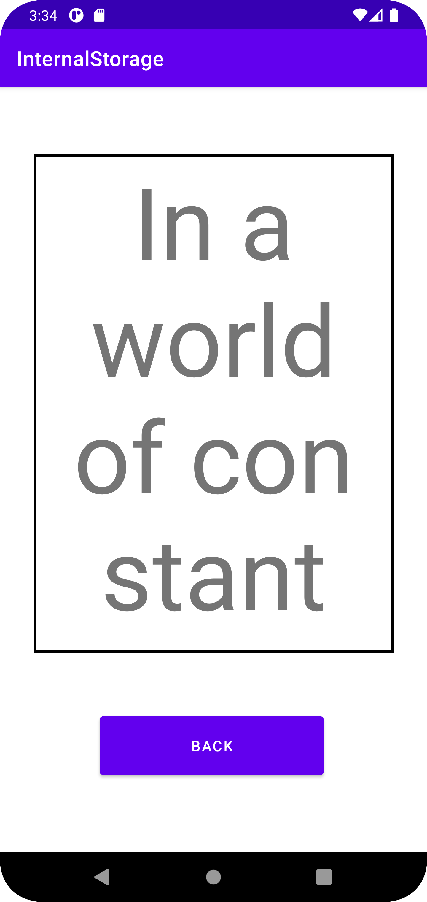

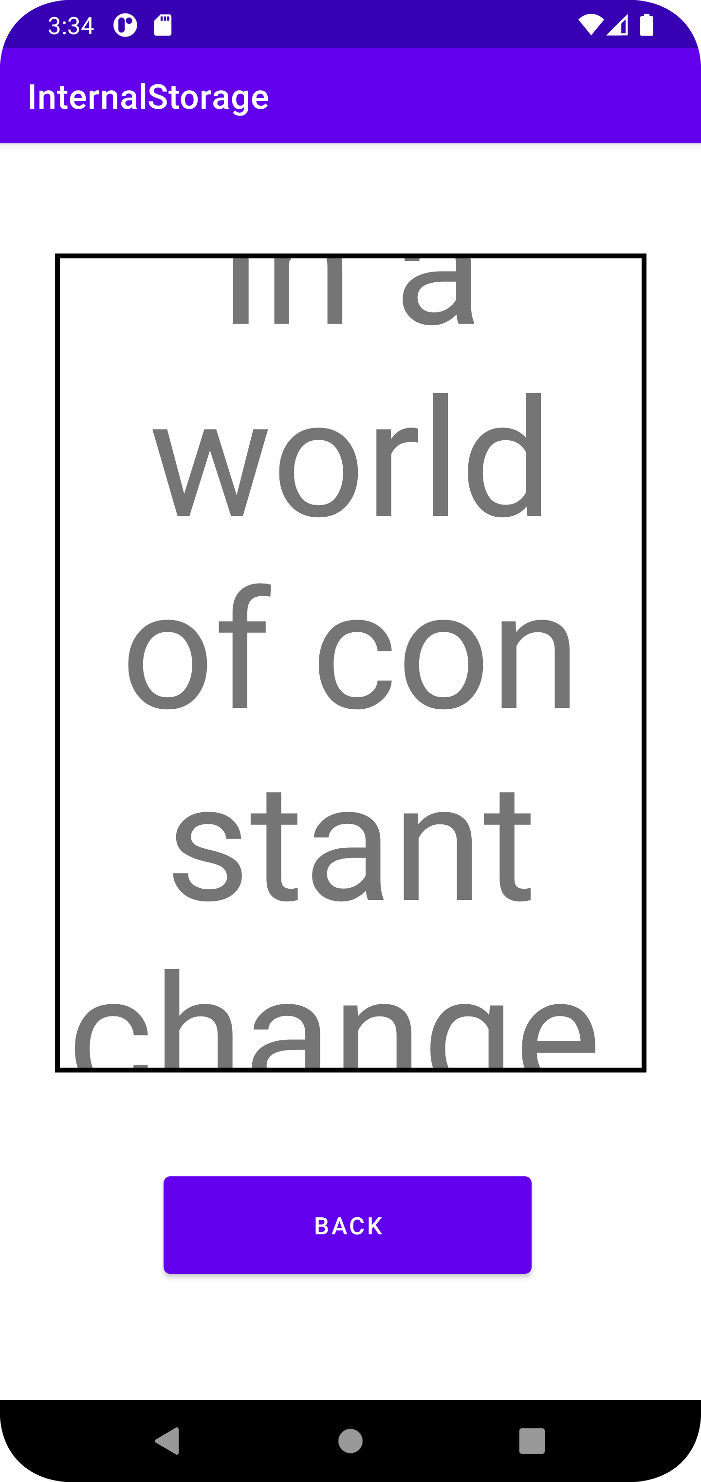

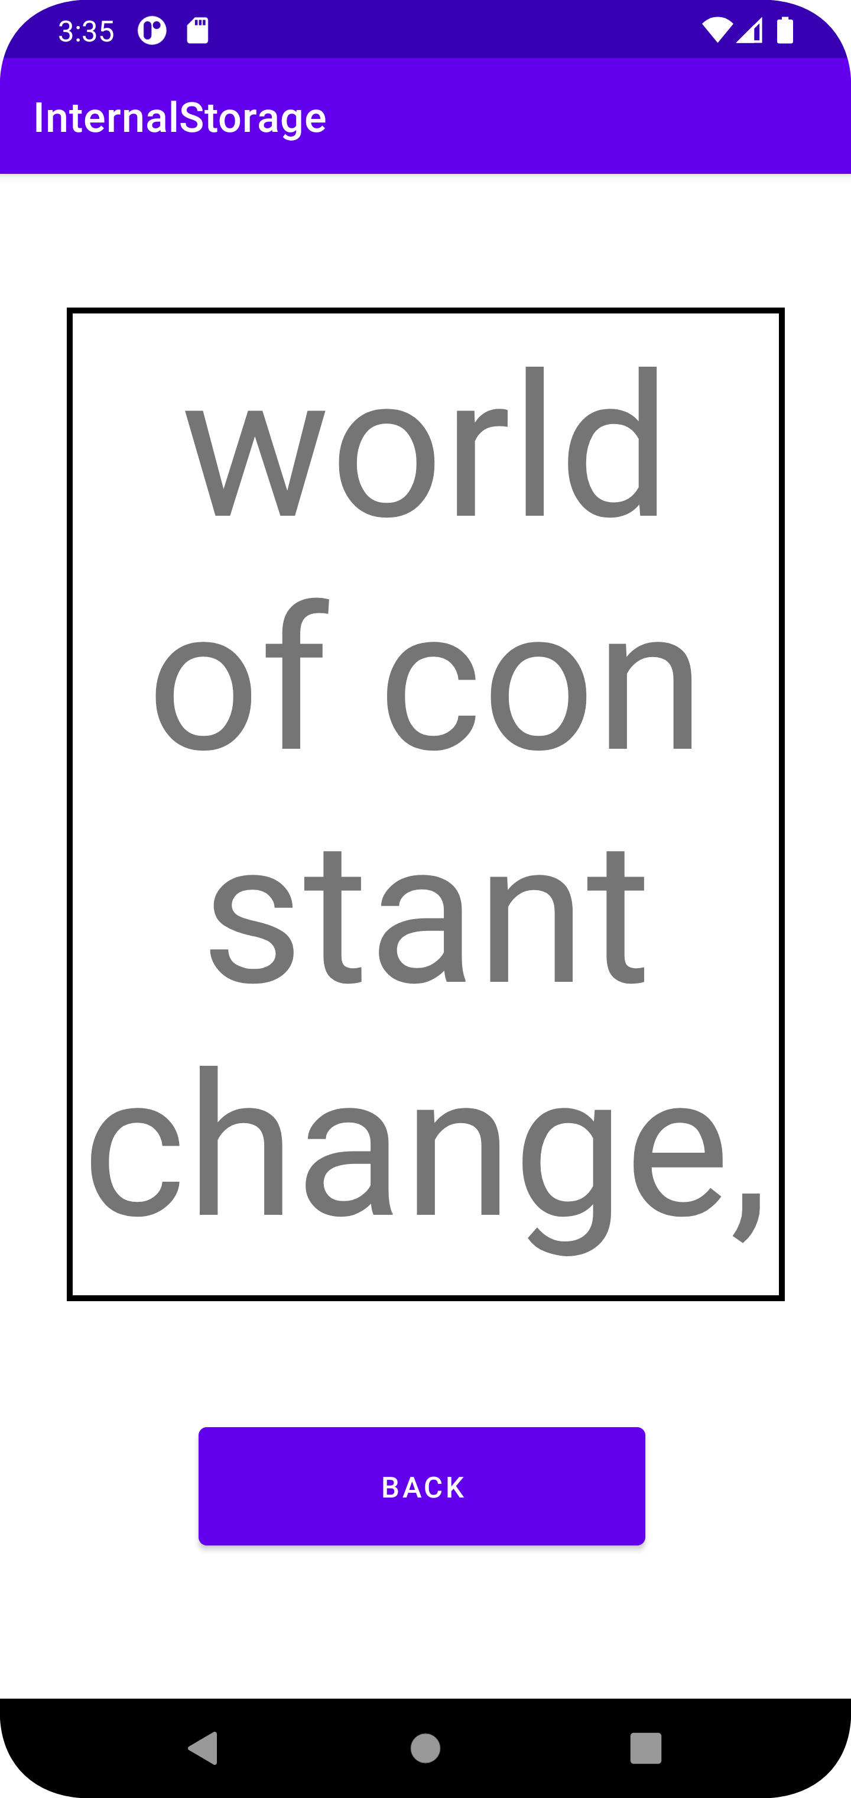

1. 注意事項
   1. 如果在步驟1，在第一次使用app(尚未產生.txt)時直接按下LOAD，則只會顯示TextView的Hint

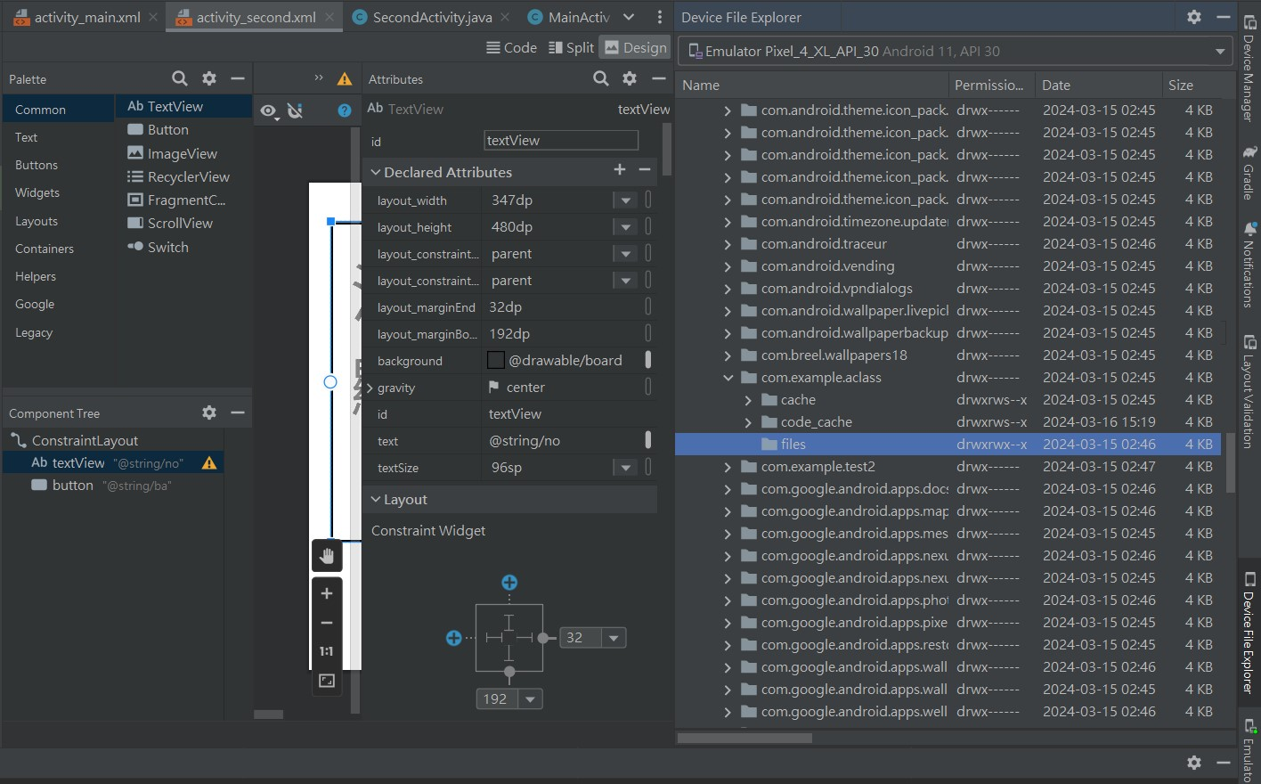

尚未產生.txt

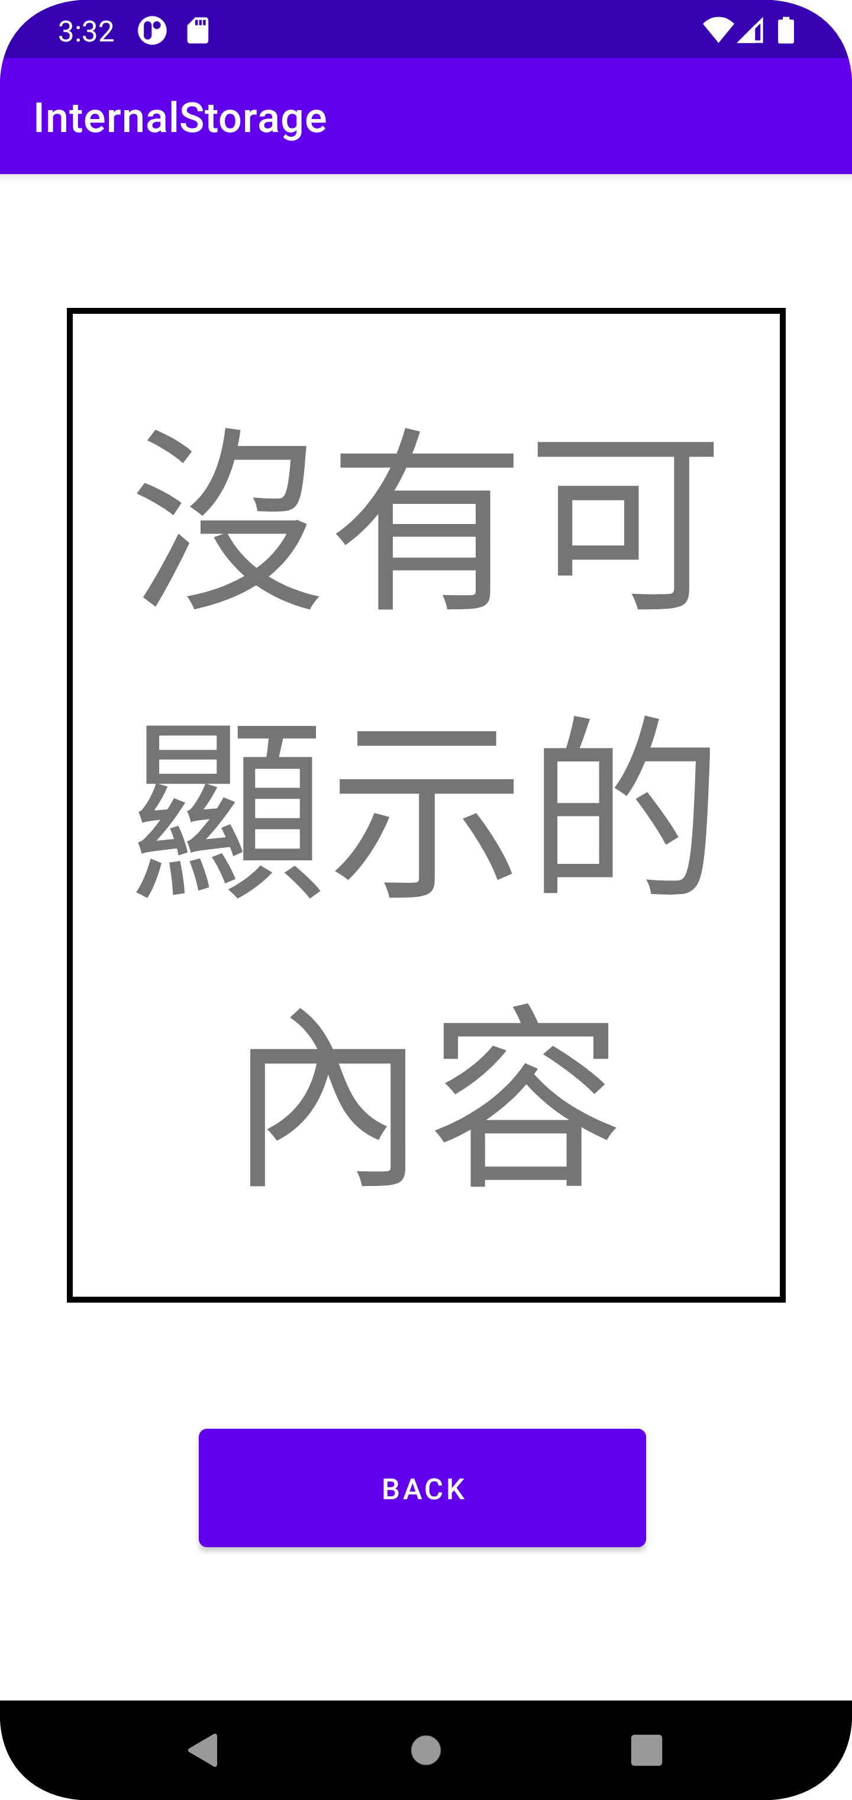

* 1. 如果在步驟1不輸入，按下SAVE再LOAD，TextView會是毫無顯示(全白)。
  2. 使用的文章儲存於以下圖中的.txt檔案中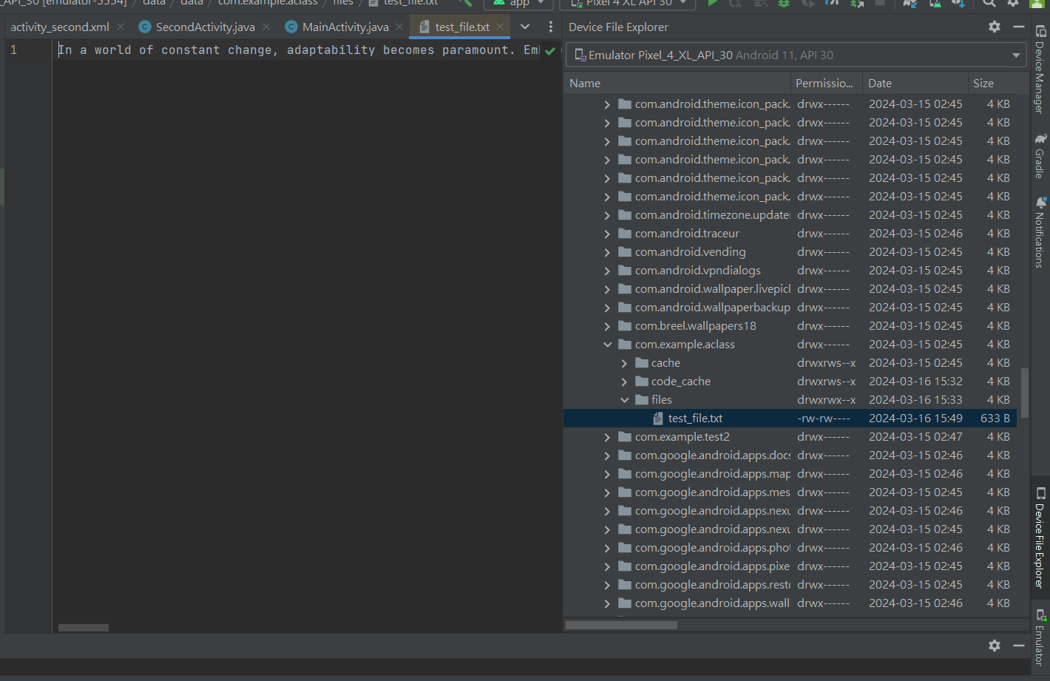
  3. 測試條下如下：
* 文章：In a world of constant change, adaptability becomes paramount. Embracing diversity and fostering cross-cultural understanding are essential for progress. Language, as a tool of communication, serves as a bridge between cultures, enabling the exchange of ideas and experiences. Mastery of multiple languages not only facilitates integration into diverse environments but also broadens perspectives. Beyond vocabulary and grammar, language learning involves understanding cultural nuances. In today's globalized society, multilingualism is a valuable asset, enhancing opportunities for career advancement and international cooperation.
* 文字大小：96sp