Create an EC2 instance (Instance_1) ubuntu using the 7 step workflow in N. Virginia Region
An Amazon EC2 instance is a virtual server in Amazon's Elastic Compute Cloud (EC2) for running applications on the Amazon Web Services (AWS) infrastructure.
Steps for Creating an EC2 instance :
- In instances dashboard → launch instances and fill in the respective parameters
- Name – instance1
- Application and OS Images (Amazon Machine Image) – choose ubuntu t2.micro
- Generate a keypair for private and public key. Save private key onto ur system
- Choose SSH port 22 and HTTP port 80 traffic from the Internet as we are connecting and launching apache server → Launch instance [needs about a minute to become ready]
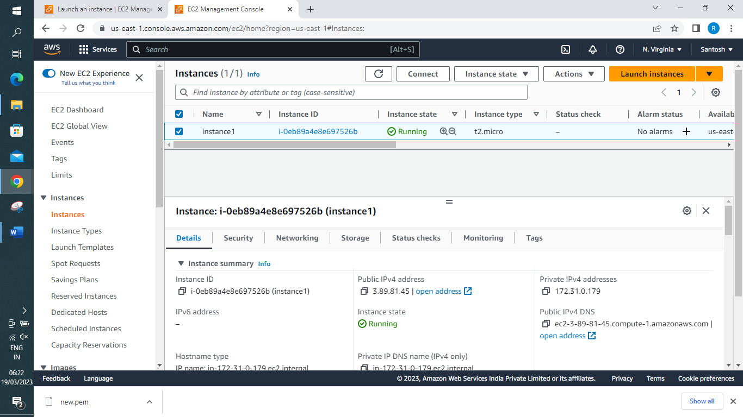
Using GitBash → Launch Terminal and set permission on your private key
chmod 400 room2.pem [providing only read access to owner of file]
ssh -i room2.pem ubuntu@ec2-3-89-81-45.compute-1.amazonaws.com
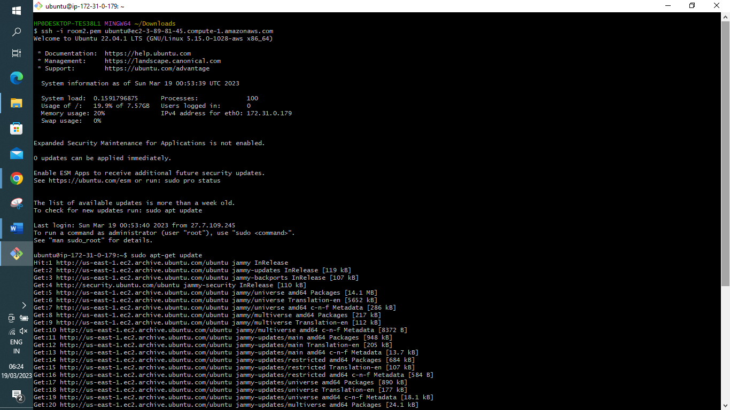
To configure the Apache server run the following as shown above:
1. sudo apt-get update
2. sudo apt-get install apache2
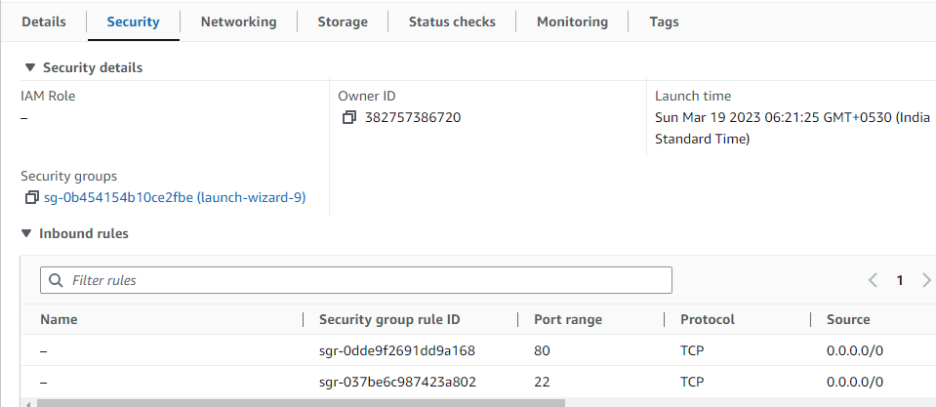
Try typing your instance public ip in your system browser. It should show default test page
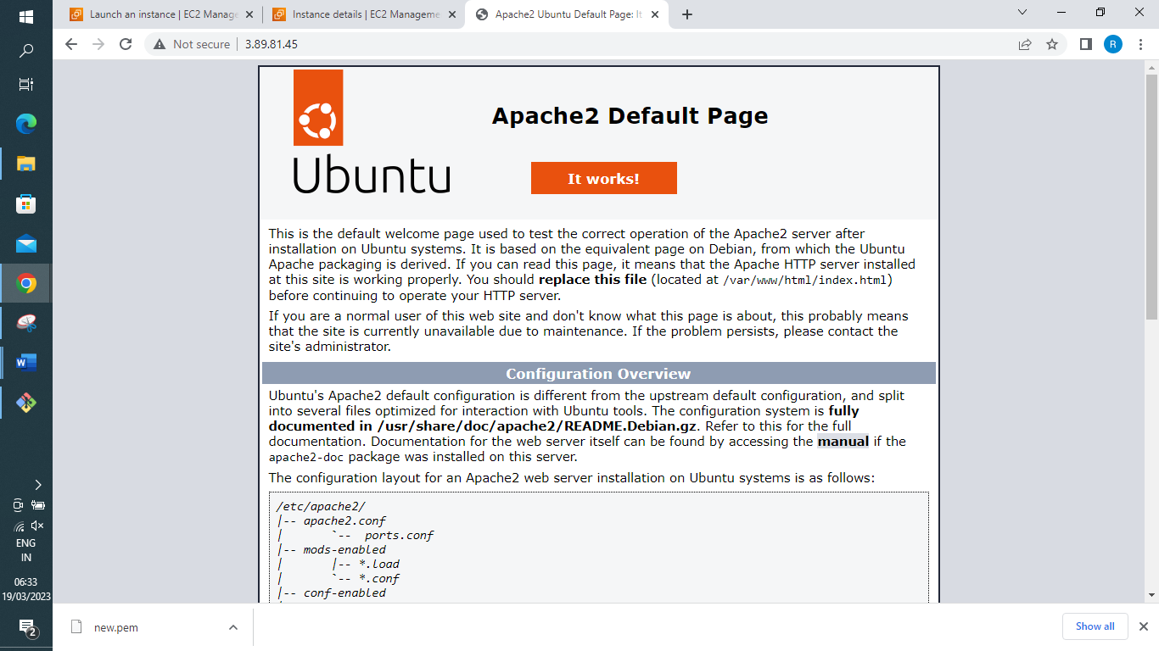

Create an AMI from Instance_1
To Create and image (also referred to as an AMI) defines the programs and settings that are applied when you launch an EC2 instance. You can create an image from the configuration of an existing instance.
Once created you can launch from the instance from the AMI.
Note : Also you need to add Account ID to share the EMI with that specific Account User
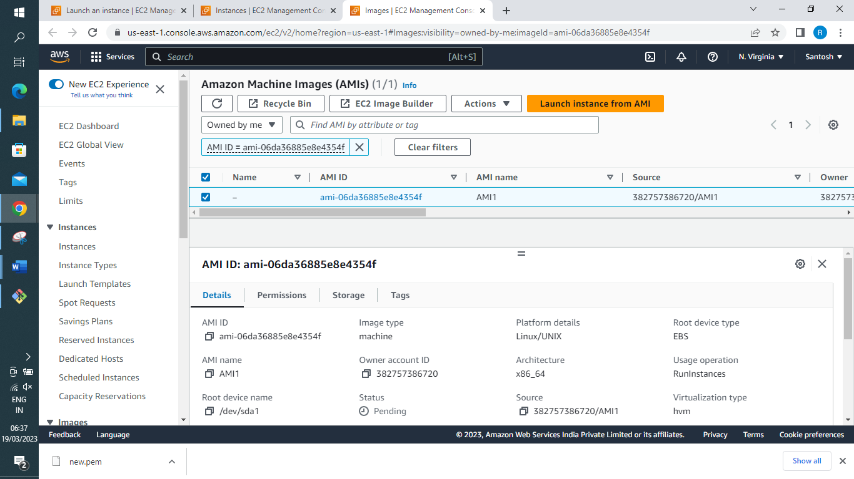
Create another EC2 instance (Instance_2) from that AMI → public IP 3.208.87.117
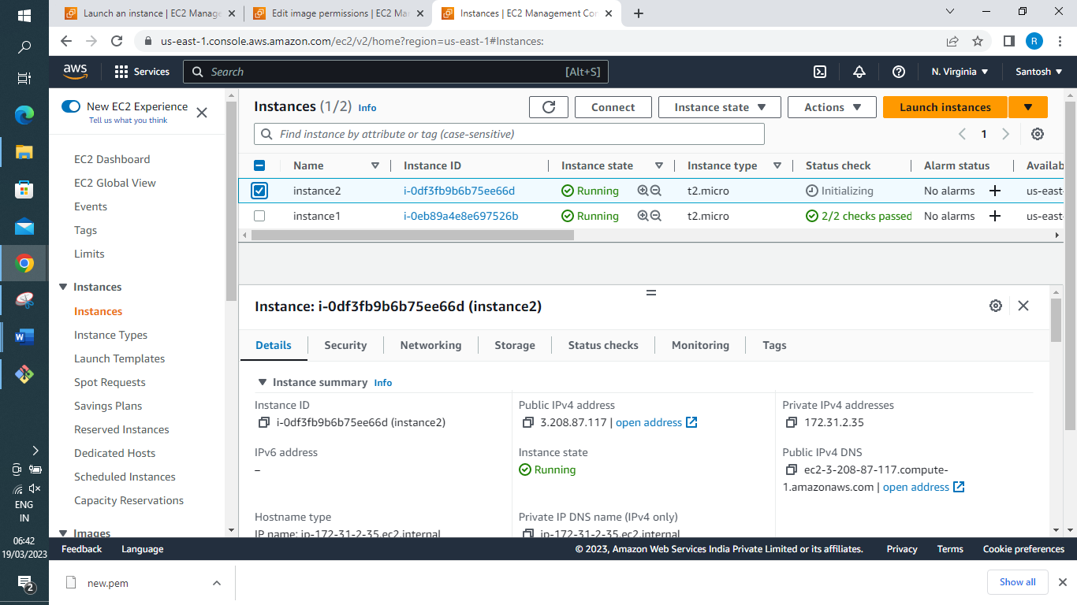
You should be able to launch web server from a browser tab as the state of instance 1 is copied in AMI image having Apache application pre-installed. As shown below
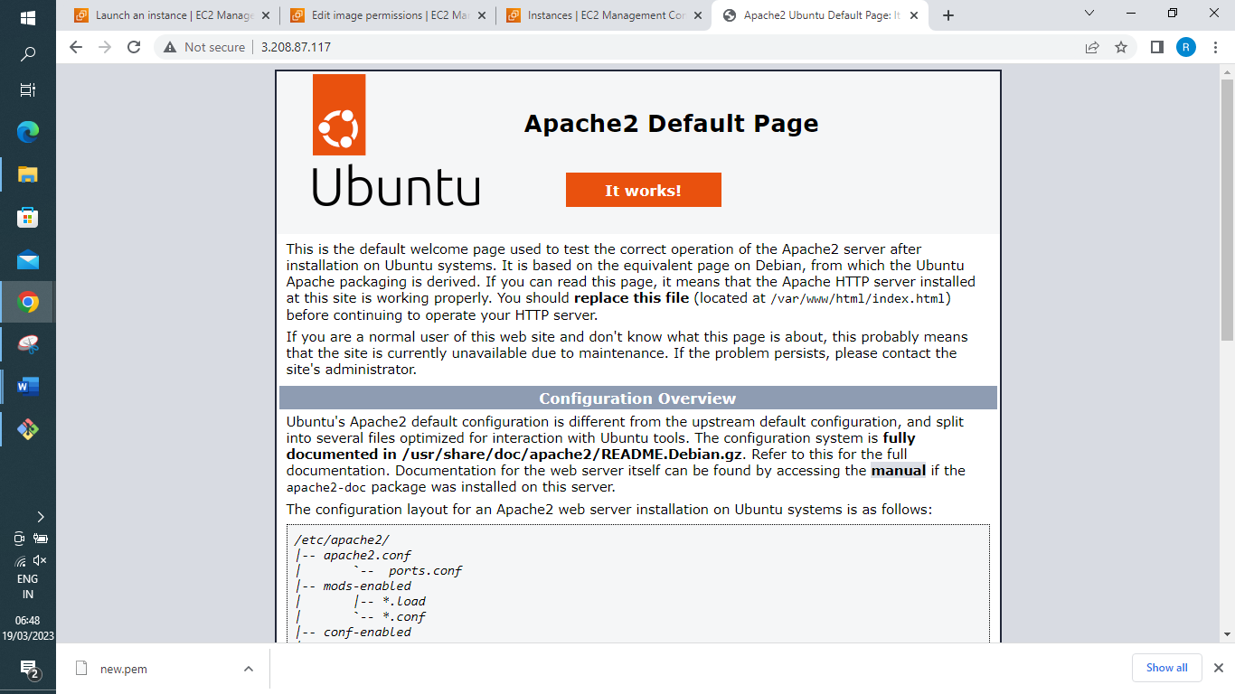
Cleanup process. – Here we need to terminate the instances and deregister the AMI and delete the snapshot
Terminate 2 EC2 instances – on instance dashboard (select both instances) → Instance state → Terminate instance.
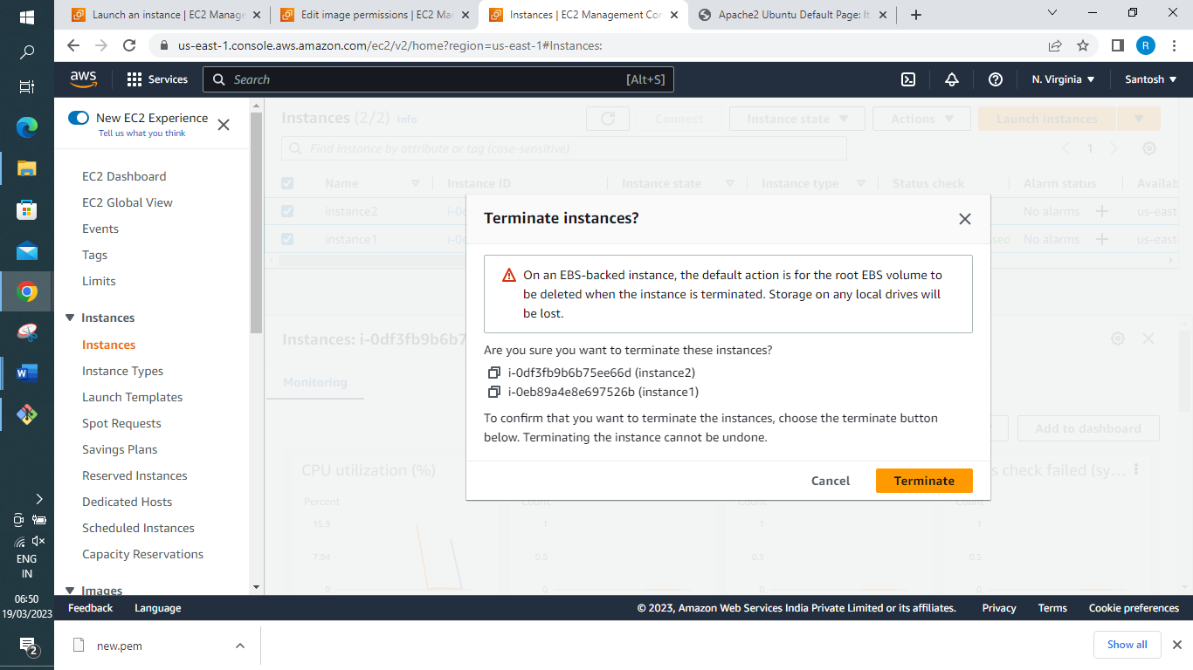

De-register AMI → Under AMI tab → select the AMI and under Actions tab select Unregister
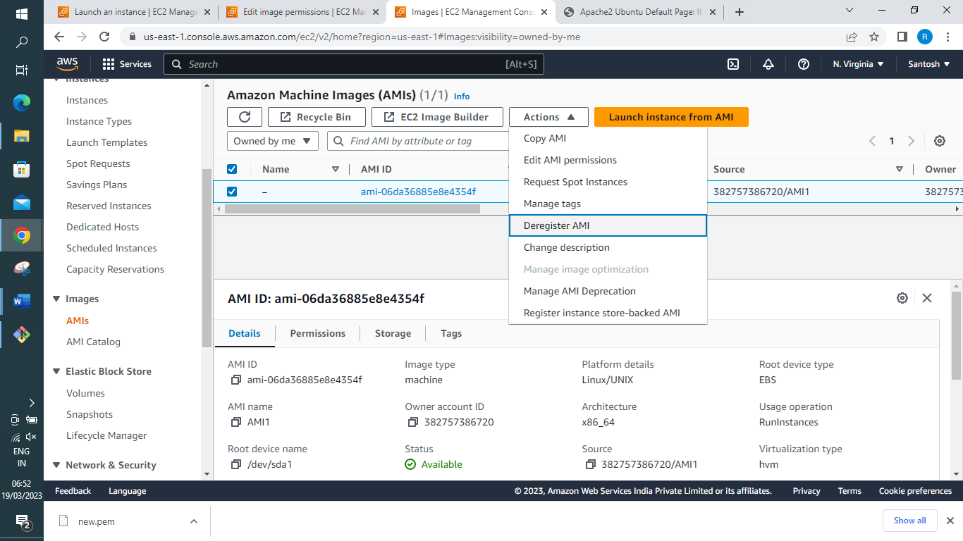
Delete the snapshot → Under snapshot tab select snapshot you created → Actions (delete snapshot)
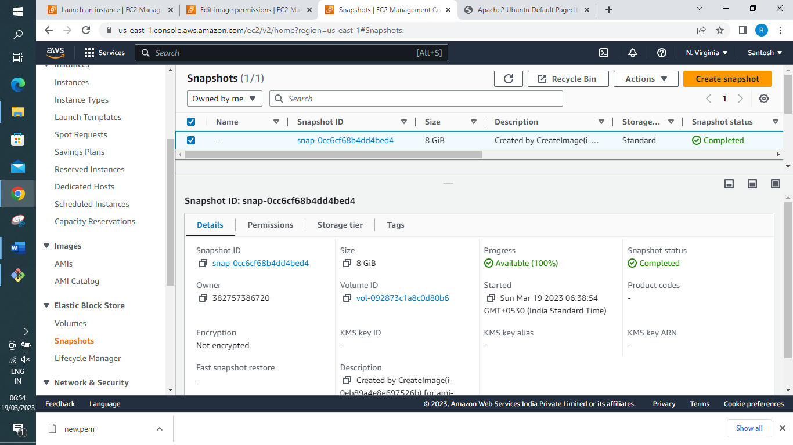
Treasure hunt: Find out where we can find ‘Launch more like this’ option and describe what it is
The option is present in instance image creation tab under Actions.
Launch More Like This feature in the Amazon EC2 console to launch an instance based on an existing instance.
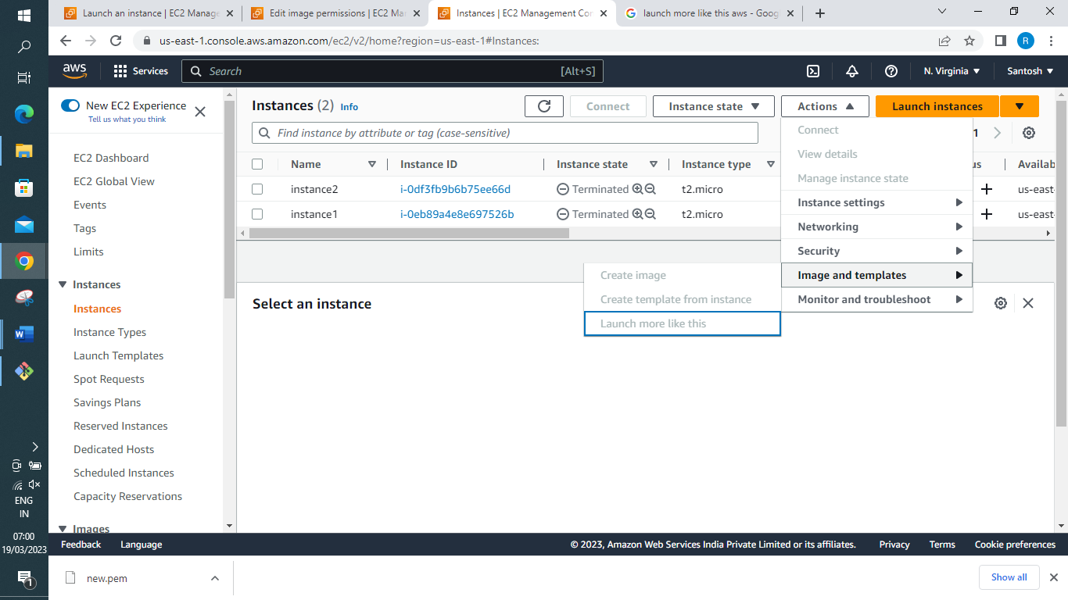
Lab Challenge: Launch a windows instance using the 7 step flow and login to it.
In instances dashboard → launch instances and fill in the parameters
- Name – Windows-Web Server
- Application and OS Images (Amazon Machine Image) – choose Microsoft Windows Server 2022 AMI t2.micro
- Generate a keypair for private and public key. Save private key onto ur system
- Choose RDP port 3389 and HTTP port 80 traffic from the Internet as we are connecting and launching apache server → Launch instance [needs about a minute to become ready]
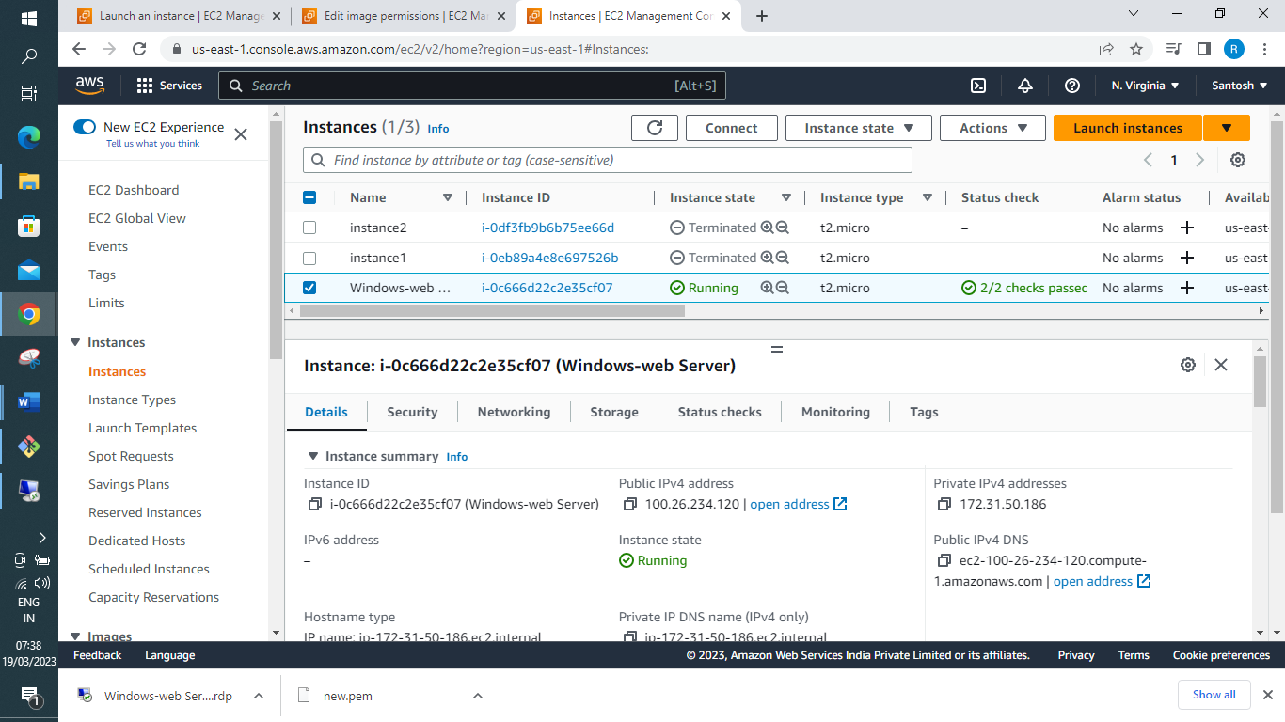
Connect using RDP client → Get password → Upload Private Key file and Decrypt password
Download Remote Desktop File and Click on it and provide password you decrypted and connect to host.
Inside EC2 instance → proceed to IIS installation [Internet Information Service]
Search for Server Manager Tool → Go to dashboard and click on add Roles and features (select Web Server IIS)→ Next → Next → Next add the IIS feature and install
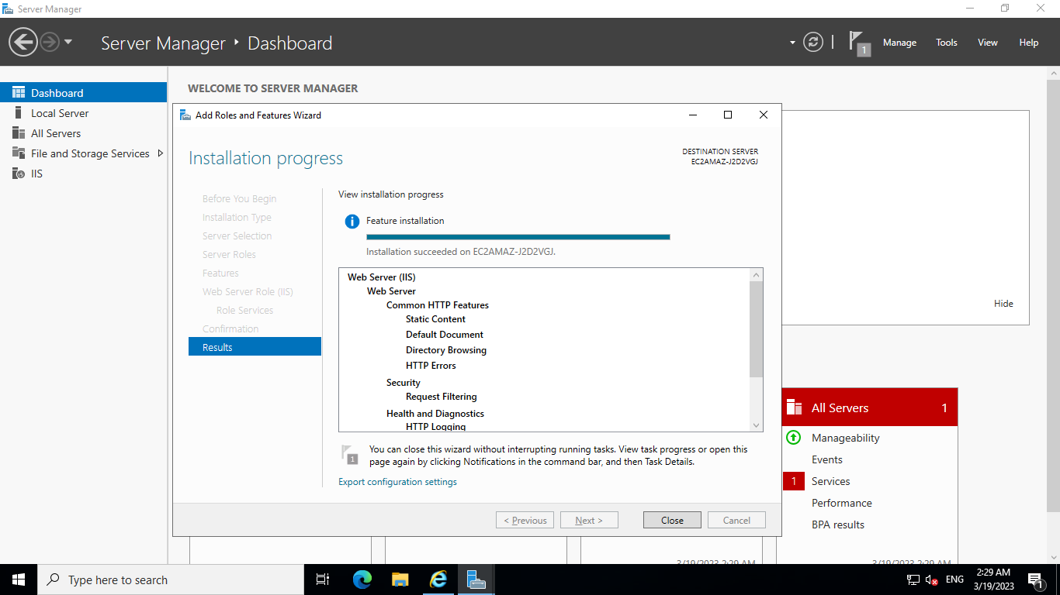
Back in Dashboard under Tools → IIS Manager → choose your Server from dropdown → Sites (click on it) → opens a window and you will have a default Website, right click and explore
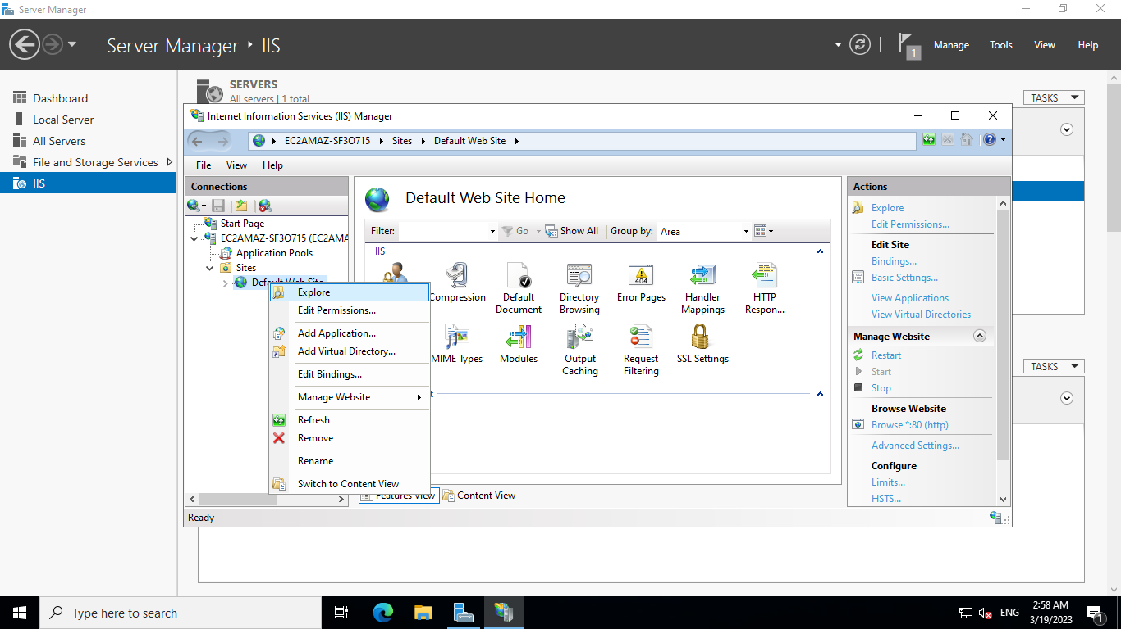
Try pasting Windows EC2 instance public IP in your local host browser, should display the Webpage.
My Server public IP was 18.213.151.164
Website contents are stored under [PC > local Disk C > inetpub > www → IISstart]
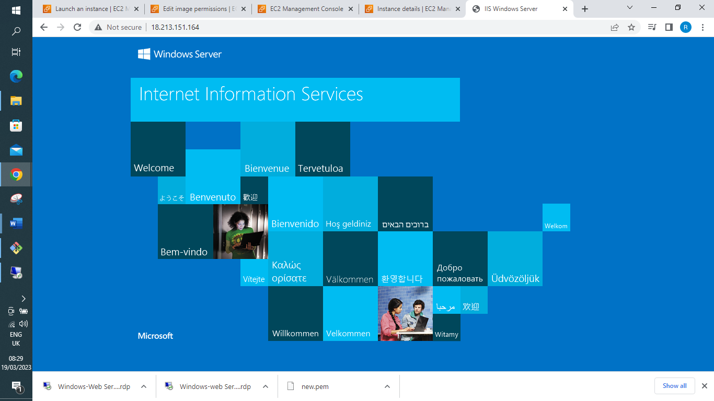
Cleanup → Terminate the instance once completed.

