Working with EC2 and EBS
- Create an EC2 instance (Ubuntu 16.04 LTS) using the 7 step workflow in 2 different availability zones(1a and 1b)
Steps for Creating an EC2 instance1a : In instances dashboard → launch instances and fill in the respective parameters
- Name – instance1a
- Application and OS Images (Amazon Machine Image) – choose ubuntu t2.micro
- Generate a keypair for private and public key. Save private key onto ur system
- Under Network Settings Edit → Subnet
For instance 1 a → Select Availability Zone 1a
For instance 1b → Select Availability Zone 1b
Launch the instance, you should have 2 perfectly created instances in different Zones
- Create an ‘EBS Volume 1’ and attach to instance which is in 1a
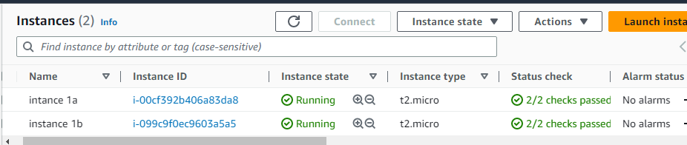
Create an Amazon EBS volume to attach to any EC2 instance in the same Availability Zone 1a of size 1GB.
Create a TAG Data Volume. [A tag is a label that you assign to an AWS resource. Each tag consists of a key and an optional value. You can use tags to search and filter your resources or track your AWS costs.]
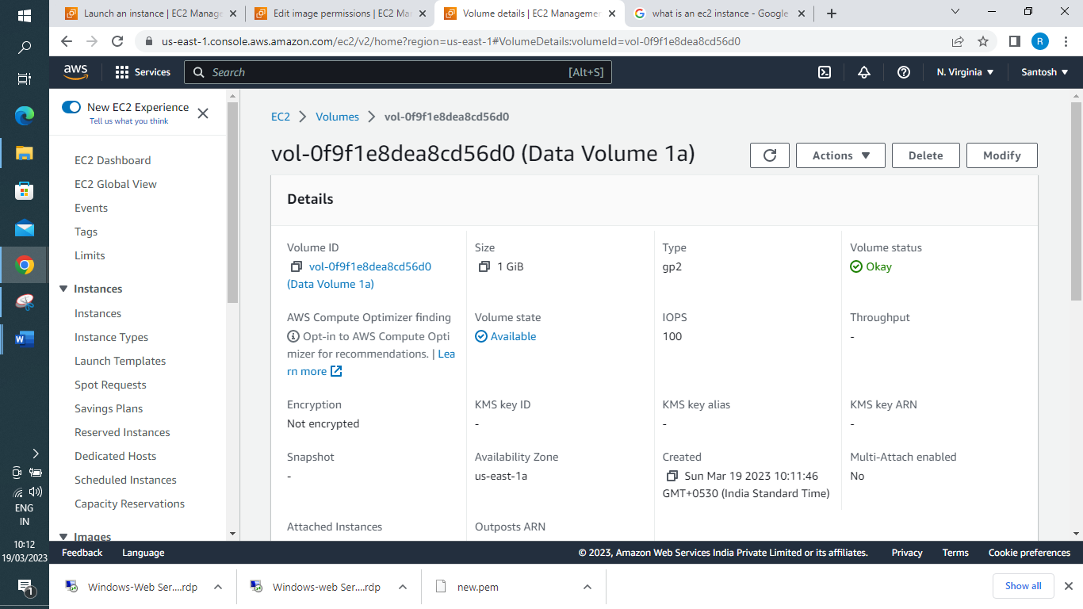
Now we need to attach the Volume to the Instance 1a to become Available for our EC2 instance.
Select the Volume → Actions → Attach Volume → Select your EC2 instance from the drop down menu
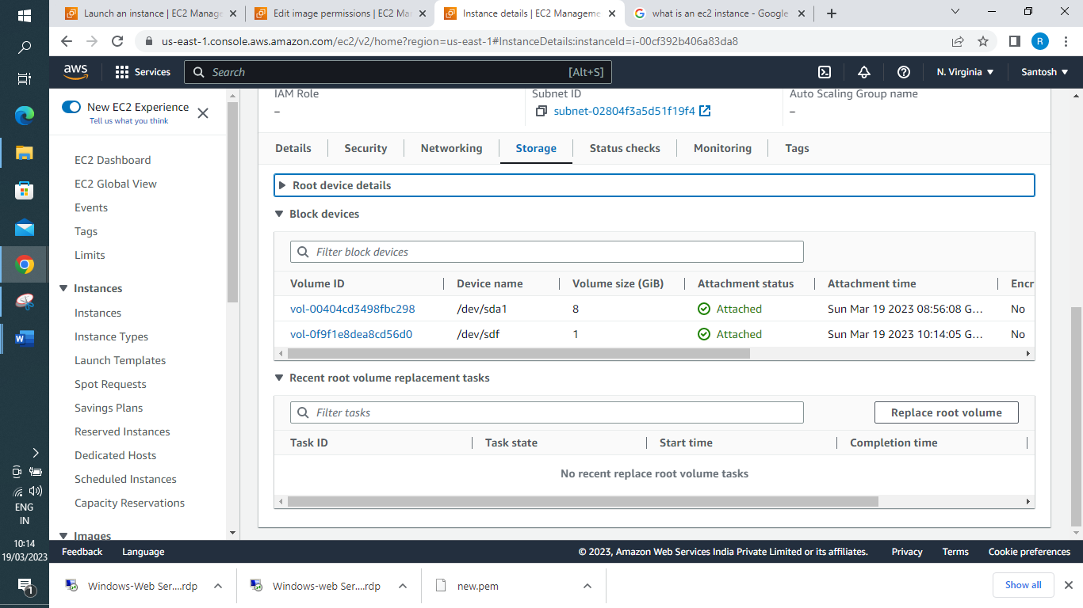
As the Volume is in AZ 1a, it cannot be attached to an instance in AZ 1b. Hence we need to Create a snapshot from the above ‘EBS volume 1’ then Create another ‘EBS volume 2’ in 1b from the snapshot and finally Attach ‘EBS volume 2’ to instance which is in 1b
For Creating Snapshot - EC2 > Snapshots > Create snapshot
Resource Type – Volume give Volume ID of Data Volume you created and mention Description about the same.
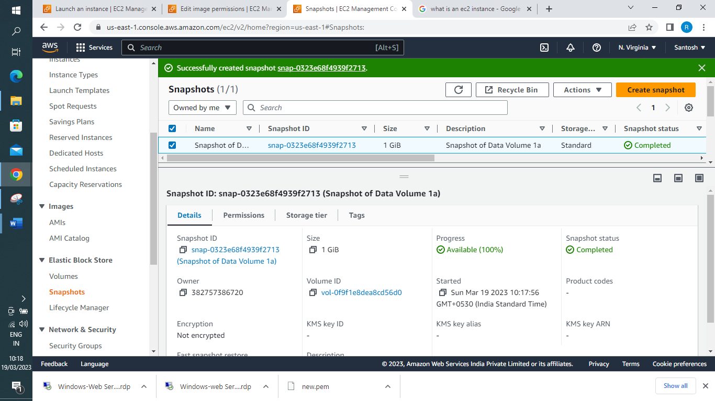
Now you need to create another Volume for instance 1b from this snapshot and Attach the same to the 1b instance. Select Snapshot > Actions > Create Volume from snapshot > make sure to select the AZ 1b
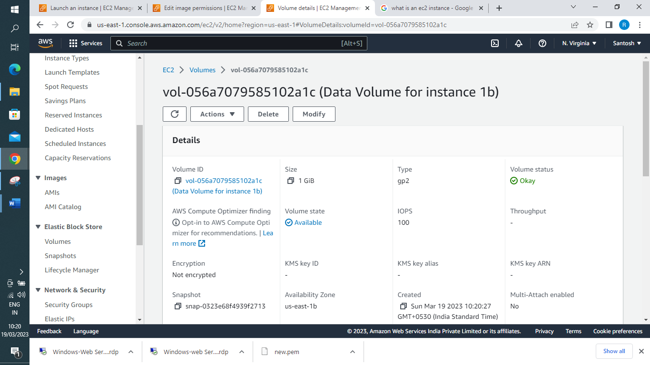
Actions > Attach Volume > Select 1b instance > The new Volume gets Attached as shown below.
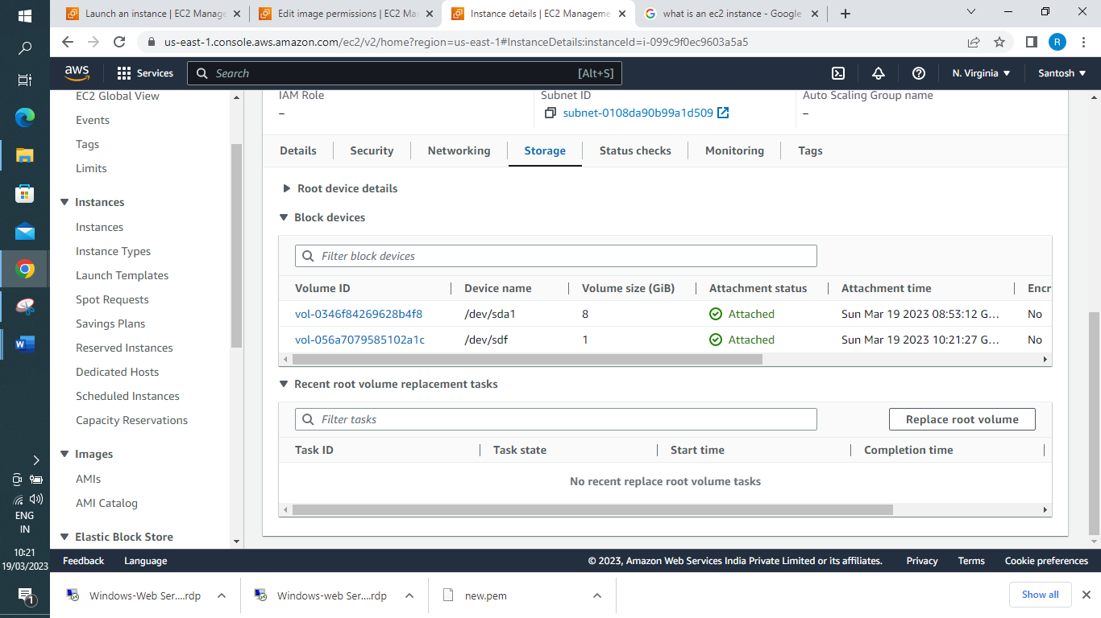
Cleanup
✓ Terminate 2 EC2 instances -Instance State > Terminate 2 EC2 instances – on instance dashboard (select both instances) → Instance state → Terminate instance.
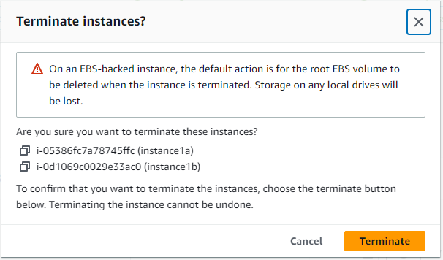
✓ Delete the snapshot – Snapshot Tab > Actions > Delete Snapshot
✓ Delete Volumes – Select both the Data Volumes and Actions > Delete Volume
Note : Root EBS Volumes by default get Attached as instance cannot live without OS and lives in the Root Volume and deleted but Additional Volume Attached we need to Attach and Delete manually.
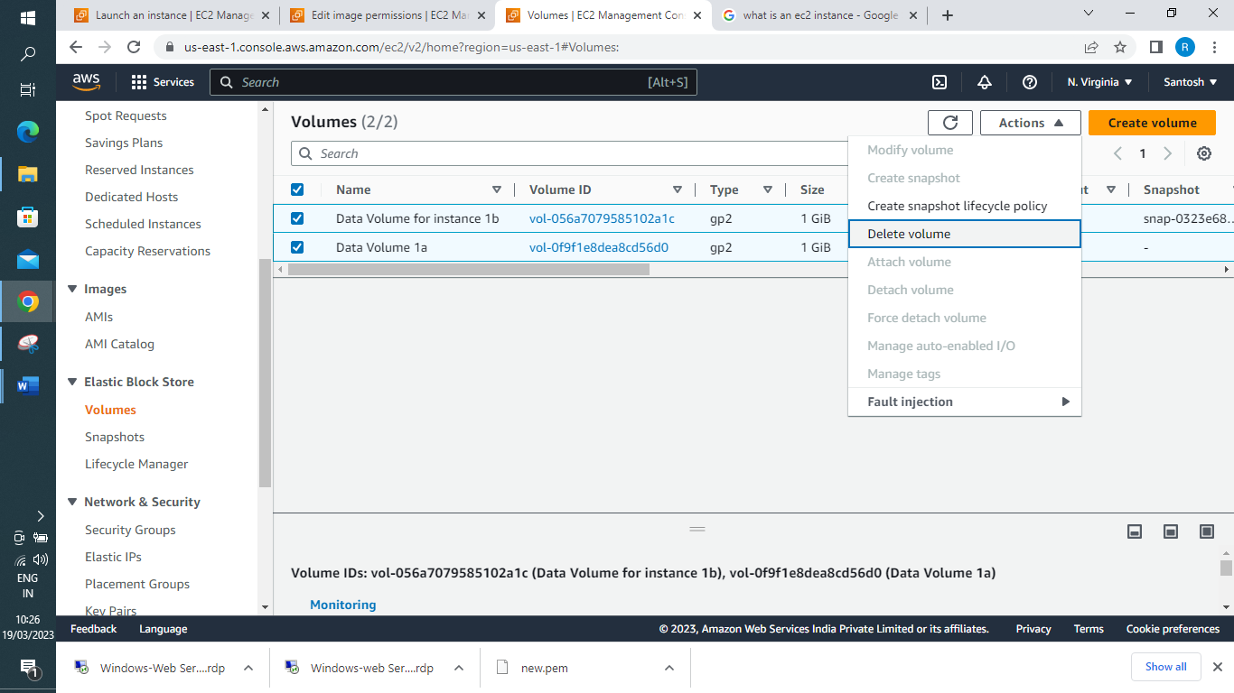
Treasure hunt: Is it possible to detach the root volume from EC2 instance? If Yes or No (with screenshots)
Yes . If you want to detach the root volume of an instance, make sure the instance is in the stopped state.
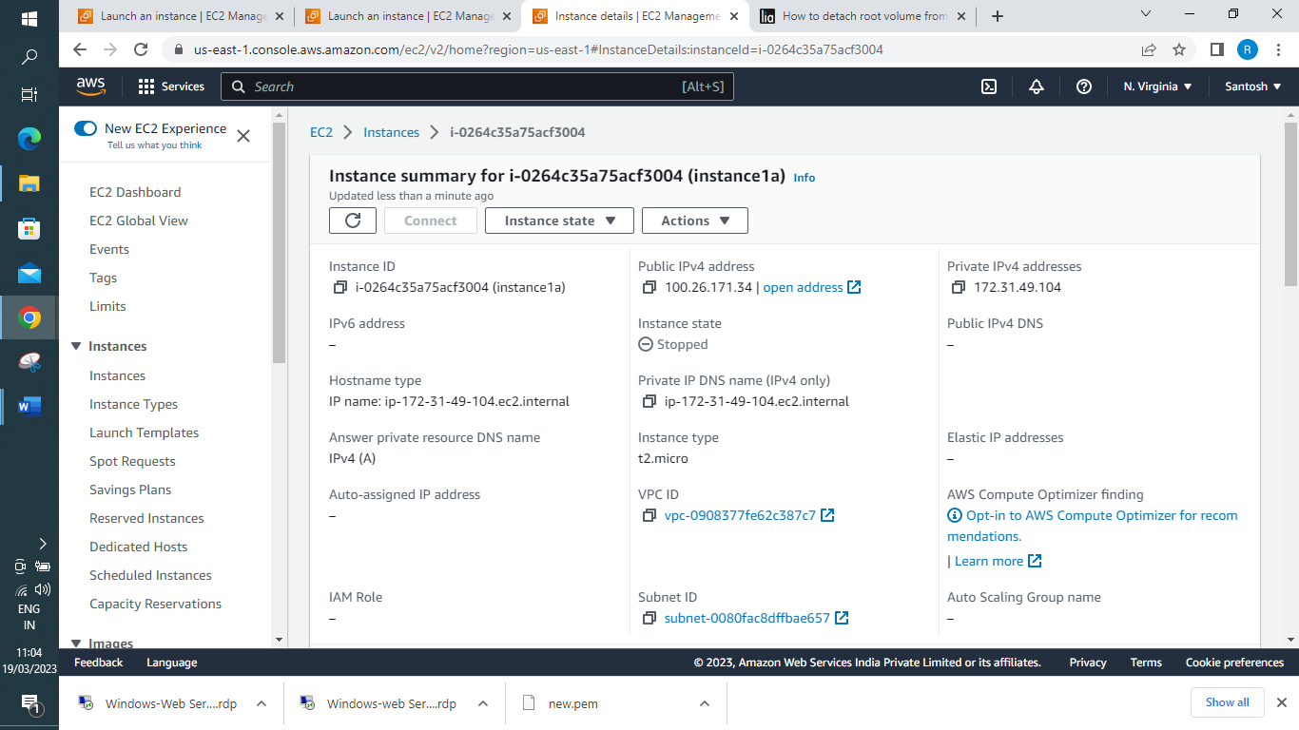

Once you have stopped your instance, then you can select on EBS Block Store > Volumes > Select Root Volume and Actions > detach Volume as shown below.
Note : U cannot start up the instance now without reattaching the Root Volume which holds the OS.
Failed to start the instance i-0264c35a75acf3004
Invalid value 'i-0264c35a75acf3004' for instanceId. Instance does not have a volume attached at root (/dev/sda1)

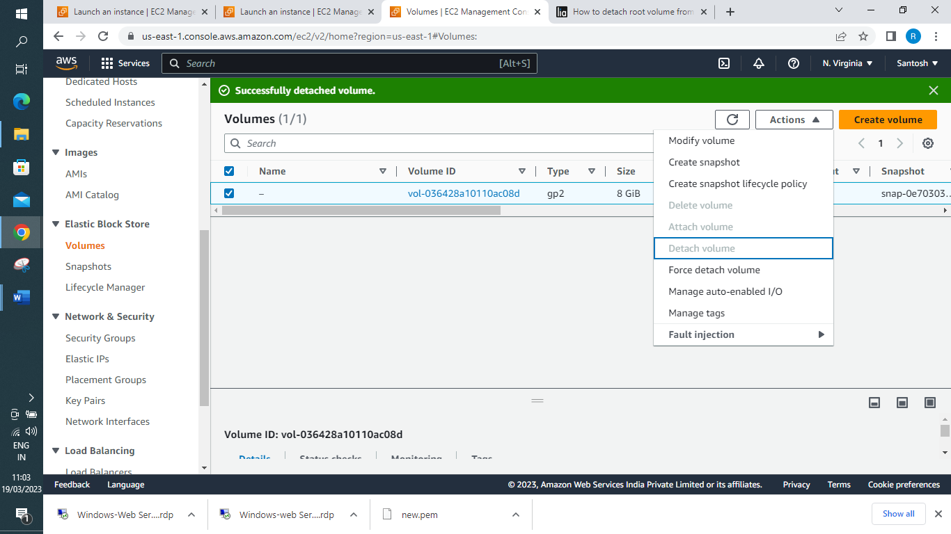
Now to reattach Volume back Note : Try to attached same volume to EC2 instance. However make sure that you are not using default “Device” such as “/dev/sdf” as below while attaching volume to EC2 instance. Instead Use Device name as /dev/sda1 which we have noted down in the step1 as below and click Attach Button:
Now you can restart your instance.
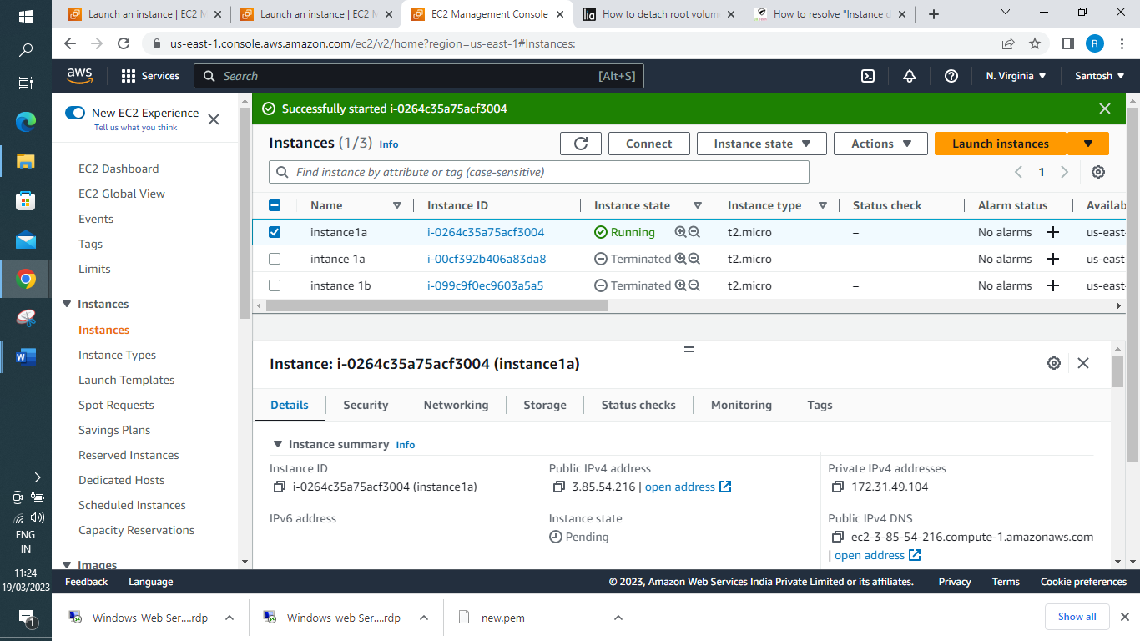
Lab Challenge: Try to login into the instance and create a file (test.txt) in EBS volume
As I had not selected ssh inbound Rule while creating instance. I need to Add ssh rule to login to my ubuntu instance.
- Select your instance and, in bottom half of the screen, choose the Security tab. Security groups lists the security groups that are associated with the instance. Inbound rules displays a list of the inbound rules that are in effect for the instance.
- For the security group to which you'll add the new rule, choose the security group ID link to open the security group.
- On the Inbound rules tab, choose Edit inbound rules.
- On the Edit inbound rules page, do the following:
  - Choose Add rule.
  - For Type, choose SSH port 22 allow from Anywhere ipv4 and save Rule

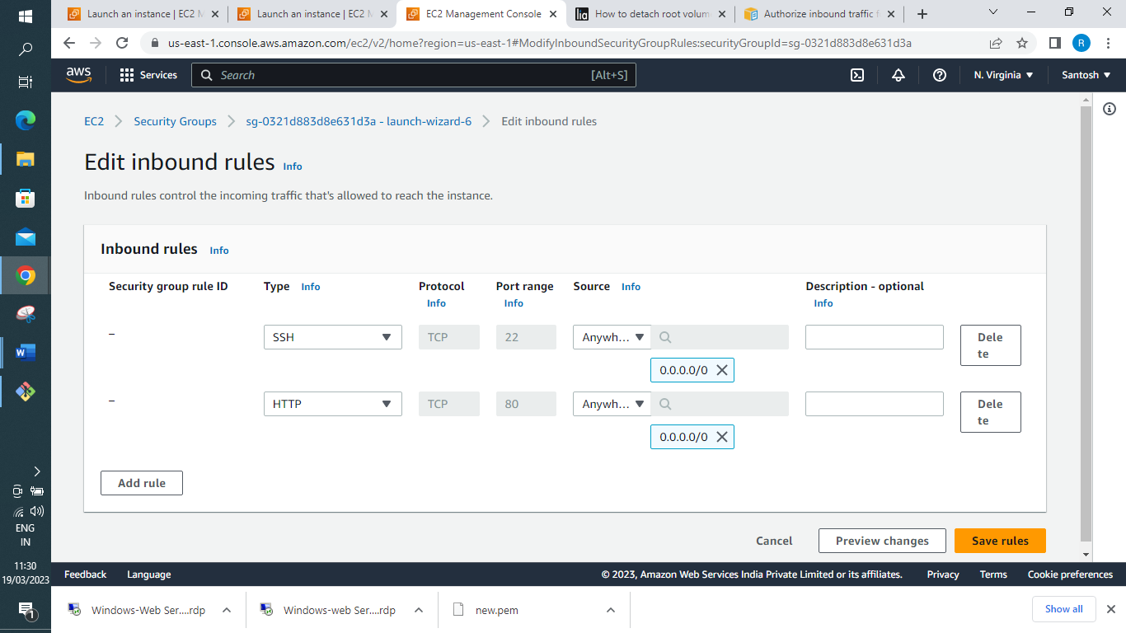
Now you should be able to login to Server
