Working with EC2 and EFS
EFS - Amazon Elastic File System (EFS) is a managed Network File System (NFS) designed for Linux-based EC2 instances, selected AWS managed services, and on-premise servers.
Create a security group with NFS protocol open
EC2 > Security Groups > Create security group → Select inbound Rules NFS port 2049, Allow from Anywhere ipv4 and create.
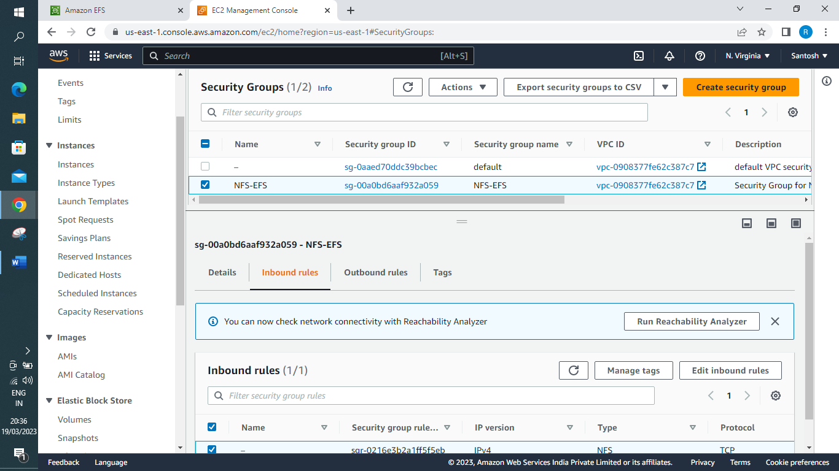
2. Create a EFS with above security group and make sure you don’t enable encryption and Lifecycle management and automated backups to avoid charges
Choose https://us-east-1.console.aws.amazon.com/efs/home?region=us-east-1#/get-started for creating EFS
Mount targets remove the default target and provide our NFS target created in previous step.
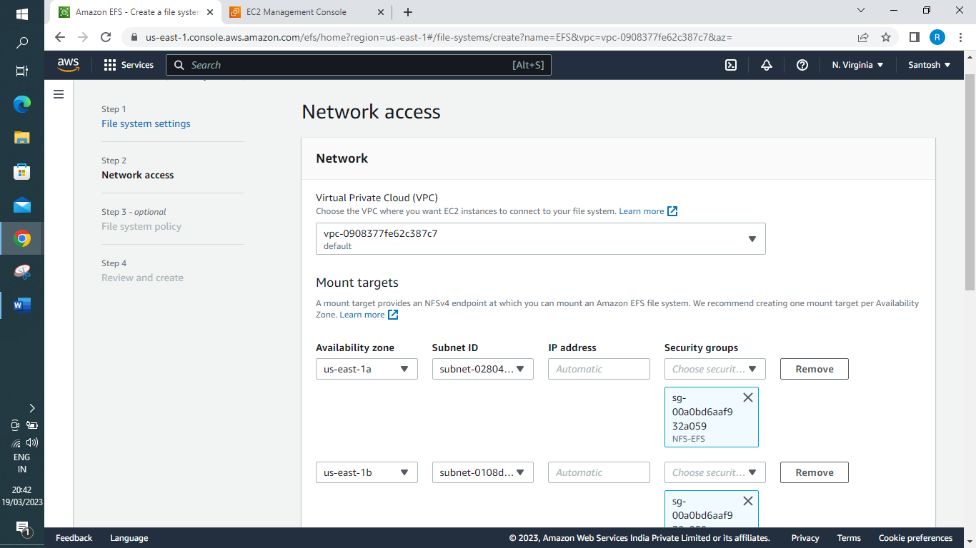

Review and create
Step 1: File system settings Edit

File system
Field | Value | Is editable?
Name | EFS | Yes
Performance mode | General Purpose | No
Throughput mode | Bursting | Yes
Encrypted | No | No
KMS Key ID | - | No
Lifecycle management | Transition into IA: None  Transition out of IA: None | Yes
Automatic backups | No | Yes
VPC ID | vpc-0908377fe62c387c7 (default) | Yes
Availability Zone | Standard | No

Tags
Tag key | Tag value
Name | EFS

Step 2: Network access
Edit

Mount targets
Availability zone | Subnet | IP address | Security groups
us-east-1a | subnet-02804f3a5d51f19f4 | - | sg-00a0bd6aaf932a059
us-east-1b | subnet-0108da90b99a1d509 | - | sg-00a0bd6aaf932a059
us-east-1c | subnet-01639b6ee5bd1d7e8 | - | sg-00a0bd6aaf932a059
us-east-1d | subnet-07aa04b9c3f6ca0f3 | - | sg-00a0bd6aaf932a059
us-east-1e | subnet-0080fac8dffbae657 | - | sg-00a0bd6aaf932a059
us-east-1f | subnet-003fa22a192261f9f | - | sg-00a0bd6aaf932a059

3. Create an EC2 instance (Ubuntu 16.04 LTS) using the 7 step workflow in 2 different availability zones(1a and 1b)
- Create an EC2 instance (Ubuntu 16.04 LTS) using the 7 step workflow in 2 different availability zones(1a and 1b)
Steps for Creating an EC2 instance1a : In instances dashboard → launch instances and fill in the respective parameters
- Name – instance1a
- Application and OS Images (Amazon Machine Image) – choose ubuntu t2.micro
- Generate a keypair for private and public key. Save private key onto ur system
- Under Network Settings Edit → Subnet
For instance 1 a → Select Availability Zone 1a
For instance 1b → Select Availability Zone 1b
Launch the instance, you should have 2 perfectly created instances in different Zones
- Create an ‘EBS Volume 1’ and attach to instance which is in 1a
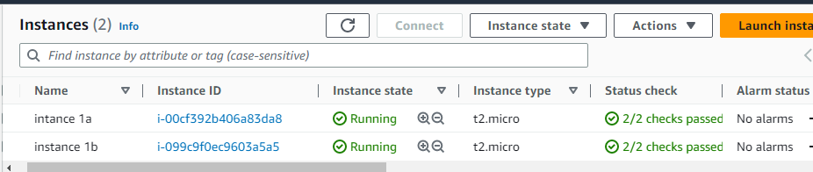
- Login into 2 EC2 instances and install required packages
Login to 2 EC2 instances and do the following
1. chmod 400 your.pem
2. ssh -i your.pem ubuntu@publicip
3. sudo apt-get update
4. sudo su
5. sudo apt-get install nfs-common
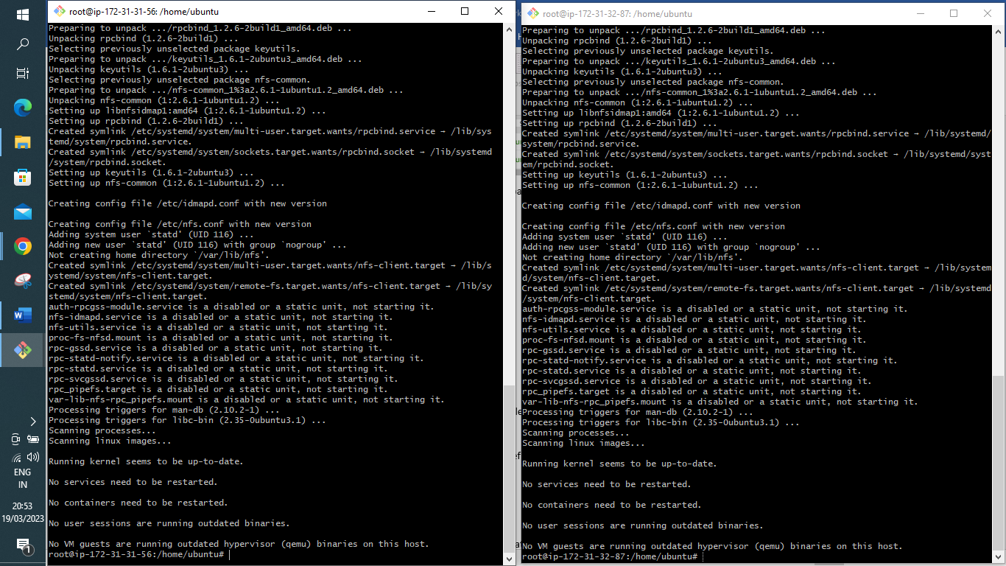
6. mkdir efs
7. mount (follow mount instructions from EFS console)
To mount your EFS click on your EFS and copy command for mounting and paste on your instances to mount
sudo mount -t nfs4 -o nfsvers=4.1,rsize=1048576,wsize=1048576,hard,timeo=600,retrans=2,noresvport fs-09838387a9f7d9eb2.efs.us-east-1.amazonaws.com:/ efs
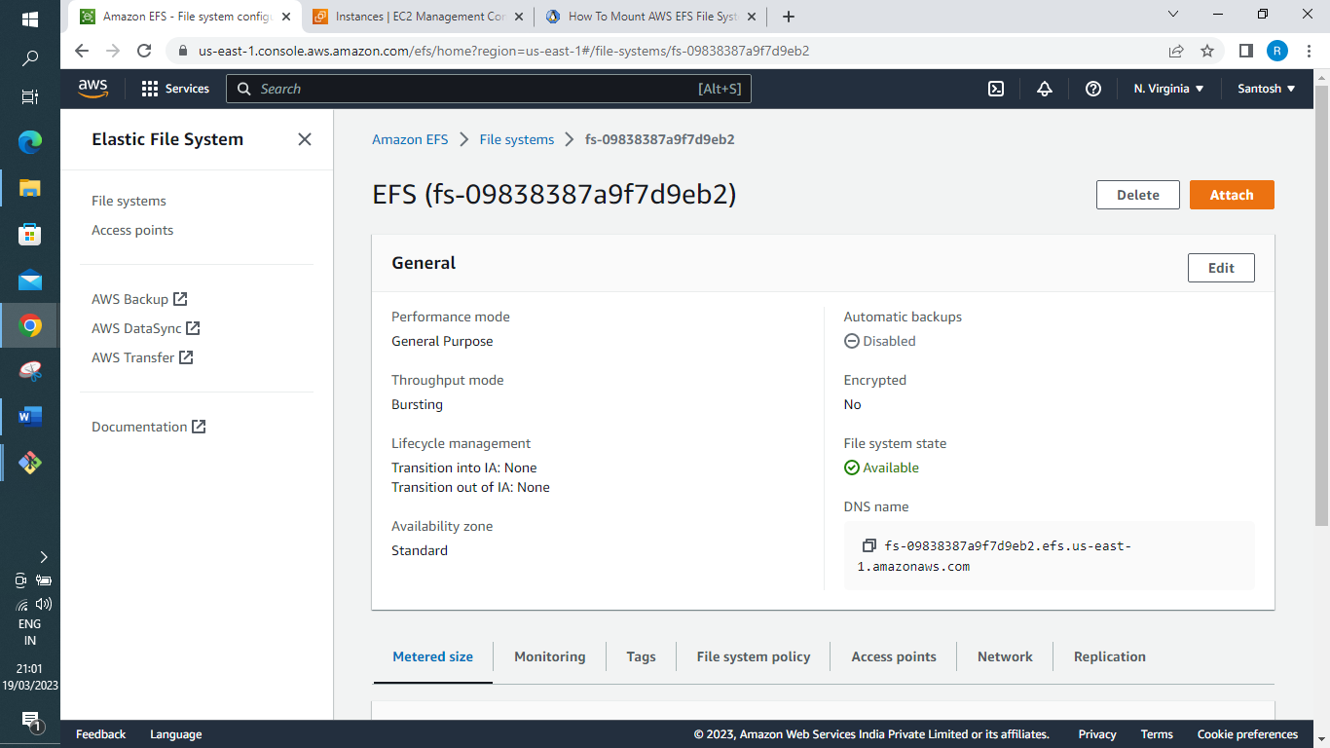
8. cd efs
9. touch file1.txt (create in instance1 and check if its reflecting in instance2)
10. touch file2.txt (create in instance2 and check if its reflecting in Instance1)
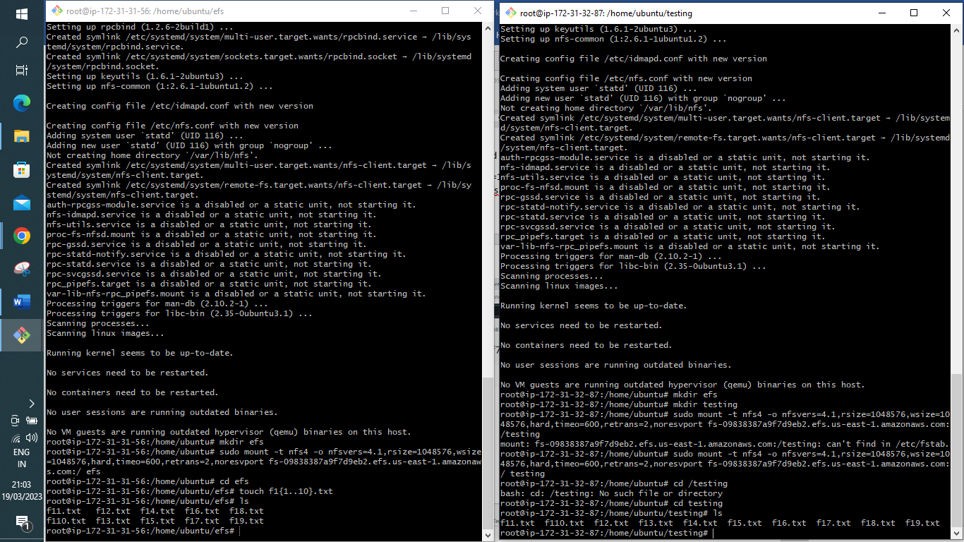
11. cd ..
12. umount efs (to unmount from EFS)
5. Mount to EFS and start creating files to check if the data is sharing between 2 instances
6. Cleanup
✓ Terminate 2 EC2 instances -Instance State > Terminate 2 EC2 instances – on instance dashboard (select both instances) → Instance state → Terminate instance.
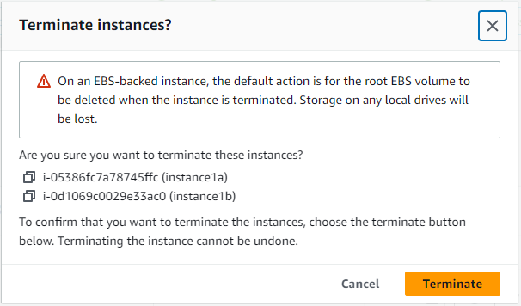
✓ Delete EFS
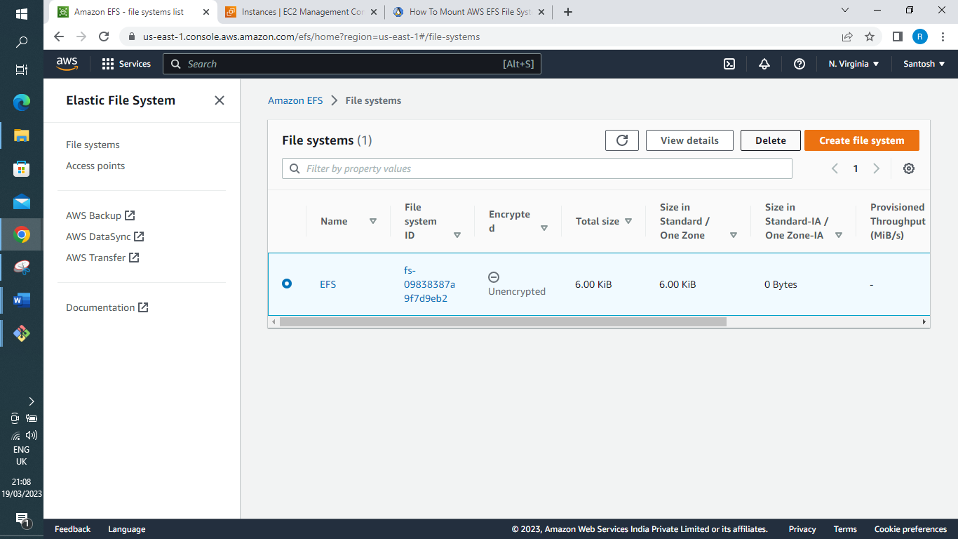
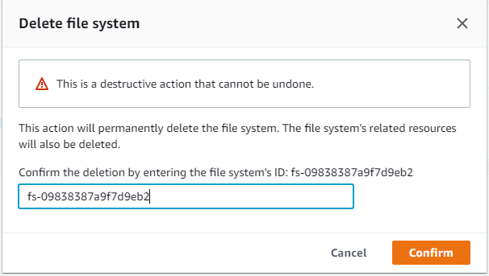
Treasure hunt: When should I use Amazon EFS vs. Amazon Elastic Block Store (EBS)
While EFS is a managed elastic file system designed for use across different machines and availability zones, EBS is designed as a fast and reliable block storage volume for single machines (although EBS multi-attach is an exception to this that applies only on very specialised scenarios).
So where should you use one and not the other?
1. If you need to access data from different machines or from different availability zones, EFS is probably your best option.
2. EFS volumes are best suited for enterprise-wide file servers, backup systems, Big Data clusters, Massively Parallel Processing (MPP) systems, Content Distribution Networks (CDN), and other such large use cases.
3. Systems requiring a lot of throughput can also benefit from EFS.
4. If you need very low latency disk operations, EBS is probably the best choice. EBS volumes are best suited for relational and NoSQL databases, enterprise applications like ERP systems, mail servers, SharePoint, web servers, directory servers, DNS servers, or middlewares. That’s because these systems typically don’t run on large clusters, and therefore don’t need commonly mounted volume. Replication between servers is done on the application level, not on disk level. The performance requirements of these workloads can also be met by existing EBS volume types.

