Working with RDS - Create an RDS database with MySQL Engine and enable only the free tier eligible features
In RDS dashboard goto RDS > Database > Create Database -
https://us-east-1.console.aws.amazon.com/rds/home?region=us-east-1#launch-dbinstance:gdb=false;s3-import=false
Choose Standard create database creation method - You set all of the configuration options, including ones for availability, security, backups, and maintenance.
Engine options – MySQL
MySQL is the most popular open source database in the world. MySQL on RDS offers the rich features of the MySQL community edition with the flexibility to easily scale compute resources or storage capacity for your database.
- Supports database size up to 64 TiB.
- Supports General Purpose, Memory Optimized, and Burstable Performance instance classes.
- Supports automated backup and point-in-time recovery.
- Supports up to 15 Read Replicas per instance, within a single Region or 5 read replicas cross-region.
Templates - Free tier Use RDS Free Tier to develop new applications, test existing applications, or gain hands-on experience with Amazon RDS.
DB instance identifier - AWSdatabase
Instance Configuration – db2.t2.micro
Storage Allowed 20 GB under free-tier
Storage autoscaling – disable [Provides dynamic scaling support for your database’s storage based on your application’s needs.]
Compute Resource – Don’t Connect to EC2
Public Access – Yes
Note : The Amazon RDS Free Tier is available to you for 12 months. Each calendar month, the free tier will allow you to use the Amazon RDS resources listed below for free:
- 750 hrs of Amazon RDS in a Single-AZ db.t2.micro, db.t3.micro or db.t4g.micro Instance.
- 20 GB of General Purpose Storage (SSD).
- 20 GB for automated backup storage and any user-initiated DB Snapshots.
Database options – name – test and create database
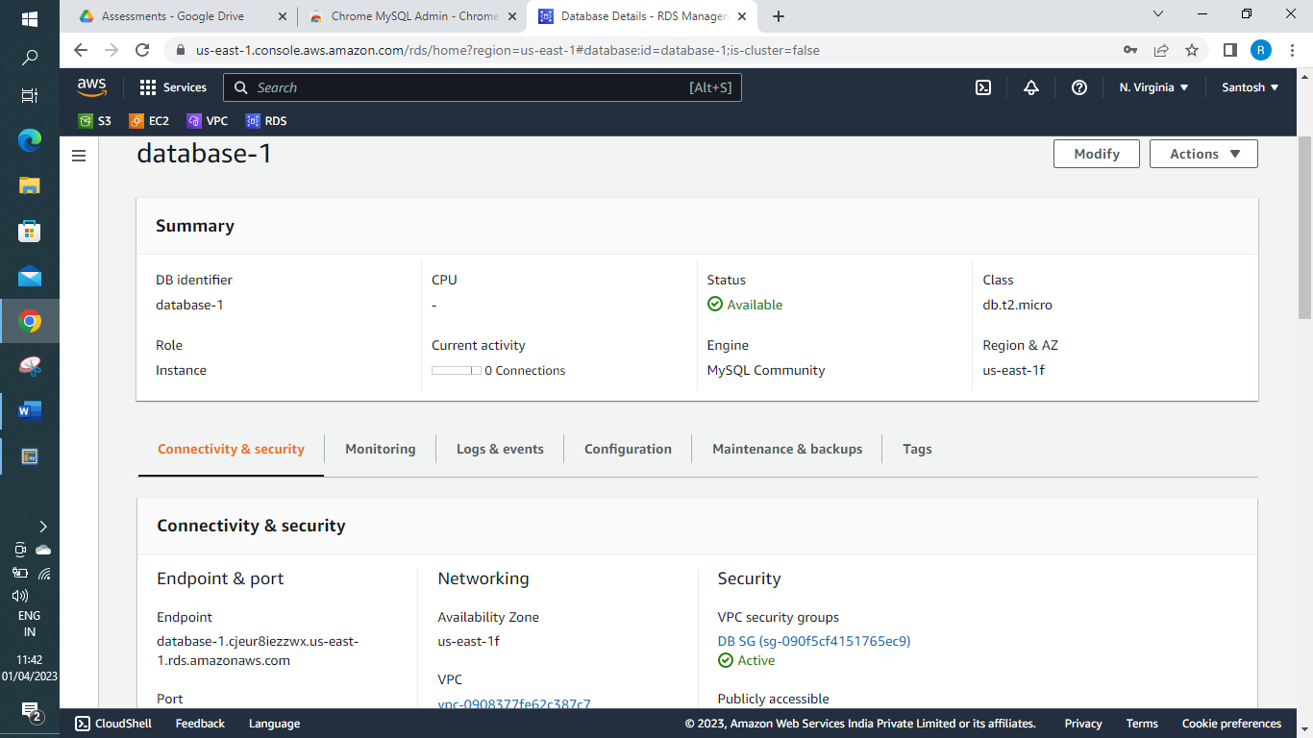
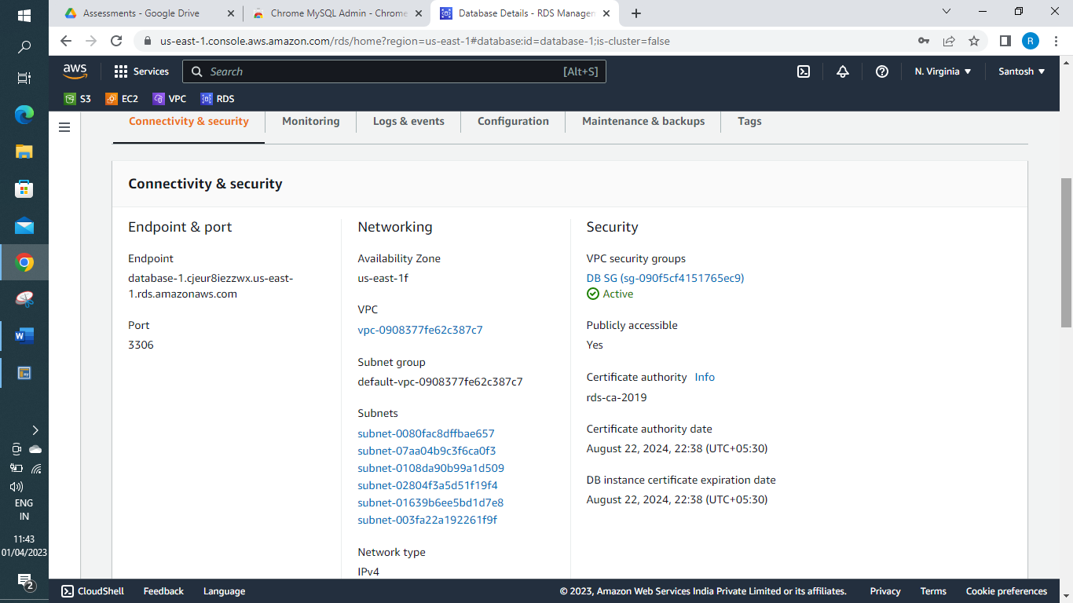
2. Make sure you remember the username and password for database
3. Connect to the MySQL Client: MySQL Admin chrome extension application
(https://chrome.google.com/webstore/detail/chrome-mysql-admin/ndgnpnpakfcdjmpgmcaknimfgcldechn?hl=en)
Once database has been made available. Use Endpoint – URL mydatabase.cjeur8iezzwx.us-east-1.rds.amazonaws.com and connect to database in client
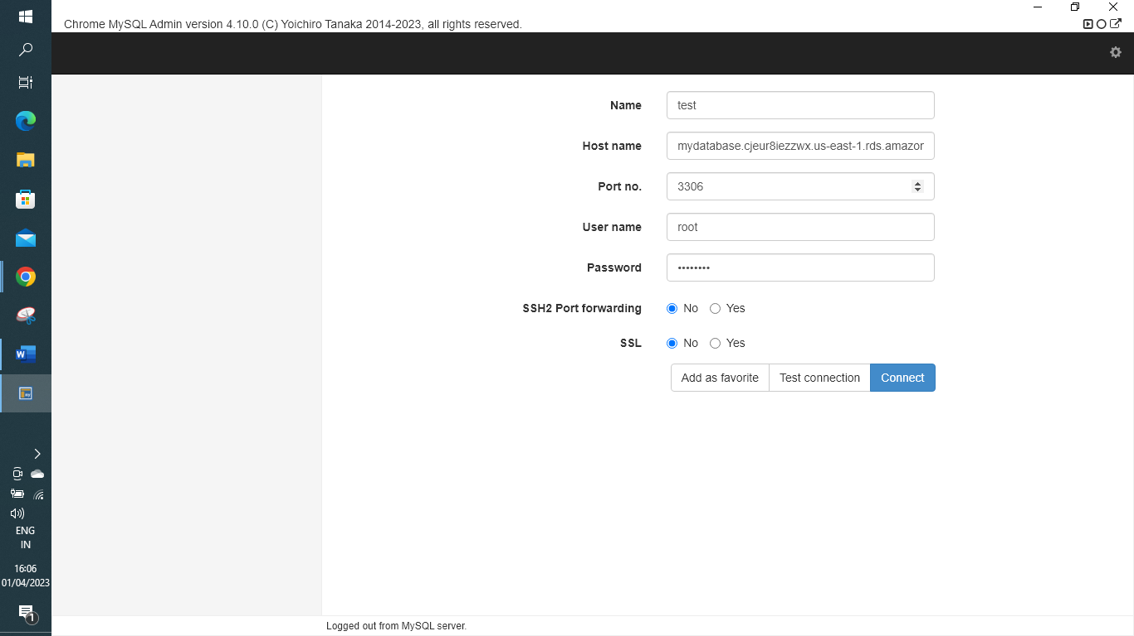
4. Create database and add tables as required
Created Database - To create a new Database – CREATE – DATABASE – RDS_DB and then logout and login to refresh and under select_database you will find RDS_DB [select]
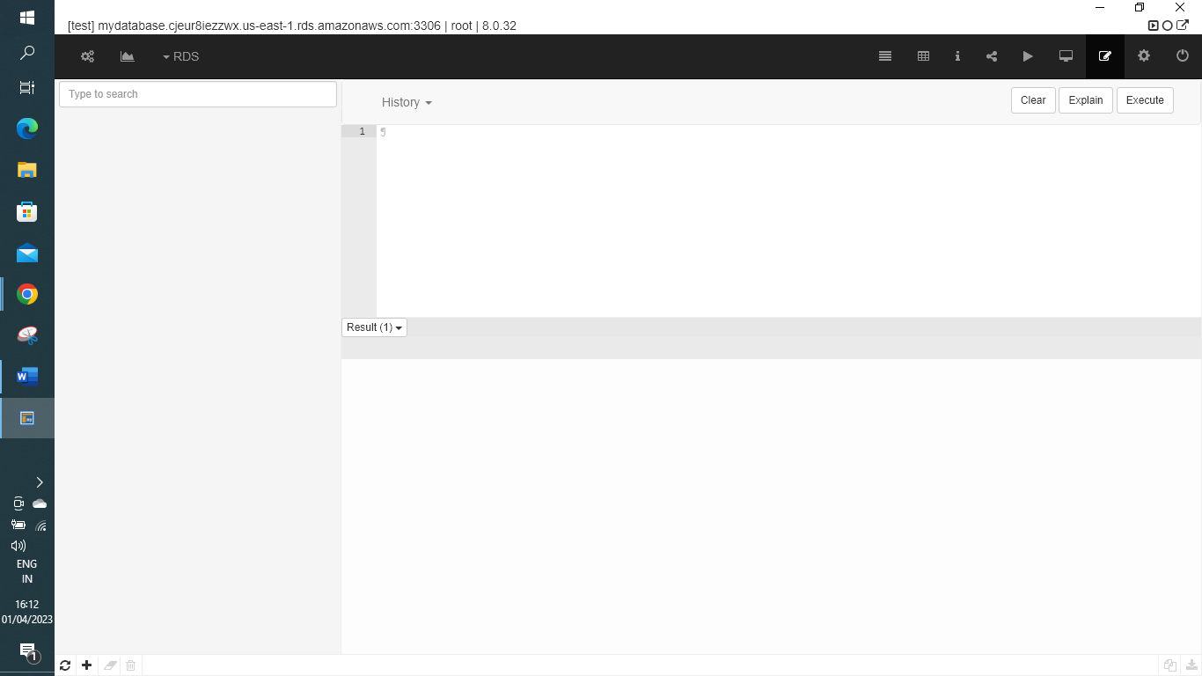
Creating a basic table involves naming the table and defining its columns and each column's data type.
The SQL CREATE TABLE statement is used to create a new table.
CREATE TABLE CUSTOMERS(
ID INT NOT NULL,
NAME VARCHAR (20) NOT NULL,
AGE INT NOT NULL,
ADDRESS CHAR (25) ,
SALARY DECIMAL (18, 2),
PRIMARY KEY (ID)
);
The SQL INSERT INTO Statement is used to add new rows of data to a table in the database.
INSERT INTO CUSTOMERS (ID,NAME,AGE,ADDRESS,SALARY)
VALUES (1, 'Ramesh', 32, 'Ahmedabad', 2000.00 );

INSERT INTO CUSTOMERS (ID,NAME,AGE,ADDRESS,SALARY)
VALUES (2, 'Khilan', 25, 'Delhi', 1500.00 );

INSERT INTO CUSTOMERS (ID,NAME,AGE,ADDRESS,SALARY)
VALUES (3, 'kaushik', 23, 'Kota', 2000.00 );

INSERT INTO CUSTOMERS (ID,NAME,AGE,ADDRESS,SALARY)
VALUES (4, 'Chaitali', 25, 'Mumbai', 6500.00 );

INSERT INTO CUSTOMERS (ID,NAME,AGE,ADDRESS,SALARY)
VALUES (5, 'Hardik', 27, 'Bhopal', 8500.00 );

INSERT INTO CUSTOMERS (ID,NAME,AGE,ADDRESS,SALARY)
VALUES (6, 'Komal', 22, 'MP', 4500.00 );

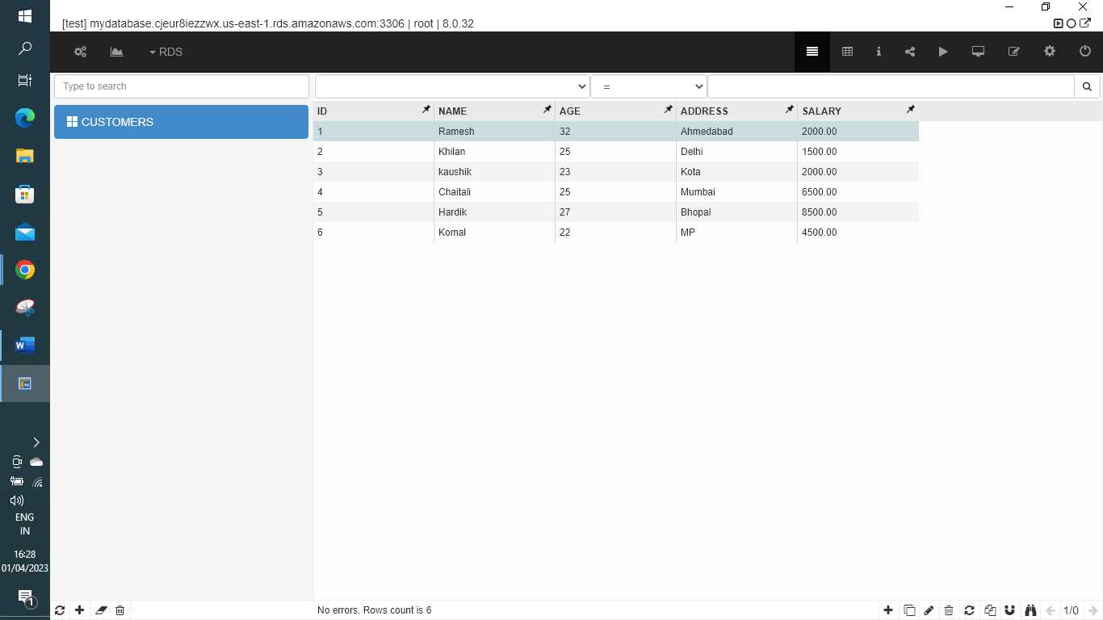
5. Cleanup
✓ Delete the RDS database
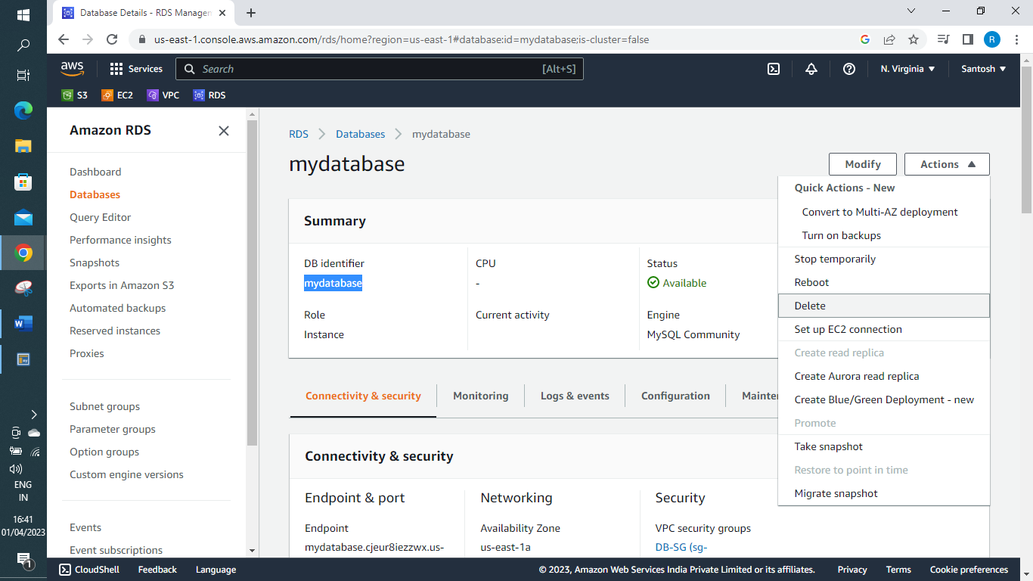
o Make sure you disable the ‘creating final snapshot’ when deleting the RDS
✓ Check and delete snapshots if created by chance
