Creating a Custom VPC
VPC (Virtual private Cloud) is an offering by Amazon that enables customers to create their own logically isolated set of Amazon EC2 instances (AWS resources) defined for customer application workloads.
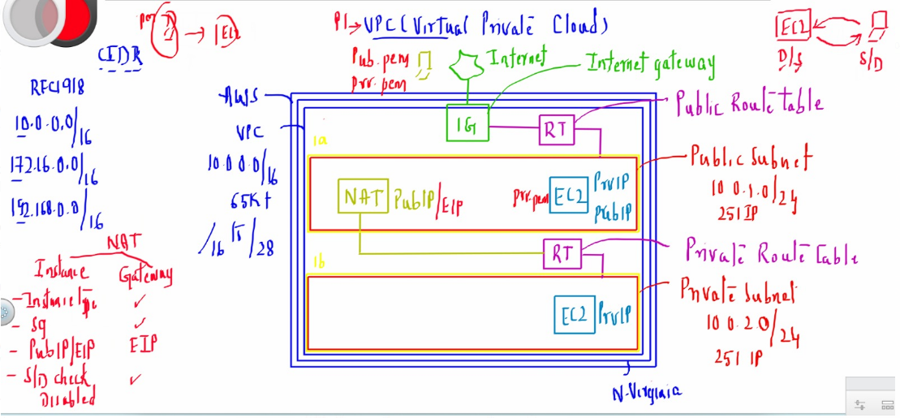
1. Create a VPC 10.0.0.0/16 - 65536 IP addresses : Use the below Link and provide the below parameters to create the same.
https://us-east-1.console.aws.amazon.com/vpc/home?region=us-east-1#CreateVpc:createMode=vpcWithResources
Resources to create – choose VPC only
Name tag – Custom VPC
IPv4 CIDR block - IPv4 CIDR manual input 10.0.0.0/16
No IPv6 CIDR block
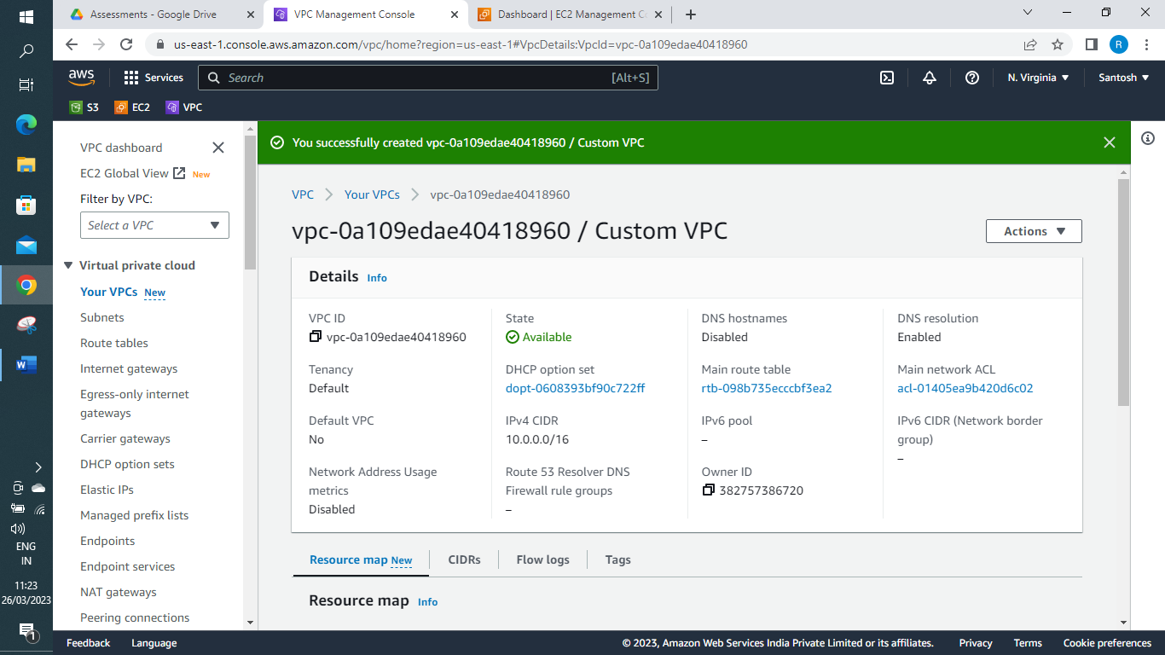
2. create public and private subnet 10.0.1.0/24, 10.0.2.0/24
Under Virtual Private Cloud > Subnets > Create Subnet.
VPC ID – select “Custom VPC” you have created.
Subnet name – Public Subnet | Availability Zone – 1a | IPv4 CIDR block – 10.0.1.0/24
Subnet name – Private Subnet | Availability Zone – 1b | IPv4 CIDR block – 10.0.2.0/24
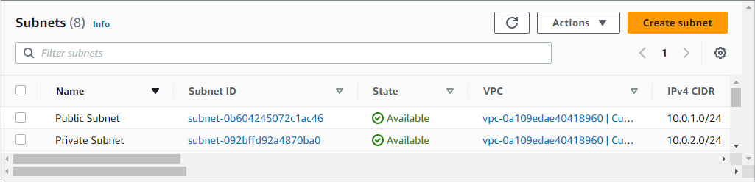
3. Enable Auto-assign public ip enable for public subnet
Go to VPC > Subnets > Public Subnet [subnet-0b604245072c1ac46] > Edit subnet settings and save
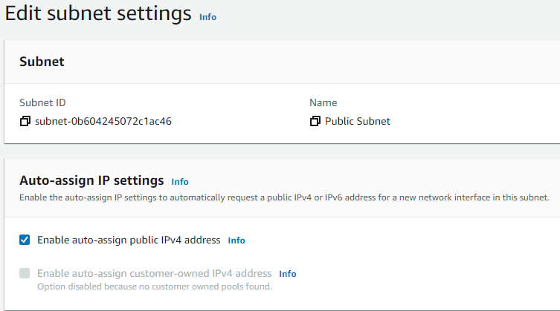
4. create public and private route table :
VPC > Route tables > Create Route table
Name – Public RT | VPC ID – select “Custom VPC” you have created.
Name – Private RT | VPC ID – select “Custom VPC” you have created.
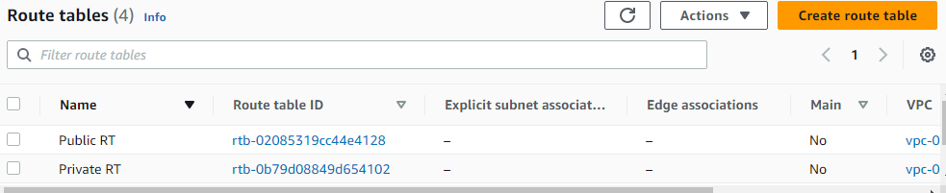
5. create internet gateway
VPC > Internet gateways > Create internet gateway
Name : Custom IG
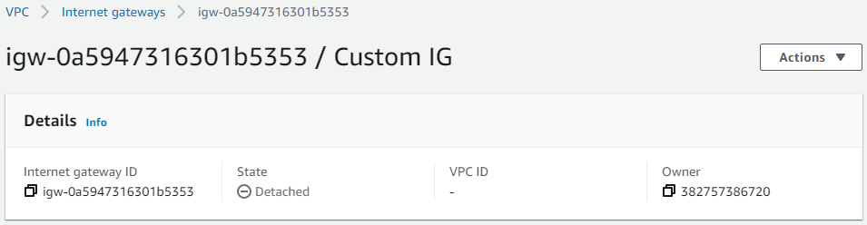
6. Attach Internet gateway to VPC
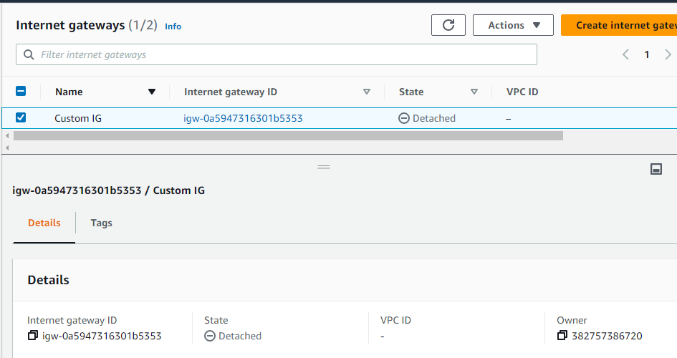
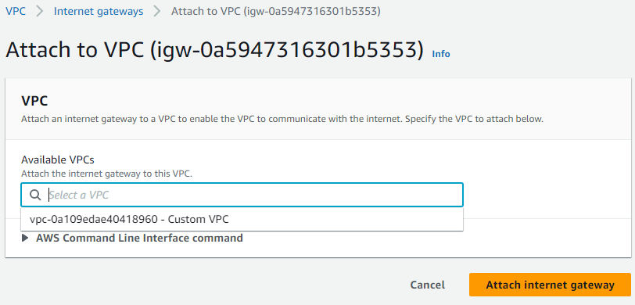
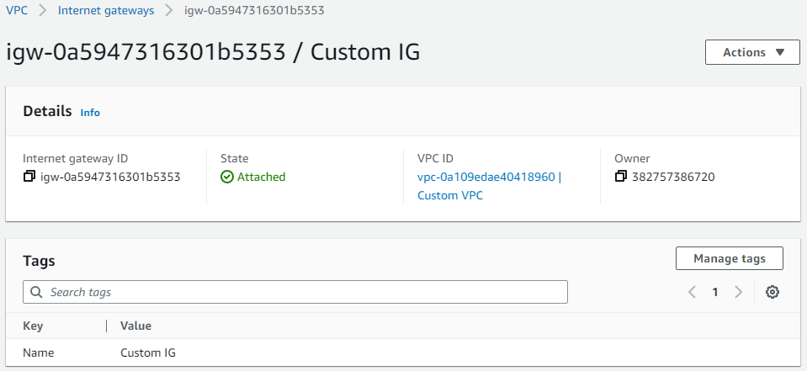
7. Add Internet gateway as a route to public route table with destination 0.0.0.0/0 [Connection to internet default ip]
VPC > Route tables > Public RT > Edit Routes
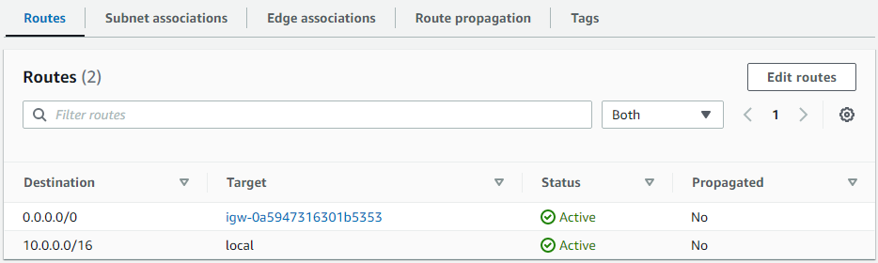
8. Create NAT Gateway with an Elastic IP (optional)
9. Add NAT Gateway as a route in the private route table with
destination 0.0.0.0/0 (optional)
10. Associate public subnet to Public route table
VPC > Route tables > Public RT > Edit subnet associations
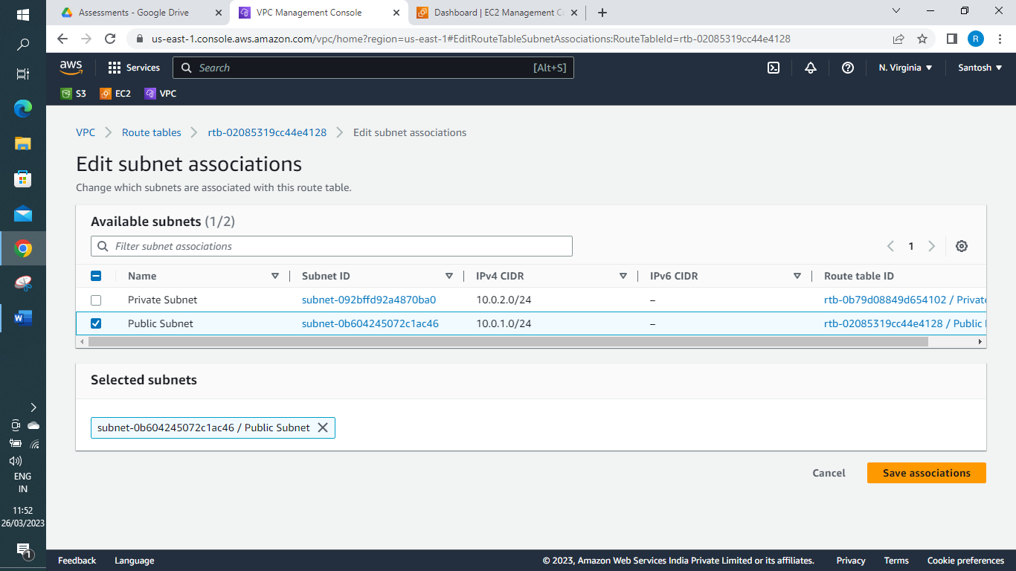
11. Associate private subnet to private route table
VPC > Route tables > Private RT > Edit subnet associations
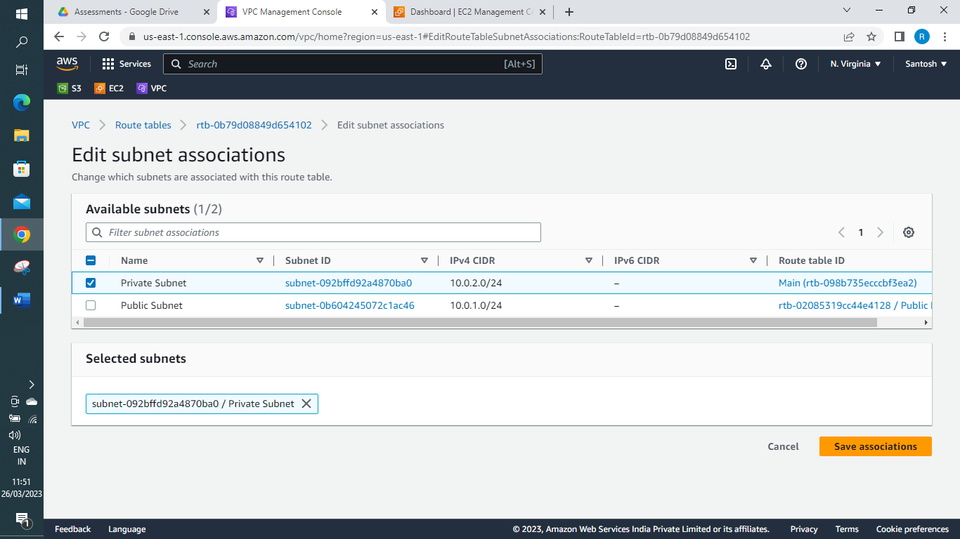

12. Create a public instance in public subnet - Creating an EC2 instance in public subnet
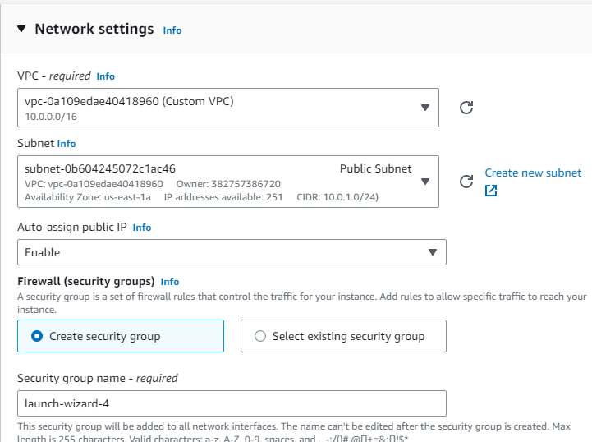

13. Create a private instance in private subnet
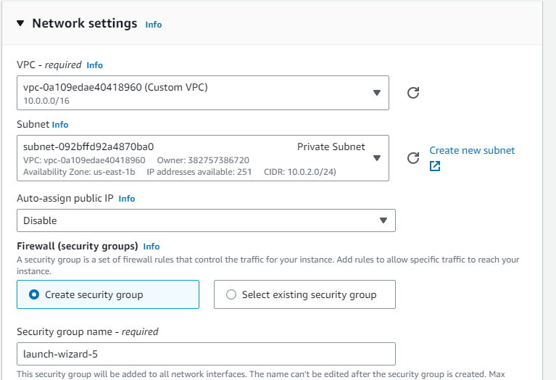
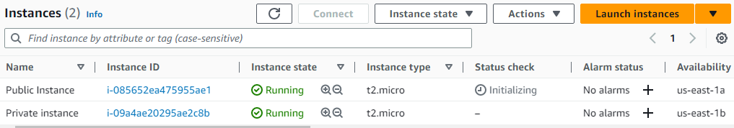

Linux instances only
------------------------------------------------------
ssh into public instance and copy the .pem file of private instance to
/opt folder of public instance and after copying go to /opt folder and
ssh into private instance with private IP address and should able to
connect

1. chmod 400 [PEM file name]
2. ssh -i [PEM file name] ubuntu@[PUBLIC IP]
3. sudo apt-get update
4. sudo su
5. chmod 777 /opt
6. exit
7. exit
8. scp -i public.pem ./private.pem ubuntu@publicip:/opt
HP@DESKTOP-TES38L1 MINGW64 ~/Downloads
$ scp -i public.pem ./private.pem ubuntu@54.83.119.103:/opt
private.pem 100% 1674 7.4KB/s 00:00

9. ssh -i public.pem ubuntu@publicip
10. cd /opt
11. ls
12. chmod 400 private.pem
ubuntu@ip-10-0-1-97:~$ cd /opt
ubuntu@ip-10-0-1-97:/opt$ ls
private.pem
ubuntu@ip-10-0-1-97:/opt$ ls -la
total 12
drwxrwxrwx 2 root root 4096 Mar 26 06:38 .
drwxr-xr-x 19 root root 4096 Mar 26 06:25 ..
-rw-r--r-- 1 ubuntu ubuntu 1674 Mar 26 06:38 private.pem
ubuntu@ip-10-0-1-97:/opt$ sudo su
root@ip-10-0-1-97:/opt# chmod 400 private.pem
root@ip-10-0-1-97:/opt# ls -la
total 12
drwxrwxrwx 2 root root 4096 Mar 26 06:38 .
drwxr-xr-x 19 root root 4096 Mar 26 06:25 ..
-r-------- 1 ubuntu ubuntu 1674 Mar 26 06:38 private.pem

13. ssh -i private.pem ubuntu@privateip
root@ip-10-0-1-97:/opt# ssh -i private.pem ubuntu@10.0.2.70
The authenticity of host '10.0.2.70 (10.0.2.70)' can't be established.
ED25519 key fingerprint is SHA256:by3Z4KBT8Y+ILw/gEXcamcrzogJOUSVSFictHbBlGrY.
This key is not known by any other names
Are you sure you want to continue connecting (yes/no/[fingerprint])? yes
Warning: Permanently added '10.0.2.70' (ED25519) to the list of known hosts.
ubuntu@10.0.2.70: Permission denied (publickey).
root@ip-10-0-1-97:/opt# uname -a
Linux ip-10-0-1-97 5.15.0-1028-aws #32-Ubuntu SMP Mon Jan 9 12:28:07 UTC 2023 x86_64 x86_64 x86_64 GNU/Linux

root@ip-10-0-1-97:/opt# ssh -i private.pem ubuntu@10.0.2.44
The authenticity of host '10.0.2.44 (10.0.2.44)' can't be established.
ED25519 key fingerprint is SHA256:vRavPzkS7SMc/l0NGdqKwB2ShplNfI/01PbGmWrBqbU.
This key is not known by any other names
Are you sure you want to continue connecting (yes/no/[fingerprint])? yes
Warning: Permanently added '10.0.2.44' (ED25519) to the list of known hosts.
Welcome to Ubuntu 22.04.1 LTS (GNU/Linux 5.15.0-1028-aws x86_64)

ubuntu@ip-10-0-2-44:~$
14. sudo apt-get update ( u will not be able to connect to
internet as private instance is in the private subnet if you don’t
Now we create NAT Gateway)
EC2 > Instances > Launch an instance > AMIs > Community AMIs (295) – search for NAT and select the Available one
Key Pair – Proceed without a key Pair
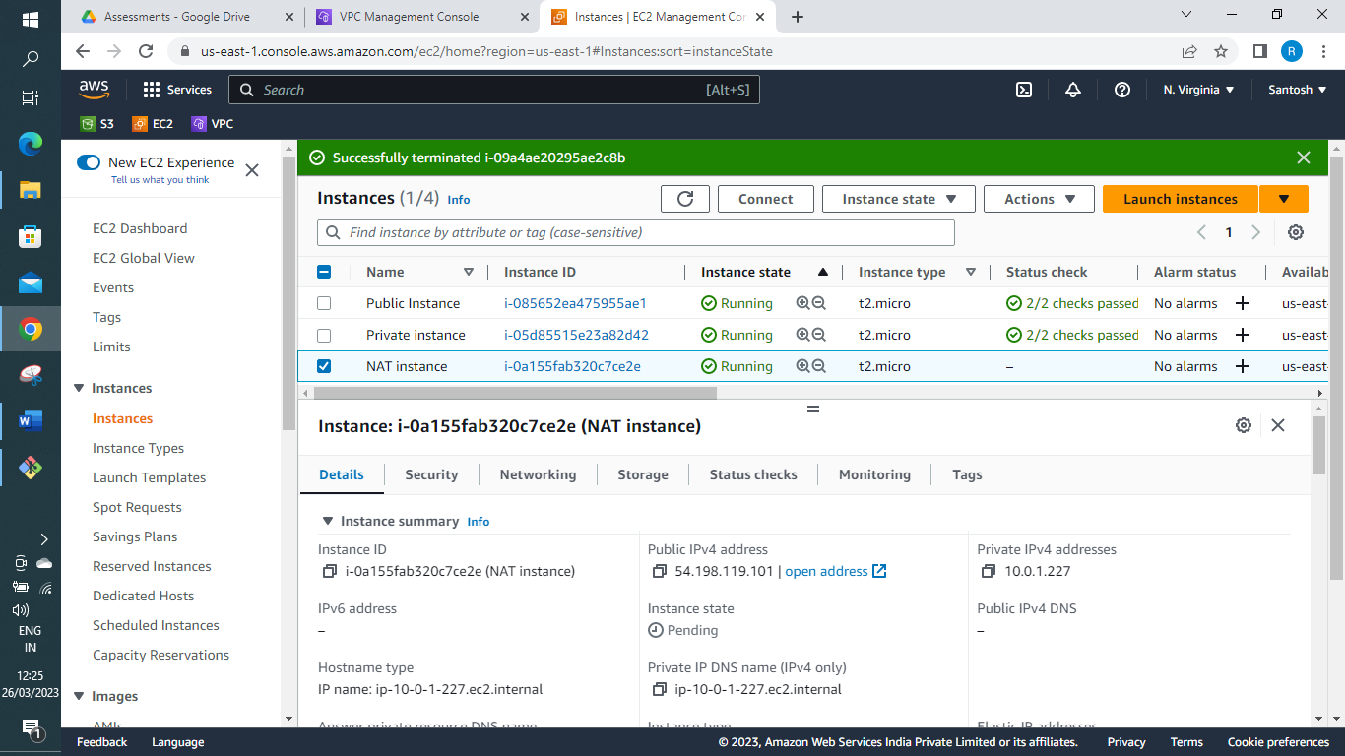
Actions > Networking > Change source/destination check – Select Stop
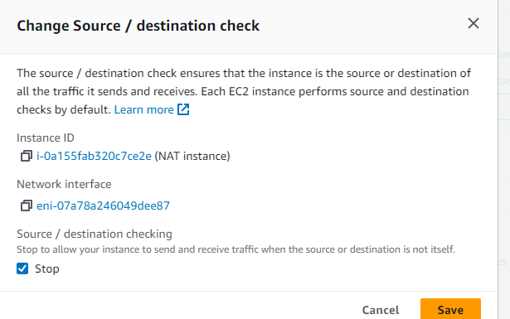
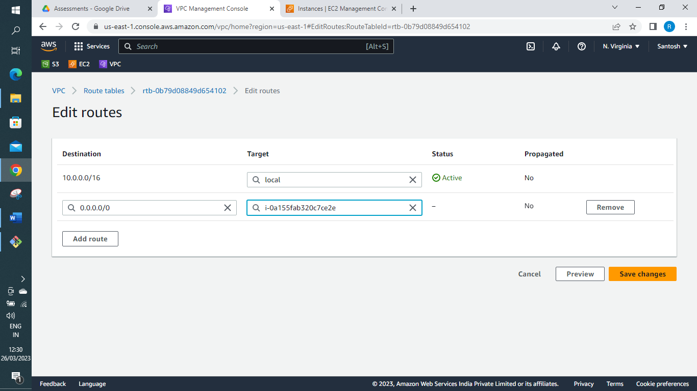
Allow all traffic for NAT for external traffic
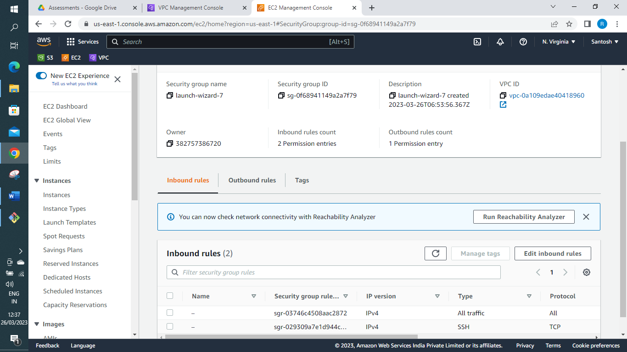
Now you private instance will be able to connect to external world
ubuntu@ip-10-0-2-44:~$ ping google.com
PING google.com (142.250.31.102) 56(84) bytes of data.
64 bytes from bj-in-f102.1e100.net (142.250.31.102): icmp_seq=733 ttl=52 time=2.65 ms
64 bytes from bj-in-f102.1e100.net (142.250.31.102): icmp_seq=734 ttl=52 time=2.56 ms
64 bytes from bj-in-f102.1e100.net (142.250.31.102): icmp_seq=735 ttl=52 time=2.64 ms
64 bytes from bj-in-f102.1e100.net (142.250.31.102): icmp_seq=736 ttl=52 time=2.68 ms
64 bytes from bj-in-f102.1e100.net (142.250.31.102): icmp_seq=737 ttl=52 time=2.65 ms
64 bytes from bj-in-f102.1e100.net (142.250.31.102): icmp_seq=738 ttl=52 time=2.69 ms
^C
--- google.com ping statistics ---
738 packets transmitted, 6 received, 99.187% packet loss, time 754587ms
rtt min/avg/max/mdev = 2.559/2.645/2.694/0.043 ms

Cleanup
✓ Terminate 2 EC2 instances
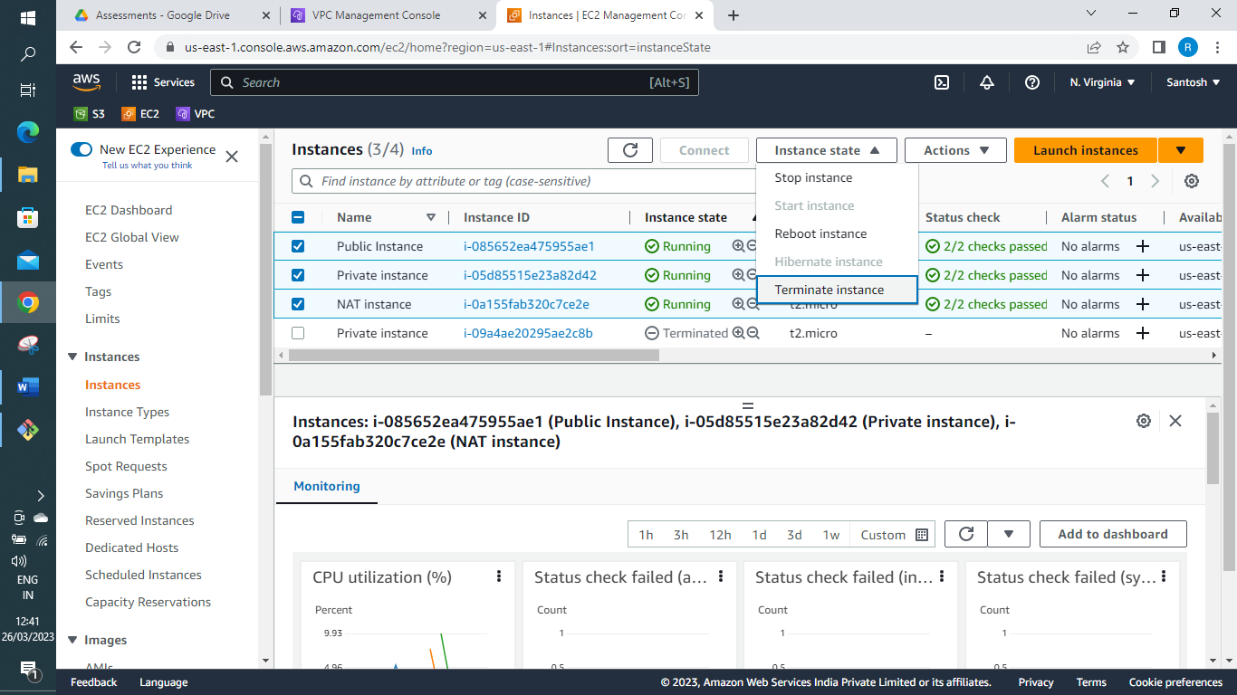
✓ Delete NAT Gateway and Elastic IP (If created)
First Detach Internet Gateway from VPC and delete Custom VPC
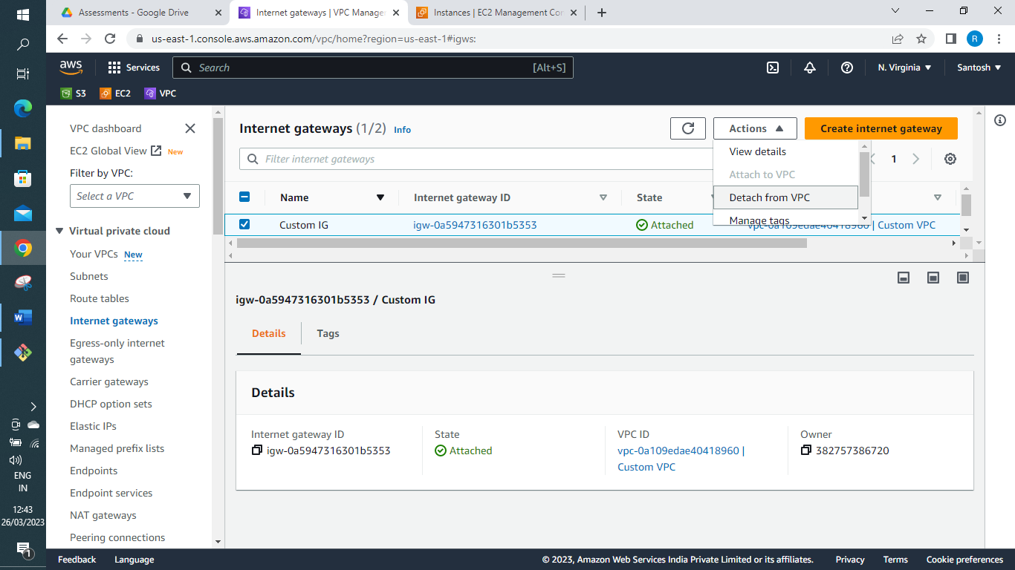
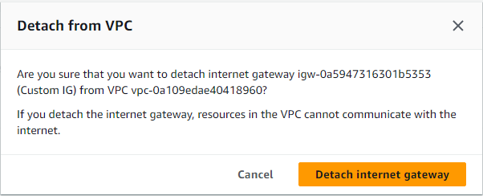
✓ Delete VPC and its components
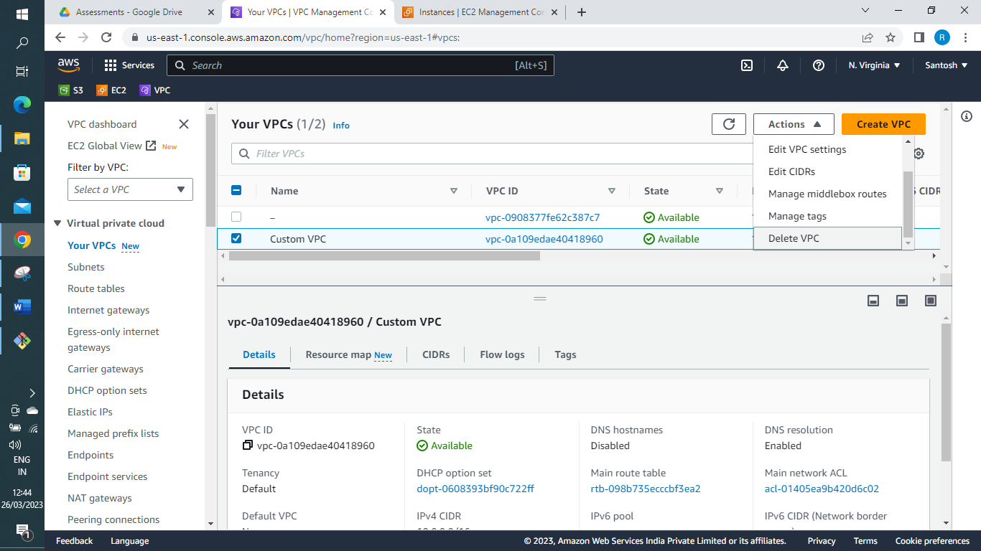
You will get options to delete all the components associated to the VPC
