Grammatical Error Detection Using Natural Language Processing  
By: - Madhaesh P(126156079), Shravwan R(126156138), Janaranjan A (126156058)

# AIM:

To develop a Natural Language Processing (NLP) model that detects grammatical errors in text data.

# WORKFLOW:

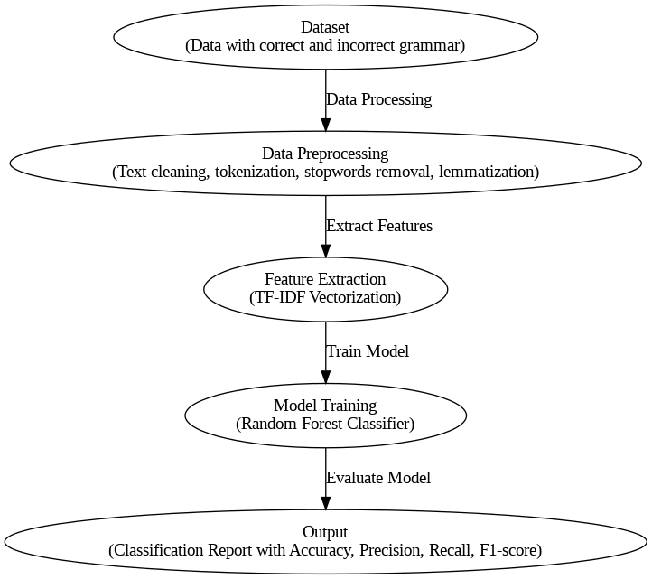  
Flowchart/Diagram:   
  
  
- Dataset: Collection of text data containing correct and incorrect grammar.  
- Method: Data preprocessing, tokenization, text cleaning, feature extraction using TF-IDF, model training with Best Model as RandomForestClassifier.  
- Output: Classification report showcasing the model's accuracy in detecting grammatical errors.

Explanation:  
  
**1. Dataset:** The dataset is preprocessed by cleaning the text, tokenizing, and removing stop words.  
**2. Method:**  
 **1. Data Exploration and Preprocessing**

* **Missing Values**: Check for missing or null values in your dataset. Missing values can lead to issues during model training, so consider either filling them in or removing them.
* **Text Normalization**: Normalize the text by converting it to lowercase, removing unnecessary punctuation, and handling special characters.
* **Tokenization**: Break down sentences into individual tokens (words). You can use libraries like nltk, spaCy, or transformers for this.
* **Stopword Removal**: Remove common words (like "and", "the", etc.) that may not contribute to grammatical error detection. However, be cautious as some stopwords may be necessary for grammatical context.
* **Lemmatization/Stemming**: Reduce words to their base or root form to standardize the text and reduce the vocabulary size.

**2. Feature Engineering**

* **POS Tagging**: Use Part-of-Speech (POS) tagging to understand the grammatical structure of sentences. This can help identify patterns of errors.
* **N-grams**: Consider using bi-grams or tri-grams to capture contextual information and common error patterns.
* **Error Labels**: If your dataset has both correct and incorrect sentences, ensure that labels are properly assigned to each sentence or token.

**3. Model Selection**

* **Baseline Model**: Start with a simple model like Logistic Regression or Naive Bayes to establish a baseline performance.

**4. Model Training and Evaluation**

* **Cross-Validation**: Use cross-validation to ensure that your model generalizes well to unseen data.
* **Evaluation Metrics**: Choose appropriate metrics like F1-score, Precision, Recall, and Accuracy to evaluate your model. Since grammatical error detection may involve imbalanced classes, F1-score might be more informative.

**3. Output:** The model is trained and evaluated using metrics such as accuracy and classification report.

# CODE:

**Data Preprocessing:-**

import pandas as pd

import numpy as np

import matplotlib.pyplot as plt

import seaborn as sns

import nltk

import re

from nltk.corpus import stopwords

from nltk.tokenize import word_tokenize

from nltk.stem import WordNetLemmatizer

from sklearn.model_selection import train_test_split

from sklearn.feature_extraction.text import TfidfVectorizer,CountVectorizer

from sklearn.naive_bayes import MultinomialNB

from sklearn.metrics import accuracy_score, classification_report

from nltk import pos_tag

from nltk.util import ngrams

from collections import Counter

nltk.download('punkt')

nltk.download('stopwords')

nltk.download('wordnet')

nltk.download('averaged_perceptron_tagger')

df=pd.read_csv('/content/All_train_data.csv')

df.head()

#Checking for missing Values

print("\n Missing values in each column:")

print(df.isnull().sum())

#Basic Statistics

print("\n Basic Statistics:")

print(df.describe())

if 'labels' in df.columns:

    print("\n Class Distribution:")

    sns.countplot(x='labels', data=df)

    plt.title('Distribution of the target variable')

    plt.show()

def clean_text(text):

  #Convert to lowercase

  text=text.lower()

  #remove punctuation and special characters

  text=re.sub(r'[^\w\s]','',text)

  #remove numbers

  text=re.sub(r'\d+','',text)

  #remove extra spaces

  text=re.sub(r'\s+',' ',text).strip()

  return text

#Text Cleaning

df['cleaned_text']= df['input'].apply(clean_text)

#Tokenization

df['tokens']=df['cleaned_text'].apply(word_tokenize)

#remove stopwords

stop_words=set(stopwords.words('english'))

df['tokens']=df['tokens'].apply(lambda x: [word for word in x if word not in stop_words])

#Lemmatization

lemmatizer=WordNetLemmatizer()

df['tokens']=df['tokens'].apply(lambda x: [lemmatizer.lemmatize(word) for word in x])

#Checking the processed data

print("\n Processed Data:")

print(df[['input','cleaned_text','tokens']].head())

if 'labels' in df.columns:

    X = df['cleaned_text']

    y = df['labels']

    X_train, X_test, y_train, y_test = train_test_split(X, y, test_size=0.2, random_state=42)

    print("\nTraining and testing data split complete:")

    print(f"Training set size: {len(X_train)}")

    print(f"Testing set size: {len(X_test)}")

df.to_csv('preprocessed_data.csv', index=False)

**Feature Engineering:-**

df1=pd.read_csv('/content/preprocessed_data.csv')

df1['tokens']=df1['tokens'].apply(eval)

#Part of Speech tagging

def pos_tagging(tokens):

    return nltk.pos_tag(tokens)

df1['pos_tags'] = df1['tokens'].apply(pos_tagging)

print("\nPOS tagging complete.")

print(df1[['tokens', 'pos_tags']].head())

*#N-grams*

def generate_ngrams(tokens, n=2):

    return list(ngrams(tokens, n))

*#Generate Bigrams*

df1['bigrams'] = df1['tokens'].apply(lambda x: generate_ngrams(x, n=2))

*#Generate Trigrams*

df1['trigrams'] = df1['tokens'].apply(lambda x: generate_ngrams(x, n=3))

print("\nN-grams generation complete.")

print(df1[['tokens', 'bigrams', 'trigrams']].head())

*#Term Frequency- Inverse Document Frequency*

df1['cleaned_text']=df1['tokens'].apply(lambda x: ' '.join(x))

*#intialize TF-IDF*

tfidf_vectorizer=TfidfVectorizer(max_features=5000)

*# Fit and Transform the cleaned text*

tfidf_matrix=tfidf_vectorizer.fit_transform(df1['cleaned_text'])

*#Convert the TF-IDF matrix to a DataFrame*

tfidf_df=pd.DataFrame(tfidf_matrix.toarray(), columns=tfidf_vectorizer.get_feature_names_out())

print("\nTF-IDF feature generation complete.")

print(tfidf_df.head())

*#Error Density (ratio of Incorrect words)*

def error_density(row):

  error_count=sum([1 for tokens in row['tokens'] if token in row['errors']])

df1.to_csv('feature_engineered_data.csv', index=False)

print("\nFeature engineering complete. Dataset saved as 'feature_engineered_data.csv'.")

return error_count/len(row['tokens']) if len(row['tokens'])>0 else 0

**Model Selection:-**

import pandas as pd

from sklearn.model_selection import train_test_split, GridSearchCV

from sklearn.metrics import accuracy_score, precision_score, recall_score, f1_score,classification_report

from sklearn.linear_model import LogisticRegression

from sklearn.ensemble import RandomForestClassifier

from sklearn.svm import SVC

from sklearn.naive_bayes import MultinomialNB

X= df2.drop(columns=['labels'])

y=df2['labels']

from sklearn.feature_extraction.text import TfidfVectorizer

vectorizer = TfidfVectorizer()

X = vectorizer.fit_transform(X['input'])

X_train, X_test, y_train, y_test = train_test_split(X, y, test_size=0.2, random_state=42)

models = {

    'Logistic Regression': LogisticRegression(),

    'Random Forest': RandomForestClassifier(),

    'Support Vector Machine': SVC(),

    'Naive Bayes': MultinomialNB()

}

def evaluate_model(model, X_train, y_train, X_test, y_test):

  model.fit(X_train, y_train)

  y_pred = model.predict(X_test)

  accuracy = accuracy_score(y_test, y_pred)

  precision = precision_score(y_test, y_pred, average='weighted')

  recall = recall_score(y_test, y_pred, average='weighted')

  f1 = f1_score(y_test, y_pred, average='weighted')

  return accuracy, precision, recall, f1

for model_name, model in models.items():

  accuracy , precision, recall, f1 = evaluate_model(model, X_train, y_train, X_test, y_test)

  print(f"{model_name} Results:")

  print(f"Accuracy: {accuracy:.4f}")

  print(f"Precision: {precision:.4f}")

  print(f"Recall: {recall:.4f}")

  print(f"F1 Score: {f1:.4f}\n")

from sklearn.model_selection import GridSearchCV

*# Define the parameter grid for GridSearchCV*

param_grid = {

    'n_estimators': [50, 100],

    'max_depth': [None, 10, 20],

    'min_samples_split': [2, 5]

}

*# Initialize GridSearchCV with the RandomForestClassifier*

grid_search = GridSearchCV(RandomForestClassifier(), param_grid=param_grid, cv=3, scoring='f1_weighted')

*# Fit the model using the training data*

grid_search.fit(X_train, y_train)

*# Get the best estimator (model) from the grid search*

best_model = grid_search.best_estimator_

from sklearn.naive_bayes import MultinomialNB

from sklearn.model_selection import GridSearchCV

from sklearn.metrics import accuracy_score, precision_score, recall_score, f1_score, classification_report

*# Define the parameter grid for GridSearchCV (alpha is the main parameter for tuning)*

param_grid = {

    'alpha': [0.1, 0.5, 1.0, 2.0, 5.0]

}

*# Initialize GridSearchCV with the MultinomialNB*

grid_search_nb = GridSearchCV(MultinomialNB(), param_grid=param_grid, cv=3, scoring='f1_weighted')

*# Fit the model using the training data*

grid_search_nb.fit(X_train, y_train)

*# Get the best estimator (model) from the grid search*

best_nb_model = grid_search_nb.best_estimator_

*# Make predictions on the test set*

y_pred_nb = best_nb_model.predict(X_test)

*# Calculate evaluation metrics*

accuracy_nb = accuracy_score(y_test, y_pred_nb)

precision_nb = precision_score(y_test, y_pred_nb, average='weighted')

recall_nb = recall_score(y_test, y_pred_nb, average='weighted')

f1_nb = f1_score(y_test, y_pred_nb, average='weighted')

*# Print evaluation results*

print("Best Multinomial Naive Bayes Model Results:")

print(f"Accuracy: {accuracy_nb:.4f}")

print(f"Precision: {precision_nb:.4f}")

print(f"Recall: {recall_nb:.4f}")

print(f"F1-Score: {f1_nb:.4f}")

print("\nClassification Report:\n", classification_report(y_test, y_pred_nb))

y_pred_best = best_model.predict(X_test)

print("Best Model (Random Forest) Results After Hyperparameter Tuning:")

print(f"Accuracy: {accuracy_score(y_test, y_pred_best):.4f}")

print(f"Precision: {precision_score(y_test, y_pred_best, average='weighted'):.4f}")

print(f"Recall: {recall_score(y_test, y_pred_best, average='weighted'):.4f}")

print(f"F1-Score: {f1_score(y_test, y_pred_best, average='weighted'):.4f}")

print("\nClassification Report:\n", classification_report(y_test, y_pred_best))

**Flowchart:-**

*# Install the necessary library if not already installed*

!pip install graphviz

from graphviz import Digraph

*# Create a new directed graph*

dot = Digraph()

*# Add nodes for each step in the workflow*

dot.node('A', 'Dataset\n(Data with correct and incorrect grammar)')

dot.node('B', 'Data Preprocessing\n(Text cleaning, tokenization, stopwords removal, lemmatization)')

dot.node('C', 'Feature Extraction\n(TF-IDF Vectorization)')

dot.node('D', 'Model Training\n(Random Forest Classifier)')

dot.node('E', 'Output\n(Classification Report with Accuracy, Precision, Recall, F1-score)')

*# Define the edges (connections) between the steps*

dot.edge('A', 'B', label='Data Processing')

dot.edge('B', 'C', label='Extract Features')

dot.edge('C', 'D', label='Train Model')

dot.edge('D', 'E', label='Evaluate Model')

*# Render the flowchart and display it*

dot.render('nlp_workflow_1', format='png', view=True)

# RESULT:

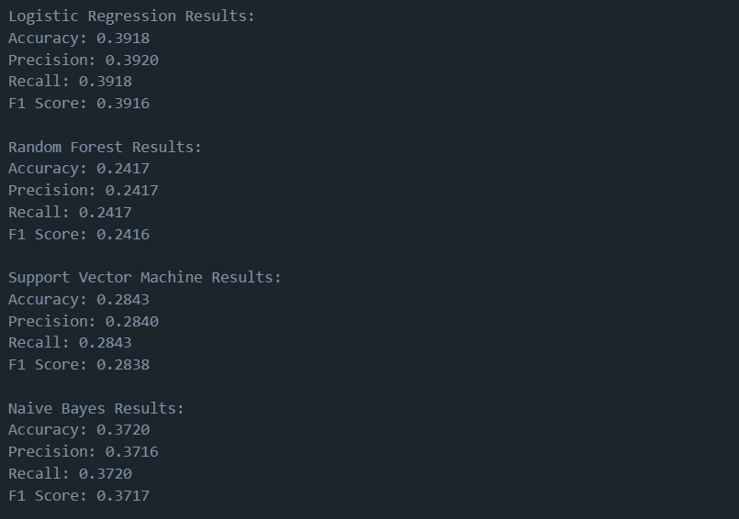

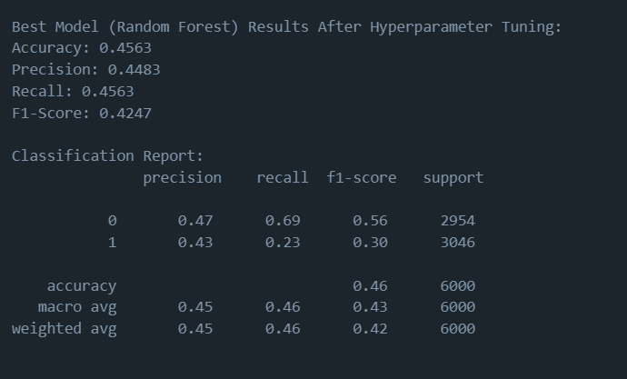

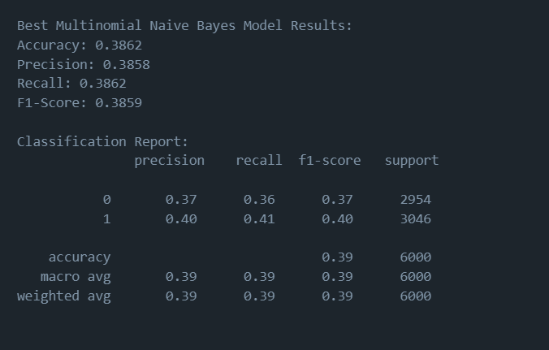

# ATTACHMENTS:

1. 

2. <https://www.kaggle.com/datasets/vipin20/nlp-word-correction>