Assignment 2# Team Members: Yuzhou Chen & Dingyang Lu & Fengyize Yu

**Ecological and Environmental Index Assessment**

**Introduction**

Our Ecological and Environmental Index Assessment System offers a comprehensive solution for assessing regional environmental quality, utilizing weighted variables to calculate an Environmental Index. Based on multiple quantifiable indicators, you can select different criteria and assign weights, calculating the comprehensive environmental index. This allows for evaluating the environmental quality of selected regions and visualizing them on a map.

**Data Source**

Our ecological environmental data is sourced from the platform https://www.data.gv.at/en/, which provides open datasets for Austria across various domains. This platform includes data relevant to different provinces of Austria. We have extracted data pertaining to ecological aspects such as water resources, landcover, and land use from this platform.

**Assessment indicators**

|  |  |
| --- | --- |
| FactorLayer | Factor |
| Urbanization | Sealed area |
| Non-vegetated unsealed surfaces |
| GreenSpaces | Woody |
| Permanent Herb |
| Periodically Herb |
| Reeds |
| BlueSpaces | Water area |
| River density |
| Snow and ice |

**Design Decision**

This project takes the Nodejs + Vue 2 + JavaScript coding framework to implement a user-definable web map application design for ecosystem assessment and use Leaflet to visualization of assessment results based on map. Below is the functionalities of our project:

The home page of the system provides a basic introduction to the system, which uses dynamic animation as the background and is based on the CSS block design of the home page. Click "Enter the Evaluation System" to enter the analysis page. On the left side of the analysis page are the basic functions, and in the middle are the maps. Clicking the World button in the upper right corner of the map can view the vector map of the world read from the json file, and clicking the Austria button in the upper right corner can view the vector map of Austria read from the json file, and the two kinds of maps have a popup when clicking the button, which are the country name and the abbreviation, and basic information and ecological indexes of the various Austrian states. Both maps have popups with the country name and abbreviation in world map, as well as basic information about each Austrian state and various ecological indicators in Austrian map.

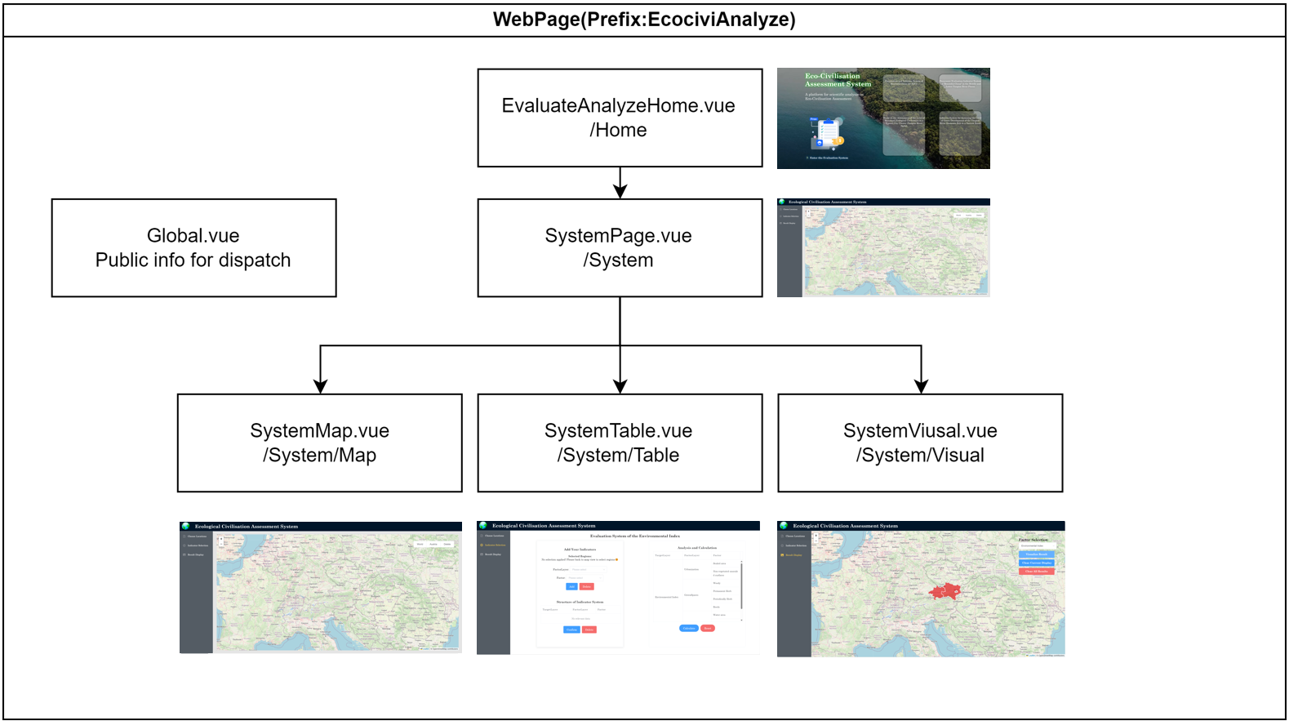

In Choose Locations page, select the area to be analysed, click Indicator Selection on the left, in this interface, the left box "Add Your Indicators" is used to select the indicators to be analysed, you can select more than one analysis indicator. After adding, click "Confirm", in the "Analysis and Calculation" box on the right, click FactorLayer and Factor to set the weight of each indicator. weights for each indicator. If only one region is selected, the value of the corresponding Factor will be automatically read from the json file after the weight is set. Please make sure that the sum of the weights of each group of FactorLayer and each group of Factor in each FactorLayer is one, and click Calculate to see the calculation result after setting. Click "Result Display" on the left side to view the calculation result in the map. Similar operation can be done for the world layer, but there are relatively few indicators in the world layer. Also, the system allows multiple regions to participate in the calculation at the same time.

**Highlights**

* A dash board with navigator and router control
* Integrate additional data sources, such as json data, external images, external environmental factor data
* Add an AJAX component: front-end gets access to a server built with node.js use *axios* technology, and the GET method is added to get GeoJson data
* Add data processing functionality: many data acquisition and processing logic, especially table page, add data interaction to calculate environmental index
* Add clickable popups: both map display page and result display page have popups
* Spatio-temporal visualization: results display pages present results through spatio-temporal color visualization
* Customization functionality: in the region selection page and table page, a large number of user-definable inputs have been added to increase the interactivity and uniqueness of the program

**Project programme structure**

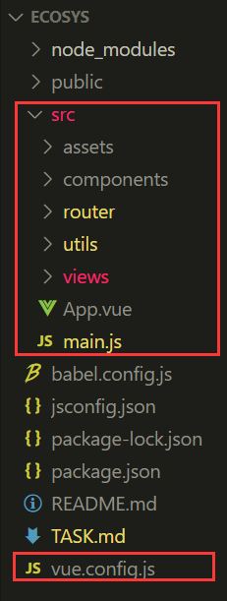**Front-end**: the core program as follows red box, vue.config.js mainly configure the port *8099* and public folder access directory.

* **App.vue** is the entry for the entire front-end page;
* **the main.js** is used for initialising the vue project, mounting external libraries and custom functions.
* **router/index.js** is used to configure the route for switching between pages
* **assets** is used to store all kinds of resources (but the two data are still placed in the backend)
* **component** is used to store reusable maps; utils is mainly responsible for the basic configuration of the map
* **views-> EvaluateAnalyze** is the core page, which includes the JS and Vue code to Run and display front-end page

**Back-end:** store required json data, configure *body-parser*, *cors* and *express* libraries to achieve cross-domain communication with the front-end. In server.js, configure the server port as 8050, and also configure two get requests at */api/world* and */api/at*.

**To run the web application, please follow the steps below:**

* Fron-end: Folder “ecosys”: Open the cmd and Enter the following command
  + npm install
  + npm run serve
* Back-end: Folder “ecosys-backend”: Open the cmd and Enter the following command
  + npm install
  + node server.js

**Authorship Contribution Statement**

**Yuzhou Chen (40%)**: Overall project design, Full Vue front-end and Node.js back-end framework construction and implementation, Implementation of environmental index calculation function and related business logic, Front-end and back-end interactions, Outlined document writing

**Fengyize Yu (30%)**: Web page style design and implementation, Leaflet map loading and visualisation, Popup functionality implementation, Final project document writing

**Dingyang Lu (30%)**: Data collection and organisation, Geojson data editing and aggregation, Geojson data parsing, Conceptulization document writing