

**————————————————————**

*Scientific Methods and Writing*

Assignment 2

**————————————————————**

Lecturer： Lang, Stefan

Augustin, Hannah Lucille

Stu-Name： Chen, Yuzhou

Stu-number： s1104123

Major： Applied Geoinformatics

Winter semester, 2023

num words: 1500

**Exploring the impact of spatial morphology of terraces on soil erosion from digital elevation model with high spatial resolution**

**1 Introduction**

全球范围内分布在不同地理位置的区域，受气候、地形、土壤质地、植被分布和水文特征影响，发生着不同程度的土壤侵蚀。该过程是主要由外营力引发的土壤颗粒运移过程，会导致土壤肥力下降、荒漠化等生态环境问题[1]。为了降低流域内水土流失的强度，改善当地生态环境，梯田成为坡面易侵蚀区常见的水土保持措施。梯田一般指开辟于山地、丘陵地区较缓坡面上顺等高线方向延伸的条状阶坎形田块[2]，能够降低径流系数，降低土壤侵蚀的强度[3]。若从土壤侵蚀的驱动营力来看，坡度、坡长等地形因子是衡量土壤剥离和水土运移效果的关键因素[4]。然而，受地理学第二定律的限制，梯田特殊的形态特征与空间位置对土壤侵蚀的强度和分布特征会产生不同程度的影响，这是因为梯田的形态一般会继承原始坡面的基本格局，即使是小样区内的梯田形态也会因所在坡面的地形的差异而表现出形态的异质性，如田面宽度、田坎高度等形态因子[2]。因此，本研究基于高精度DEM数据，应用DTA方法和RUSLE土壤侵蚀评估模型，比较有/无梯田情景下地形因子改变带来的田区土壤侵蚀量变化，并将在后续研究中深入探索样区内的梯田田面宽度、田坎高度等综合形态因子与平均土壤侵蚀量的关系。

Influenced by factors such as climate, topography, soil composition, and hydrological characteristics, soil erosion varies among different geographical locations. This phenomenon involves the transport of soil particles primarily due to external forces, leading to ecological and environmental issues such as declining soil fertility and desertification(1). So, terracing has emerged as a common soil and water conservation practice in areas prone to erosion on sloping terrains, aiming to mitigate erosion intensity in watersheds and enhance local ecological conditions. Terraces typically denote step-like fields aligned with the contour of slopes in mountainous and hilly terrains, effectively reducing runoff and soil erosion(2,3). Notably, topographic factors, including slope gradient and length, play pivotal roles in assessing soil erosion effectiveness in stripping and soil-water transport(4). However, constrained by the second law of geography, the distinct morphological attributes and spatial arrangement of terraces significantly impact the intensity and distribution of soil erosion. This is attributed to the inherent morphology of terraces, mirroring the original slope pattern. Even within a confined area, terraces exhibit morphological diversity due to slope topography variations, encompassing width of terraced fields, height of sharp inclines, and other morphological elements(2). Therefore, leveraging high-precision Digital Elevation Model (DEM) data, this study employs the Digital Terrain Analysis (DTA) method alongside the Revised Universal Soil Loss Equation (RUSLE) model to assess soil erosion changes in terraced versus non-terraced scenarios, elucidating the relationship between sample area terraces' comprehensive morphological factors (e.g., field width, cantilever height) and average soil erosion levels in subsequent investigations.

**2 Study Area and Data**

研究区是中国的黄土高原上的一个名为姚家湾的小流域，流域总面积约为1.803km2，经纬度范围为37°32´ N，110°14´ E~37°30´ N，110°16´ E。该地谷坡交错、地形复杂，发育有黄土高原特有的’墚’地貌，为内陆干旱气候向暖温带湿润季风气候过渡地带，总体呈现半干旱的气候特征，而夏季的集中降雨是该流域土壤侵蚀的主要驱动力。姚家湾流域的山地坡面普遍呈纵列布设有梯田工程，占据着较多的空间比重，使得区域很适合梯田土壤侵蚀量的比较研究。

考虑姚家湾流域梯田形态的异质性，基于预处理的研究区总范围DEM，依据典型梯田的分布位置裁取合适的小区域DEM开展实验研究。样区的DEM数据由无人机倾斜摄影（UAV Oblique Photogrammetry）实测得到的0.01m分辨率高精度地表密集点云数据内插而成，空间分辨率为0.1m。点云生成时间为2019年8月，原始航片影像的平均地表采样距离（AGSD）为4.53cm/1.78in。研究使用该数据计算坡面地形因子LS。此外，土壤侵蚀流失方程中的其他环境因子分别基于研究区的气象数据、土壤类型空间分布、植被特征和护坡工程效益计算得到。

The study area is a watershed named Yaojiawan on the Loess Plateau of China, and covers 1.803 *km2* in the range of 37°32´ N, 110°14´ E to 37°30´ N, 110°16´ E. The area contains many valleys and slopes, complex topography, and the development of the 'Liang' landform. It is a transition zone from an inland arid climate to a warm-temperate humid monsoon climate, with an overall semi-arid climate, and the concentrated summer rainfall is the main driver of soil erosion in the watershed. The mountain slopes of Yaojiawan watershed are generally arranged in longitudinal columns with terracing works, occupying more spatial weight, which makes the region very suitable for comparative study of terraced soil erosion. Considering the heterogeneity of terrace morphology in Yaojiawan, based on the pre-processed DEM of the total area of the study area, a suitable small-area DEM was cropped to carry out the study based on the distribution of typical terraces. The DEM data of the sample area was interpolated from the 0.01m resolution high-precision surface dense point cloud data measured by UAV, with a spatial resolution of 0.1 m. The point cloud was generated in August 2019, and the average ground sampling distance (AGSD) of the original aerial film image was 4.53 cm/1.78 in. The study used this data to calculate the average ground sampling distance (AGSD) of the original aerial film image. The data to calculate the slope topography factor LS. In addition, other environmental factors in RUSLE were calculated based on the meteorological data, spatial distribution of soil types, vegetation characteristics, and effectiveness of the slope protection project in the study area, respectively.

**3 Method**

**3.1 RUSLE: Soil erosion evaluation model**

土壤流失程度用土壤侵蚀模数来定量评估，其表示单位时段内单位水平投影面积上的土壤侵蚀总量。由于研究区气候干旱，夏季降水集中，以水力侵蚀为主，因此本研究采用诞生于美国中部农业实践的RUSLE模型来计算姚家湾小流域的土壤侵蚀模数[5]。公式如下：

$A=f·R·K·LS·C·P$（4-1）

式中：*A*为单位面积年土壤侵蚀量[t/(hm2·a)]； *f*为修正常量；*R*为降雨侵蚀力因子[MJ·mm/(hm2·h·a)]；*K*为土壤可蚀性因子[t·hm2·h/(hm2·MJ·mm)]；*LS*为坡度坡长因子，无量纲；*C*为植被覆盖度因子，无量纲；*P*为水土保持措施因子，无量纲，取值范围为[0,1]，当区域分布林地时，*P*=1。

考虑到地形形态控制着区域的水土运移过程，地形既是水土流失的场所，同时又是影响土壤侵蚀发展过程的基本因素，对地表物质与能量的累积和再分配起决定性的作用。在梯田建设前后，上述公式中变化最为显著的因子是坡度坡长因子LS[6] [7]。因此，需要构建梯田的数学模型。

**3.2 Spatial morphology and destruction of terraced fields**

依据形态特征划分，梯田可以分为坡式梯田、水平梯田和反坡梯田。姚家湾流域的梯田表面总体平整稍有起伏，以水平梯田为主。通过提取梯田田坎及相应约束线，能够实现梯田模型的快速构建(图2-a)。本研究欲比较梯田构建前后样区内土壤侵蚀量的变化，考虑到现有样区DEM为含梯田的DEM，需将其通过去梯田化方法，形成假想的无梯田的自然表面DEM，分别计算前后两种情况下的梯田空间形态。

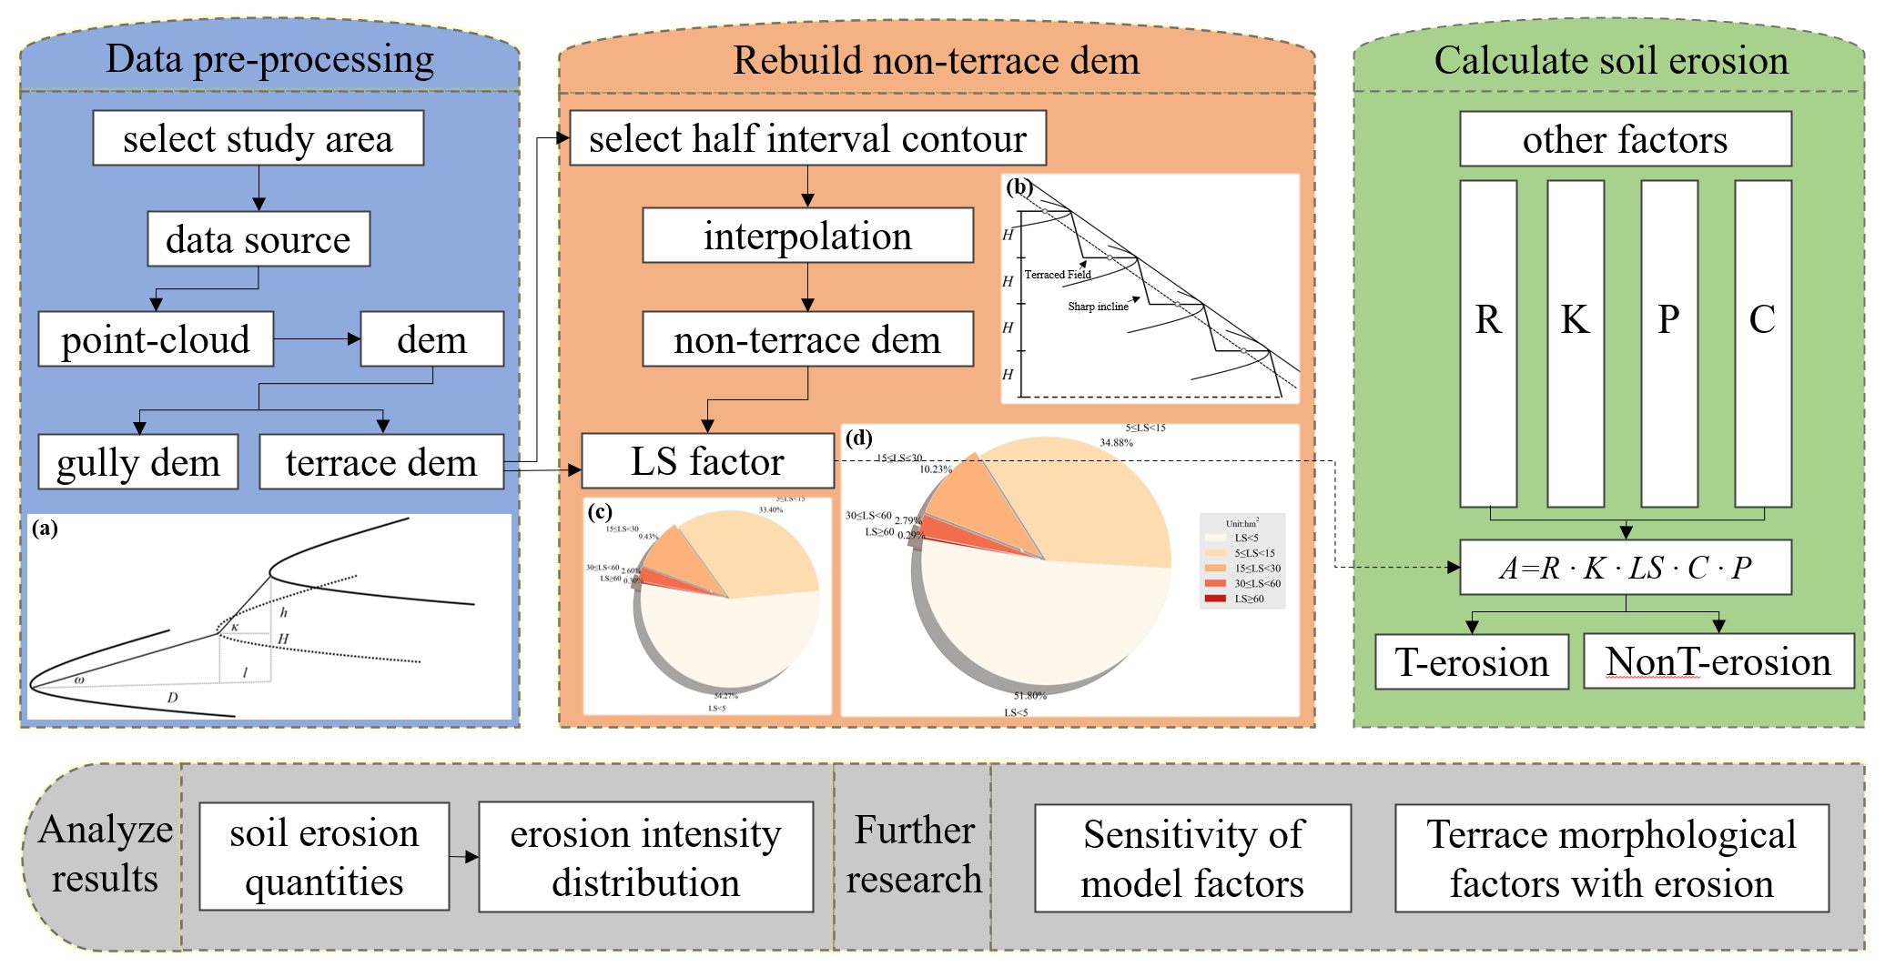

本研究于梯田的每层的田面上，提取与台沿线、台沿偏移线基本平行的等高线，表征该层梯田田面高程，等高距选择样区田坎的平均高度*h*，经插值后形成新的无梯田DEM。基于上述有梯田和无梯田的DEM数据，在流域尺度下计算用于表征梯田空间形态的LS因子[5]。

（4-2）

式中：*L*是山坡长度（m）；*L0*=22.1m是标准USLE实验坡的长度；*θ*是以角度表示的斜率；*m*为可变指数，范围在0.2~0.5，由坡面斜率决定。

**3.3 Assessment of other factors in RUSLE**

1）Rainfall erosivity factor (R)

降雨是土壤侵蚀的核心驱动力，降雨过程持续的时间、雨强、降雨类型、降水总量都密切关系着土壤的流失量[8]。本文获取姚家湾所在地绥德县2019年降水记录，使用章文波等[9]修缮的Wischmeie[10]的日降雨强度评估模型计算姚家湾地区的降雨侵蚀力。求算得到姚家湾样区范围的年降雨侵蚀力R为1067 [MJ·mm/(hm2·h·a)]。

（4-3）

2）Soil erodibility factor (K)

土壤可蚀性因子衡量了土壤对于侵蚀的固有易感性，本文采用Williams[11]提出的侵蚀与生产力评价模型EPIC方程估算*K*因子。将三种土质的分布状况分别制图，依据姚家湾样区的地理位置提取当地的土壤性质和有机碳含量，得到砂粒、粉粒和黏土的质量分数，经验证三种土壤组分和为100%

$K=θ_{c-sand}·θ_{cl-si}·θ_{orc}·θ_{h-sand}$（4-6）

3）Cover management factor (C)

覆盖度因子C是特定植被覆盖和管理下的侵蚀量与裸休耕地的土壤侵蚀量之比，因此其取值范围为0~1，*C*值愈高愈能够降低土壤侵蚀，起到抑制土壤侵蚀的作用。参考Sulistyo等[12]开发的评价方程式进行计算：

$C=0.6-0.77 NDVI$（4-11）

4）Conservation practice factor (P)

管理措施因子P与区域的土地利用状况有关，借鉴同样选取黄土高原为样区的土壤侵蚀研究，从而为P因子赋值[13]。

**4 Result and Discussion**

论文分别采用姚家湾地区流域内的含梯田和non梯田的DEM数据作为地形形态数据，结合该区域的其他环境因子，基于RUSLE模型，评估有无坡面梯田工程的情况下，土壤侵蚀模数和侵蚀强度在流域空间范围中的分异情况。The result shows that, the conversion of the natural slope to the terraced field will significantly impact slope length factor LS, and then change the total amount and distribution of soil erosion in the basin. After the terraced field construction, the total area of soil erosion decreased by 25%, from 23.59hm2 to 17.76hm2 under simulated terraced field removal, while the erosion rate decreased from 8.97 t/(hm2·a) to 7.65 t/(hm2·a). It is inferred that the annual rate of soil erosion loss in the sample area will decrease from 211.98t/a to 136.25t/a, which is improved compared with the extent and intensity of erosion before terraced field construction. The calculation results of several typical terraced fields consistently show that terraced fields can reduce the total soil erosion on corresponding slopes by about 50%. In the slope with terraced fields, the erosion coverage of light intensity and below intensity increased compared with that without terraced fields. In the area with terraced fields, the overall soil erosion rate slowed down, and the moderate and above intensity erosion was significantly improved. Terraced fields with different area proportions have different benefits for soil and water conservation on a slope: there is a certain correlation between these two fields when the total area of terraced fields is within a reasonable range. The more widely terraced fields distribute, the less the change of average soil erosion rate is.

尽管前述研究已就梯田建设对土壤侵蚀的影响问题进行了多角度探讨，但笔者深知相关的研究工作is nowhere near finished。除了坡度和坡长，梯田的形态特征还有其他表达形式，如梯田的宽窄形态和田区的坡面频谱，后续的研究可以基于数学思路，探究上述梯田特征与土壤侵蚀前后变化的数学关系，提升研究的整体深度与广度。

**References**

包玉斌,黄涛,吕林涛.陕北黄土高原实施退耕还林还草工程后的土壤保持效应[J/OL].宁夏大学学报:1-8[2022-03-16].

祝士杰,汤国安,张维,赵卫东.梯田DEM快速构建方法研究[J].测绘通报,2011(04):68-70+82

王翊人,赵牡丹,冯园,张倩.梯田对土壤侵蚀地形因子扰动特征研究[J].山东农业大学学报(自然科学版),2017,48(01):46-51.

杨蕾,李天文,王伟星,刘军华.黄土高原微地貌之梯田三维建模方法探讨[J].西北大学学报(自然科学版),2006(02):321-324.

A Review of RUSLE Model，Kaushik Ghosal & Santasmita Das Bhattacharya

张光辉,杨扬,刘瑛娜,王志强.东北黑土区土壤侵蚀研究进展与展望[J/OL].水土保持学报:1-12[2022-03-16]. <http://kns.cnki.net/kcms/detail/61.1362.TV.20220228.1542.002.html>

张新艳.新疆伊犁土壤侵蚀分布规律及侵蚀量研究[J].黑龙江水利科技,2021,49(08):8-12.DOI:10.14122/j.cnki.hskj.2021.08.003.

章文波,谢云,刘宝元.利用日雨量计算降雨侵蚀力的方法研究[J].地理科学,2002(06):705-711.

Walter H. Wischmeier. A Rainfall Erosion Index for a Universal Soil-Loss Equation[J]. Soil Science Society Proceedings, 1959, 23(3): 246-249.

Williams J, Nearing M, Nicks A, et al. Using soil erosion models for global change studies[J]. Journal of Soil and Water Conservation, 1996,51(5):381-385.

Sulistyo, B., The effect of choosing three different C factor formulae derived from NDVI on a fully raster-based erosion modeling. 2016, IOP Conf. Series: Earth and Environmental Science, 47, 012030.

武翠翠,王世杰.黄河流域兰州段土壤侵蚀敏感性评价[J].科学技术与工程,2021,21(29):12390-12397.