

**————————————————————**

*Scientific Methods and Writing*

Assignment 4

**————————————————————**

Lecturer： Lang, Stefan

Augustin, Hannah Lucille

Stu-Name： Chen, Yuzhou

Stu-number： s1104123

Major： Applied Geoinformatics

Winter semester, 2023

**Exploring the impact of spatial morphology of terraces on soil erosion from high spatial resolution digital elevation models**

**Abstract**

The Loess Plateau in northwestern China has long been the focus of soil erosion study due to its fragile ecological environment and over-exploitation. To reduce soil erosion on slopes, terrace, a kind of artificial landform, became the most widely distributed soil and water conservation project on the Loess Plateau. In this paper, terraced digital elevation model (DEM) is generated from the high-precision point cloud of the Yaojiawan watershed, and the Revised Universal Soil Loss Equation (RUSLE) is used for calculating the amount of soil erosion. By keeping model factors such as soil properties, vegetation coverage and rainfall erosivity unchanged, soil erosion corresponding to the real terraced DEM are compared with the calculation results of the natural slope DEM, so the impact of the terraces on soil erosion can be quantitatively evaluated. The result shows that: the conversion from natural slope to terraced field will significantly impact slope and slope length factor (LS) in RUSLE, thus changing the total amount and distribution of soil erosion in the study area. After the construction of terraced field, the total area suffering from soil erosion decreased from 36.96 hm2 in terrace-removal scenario to 32.86 hm2, while the erosion modulus decreased by 11%, from 9.29 t/(hm2·a) to 8.30 t/(hm2·a). It is inferred that the annual soil loss quantity in the sample area will decrease from 343.36 t/a to 272.74 t/a, which recovers compared with the extent and intensity of erosion before terraced field being constructed. The result in several typical terracing areas consistently shows that terraces can reduce the total amount of soil erosion by about 50% to 60% within it. In conclusion, the findings have proved the effective protection capability of terraces on the soil and ecology of the study area, providing support for the widespread use of artificial landforms in arid zones.

**Keywords**：Terrace Construction; Soil Erosion Modulus Assessment; RUSLE; Point Cloud; Spatial Morphology

**1 Introduction**

Influenced by factors such as climate, soil composition, and hydrological characteristics, soil erosion varies among different geographical locations. This phenomenon involves the soil particles transportations primarily due to external forces, leading to ecological issues such as soil fertility decline and desertification (Bao et al., 2022). So, terracing has emerged as a common soil and water conservation practice in areas prone to erosion on sloping terrains, aiming to mitigate erosion intensity in watersheds. Terraces typically denote step-like fields aligned with the contour of slopes in mountainous and hilly terrains, effectively reducing runoff and soil erosion (Zhu et al., 2011; Wang et al., 2017). Notably, topographic factors, including slope and slope length, play pivotal roles in assessing soil erosion effectiveness in stripping and soil-water transportation (Yang et al., 2006). However, constrained by the second law of geography, spatial morphology of terraces significantly impacts soil erosion intensity and distribution. This stems from inherent terrace spatial patterns, mirroring the original slope pattern. Even within a limited area, terrace morphological diversity arises due to variations in slope topography, encompassing terraced field width, sharp incline height, and other morphological elements (Zhu et al., 2011).

In previous research, the absence of high-resolution Digital Elevation Model (DEM) imposes a constraint related to terraces, for the detailed contour of terraces only become visible in DEMs at sub-meter scales, otherwise researchers need to take extra work on generating simulated terraced DEMs as research data (Zhu et al., 2011). So, a high-resolution DEM generated from point cloud is used to show the real morphology of terraces, ensuring the authenticity and rationality of this study.

Therefore, based on high-resolution DEM, this study employs the Digital Terrain Analysis (DTA) methods alongside the RUSLE model to assess soil erosion changes in terraced versus non-terraced scenarios, elucidating the relationship between terraces' comprehensive morphological factors and average soil erosion levels in further study.

**2 Study Area and Data**

**2.1 Study Area**

The study area is a watershed named Yaojiawan on the Loess Plateau of China, and covers 1.803 km2 in the range of 37°32´ N, 110°14´ E to 37°30´ N, 110°16´ E (Fig 1). It contains many valleys and slopes, complex topography, and the development of the 'Liang' landform, which is elongated with steeper slopes. Terraces will be subsequently constructed on 'Liang' to mitigate the slope gradient and facilitate crop cultivation.

This area is a transition zone from an inland arid climate to a warm-temperate humid monsoon climate, with an overall semi-arid climate, and the concentrated summer rainfall is the main driver of soil erosion in the watershed. The mountain slopes of Yaojiawan watershed are generally arranged in longitudinal columns with terracing works, occupying more spatial weight, which makes the region very suitable for comparative study of terraced soil erosion.

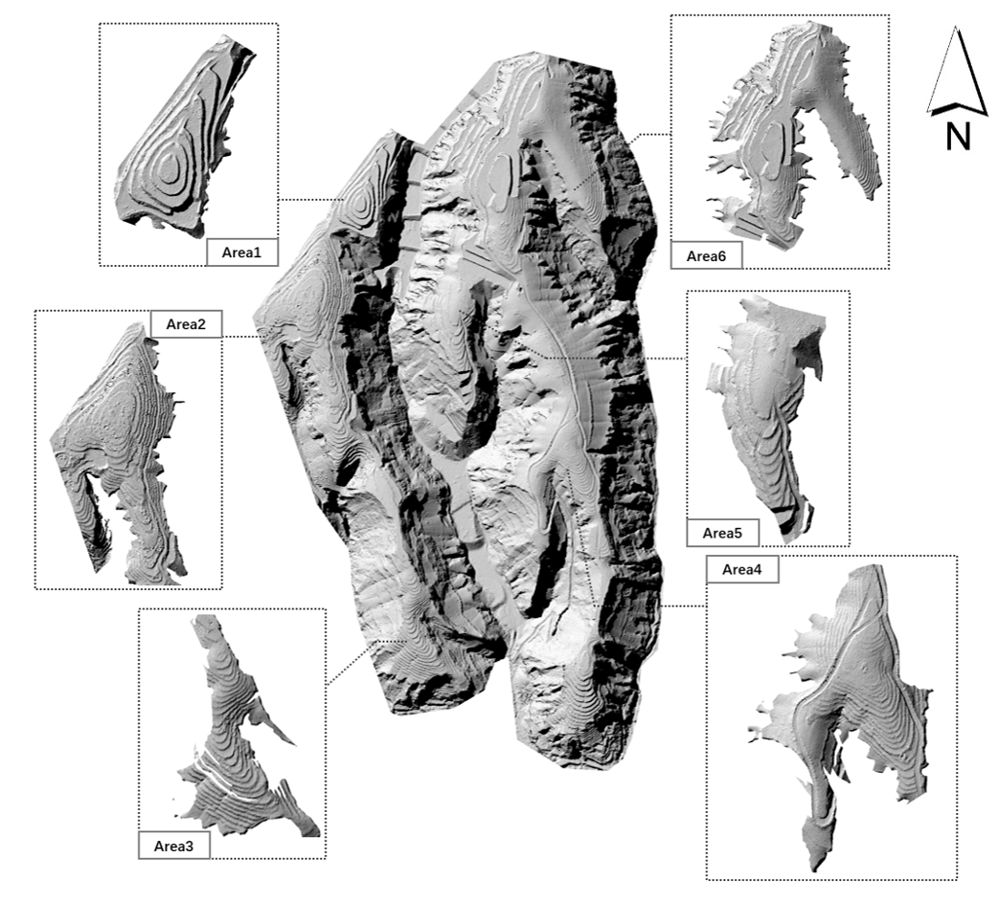

Fig 1. The whole study area and location of terraces, from 0.1m resolution DEM

**2.2 Data**

Considering the heterogeneity of terrace morphology in Yaojiawan, based on the pre-processed DEM of the total area of the study area, a suitable DEM of a small area was cropped to carry out the study based on the distribution of typical terraces. However, even in a 1m resolution DEM, the contour of the terraces will still not enough in depicting terraced fields (Fig 2). So DEM data in sub-meter resolution is needed in this study to show the real morphology of the terraces, such high-resolution data is rarely mentioned in existing literatures related to soil erosion. Therefore, the DEM data of the sample area was interpolated from the 0.01m resolution surface dense point cloud data measured by UAV, with a spatial resolution of 0.1 m. The point cloud was generated in August 2019, and the average ground sampling distance (AGSD) of the original aerial film image was 4.53 cm/1.78 in.

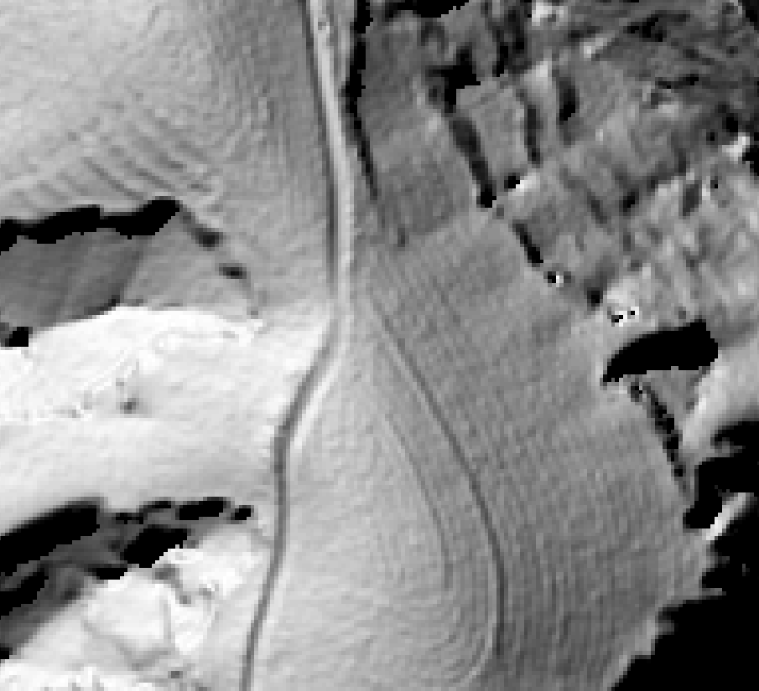

Fig 2. 1m resolution DEM

The data was mainly used to calculate the topography factor, Slope and Slope Length (LS) factor. In addition, other environmental factors in RUSLE were calculated based on the meteorological data, spatial distribution of soil types, vegetation characteristics, and effectiveness of the slope protection project in the study area, respectively.

**3 Method**

**3.1 RUSLE: Soil erosion evaluation model**

Soil erosion is a global environmental challenge shaped by natural and human influences. The extent of soil erosion can be quantified through the soil erosion modulus. Over the years, various soil erosion models like USLE and RUSLE have been developed to calculate the soil erosion modulus, however, the application of these models depends on the environmental conditions in the study area (Igwe et al., 2017). Among them, the RUSLE model (Renard et al., 1991), is a revised version of USLE, which not only has the capability of the USLE model to be used for soil loss assessment in croplands or gently sloping topography, but also increases the accuracy of the results (McCool et al., 1995). In addition, the RUSLE model have been proven to be an effective method for evaluating soil erosion in small or medium-sized watersheds in China and has been widely applied in some neighbouring provinces of the study area (Wu et al., 2021; Hu et al., 2018; Peng et al., 2018).

Given the arid climate prevailing in the study area characterized by concentrated summer precipitation and hydraulic erosion dominance, and the large part of cropland, the RUSLE model is the most suitable model for computing the soil erosion modulus in the study area.

*(1)*

where, *A* represents the annual soil erosion per unit area [t/(hm²·a)], *f* denotes the modification constant; *R* stands for the rainfall erosivity factor [MJ.mm/(hm²·h·a)]; *K* signifies the soil erodibility factor [t·hm²·h/(hm²·MJ·mm)]; *LS* denotes the slope length factor, dimensionless; *C* signifies the vegetation cover factor, dimensionless; *P* represents the factor of soil and water conservation measures, dimensionless, within a value range of [0,1], and *P=1* when the area is distributed with forest land.

The topography profoundly governs the mechanisms of soil and water transport within the region, acting as a locus for both soil erosion and a fundamental influencer in the soil erosion development process. It holds a pivotal role in accumulating and redistributing material and energy across the surface. Notably, prior to and following the implementation of terraces, the most notably altered factor in the equation is the slope length factor LS(Zhang et al., 2022). Hence, a mathematical model becomes indispensable for terracing.

**3.2 Spatial morphology and destruction of terraced fields**

Terraces within Yaojiawan exhibit various morphological traits, categorized into slope terraces, horizontal terraces, and reverse slope terraces. The basin's terraces display a generally flat and gently undulating surface, with horizontal terraces being the primary type. Efficiently modeling terraces involves their extraction along with the corresponding constraint lines (Fig. 3a). This study aims to assess the alterations in soil erosion within the sample area pre- and post-terrace construction. Given that the current Digital Elevation Model (DEM) of the sample area already includes terraces, it becomes essential to generate a hypothetical natural surface DEM devoid of terraces through a de-terracing method. Subsequently, the spatial morphology of the terraces will be calculated for both pre- and post-construction scenarios.

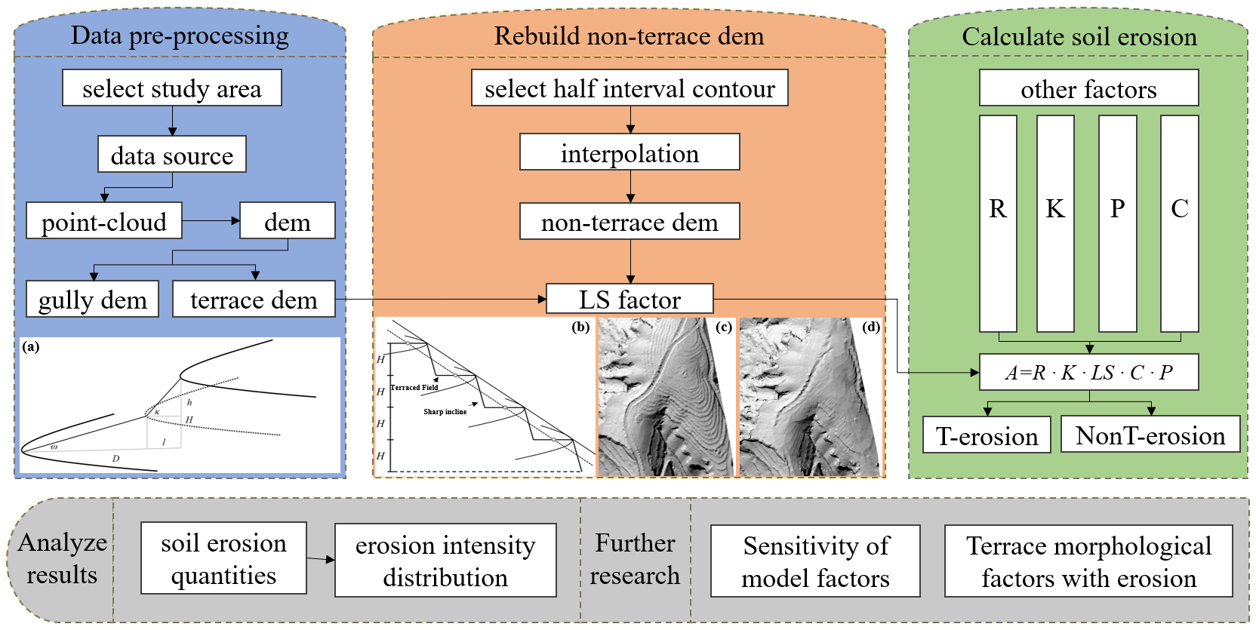

Fig 3. Overall work flow. (a) Terrace model; (b) Destruction method for terrace;

(c)-(d) Example of a terrace and its destruction result

In terraces, contour lines running parallel to the table edge line and the table edge offset line were extracted from the field surface of each terraced field layer in the study. These contour lines served to depict the elevation of the terraced field at each layer, with the contour distance set as the average height of the canopies within the sample area, denoted as *h*. Subsequently, these contour lines were interpolated to generate a new DEM representing terrace-free fields.

**3.3 Topographic changes before and after terrace destruction**

Using the methods in the previous section, the terraced DEM can be destructed to a natural slope. In order to evaluate the differences in topographic features before and after the destruction, the topographic factor, slope, is extracted from the scale of the whole study area and the regional scale of the terraced fields respectively for statistical analysis. From the perspective of the whole area, the mean value of slope without terraces is 32.51°, with a standard deviation of 18.52, while the mean value of slope in the presence of terraces rises to 32.63°, with a standard deviation of 18.94, which proves that the conservation project really affects the distribution of slope. Meanwhile, slope value of the six terraced areas in this study were locally analyzed, and the results are shown in Table 1.

Table 1. Slope in local terracing areas after and before terrace destruction

|  |  |  |  |  |  |  |  |
| --- | --- | --- | --- | --- | --- | --- | --- |
| **Situation** | **Statistics** | **Area1** | **Area2** | **Area3** | **Area4** | **Area5** | **Area6** |
| **terraced** | Maximum | 87.27 | 88.57 | 87.15 | 84.90 | 87.86 | 89.01 |
| Mean | 21.20 | 19.22 | 20.98 | 20.41 | 19.53 | 21.98 |
| SD | 18.98 | 15.30 | 13.81 | 12.67 | 14.04 | 16.80 |
| **non-terraced** | Maximum | 82.73 | 86.27 | 82.50 | 75.23 | 79.68 | 87.20 |
| Mean | 21.74 | 17.62 | 20.81 | 19.75 | 19.30 | 22.16 |
| SD | 18.05 | 13.57 | 11.66 | 11.23 | 12.60 | 15.99 |

As is shown in Table 1, the Mean and Standard Deviation (SD) of slope value in terracing areas with terraces are higher than those without terraces, due to the addition of a number of sharp inclines after terrace construction. Considering that in general process of rainfall erosion, the steeper the slope is, the greater the intensity of soil erosion is, the results of terrace construction would be contrary to common sense if erosion intensity were to be measured only by the average slope. Thus, slope is not the only topographical factor affecting erosion.

**3.4 Assessment of *LS* factor in RUSLE**

3.4.1 The importance of *LS* factor

The LS factor is a vital factor in evaluating soil erosion, which is used to characterize the influence of topographic morphology on soil erosion intensity. In Yaojiawan watershed, the construction of terraces added some sharp incline to the originally smooth slopes, which greatly changed the slope morphology, and was directly expressed in the RUSLE model as the change of LS factor, thus affecting the quantity of soil erosion in the watershed.

3.4.2 Calculation of *LS* factor

In the RUSLE model, the slope length factor (L) and slope factor (S) can be calculated separately or combined into LS factor as demonstrated in this paper. Utilize the data obtained from the terraced DEM, and the non-terraced DEM from the previous destruction work to calculate the LS factor respectively (Fig 4) (Jain et. al).

*(2)*

where, *L* is the length of the hillside (m); *L0* = 22.1 m is the length of the standard USLE experimental slope; *θ* is the slope expressed as an angle; *m* is a variable exponent ranging from 0.2 to 0.5, determined by the slope.

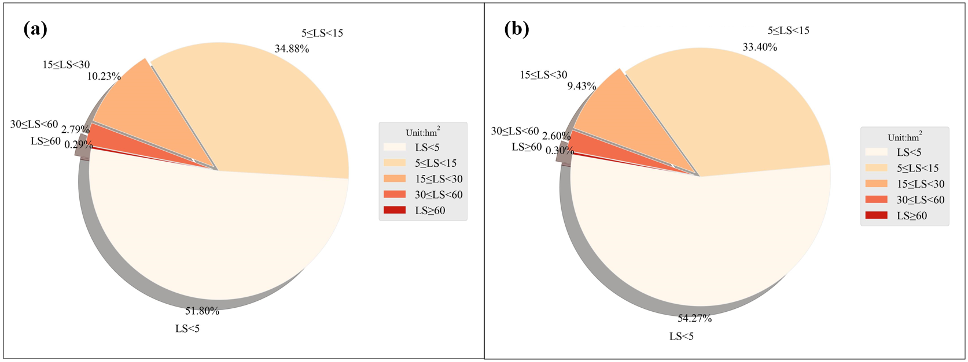

Fig 4. LS factor value proportional distribution. (a) LS factor calculated in terraced DEM;

(b) LS factor calculated in non-terraced DEM

**3.5 Assessment of other factors in RUSLE**

In natural environment, soil erosion is the result of the combined influence of several environmental and human factors. Apart from topographic elements governing surface processes, rainfall, soil composition, surface cover, and protective measures collectively influence the soil erosion modulus. Rainfall acts as a direct catalyst for soil erosion, while soil type and texture dictate the soil's erosion intensity. Surface cover mirrors the protective impact of vegetation on slopes, and protective measures signify the safeguarding effect of engineered structures. Subsequently, the values of each contributing factor within the study sample area are individually computed.

3.5.1 Rainfall erosivity factor *(R)*

Precipitation is the primary driving force for soil erosion, with factors such as rainfall process duration, intensity, type, and total precipitation significantly influencing soil loss (Zhang et al., 2021). Within this study, the 2019 precipitation records for Suide County, encompassing the location of Yaojiawan, were obtained. We utilized the daily rainfall intensity assessment model originally proposed by Wischmeier (1959) but revised by Zhang (2002), to compute the rainfall erosive potential in the Yaojiawan area.

*(3)*

*(4)*

*(5)*

where, *Rh-mon* is the total rainfall erosivity in a given half-monthly period; *k* records the total number of days in the half-monthly period; and *Pn* records the daily rainfall that is erosive on day *n* in the half-monthly period, and if the rainfall on that day is less than 12 mm, then 0 is substituted for the real data on that day; , are fixed params.

3.5.2 Soil erodibility factor (K)

K factor gauges the natural vulnerability of soil to erosion. Within this study, the estimation of the K factor was conducted using the EPIC equation—an erosion and productivity evaluation model introduced by Williams (1996). Mapping was performed to delineate the distribution patterns of three distinct soil types. Leveraging the geographical coordinates of the Yaojiwan watershed, local soil characteristics and organic carbon content were extracted, enabling the determination of mass fractions for sand, silt, and clay.

*(4)*

*(5)*

*(6)*

*(7)*

*(8)*

where *ms*, *msilt*, and *mc* stands for the percentage of sand, silt, and clay in the soil, respectively; *orgC* stands for the percentage of organic carbon in the soil layer.

3.5.3 Cover management factor (C)

Cfactor represents the erosion ratio under a particular vegetation cover and management compared to erosion in bare fallow cropland, varying between 0 and 1. Good vegetation coverage intercepts the waterflow eroding the surface and provides a shelter in the Loess Plateau where vertical joints is severely developed. The assessment equation formulated by Wu (2021) in Lanzhou section of the Yellow River was employed to compute C factor in this study, for the spatial location is really close to the Loess Plateau.

*(5)*

*(6)*

where *c* stands for vegetation coverage, *VFC* stands for vegetation fraction coverage, *NDVImin* and *NDVImax* stands for the min and max value of *NDVI* in the study area.

3.5.4 Conservation practice factor (P)

P factor is related to the land use status of the region, drawing on a soil erosion study that also selected the Loess Plateau as a sample area, thus assigning a value to the P factor (Table 2) (Wu et al., 2021).

Table 2. P values of different land use types

|  |  |  |  |  |  |
| --- | --- | --- | --- | --- | --- |
| ***land use Types*** | **Forest** | **Grassland** | **Dryland** | **River** | **Unused** |
| ***P*** | 1 | 0.15 | 0.35 | 0 | 1 |

**4 Result**

This study utilized Digital Elevation Model (DEM) data from both terraced and non-terraced fields within the Yaojiawan watershed area as topographic morphology data. These datasets were integrated with other pertinent environmental factors in the region. Employing the RUSLE model, the study aimed to evaluate the variation in soil erosion modulus and erosion intensity within the watershed's spatial scale concerning the presence or absence of slope terracing projects.

The result shows that, the conversion of the natural slope to the terraced field will significantly impact slope length factor *LS*, and then change the total amount and distribution of soil erosion in the study area (Fig 5-6). In Fig 6, label *stable* stands for changes on modulus less than 0.00001.

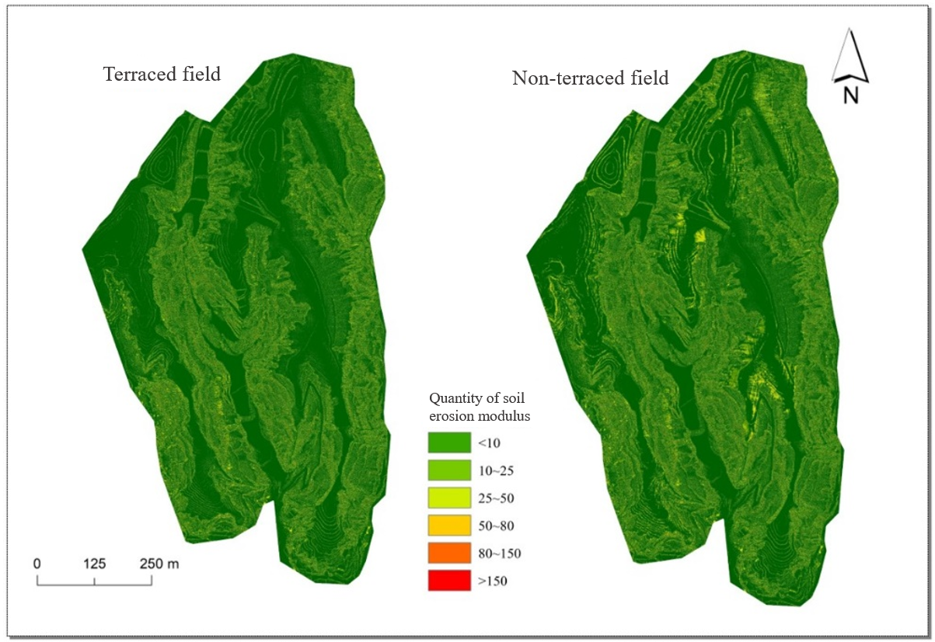

Fig 5. Distribution of soil erosion modulus before and after terrace construction

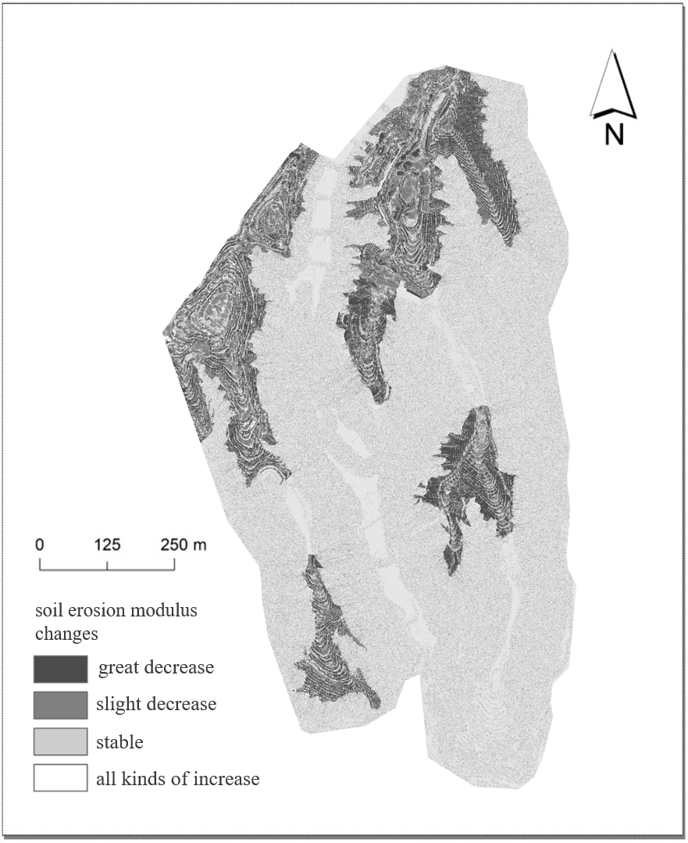

Fig 6. Changes in soil erosion modulus in before and after terrace construction

According to the *SL190-2007* Criteria for Soil Erosion Classification in China, the situations of soil erosion in the study area were assessed as follows: In the scenario when all terraced areas were destructed to natural surfaces, the average soil erosion modulus of the whole study area was 9.29 t/(hm2·a) throughout the year, which was lower than the upper limit of 10 t/(hm2·a) of the permissible soil loss stipulated by the Ministry of Water Resources for the Loess Plateau. Additionally, the total area suffering from soil erosion was 36.96 hm2, and the annual soil loss in the study area was calculated to be 343.36 t/a based on the average value, whereas in the presence of terraces, the soil erosion modulus significantly reduced to 8.30 t/(hm2·a), which was about 11% lower than that in the absence of terraces.

Comparison of the statistical data calculated for the two scenarios shows that, the protection of slope soils by terracing is most directly reflected in the reduction of the total area affected by erosion. There are 36.96 million rasters affected by soil erosion without the protection of terraces, while only about 32.86 million rasters were affected after the construction of terraces, leading to a sharp decline of the affected area for about 4.11 hm2. In other words, if the slopes of the watershed can be protected by terraces throughout the year, the total soil erosion would be reduced to 272.74 t/a.

The benefits of terracing for soil protection would be more noticeable if only evaluate the soil erosion quantity at the scale of the selected terracing areas (Fig 7).

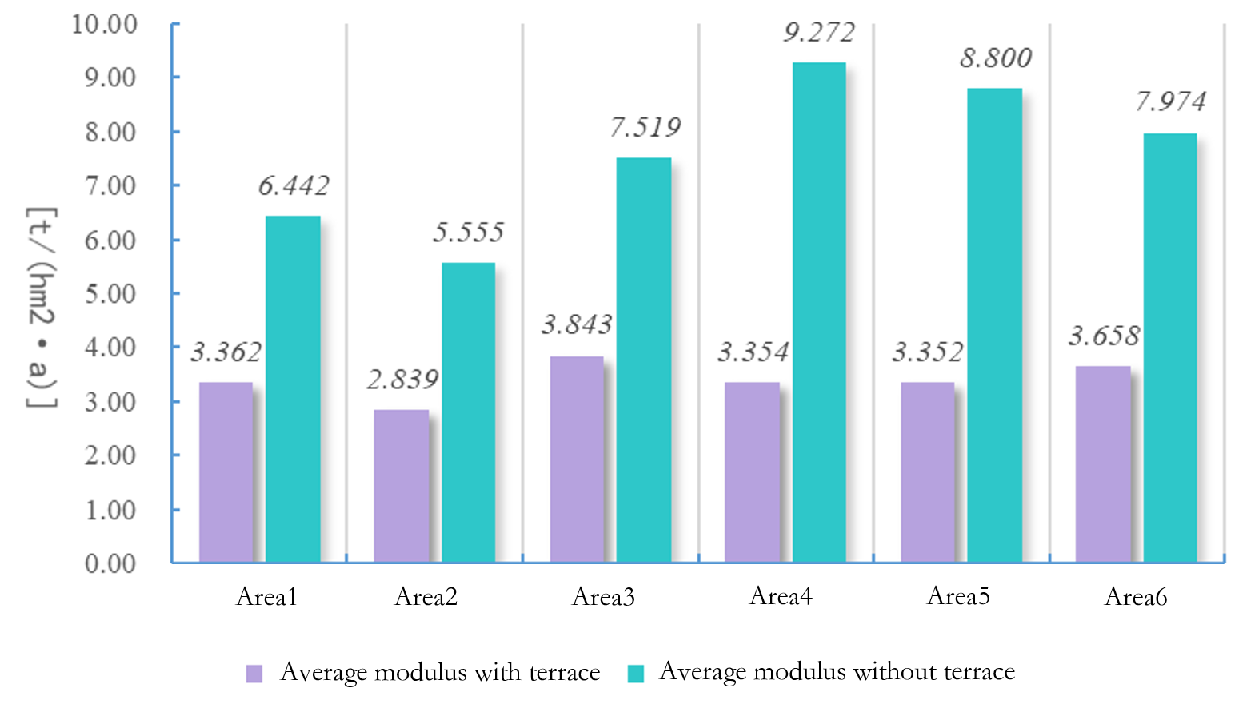

Fig 7. Average soil erosion modulus in selected terracing areas

As is shown in the bar chart (Fig 7), the average soil erosion modulus inside terracing area would be reduced by about 50% to 60% after the construction of the terraces, and the ratio of the total annual soil erosion inside would also be reduced if the total area of the slope remained unchanged in the process.

And in the slope with terraced fields, the erosion coverage of light intensity and below intensity increased compared with that without terraced fields. In the area with terraced fields, the overall soil erosion rate slowed down, and the moderate and above intensity erosion was significantly improved.

**5 Discussion**

In this research, the RUSLE model and high-resolution DEM were used to evaluate the capacity of terrace projects on soil protection, some reasonable and credible results were achieved. However, to better depict the real morphology of terraced fields, this paper uses a 0.1m DEM, which limits the size of the analysis window for slope, resulting in many unexpected noises in the raster map of the soil erosion modulus. Meanwhile, the scale effect of DEM is not considered, which may affect the LS factor in the soil erosion model, thus changing the model outputs. So, the data resolution needs to be reconsidered in further research.

While previous studies have dived into the impact of terrace construction on soil erosion from diverse perspectives, the research on the relationship between terrace morphology and soil erosion is nowhere near finished. Beyond slope and slope length, terrace morphology encompasses additional aspects, including terrace width, narrowness, field area slope spectra, and other expressions (Table 3).

Table 3. Morphological factors of terraces

|  |  |
| --- | --- |
| **Name of morphological factor** | **Definition** |
|  | Average width of the terraced fields in a terrace |
| *AR* | Area of a terrace |
|  | Average number of terrace steps passed by the ridge line |
|  | Average height of the sharp declines in a terrace |
|  | Average slope of a terraced area |
|  | Average slope of all side slopes in a terrace |
| *H* | Total elevation difference of a terrace |

Future investigations can adopt mathematical approaches to elucidate the correlation between these terrace characteristics and the pre- and post-erosion alterations. This approach aims to augment both the breadth and depth of the study, enriching our understanding of the subject.

**References**

Bao, Y., Huang, T., & Lv, L. (2022). Soil conservation effect after implementing the project of returning farmland to forest and grassland in the Loess Plateau of northern Shaanxi, *Journal of Ningxia University,* 3, 1-8.

Ghosal, K., & Das Bhattacharya, S. (2020). A review of RUSLE model. *Journal of the Indian Society of Remote Sensing*, 48, 689-707.

Hu, G., Song, H., & Shi, X. J. Analysis of soil erosion characteristics in the Wohu mountain reservoir watershed based on RUSLE. *Geographical Science*, 2018, 38(4):610-617.

Igwe, P. U., Onuigbo, A. A., Chinedu, O. C., Ezeaku, I. I., & Muoneke, M. M. (2017). Soil erosion: A review of models and applications. *International Journal of Advanced Engineering Research and Science*, 4(12), 237341.

Jain, S.K., & Singh, V.P. (2003). Chapter 12 - Reservoir Sedimentation, *Developments in Water Science*, 51, 681-741.

McCool, D.K., Foster G.R., Renard, K.G., Yoder, D.C., & Weeisies, G.A. (1995). The Revised Universal Soil Loss Equation. *Department of Defense/Interagency Workshop on Technologies to Address Soil Erosion on Department of Defense Lands San Antonio*, TX, June 11-15,1995.

Peng, S. Y., Yang, K., & Hong, L. (2018). Spatio-temporal evolution of soil erosion in Dianchi Lake watershed based on USLE model. *Transactions of the Chinese Society of Agricultural Engineering*, 34(10), 138-146.

Renard, K. G., Foster, G. R., Weesies, G. A., & Porter, J. P. (1991). RUSLE: Revised universal soil loss equation. *Journal of soil and Water Conservation*, 46(1), 30-33.

Wischmeier, W. H. (1959). A rainfall erosion index for a universal soil‐loss equation. *Soil Science Society of America Journal*, 23(3), 246-249.

Williams, J., Nearing, M., Nicks, A., Skidmore, E., Valentin, C., King, K., & Savabi, R. (1996). Using soil erosion models for global change studies. *Journal of Soil and Water Conservation*, 51(5), 381-385.

Wang, Y., Zhao, M., Feng., Y., & Zhang, Q. (2017). Study on the disturbance characteristics of terraces on soil erosion topographic factors. *Journal of Shandong Agricultural University (Natural Science Edition)*, 48(1), 46-51.

Wu, C. C., & Wang, S. J. (2021). Evaluation of soil erosion sensitivity in the Lanzhou section of the Yellow River Basin. Science, *Technology and Engineering*, 21(29), 12390-12397.

Yang, L., Li, T., Wang, W., & Liu, X. (2006). Discussion on the three-dimensional modelling method of terraces in micro-geomorphology of Loess Plateau. *Journal of Northwest University (Natural Science Edition)*, 2, 321-324.

Zhang, W., Xie, Y., & Liu, B. (2002). A study on the method of calculating rainfall erosivity using daily rainfall. *Geoscience*, 6, 705-711.

Zhu, S., Tang, G., Zhang, W., & Zhao, W. (2011). Research on rapid construction method of terrace DEM. *Bulletin of Surveying and Mapping*, 4, 68-70 & 82

Zhang, X. (2021). Study on the distribution law of soil erosion and the amount of erosion in Yili, Xinjiang. *Heilongjiang Water Resources Science and Technology*, 49(08), 8-12.

Zhang, G., Yang, Y., Liu, Y., & Wang, Q. (2022). Progress and prospects of soil erosion research in the Northeast Black Soil Region, *Journal of Soil and Water Conservation*, 3, 1-12.