**Problem Solving using Pseudo code and Flowchart, Simple programs, understanding errors and error handling.**

***Objective-To demonstrate the use of data types, simple operators and expressions***

**Problem Statement – 1:** Accept radius and calculate area and circumference of a circle

**CODE:**

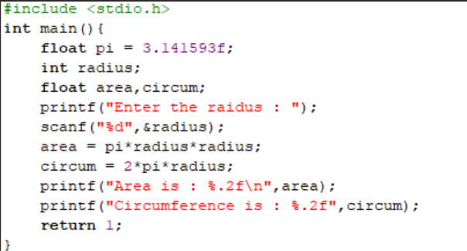

**OUTPUT:**

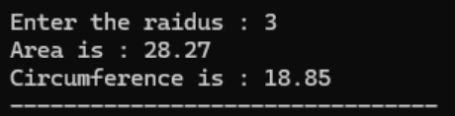

**Problem Statement - 2:** Check if a number is even

**CODE:**



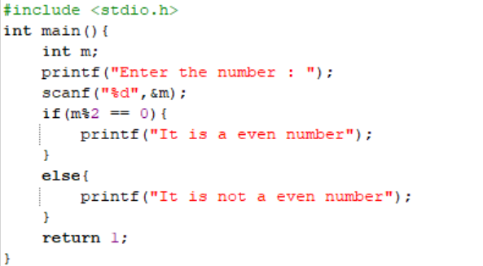

**OUTPUT:**

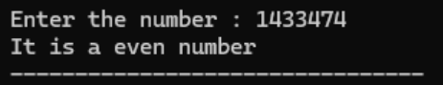

**Problem Statement - 3:** Find maximum of two numbers

**CODE:**



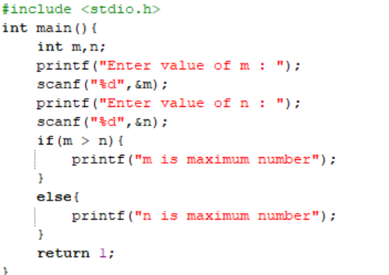

**OUTPUT:**

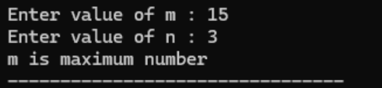

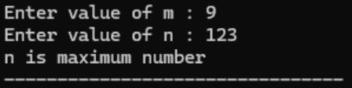

**Problem Statement – 4:** Give a discount of 25 % when purchase amount exceeds 5000, otherwise give a discount of 15%

**CODE:**



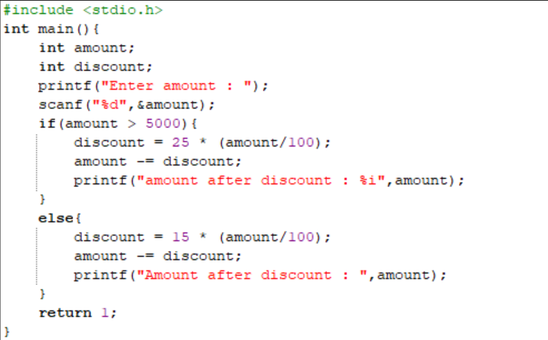

**OUTPUT:**

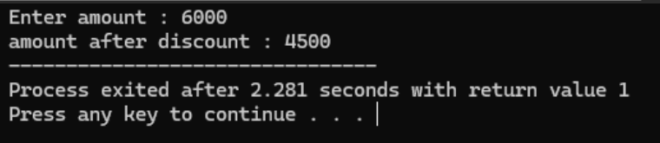

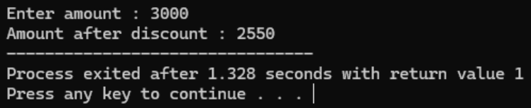

**Problem Statement –** 5**:** Given a set of 5 values representing marks of students, count the total students that have passed. (A score of 40 is required for passing.)

**CODE :**



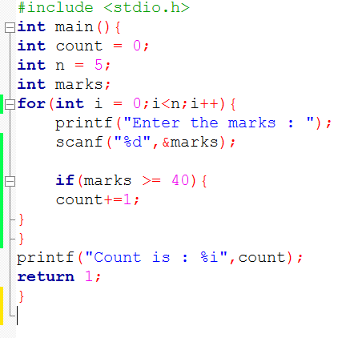

**OUTPUT:**

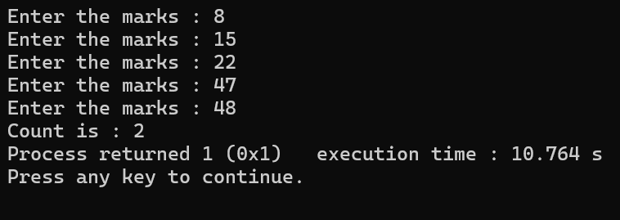

**Problem Statement – 6:** Accept characters till a * is entered from the keyboard and count the number of characters entered

**CODE:**



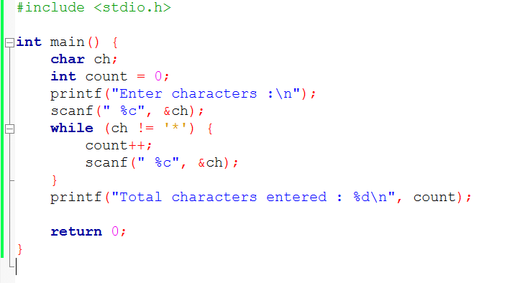

**OUTPUT:**

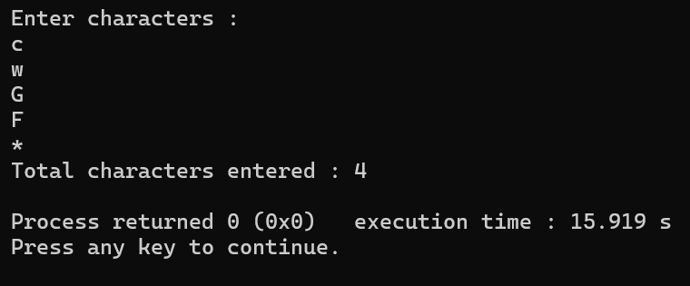

**Problem Statement – 7:** Accept a number and calculate the sum of its digits.

**INPUT:**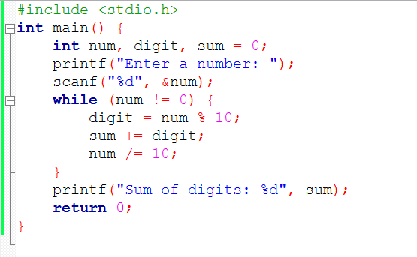



**OUTPUT:**

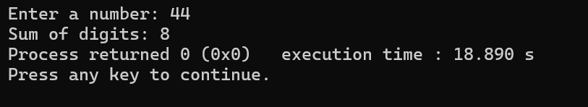

**Q1)**

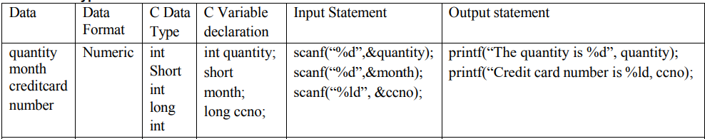

**CODE:**



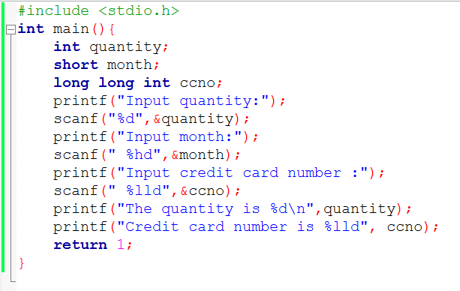

**OUTPUT:**

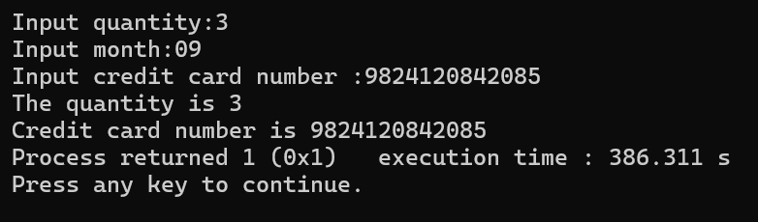

**Q2)**

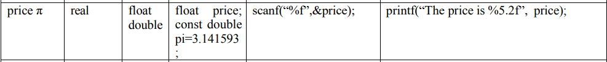

**CODE:**



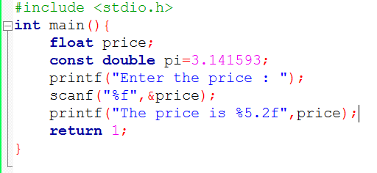

**OUTPUT:**

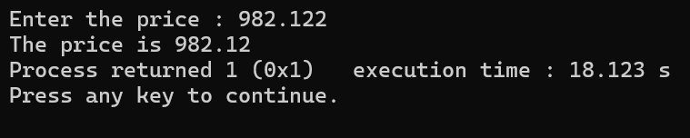

**Q3)**



**CODE:**



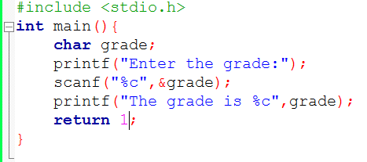

**OUTPUT:**

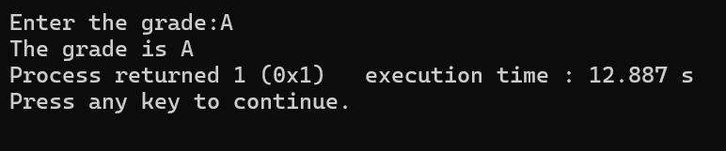

**SELF ACTIVITY:**

|  |  |  |  |  |
| --- | --- | --- | --- | --- |
| **Sr_no** | **Principle amount** | **No of year** | **Rate of Intrest** | **Simple intrest** |
| **1** | **2000** | **3** | **5** | **300.00** |
| **2** | **4500** | **2** | **4.5** | **405.00** |
| **3** | **5000** | **6** | **8.3** | **2490.00** |

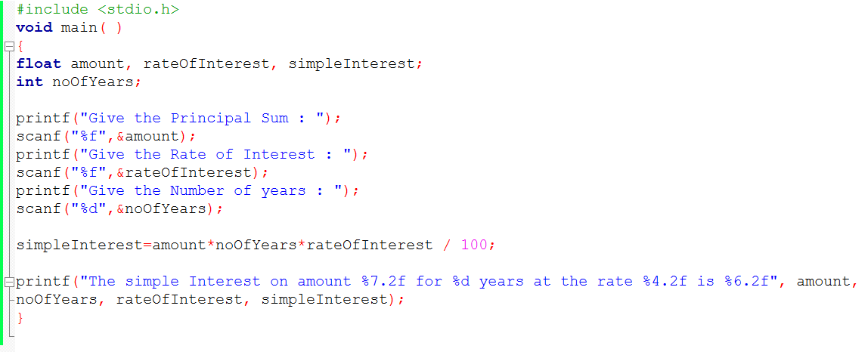

**OUTPUT – 1:**

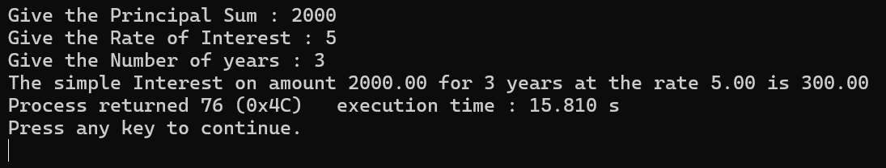

**OUTPUT – 2:**

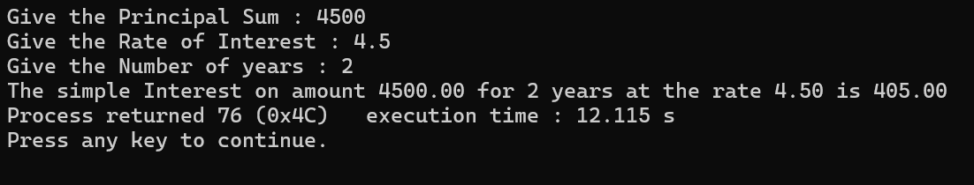

**OUTPUT – 3:**

