**WEBPAGE CREATION**

**UI ASSIGNMENT**

NAME: S. DEEPAK BHARATHWAJ

ROLL NO: CH.SC.U4CSE24015

**AIM:**

To create a webpage using html

**SOFTWARE REQUIRED:**

Notepad, browser

**CODE:**

**<!DOCTYPE html>**

**<head>**

**<title>Simple Webpage</title>**

**<link rel="icon" href="html.jpg">**

**<style>**

**body {**

**margin: 0;**

**font-family: Arial, sans-serif;**

**color: black;**

**background-image: url('backs.jpg');**

**background-repeat: no-repeat;**

**background-size: cover;**

**background-attachment: fixed;**

**}**

**header {**

**text-align: center;**

**color: white;**

**}**

**h1 {**

**font-size: 50px;**

**}**

**.topnav {**

**overflow: hidden;**

**background-color: white;**

**padding: 10px 0;**

**display: flex;**

**justify-content: center;**

**align-items: center;**

**gap: 30px;**

**}**

**.topnav a {**

**color: black;**

**text-decoration: none;**

**font-size: 17px;**

**padding: 14px 16px;**

**transition: background-color 0.3s ease;**

**}**

**.topnav a:hover {**

**background-color: #f1f1f1;**

**}**

**.topnav a.title {**

**font-weight: bold;**

**}**

**.content {**

**text-align: center;**

**margin-top: 50px;**

**}**

**.content h2 {**

**font-size: 80px;**

**color: lightblue;**

**}**

**.content p {**

**font-size: 25px;**

**color: lightgreen;**

**text-align: left;**

**padding: 0 70px;**

**}**

**.button {**

**display: inline-block;**

**background-color: black;**

**color: white;**

**border: none;**

**border-radius: 30px;**

**padding: 12px 30px;**

**font-size: 20px;**

**margin-top: 20px;**

**transition: background-color 0.3s ease;**

**}**

**.button:hover {**

**background-color: #4CAF50;**

**}**

**@media (max-width: 768px) {**

**.topnav {**

**flex-direction: column;**

**}**

**.content p {**

**padding: 0 20px;**

**}**

**.content h2 {**

**font-size: 60px;**

**}**

**.button {**

**padding: 12px 20px;**

**}**

**}**

**</style>**

**</head>**

**<body>**

**<header>**

**<h1>Creating a Simple Webpage</h1>**

**<hr>**

**</header>**

**<div class="topnav">**

**<a class="title" href="#" style="font-size:190%;">Website Design</a>**

**<pre> </pre>**

**<a href="https://www.w3schools.com/howto/howto_website.asp">Home</a>**

**<a href="https://ekommerce360.com">Shop</a>**

**<a href="https://www.awwwards.com/websites/gallery/#google_vignette">Gallery</a>**

**<a href="https://www.linkedin.com/in/deepak-bharathwaj-317110321/">Contact</a>**

**<a href="https://en.wikipedia.org/wiki/Web_design">About</a>**

**<a href="https://www.amazon.in">🛒</a>**

**</div>**

**<div class="content">**

**<h2>Simple Webpage Design 🧑‍💻</h2>**

**<p>Learning how to design a website is an effort-intensive process. Starting with the fundamentals will save you time fixing errors later. This guide covers everything you need to better understand web design so you can start the creation process with a big-picture perspective.</p>**

**<a href="https://en.wikipedia.org/wiki/Web_design" class="button">Learn More</a>**

**</div>**

**</body>**

**</html>**

**OUTPUT:**

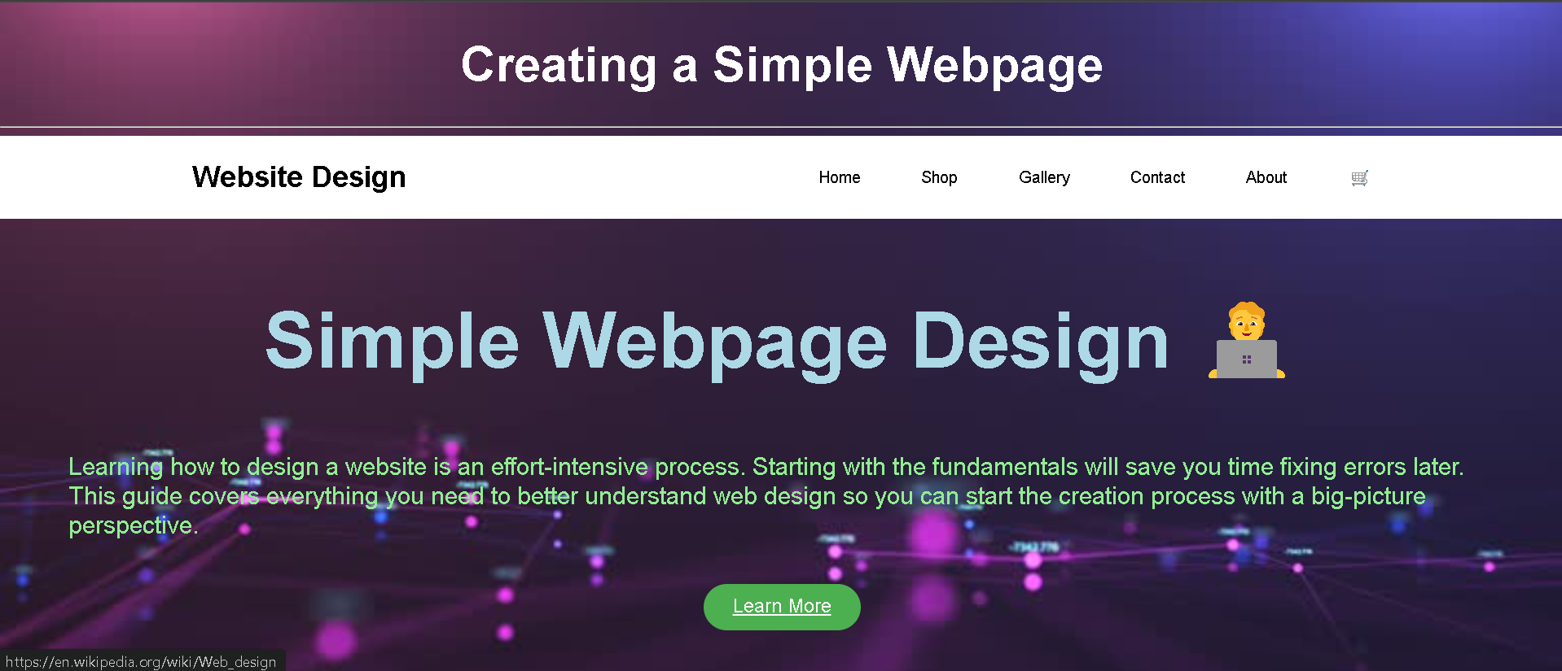360