HYDRA-24: Dynamic Water Distribution Optimization

Abstract
This project models a city water distribution network where water must be sent from a reservoir (S) to a residential district (T) over a 24-hour period. Each pipe has a capacity and a base cost per liter. However, repeated usage creates mechanical stress that increases the cost dynamically. The objective is to compute a 24-hour flow schedule that minimizes the total cost while delivering the required volume without exceeding pipe capacities.

Problem Statement
The water utility network is represented as a directed graph connecting a Reservoir (S) to a District (T). Pipes have capacity limits and base costs. A Dynamic Stress Tax increases the cost of a pipe based on the flow used in the previous three hours. Pipes that are unused gradually return to their base cost. The system must determine when and which paths to use in order to deliver the required water volume V within 24 hours at the lowest total cost.

Constraints:
• The network is a directed graph with Source (S) and Sink (T).
• Each pipe has a maximum hourly capacity.
• Cost per liter changes dynamically based on previous flow usage.
• Flow entering a node must equal flow leaving it (except S and T).

Dynamic Cost Formula:
C(e,t) = BaseCost_e + (Flow(t-1)*3 + Flow(t-2)*2 + Flow(t-3)*1) / 6

Objective:
Compute a 24‑hour flow schedule that minimizes total transportation cost while delivering the required volume V from S to T without exceeding pipe capacity in any hour.

Input:
• Graph adjacency list with pipe capacity and base cost
• Source node S and Target node T
• Total water volume V
Output:
• Flow through each pipe for every hour
• Total cost of the 24‑hour operation
Proposed Algorithm
The algorithm consists of three major stages: dynamic cost calculation, hourly flow scheduling, and minimum cost path selection.
1. Dynamic Cost Calculation
Each pipe in the network has a base cost per liter. However, the actual cost changes dynamically depending on how much water flowed through the pipe in the previous three hours. A weighted average of these past flows is added to the base cost to represent the mechanical stress on the pipe. Pipes that were heavily used become more expensive, while pipes that remain unused gradually return to their base cost.
2. Hourly Flow Scheduling
The total required water volume must be delivered within a 24-hour period. At each hour, the algorithm calculates how much water remains to be delivered and distributes this demand across the remaining hours. This ensures that the required volume is delivered before the end of the 24-hour period while preventing sudden overload of the network.
3. Minimum Cost Path Selection
Using the updated pipe costs, the algorithm identifies the lowest-cost path from the reservoir (source node S) to the district (sink node T). The selected path must also respect pipe capacity constraints. Water is sent through this path, the hourly cost is calculated, and the pipe usage history is updated for future cost calculations.
Applications:
• Smart city water distribution systems
• Pipeline transportation networks
• Traffic flow optimization
• Dynamic resource distribution networks
• Infrastructure stress management systems
Flowchart(Conceptual Steps)
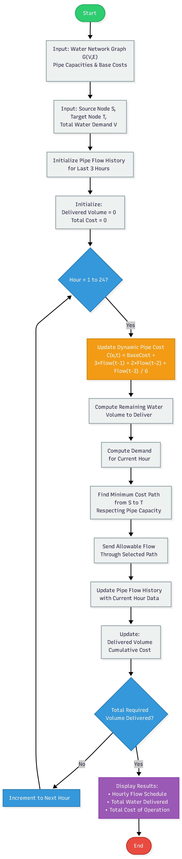



Pseudo Code
Start
Input graph G(V,E)
Input base cost and capacity for each pipe
Input source node S and target node T
Input total required water volume V
Initialize flow history for every pipe
Set totalCost = 0
Set deliveredVolume = 0
FOR hour = 1 to 24
Update dynamic cost of each pipe using:
C(e,t) = BaseCost + (3*Flow(t-1) + 2*Flow(t-2) + Flow(t-3)) / 6
remainingVolume = V – deliveredVolume
remainingHours = 24 - hour + 1
demand = remainingVolume / remainingHours
Find the minimum cost path from S to T
while respecting pipe capacity constraints
Send allowable flow through the selected path
Update deliveredVolume
Calculate cost for the hour
Add hourly cost to totalCost
Update pipe flow history
END FOR
Display hourly flow schedule
Display total cost of operation
End

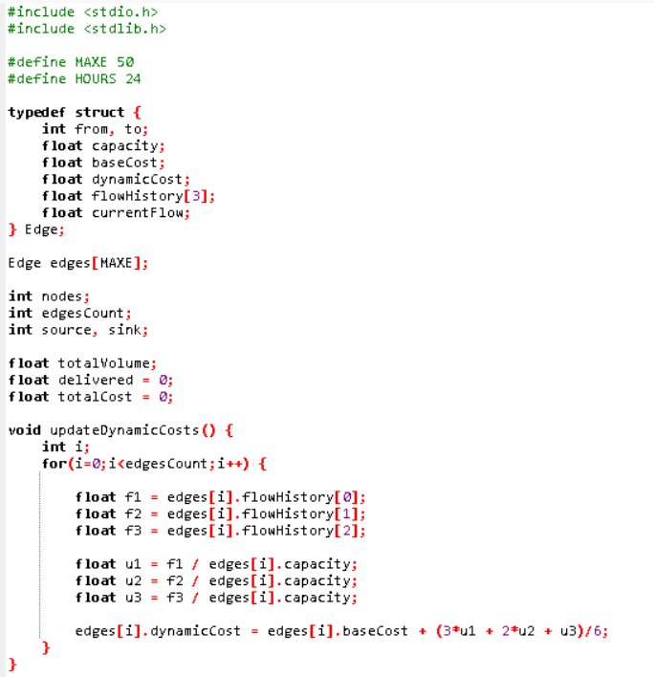
Implementation
Programming Language Used: C
Tools Used: GCC Compiler, Standard C Libraries (stdio.h, stdlib.h)
The program begins by accepting the network parameters including the number of nodes, number of pipes, pipe capacities, and base costs. It also reads the source node, destination node, and the total volume of water that must be delivered.
The system then initializes the pipe flow history and calculates the dynamic cost of each pipe based on the weighted average of the flow used in the previous three hours. For each hour in the 24-hour schedule, the algorithm determines the remaining water demand and identifies the lowest cost path from the reservoir (S) to the district (T) while respecting pipe capacity limits.
Water is then sent through the selected path, the hourly transportation cost is calculated, and the pipe usage history is updated. This process continues for all 24 hours. Finally, the program outputs the hourly flow schedule and the total cost of the entire operation.
CODE

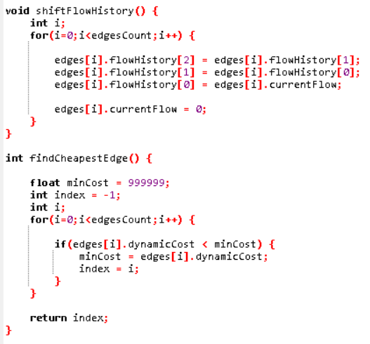
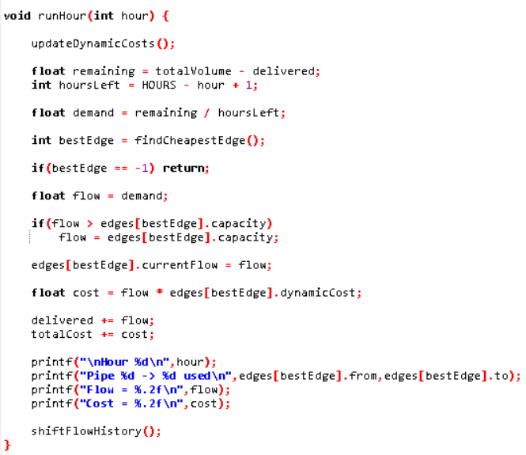

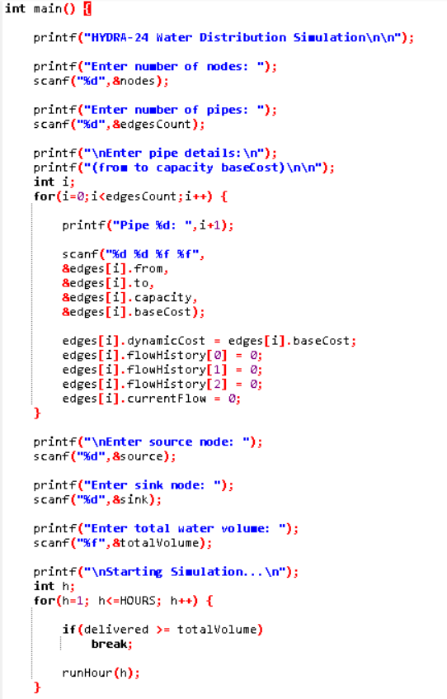
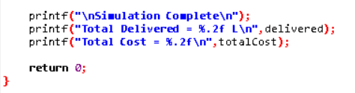

Input
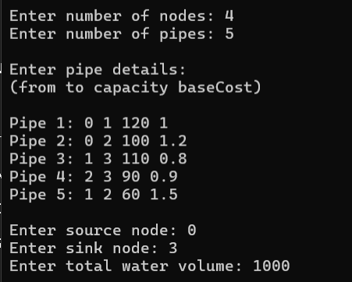
Output
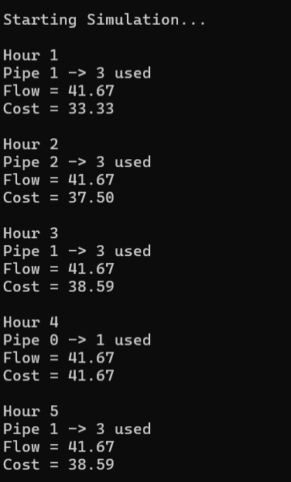

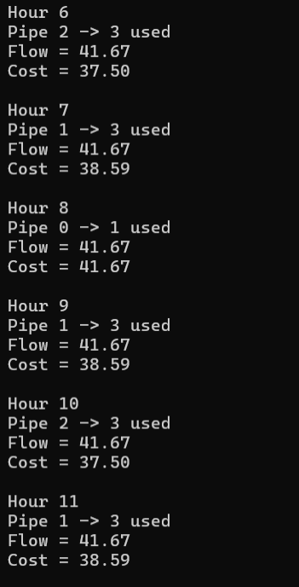
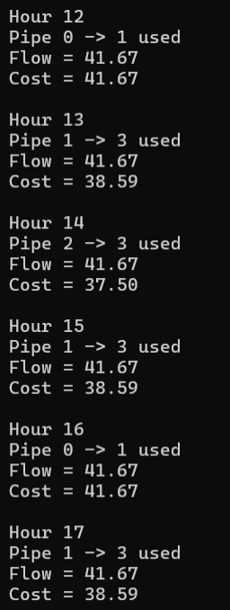

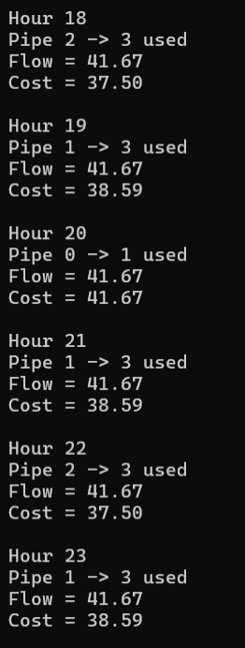
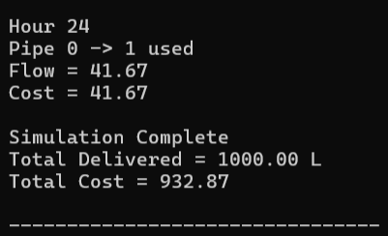

Algorithm Performance
Time Complexity:
• Dynamic Cost Calculation: O(E)
• Minimum Cost Path Computation: O(E log V)
• Hourly Flow Scheduling (24 iterations): O(24 × E log V)
Overall Complexity: O(E log V)
Space Complexity:
O(E + V) for storing:
• Graph structure (nodes and pipes)
• Pipe flow history for the last three hours
• Dynamic cost values for each pipe

Conclusion
The HYDRA‑24 system demonstrates how dynamic cost modeling can be used to distribute resources efficiently in a network. By adjusting pipe costs based on recent usage, the algorithm balances flow across the network and reduces overall operational cost.

